Mage Types
(WIP Name)
Table of Contents
Background 3
Lore 3
The Elements and their Regions 3
Blue 3
Purple 4
Magenta 4
Red 5
Orange 5
Yellow 5
Green 6
Cyan 6
Elemental Bias and Transmutation 7
Map 8
Story 9
Introduction 9
Elemental Mechanics 10
Matchup Chart 12
Elemental Traits and Abilities 13
Environmental Abilities 14
Ability Summary 16
Battle Mechanics 18
Overworld Spells 18
Technical 19
Technology Used 19
Requirements 19
Specifications 23
Battle System (BATT) 23
Main Classes: 23
BattleGUI Layout 26
Battle Loop 28
Attacks 30
Status Effects 30
Defeat 32
Component-based Attack Design 32
Adding Content 33
Overworld (OVER) 35
Overworld-Battle System Connection 35
Character Controller 35
Items & Inventory 35
Level Design 36
Npcs Interactions 36
Monsters, Enemies, & Combat 36
Story System (STRY) 36
Character Management (CHAR) 36
Settings and Accessibility (ACCS) 36
Systems Overview 36
Character 36
Elemental System 37
Adding Content 37
Design 38
Current design questions 38
Character List 38
Plot 38
Idea #1 38
Attack List 38
Equipment List 38
Item List 38
Scratchpad 39
Battle System 40
Adding Content 41

Background

Lore
Forlorn is a pocket dimension tucked away from mainstream reality that people sometimes get stuck in. The survivors here have done their best to cope in this hostile environment, building little communities and studying the world and its magic. Forlorn consists of an island, surrounding by an inky sea underneath a rocky dome made of strange black rock. There is a day-night cycle, however its not quite clear where the daylight comes from.
Forlorn is currently governed by 8 elements: Red, Green, Blue, Yellow, Cyan, Magenta, Orange, and Purple... although elder survivors recall a time when there were more, like Pink or Chartreuse. These tertiary types have long been consumed by the current 8. As it stands, Purple will likely be consumed by either Blue or Magenta, but this process seems to be happening very slowly. Forlorn is divided into 8 regions, each one representing a concentrated pool of an element’s energy.
Certain combinations of these elements are highly reactive, quickly transmuting into another element. For instance, upon contact Red and Blue forms Magenta. What’s more, the survivors find themselves transmuting from earthly matter into Forlorn matter. Survivors find themselves experiencing superficial transmutations as they use different tools and spells. Frequent, prolonged exposure to a single element leads to a phenomena called ‘biasing,’ where their bodies permanently shift to be composed of that element. With enough care, survivors can keep their composition balance, however this is rarely achieved. Staying within a specific region for too long, using elemental magic too often, and even prolonged contact with certain items can all lead to a bias forming.
To keep them from becoming biased too quickly, newcomers are given a ‘quest.’ This entails traveling to each region and completing various challenges devised from the locals. This acts as a way to introduce newcomers to the attributes of each element, as well as provide a distraction to the survivors. To begin their quest, the newcomers are brought to Blue and given either a necklace or bracelet containing a sample of each element. Technically the trials are optional, but highly encouraged.

The Elements and their Regions
Each region and element has an industry it contributes towards the larger civilization, although these are not strictly region-locked. Each region has its own research, manufacturing, food production, etc and could be somewhat self sufficient.
Each region should have its own visual identity. Ideally, a player should be able to tell what region they’re in, even if the screen was in gray scale (this is more of a guideline than a rule. Each area should also have its own color palette).

Blue
Blue is a very introspective, internal element, creating a sort of psychic link between its wielders and the world. As such, Blue-biased people tend to have deep insight into how the world of Forlorn works. This would make them ideal scientists, with one important caveat. Blue is, for lack of a better term, a very self-absorbed element. This makes Blue researchers excellent at discovering and explaining general principles and Blue related info, but unable to adequately study any other elements, with the exception of Purple.
Blue is also a very static element and those that bias towards Blue eventually become rooted in place. Many of the original founders of Forlorn biased towards Blue (for various reasons), which contributed to the region becoming the administrative capital.
Blue is located inside of a valley, between the cliffs of Purple and mountains of Cyan. The landscape largely consists of rocky beaches and tide pools, interspersed with towering pillars of rough stone. Many grand architectural projects can be found tucked away in secluded corners of this region, however all have been abandoned before being completed. These projects were all borne out of ego, an attempt to match the physical wonders built by other regions. Blue architecture developed more naturally tends towards simplicity.
Industry: Administration and research

Purple
Towering over the Northwest of Blue are the cliffs of Purple. The surface of this region is perpetually covered in a thick, ominous fog. While this suits the light-sensitive inhabitants of Purple, most of them still take refuge in the deep cave system below. In contrast to the wide open mines of Green and Cyan, these caves are winding and claustrophobic. The denizens of Purple are typically very reclusive, with feral energy and glowing eyes. These factors combine to make Purple a place few outsiders want to visit.
Purple, like Blue, is a very introspective element. Those who wield it develop deep insight into the world around them. However, Purple is less ‘self-absorbed,’ allowing those who use it to explore broader topics, including other elements.

Magenta
Magenta is the entertainment capital of Forlorn. Large amounts of the region have been developed into fairgrounds, gardens, and similar features. Magenta acts as a sort of resort for the rest of the island. People can typically visit for a couple of days w/o risk of biasing. Magenta is a very soft element as well, which greatly reduces the risk of injury.
Those who are Magenta-aligned tend to go one of two ways. Some become artistic visionaries, contributing to the overall industry. Others become hedonistic, becoming the main patrons of the latter. Despite their differences, however, both paths share a similar destination. If not careful, those who are Magenta-aligned can quickly spiral, losing sight of everything except their pursuit of passion.
Due to the nature of their industry, Magenta’s leadership are heavily invested in keeping their parks safe. This has led to them blocking off dangerous attractions, leading to the formation of these off-limits abandoned backrooms. These areas tend to be infested with monsters, with deeper sections being reclaimed by the wilds of Magenta. In stark contrast to their developed areas, the wildlands of Magenta are some of the most dangerous areas on Forlorn, comparable to the jungles of Green.
Industry: Entertainment

Red
The vast plains of Red make excellent farmlands, responsible for the majority of food production on the island. The monotony of the landscape is broken by these large, uncanny machines. Many of these machines were built to help with agricultural production, or are walking greenhouses themselves. A select few, however, were built as proofs of concept, acting as prototypes for the more useful counterparts.
Though livestock consists of a relatively small percentage of their agricultural output, most of their food has a visceral, fleshy appearance. Even plants grown in Red could easily be mistaken for meat, at least by appearance. When refined into machinery, Red matter loses some of its visceral quality, although there is still something strangely alive about them.
Red is not a common element to become biased towards. For unknown reasons, the process of becoming Red-biased is very long, almost requiring active participation from the person. A common adage on Forlorn is that ‘Becoming Blue drives you mad, becoming Red requires you already be mad.’ This is due to the fanatical nature of Red-biased people, who form what some might call a cult.
Industry: Agriculture/Food production

Orange
The entire region of Orange is contained inside of a subterranean compound, full of research labs and libraries. Orange is unique as far as regions go. Firstly, it is unique in that it is completely inside of Red. Secondly, Orange is the only region to begin getting absorbed into another color (Red), only for this process to completely halt with no signs of resuming. Orange is the only element to be liquid in its base form, forming a viscous goop many find to be unpleasant.
Orange is a highly reactive element, being used to create a wide variety of volatile compounds. In earlier drafts of the game, Orange had the most reactions, reacting with 6 different elements. The only element that was close to this was Magenta, having 5. However, this turned out to be a mistake. Originally, Orange + Cyan => Blue && Cyan + Purple => None. This relationship was meant to be flipped, however, leading to Orange being in a 3 way tie for most reactions (Orange, Purple, Magenta). Despite this, I intend to keep the lore calling Orange the most reactive.
Being composed of the highly volatile Orange, those with this condition are confined largely to their compound. Here they form a tight knit group of researchers and alchemists. They are considered to be the foremost experts on the topic of transmutation.
Industry: Research, Alchemy, Chemical Manufacturing

Yellow
On the ground, Yellow seems like a barren desert, covered with raging sandstorms and high winds. However, despite the difficult to traverse landscape, Yellow acts as the transportation hub of Forlorn. This is because the vast majority of Yellow’s infrastructure is located in the clouds. A perpetual hurricane is centered above Yellow, with tendrils reaching across the entire island. As one becomes more Yellow-aligned, they begin to lose density, as their bodies slowly evaporate into the air around them, gaining the ability to fly/float. It is all but confirmed that the storm is composed of the bodies of the ancient Yellow-aligned. The storm currently touches down at one location, near the center of Forlorn. This location can be changed via powerful Yellow magic; its current location was chosen based on its proximity to the capitals of Red and Cyan, who have the most goods in need of transport.
This element resembles a yellow mist and is the only Element to be a gas in its base state. Yellow magic contains a lot of useful utility spells, allowing for fast travel and communication. As such, its a common secondary type (for the elements that do not react with it).
Industry: Communication, transportation, logistics

Green
The region of Green is home to a dense jungle, although the Southern half has been cleared to make place for mining and manufacturing infrastructure. Decades ago in Forlorn’s history, there was a great war. During this time, Green was the most powerful region, home to both powerful weapons and warriors. This region was instrumental in ending the war and bringing in the current era of peace, however this prestige did not last. Many of the other regions preferred dealing with calm and pragmatic Cyan, over the fierce and solitary Green, leading to the latter taking on most of the former’s industry. This has led to much discontent on the part of Green, who feel abandoned and disrespected. These feelings were further exacerbated by Cyan, after years of indifference towards them, suddenly asked for a large shipment of a deadly power source, the mining operations of which had been long abandoned. Feeling used, Green made a shift, isolating themselves from the rest of the island. Their capital was moved to the Northern-most tip of the island, deep in the jungle.
One of the main resources native to Green is a green crystalline power source, reminiscent of uranium. It is commonly believed that this material is radioactive, however this seems to be based on it being a glowing green rock used for power. This connection is intentional, one of Green’s abilities is a ‘uranium type’ ability I’ve been sitting on for years. Essentially, when a Green-type is alone on the field, they receive a massive attack buff. This buff is removed when the opponent uses their own Green-type (so basically MAD). In lore, this is considered to be a battle trance certain Green-aligned warriors can enter, where they progressively become more powerful. Mechanically, this concept is helped by the fact that only 1 combination of types forms Green (Cyan + Yellow).
Despite being in a time of peace, some Green-aligned warriors are used as hunters to track down and kill dangerous monsters.
Industry: Hunters, special weapons, soldiers.

Cyan
Cyan is by far the largest region, taking up most of the Eastern half of the island. It is comprised mostly of mountainous terrain. Cyan acts as the manufacturing capital of Forlorn, home to many factories, warehouses, mines, etc. Cyan is the most stable element, only reacting with 3 other elements. This makes it a good material for building durable tools. Furthermore, Cyan matter can take many forms, including metallic and stone like materials. Cyan matter also seems to radiate a cold energy, leading to their region being noticeably colder than the rest, even at lower altitudes.
Though they do rely somewhat on Yellow for logistics (especially for inter-region trade), Cyan has invested heavily in internal transportation. These include railways and cable lifts. They also have dabbled in shipping via boats, though this is mostly in shallow waters.
Becoming Cyan-aligned is difficult, much like Red. Those who do become very stiff, their skin taking on a metallic quality. They tend to be very focused and calm, bordering on robotic.

Elemental Bias and Transmutation
A bias forms when a person experiences frequent, prolonged exposure to one particular element. This bias drastically changes the composition of their body, affecting their appearance, abilities, and sometimes even personality. Someone with a bias can be transmuted, but this state is typically temporary, only affecting their outermost layers of skin. However, more debilitating transmutations can occur, usually as a result of injury or attack. Transmutations that penetrate deeper have a greater risk of causing a runaway reaction, resulting in death. In general, transmutations act similar to physical injuries. A Red-biased person entering the Blue region will experience discomfort and superficial patches of Magenta will grow on their skin, but they will generally be fine (barring injury and the like).
Someone who does not have a bias can experience transmutations as well. In these cases, only patches of the body are affected, allowing up to two elements to be present at once. These changes will last until actions are taken to revert back (magic, etc) or another transmutation occurs. Maintaining the same transmutation for extended periods of time increases one’s risk of becoming biased towards that element, however this by itself isn’t enough to bias someone (quickly, it would take over a year). Usually, bias occurs with a combination of factors. E.g. being Blue-transmuted, inside the Blue region, while using Blue spells and tools. Becoming seriously injured inside a region is the only factor that by itself causes bias, but even this takes upwards of a week.
The process of becoming biased is perceived as inevitable, but it is by no means a fast process. One person in Forlorn’s history has gone 12 years (and counting, they’re still alive and unbiased) without becoming biased. Most people who participated in the Quest last an average of 5 years. People before the Questing system was implemented would last an average of 2. Many people start out vigilant, making sure to travel to different regions regularly and to vary the spells/tools they use. However, over time people get complacent. This isn’t helped by the fact that the consequences are not immediately apparent and by the time you notice yourself changing its too late.
Different elements bias people at different rates. The following time-spans assume a person isn’t actively trying to become biased, except when otherwise mentioned (Red and Purple). Magenta happens the fastest, helped by the pleasant nature of both the region and the element (Average: ~2y, post-quest). Red is the slowest, you essentially have to try to become Red-biased. Cyan is also rather slow (~6y). Green biases people at an average rate, however it takes a certain personality type to choose to camp out in the jungle and specialize almost entirely on combat. Yellow also biases people at an average rate, however this is a rather common bias to form, as many useful spells draw on the Yellow element (teleportation, long distance communication, flight). Blue is also a common bias to form (~3-4y). People tend to resign themselves to becoming Blue-biased​ much earlier than other elements (even if they still have time to reverse the transformation, they frequently won’t). Purple is similar to Red and Green, where is takes a certain personality type (reclusive) and a degree of effort to become Purple-biased. Purple is one of, if not the most, rare bias to form and not much is known about the process (ppl in universe don’t know this for sure, but its about ~5y to form). Orange is second rarest, owing to the small size of its region and specialized nature of many of its spells/etc.

Rarity of bias to form (Rarest – Most common): Purple > Orange > Green > Red, Cyan > Blue, Magenta, Yellow. This acts as a general guideline of the population of each region.
Speed of bias (fastest – slowest): Magenta > Blue > Yellow, Purple, Orange, Green > Red, Cyan.

Map
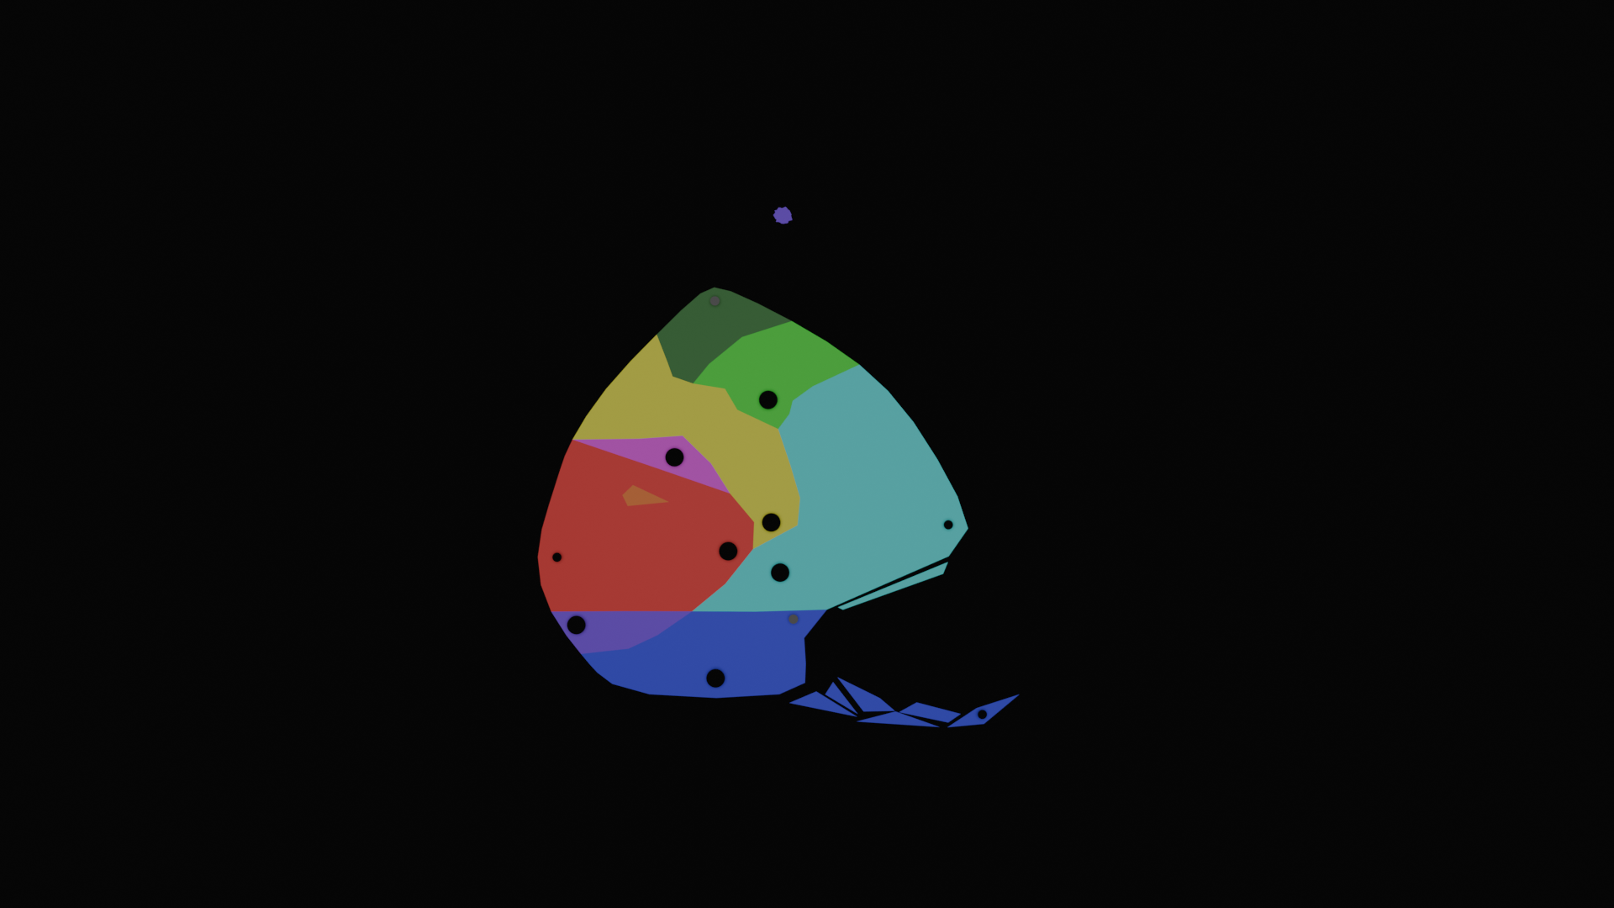
A crude map of Forlorn, showing the rough boundaries of each region and approximate locations of cities.
- Capitals are typically placed towards the center of the island, to give close access to other regions, especially Red, Cyan, and Yellow.
  - Close access to Yellow gives access to their communication and logistics networks, which lessens the need to be close to Red or Cyan.
  - The Blue capital is placed nearest to where survivors typically wash ashore.
  - Purple, being more a network of individuals than a full-fledged region, placed their capital to maximize solitude.
- Secondary towns are typically placed deep inside of a region, where the elemental energy is most concentrated.
- A large, permanent vortex resembling a hurricane sits above Yellow. The arms radiating off of this stretch across the entirety of the island, acting as one way routes to deliver stuff from Yellow to the other regions.
- Very, very few people know about the Northeastern island above Green.
- Orange is too small to have its own city. Instead, its more of one large compound expanding vertically into the ground.
- Green is either trying to build or has built a second city at its Northern most tip.
  - They also lowkey resent not having great access to any of the other capitals.
  - The Northern section of Green is covered with really dense jungle.

Story

Introduction
The player wakes up to find themselves on a raft as it comes aground on a lonely blue beach. A light in a nearby shack turns on and you watch as a figure exits and heads towards you. They help you to your feet, greeting you in several languages until settling on your mother tongue. They seem friendly enough, so you follow them back to the shack. Where else are you supposed to go?
Inside sits another castaway, a girl by the name of Alice. The three of you chat, getting to know each other. The man tells you the broad strokes of the setting, remarking how unusual it is to have two survivors arrive within such a short time period.
You are given the option to ask Alice a few different questions, as well as respond to a few of hers. The options you select are used to select her fated bias. A key character trait of Alice is that she hates the idea of forming a bias, but falls in love with a specific element. The element she falls in love in is considered her ‘fated bias.’
The man then takes you to a nearby town. It is currently early morning, so not many people are around. One of these is the mayor, who is sitting on the steps going up to the city hall, wrapped in a blanket. They seem surprised not only that the island received two survivors in such a short time span, but that they would receive new survivors “less than a month since the last arrival.” The mayor explains about quest, the different regions, and the elements. They also reveal that they are Blue-biased and explain the concept. Alice expresses horror at the concept. The mayor doesn’t find this offensive, in fact expressing a similar horror, jaded by the seeming inevitability of the phenomena. They tell Alice about a woman living in Cyan (the last area the players will find) who has the ongoing record for going the longest without forming a bias. Alice wants to visit Cyan immediately, but the mayor explains that the entire purpose of the quest is to help prevent people from biasing, so she will be perfectly fine.
Going into city hall, the two are introduced to an artisan, who creates a magic item that allows survivors to learn to channel elemental energy, as well as staving off bias. The player is offered a choice between a necklace or a bracelet. The necklace gives a boost to ranged attack/defense, while the bracelet gives the same boost but for melee. Alice will choose the opposite of whatever the player picks.
The pair then prepare to begin their quest and the player is given the freedom to explore the town. They are able to talk to different NPC, who give extra info about the town, world, etc. As the player tries to leave the town, they are interrupted by the arrival of Alex. Alex has just completed their quest (and is the person who arrived less than a month ago, mentioned by the mayor). Him and the beach-caretaker (the one who first found you) begin to talk, and the caretaker jokingly asks him which bias he’s selected. Its revealed that Alex, immediately upon hearing about the concept, became enamored with the idea. This shocks Alice and it becomes apparent through the caretaker that Alex holds a minority opinion. Most people view biasing as an inevitable horror, believing it to be unrealistic to remain unbiased forever. Despite being open to the idea, however, Alex cannot decide which element he would want to align with, being fascinated by all of them. (Maybe before Alex left he expressed interest in a specific element, only to find he liked something about all of them. This specific element could be Alice’s fated bias).
Upon learning that the two of you are about to embark on your quest, Alex asks to join you. The caretaker says its fine, if not a bit unorthodox. Despite her disgust with his life choices, Alice doesn’t mind him coming along (and the player doesn’t have a choice). And with that, the three of you head out.

Elemental Mechanics
- Each player has a primary and an optional secondary type. This is different to a character’s bias. Primary/Secondary types are more temporary. A biased character’s primary type can change, but will eventually revert back to its bias.
- Each type is based off of a color (R, G, B, Y, M, C, O, P).
- Using an attack that matches your secondary type twice in a row will swap your primary and secondary typing.
- Using an attack that matches neither of your types twice in a row will replace your secondary typing.
- Certain type combos will cause a reaction, forming a new type.
  - This includes the player's primary and secondary types.
  - A melee attack will affect the type of both the user and target. Ranged will only effect the target.
Examples
Attacker Type | Defender Type | Attack Type | Attacker Result | Defender Result
Red | Blue | Red Melee | Magenta | Magenta
Red | Blue | Red Ranged | … | Magenta
Red | Red & Blue | Red Ranged | … | … & Magenta
Red | Blue & Cyan | Red Ranged | … | Magenta & … →  Blue
Red & Magenta | Blue & Yellow | Green Melee | Yellow & … →  Red | Cyan & … →  Green
** I might consider making it take two hits from an opponent to make a reaction occur. **

Matchup Chart
Note: These colors may not represent the exact shade that will be used.
Element | Reactions (#other elements it can react with) | Reactants (#of reactions that form it)
Blue | 4 | 3
Purple | 5 | 2
Magenta | 5 | 3
Red | 4 | 3
Orange | 5 | 1
Yellow | 4 | 2
Green | 4 | 1
Cyan | 3 | 2

An unnecessary explanation for why each matchup was chosen:
Color 1 | Color 2 | Result | Selected Color | Explanation
FF0000 | 00FF00 | 808000 | FFFF00 | Proportional
FF0000 | 0000FF | 800080 | FF00FF | Proportional
FF0000 | FFFF00 | FF8000 | FF7F00 | Exact
FF0000 | 00FFFF | 808080 | None | No Match
FF0000 | FF00FF | FF0080 | None | Resembles 2
FF0000 | FF7F00 | FF4000 | None | Resembles 2
FF0000 | 7F00FF | C00080 | FF00FF | Proportionalish
00FF00 | 0000FF | 008080 | 00FFFF | Proportional
00FF00 | FFFF00 | 80FF00 | None | Resembles 1
00FF00 | 00FFFF | 00FF80 | None | Resembles 2
00FF00 | FF00FF | 808080 | None | No Match
00FF00 | FF7F00 | 80C000 | FFFF00 | Proportionalish
00FF00 | 7F00FF | 408080 | 00FFFF | Proportionalish
0000FF | FFFF00 | 808080 | None | No Match
0000FF | 00FFFF | 0080FF | None | Resembles 1
0000FF | FF00FF | 8000FF | 7F00FF | Exact
0000FF | FF7F00 | 804080 | 7F00FF | Proportionalish
0000FF | 7F00FF | 4000FF | None | Resembles 1
FFFF00 | 00FFFF | 80FF80 | 00FF00 | Max Channel
FFFF00 | FF00FF | FF8080 | FF0000 | Max Channel
FFFF00 | FF7F00 | FFC000 | FF0000 | Max Channel
FFFF00 | 7F00FF | C08080 | None | No Match
00FFFF | FF00FF | 8080FF | 0000FF | Max Channel
00FFFF | FF7F00 | 80C080 | None | Mb Green**
00FFFF | 7F00FF | 4080FF | 0000FF | Max Channel
FF00FF | FF7F00 | FF4080 | FF0000 | Max Channel
FF00FF | 7F00FF | C000FF | 0000FF | Max Channel
FF7F00 | 7F00FF | C04080 | FF00FF | Proportionalish

Elemental Traits and Abilities
Each element has a special status effect unique to itself. These traits should either have a positive and negative effect, or require a higher level of skill/strategy. It might be smart to design the abilities in such a way that each element could be given multiple battle oriented traits (similar to abilities in Pokemon).
It would also be cool for each element to have an ability that interacts with the environment outside of battle.
Scratch Work
3 types of relationships (in battle):*
- Ally to Enemy (DPS)
- Enemy to Ally (Tank)
- Ally to Ally (Support)
Transmutation and elemental interactions are the prime mechanic in this game, so battle-abilities should be centered around this.
It is also important to keep in mind that the player will likely be changing types frequently throughout the battle. Therefore, careful thought must be put towards whether a strategy should require staying as one element or changing frequently.
- Changing your element yourself.
- Manipulating your opponent’s element to limit/control how they can influence yours.
- Preventing your element from being changed.
- Embracing how your element changes.
Perhaps each element could have several potential traits and the player can select one of each. This way, the player can have a greater level of control over their strategy, even tho their type will frequently change.
I want the transmutation system to be chaotic and dynamic. I think it would be ideal for strategies to rely on staying within 3-4 elements. This way, the player can focus on preventing a few detrimental transmutations from occurring. (See section Transmutation in Battle for further discussion).
Ability System 0.2
- Each element has 2 passive abilities the player can select from (on a per character basis). Each ability has either an up and down side or some level of internal complexity. These abilities are only active when the character is this element.
- Each character has an ability unique to them. This affects them regardless of their current composition.
  - Alice has her “Fated Bias”, (which technically does concern her composition). This buffs her when she transmutes into this element.
  - Alex has “Jack of all Trades”, which will encourage them to use change composition frequently.
  - Idk if the player will have an ability, have multiple abilities the player can select from, or have something like an extra equipment slot. I think the first is the best option.
- Equipment abilities which are element/character agnostic, but have certain requirements. This can be things like stat thresholds, maintaining the same composition for x-turns, etc. This can be attached to specific characters.

Environmental Abilities
These can be extra traversal options, like in a metroidvania or the items in LOZ.
It might be confusing for there to be 8 different abilities however, so certain regions should simply expand the player’s current arsenal. I think 4-5 base abilities + 3-4 enhancements sounds good.
The player should start out with the ability to walk, run, and jump.

Blue:
Since Blue is the first area the player will visit, its dungeon will essentially act as a tutorial. The player will receive a ranged, non-elemental projectile. If a puzzle requires the projectile to have elemental effects, this will involve a mechanic local to that scene (e.g. a station to interact with). This projectile can be used on overworld monsters without starting a turn-based battle, however only really basic enemies will be allowed to be defeated this way.
- Kamikaze enemies will die on impact instead of initiating battle. Hitting them with a projectile will immediately destroy them.
- Featherweight enemies can be killed when hit with enough projectiles. All enemies sufficiently under the player’s level will automatically be considered ‘light.’
- Lightweight enemies can be stunned if hit with enough projectiles. This will stop them from chasing the player for a short period of time. If the player initiates battle with a stunned enemy, the enemy will start the battle with the flinched/dazed condition.
- Middleweight enemies can be stunned if hit with a projectile while not pursuing the player.
- Heavyweight enemies cannot be stunned. If hit with a projectile, they will begin pursuing the player.
Purple:
Darkvision, or something mechanically like it, would make the most sense for an ability unlocked here. However, I think it would be cool to have some places that are too dark to navigate that the player has to backtrack to once they unlock this power. Because of this, I think darkvision would be a better late game ability. Purple could give some kind of echolocation ability that is later upgraded into darkvision.
Echolocation could highlight the outline of different objects in a room, allowing certain objects to be interacted with, while still obscuring others. When echolocation is active, it passively shows the outlines of all nearby edges. The player can also hit a button to ping, revealing further away objects, highlighting which objects are interactable, and luring certain enemies towards the player.
Red:
The Red region uses strange ritualistic machinery to manipulate the environment to produce food. Although they are very secretive about the specifics, the player is tasked with using these machines to solve logic puzzles, the manipulation of which requires a special ability. These puzzles will be based on logic gates and games like Mindustry/Factorio (but like, way simpler). These machines will look very culty and biopunk.
Orange:
Orange, being a very reactive element, would lend itself well to some form of bomb. This could work well as an augmentation to the projectile, drastically shortening the range and allowing the destruction of certain obstacles.
Magenta:
In Magenta, the player is tasked with pushing and pulling set pieces around a fairground/circus. Alternatively, if Yellow gives a climb instead of a double jump, this could give an upgraded dash or some form of horizontal boost.
Yellow:
In Yellow it would make the most sense to give the player a double or even triple jump. This could perhaps also include a short glide, maybe requiring something like updrafts of wind to activate.
Alternatively, climbing certain surfaces might fit the game better. Some form of vertical movement.
Green:
Green will have two major biomes, crystal caves and jungle. It could make sense to have the player receive two abilities in Green, the darkvision upgrade and something more thematic. Earlier in Forlorn’s history, Green had its trial inside of its caves. But now, with growing tensions with the rest of the island, they have moved their trial into the far more hostile jungles. This makes the darkvision/cave dungeon optional.
The other ability could be a climbing ability (upgraded if Yellow gives a basic climb instead). This could also be a form of plant manipulation.
Cyan
Since this is the final area, this dungeon would act as the culmination of everything the player has done. The ability given here might best be an upgrade to at least one skill, potentially the projectile earned in the first dungeon.

Ability Summary v0.2
Element | Battle Ability (Trait) 1 | Battle Ability (Trait) 2 | Environmental Ability
Blue | Ascended: For every turn this actor is confused, gain +defs.  Actor is more likely to become confused. | Omniscient: Higher likelihood of landing a critical hit. | Projectile
Purple | Inspired: Every time this actor flinches/is dazed, the next attack deals x2 damage.  Actor is more likely to flinch or become dazed. | Uncanny Presence: Until this actor takes damage, apply -def || -att to random opponent || enemy team every turn. | Echolocation
Red | Vampire: When an ally takes damage, this actor heals some hp. | Zealot: When this actor takes damage, allies heal some hp. | Machine Interfacing
Orange | Unstable: Receive a stat buff upon transmutation. | Regenerator: Heal a small amount of hp upon transmutation. | Bombs
Magenta | Mesmerizing: Every attack landed by this actor has a chance to flinch the opponent.  Actor has a higher likelihood of receiving critical hits. | Cheerleader: Every stat buff to allies is doubled. | Dash upgrade.
Yellow | Flighty: +Spe, +Eva, -Defs | Interceptor: -Eva for self, +Eva for team. | Double/Triple jump || Climbing
Green | MAD: Every turn that this actor is the sole Green-type on the field, +Atts.  If another Green-type enters the field, the Att stats of both are reset and debuffed. | Fusion: Whenever an ally transmutes, entire team gets mana*. | Plant Manipulation & Darkvision
Cyan | Resilient: Actor is less likely to receive a status effect (whether positive or negative).  Depending how this is implemented/is balanced, this may include the ability for the next type it transmutes into. | Calculating: Actor is more likely to inflict a status effect (whether positive or negative).
- At least one battle ability should directly involve transmutation.
- Battle abilities can be loosely classified as (Ally vs Enemy), (Enemy vs Ally), or (Ally vs Ally).
- Italics means this aspect of battle ability is currently just an idea and should probably be play tested until right balance is found.
- *Mana will be whatever resource is expended to use an action (e.g. PP from Pokemon, AP from CB, etc).
Dps (Ally vs Enemy): G1 (MAD), P1 (Inspired), C2 (Calculating), B2 (Omniscient), M1 (Mesmerizing)
Tank (Enemy vs Ally): Y1 (Flighty), R1 (Vampire), O2 (Regenerator), C1 (Resilient), B1 (Ascended)
Support (Ally vs Ally): G2 (Fusion), R2 (Zealot), Y2 (Interceptor), P2 (Uncanny Presence), M2 (Cheerleader)
Misc: O1 (Unstable)
- There’s an argument to be made that C1 could be a Dps ability (less likely to receive -Att) and that C2 could be support (opponents are more likely to receive -Att/-Def). However, I believe the exact distinction between the two is ultimately unimportant.

Battle Mechanics
- Allies and opponents each have 1-4 actors.
- Each actor gets 1 action per turn.
- An action can consist of using a spell or an item.
- An action has a cost associated with it.
  - Items either cost a move or have a limited supply.
  - Attacks/Spells have a mana cost. The exact mechanics of this is TBD.
- Each actor can have a list of status effects afflicting them. These include stat modifications.
- Allies and opponents can use equipment, which are items applied outside of battle. These can have a wide variety of effects, including expanding/adding to a character’s movepool, stat modifications, etc.
  - Preferably, these effects are applied before a battle begins. This way, the battle doesn’t have to know about equipment.

Transmutation in Battle
Transmutation should be the central mechanic in battle. It should be assumed that transmutations should occur ~every turn, unless the character takes an action to prevent it. I think the best version of this system would be dynamic and chaotic, allowing for high level strategy and predictions, without being too punishing.
“Why should the player care that their character/opponent has transmuted?” Here are a couple ideas:
- Negative stab: Using attacks that don’t match your typing will result in a debuff.
- Massive stab: Using attacks that do match your typing results in a major, highly-noticeable buff.
- Compounding buff for consecutive turns as the same element.
- More expensive to use non-stab moves.
- Heavy limitations on what attacks/items are available. This mechanic is already in the game, but in this instance it would be featured heavily.
- Transmutations apply stat changes to characters, which have mixed potential for cost and benefit.
- Traditional supereffective & resistant damage.
I think using 3 and 6 together could make for a interesting mechanic. Subtle versions of 1, 2, and 4 could also be used to supplement this. 5 will be used, but be uncommon/rare. The current Elemental Trait system would be reworked/merged into 3. I might have a class of spells that are supereffective against a specific type, to provide a lower-bar-to-entry level of strategy.
An example of #6:
- A Red character transmutes into Orange, gaining +Att and -Def.
- Upon transmuting into Purple, Orange gains -Att and +Def.
- However, if Orange transmutes into Yellow, it gains +Att and -Spe.
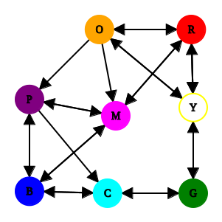
Fig: A graph showing what each element can transmute into.
Thematically, it could make sense to use the following structure when designing these buffs/debuffs.
- Cold => Cold
- Cold => Warm
- Warm => Warm
- Warm => Cold
Where Cold = { Blue, Cyan, Purple, Green } and Warm = { Red, Orange, Yellow, Magenta }. To be completely honest, I’m not 100% sure if magenta is a warm color, my source is idk, look at it.
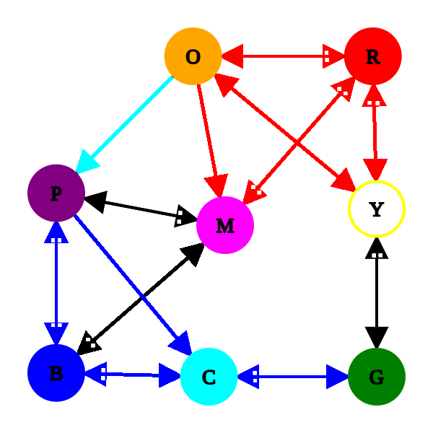
Fig: Color coded match-up chart.
Key
Cold => Cold: Blue
Warm => Warm: Red
Warm => Cold: Cyan
Mixed: Black

The white dots represent the number of reactions end with this result.

E.g. Two colors, when mixed with Blue, become Magenta. However, only one color, when mixed with Magenta, becomes Blue.
Each reaction should have two side effects, a buff and a debuff. These should be balanced such that a player can strategically gain offensive or defensive bonuses, but not both. Each element could also have 2+ abilities that benefit the character the longer they remain in that type. I’m also leaning towards the idea of having some sort of penalty if the player oscillates between two types too many times in a row.
To make the implementation of this mechanic simpler, these side effects should be applied at the beginning of the next turn. So all of the effects would be applied, then the characters perform their actions.
Idea #1
- Cold => Cold = Minor defense boosts.
- Warm => Cold = Major defense boost, minor offense drop.
- Cold => Warm = Major offense boost, minor offense drop.
- Warm => Warm = Minor offense boost.
Idea #2
- Towards Blue = Defensive.
- Towards Green = Offensive.
- Towards Red = Speed or mana? Longer term strats?
- Specific effects should make sense from a lore perspective. How do the two Elements contrast?

Since Green is difficult to transmute into and easier to get out of, I think it would be reasonable to let it be a little more powerful (This would also mesh really well with the lore).
Potential pool effects can draw from:
- Attack (ranged, melee, or both)
- Defense (ranged, melee, or both)
- Speed
- Evasion*
- Hp (Healing)
- Curing status conditions
*Evasion has a very “its BS unless I do it” vibe.
Element | Potential Buffs | Potential Debuffs
Blue | Defense | Speed, Evasion
Purple | Evasion, Attack | Hp
Magenta | Attack, Hp, Speed | Defense
Red | Hp, Status cure | Attack, Speed
Orange
Yellow | Speed, Evasion | Defense, Hp
Green | Attack, Speed | Defense
Cyan | Defense | Evasion, Speed

- All transmutations into Green should give +Att.
- All transmutations into Blue should give +Def.
- All transmutations into Red should give +Hp.
The simplicity of this would make it easier to teach the player about how transmutation works, since it gives a simple starting rule of thumb.
- It could make sense to have all transmutations into Yellow give +Spe. Also, all transmutations out of Yellow would give -Spe.
I think these four rules make a good foundation. When designing this system, it should be easy to tweak these parameters.

Overworld Spells
This section is a continuation of the Environmental Abilities section above.
I want to encourage the player to return to previous areas by having them unlock new traversal options. These could be spells the player unlocks when completing the main quest objectives (‘temples’). Functionally, I’d like these to be a cross between Hms from Pokemon and the items from LOZ.
Most spells won’t have the option to be used outside of combat. The ones that do can fall into one of 3 categories:
- Gray/Blank spells: These spells are unlocked during the main quest objectives. They cannot be used in battle, do not cost anything to use, and are mandatory to progress in the game. These should be rather simple, allowing the player to get passed obstacles. These spells also don’t have an Elemental type.
- Utility spells: These are spells can be used both in battle and in the overworld. They are optional to proceed.
- Blood spells: These are rare spells that cost hp to use. Their abilities can be used to access optional areas with higher difficulty levels.
Each ‘temple’ should either offer a new Gray spell or upgrade a previous one. These abilities should be broad enough to have creative applications, without going overboard. It would be cool if one or two had higher skill ceilings to provide greater challenge. Furthermore, each temple could possibly have a utility spell that aligns with its particular element. This would be an optional thing, however.

Technical

Technology Used
Game Engine: Godot
Project will be made in Godot. C# will be used to create foundational systems. Things like UI and signal handling can be handed in GDScript, if the implementation would be simpler. Nodes written in GDScript can interface with C# nodes, but not vice versa. C# systems should be self contained.
Using the “Dialogue Nodes” by Nagi addon for Godot. This should make designing the dialog/story system easier.
Art: TBD, probably Blender.
Clay Doh by DoubleGum is a procedural shader pack that gives objects a clay-like material. It cost $30 and contains 13 different materials, which I personally think is a great deal. It has a royalty-free license as well.
Audio: TBD.

Requirements
Color Key
- Unimplemented
- Implemented, but not tested (Ctrl-H)
- Implemented and failing (Alt-H)
- Implemented, but needs polish (Ctrl-Shift-H)
- Ready (Ctrl-Alt-Shift-H)
Battle System (BATT)
- Battle UI.
  - Support 1-4 allies and 1-6 enemies.
    - Enemy actors are shown left to right across top of screen.
    - Ally actors are shown left to right at bottom of screen.
  - Display info about each actor on screen.
    - Sprite & animations.
    - Name, HP, element(s).
    - Status conditions & stat changes.
      - At rest, these should be icons.
      - The player can hover/select these icons to get more detailed info about condition.
      - If these expire at a later point, display turns until expiration.
        - Show expiration in icons.
        - Show expiration in info box.
      - Show how each stat is currently being modified.
  - Allow player to select/deselect actions for each of their characters.
    - Player selects an action for each actor, moving from right to left.
    - Once an action is selected, UI automatically moves to next actor.
    - The player has the option to select different actions for previous actors.
      - This should not cause the game to forget any other selected actions (e.g. Alice chooses attack, then Bob chooses attack. If player goes back to change Alice’s action, this should not deselect Bob’s action).
  - Display relevant information about attacks, items, enemies, etc.
    - Player should have access to detailed info about their team/items/etc.
    - Player should be able to view limited info about enemy team.
      - The amount of info that can be viewed should be controllable, for debugging purposes (see BATT.1.6).
  - Allow use of various AI models for opponent choices.
    - Control difficulty of different encounters.
    - Allow for different NPCs to use different strategies.
    - Each team will be controlled by 1 AI, even if they technically are a group of wild monsters.
  - Enable verbose debugging to be displayed for diagnostic purposes.
- Elemental System.
  - Attack + (Primary || Secondary) transmutation.
  - Primary + Secondary transmutation.
  - Apply/Remove ability elemental traits upon transmutation.
    - For each actor, check how their type has changed, compared to last turn.
    - If their type changed, apply relevant side effects.
    - If their type didn’t change, apply relevant ability.
  - Change character’s primary type when they use an attack that matches their secondary type?
  - Change character’s secondary type when they use an attack that they aren’t currently?
- Attack effects.
  - Play animation.
  - Calculate damage based on target and user’s stats.
  - Apply damage.
  - Apply status effect, if applicable.
  - Allow attacks to feature unique mechanics.
  - Incur some level of cost on the player.
    - How should this resource be regained?
    - Zero cost moves for when character is out of options.
- Status/Ability effects.
  - Calculate and apply effects at end of turn.
  - Remove expired status effects.
- Item effects/usage.
  - Play animation.
  - Apply effects to target(s).
Overworld (OVER)
- Character controller.
  - The player’s movements will be largely constrained to a 2D horizontal plane.
  - Controlled by using mouse and keyboard.
  - Only the player’s stamina and hp stat will affect the overworld.
    - Stamina should regenerate rapidly.
    - Hp should regenerate slowly, with the option to turn this off.
  - Overworld spells.
    - The player will have up to 8 “Gray” spells
      - These are unlocked through the main quest.
      - These are mandatory to progress with the story. They should allow the player to pass obstacles.
      - These should be easy to use. E.g. there shouldn’t be any fiddling with menus to activate them.
        - Most likely, these will have keyboard shortcuts, like ctrl or spacebar.
      - These may or may not have in-battle counterparts. If they do, they won’t take up extra slots. (Maybe they will technically be items).
    - The player can have 0+ utility spells.
      - These all have in-battle counterparts.
      - These will all have an elemental type.
      - These can be accessed using a menu, however it should still be rather straightforward.
      - These will likely cost stamina, depending on how useful they are.
    - The player can have 0+ rare spells.
      - These all have in-battle counterparts.
      - Most-all of these will have an elemental type.
      - These will likely cost hp to use.
      - These will likely be used to access late-game, optional areas.
      - These should probably be accessed from the same menu as the utility spells.
  - Partner follow mechanics.
    - The player’s partners will follow them closely.
    - It could be funny to have the partners turn into little chibi fairies if they get too far away or stuck. They’d then turn back into their human forms when the player stops moving.
  - Pause menu.
    - Opening the menu should pause the game.
    - Should provide access to character management (CHAR) and inventory.
- Level design.
  - Puzzles.
  - Environments.
  - Setpieces.
- Monsters & enemies.
  - Spawners.
  - Overworld combat.
    - Enemy weight (feather-heavy).
  - Turn-based combat initiation.
- Npc interactions.
  - Dialog.
  - Combat initiation & battle actors (OVER.3 & BATT).
  - Story actors (STRY).
Story (STRY)
- Dialog tree.
  - Cycle through text.
  - Allow user to select responses.
  - Allow certain NPCs to remember limited character actions/responses.
- Story events.
  - Lock/unlock branches on dialog tree.
Character Management and Inventory (CHAR)
- Pause overworld/battle when opened.
- Give player option to save game, return to settings, and exit game.
- View info about player characters.
  - Screen to view MC, Alice, and Alex’s info + any temporary companions.
    - Add/Remove screen.
    - Show base stats, movepool, equipment enhancements.
  - Equip/Remove equipment.
    - Query inventory for valid equipment.
    - Modify character’s data according to equipment.
    - Remove modifications when item is unequipped.
  - Learn/unlearn spells.
    - Query inventory? for valid spells.
    - Add/remove spell from battle actor.
    - Add/remove spell from overworld utility menu, if applicable.
    - View detailed info about spell.
- Inventory
  - Different items should have the ability to define rules about when/where they can be used.
    - Items that can be used in battle will have a BattleItem component.
    - Key items can only be used during story events.
      - The game should really just check to see if the player has them.
      - The only fields that really should be filled out are Name and Details.
      - It would probably be best to alter the class hierarchy to remove the extraneous fields.
    - If an Enemy has an item, it should be assumed that they can use it.
    - Types of requirements:
      - Character (Companions/Player).
      - Elemental Bias.
        - Alice’s Fated Bias.
      - Current typing (Primary/secondary agnostic). *This one will need to be updated during the battle.
      - Base stats.
      - Status conditions. *This one will need to be updated during the battle.
  - Add items when picked up/etc by player.
  - Remove items when used by player.
  - Overworld usage
    - The player opens their Inventory in overworld.
    - All of player’s items are displayed in appropriate tabs.
    - Player clicks on Item to view its information.
    - Player is given the option to use Item on a character, if applicable.
    - Game checks that character is eligible for usage.
    - Player filters items by set criteria.
  - When battle is initiated, pass list of BattleItems to it.
    - BattleItems should be cached to make this quick.
  - Battle Usage
    - Battle receives list of BattleItems from Player.
    - Disable the items a BattleActor cannot use.
      - This could tie into the mana system.
Settings and Accessibility (ACCS)
- Colorblindness mode.
- Controller support/input remapping.

Specifications

Battle System (BATT)

Main Classes:
Battle:
- The entry point for starting a battle.
- Receive list of combatants.
- Initialize battle UI.
- Once battle is finished (team is defeated or ran away), return control.
BattleActor:
- Represents 1 participant in battle.
- Each BattleActor can take 1 action per turn.
- This action is selected by their owner (either player or AI).
BattleAction:
- Either a spell or item.
- Has 1+ target(s).
- Has an animation that plays.
- Has priority that is used to determine turn order.
BattleController:
- Either player or AI.
- Owns 1+ BattleActors.
- Chooses actions for each of their BattleActors.
BattleGUI:
- Get action selections from user.
- Send list of actions to Battle.
- Receive animations from Battle and play them.
- Receive messages from Battle (e.g. “Alice used attack”) and display them.
- Update healthbars when prompted by Battle.
Battle is initiated:
- A battle can be initiated by either an enemy in the overworld or via the battle simulator.
- Once it is initiated, the Battle object will handle everything until the battle is ended.
- Once the battle is over, return control back to the component that initated it (overworld or character creator of battle simulator).
- Battle initiates GUI by sending list of opponents and allies.
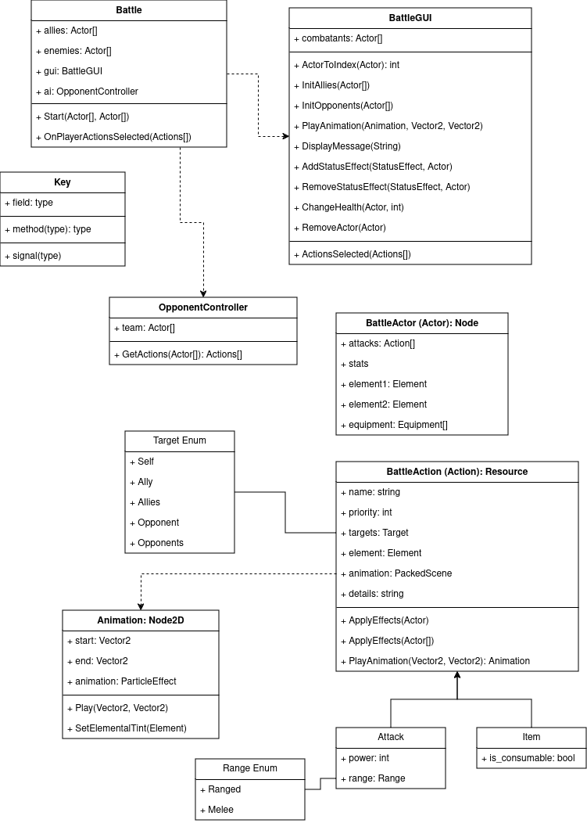
Fig 1: UML_v3 for Battle System.

BattleGUI Layout
Requirements:
- Display and clear messages.
- Display BattleActor sprites.
- Display BattleAnimations.***
- Show health, elemental typing, status conditions, etc for each actor.
- Select action for each actor.
- View info about attacks and items.
- View info about status conditions.***
- View info about enemy team.
- End/Run away from battle.
BattleActorDisplay:
- Each BattleActor has a Sprite property, which is a class inheriting from Sprite2D. This class has a SetElement method, which tints it based on the actor’s current typing.
- GetWorldPosition() → Converts the center of the texture from screen space/GUI coords to Vector2. This can be used to calculate the user and target positions when playing a BattleAnimation.
- SetHealth(int).
- Add/Remove status condition icon. When an icon is hovered over, it should display a simple tool tip. At least the effect’s name.
MessageBox:
- Can display 2 types of messages: blocking and non-blocking.
- During phase 2 of battle (see Battle Loop section), all messages should be non-blocking. This means they can only be cleared when the message box receives a new message.
- During phase 3, all messages should be blocking. This means they should only be cleared when the user clicks a specific “clear message” button.
- This could potentially be controlled by the caller. For blocking messages, the caller would await. Otherwise, it would not. (UPDATE: This is handled by having two display message methods, one that blocks and one that doesn’t).
- MessageBox handles all special formatting, specifically in its non-blocking method.
  - DisplayMessageNonBlocking(string msg, Object obj=null)
  - If obj is null, simply display message as normal.
  - Otherwise, check if obj is Attack/Item/StatusEffect/BattleActor/etc. If so, pass obj to appropriate Format() method. The msg parameter is ignored.
PlayerControl:
- Should display the name of the action each actor has selected.
- Allow player to go to previous actors and change their actions.
- Once every actor has selected an action, allow user to end selection phase.
- Display message whenever player selects an attack, item, or status effect icon.
- Allow user to view detailed info about their party.
- Allow player to view limited info about the enemy party.
- Allow player to view log history (every message that has been displayed).
- DEBUG: Allow user to save items, attacks, actors as resources to filesystem.
TeamDisplay:
- Used as plumbing to query the correct actor displays from their coordinates.
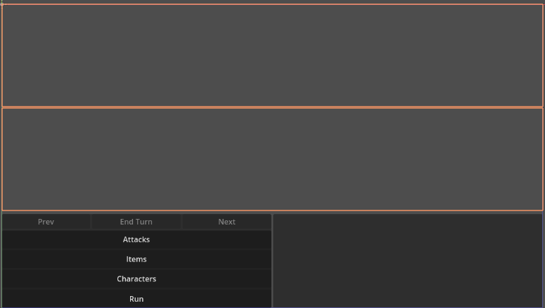
Fig 2.1: BattleGUI v1
MessageBox
TeamDisplay (Allies)
TeamDisplay (Enemies)
PlayerControl
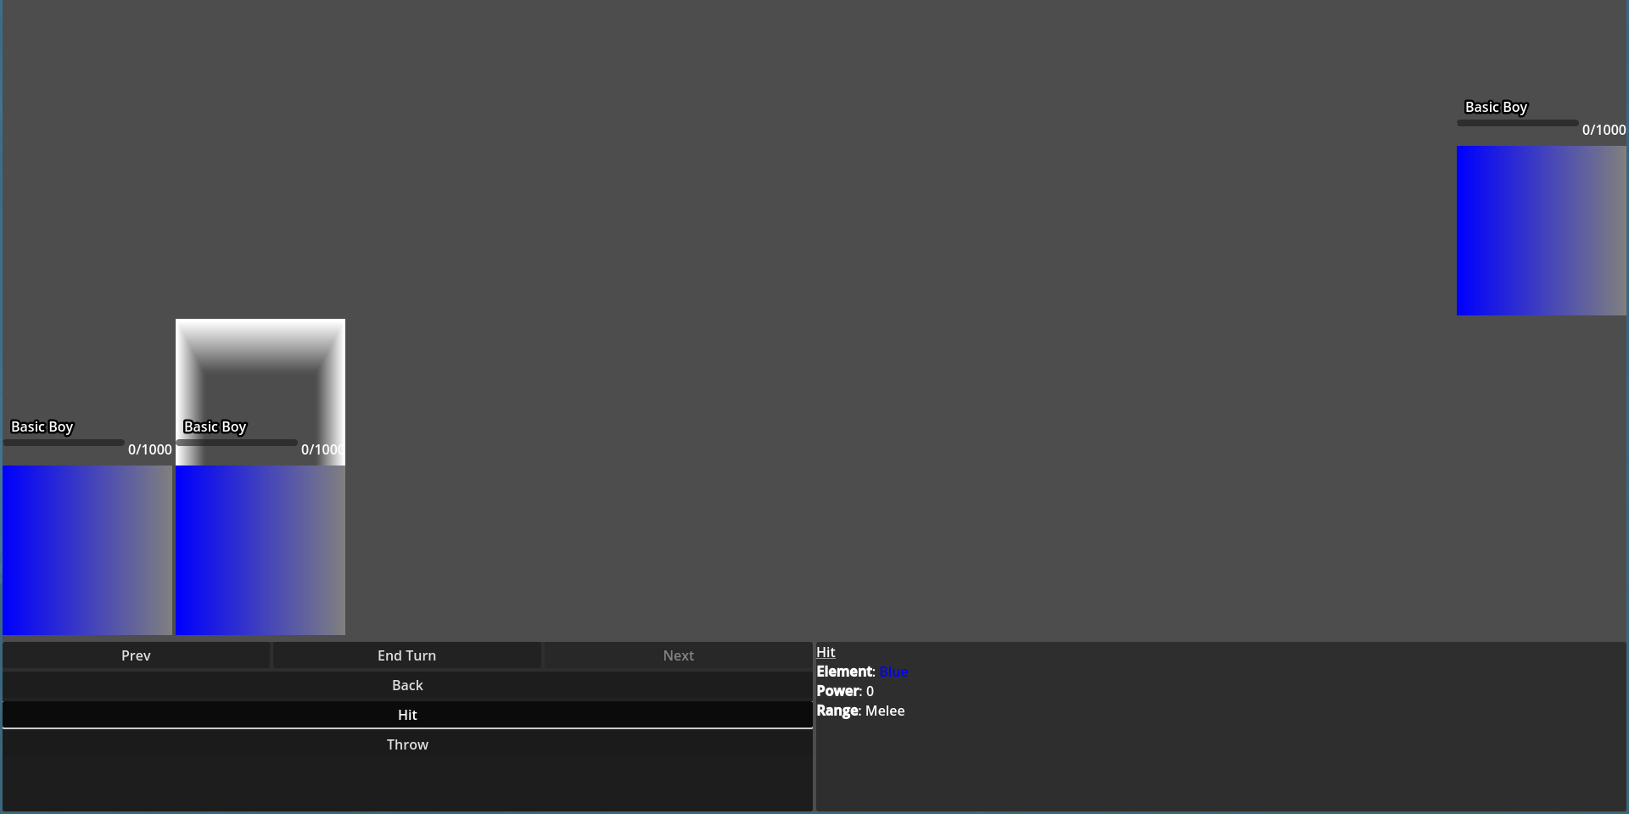
Fig 2.2: BattleGUI v1 showing a 2v1 battle.
- In figure 2.2, the player has pressed the “Attack” button shown in figure 2.1.
- The rightmost character is active, which is shown by the white box above it.
- This character has 2 attacks, “Hit” and “Throw.” Above these two attack buttons is the “Back,” which will return the PlayerControl to the state shown in figure 2.1.
- Pressing an action button once will display its info in the MessageBox. In figure 2.2, the player has pressed the “Hit” attack, which is highlighted. Pressing the same button again will select the action and move the focus to the next character.
- Pressing the “Prev” button will focus on the leftmost character. In figure 2.2, this character has already selected an action, but this isn’t locked in until the player presses the “End Turn” button.
- NOTE: The “End Turn” button shouldn’t be enabled in figure 2.2, the fact that it is is a bug. It should only be enabled once all characters have selected an action (in this instance, after the player presses the “Hit” button again). This bug has been fixed in the latest build of the game.

Battle Loop
A battle has 3 main phases:
- Setup
  - BattleGUI is initialized.
- Action selection
  - Select item action.
  - Select attack action.
  - Go to previous actor.
  - Go to next actor.
  - View attack/item info.
  - View ally info.
  - View enemy info.
  - View status effect info.
- Action resolution
  - Starts when Battle receives the ActionsSelected signal from the BattleGUI.
  - Battle calculates action priorities.
  - Animation is played.
    - Get user’s coordinates.
    - Get target’s coordinates.
    - animation = Action.PlayAnimation(user, target).
    - Attach animation to scene.
    - Wait for animation to complete.
  - Battle calculates action’s effects.
  - Calculate and apply damage/primary effect(s).
  - Display message and await player’s input.
  - If applicable, calculate target transmutation(s):
    - Apply new primary element.
    - Update sprite/Play animation.
    - Display message and await.
    - Repeat steps 1-3 for secondary element.
    - Check if primary and secondary elements react.
    - If so, repeat steps 1-3 for this reaction.
  - If applicable, repeat step 7 for user transmutation(s).
  - If applicable, apply new status conditions to target/user.
    - Add associated status effect icon.
    - Display message and await.
  - Resolve status effects for user.
    - Apply effects.
    - If expired, remove.
    - Display message and await.

Attacks
- A BattleAction is a Resource that acts as a parent to Items and Attacks.
- A BattleAction has a BattleAnimation, which is a packed scene. This is a particle effect or animation that plays when the action is used.
- A BattleActor has a list of Attacks it can select from.
- When an Attack is selected, it is given to the Battle.
  - The Battle calculates and applies the Attack’s effects.
  - The Battle sends a message to the BattleGUI.
  - The Battle initializes the BattleAnimation and passes it to BattleGUI.
  - BattleGUI plays animation.
Its easier to manipulate particle systems in GDScript than C#, so it would be helpful to have the Battle object (C#) send Vector2 data to GDScript, which can then handle its own logic. This functionality could be placed inside of BattleAction (C#).
# User selects an attack in GUI. This selection is sent to Battle.
Battle.DoAction(BattleAction action)
# Find user and target(s)
animation = action.PlayAnimation(user.position, target.position)
AddChild(animation)
string msg = action.ApplyEffects(target)
await BattleGUI.DisplayMessage(msg) # Display message and await user clearing it.
# Send status effects, damage, etc to BattleGUI

Status Effects
Ideas
- Confusion: Makes the opponents appear to be elements they are not. Any reactions performed on opponents while confused are obfuscated (colors replaced with random other colors).
- Flinched
- Dazed: Mix of flinched and sleep. Player misses some number of their next turns.
- Poison
- Heal over time
- <Melee Attack, Melee Defense, Ranged Attack, Ranged Defense, Speed, Evasion> Up/Down
- <Element>-biased: When primary element != <Element>, there is a chance primary element will revert back.
- <Element>-phobic: Receive damage when transmuting into <Element>.
- <Element>-philic: Receive health/buff when transmuting into <Element>.
- <Element>-trait: Status effect based on <Element> traits. Each might be given a unique name.
- Stasis: Negate the next transmutation.
- Blocking: Reduce/Negate the damage from the next attack.
- Dissonance: Actors primary and secondary types will not react together.
Name | Description | When is effect applied? | Properties
Flinched | Actor skips next turn. | BattleActor.IsFlinching() | Duration = 1 Turn  Chance = 100%
Dazed | Mix of flinched and sleep. Actor misses some number of their next turns. | BattleActor.IsFlinching() | Duration: Number turns  Chance: Percentage
<Stat> up/down* | Raises a specific stat for some number of turns. | Inside properties getter? | Duration  Stat: String  Amount: Percentage  Stack: uint
Blocking* | Reduce amount of damage taken from the next attack. | BattleActor.ApplyDamage() | Duration = 1 Attack  Amount
<Element>-phobic | Take damage upon transmuting into <Element>. | BattleActor.SetElement() | Element: ElementalType  Amount
<Element>-philic | Heal upon transmuting into <Element>. | BattleActor.SetElement() | Element  Amount
Stasis* | Negate the next transmutation. | Battle.CalculateTransmutations | Duration = 1 trans.
Dissonance | Prevent actor’s primary and secondary types reacting. | Battle.CalculateTransmutations | Duration: Turns
Poison/Heal | Damage/Heal over time. | BattleActor.ResolveEndOfTurn() | Duration: Turns  Amount: Percentage
<Element>-bias | At end of turn, % target will transmute into this type. | BattleActor.TryRevertToBias() | Element  Chance
*These status effects are special cases inside of the StatusEffectManager. The stat modifiers are accessed anytime the BattleActor’s stat fields are accessed, so this is done for efficiency and ease of access. Stasis and Blocking have a unique (non-turn based) duration, so they need to be handled specially.
All properties:
- Turn duration: Number of turns until this effect is removed.
- Effect chance: Percent chance this effect will proc.
- Effect amount/Strength: Strength of this effect. Usually a percentage of affected’s health.
- Stat: Name of stat this effect targets.
- Stack: How many times to apply <Effect amount>
- Element: ElementalType this effect targets.
- Transmutation duration: Number of transmutations until this effect is removed.
- Attack duration: Number of attacks until this effect is removed.
The application of the different status effects will be handled by the BattleActor and Battle classes. The parameters determining the effects will be set using a unique resource for each status condition.
An effect can be set to last an infinite amount of time by setting its duration to -1.

Defeat
- When an actor.CurrentHp <= 0, it is defeated.
- When all actors on a team are defeated, the team is defeated and the battle ends.
- The actions of defeated actors are null. So when querying a team for its list of actions, entries that are null correspond with defeated actors.
- When an actor is defeated, it emits a WasDefeated signal. This is listened to by the following objects:
  - BattleActorDisplay: Grays out the icon and sets the hp bar to 0.
  - PlayerControl: Prevents the player from selecting actions for the defeated actor.

Component-based Attack Design
To avoid having to create a new script for every attack, I think it would make sense to have each attack have a list of premade effects it can use. This would build off of the current status effect system and extended to include damage.
Essentially, the damage functionality would be pulled out of Attack and placed inside a special attack effect.
This will require a large overhaul of the attack builder section of the character creator, which will need to be done anyways.
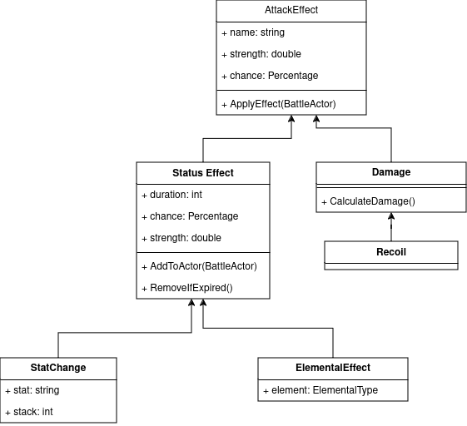

Abilities and Side Effects
In battle:
- Keep track of what type each actor was last turn.
- Check whether actor’s type changed.
- If it did, apply side effects.
- If it didn’t, apply ability effects.
In the editor:
- Define the side effects for each transmutation.
  - Internally, these will be status effects.

Iterating over actors:
- Compare previous primary & current primary types.
  - If equal: increment counter & apply ability effect.
  - Else: reset counter & apply side effect.
- Repeat step 2 for previous & current secondary types.
To help with saving this information, the ElementManager class will be modified to use a graph internally, instead of a dictionary, to store matchup data. This graph has 8 nodes, one for each element. On top of storing the next node, each edge also remembers the side effects of this transmutation.

Side effects should be applied after every transmutation, not once per turn. Consider the following edge case:
- Target is Red & Cyan
- Target is hit with an Orange attack.
- Target becomes Yellow & Cyan.
- Yellow & Cyan react to form Green.
In this example, the game would try and find an edge between Red and Green, which does not exist.
So in this new model, after a transmutation occurs, the ElementManager is queried directly for the effect between the start and end elements. So in the example above, there would be 2 side effect calculations.

Opponent Controllers

Adding Content
To add an Attack:
- Create a new Resource inheriting from Attack.
- Add a BattleAnimation:
  - Select from existing animations in “res://data/battle_system/battle_actions/animations/” or...
  - Create a new Node2D scene with a GPUParticle2D child.
  - Create a script inheriting from battle_action_animation.gd.
  - Override _play, if applicable.
  - Save new scene in previously mentioned directory.
  - By default, Attack animations use template particle effects as a base and colors these based on the attack’s element via modulate. If this behavior is undesirable, override SetElementalTint.
- Add effects:
  - For simple effects, add new elements to the Effects array on the Attack resource.
    - Click “Add Element”.
    - Click on the newly created dropdown labeled “Empty”. In the popup, select “New Effect”.
    - Click on “Empty” dropdown next to “Attack Effect” label.
      - Add damage by selecting “New Damage”. Fill out the Strength field to match desired power. Ensure both Chance fields are at 1 to guarantee damage is dealt.
      - Use “Load” option to load more complicated effects from the filesystem.
  - Override ApplyEffects() to define attack logic. Effects of attack should be applied directly to opponent. This method returns a string, stating what had occurred.
  - NOTE: Changing a field inside of a loaded AttackEffect will change that field in the original, unless the “Make Unique” option is selected. However, this will result in the new attack not reflecting changes made to the original.
    - e.g.
      - (AttackEffect) ←ElementalPhobia← BluePhobia
      - Desired behavior:
      - Changing BluePhobia.Element = Blue does not affect ElementalPhobia.Element.
      - Actual behavior:
      - Changing one field changes both.
- Optionally, add a description by filling out the Details field. Text in this field can be styled using BBCode.
- Save resource in “res://data/battle_system/battle_actions/attacks/”.
To add an item:
- Create a new resource inheriting from BattleItem and save it to “res://data/battle_system/battle_actions/items/”.
- See the section on adding an attack for further details.
To add an opponent controller (battle AI):
To add a character w/ a BattleActor:
- Create a new Node2D scene.
- Attach “res://src/battle_system/BattleActor.cs” to root.
- Fill out instance data.
To add a status effect:
- Create a new resource inheriting from StatusEffect.
- Save resource to “res://data/battle_system/status_effects/”.
- Determine when in battle loop effect needs to trigger.
- Either:
  - Add new method to BattleActor and call it from Battle.
  - Add new lines of code to existing BattleActor method.
  - Add new lines of code to Battle.
- If needed, modify StatusEffectManager.
- To change how this effect stacks (e.g. an actor is poisoned while already being poisoned), override StatusEffect.Combine(…).
- To create a new icon, create a new scene inheriting from “res://data/battle_system/status_effects/icons/status_effect_icon.tscn.”
  - Add a tooltip to the topmost node in the scene. This should at least show the name of the status effect.

Overworld (OVER)
The art style will be low-poly and 3D. Art is not my strong suit and I’m most familiar with 3D modeling and Blender, so I’m hoping this will be a good compromise. Right now, I’m aiming for a chibi style, similar to the LOZ Link’s Awakening remake for Nintendo Switch.
The camera will be a fixed, 3rd person perspective, similar to the aforementioned LOZ game or many mainline Pokemon games. Therefore, the game (at least in its current iteration) will be functionally 2D.

Overworld-Battle System Connection
Some items, characters, and spells have both counterparts in the battle system and the overworld. These also will likely have to show up in different menus/ui elements. This functionality should be provided using Resources.
A character can have a BattleActor, StoryActor, and/or an OverworldActor.
An item can have a BattleItem, StoryItem, MenuItem, and/or an OverworldItem.
A spell can have an Attack and/or an OverworldSpell.
Traits like a Name, Elemental Bias, etc will be defined in the topmost resource and propagated down to the children. These scripts will likely be given the @tool annotation, so that this propagation will be reflected in the editor.

Character Controller
The character will be controlled using WASD. The player should have the option to toggle running, which by default will be by pressing the shift key. The option to change this to holding the shift key (no-toggling) should be provided.

Level Design

Npcs Interactions

Monsters, Enemies, & Combat

Story System (STRY)

Character Management and Inventory (CHAR)

Characters
- Has dialog
- Participates in story (StoryActor)
- Opponents (BattleActor & OpponentController)
  - Have a method to initiate a battle.
- Companions (BattleActor)
  - Follow player.
  - Teleport to player position if they get stuck/too far away.
    - Fairy mode?
  - Available movepool, items, equipment.

Items
Items can fall into one of the following:
- Item/Regular
- Equipment
- Spell scroll: Used to teach characters different spells.
- Key/Story: Used during story events.
An item can have restrictions on who can use it.
An item can be consumable.
Some items can be used in battle. This uses a secondary component, called a BattleItem.

Item Requirements
Ultimately, an item’s requirements result in a list of characters that can use them. Some of these values will not need to be recomputed, computed only once, or computed every turn during a battle.

Adding Content
To add an item:
- Create new resource inheriting from an Item class.
  - Save resource to appropriate subdirectory in “res://data/items/”.
- If item should have a BattleItem, create this first. This is because when certain fields on Item are set, these values are passed down to BattleItem as well.
  - Create a resource inheriting from BattleItem and save it into “res://data/items/battle_items/”.
  - OR create a new BattleItem in the inspector.
- Fill out other fields.
  - If MaxQuantity should be unlimited, set this field to -1.

Settings and Accessibility (ACCS)

Design

Current Design Questions
- What should be the cost of using spells/attacks in battle?

Art Direction
- Simple enough for a solo dev to handle.
  - Low poly
- Using tools I already understand.
  - Blender/3D
- Looks distinct and appealing.
  - Emphasize the alien atmosphere of Forlorn.
    - Backrooms/liminal spaces. This is a place where humans can survive, but it isn’t meant for us.
  - Maybe a clay/playdoh material?
    - The Clahdoh shader pack by DoubleGum would be the best way to make this work.
      - It has 13 different materials, which could be used to subtly distinguish each region.
      - Blue: ???, Purple: Space clay, Magenta: Bubble gum, Red: Ceramic/Terracotta/Drought soil, Yellow: ???, Green: Translucent, Cyan: Metalliclay.
      - Blue could use Wet clay, which would fit the beach vibes. It could also use ceramic.
      - The deserts of Yellow could be textured using Drought soil and Terracotta. It would make sense for the Northern edge of Red to use these textures as well as the regions bleed together.
I think a lowpoly, cartoony/chibi style would fit best, similar to the LOZ Link’s Awakening Switch remake. I think it would be interesting to have the landscape be a clay-like texture and the monsters & people be plasticky. Maybe the longer something has been on Forlorn, the more clay-like it becomes.

Characters

Main Cast
Player
- Silent protagonist. Player will be presented with dialog options that will allow them to flesh out the MC, but these will be largely cosmetic.
Alice
- Bad home life. Appreciates the escape the circumstances have provided.
- Hates the concept of alignment, feeling disturbed by the body horror.
- Technical/Stem major? Scientifically minded.
- Introverted and shy.
Alex
- Promising future back on Earth.
  - Recently turned life around. Hospitalized?
  - Promising job, relationship, etc.
- In love with the idea of magic and alignment.
  - If he could find an Element he wanted to focus on, he would purposefully pursue alignment.
- Extroverted and charismatic. Loved traveling around the island meeting new people.
So the main dynamic is that Alex wants to have an adventure on Forlorn, but also wants to return home. Alice doesn’t want to be on Forlorn, but wants to go home even less. Another point of contrast is that Alex likes the idea of alignment, but can’t decide which element to specialize in. Alice hates the idea of alignment, but really likes one particular element. In general, the two of them are opposite personalities, and can usually be found in disagreement, but are fiercely loyal to each other and the player.

Antagonists

Plot
Green feels disrespected:
- Decades ago, there was a war. Green was instrumental in winning this war.
- After the war ended, Green felt like they were abandoned. They feel like no other region respect them.
- W/in the last year, Cyan approached them, asking them to restart their mining operations b/c they needed more ‘uranium.’
- Green essentially tells them to fuck off and move deeper into the jungle.
- This led them to discover the Northern Island.

Idea #1
During the war, the Northern Island was used as a research facility, committing atrocities in the name of the “greater good.” This eventually became too much for the leadership, leading them to shut down the program. While this was covered up and forgotten, there are a few people who want to pick it back up.

Attack List
Impl? | Name | Element | Power | Cost | Range/Targets | Description/Extra Effects
Y | Hit | Any* | Low*** | Low*** | Melee/Enemy | The most basic melee attack.
Y | Throw | Any | Low | Low | Ranged/Enemy | The most basic ranged attack.
Y | Channel | Any | --- |  | Self | Changes the user’s primary type.
Y | Conduct | Any | --- |  | Self | Changes the user’s secondary type.
N | Recenter | Any | --- | 0 | Self | Changes user’s primary type to match region.
N | Realign | Any | --- | 0 | Self | Changes user’s primary type to match their bias.
N | Gamble | Blank | --- | 0 | Self | Randomizes user’s primary and secondary types.
Y | Sting | Green | Low | Low | Melee/Enemy | 10% chance of poisoning target.
*Any means that there will be a version of this attack for every type.
**Blank/Gray means there is one version of this attack that has no type.
***These will eventually be replaced with exact numbers.

Equipment List

Item List

Scratchpad

