How to use the Character Builder
Driver scene located in: “src/battle_system/simulator/character_builder.tscn”.
Running this scene in Godot should result in the following screen:
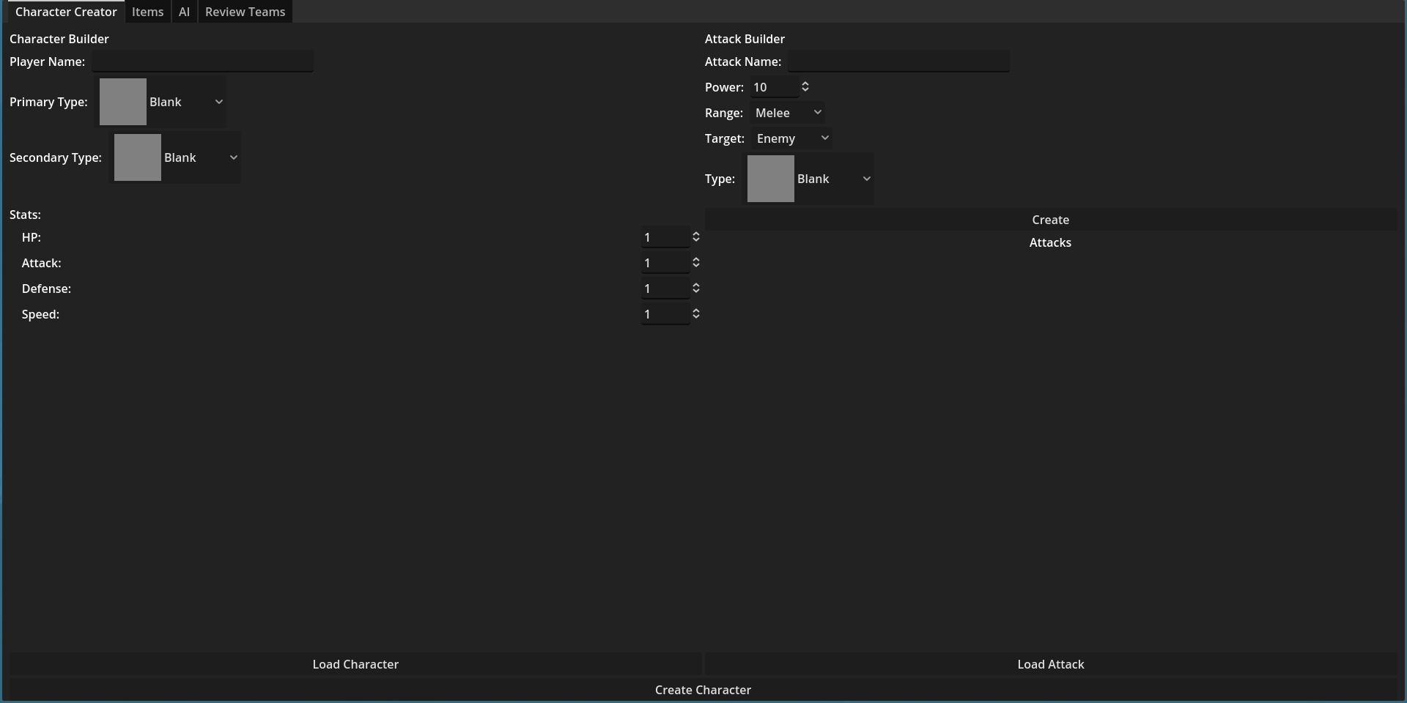
Fig 1.1: The home screen for the character builder.
As can be seen in figure 1.1, there are 4 tabs: “Character Creator”, “Items”, “AI”, and “Review Teams”.
The left half of the first screen is used to make characters. A character in this instance has the following:
- A name.
- A primary and secondary type.
- Hp, Attack, Defense, Speed stats. Both types of attack and defense are merged together, at least in this version.
- A list of attacks.
Using the “Load Character” button will allow you to use premade character files.
The right half of the first screen is where you can make attacks. An attack has the following:
- A name.
- Power.
- A range, either Melee or Ranged.
- A target. This is who the attack hits. The options are Self, Ally, Allies, Enemy, Enemies. The default option is Enemy.
- A type.
Using the “Load Attack” button will allow you to use premade attack files.
After you have finished making your character, you may press the “Create Character” button. Characters that have been created can viewed in the “Review Teams” tab. By default, two basic characters are loaded from the filesystem, 1 per team. To immediately begin a battle, you can press the Enter key.
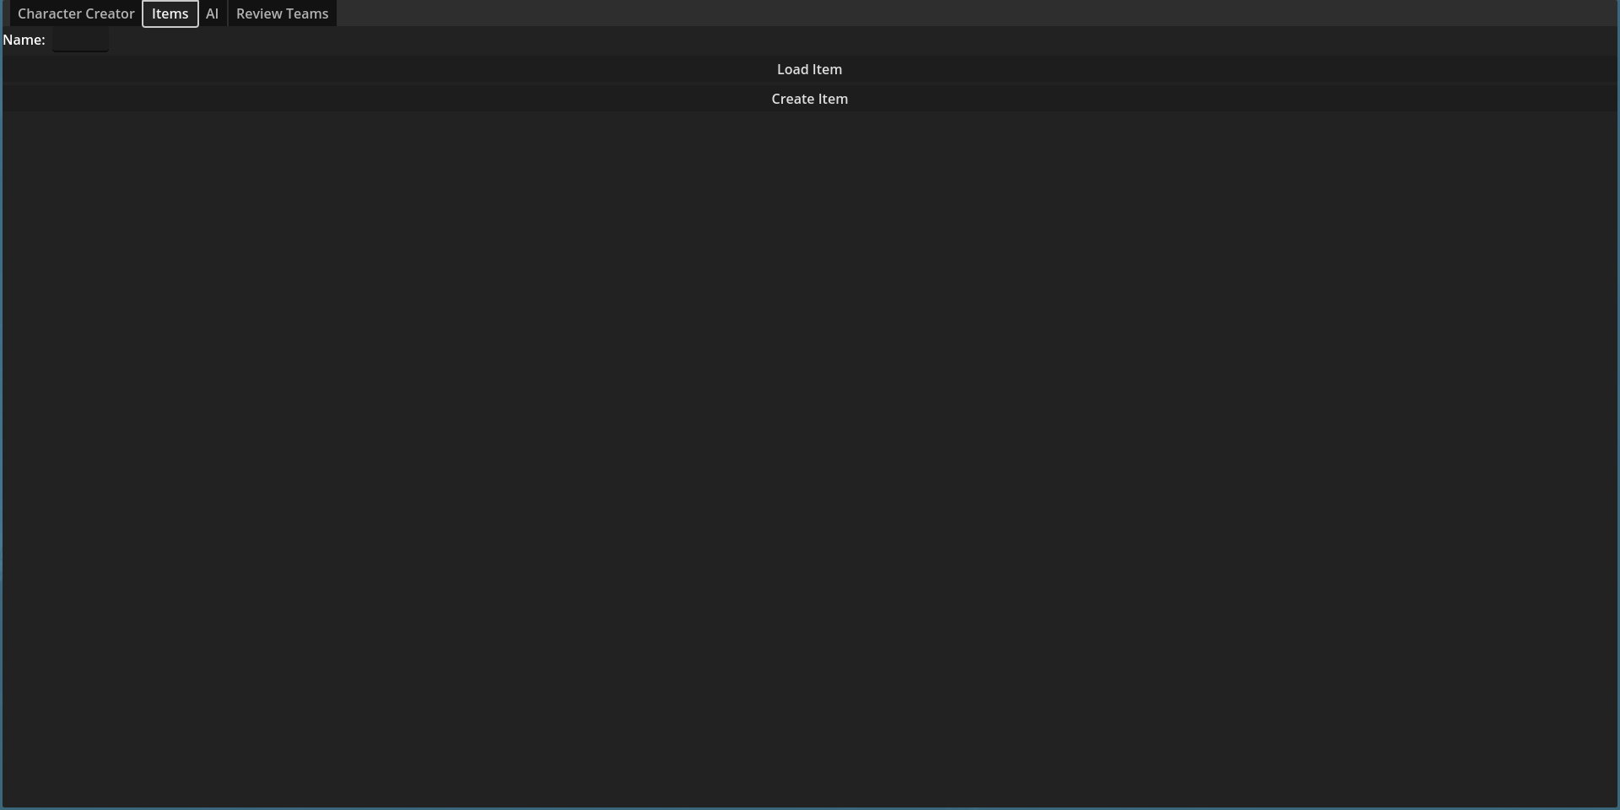
Fig 1.2: The Items tab.
This tab is currently a wip. Currently, the only trait that can be given to an item is a name.

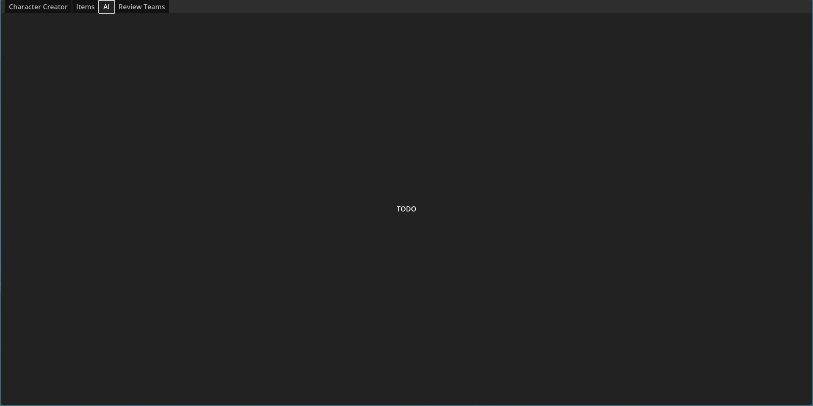
Fig 1.3: The AI tab.
This tab is also still WIP.
This is where the opponent’s AI can be created. This will control how they perform in battle. Currently, the default AI will simply use the first attack to attack your first character.

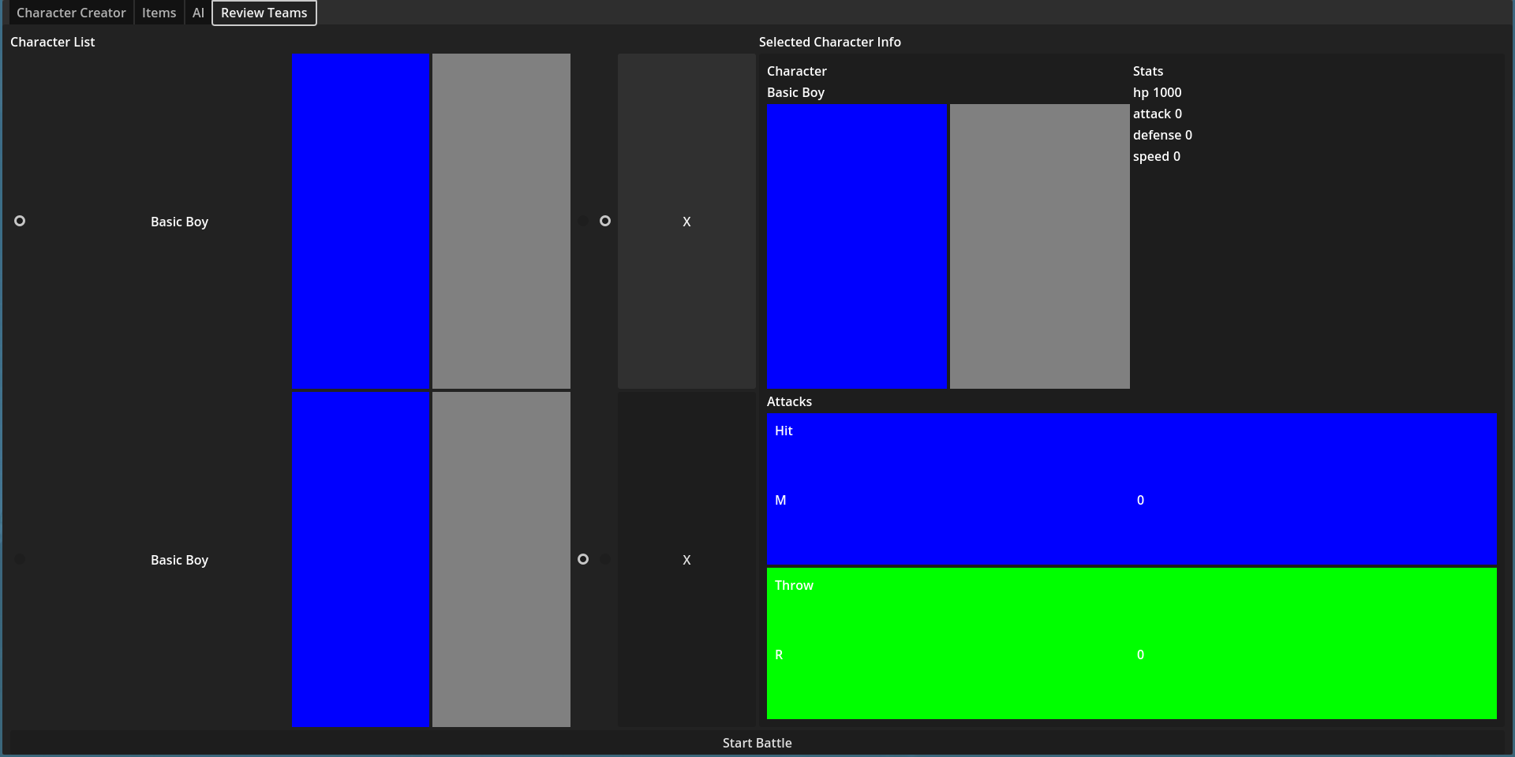
Fig 1.4: The Review Teams tab.
This tab lists all the characters that have been created. By clicking the leftmost toggle next to each character (as seen in figure 1.4), you can view its information.
The two rightmost toggles determine which team a character is on. Selecting the left toggle will put them on your team, while the right toggle with make them your opponent.
When you’re ready to begin the battle, press the “Start Battle” button.

Battle
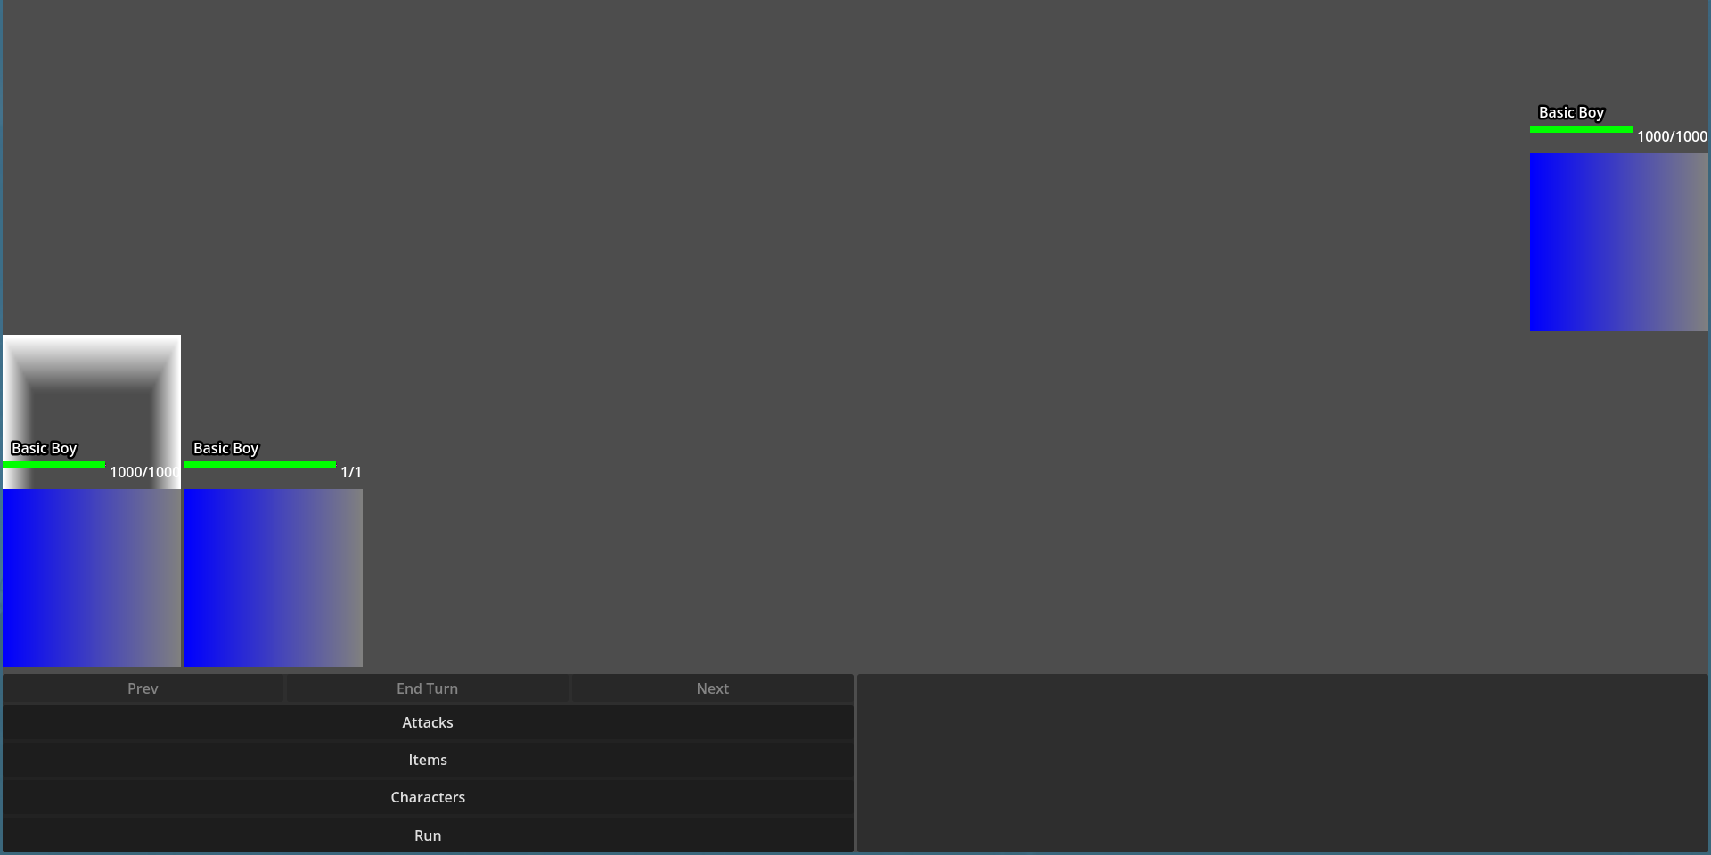
Fig 2.1: The opening screen of the battle simulator, depicting a 2v1 battle.
Each character gets to take 1 action per turn, using either an attack or item.
Clicking on the “Characters” button will allow you to view information about your allies and enemies.

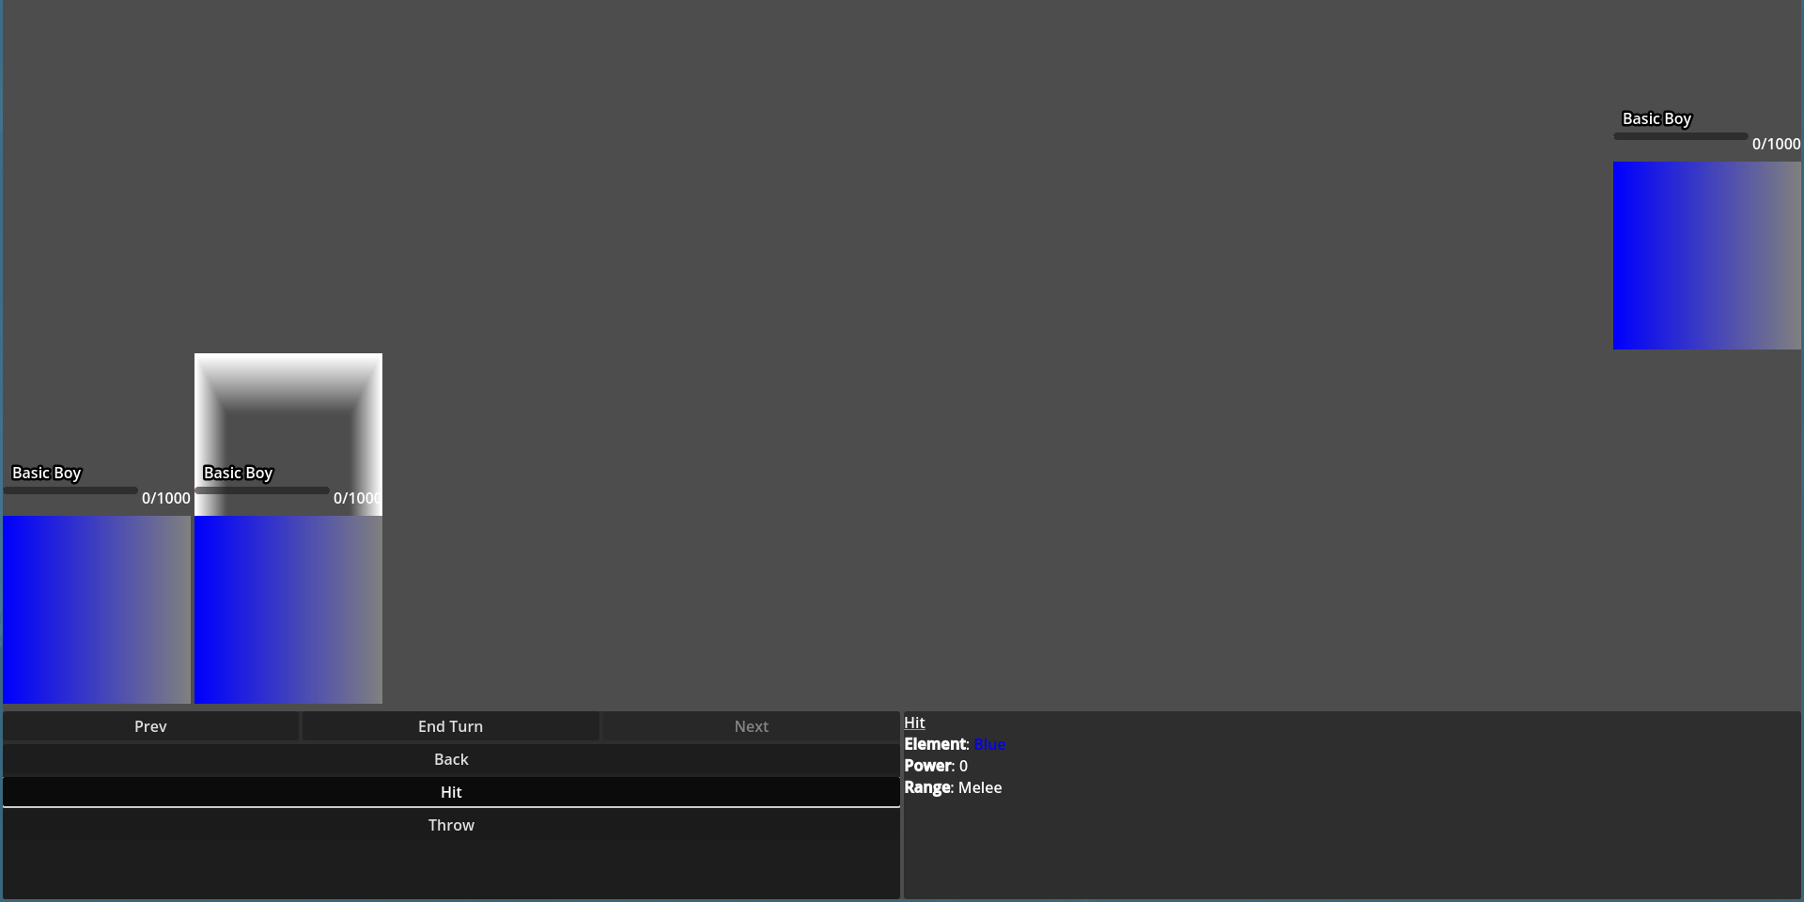
Fig 2.2: Inside of the Attack menu.
- In figure 2.2, the player has pressed the “Attack” button shown in figure 2.1.
- The rightmost character is active, which is shown by the white halo above it.
- This character has 2 attacks, “Hit” and “Throw.” Above these two attack buttons is the “Back,” which will return to the menu shown in figure 2.1.
- Pressing an action button once will display its info. In figure 2.2, the player has pressed the “Hit” attack, which is highlighted. Pressing the same button again will select the action and move the focus to the next character.
- Attacks that target either an ally or enemy will require you to select which character will be targeted. This is done by clicking on your desired target.
- Pressing the “Prev” button will focus on the leftmost character. In figure 2.2, this character has already selected an action, but this isn’t locked in until the player presses the “End Turn” button.
- NOTE: The “End Turn” button shouldn’t be enabled in figure 2.2, the fact that it is is a bug. It should only be enabled once all characters have selected an action (in this instance, after the player presses the “Hit” button again). This bug has been fixed in the latest build of the game.

