## Seoul National University

M1522.000900 Data Structure

Fall 2017, Kang

Homework 1: Mathematical Preliminaries (Chapter 2)

Due: September 21, 02:00 PM

**Reminders**

* The points of this homework add up to 100.
* Like all homework, this has to be done individually.
* Lead T.A.: Beunguk Ahn ([beunguk.ahn@gmail.com](mailto:beunguk.ahn@gmail.com))
* Please type your answers in English. Illegible handwriting may get no points, at the discretion of the graders.
* If you have a question about assignments, please upload your question in eTL.
* If you want to use slipdays or consider late submission with penalties, please note that you are allowed one week to submit your assignment after the due date.

Remember that:

* Whenever you are making an assumption, please state it clearly

**Question 1**

For each question, answer whether $R$ on {0, 1, 2, 3} is an equivalence relation or not. Each question shows a set of all the pairs $(a,b)$ satisfying $aRb$. [15 points]

1. {(0, 0), (1, 1), (2, 2), (3, 3)}
2. {(0, 0), (0, 2), (2, 0), (2, 2), (2, 3), (3, 2), (3, 3)}
3. {(0, 0), (1, 1), (1, 2), (2, 1), (2, 2), (3, 3)}
4. {(0, 0), (1, 1), (1, 3), (2, 2), (2, 3), (3, 1), (3, 2)}
5. {(0, 0), (0, 1), (0, 2), (1, 0), (1, 1), (1, 2), (2, 0), (2, 2), (3, 3)}

**Question 2**

The Tower of Hanoi is a game to move all the disks from the leftmost pole to the rightmost pole in the minimal number of moves (see a figure below). You can move a disk on top of the towers to other towers at a time. You cannot place a larger disk onto a smaller disk. Let $T(n)$ be the number of disk movements to finish the game with $n$ disks. Answer the following questions. [25 points]

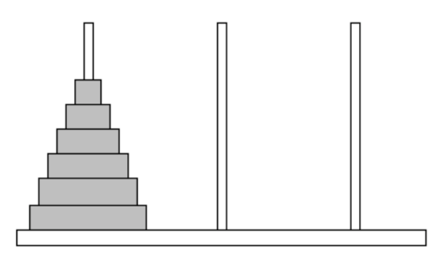

Figure . Tower of Hanoi game with 6 disks. The left figure is an initial state of disks and the right figure is the final state of disks.

1. What is value of $T(7)$?
2. Write $T(n)$ as a recurrence relation.
3. What is a closed form solution of $T(n)$?

**Question 3**

Expand the following recurrence to help you find a closed-form solution, and then use induction to prove your answer is correct. [30 points]

$T\left(n\right)=T\left(n-1\right)+3n+1$ for $n>0;T\left(0\right)=1$

(a) Derive closed-form solution.

(b) **Basis:** Show $T\left(n\right)$ holds for $n=1$.

**(c) Inductive step:** Show that the following recurrence holds: If $T\left(n\right)$ holds for $n=k$*,* then $T\left(n\right)$ also holds for $n=k$*+1*.

**Question 4**

Expand the following recurrence to help you find a closed-form solution, and then use induction to prove your answer is correct. [30 points]

$S\left(n\right)=2S\left(n/2\right)+n$ for $n=2^{i}, where i>0;S\left(1\right)=1$

(a) Derive closed-form solution.

(b) **Basis:** Show that $S\left(n\right)$ holds for $n=2$.

**(c) Inductive step**: Show that the following recurrence holds: If $S\left(n\right)$ holds for $n=2^{k}$, then $S\left(n\right)$ also holds for ${n=2}^{k+1}$.