
Raspberry Pi Local
Web Server
Could I start you off with a beverage?...

MARCH 18, 2026
DAVID COGBILL

Table of Contents
Introduction 2
Building App 2
Back End 2
Front End 3
Local Server Setup 3
Initial Raspberry Pi Setup 3
Install Node.js 3
Install , Enable , and Start MongoDB 3
Clone Project to Raspberry Pi 4
Installing Dependencies 4
Configure PM2 for Backend Persistence 4
Configure Nginx as a Reverse Proxy 4

Introduction
This capstone project involved designing, developing, and deploying a professional profile web application using the MERN stack (MongoDB, Express.js, React, and Node.js) on a Raspberry Pi. The application serves as a personal portfolio and professional profile platform, showcasing skills, projects, education, certifications, and contact information through a responsive and user-friendly interface.
The frontend was built with React to provide a dynamic user experience, while the backend utilized Node.js and Express.js to handle API requests and data management. MongoDB was used as the database to store profile information and project details. After development and testing, the application was deployed on a Raspberry Pi configured as a self-hosted web server, demonstrating the ability to host full-stack applications on low-cost, energy-efficient hardware.
The project emphasized full-stack development, Linux system administration, network configuration, deployment automation, and cybersecurity best practices. By successfully hosting the application on a Raspberry Pi, the project showcased practical skills in web development, server management, and edge computing while providing a scalable and accessible professional online presence.
Currently the database functionality on the raspberry Pi still needs work. However, this creates a space for improvements in web developing and opportunities to add more projects and content to the app.

Building App
GitHub repository: https://github.com/dlcogbilltech/TechLaunchCapstone

Back End
The backend of this project is used to keep information about users and content for projects to be displayed. Each content has a title, description, the file name, the filename of the thumb nail it uses, a list of user ids of likes, and a list of comments with a user id as the author and comment to go with it. Each user has email, password, first name, and last name to provide a record of the comments and likes the content receives.
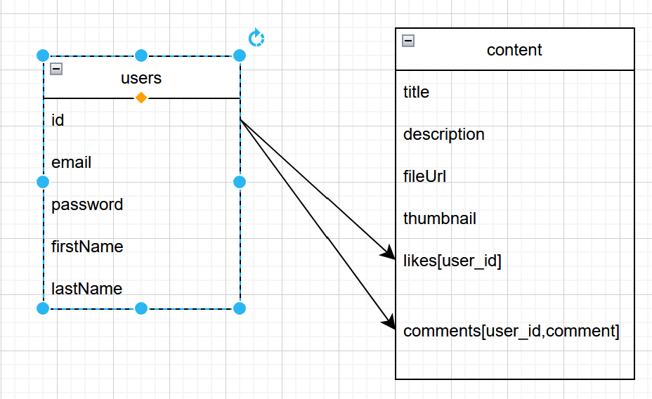

Backend dependencies:
Dependency | Version | Purpose
Bcrypt | 6.0.0 | Hashes user passwords securely before storing them in the database
cookie-parser | 1.4.7 | Parses incoming HTTP request cookies and populates req.cookies.
cors | 2.8.6 | Configures Cross-Origin Resource Sharing to allow your React frontend to connect.
dotenv | 17.4.2 | Loads environment variables from a .env file into process.env.
express | 5.2.1 | Minimalist web framework used to build the REST API endpoints and middleware.
jsonwebtoken | 9.0.3 | Generates and verifies secure JWTs for stateless user authentication.
mongoose | 9.6.3 | Manages data schemas and structures queries for the MongoDB database.
mongoose-unique-validator | 6.1.1 | Adds custom pre-save validation to Mongoose schemas for unique fields like emails.
Node.js | 24.17.0 | Runtime environment
nodemon | 11.13.0 | Automatically restarts the Node.js application when backend file changes are detected.

Front End
The purpose of this project was to create a user-friendly and fun way to present my skills and accomplishments to prospective employers or collaborators. The front end of this project was created with React. I used Paint.net for editing and creating the photos and thumbnails used in the project. I decided on a simple design with a side navigation bar for moving within the app and a large page to display content next to it, while employing a footer with different methods of contact information.


Frontend dependencies:
Dependency | Version | Purpose
axios | 1.17.0 | Handles HTTP requests to fetch data from your backend REST API.
js-cookie | 3.0.8 | Provides a simple, lightweight JavaScript API for handling browser cookies.
jwt-decode | 4.0.0 | Decodes JSON Web Tokens (JWTs) to read user payload and expiration data.
react | 19.2.6 | Core library for building component-based user interfaces.
react-bootstrap | 2.10.10 | Replaces Bootstrap JavaScript with native React components for UI styling.
react-dom | 19.2.6 | Serves as the entry point to the DOM and server renderers for React.
react-hash-link | 1.0.2 | Enables smooth scrolling to specific anchor links (#hash) on a page.
react-icons | 5.6.0 | Includes popular icon packs (FontAwesome, Material, etc.) as React components.
react-pdf | 10.4.1 | Renders and displays PDF files directly inside your React layout.
react-router-dom | 7.17.0 | Manages routing, navigation, and page layouts in your web application.
react-router-hash-link | 2.4.3 | Combines React Router navigation with hash link anchor scrolling functionality.
vite | 8.0.12 | Runs your local development server and builds the production frontend code.

Local Server Setup

Initial Raspberry Pi Setup
- Open the Raspberry Pi Imager, choose the device and operating system, enter the host name, local settings, username, password, Wi-Fi credentials, write the image, insert the sd card in to the Raspberry Pi.
- Using the command prompt from a device on the network, use the command ping [hostname]. Local -4 to get the IP address of your Raspberry Pi
- Open putty, enter the IP address in the field labeled Host Name, click Open, then click Okay.The SSH terminal will display asking for your username.
- Enter the username and password
- Use the command sudo apt update && sudo apt upgrade -y to update the package list and install available software and security updates in putty

Install Node.js
Run the commands highlighted in black in putty while connected to the Raspberry Pi
- curl -o- https://raw.githubusercontent.com/nvm-sh/nvm/v0.39.7/install.sh | bash (Download and run the NVM installation script)
- source ~/.bashrc (Refresh your terminal environment to make NVM active)
- nvm install --lts (Install the latest Long-Term Support (LTS) version of Node.js)
- “node – v” and “npm -v” (Verify your versions of node and npm)

Install , Enable , and Start MongoDB
Because you are using a Raspberry Pi 4, official native installations of MongoDB 5.0 through 8.0 will always fail with an Illegal instruction (core dumped) error. This happens because modern MongoDB packages require ARMv8.2-A CPU architecture instructions, which the Raspberry Pi 4's processor does not have.

- sudo apt-get install -y docker.io (Install Docker)
- sudo docker run -d --name mongodb -p 27017:27017 -v ~/mongo_data:/data/db --restart unless-stopped arm64v8/mongo (Spin up an ARM64-compatible MongoDB Container)

Clone Project to Raspberry Pi
- mkdir -p Projects (Create and navigate to projects folder to clone repository to)
- cd Projects
- sudo apt update && sudo apt install git (Install Git)
- git clone https://github.com/dlcogbilltech/TechLaunchCapstone (To clone existing code to the Raspberry Pi)

Configure PM2 for Backend Persistence
Use the PM2 process manager to ensure your Node/Express server runs continuously in the background and restarts automatically if the Pi reboots
- sudo npm install -g pm2 (Install PM2)
- pm2 start server.js (Navigate to your backend folder and launch the app. This command outputs an exact customized line of bash code containing environmental variables for your system. Copy that generated line, paste it into your terminal and hit enter)
- pm2 save (Freeze your active list of managed applications so PM2 knows exactly what to spin back up during a system reboot)
- sudo apt install -y nginx (Install Nginx)
- david@capstonePi:/var/www $ sudo git clone https://github.com/dlcogbilltech/TechLaunchCapstone (clone project repository to web directory. Ensure you are in the correct directory!)
- sudo chown -R david:david /var/www/TechLaunchCapstone (To set the permissions for your project directory)

Configure Nginx as a Reverse Proxy
- sudo rm /etc/nginx/sites-enabled/default (Delete the default Nginx configuration file to avoid potential routing conflicts)
- sudo nano /etc/nginx/sites-available/ TechLaunchCapstone (Create a brand new configuration file for your web application using the following server block code)
server {
listen 80;
server 172.17.196.142;
# Frontend Setup
location / {
root /var/www/TechLaunchCapstone/frontend/dist;
index index.html;
try_files $uri /index.html;
}

# Backend Setup
location / api/ {
proxy_pass http://localhost:5000;
proxy_http_version 1.1;
proxy_set_header Upgrade $http_upgrade;
proxy_set_header Connection ‘upgrade’;
proxy_set_header Host $host;
proxy_cache_bypass $http_upgrade;
}
}
sudo ln -s /etc/nginx/sites-available/TechLaunchCapstone /etc/nginx/sites-enabled/ (Enable your new configuration by creating a symbolic link to the sites-enabled directory)
echo " pineapples" > db_password.txt

Updating Project Code
git add. ()

