Tim·bit / HPE Networking — Admin Guide For Admins Only

Contents
Overview Admin Access

Weekly Workflow
Adding an Entry Publishing Entries Generating the Email Sending the Email

Tools
Import History Property Pane Settings

Reference
Field Reference Categories Formats Troubleshooting

Tim·bit History — Admin Guide
Last updated: July 2026 · For questions contact Dennis Dodd
What is Tim·bit? A weekly HPE Networking sales enablement archive maintained by Tim Vanevenhoven. Each week Tim publishes 2–3 bite-sized resources — videos, case studies, blog posts, solutions — that SEs and TMs can share with customers. As an admin, your job is to add those entries, publish them, and send the weekly email to the distribution list.

Overview
The Tim·bit History web part lives on the EnterpriseSalesTeamHome SharePoint site. It has two views:
- Public (Archive view) — visible to all site members; shows published entries with search and filters
- Admin view — only visible to users listed in the Admin Emails property; adds the dark nav bar at the top with Add/Edit Entries, Generate Email, Import History, and Admin Guide tabs

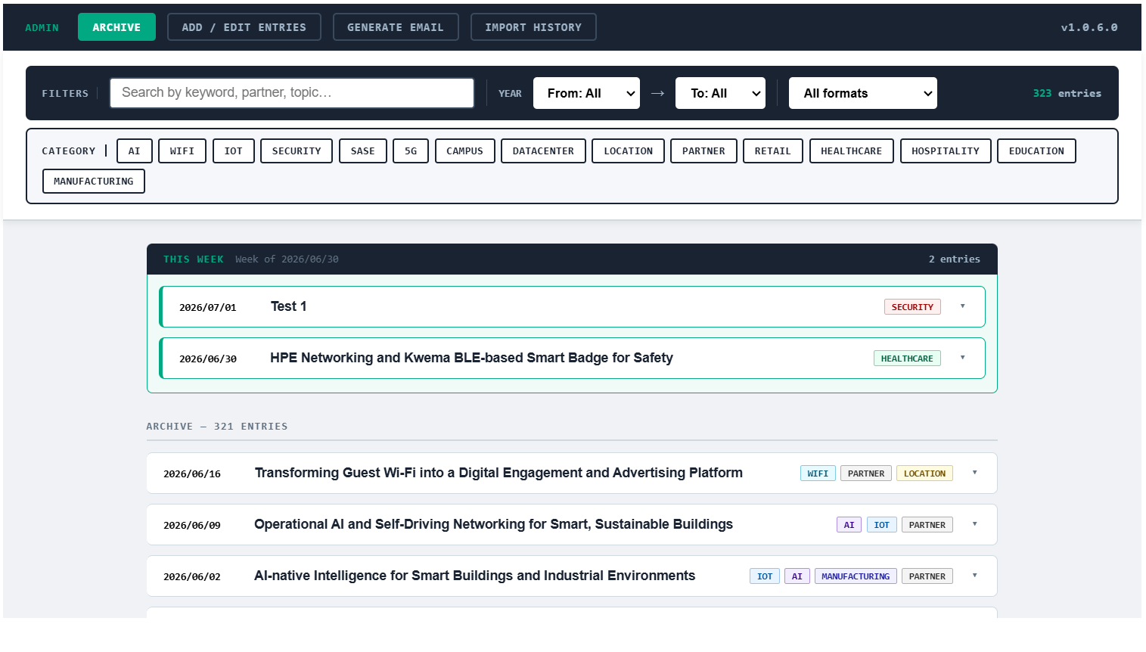Admin Access
Admin access is controlled by the Admin Emails field in the web part property pane. Any user whose HPE email is listed there will see the admin nav bar.
1
Navigate to the Tim-Bits page on EnterpriseSalesTeamHome
2
Click Edit on the page (top right)
3
Click the web part → click the two parallel lines icon (property pane)
4
Under Admin Access, add the email address (comma-separated)
5
Click Republish
Admin emails are case-insensitive but must match the user's HPE login email exactly.

Adding an Entry
Click Add / Edit Entries in the admin nav bar to open the entry form.
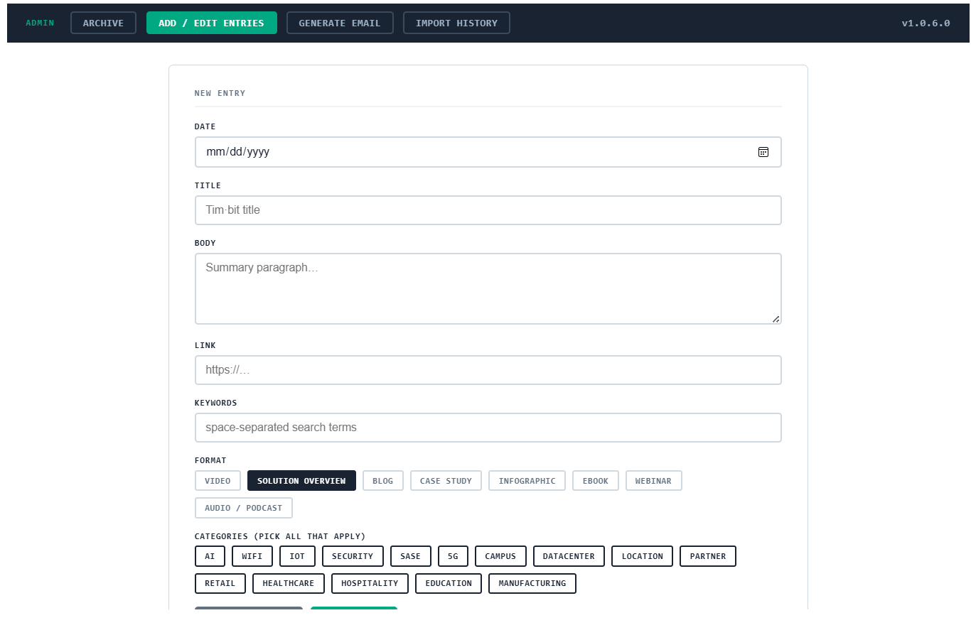
Field | Required | Notes
Title | Required | Short, descriptive headline for the Tim·bit
Date | Required | Format: YYYY/MM/DD — the date the resource was published or shared
Week Of | Required | YYYY/MM/DD of the Monday of the week — used to group entries for the weekly email
Format | Required | Type of resource — see Formats reference below
Categories | Required | One or more vertical/topic tags — see Categories reference below
Body | Required | 2–4 sentence summary of why this resource matters to HPE Networking SEs
Link | Required | Full URL to the resource (video, article, case study, etc.)
Keywords | Optional | Space-separated search terms — include partner names, product codes, acronyms
Published | — | Toggle to make entry visible to all users; leave off to save as draft
Keep the Body field focused on the sales angle — why should an SE share this with a customer? What problem does it solve?

Publishing Entries
New entries are saved as drafts by default (Published = Off). Drafts are visible to admins in the archive with a yellow "Draft" badge but hidden from regular users.
To publish, open the entry in Add / Edit Entries, toggle Published to On, and click Save.
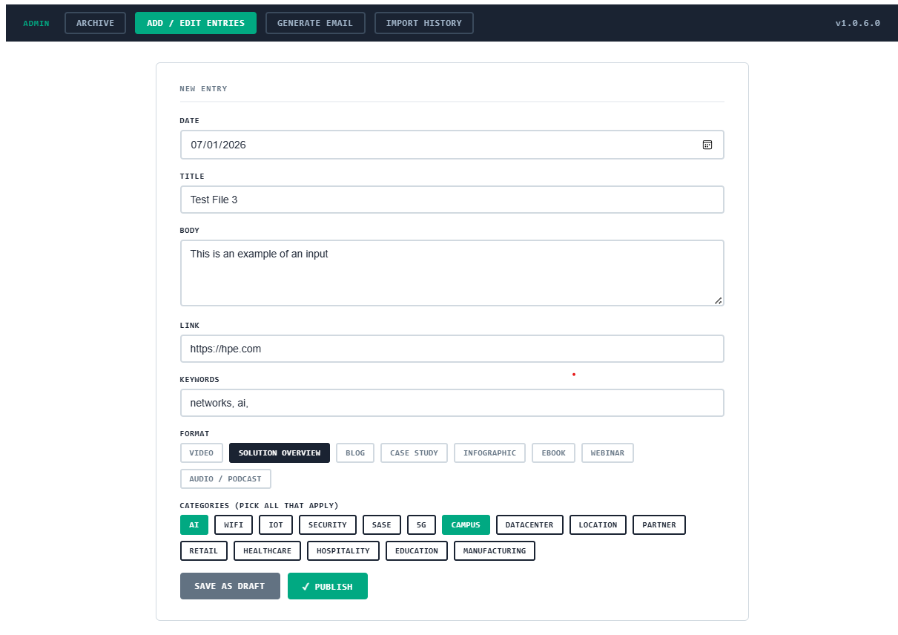Once published, the entry immediately appears in the public archive. The "This Week" highlighted section at the top of the archive automatically shows entries from the most recent Week Of date.

Generating the Weekly Email
Click Generate Email in the admin nav bar. The tab automatically loads all published entries from the most recent Week Of date and renders a preview of the formatted HTML email.
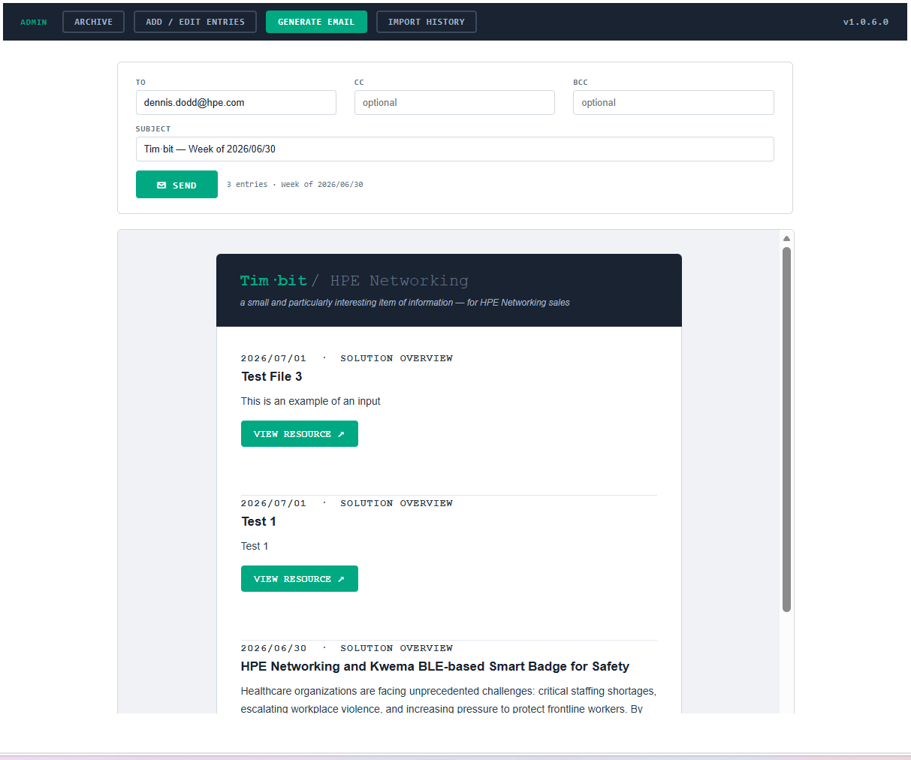The compose fields are pre-filled:
- To — distribution list email (set in property pane)
- CC — optional, blank by default
- BCC — optional; Tim typically puts himself here and moves the DL to BCC to suppress recipient visibility
- Subject — auto-generated as Tim·bit — Week of YYYY/MM/DD

Sending the Weekly Email
After reviewing the preview, adjust the To/CC/BCC/Subject fields as needed and click ✉ Send.
1
Confirm the correct entries appear in the preview (they should match the current week)
2
Verify the To field has the distribution list address
3
Add yourself to BCC if you want a copy for confirmation
4
Click ✉ Send — you will see "Email queued — it will be sent shortly!"
5
The email is delivered within 1–2 minutes via Power Automate
How it works: clicking Send writes the email details to a SharePoint list (TimBitEmailQueue). A Power Automate flow watches that list and sends the formatted HTML email automatically.

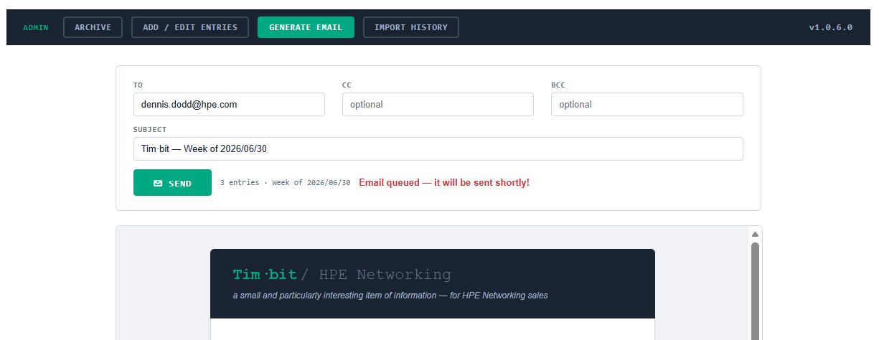

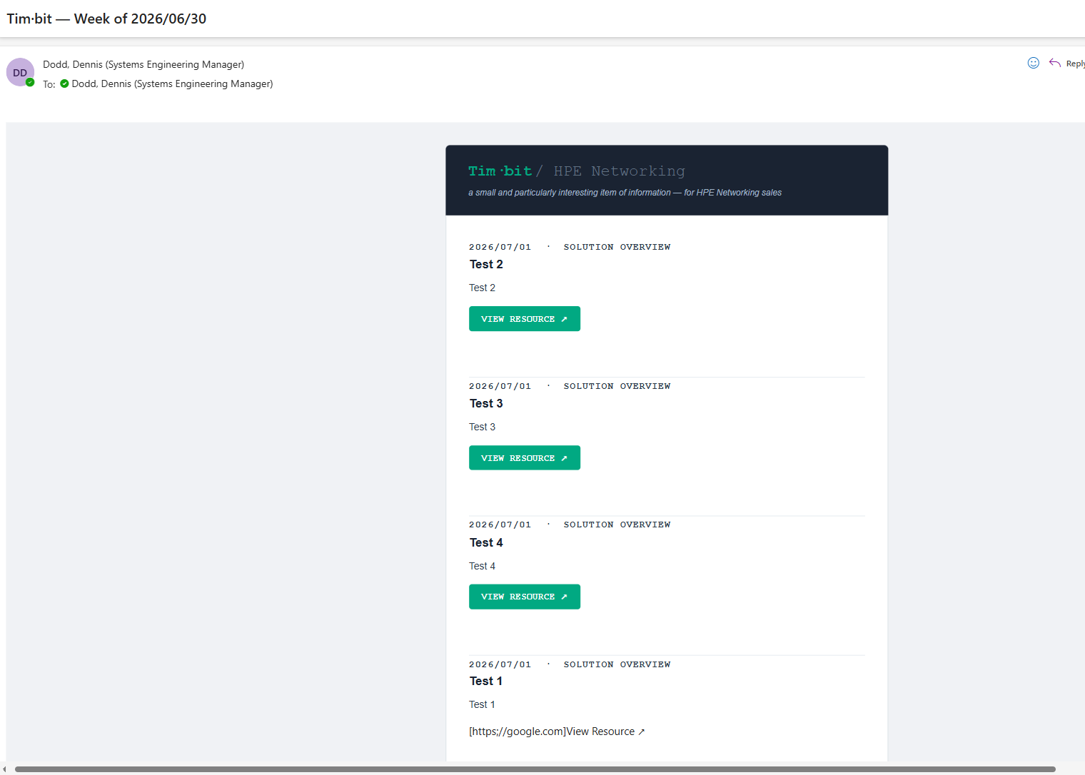Import History
The Import History tab allows bulk-importing entries from the standalone HTML Tim·bit history file. This is primarily used for one-time migration of historical entries and is unlikely to be needed again.
1
Open timbit-history.html in a text editor
2
Find the const entries = [ line and copy everything from the first {'{{'} to the last {'}}'}
3
Paste into the text area and click Preview to see how many entries will be imported vs skipped
4
Click Import — entries already in the system (matched by title) are skipped automatically

Property Pane Settings
Access via page Edit mode → click web part → two parallel lines icon.
Setting | Description
Admin Emails | Comma-separated list of HPE emails that can access the admin nav bar
Distribution List Email | Pre-populates the To field in Generate Email; Tim's PDL address
Admin Guide URL | SharePoint URL to this guide file; powers the Admin Guide button in the nav bar

Field Reference

Categories
Select all that apply. Used for filtering in the archive.
AI WiFi IoT Security SASE 5G Campus Datacenter Location Partner Retail Healthcare Hospitality Education Manufacturing

Formats
Value | Label | When to use
solution | Solution Brief | Product solution overviews, data sheets
video | Video | Demo videos, product walkthroughs, webinar recordings
blog | Blog / Article | Written articles, thought leadership, how-to posts
case-study | Case Study | Customer win stories, deployment examples
infographic | Infographic | Visual one-pagers, comparison charts
ebook | eBook / Guide | Long-form guides, whitepapers, playbooks
webinar | Webinar | Upcoming or recorded live sessions
audio | Podcast / Audio | Podcast episodes, audio content

Troubleshooting

Changes not showing after save
SharePoint caches aggressively. Do a hard refresh: Ctrl+Shift+Delete → clear cached images and files → Ctrl+Shift+R.

Email preview shows "No published entries found"
Make sure at least one entry for the current week is published (Published toggle = On) and that the Week Of date matches across all entries for that week.

"Failed to queue email" error on Send
The TimBitEmailQueue SharePoint list or the Power Automate flow may be unavailable. Check that the flow HPEN Tim·bit — Send Weekly Email is turned On in Power Automate (flow.microsoft.com).

Admin nav bar not visible
Your email is not in the Admin Emails property pane field. Ask an existing admin to add your HPE email address.

New entries not appearing in "This Week" section
Check that the Week Of field on your new entry matches exactly (YYYY/MM/DD) with the most recent week's entries. A mismatch will push the entry into the archive instead.
Tim·bit History SPFx v1.0.5.0 · Developed by Dennis Dodd · HPE Networking Sales Engineering — TOLA SEM

