Assignment 1

Technology and Engineering (011)

Computer Science

2016133

Lee Yujin

**Silverwing S1**

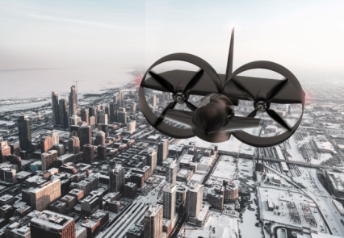Silverwing S1 is a fully electric Vertical Take-Off and Landing (VTOL) hover-bike. S1’s appearance is designed for speed. Its aerodynamic surfaces can let S1 fly at a top speed of 140 kilometers per hour. The range of the S1 is 60 kilometers.

**The flight controls**

*Image source: Silverwing official*

S1 has an intelligent autopilot system by default so passenger can enjoy hands-free flying. It provides head-up display (HUD) that presents various data on the front glass which is the visible area of the driver, so that the driver doesn’t have to look away from their usual viewpoints.

*Image source: Silverwing official*

*Head up display (HUD)*

**Safety Features**

S1 can fly up to 200 meters above ground. Its maximum flight height is higher than most of the apartments, so there is less risk of being hit except for a few skyscraper. Its autopilot system will help driver to stay safe by automatically avoiding obstacles.

**How it works**

Like other electrically operated devices, the S1 is powered by electricity using lithium batteries. Its ducted-fans and aerodynamic cockpit which is used in a jet engine to have greater thrust makes S1 to take off without a runway. S1 has one seating for an adult and will carry maximum 90kg of payload.

**Benefits**

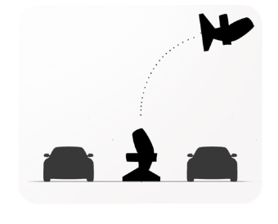S1 is an eco-friendly new generation device with zero CO2 emissions. Its lightweight structure makes it easy to take off even in a narrow space. It occupies just 44 square meters (height 240 cm, width 258 cm) that is smaller than a sedan. Like the picture on the right, S1 can be kept in vertical so that it can use spaces efficiently.

*Image source : Silverwing official*

*Parking S1*

**Things to be addressed**

Its maximum noise is up to 87 decibel which is similar to that of a car. Though we experience this noise in our daily lives, we need to find ways to reduce noise since S1 flies above the ground, the noise will effect on the high floors of buildings.