CJSG

요구사항명세서

Version <1.0.1>

이 페이지는 CJSG 프로젝트의 요구사항과 설명을 정의합니다.

Revision History

|  |  |  |  |
| --- | --- | --- | --- |
| **Date** | **Version** | **Description** | **Author** |
| **<27/03/24>** | **<0.1>** | * **문서를 시작합니다.** * **요구사항과 설명을 정의합니다.** | **LEE HOE CHEOL** |
| **<07/05/24>** | **<0.1.1>** |  |  |
|  |  |  |  |
|  |  |  |  |

Table of Contents

1. Introduction 4

1.1 Purpose 4

1.2 Scope 4

1.3 Definitions, Acronyms and Abbreviations 4

1.4 References 4

1.5 Overview 4

2. Overall Description 5

3. Specific Requirements 6

3.1 Functionality 6

3.2 Usability 6

3.3 Design Constraints 6

3.4 Interfaces 7

3.9.1 User Interfaces 7

3.9.2 Hardware Interfaces 7

3.9.3 Software Interfaces 7

3.5 Copyright 7

4. Supporting Information 8

4.1 Usecase diagram 8

4.2 Interface Description 9

Software Requirements Specification

# Introduction

## Purpose

*Smartphones are inseparable from our lives.*

*But when you have to focus or hang out with people*

*I have to take my phone off for a while and focus only on my schedule and my daily routine.*

*We decided to work on a project to create this environment.*

## Scope

*This application is built on Android.*

*Users can manage weekly schedules through their phones Certain functions allow you to set your schedule and lock your phone.*

## Definitions, Acronyms and Abbreviations

* *NULL*

## References

* *Scheduler Apps on the Play Store*

## Overview

* *This scheduler app can manage weekly schedules and offers a variety of features.*

# Overall Description

* *product perspective : This application is an Android-based weekly scheduler that allows users to   
   easily manage their weekly schedules.*
* *product functions :  
  - Weekly Scheduler at a Glance  
  - Add and edit schedules  
  - Schedule name, content, time, place, mobile phone lock, etc. can be set*
* *user characteristics : The user is an Android device user with different ages and usage experience.*
* *constraints :  
  - The application should be developed on the Android platform.  
  - It should be designed as an offline application with no server functionality.  
  - You should use colors and fonts that are readable.*

# Specific Requirements

## Functionality

1. Add Weekly Schedule function  
   - Users must be able to add schedules on a weekly basis.  
   - When adding a schedule, you must be able to specify the title, date, start time, and end time of the   
    schedule.
2. Place setting function  
   - When you add a schedule, you must be able to set where it occurs.  
   - Place settings must be able to be specified by address or by a location on a map.
3. Mobile phone automatic lock function  
   - When you add a schedule, users should be able to select the option to automatically lock their phones   
    at the start of that schedule.  
   - When this option is enabled, users cannot use their phones and only use time, schedule information,   
    and emergency calls on the screen.
4. Edit and delete schedules function  
   - Users must be able to edit or delete the weekly schedule they add.  
   - Edit functions should be able to modify the title, date, start time, end time, place, and so on of the   
    schedule.
5. View your schedule at a glance function  
   - Users should be able to check the list of weekly schedules they have added  
   - The list must contain information such as the title, date, and start time of the schedule.  
   - The schedule should be easily viewed at a glance using UI/UX.
6. Notification function  
   - Users should be able to receive notifications at the start time of the added schedule.

## Usability

1. Tutorials on Required Features  
   - As universal users use the app, they need to provide tutorials  
   - Tutorial time: Within 2 minutes
2. Measureble working hours for general tasks  
   - Adding a weekly schedule usually needs to be completed within a minute.  
   - Modification and deletion of the schedule must be completed within 30 seconds each.
3. Compliance with usability standards  
   - Use UI/UX to use the features and interface designs that users are familiar with.

## Design Constraints - Software languages and environments : Android Studio(Hedgehod) – JAVA - Software process requirements : Agile software development methodology must be followed.

## Interfaces

### User Interfaces - Users should provide an intuitive and easy-to-use user interface to add, modify, and delete weekly schedules. - You need to create UI/UX design elements using pygma and implement UI using Android basic UI components.

### Hardware Interfaces - GPS : The application must be able to access the GPS functionality of the Android device to check the current location of the user and set it to a certain location. - Display : The application must display the schedule and interface to the user using the display on the Android device.

### Software Interfaces - local database : Applications must interact with the local SQLite database to store and manage schedule data. - Android system service : Applications must be able to interact with Android system services to access hardware resources and other system functions.

## Copyright

- copyright notice :   
All copyrights of this application belong to Team.CJSG. Reproduction, modification, or distribution of all or part of the content described herein without permission is prohibited and may be legally liable under copyright law.

# Supporting Information

* *Usecase diagram  
  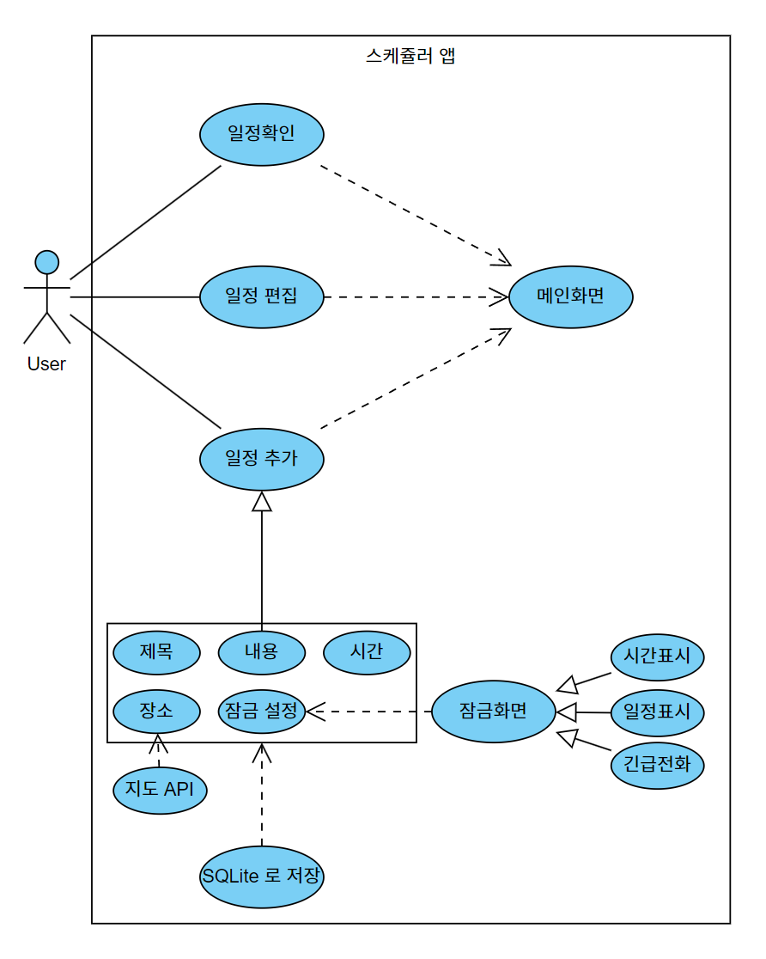*
* *Interface Description*

