Get data work flow

1. In the PDF file, choose Zoom in and make the picture clearer and bigger.

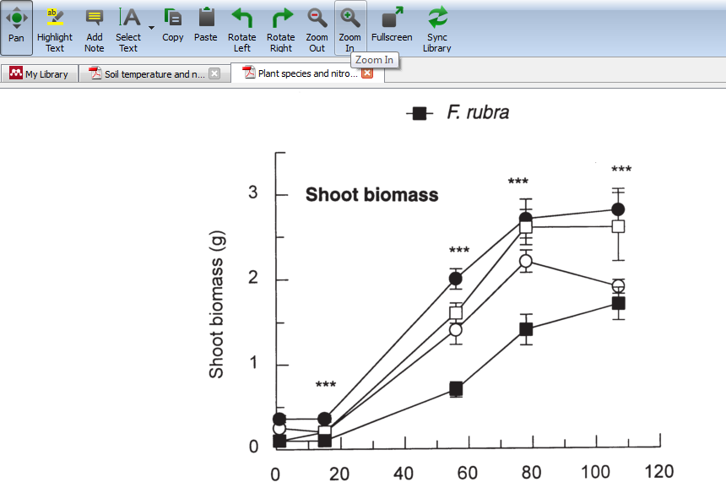

1. Press the “print screen” key on keyboard.

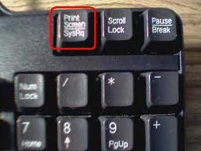

1. Go to Paint and paste the picture.

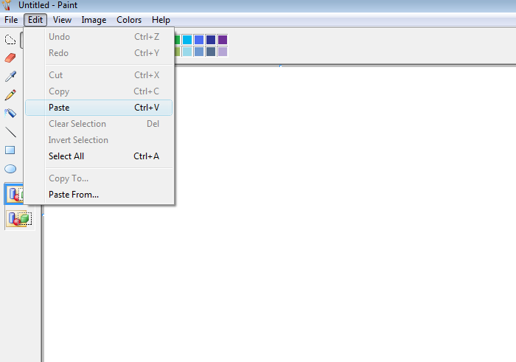

1. Cut the picture with the paint tool and open a new paint file and save it as JPEG. For saving picture, it should be saved as the last name of the author plus the year published plus the first letters of the first three words of the title.

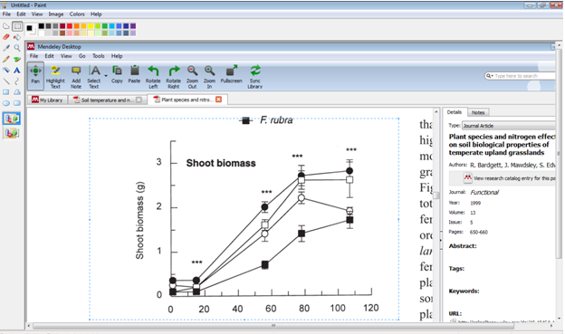

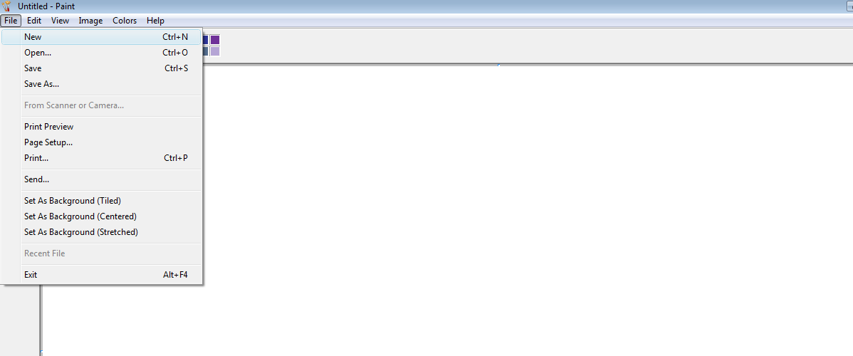

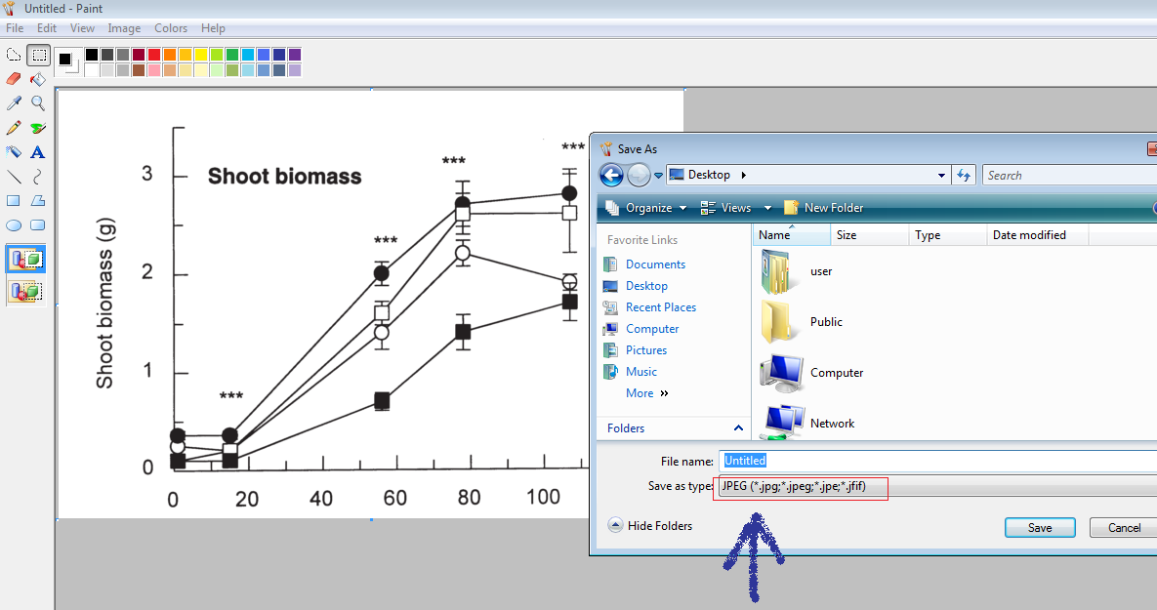

1. Go to get data and open picture.

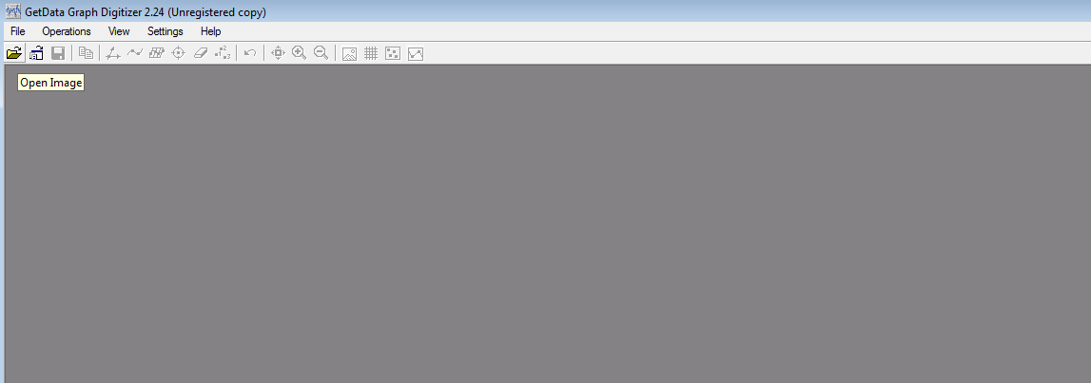

1. Pressing the following button make axis for the get data file.

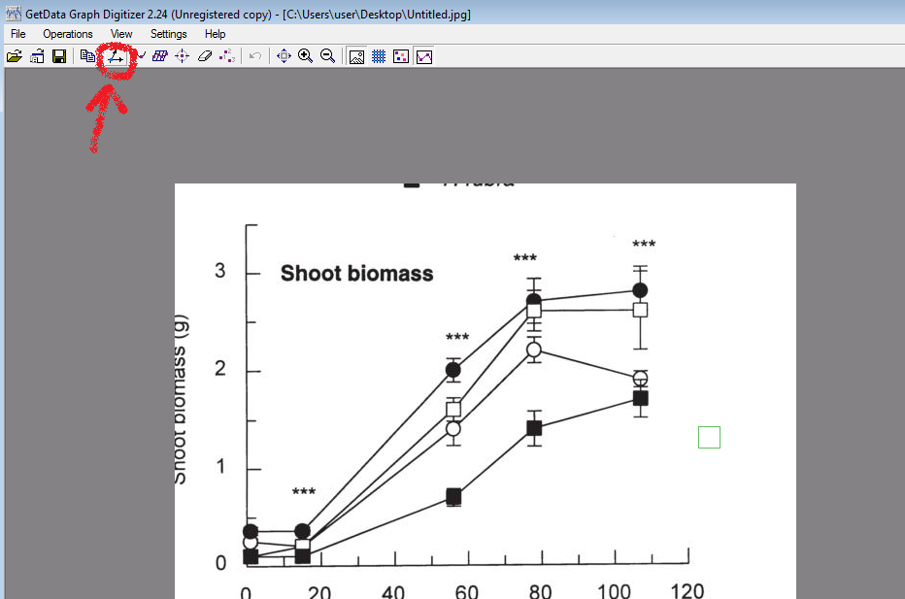

1. Using the following button, get the data of Mean values by clicking the middle of the mean points by looking in the zoomed section.

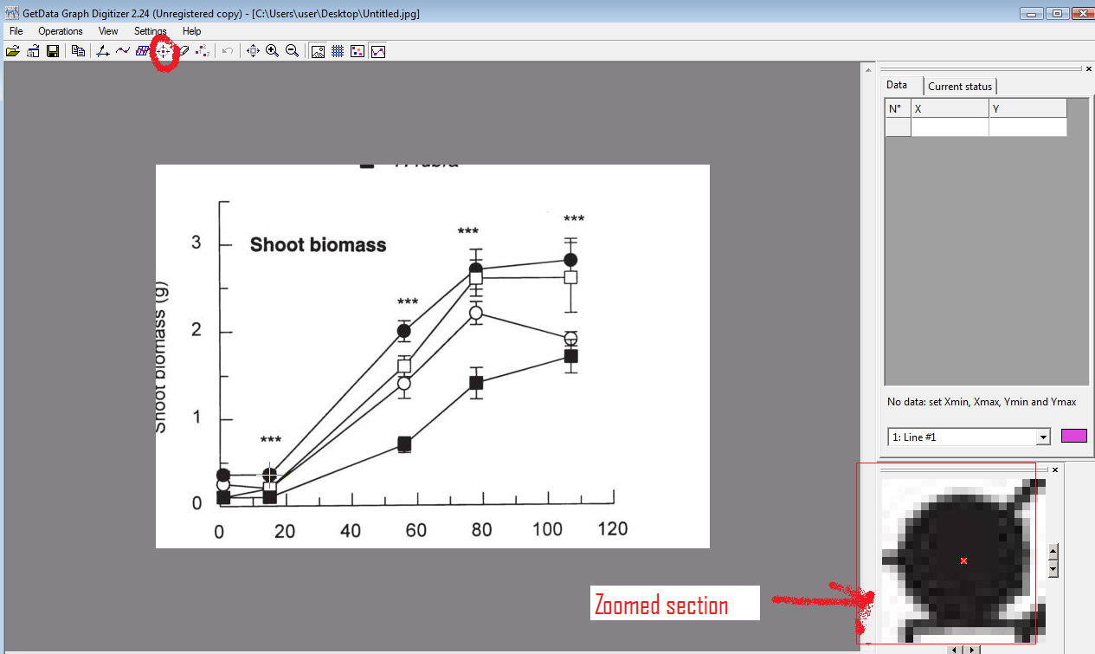

1. For getting the data of the error(if it is provided on the graph), press on the top or bottom portion of the line of error and then for the Error value calculate the absolute value of the Error minus the Mean value which will be the Y values.

