Chapter 3: Fungal Diversity and Decomposition Microcosm Study
David LeBauer

August 18, 2008

Abstract

Introduction
Because humans have increased rates of species extinctions and local population declines, it is important to understand how these losses affect ecosystem functioning. The impact of this biodiversity loss on the habitability of our biosphere is fundamental to the most dire arguments for the conservation of biodiversity [Schwartz et al., 2000, Ehrlich and Pringle, 2008]. At the same time, the models that are used to predict future climates and carbon budgets assume that the loss and redistribution of species do not have the same substantial effects on carbon cycling as the rates of fossil fuel combustion and climate change will. This assumption requires that ecosystem functions only depend on environmental conditions and resource availability rather than on the distribution of organisms and biomes [IPCC, 2007]. Although we have ample evidence that the number and identity of species does affect many ecosystem functions [Cardinale et al. 2006], there is insufficient empirical data to incorporate ecological interactions into the predictions made by the IPCC. By omitting biodiversity effects, the IPCC implicitly assumes that individual species are functionally redundant within an ecosystem or land cover type. For example, these models use temperature, moisture, and substrate availability but not species to predict respiration of carbon by the biosphere to the atmosphere. Not only do biodiversity effects on production and decompositoin affect the concentration of CO₂ in our atmposphere, CO₂ and other global change agents usually alter the structure of decomposer communities [Allison and Martiny, 2008].
For Aspen leaves decomposing in a boreal forest, fungal enzymes that target lignin and cellulose provide a likely link between fungal species diversity and function. If a group of these fungi produce the same enzymes, then we could predict that the species in this group are functionally redundant. In this case we would not expect that the number of species present would have an effect on enzyme activity or decomposition. On the other hand, if species vary in the enzymes that they produce, then they should exhibit analagous variation in the substrates that they decompose. In this case, the decomposition of a complex substrate like Aspen leaves should increase when multiple species are present if the species target different chemicals within the leaf.
We know that species are not completely redundant because most previous studies show that there is a positive effect of species number and identity on functions at many trophic levels [Schwartz et al., 2000, Cardinale et al., 2006], including decomposition rate [Salonius, 1981, Tiunov and Scheu, 2005, Setälä and McLean, 2004]. In addition, previous studies clearly demonstrate that species identity is an important component of the biodiversity - ecosystem link [Cardinale et al. 2006]. Compared to the kinetics of fossil fuel combustion to CO₂, we know very little about the biological catalysts that account for the much greater flux of CO₂that is respired by the biosphere. This lack of knowledge represents a dramatic gap in our ability to predict future carbon budgets under global change.
Because we are rapidly losing species, we should be concerned that the magnitude of biogeochemical fluxes will decline with declining biodiversity. The primary biotic mechanism used to explain the link between species diversity and function is niche partitioning [Tilman et al., 1997]. Niche partitioning results from variation in species traits related to the use of available resources. Niche partitioning predicts that increasing the number of species, on average, increases the diversity of resources that can be utilized. When two species utilize different substrates, total substrate utilization should increase with two species compared to either species in monoculture unless there is an antagonistic interaction. Plant litter is a primarily a matrix of cellulose interlinked with and stabilized by lignin, and the decomposition of lignin can increase the amount of cellulose that is available. Because fungi vary in their ability to produce enzymes, fungal species that target different substrates within this matrix can decompose a complex substrate more rapidly when grown as a pair than when grown individually. For example, decomposition of cellulose by Chaetomium thermophile increased when a non-cellulolytic fungus, Thermomyces lanuginosusa was present [Deacon, 1985].
I hypothesized that decomposition of Aspen litter would increase with the number of species in laboratory fungal communities. Furthermore, I predicted that enzyme activities would increase with species number. To evaluate relationships among the diversity of fungal communities, enzyme activity, and decomposition, I isolated functionally diverse fungi and conducted a laboratory microcosm experiment in which I manipulated species number.

Methods

Isolation of Fungi
Fungi were collected from boreal forests near Delta Junction, Alaska 63∘55’N, 145∘44’W. These forests are characterized by intermittent stand replacing fires that are followed by succession of Aspen (Populus tremuloides) that is subsequently replaced by spruce (Tsuga canadensis). This study area and its ecology are described in detail by Treseder et. al. (2004).
I cultured Basidiomycetes directly from mushroom tissue, decomposing wood, and soil using selective malt yeast agar (MYA) media (5 g malt extract, 5 g yeast extract, 20 g agar, 2 mg phenyl-phenol and 1.5 mg benomyl per liter). Other fungi were isolated from soil in minimal nutrient agar with either glucose or bismuth sulphite + tannic acid plus [Xmolar] Streptomycin and [Xmolar] Chlrorotetracyclin as bacteriocide. After isolation, I maintained all cultures on MYA without microbiocides. To identify the fungal isolates, we extracted DNA using the PowerSoilDNA(?) kit (MoBio Laboratories), amplified the 18S ITS region using polymerase chain reaction, and sent the DNA products to (company, location) for sequencing. I chose eleven basidiomycetes with differing fruiting morphologies and growth rates on malt yeast agar. In addition, I selected five frequently found non-basidiomycete fungi from soil cultures (Table 1).
Experimental Design I randomly assigned an the sixteen isolates to the one, two, four, and eight species assemblages with each species represented equally at each level. The experimental unit of replication was the specific combination of species. The Aspen litter samples used as substrate were collected from a 15-year old Aspen forest near Delta Junction, air dried, placed in 1-mm mesh nylon bags, and affixed to the soil surface in an 80-year old black spruce (Picea mariana) forest in September 2005 and collected in September 2006. After collection of the partially decomposed Aspen litter, I dried it overnight at 60^{circ}C, ground it in a coffee-mill and sterilized it by exposure to 2.5-3.0 Mrad of γ-irradiation in a self-sheilded gamma irradiator with a CS-137 source (Shepherd and Associates, Mark I).
Each combination of species was placed into a 40 mL glass vial with rubber septa that permitted me to remove gas samples with a needle (product id and source). First, we added 1.00 g of 30-60 grit sand to each of sixty microcosms. autoclaved sand + tube at 120∘C for 40 minutes. Next, I weighed approximately 50 mg of γ-irradiated Aspen litter into each microcosm and recorded the mass of litter added. To inoculate microcosms, I removed approximately 125 mm³ of each culture growing on malt extract agar and homogenized this with 0.5 mL <cation solution> in a 1.5 ml eppendorf tube, and then transferred 0.5 mL to a 15 mL volume of <cation solution>. For each combination of species, I evenly mixed the component species in eppendorf tubes and transfered 0.6 mL of the mixture to a microcosm tube.
Decomposition rates I sampled CO₂ concentration in microcosms at seven time points (6, 9, 15, 25, 45, 76, and 111 days). At each time point, I used a syringe to remove 10 ml of gas from the headspace, injected this into an EGM-4 infrared gas analyzer (PP Systems, Amesbury, MA). After sampling, I removed caps under a sterile laminar flow hood to allow headspace to equilibrate with the ambient air for at least 5 min. I calculated total decomposition as the total cumulative CO₂-C produced between replacing the cap and the next sampling time. Total CO₂ released was divided by the initial mass of the litter in each vial. I report total decomposition for the 111 day study in units of mg CO₂-C respired per g litter at the beginning of the experiment.
Enzyme Activities At the end of the 111 day study, I used colorometric assays [Allison and Jastrow, 2006] to determine the activities of the cellulose degrading enzyme β-glucosidase (BG) and the lignin degrading enzyme polyphenol oxidase (PPO). First I added 10 ml of 50 mM pH 5.0 acetate buffer to each microcosm, then I vigorously swrilled the vials on a culture rotating machine at 90 rpm for one hour to create a homogenized slurry of buffer, litter, sand, and fungi. Next, I added 50 μL of this homogenate to 150 μL of a substrate solution in a 96 well plate. In acetate buffer, I used 5mM p-nitrophenyl-β-glucopyranosidase to assay BG activity and 50 mM pyrogallol, 50 mM EDTA to assay PPO activity. For each microcosm I ran seven analytical replicates and seven controls with homogenate and no substrate. In addition, I ran a set of six controls for substrate absorbance with each 96 well plate. After combining homogenate and substrate, the reactions incubated 20∘C for 2-4 hours on a rotary shaker that I set just slow enough to prevent the sample from shaking out of the wells. At the end of the BG assay, I added 5 μL of 1 M NaOH to terminate the reaction and develop color from the pNp products. I used absorbance at 405 nm to calculate activities based on the amount of pNp produced (for BG) or pyrogallol consumed (for PPO) from empirically determined extinction coefficients for each substrate [Allison and Jastrow, 2006]. Enzyme activities are expressed in units of μmol substrate formed (for BG) or consumed (PPO) g⁻¹h⁻¹.

Data Analysis
To test the effect of species number on respiration and enzyme activity, I fit a log-linear regression with species number as the predictor and respiration or enzyme activity as the functional response variable. A positive slope significantly different from zero for any of these regressions would have supported my hypothesis that total decomposition and enzyme activity increase with species number. Next, I conducted an ANOVA with 16 binary variables indicating the presence or absence of each of the sixteen isolates as predictors and decomposition or enzyme activity as the response variable. I interpret a significant effect of one of the isolates as indication that the presence of that isolate had a disproportionate impact on the communities into which it was added. Furthermore, the sign of the coefficient indicated the direction of the isolate’s effect. The absence of a selection effect was supported when none of the species had a significant effect on function when present. However, I can not formally partition selection without knowing the contribution of each species to the enzyme pool or CO₂ flux [Loreau and Hector, 2001]. If individual species affected decomposition or enzyme activity, I would conclude that species identity and not only species number affects function. Finally, I calculated and tested the correlations between enzyme activity and decomposition. I interpret a significant correlation as support for my hypothesis that enzyme activity is an important control on decomposition. I omitted CO₂ and enzyme data from two leaky microcosms and enzyme data from a tray of twenty-four tubes that were evenly distributed across treatments. All analyses were performed using the lm() function in R [R Development Core Team, 2007].

Results
Total CO₂ released increased with species diversity (P = 0.003; r² = 0.05)(Fig. 2). Similarly, activity of the enzyme BG also increased with species diversity (P < 0.001; r² = 0.16). In contrast, PPO activity was invariant with species number.
Observed decomposition was not significantly affected by the presence of any single species (Fig. 1). BG was significantly elevated in microcosms that contained one of three isolates: Trametes versicolor (P = 0.034), Flammulina populicola (P = 0.014), or the unidentified Ascomycete (P < 0.0001); presence of the unidentified Ascomycete also had a marginally significant negative effect on PPO (P = 0.051). BG had only a marginally significant positive correlation with total CO₂ (P = 0.07; r² = 0.014). Finally, I found no correlation between total CO ₂ and PPO activity.

Discussion
Total CO₂ released from Aspen litter increased as a log-linear function of the number of species added to the microcosm (Fig. 2). This response supports our hypothesis that the number of species present has a positive impact on decomposition. Similarly, the log-linear increase in BG activity with species number supports my second hypothesis, and provides a possible mechanism for the increase in decomposition rate. From these results, we conclude that species diversity is important to both decomposition and BG activity, but there is no link between diversity and PPO activity.
Differences in the ecology of BG and PPO enzymes likely explain the different responses of these two enzymes. PPO reflects the activity of a large family of oxidative enzymes [Baldrian, 2006], and these enzymes target a diverse group of relatively recalcitrant polyphenols that are found at all stages of decomposition [ref]. Because the polyphenolic substrates targeted by PPO are diverse and abundant in leaves and soils, it is less likely that PPO will be substrate limited compared to BG. Rather than being limited by substrate availability, PPO production is more likely limited by the physical conditions that control the diffusion of enzymes and substrates and by the availability of other resources [Sinsabaugh and Moorhead, 1994, Moorhead and Sinsabaugh, 2006]. Both the availability of resources and the physical conditions were initially controlled in my present study, although nutrient cycling likely increased in the microcosms that had higher decomposition rates. Therefore, it is unlikely that nutrient availability limited PPO production because PPO activity and total CO₂ released were not correlated. BG is a more specialized enzyme that conducts a specific catalytic reaction to breakdown cellulose. Because of this substrate specificity, and because cellulose availability can be limited by lignin decomposition, BG may be more likely to be substrate limited than PPO. Although the BG activity only explained a small portion of the variationin decomposition in the present study, this finding in combination with the parallel responses of BG activity and CO₂ release to species number supports a link between enzyme production and decomposition. Such a relationship is consistent with biological models of decomposition [Moorhead and Sinsabaugh, 2006]
Positive relationships between the number of fungal species and the rate of decomposition have been previously demonstrated in experimental microcosms [Setälä and McLean, 2004, Robinson et al., 1981, Tiunov and Scheu, 2005]. Setala and McLean [Setälä and McLean, 2004] conclude that decomposition and response to diverse substrates increases with the number of saprophytic fungi. Furthermore, they find that the species number - function curve saturated above 2-6 species. Similarly, Tiunov and Sechu (2005) observe an increase in respiration of CO₂ from forest soil with increasing species number. The effect of species number decomposition of cellulose filters was additive, such that the respiration of cellulose was directly proportional to the number (one to five) of species present [Tiunov and Scheu, 2005].
However, the opposite response also occurs. For example, Toljander et al. (2006) observe reduced decomposition rates with increasing species diversity. In another study, decomposition is higher with one species of fungus on sterilized straw compared to multiple species of fungi [Janzen et al., 1995]. Decomposition of litter in a pine forest was greater when litter was pre-inoculated with a single fungal isolate prior to being decomposed by native microflora in the field compared to litter that was not pre-inoculated [Cox et al., 2001]. In that study, Cox et al (2001) find an effect on litter chemistry but not on total decomposition when the species used in pre-inoculation was a lignin versus a cellulose degrading fungus. Still, no previous study evaluates the effect of fungal species diversity on the activity of extracellular enzymes involved in decomposition.
In the present study, we observe important effects of biodiversity on two important ecosystem functions. Species number has clear impacts on decomposition and BG activity, and species identity affects BG and PPO activities. The lack of an effect of species identity on CO₂ released is consistent with other research at the site from where I collected the fungi in this experiment. Despite the large changes in the species composition of the fungal community resulting from N addition, Allison et al (2008) observe no change in total fungal abundance or CO₂ efflux from the soil. This finding is consistent with the present study in which I find an effect of species number but not species identity on total CO₂ release. Most microbial communities are sensitive to components of global change including warming, increased CO₂, and fertilizer additions [Allison and Martiny, 2008]. For example, experimental additions of nitrogen to a boreal forest dramatically reduced mushroom biomass eight fold and dramatically altered abundances of dominant Basidiomycetes, but did not change the total abundance of fungal in soil based on quantitative polymerase chain reaction (PCR) [Allison et al., 2008]. Furthermore, activities of the cellulose degrading enzyme β-glucosidase increased with nitrogen but there was no change in the flux of CO₂. Despite the divergence of diversity and function, neither microbial biomass nor CO₂ flux was affected. Both decomposition and microbial biomass in this ecosystem were unaffected despite the changes in community composition and enzyme activity that were evident.
Future directions:
It would be posible to use qPCR to estimate DNA copy number of individual isolates or microscopy with staining to estimate hyphal biovolume by species. This would permit the formal partitioning of the selection and complementarity effects with respect to total yield. In this case, the yield would be in DNA or volume- either of which could provide an indirect index of biomass. This would permit microbiologists to study soil organisms using analyses analogous to those used in studies of plant diversity and productivity. However, it is unclear if such biomass proxies would be as useful with respect to decomposition as biomass measurements are for plant production. First, plant biomass directly estimates the entire flux of carbon into the ecosystem. By contrast, microbial biomass is a small part of the much larger soil carbon pool, and the flux of carbon through respiration is the function most relevant to biogeochemical models. For applications relevant to predictive biogeochemical modeling, a more direct measure of carbon flux out of the ecosystem would be more useful. Howver, no methods are presently available to partition this flux according to the contribution of each species in a mixture or community. Although enzyme activity has not been convincingly linked to decomposition in the present study, knowing the contribution of individual species to the enzyme pool would provide a better understanding of the interactions among decomposer organisms [Moorhead and Sinsabaugh, 2006]. Future applications of proteomics may enable us to quantify the contribution of enzymes from individual species. If this is possible, new insights into the links between community composition and ecosystem function will be possible.

Conclusions

Acknowledgements

References
S.D. Allison and J.D. Jastrow. Activities of extracellular enzymes in physically isolated fractions of restored grassland soils. Soil Biology and Biochemistry, 38(11):3245–3256, 2006.
S.D. Allison and J.B.H. Martiny. Resistance, resilience, and redundancy in microbial communities. Proceedings of the National Academy of Sciences, 2008. in press.
S.D. Allison, C.I. Czimczik, and K.K. Treseder. Microbial activity and soil respiration under nitrogen addition in Alaskan boreal forest. Global Change Biology, 14, 2008.
P. Baldrian. Fungal laccases-occurrence and properties. FEMS Microbiology Reviews, 30(2):215–242, 2006.
BJ Cardinale, DS Srivastava, JE Duffy, JP Wright, AL Downing, M. Sankaran, and C. Jouseau. Effects of biodiversity on the functioning of trophic groups and ecosystems. Nature, 443(7114):989–92, 2006.
P. Cox, SP Wilkinson, and JM Anderson. Effects of fungal inocula on the decomposition of lignin and structural polysaccharides in Pinus sylvestris litter. Biology and Fertility of Soils, 33(3):246–251, 2001.
J.W. Deacon. Decomposition of filter paper cellulose by thermophilic fungi acting singly, in combination, and in sequence. Tans. Br. Mycol. Soc., 85(4):663–669, 1985.
P.R. Ehrlich and R.M. Pringle. Where does biodiversity go from here? A grim business-as-usual forecast and a hopeful portfolio of partial solutions. Proceedings of the National Academy of Sciences, 105, 2008.
IPCC. Climate Change 2007: The Physical Science Basis. Contribution of Working Group I to the Fourth Assessment Report of the Intergovernmental Panel on Climate Change. Cambridge University Press, Cambridge, United Kingdom and New York, NY, USA, 2007.
R.A. Janzen, J.F. Dormaar, and W.B. McGill. A community-level concept of controls on decomposition processes: Decomposition of barley straw by Phanerochaete chrysosporium or Phlebia radiata in pure or mixed culture. Soil Biology and Biochemistry, 27(2):173–179, 1995.
M. Loreau and A. Hector. Partitioning selection and complementarity in biodiversity experiments. Nature, 412(6842):72–76, 2001.
DL Moorhead and RL Sinsabaugh. A Theoretical Model of Litter Decay and Microbial Interaction. Ecological Monographs, 76(2):151–174, 2006.
R Development Core Team. R: A Language and Environment for Statistical Computing. R Foundation for Statistical Computing, Vienna, Austria, 2007. URL http://www.R-project.org. ISBN 3-900051-07-0.
C.H. Robinson, J. Dighton, J.C. Frankland, and P.A. Coward. Nitrogen and carbon dioxide release by interacting species of straw-decomposing fungi. Soil Biol Biochem, 13 (1):1–10, 1981.
PO Salonius. Metabolic capabilities of forest soil microbial populations with reduced species diversity. Soil Biol Biochem, 13(1):1–10, 1981.
M.W. Schwartz, C.A. Brigham, J.D. Hoeksema, K.G. Lyons, M.H. Mills, and P.J. van Mantgem. Linking biodiversity to ecosystem function: implications for conservation ecology. Oecologia, 122(3):297–305, 2000.
H Setälä and MA McLean. Decomposition rate of organic substrates in relation to the species diversity of soil saprophytic fungi. Oecologia, 139(1):98–107, 2004.
RL Sinsabaugh and DL Moorhead. Resource allocation to extracellular enzyme production: A model for nitrogen and phosphorus control of litter decomposition. Soil Biology and Biochemistry, 26(10):1305–1311, 1994.
D. Tilman, C.L. Lehman, and K.T. Thomson. Plant diversity and ecosystem productivity: Theoretical considerations. Proceedings of the National Academy of Sciences, 94(5):1857, 1997.
A.V. Tiunov and S. Scheu. Facilitative interactions rather than resource partitioning drive diversity-functioning relationships in laboratory fungal communities. Ecology Letters, 8(6):618–625, 2005.
Y.K. Toljander, B.D. Lindahl, L. Holmer, and N.O.S. Högberg. Environmental fluctuations facilitate species co-existence and increase decomposition in communities of wood decay fungi. Oecologia, 148(4):625–631, 2006.
K.K. Treseder, M.C. Mack, and A. Cross. Relationships among fires, fungi, and soil dynamics in Alaskan boreal forests. Ecological Applications, 14(6):1826–1838, 2004.

Species |  | Group | BG | PPO | CO₂
 |  |  | (μmol g⁻¹litter h⁻¹ ) | (μmol g⁻¹litter h⁻¹) | (total CO ₂-C g⁻¹litter)
Ascomycete |  | A | 5.1 ± 2.8 (2) | 17 ± 13.4 (2) | 12.8 ± 15.4 (2)
Flammulina populicola |  | B,ag | 3.7 ± 2.1 (2) | 0.1 ± 0.06 (2) | 5.3 ± 4.8 (2)
Trametes versicolor |  | B,pp | 2.6 (1) | 0.4 (1) | 24 ± 0.8 (2)
Ambomucor sp |  | Z | 0.12 ± 0.1 (2) | 1 ± 1.5 (2) | 16.5 ± 3.9 (2)
Collybia cirrhata |  | B,ag | 0.03 (1) | 0.1 (1) | 10.9 ± 5.3 (2)
unknown |  | H | 0.2 ± 0.1 (2) | 0.3 ± 0.1 (2) | 18.4 (1)
Penicillium sp |  | A | 1 ± 0.1 (2) | 0.8 ± 0.7 (2) | 22.3 ± 17.8 (2)
Polyporus varius |  | B,pp | 0.1 (1) | 0.9 (1) | 18.6 ± 8.1 (2)
Rhizoctonia sp |  | B,scl | 1.2 ± 1.1 (2) | 21.9 ± 0.3 (2) | 0.6 ± 16.6 (2)
Mortierellaceae |  | Z,scl | 2.3 ± 2.2 (2) | 1.3 ± 0.01 (2) | 2.6 ± 2.1 (2)
Pholiota carbonaria |  | B,ag | 0.2 ± 0.02 (2) | 0.7 ± 0.6(2) | 0.2 ± 0.1 (2)
Ceriporiopsis sp |  | B,pp | 0.3 ± 0.02 (2) | 0.2 ± 0.3 (2) | 0.4 ± 0.1 (2)
Marchandiomyces sp |  | B | 1.1 ± 0.9 (2) | 0.4 ± 0.2 (2) | 22.9 ± 11.3 (2)
Lyophyllum sp |  | B,ag | 0.2 (1) | 0.9 (1) | 27.6 ± 15.9 (2)
Coprinus sp |  | B,ag | 0 (1) | 4.7 (1) | 33.6 ± 4.3 (2)
Table 1: | Inidivual traits of isolates in monoculture. Enzyme activities presented as mean ± SE (n). Enzyme activities of polyphenol oxidase (PPO) andβ-glucosidase (BG) are reported inμmol g⁻¹litter h⁻¹and total decomposition is reported in mg CO ₂-C g⁻¹litter over the course of the experiment. B = Basidiomycete; pp = Polypore; ag = Agaric; scl = Sclerotia-forming; A = Ascomycete, H= Hyphomycete, Z = Zygomycete

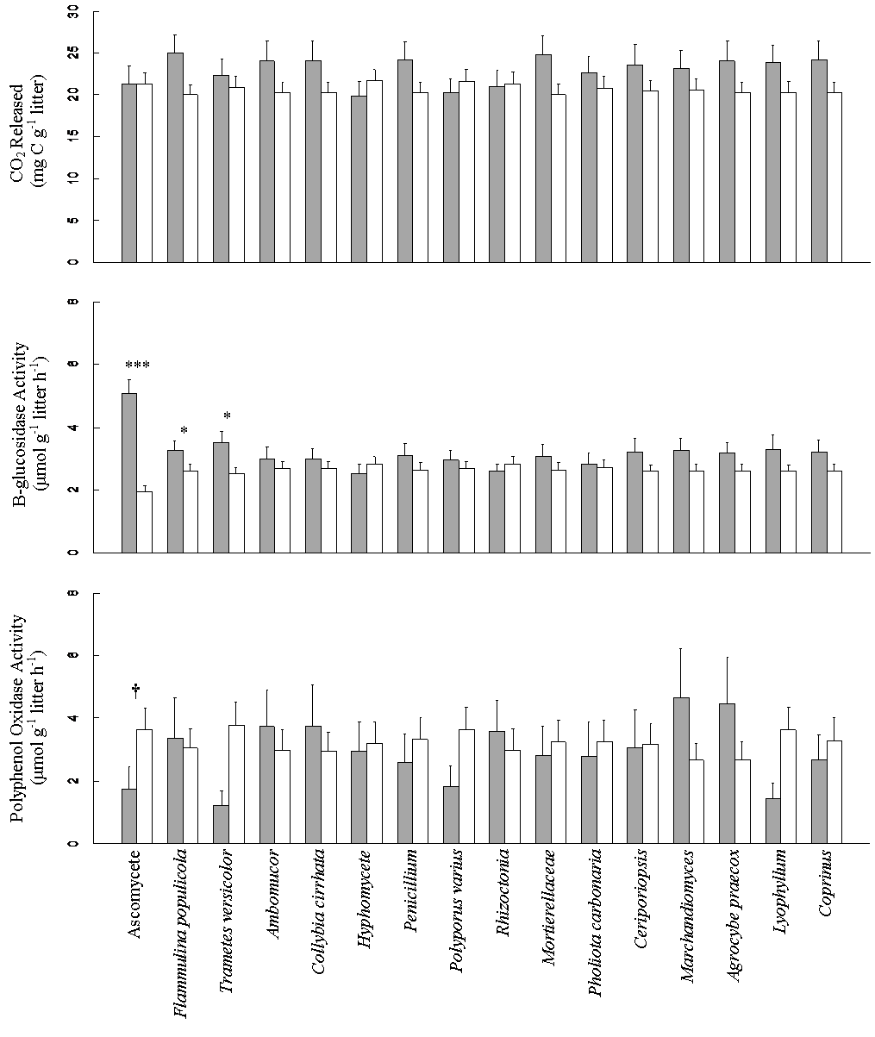
Figure 1: | Effect of presence (gray bars) and absence (hollow bars) of each species on decomposition and enzyme activity. *** P < 0.0001, * P < 0.05, † P = 0.051

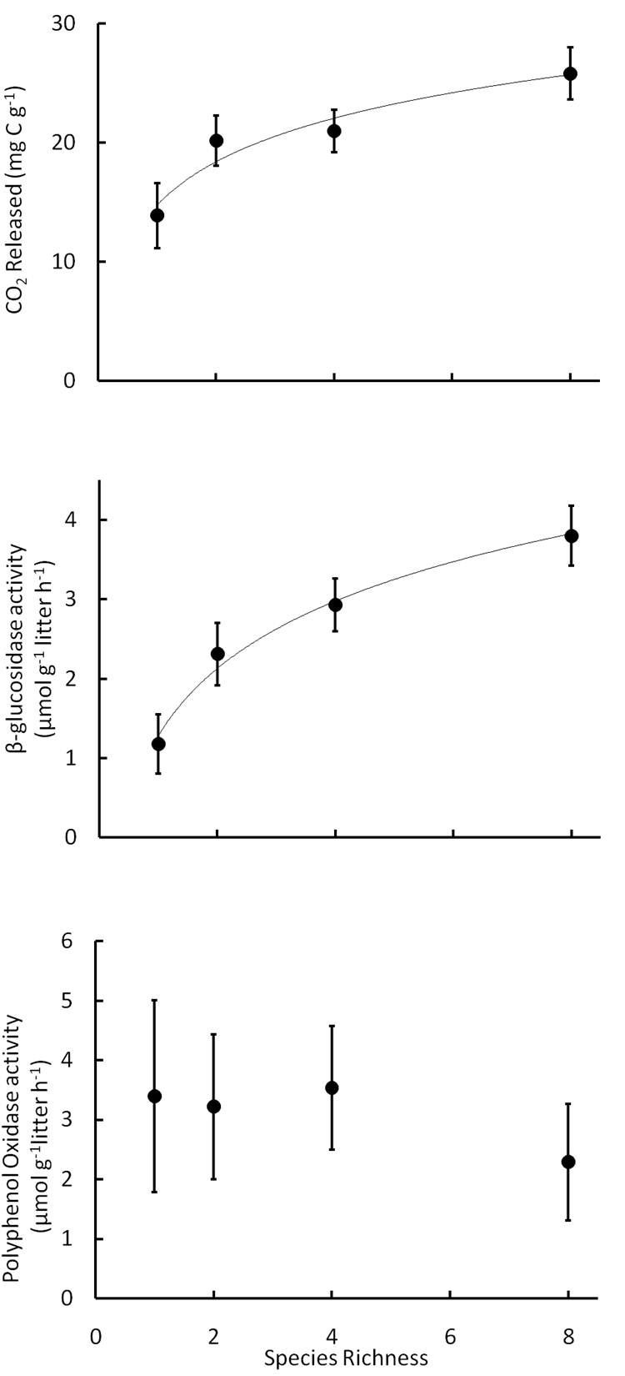
Figure 2: | The effect of species diversity on total decomposition (P = 0.03), β-glucosidase activity (P < 0.0001), and polyphenol oxidase activity (NS). Mean±SE.

