**CSE 212 – Programming with Data Structures**

**W01 Prove – Response Document**

|  |  |
| --- | --- |
| **Name:** | Dae Lee |
| **Date:** | Jan 14 |
| **Teacher:** | Brother |

*It is a violation of BYU-Idaho Honor Code to post or share this document with others or to post it online. Storage into a personal and private repository (e.g. private GitHub repository, unshared Google Drive folder) is acceptable.*

**Question 1: For the rotate right problem, provide a description of how you solved the problem.**

I made a sub-list using a range starting from the amount integer to the integer at the end of the list. I removed the sub list from the original list and added the sub list to the beginning of the list, resulting in a list with the rotated numbers.

**Question 2: For the rotate right problem, draw a picture of how you solved the problem.**

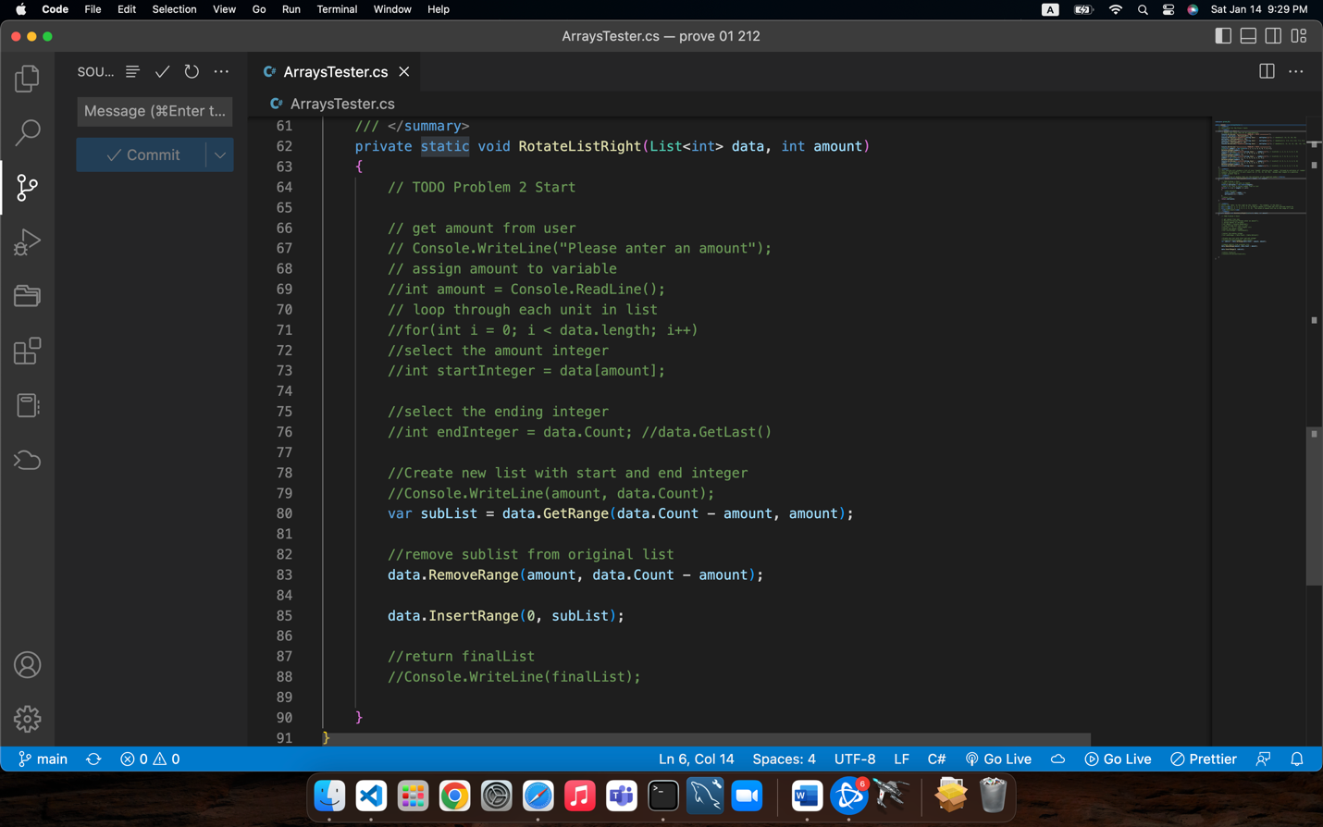

Remember: You need to commit all the changes to the prove-01-<username> repository along with this document. Then submit a link to the repository in I-Learn.