Dong (Bob) Lee
04/08/18
Machine Learning Independent Study, Assignment 5
Abstract/Motivation
This assignment is the direct continuation of the previous assignment, where the project is to have the application be able to categorize the user’s input (under the assumption that it’s a text file) into either 0 or 1.
Introduction
Now that there is a list of ProcessText objects, the data it contains needs to be parsed again because they are still not meaningful to the MLAlg.py, and cannot be processed with K Nearest Neighbors algorithm. This paper will go over the MLAlg.py and FeedText.py, describing how they interact with each other. The FeedText class further parses the information created from the ConsumeText object, so the MLAlg object produces a resultant from them.
Method/Measurement
There is a need to recognize that algorithms provided by the Sklearn-tools require list or numbers to be passed, in order to have any significant resultant; therefore, the FeedText needs to convert all the information in the ProcessText objects to something meaningful; in this case, since, the KNN algorithm requires input values according to the x and y values, and list of 0’s and 1’s, which is the target values.

import nltk
import os
import sys
sys.path.append("../src")
from ConsumeText import ConsumeText
from pathlib import Path

class FeedText(object):

def __init__(self):
self.consumedTexts = ConsumeText()
self.directory = None
self.listOfFiles = None
self.taggerPattern = open(os.path.join(os.path.dirname(__file__) + "/../src/patternList.txt")).read().split(",")
self.targetValues = []
self.inputValues = None

def setDirectory(self, userInput):
self.directory = userInput

def setListOfFiles(self):
self.listOfFiles = os.listdir(Path(self.directory))
for fileName in self.listOfFiles:
if((fileName.find(".txt") >= 0)):
self.consumedTexts.populateList(self.directory + "/" + fileName, self.taggerPattern)

def generateTargetValues(self):
for obj in self.consumedTexts.listOfProcessedText:
if (obj.isCategory == True):
self.targetValues.append(0)
elif (obj.isCategory == False):
self.targetValues.append(1)
self.targetValues.sort()

def generateInputValues(self):
self.inputValues = []
for obj in self.consumedTexts.listOfProcessedText:
newElement = [obj.patternMatchCount, obj.tokenCount]
self.inputValues.append(newElement)

The mechanism of the FeedText goes something like this: the directory, listOfFiles, and taggerPattern fields need to be assigned with values, before calling any other functions because they are dependent on those fields. If the fields mentioned in the previous sentence isn't assigned to anything, the MLAlg.py object will eventually be passed with None values. The FeedText best used after calling setDirectory(), setListOfFiles(), and consumedTextFiles(); however, the consumedTextFiles() should be called, after the setDirectory() and setListOfFiles are called because consumedTextFiles() assumes that there is a pool of text files to generate meaningful values for MLAlg.py. The taggerPattern field assumes that there is a patternList.txt in the src directory, which will be passed into the populateList function (there isn't any interface that allows the end user to interact with the patternList.txt, yet), within the consumeTextFiles() function. The taggerPattern field is assigned with the value fetched from the patternList.txt; where the patternList.txt is filled with string tokens, separated by commas. The listOfFiles does not populate more than 1 directories in a single cycle; therefore, if a user wishes to consume more than 1 pool of text files, there is a needs to initialize FeedText object twice.
Since, the K nearest neighborhood algorithm requires the target values and input values, generateTargetValues() and generateInputValues() could be used to assign values to targetvalues and inputValues fields. As one can see in the generateTargetValues(), 0 or 1 is appended to the targetValues depends on the isCategory’s value; the generateInputValues() also depends on the ProcessText objects heavily because the newElement is assigned with the values from the ProcessText object’s patternMatchCount and tokenCount.
import unittest
import sys
sys.path.append("../src")
import os
#os.chdir("../src/e-mails")
from ConsumeText import ConsumeText
from ProcessText import ProcessText
from FeedText import FeedText
from unittest import TestCase
from unittest.mock import patch
from unittest import TestCase

class Test(unittest.TestCase):

def test_innitialization(self):
feedTextObj = FeedText()
self.assertEqual(feedTextObj.taggerPattern, open(os.path.join(os.path.dirname(__file__) + "/../src/patternList.txt")).read().split(","))

def test_setDirectory(self):
feedTextObj = FeedText()
feedTextObj.setDirectory("/home/bob/Desktop/WorkSpace/TextFilterUI")
self.assertEqual(feedTextObj.directory, "/home/bob/Desktop/WorkSpace/TextFilterUI")

def test_setListOfFile(self):
feedText = FeedText()
feedText.setDirectory("/home/bob/Desktop/WorkSpace/TextFilterUI/src/SampleTxtFiles")
feedText.setListOfFiles()
self.assertEqual("poem_of_unicorn.txt" in feedText.listOfFiles, True)
self.assertEqual("sample_one.txt" in feedText.listOfFiles, True)
self.assertEqual("sample_two.txt" in feedText.listOfFiles, True)

def test_consumeTextFiles(self):
feedText = FeedText()
processedTextStrings = []

feedText.setDirectory("/home/bob/Desktop/WorkSpace/TextFilterUI/src/e-mails/spams")
feedText.setListOfFiles() # Innitialize the list of file names.
feedText.consumeTextFiles() # In the specified directory, with the set of file names, populate the list in ConsumeText object.
for index in range(0, 5):
processedTextStrings.append(feedText.consumedTexts.listOfProcessedText[index].textFileContent)
self.assertEqual(open("../src/e-mails/spams/sample_one.txt", "r").read() in processedTextStrings, True)
self.assertEqual(open("../src/e-mails/spams/sample_two.txt", "r").read() in processedTextStrings, True)
self.assertEqual(open("../src/e-mails/spams/sample_three.txt", "r").read() in processedTextStrings, True)
self.assertEqual(open("../src/e-mails/spams/sample_four.txt", "r").read() in processedTextStrings, True)
self.assertEqual(open("../src/e-mails/spams/sample_five.txt", "r").read() in processedTextStrings, True)

feedText.setDirectory("/home/bob/Desktop/WorkSpace/TextFilterUI/src/e-mails/non-spams")
feedText.setListOfFiles()
feedText.consumeTextFiles()
for index in range(5, 10):
processedTextStrings.append(feedText.consumedTexts.listOfProcessedText[index].textFileContent)
self.assertEqual(open("../src/e-mails/non-spams/sample_one.txt", "r").read() in processedTextStrings, True)
self.assertEqual(open("../src/e-mails/non-spams/sample_two.txt", "r").read() in processedTextStrings, True)
self.assertEqual(open("../src/e-mails/non-spams/sample_three.txt", "r").read() in processedTextStrings, True)
self.assertEqual(open("../src/e-mails/non-spams/sample_four.txt", "r").read() in processedTextStrings, True)
self.assertEqual(open("../src/e-mails/non-spams/sample_five.txt", "r").read() in processedTextStrings, True)

def test_generateTargetValues(self):
feedText = FeedText()
feedText.setDirectory("/home/bob/Desktop/WorkSpace/TextFilterUI/src/e-mails/spams")
feedText.setListOfFiles()
feedText.consumeTextFiles()
feedText.setDirectory("/home/bob/Desktop/WorkSpace/TextFilterUI/src/e-mails/non-spams")
feedText.setListOfFiles()
feedText.consumeTextFiles()
feedText.generateTargetValues()
self.assertEqual(feedText.targetValues, [0, 0, 0, 0, 0, 1, 1, 1, 1, 1])

def test_generateInputValues(self):
print("In the block of test_generateInputValues")
feedText = FeedText()
feedText.setDirectory("/home/bob/Desktop/WorkSpace/TextFilterUI/src/e-mails/spams")
feedText.setListOfFiles()
feedText.consumeTextFiles()
feedText.setDirectory("/home/bob/Desktop/WorkSpace/TextFilterUI/src/e-mails/non-spams")
feedText.setListOfFiles()
feedText.consumeTextFiles()
feedText.generateInputValues()
print(feedText.inputValues)

The above is the testings for the FeedText.py, which it assumes that 5 spam e-mails and non-spam e-mails are present within the e-mails directory.
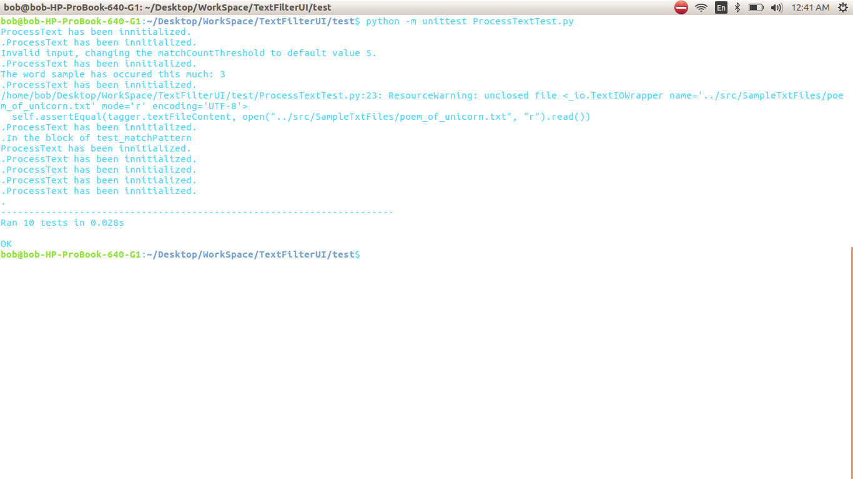
Currently, all the unit test are passing, where the unit tests are used to demonstrate that all the functions implemented FeedText.py is producing expected results.
Regarding the MLAlg.py, this class is where the target values and the input values are used to train the K Nearest Neighbor algorithm, and allow the end users to introduce the new text file needing to be guessed by the algorithm. The majority of the heavyweight is lifted by using createUserInputAndPredict(); however, the function requires the user to have triggerPattern field to be assigned with triggerPatterns, before doing anything with createUserInputAndPredict(); also, the directory of a text file needs to be passed in, which is represented as a directory parameter within the function. Within the createUserInputAndPredict(), the predictUserInput() called, and that’s where the machine learning algorithm will make the guess which category the text file belongs to.
import unittest
import sys
sys.path.append("../src")
import os
from ConsumeText import ConsumeText
from ProcessText import ProcessText
from FeedText import FeedText
from MLAlg import MLAlg
from unittest import TestCase
from unittest.mock import patch
from unittest import TestCase

class Test(unittest.TestCase):

def test_setTargetValues(self):
kAlg = MLAlg()
feedText = FeedText()
processedTextStrings = []

feedText.setDirectory("/home/bob/Desktop/WorkSpace/TextFilterUI/src/e-mails/spams")
feedText.setListOfFiles() # Innitialize the list of file names.
feedText.consumeTextFiles() # In the specified directory, with the set of file names, populate the list in ConsumeText object.
feedText.setDirectory("/home/bob/Desktop/WorkSpace/TextFilterUI/src/e-mails/non-spams")
feedText.setListOfFiles()
feedText.consumeTextFiles()
feedText.generateTargetValues()
kAlg.setTargetValues(feedText.targetValues)
self.assertEqual(kAlg.targetValues, [0, 0, 0, 0, 0, 1, 1, 1, 1, 1])

def test_createUserInput(self):
kAlg = MLAlg()
feedText = FeedText()
processedTextStrings = []
feedText.setDirectory("/home/bob/Desktop/WorkSpace/TextFilterUI/src/e-mails/spams")
feedText.setListOfFiles() # Innitialize the list of file names.
feedText.consumeTextFiles() # In the specified directory, with the set of file names, populate the list in ConsumeText object.
feedText.setDirectory("/home/bob/Desktop/WorkSpace/TextFilterUI/src/e-mails/non-spams")
feedText.setListOfFiles()
feedText.consumeTextFiles()
feedText.generateInputValues()
feedText.generateTargetValues()
kAlg.setTargetValues(feedText.targetValues)
kAlg.setInputValues(feedText.inputValues)
kAlg.setTriggerPattern(feedText.taggerPattern)
self.assertEqual(kAlg.createUserInputAndPredict("/home/bob/Desktop/WorkSpace/TextFilterUI/src/e-mails/TestInput/sample_one.txt"), [1])

The test_setTargetValues() assumed that e-mail text files have been consumed by FeedText object, and 5 of them are spams, and 5 of them are not; therefore, the expected target values generated by the MLAlg object should [0, 0, 0, 0, 0, 1, 1, 1, 1, 1]. The test_createUserInput() assumes the same, where it comes to the pool of e-mails being required, and the createUserInputAndPredict function in this unit test expects the text file being specified is not a spam mail.
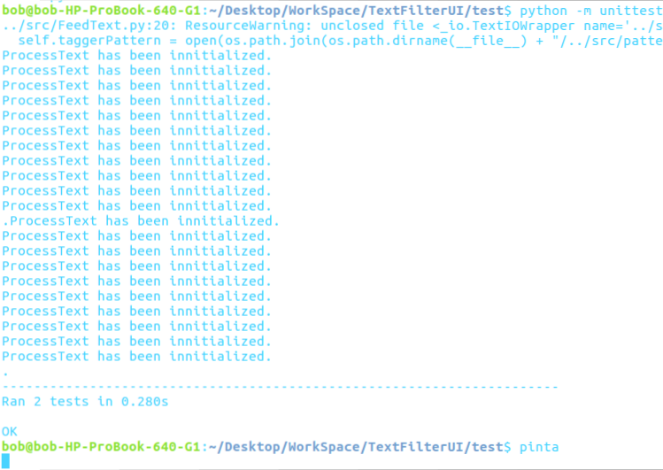
The tests appear to be passing, and the MLAlg.py is seems to be displaying a stable behavior.

Results/Conclusion
The application is not fully completed yet, it has a minimal necessity to guess the user’s input (which should be a text file) categorization. At the same time, there aren’t any further planning to enhance the user interface, so this project could stand as a legitimate application. For now, this project will go into a hibernation to give me a bigger focus on other projects.
Relating back to the previous paragraph, I still don’t have a firm grasp on how the user could interact with the application. The project was never meant to be something that was user friendly; however, if it were to be finished, the application should be able to produce a user friendly resultant (like, an HTML page); because of this, the project should currently be on a halt, so a design could be thought up. Also, the K nearest neighbors right now are not reliable. The unit test is displaying that MLAlg is behaving as expected; however, currently, the MLAlg’s KNN algorithm is only requiring 1 nearest neighbor; in a real-life scenario, this can’t possibly be a useful functionality.
Feedback for Instructor
Relating back to the previous paragraph, again, the designing of this project was the greatest difficulty so far because designing of this project happened as the project grew bigger.
The learning experience, I believe, can’t get any better; unless I walk down the path of computer science for longer, and the reason is that the problem is arising because I don’t have much experience in creating applications following certain design patterns.
From this development process, I’ve learned that there is a weakness in my programming skill, and there is a need to further educate myself in the study of the design pattern.

Bibliography
“26.4. Unittest - Unit Testing Framework¶.” 26.4. Unittest - Unit Testing Framework - Python 3.6.5 Documentation, docs.python.org/3/library/unittest.html.
“Natural Language Toolkit¶.” Natural Language Toolkit - NLTK 3.2.5 Documentation, www.nltk.org/.

