Dong (Bob) Lee
04/08/18
Machine Learning Independent Study, Assignment 4
Abstract/Motivation
I and my peers were at this event called HackCU 4, and stumbled upon a library called NLTK; at first, I thought nothing of it and thought it was another useful utility to keep in mind of for later. After 2, or 3, months have passed by, I got an interview with a company, and they told me that one of the projects that they were dealing with has to do with organizing various logs. During that same day, I remembered that there was the field of study in computer science called Natural Language Processing, and it was one of the fields I still haven’t ventured yet; thus, I have decided to pursue the project described below.
The project began with the question, “what if I can classify text files in either 1 or 0?” After being able to classify the text file with either 1 or 0, it should be possible to fit it in the machine learning algorithms provided by Scikit-learn; and the parsing of the text files could certainly be done in Natural Language Toolkit. Abstractly, the project will approach the problem by finding for certain patterns, and count the frequency of user-specified patterns, and the amount of total words in the text file; accordance with those two values, each text files will be classified into either 1 or 0, and they will be used to train the machine learning algorithm. After the machine learning algorithm has been trained, when the new text file is introduced to the algorithm, the application will guess if the new data is classified into 1 or 0. The category of the classification is entirely up to the user.

Introduction
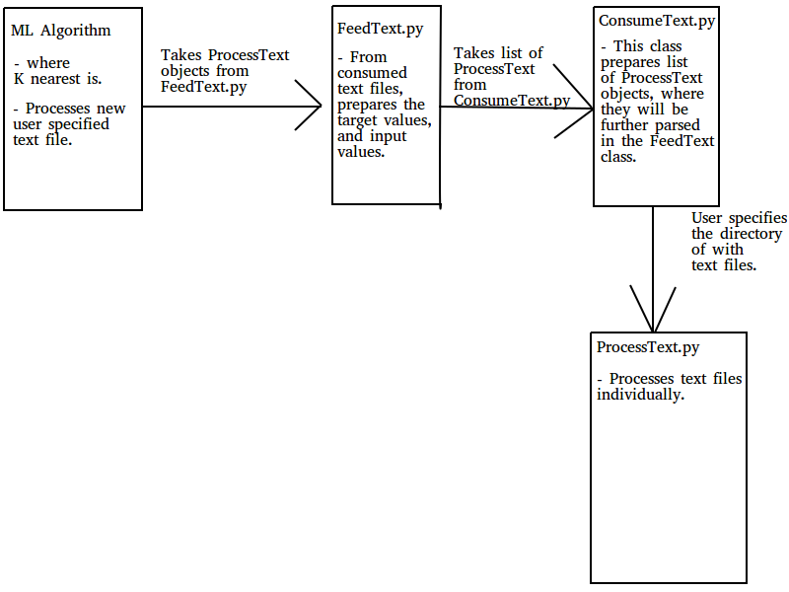
The picture above is the architecture of this project, and as stated in the Abstract/Motivation, the application will guess how the text file will be categorized by K nearest algorithm.
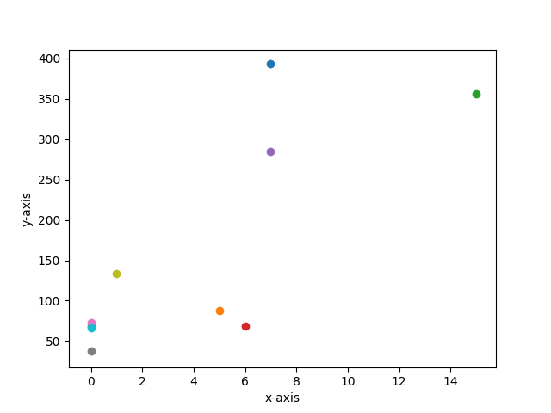

The picture on the previous page contains dots, where each dots are the representation of the text files, where dots within the interval of 0 <5 for x, and
0 < 25 y are 0’s, and vice versa are 1’s. The x-axis of the graph represents the frequency of the matched patterns, and the y-axis represents the number of words occurred in the text files. Under the assumption that the project is fully completed, and a user has introduced a new text file to the algorithm, where the 6 user specified pattern has occurred, and 120 words are present in the text file, the application will categorize that text file within the 1’s category.
Every resultants are to be presented through the command shell, “enhancements” of the user interface has not been thought of yet; also, there hasn’t been any planning to add new components to the architecture specified in the above paper.

