SQL’s have tables; that’s the main structures in the database, each of those tables represents single specific subject.
In the SQL table, I must have at least one column called primary key, which has unique identifiers for each rows.
There are two types of keys primarily.
Primary key identifies rows within table.

There is a table specifically called views, and it has one or more columns from different tables. Such tables are called base tables (then why bother calling it the views?).

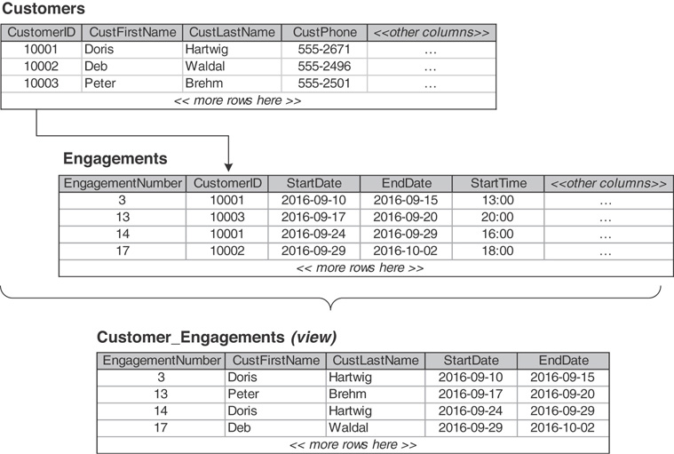

So, there is this concept called Relations, in the world of relational database, and this is where the SQL truly shines; without this feature, SQL is near useless.

We got one-to-one.
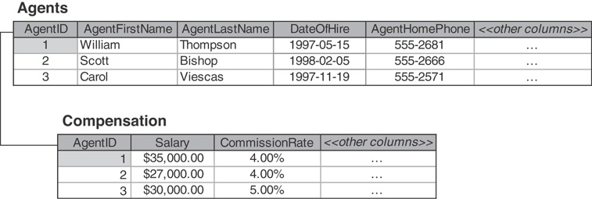

We got one-to-many.

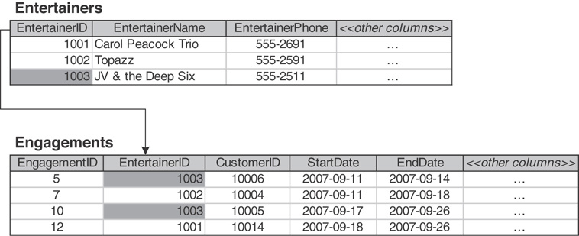
We got many-to-many.
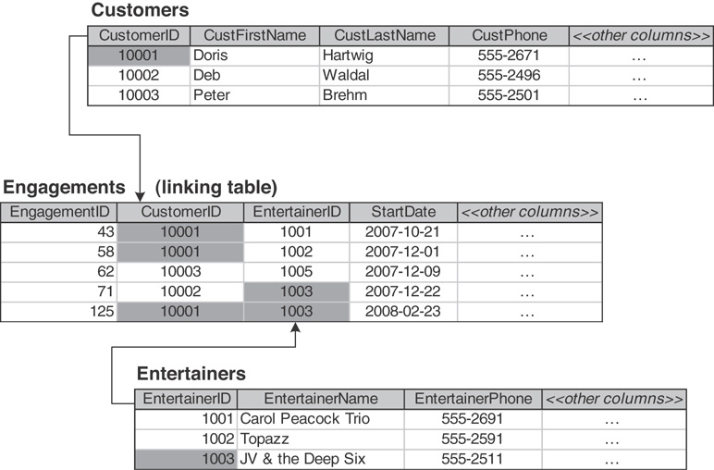
Ichi-ryu is agile. SELECT, FROM, WHERE, etc … there are called clauses.
The datatypes being used in the SQL is completely different from the programming languages we deal with.
We got CHARACTER, NATIONAL CHARACTER, BINARY, EXACT NUMERIC, APPROXIMATE NUMERIC, BOOLEAN, DATETIME, and INTERVAL.
If I want to change the data type of a certain value, I can cast them.
---------------------------------
https://www.youtube.com/watch?v=OADK75stulU&feature=youtu.be
Essential concepts of SQLs for the devs.
---------------------------------
https://www.w3schools.com/sql/func_sqlserver_cast.asp
Casting is still a concept that exists in the realm of SQL.
---------------------------------
Expressions in the SQL are consisted of:
Concatenation, Mathematical, and Date and Time Arithmetic.

Concatenation, as the name suggests, is a concatenation, it’s very simple.

'Order Number ' || CAST(OrderNumber AS
CHARACTER(2)) ||' was placed on ' ||
CAST(OrderDate AS CHARACTER(10))

The above expression produces “Order Number 1 was placed on 2017-09-02."
The functions for the mathematical expressions are quite a lot, I can’t really put everyone of them in here. SQL can do operations like SQRT(), EXP(), and LN() (natural logarithm).
SQL can handle mathematical expressions intuitive enough, where expressions like ...

CAST(Salary + (50000 * CommissionRate) AS CHARACTER)

Is allowed.

Null is also a thing in SQL.

During the SELECT statement, elements can be filtered out via using WHERE clause.

For example, this table of mine “techsites” contains column named “category.”
SQL statement select * from techsites where category=”general”;
Will only fetch the rows which contains the “general” as its category.
Cool thing is, conditional operators are also a thing in SQL; however, not operator is <> … But the inconvenience like the left can be avoided via statements like …
Select * from techsites where not category=”general”;
They have ReGex like pattern string, but it’s weird (chapter 6 SQL for mere mortals).
If I want to do AND operation ...

Select * from techsites where not category=”general” AND category=”hackathon”;

SQL statement like the above can be used.

Also, there is this SQL clause called IN.
SELECT * FROM techsites WHERE category IN ("Machine Learning", "HPC");
The above SQL statement will fetch me elements that has category columns assigned with either Machine Learning or HPC.

With the above information so far, you can essentially do a set theory.
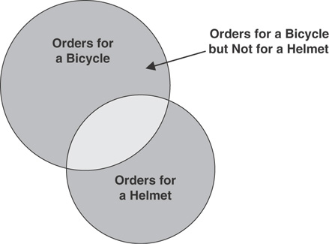
Something like the above picture.

There is this thing called column reference, and it’s used like the below:

SELECT techsites.URL, academicsites.URL from techsites, academicsites;

The above pretty much fetches everything in URL for techsites and academicsites.

There is this concept called JOIN. This is where the relational part of the SQL comes in.

SELECT * from techsites inner join academicsites on techsites.category = academicsites.category;

The above SQL statement fetches me the elements in both techsites table and academicsites table, where the rows must have the same categories in both techsites.category and academicsites.category.

This is where using vanilla sql queries kinda shines

SELECT R.RecipeTitle, R.Preparation,
RCFiltered.ClassName FROM
(SELECT RecipeClassID,
RecipeClassDescription AS ClassName
FROM Recipe_Classes AS RC
WHERE RC.ClassName = 'Main course' OR
RC.ClassName = 'Dessert')
AS RCFiltered INNER JOIN Recipes AS R
ON RCFiltered.RecipeClassID = R.RecipeClassID

I can have select clause within the ongoing select clause.
Such technique is called subquery, where
https://www.dofactory.com/sql/subquery
Further exaplanation is in the above.

https://www.diffen.com/difference/Inner_Join_vs_Outer_Join
Further details on inner join and outer join can be found in the above.
https://www.techonthenet.com/sql/union.php
There is also this concept called UNION.

The rest of the things you can do via SQL aren’t too complicated. They are just rest of the CRUD operation; since, this document explains the create and read of the CRUD.

