The idea of spinning embedded system intended application on Android began from Karim Yaghmour’s story; at one point in Karim's life, his customer came to him and told him, "we want Android in our headless system." His client came up with two reasons why he wanted just that:

1.) Client's company has to maintain multiple platforms, some of them
requires GUI interactions, while others didn't; therefore, let's
standardize the OS being used to Android, where headless Android can deal with headless and non-headless things.

2.) We can grab a random Android developer from some street and
have him/her start developing their embedded system.

I think we have a theme here, “not better, but more and faster.”

To give a descent compare and contrast between the usual embedded system development and Android Things, I have decided to learn bits and pieces about the Embedded Systems, where I have largely referred the book called, "Mastering Embedded Linux Programming."

In the world of Embedded Linux Programming, we need this thing called toolchain; basically, it's a chain of software utilities contributing for program's compilation, which could be composed with things like GCC and C libraries.

The book instructs the reader with this utility called crosstool-NG.

sudo apt-get install automake bison chrpath flex g++ git gperf \
gawk libexpat1-dev libncurses5-dev libsdl1.2-dev libtool \
python2.7-dev texinfo

The exact command above was needed to download the packes for crosstool-NG.

git clone https://github.com/crosstool-ng/crosstool-ng.git
cd crosstool-ng
git checkout crosstool-ng-1.22.0
./bootstrap
./configure --enable-local
make
make install

Where crosstool-NG is a set of make scripts, which is comparable to the
bunch of Gradle files.

After installing the utilities mentioned above, I've never encountered something
more unwelcoming than this. Consider this hardware called BeagleBone Black. The BeagleBone Black has a TI AM335x SoC (system on chip), which spins on ARM Cortex A8 core; therefore, we can use this toolchain called arm-cortex_a8-linux-gnueabi.

After the compilation of the program with the specified toolchain,
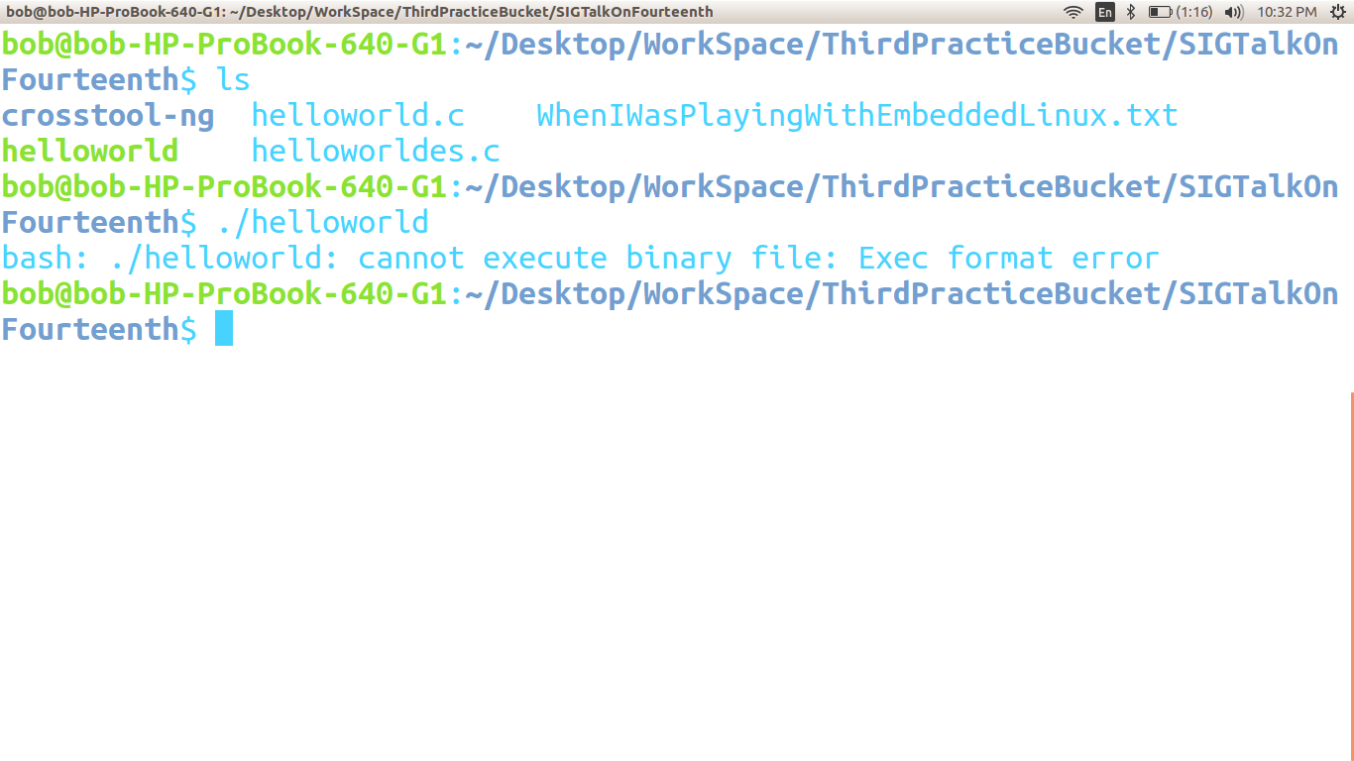
We are only left with the, “cannot execute binary file: Exec format error.”

So, here it is; since, the helloworld application was compiled with the toolchain specifically for the ARM architecture, my system refused to spin the app.

