英文网页制作，

首页，导航栏（蓝色白字，右上角公司图标-图片logo），Home，About us, Our business, News & Events, , Contact us.
首页底部：Copyright © Jaax Group 2025 — All rights reserved. Disclaimer
Home 页面图片，picture 1（显示文字 INNOVATING SOLUTIONS），

About us 点击后跳转至home页面下拉第二页图片 图2，
图片2伴随文字公司介绍
Headquartered in Dubai Maritime City, JAAX Marine Engineering FZC delivers integrated maritime and offshore solutions through three focused divisions: 1. genuine spare-parts supply for marine and oil & gas assets, 2. round-the-clock ship repair and maintenance within the maritime city and UAE waters, 3. specialist oilfield services spanning drilling support and cutting end data processing and subsurface geoscience modelling.
Our on-site workshops, Class-certified inventory and multidisciplinary engineers guarantee minimum downtime, strict HSSE compliance and transparent project controls bring our customer excellent delivery.

下拉第三页图片3 三个主题
Vision（To be a global partner in marine services and premier supply chain solution provider）
Mission（Commitment to excellence & cost effectivenes, innovation, and environmental stewardship to create Value)
Core Value(Unwavering probity, engineered exactitude, symbiotic stewardship)

下拉第四页
蓝色背景图片+4个图
ISO1，2，3三张图片+QHSE policy图

Contact us 部分：
- 整体纯蓝色背景图
- 蓝色导航栏+右上角公司logo图标
- 导航栏下面蓝色部分插入公司Google 位置图链接为：https://maps.app.goo.gl/S7E1UAPeja2D3BGP8 位置图需要占二分之一右侧板面
- 另外二分之一左侧板面为蓝色底图+如下公司信息

Contact us:
Tel No: +971 4 570 3121
Email us: info@jaaxgroup.com / sales@jaaxgroup.com
Address:
Warehouse No. 300A – W342,
Dubai Maritime City,Dubai,United Arab Emirates

- inquiry 部分需要四个部分填写问卷后需要自动发送邮件至info@jaaxgroup.com
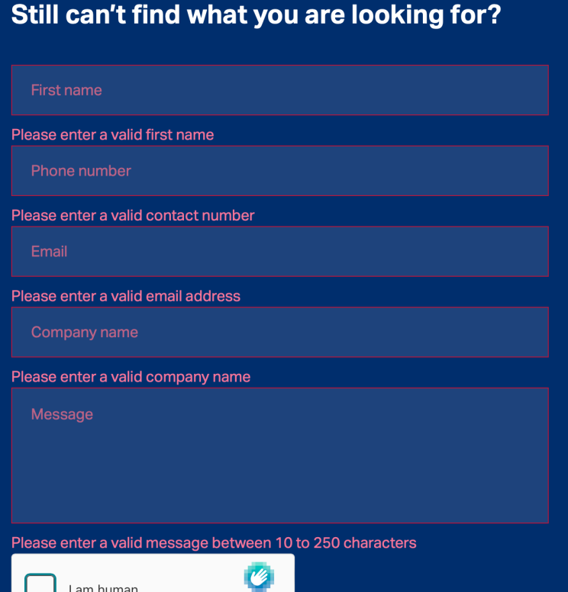
右下角需要设置三个图标对应链接：

- https://www.facebook.com/profile.php?id=61584956393896
- https://www.linkedin.com/in/jaax-group-b045703a0/
- https://x.com/JAAX_GROUP

News & Events

- 蓝色导航栏+右上角公司logo图标
- 纯白色底图+公司新闻及大事件列表
- Company attend the China Maritime Exhibition together with E&ON ,2-5th Dec 2025.
11.jpg 18.jpg
- Company get first Service PO from Dragon Oil ,11th Dec 2025.
10.jpg
- Company successfully registered for ENOC and Dragon Oil vendor list,3rd Dec 2025
19.png
- Company initiate the first Seismic Data Coping PO to one of CNPC company 9th Dec 2025.

- The regional exclusive agent agreement was signed by Jaax and E&ON, 17th Sep,2025
9.png
- Company accredit with ISO 9001, ISO14001, ISO 45001 17th Nov,2025
图片组合（3 ISO证书图片） 1,2,3.png

Our Business
- 蓝色导航栏+右上角公司logo图标
三个页面，
第一部分配合Pic1
Marine Equipment& spare parts Trading
- Generators series and spare parts supply
- Marine class standard light and system
- Cable, Electric accessories and spare parts.
- Pipes and fitting
- Tools and labors over hall, Central Kitchen appliances
- Import and export the consumable mechanical equipment, values and pumps.

- 配合Pic2，3
Retail of Oil and Gas well Equipment and Devices and Spare Parts
- Top drive and drill floor equipment spare parts
b. Wellhead equipment, manifold and valves.
c. BOP spare parts, handling tools
d. Drilling tools (tubing sub, casing ,drill pipe, crossover, lifting sub, rotary drilling tools and other tools thread process and supply
e. Mud pump and consumable spare parts
f. Solid control equipment and tools
g. Other accessories for Oil and Natural Gas well Equipment, Devices and Spare Parts

第三部分pic4，5
Ship Repairs & Conversions
- Steel Works
- Blasting & Painting
- Machining Services
- Electrical and Automation Services
- Services for Electrical Equipment
- Hydraulic Services

第四部分pic6
Geoscience & Drilling Support Services
• Seismic data processing: 2-D/3-D/4-D pre-stack depth migration, noise attenuation,
AVO/AVA inversion, fracture detection.
• VSP & LWD seismic: corridor stack, anisotropic tomography, time-depth tie for well positioning.
• Wireline & LWD log interpretation: triple-combo, NMR, image logs, saturation-height
modelling, TOC/brittleness for unconventionally.
• Static & dynamic modelling: Petrel/Eclipse/INTERSECT geological models, history matching,
uncertainty analysis, field-development scenarios.
• While-drilling services: MWD real-time monitoring, geosteering, torque-and-drag modelling,
pore-pressure prediction, casing-point selection, wiper-trip optimization and daily geo-reporting.
第五部分 浮动留言框 填写留言内容 直接发送到邮箱里面

