Санкт-Петербургский политехнический университет Петра Великого Институт компьютерных наук и технологий

Высшая школа программной инженерии

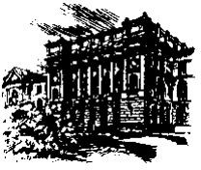

**Методы анизотропной и пороговой статистической фильтрации**

## Расчетное задание №3 по курсу

Цифровая обработка и передача многомерных сигналов



Выполнил: студент группы 43504/2, Лелюхин Д.О.

Руководитель: Сараджишвили С.Э.

Санкт-Петербург 2019

# Задание

Есть исходная матрица:

|  |  |  |  |  |  |  |  |  |  |  |  |  |
| --- | --- | --- | --- | --- | --- | --- | --- | --- | --- | --- | --- | --- |
| 0 | 9 | 18 | 15 | 27 | 24 | 16 | 19 | 11 | 5 | 10 | 0 | 0 |
| 12 | 21 | 26 | 45 | 50 | 53 | 79 | 51 | 39 | 30 | 8 | 12 | 8 |
| 19 | 36 | 57 | 78 | 100 | 105 | 124 | 131 | 82 | 80 | 57 | 23 | 14 |
| 28 | 53 | 91 | 113 | 107 | 160 | 160 | 125 | 137 | 80 | 53 | 58 | 16 |
| 23 | 57 | 102 | 151 | 133 | 171 | 220 | 188 | 162 | 149 | 85 | 63 | 44 |
| 29 | 82 | 109 | 144 | 162 | 217 | 261 | 270 | 195 | 129 | 146 | 96 | 30 |
| 13 | 77 | 119 | 161 | 175 | 221 | 323 | 272 | 290 | 230 | 152 | 174 | 107 |
| 6 | 80 | 116 | 143 | 194 | 249 | 357 | 330 | 242 | 233 | 177 | 188 | 97 |
| 6 | 54 | 99 | 125 | 147 | 209 | 293 | 311 | 264 | 158 | 143 | 183 | 113 |
| 0 | 37 | 75 | 88 | 133 | 139 | 268 | 243 | 142 | 171 | 101 | 124 | 81 |
| 0 | 17 | 47 | 75 | 95 | 111 | 137 | 226 | 153 | 95 | 108 | 141 | 121 |
| 0 | 9 | 37 | 34 | 60 | 92 | 126 | 139 | 151 | 131 | 95 | 106 | 77 |
| 0 | 0 | 15 | 20 | 52 | 41 | 78 | 113 | 80 | 104 | 75 | 52 | 42 |
| 0 | 0 | 12 | 12 | 15 | 46 | 31 | 48 | 40 | 55 | 35 | 0 | 0 |

В нее вносятся две точечные помехи:

|  |  |  |  |  |  |  |  |  |  |  |  |  |
| --- | --- | --- | --- | --- | --- | --- | --- | --- | --- | --- | --- | --- |
| 0 | 9 | 18 | 15 | 27 | 24 | 16 | 19 | 11 | 5 | 10 | 0 | 0 |
| 12 | 21 | 26 | 45 | 50 | 53 | 79 | 51 | 39 | 30 | 8 | 12 | 8 |
| 19 | 36 | 57 | 78 | 100 | 105 | 124 | 131 | 82 | 80 | 57 | 23 | 14 |
| 28 | 53 | 91 | 113 | 107 | 160 | 160 | 125 | 137 | 80 | 53 | 58 | 16 |
| 23 | 57 | 102 | 151 | 133 | 171 | 220 | 188 | 162 | 149 | 85 | 63 | 44 |
| 29 | 82 | 109 | 144 | **400** | 217 | 261 | 270 | 195 | 129 | 146 | 96 | 30 |
| 13 | 77 | 119 | 161 | 175 | 221 | 323 | 272 | 290 | 230 | 152 | 174 | 107 |
| 6 | 80 | 116 | 143 | 194 | 249 | 357 | 330 | **450** | 233 | 177 | 188 | 97 |
| 6 | 54 | 99 | 125 | 147 | 209 | 293 | 311 | 264 | 158 | 143 | 183 | 113 |
| 0 | 37 | 75 | 88 | 133 | 139 | 268 | 243 | 142 | 171 | 101 | 124 | 81 |
| 0 | 17 | 47 | 75 | 95 | 111 | 137 | 226 | 153 | 95 | 108 | 141 | 121 |
| 0 | 9 | 37 | 34 | 60 | 92 | 126 | 139 | 151 | 131 | 95 | 106 | 77 |
| 0 | 0 | 15 | 20 | 52 | 41 | 78 | 113 | 80 | 104 | 75 | 52 | 42 |
| 0 | 0 | 12 | 12 | 15 | 46 | 31 | 48 | 40 | 55 | 35 | 0 | 0 |

Необходимо обработать матрицу с помехами двумя способами:

1. методом анизотропной фильтрации:
$$\frac{1}{22} \left(\begin{matrix}2 & 3 & 2 \\ 2 & 4 & 2 \\ 2 & 3 & 2\end{matrix}\right)$$

2. методом статистической пороговой фильтрации:

m = 1.25, N = 3

В обоих способах используется нерекурентная фильтрация.

Крайние элементы отбрасываются (не обрабатываются).

Результаты фильтрации представить таблично и графически.

# Текст программы

Программы для вычисления реакции системы написаны на языке С++ 11, в среде разработки Qt Creator 5.9.2. Программа для визуализации данных написана с использованием среды MatLab R2016a.

## **1) Применение фильтров к зашумленному сигналу**

#include <stdio.h>

#include <math.h>

#define ROW 14 // n2 = ROW - i

#define COL 13 // n1 = j + 1

#define WINDOW_SIZE 3

void PrintMatrix(FILE* file, int* matrix[], const char* name)

{

fprintf(file, "======= Matrix %s =======\n", name);

for(int i = 0; i < ROW; i++)

{

for(int j = 0; j < COL; j++)

{

fprintf(file, "%d\t", matrix[i * COL + j]);

}

fprintf(file, "\n");

}

fprintf(file, "\n\n");

}

void main(void)

{

// [n1][n2] [n1][n2]

// in signal without noise: [5][4] = 162, [7][8] = 242

const int signal_noise[14][13] =

{{ 0, 9, 18, 15, 27, 24, 16, 19, 11, 5, 10, 0, 0 },

{ 12, 21, 26, 45, 50, 53, 79, 51, 39, 30, 8, 12, 8 },

{ 19, 36, 57, 78, 100, 105, 124, 131, 82, 80, 57, 23, 14 },

{ 28, 53, 91, 113, 107, 160, 160, 125, 137, 80, 53, 58, 16 },

{ 23, 57, 102, 151, 133, 171, 220, 188, 162, 149, 85, 63, 44 },

{ 29, 82, 109, 144, 400, 217, 261, 270, 195, 129, 146, 96, 30 },

{ 13, 77, 119, 161, 175, 221, 323, 272, 290, 230, 152, 174, 107 },

{ 6, 80, 116, 143, 194, 249, 357, 330, 450, 233, 177, 188, 97 },

{ 6, 54, 99, 125, 147, 209, 293, 311, 264, 158, 143, 183, 113 },

{ 0, 37, 75, 88, 133, 139, 268, 243, 142, 171, 101, 124, 81 },

{ 0, 17, 47, 75, 95, 111, 137, 226, 153, 95, 108, 141, 121 },

{ 0, 9, 37, 34, 60, 92, 126, 139, 151, 131, 95, 106, 77 },

{ 0, 0, 15, 20, 52, 41, 78, 113, 80, 104, 75, 52, 42 },

{ 0, 0, 12, 12, 15, 46, 31, 48, 40, 55, 35, 0, 0 }};

int filter[3][3] = {{2, 3, 2},

{2, 4, 2},

{2, 3, 2}};

const int amount = 22;

const double m = 1.25;

double nu = 0.0;

int signal[14][13];

int delta[14][13];

FILE* file = fopen("../results/rash3.xls", "w");

// anisotropic filter

for(int i = 0; i < ROW; i++)

{

for(int j = 0; j < COL; j++)

{

signal[i][j] = 0;

delta[i][j] = 0;

}

}

for(int i = 0; i < ROW; i++)

{

for(int j = 0; j < COL; j++)

{

if(i == 0 || i == ROW - 1 || j == 0 || j == COL - 1)

{

signal[i][j] = signal_noise[i][j];

}

else

{

int sg = 0;

for(int k1 = 0; k1 < WINDOW_SIZE; k1++)

{

for(int k2 = 0; k2 < WINDOW_SIZE; k2++)

{

sg += filter[k1][k2] * signal_noise[i - 1 + k1][j - 1 + k2];

}

}

signal[i][j] = sg / amount;

}

}

}

for(int i = 0; i < ROW; i++)

{

for(int j = 0; j < COL; j++)

{

delta[i][j] = signal_noise[i][j] - signal[i][j];

}

}

fprintf(file, "Anisotropic filter\n\n");

PrintMatrix(file, (int**)signal_noise, "Signal-noise");

PrintMatrix(file, (int**)signal, "Signal");

PrintMatrix(file, (int**)delta, "Delta (Signal-noise - Signal)");

fprintf(file, "\n\n");

// statistic filter (nu = m * sigma)

for(int i = 0; i < ROW; i++)

{

for(int j = 0; j < COL; j++)

{

signal[i][j] = 0;

delta[i][j] = 0;

}

}

for(int i = 0; i < ROW; i++)

{

for(int j = 0; j < COL; j++)

{

int sum1 = 0;

double sum2 = 0.0;

for(int k1 = 0; k1 < WINDOW_SIZE; k1++)

{

for(int k2 = 0; k2 < WINDOW_SIZE; k2++)

{

sum1 += signal_noise[i - 1 + k1][j - 1 + k2];

}

}

double G = (double)sum1 / pow((double)WINDOW_SIZE, 2);

for(int k1 = 0; k1 < WINDOW_SIZE; k1++)

{

for(int k2 = 0; k2 < WINDOW_SIZE; k2++)

{

sum2 += pow((double)signal_noise[i - 1 + k1][j - 1 + k2] - G, 2);

}

}

double D = sum2 / (pow((double)WINDOW_SIZE, 2) - 1);

nu = m * sqrt(D);

signal[i][j] = (signal_noise[i][j] - G) < nu ? signal_noise[i][j] : (int)G;

}

}

for(int i = 0; i < ROW; i++)

{

for(int j = 0; j < COL; j++)

{

delta[i][j] = signal_noise[i][j] - signal[i][j];

}

}

fprintf(file, "Statistic filter\n\n");

PrintMatrix(file, (int**)signal_noise, "Signal-noise");

PrintMatrix(file, (int**)signal, "Signal");

PrintMatrix(file, (int**)delta, "Delta (Signal-noise - Signal)");

fprintf(file, "\n\n");

fclose(file);

}

## **2) Суммирование взвешенных и сдвинутых импульсных откликов**

## **2) Построение 3D графиков реакции системы.**

function [] = filter_signals()

%% FILTER_SIGNALS

% Summary of this function goes here.

%

% * Syntax

%

% [OUTPUTARGS] = FILTER_SIGNALS(INPUTARGS)

%

% * Input

%

% -- INPUTARGS -

%

% * Output

%

% -- OUTPUTARGS -

%

% * Examples:

%

% Provide sample usage code here

%

% * See also:

%

% List related files here

%

% * Author: Dmitrii Leliuhin

% * Email: dleliuhin@mail.ru

% * Date: 04/04/2019 22:55:53

% * Version: 1.0 $

% * Requirements: PCWIN64, MatLab R2016a

%

% * Warning:

%

% # Warnings list.

%

% * TODO:

%

% # TODO list.

%

%% Code

clc;

clear all;

close all;

y.rows = 14;

y.cols = 13;

file_name_1 = '../results/rash3.xls';

file_name_2 = '../results/method_1.xls';

mat_origin = zeros(y.rows, y.cols);

mat_noise = zeros(y.rows, y.cols);

mat_anis_filt = zeros(y.rows, y.cols);

mat_diff_anis = zeros(y.rows, y.cols);

mat_stat_filt = zeros(y.rows, y.cols);

mat_diff_stat = zeros(y.rows, y.cols);

xls_range_origin = 'A23:M36';

xls_range_noise = 'A4:M17';

xls_range_1 = 'A21:M34';

xls_range_3 = 'A76:M89';

mat_origin = xlsread(file_name_2, xls_range_origin);

mat_noise = xlsread(file_name_1, xls_range_noise);

mat_anis_filt = xlsread(file_name_1, xls_range_1);

mat_stat_filt = xlsread(file_name_1, xls_range_3);

diff_anis = mat_origin - mat_anis_filt;

diff_stat = mat_origin - mat_stat_filt;

%==========================================================================

figure;

title('Noised signal 2D.', 'FontSize', 18);

surf(mat_noise);

view(2);

snapnow;

saveas(gcf, '../results/2D-view-noised', 'jpg');

figure;

title('Noised signal.', 'FontSize', 18);

surf(mat_noise)

saveas(gcf, '../results/noised', 'jpg');

%==========================================================================

%==========================================================================

figure;

title('Anisotropic filtered signal 2D.', 'FontSize', 18);

surf(mat_anis_filt);

view(2)

snapnow;

saveas(gcf, '../results/2D-view-anisotr-filter', 'jpg');

figure;

title('Anisotropic filtered signal.', 'FontSize', 18);

surf(mat_anis_filt)

saveas(gcf, '../results/anisotr-filter', 'jpg');

%==========================================================================

figure;

title('Anisotropic difference 2D.', 'FontSize', 18);

surf(diff_anis);

view(2)

snapnow;

saveas(gcf, '../results/2D-view-anisotr-diff', 'jpg');

figure;

title('Anisotropic difference.', 'FontSize', 18);

surf(diff_anis)

saveas(gcf, '../results/anisotr-diff', 'jpg');

%==========================================================================

%==========================================================================

figure;

title('Statistic filter 2D.', 'FontSize', 18);

surf(mat_stat_filt);

view(2)

snapnow;

saveas(gcf, '../results/2D-view-stat-filter', 'jpg');

figure;

title('Statistic filter.', 'FontSize', 18);

surf(mat_stat_filt)

saveas(gcf, '../results/stat-filter', 'jpg');

%==========================================================================

figure;

title('Statistic difference 2D.', 'FontSize', 18);

surf(diff_stat);

view(2)

snapnow;

saveas(gcf, '../results/2D-view-stat-diff', 'jpg');

figure;

title('Statistic difference.', 'FontSize', 18);

surf(diff_stat)

saveas(gcf, '../results/stat-diff', 'jpg');

%==========================================================================

save('../results/workspace.mat');

close all;

end

# Результаты

## **обработка на основе анизотропного фильтра**

Матрица до применения фильтра:

|  |  |  |  |  |  |  |  |  |  |  |  |  |
| --- | --- | --- | --- | --- | --- | --- | --- | --- | --- | --- | --- | --- |
| 0 | 9 | 18 | 15 | 27 | 24 | 16 | 19 | 11 | 5 | 10 | 0 | 0 |
| 12 | 21 | 26 | 45 | 50 | 53 | 79 | 51 | 39 | 30 | 8 | 12 | 8 |
| 19 | 36 | 57 | 78 | 100 | 105 | 124 | 131 | 82 | 80 | 57 | 23 | 14 |
| 28 | 53 | 91 | 113 | 107 | 160 | 160 | 125 | 137 | 80 | 53 | 58 | 16 |
| 23 | 57 | 102 | 151 | 133 | 171 | 220 | 188 | 162 | 149 | 85 | 63 | 44 |
| 29 | 82 | 109 | 144 | **400** | 217 | 261 | 270 | 195 | 129 | 146 | 96 | 30 |
| 13 | 77 | 119 | 161 | 175 | 221 | 323 | 272 | 290 | 230 | 152 | 174 | 107 |
| 6 | 80 | 116 | 143 | 194 | 249 | 357 | 330 | **450** | 233 | 177 | 188 | 97 |
| 6 | 54 | 99 | 125 | 147 | 209 | 293 | 311 | 264 | 158 | 143 | 183 | 113 |
| 0 | 37 | 75 | 88 | 133 | 139 | 268 | 243 | 142 | 171 | 101 | 124 | 81 |
| 0 | 17 | 47 | 75 | 95 | 111 | 137 | 226 | 153 | 95 | 108 | 141 | 121 |
| 0 | 9 | 37 | 34 | 60 | 92 | 126 | 139 | 151 | 131 | 95 | 106 | 77 |
| 0 | 0 | 15 | 20 | 52 | 41 | 78 | 113 | 80 | 104 | 75 | 52 | 42 |
| 0 | 0 | 12 | 12 | 15 | 46 | 31 | 48 | 40 | 55 | 35 | 0 | 0 |

Матрица после применения фильтра:

|  |  |  |  |  |  |  |  |  |  |  |  |  |
| --- | --- | --- | --- | --- | --- | --- | --- | --- | --- | --- | --- | --- |
| 0 | 9 | 18 | 15 | 27 | 24 | 16 | 19 | 11 | 5 | 10 | 0 | 0 |
| 12 | 21 | 33 | 46 | 55 | 63 | 68 | 61 | 48 | 35 | 24 | 14 | 8 |
| 19 | 37 | 57 | 74 | 89 | 104 | 111 | 104 | 84 | 63 | 44 | 27 | 14 |
| 28 | 51 | 82 | 105 | 121 | 143 | 156 | 146 | 126 | 98 | 70 | 46 | 16 |
| 23 | 63 | 100 | 148 | 180 | 198 | 200 | 191 | 160 | 126 | 94 | 66 | 44 |
| 29 | 69 | 111 | 163 | 211 | 230 | 243 | 243 | 209 | 168 | 135 | 101 | 30 |
| 13 | 71 | 114 | 169 | 216 | 259 | 284 | 301 | 273 | 219 | 167 | 134 | 107 |
| 6 | 65 | 109 | 142 | 179 | 239 | 293 | 319 | 296 | 229 | 178 | 154 | 97 |
| 6 | 53 | 91 | 123 | 157 | 217 | 273 | 295 | 260 | 199 | 160 | 140 | 113 |
| 0 | 37 | 69 | 97 | 125 | 166 | 220 | 231 | 192 | 148 | 131 | 127 | 81 |
| 0 | 23 | 47 | 70 | 92 | 126 | 165 | 182 | 159 | 126 | 116 | 110 | 121 |
| 0 | 12 | 29 | 46 | 64 | 87 | 117 | 137 | 132 | 111 | 99 | 92 | 77 |
| 0 | 7 | 16 | 27 | 41 | 59 | 79 | 92 | 94 | 87 | 72 | 53 | 42 |
| 0 | 0 | 12 | 12 | 15 | 46 | 31 | 48 | 40 | 55 | 35 | 0 | 0 |

Разница матриц до и после применения фильтра:

|  |  |  |  |  |  |  |  |  |  |  |  |  |
| --- | --- | --- | --- | --- | --- | --- | --- | --- | --- | --- | --- | --- |
| 0 | 0 | 0 | 0 | 0 | 0 | 0 | 0 | 0 | 0 | 0 | 0 | 0 |
| 0 | 0 | -7 | -1 | -5 | -10 | 11 | -10 | -9 | -5 | -16 | -2 | 0 |
| 0 | -1 | 0 | 4 | 11 | 1 | 13 | 27 | -2 | 17 | 13 | -4 | 0 |
| 0 | 2 | 9 | 8 | -14 | 17 | 4 | -21 | 11 | -18 | -17 | 12 | 0 |
| 0 | -6 | 2 | 3 | -47 | -27 | 20 | -3 | 2 | 23 | -9 | -3 | 0 |
| 0 | 13 | -2 | -19 | -49 | -13 | 18 | 27 | -14 | -39 | 11 | -5 | 0 |
| 0 | 6 | 5 | -8 | -41 | -38 | 39 | -29 | 17 | 11 | -15 | 40 | 0 |
| 0 | 15 | 7 | 1 | 15 | 10 | 64 | 11 | -54 | 4 | -1 | 34 | 0 |
| 0 | 1 | 8 | 2 | -10 | -8 | 20 | 16 | 4 | -41 | -17 | 43 | 0 |
| 0 | 0 | 6 | -9 | 8 | -27 | 48 | 12 | -50 | 23 | -30 | -3 | 0 |
| 0 | -6 | 0 | 5 | 3 | -15 | -28 | 44 | -6 | -31 | -8 | 31 | 0 |
| 0 | -3 | 8 | -12 | -4 | 5 | 9 | 2 | 19 | 20 | -4 | 14 | 0 |
| 0 | -7 | -1 | -7 | 11 | -18 | -1 | 21 | -14 | 17 | 3 | -1 | 0 |
| 0 | 0 | 0 | 0 | 0 | 0 | 0 | 0 | 0 | 0 | 0 | 0 | 0 |

## **обработка на основе анизотропного фильтра**

Матрица до применения фильтра:

|  |  |  |  |  |  |  |  |  |  |  |  |  |
| --- | --- | --- | --- | --- | --- | --- | --- | --- | --- | --- | --- | --- |
| 0 | 9 | 18 | 15 | 27 | 24 | 16 | 19 | 11 | 5 | 10 | 0 | 0 |
| 12 | 21 | 26 | 45 | 50 | 53 | 79 | 51 | 39 | 30 | 8 | 12 | 8 |
| 19 | 36 | 57 | 78 | 100 | 105 | 124 | 131 | 82 | 80 | 57 | 23 | 14 |
| 28 | 53 | 91 | 113 | 107 | 160 | 160 | 125 | 137 | 80 | 53 | 58 | 16 |
| 23 | 57 | 102 | 151 | 133 | 171 | 220 | 188 | 162 | 149 | 85 | 63 | 44 |
| 29 | 82 | 109 | 144 | **400** | 217 | 261 | 270 | 195 | 129 | 146 | 96 | 30 |
| 13 | 77 | 119 | 161 | 175 | 221 | 323 | 272 | 290 | 230 | 152 | 174 | 107 |
| 6 | 80 | 116 | 143 | 194 | 249 | 357 | 330 | **450** | 233 | 177 | 188 | 97 |
| 6 | 54 | 99 | 125 | 147 | 209 | 293 | 311 | 264 | 158 | 143 | 183 | 113 |
| 0 | 37 | 75 | 88 | 133 | 139 | 268 | 243 | 142 | 171 | 101 | 124 | 81 |
| 0 | 17 | 47 | 75 | 95 | 111 | 137 | 226 | 153 | 95 | 108 | 141 | 121 |
| 0 | 9 | 37 | 34 | 60 | 92 | 126 | 139 | 151 | 131 | 95 | 106 | 77 |
| 0 | 0 | 15 | 20 | 52 | 41 | 78 | 113 | 80 | 104 | 75 | 52 | 42 |
| 0 | 0 | 12 | 12 | 15 | 46 | 31 | 48 | 40 | 55 | 35 | 0 | 0 |

Матрица после применения фильтра:

|  |  |  |  |  |  |  |  |  |  |  |  |  |
| --- | --- | --- | --- | --- | --- | --- | --- | --- | --- | --- | --- | --- |
| 0 | 9 | 18 | 15 | 27 | 24 | 16 | 19 | 11 | 5 | 10 | 0 | 0 |
| 12 | 21 | 26 | 45 | 50 | 53 | 79 | 51 | 39 | 30 | 8 | 12 | 8 |
| 19 | 36 | 57 | 78 | 100 | 105 | 124 | 131 | 82 | 80 | 57 | 23 | 14 |
| 28 | 53 | 91 | 113 | 107 | 160 | 160 | 125 | 137 | 80 | 53 | 58 | 16 |
| 23 | 57 | 102 | 151 | 133 | 171 | 220 | 188 | 162 | 149 | 85 | 63 | 44 |
| 29 | 82 | 109 | 144 | 197 | 217 | 261 | 270 | 195 | 129 | 146 | 96 | 30 |
| 13 | 77 | 119 | 161 | 175 | 221 | 323 | 272 | 290 | 230 | 152 | 174 | 107 |
| 6 | 80 | 116 | 143 | 194 | 249 | 285 | 330 | 282 | 233 | 177 | 188 | 97 |
| 6 | 54 | 99 | 125 | 147 | 209 | 293 | 311 | 264 | 158 | 143 | 183 | 113 |
| 0 | 37 | 75 | 88 | 133 | 139 | 268 | 243 | 142 | 171 | 101 | 124 | 81 |
| 0 | 17 | 47 | 75 | 95 | 111 | 137 | 226 | 153 | 95 | 108 | 106 | 121 |
| 0 | 9 | 37 | 34 | 60 | 92 | 126 | 139 | 151 | 131 | 95 | 106 | 77 |
| 0 | 0 | 15 | 20 | 52 | 41 | 78 | 113 | 80 | 104 | 75 | 52 | 42 |
| 0 | 0 | 12 | 12 | 15 | 46 | 31 | 48 | 40 | 55 | 35 | 0 | 0 |

Разница матриц до и после применения фильтра:

|  |  |  |  |  |  |  |  |  |  |  |  |  |
| --- | --- | --- | --- | --- | --- | --- | --- | --- | --- | --- | --- | --- |
| 0 | 0 | 0 | 0 | 0 | 0 | 0 | 0 | 0 | 0 | 0 | 0 | 0 |
| 0 | 0 | 0 | 0 | 0 | 0 | 0 | 0 | 0 | 0 | 0 | 0 | 0 |
| 0 | 0 | 0 | 0 | 0 | 0 | 0 | 0 | 0 | 0 | 0 | 0 | 0 |
| 0 | 0 | 0 | 0 | 0 | 0 | 0 | 0 | 0 | 0 | 0 | 0 | 0 |
| 0 | 0 | 0 | 0 | 0 | 0 | 0 | 0 | 0 | 0 | 0 | 0 | 0 |
| 0 | 0 | 0 | 0 | -35 | 0 | 0 | 0 | 0 | 0 | 0 | 0 | 0 |
| 0 | 0 | 0 | 0 | 0 | 0 | 0 | 0 | 0 | 0 | 0 | 0 | 0 |
| 0 | 0 | 0 | 0 | 0 | 0 | 72 | 0 | -40 | 0 | 0 | 0 | 0 |
| 0 | 0 | 0 | 0 | 0 | 0 | 0 | 0 | 0 | 0 | 0 | 0 | 0 |
| 0 | 0 | 0 | 0 | 0 | 0 | 0 | 0 | 0 | 0 | 0 | 0 | 0 |
| 0 | 0 | 0 | 0 | 0 | 0 | 0 | 0 | 0 | 0 | 0 | 35 | 0 |
| 0 | 0 | 0 | 0 | 0 | 0 | 0 | 0 | 0 | 0 | 0 | 0 | 0 |
| 0 | 0 | 0 | 0 | 0 | 0 | 0 | 0 | 0 | 0 | 0 | 0 | 0 |
| 0 | 0 | 0 | 0 | 0 | 0 | 0 | 0 | 0 | 0 | 0 | 0 | 0 |

## **Графическое представление выходного сигнала**

Графики построены в среде MatLab R2016a.

Вид сигнала до применения фильтров (сигнал с шумом):

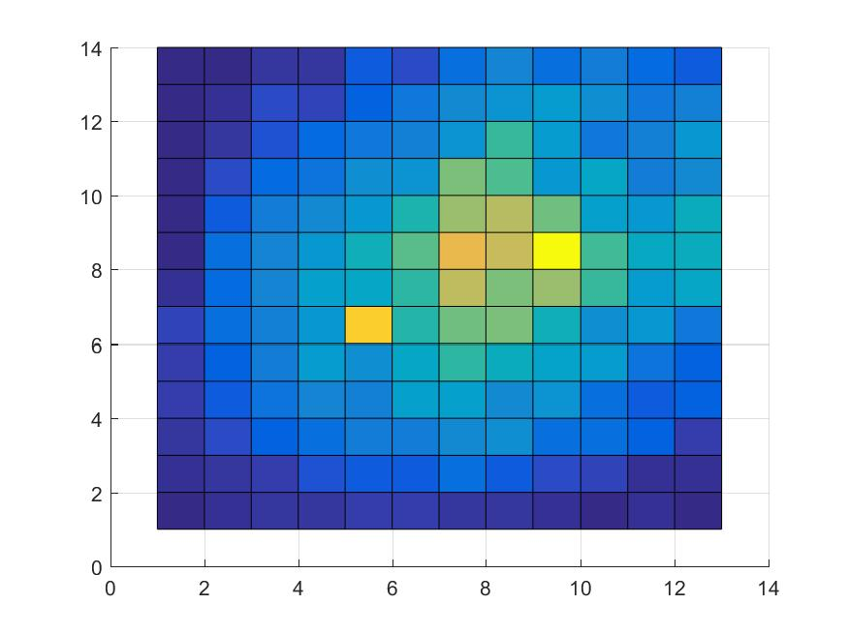

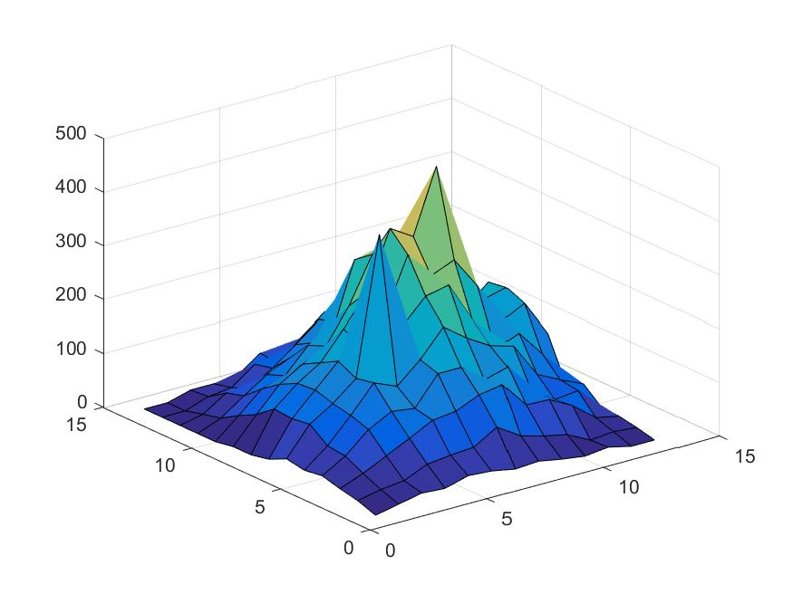

Вид сигнала после применения анизотропного фильтра:

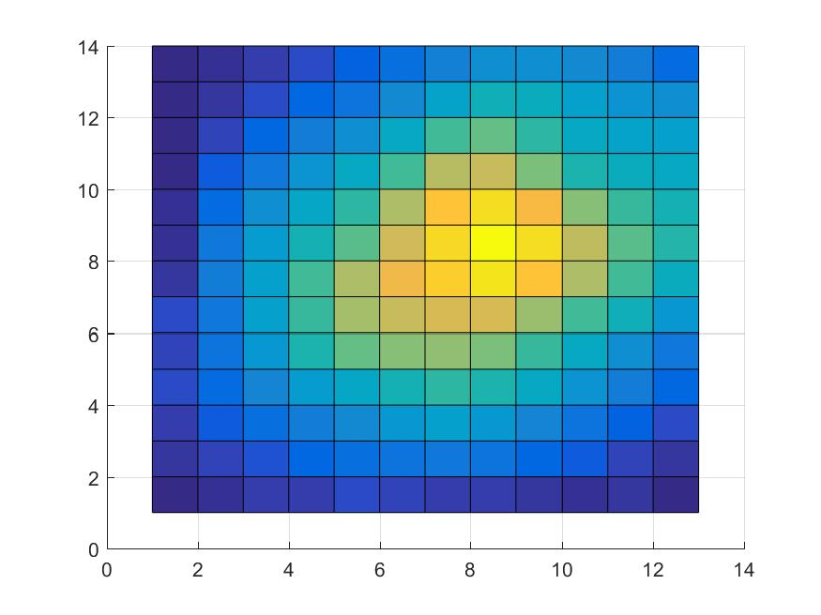

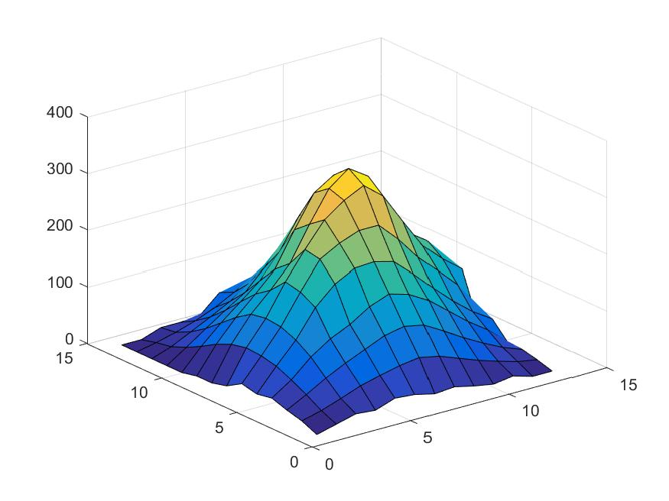

Разница между сигналом без шума и сигналом после применения

анизотропного фильтра:

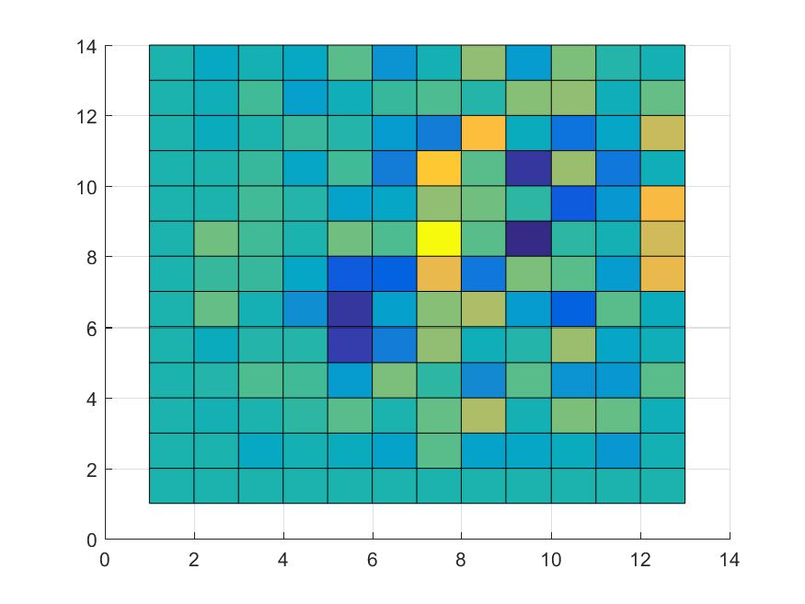

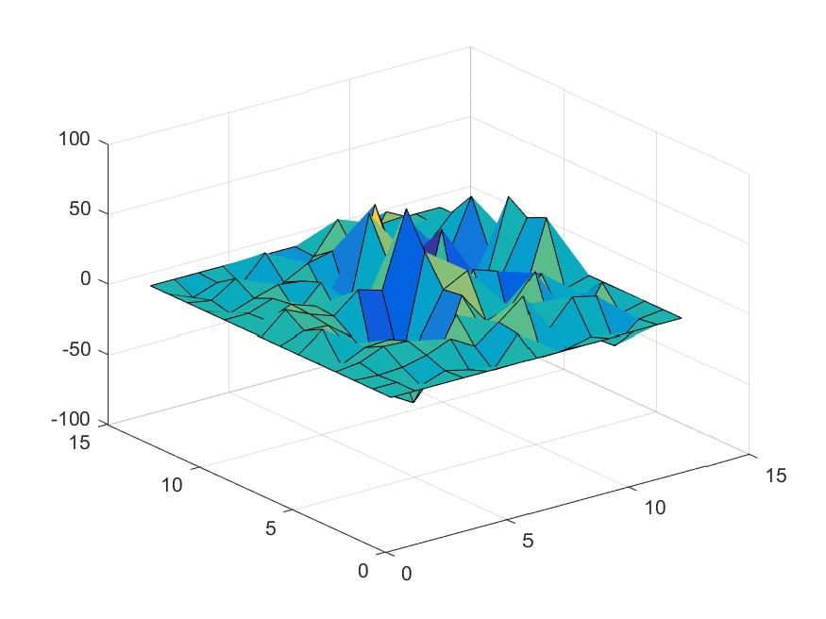

Вид сигнала после применения статистического порогового фильтра:

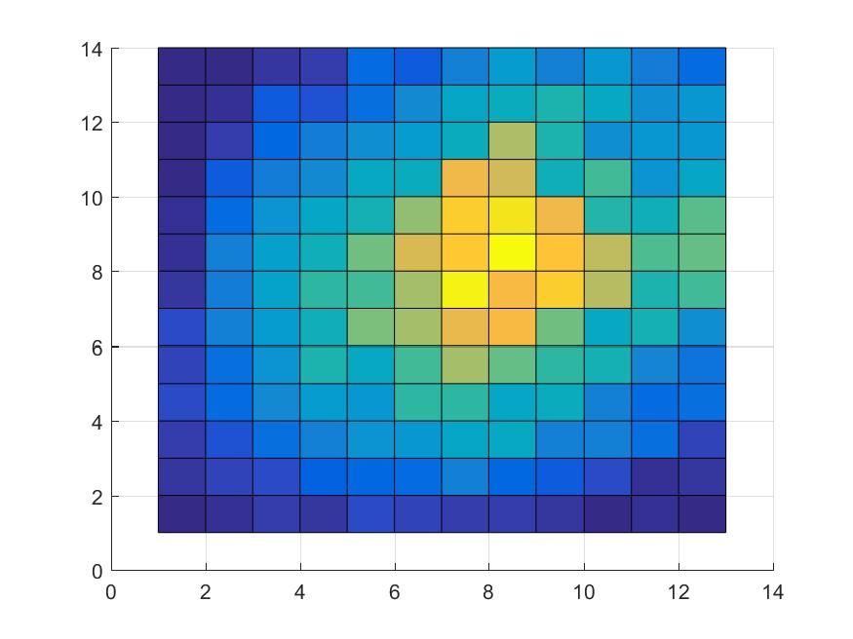

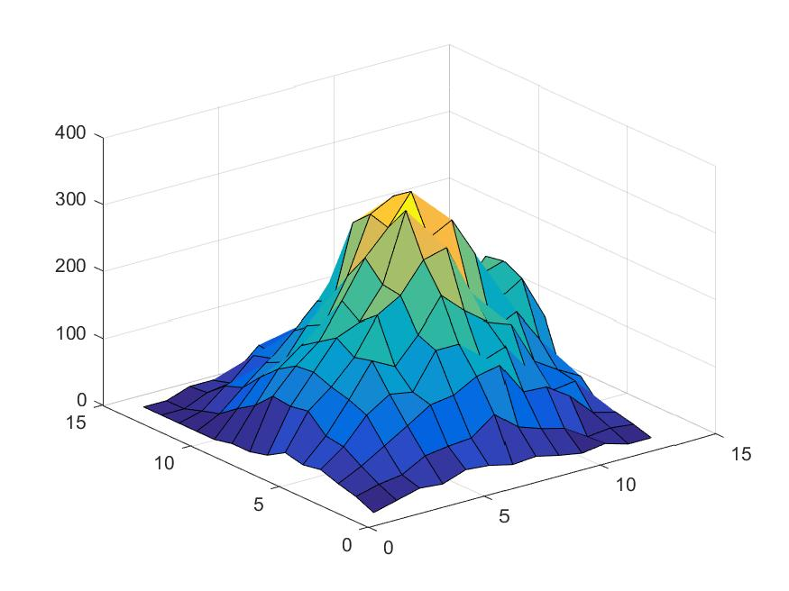

Разница между сигналом без шума и сигналом после применения

статистического фильтра:

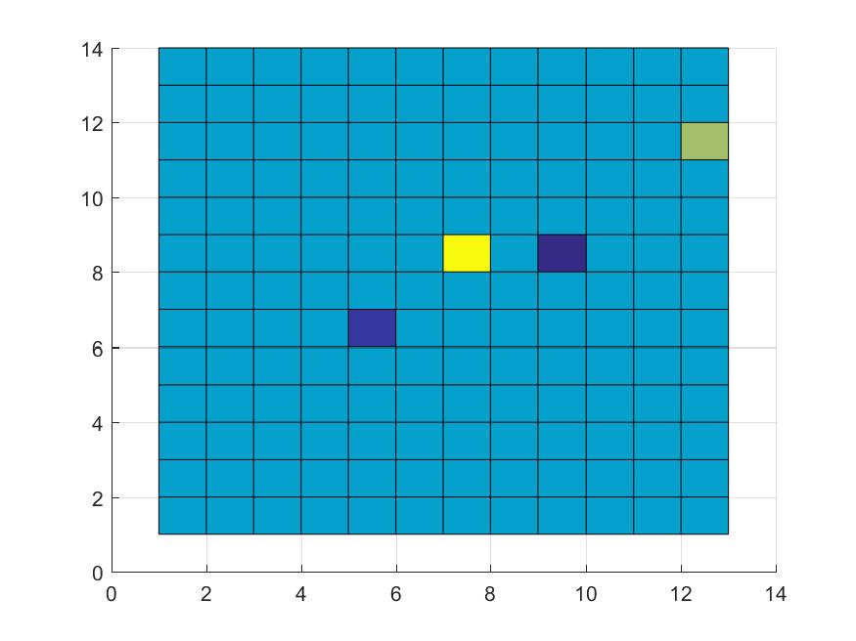

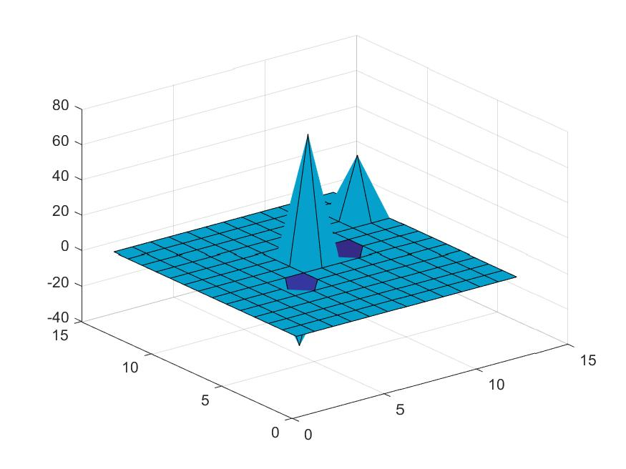

# Выводы

Как видно из графиков и таблиц применение статистической пороговой фильтрации дало лучшие результаты, чем анизотропный фильтр для данного сигнала и характера внесенных помех.