 Sebastopol Peaceful Air Effort 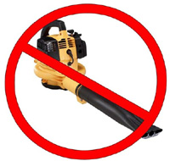

I support the work of the Sebastopol Peaceful Air Effort and the Sebastopol City Council to create and implement a city ordinance to effectively restrict the use of leaf blowers in order to prevent hazardous air and noise pollution.

Name Signature ZIP e-mail address (optional)*

_________________________________________________________________________________________________

_________________________________________________________________________________________________
_________________________________________________________________________________________________
_________________________________________________________________________________________________
_________________________________________________________________________________________________
__________________________________________________________________________________________________________________________________________________________________________________________________
_________________________________________________________________________________________________
_________________________________________________________________________________________________
_________________________________________________________________________________________________

* Please provide your e-mail address if you would like to be updated by us no more than four times a year.
We will never trade or sell your e-mail information.

Send completed forms to:
Sebastopol Peaceful Air Effort, c/o Progressive Source Communications
145 Pleasant Hill Ave N Ste 203, Sebastopol CA 95472
Or via fax: 707-824-4880

