CPE301 – SPRING 2023

Design Assignment 2

Student Name: David Lenzin

Student #: 2001654470

Student Email: lenzin@unlv.nevada.edu

Primary Github address: <https://github.com/dlenzin15/submissions>

Directory: submissions/DA2

Submit the following for all Labs:

1. In the document, for each task submit the modified or included code (only) with highlights and justifications of the modifications. Also, include the comments.
2. Use the previously create a Github repository with a random name (no CPE/301, Lastname, Firstname). Place all labs under the root folder ESD301/DA, sub-folder named LABXX, with one document and one video link file for each lab, place modified asm/c files named as LabXX-TYY.asm/c.
3. If multiple asm/c files or other libraries are used, create a folder LabXX-TYY and place these files inside the folder.
4. The folder should have a) Word document (see template), b) source code file(s) and other include files, c) text file with youtube video links (see template).

1. **COMPONENTS LIST AND CONNECTION BLOCK DIAGRAM w/ PINS**

Atmega328PB board was used. No other hardware was introduced. See schematic below for pin layout.

1. **INITIAL/MODIFIED/DEVELOPED CODE OF TASK 2**

Insert initial code here:

C Code:

|  |
| --- |
| /*  * DA2_Task2_C.c  *  * Created: 3/6/2023 7:29:13 PM  * Author : david  */  #define *F_CPU* 16000000UL  #include <avr/io.h>  #include <util/delay.h>  int main(void)  {  DDRC &= ~(1<<1); //Set PC5 to an input, which is connected to switch 1  PORTC |= (1<<1); //Pull-up resistor    DDRB |= (1<<5); //Set PB5 as an output, which is connected to LED  PORTB |= (1<<5); //Initially turn LED off  while (1)  {  if (!(PINC & (1 << 1))) { //If switch is pressed  PORTB &= ~(1 << 5); //Turn on LED  *_delay_ms*(1750); //Delay for 1.75 seconds  PORTB |= (1 << 5); //Turn off the LED  }  PORTB |= (1 << 5); //Keep the LED to off if button not pressed  }  } |

Compilation:

Waveform:

Assembly Code:

|  |
| --- |
| ;  ; DA2_Task2_Assembly.asm  ;  ; Created: 3/6/2023 9:39:36 PM  ; Author : david  ;  .include "m328pbdef.inc" ; Include the header file for the Atmega328PB board  ldi r16, (1<<5)  out DDRB, r16 ; Set PB5 as an output  out PORTB, r16 ; Initially turn off the LED  loop:  sbis PINC, 1 ; check if switch at PC1 is pressed  rjmp led_on ; jump to button_pressed if it is  rjmp loop ; Loop forever  led_on:  ldi r16, ~(1<<5) ; Turn on the LED  out PORTB, r16  rjmp delay ; Jump to delay function  delay: ; Delay function to generate a delay of 1.75 seconds  ldi r21, 143  ldi r22, 12  ldi r23, 66  L1: dec r23  brne L1  dec r22  brne L1  dec r21  brne L1    ldi r16, (1<<5) ; Turn off the LED  out PORTB, r16  rjmp loop ; Return to loop |

Compilation:

Waveform:

1. **DEVELOPED MODIFIED CODE OF TASK 3**

Insert only the modified sections here

C Code:

|  |
| --- |
| /*  * DA2_Task3_C.c  *  * Created: 3/6/2023 8:36:47 PM  * Author : david  */  #define *F_CPU* 16000000UL  #include <avr/io.h>  #include <util/delay.h>  #include <avr/interrupt.h>  ISR(INT0_vect) {  PORTB &= ~(1<<5); //Turn LED on  *_delay_ms*(3500); //Delay for 3.5 seconds  PORTB |= (1<<5); //Turn LED off  }  int main(void)  {  PORTD |= (1<<2); //Activate Pull-up resistor for INT0 pin    DDRB |= (1<<5); //Set PB5 as an output, which is connected to LED  PORTB |= (1<<5); //Initially turn LED off    EIMSK = (1 << INT0); //Enable interrupts on external pin INT0  EICRA = 0x03; //The rising edge of INT0 generate an interrupt request  sei(); //Enable interrupts    while (1);  } |

Compilation:

Waveform:

Assembly:

|  |
| --- |
| ;  ; DA2_Task3_Assembly.asm  ;  ; Created: 3/7/2023 9:04:30 PM  ; Author : david  ;  .equ F_CPU = 16000000  .include "m328pbdef.inc" ;Include the header file  .org 0x0000  jmp main  .org 0x0002 ; External interrupt request 0 vector  jmp INT0_ISR  main:  ldi r16, (1<<5)  out DDRB, r16 ; Set PB5 as an output  out PORTB, r16 ; Initially turn off the LED  ldi r17, (1<<2)  OUT PORTD, r17 ; Pull up for INTO pin  ldi r18, (1<<INT0) ; load the bit mask for INT0 into r16  out EIMSK, r18 ; enable interrupts on external pin INT0    ldi r18, 0x03 ; load the value 0x03 into r16  sts EICRA, r18 ; set the rising edge of INT0 to generate an interrupt request  sei ; enable interrupts globally  loop:  rjmp loop ; Infinite Loop  INT0_ISR:  ldi r16, ~(1<<5) ; Turn on the LED  out PORTB, r16    ; Delay loops to generate a delay of 3.5 seconds  ldi r21, 2  ldi r22, 29  ldi r23, 23  ldi r24, 133  L1: dec r24  brne L1  dec r23  brne L1  dec r22  brne L1  dec r21  brne L1    ldi r16, (1<<5) ; Turn off the LED  out PORTB, r16  reti ; Return from Interrupt |

Compilation:

Waveform:

1. **SCHEMATICS**

**Task 2:**

**Task 3:**

1. **SCREENSHOT OF EACH DEMO (BOARD SETUP)**

Task 2:

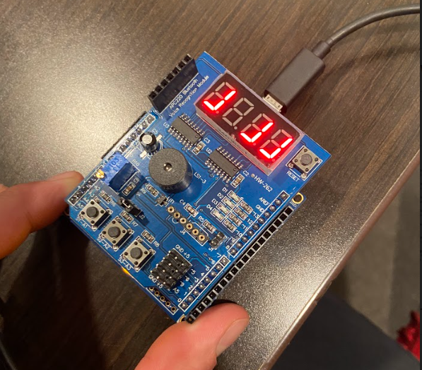

Task 3:

1. **VIDEO LINKS OF EACH DEMO**

Link to Playlist: <https://www.youtube.com/playlist?list=PLlHKEZIJ23uAW9Wtslh2ZcF6vdceCNBiI>

Link to Task 2 C: <https://youtu.be/OvwKFsnboKM>

Link to Task 2 Assembly: <https://youtu.be/ozF4z_ViWo8>

Link to Task 3 C: <https://youtu.be/cus2H9IzRUw>

Link to Task 3 Assembly: <https://youtu.be/A67nv6LcItk>

1. **GITHUB LINK OF THIS DA**

<https://github.com/dlenzin15/submissions/tree/main/DA2>

**Student Academic Misconduct Policy**

<http://studentconduct.unlv.edu/misconduct/policy.html>

“This assignment submission is my own, original work”.

David Lenzin