TO DO:
Including to NASh an adaptive mechanism to avoid decreasing parameters for temperature, exploration, transfering.

Tests varying learning rate (alpha)

e-greedy with incremental learning rate

RL.param.alpha = 0.5; % 0.3-0.5 learning rate
RL.param.gamma = 1; % discount factor
RL.param.lambda = 0.9; % the decaying elegibiliy trace parameter
epsilon0 = 1; % probability of a random action selection
p0 = 1;
temp0 = conf.boltzmann;
alpha0 = 1;%RL.param.alpha;

if conf.TRANSFER<0 %Para pruebas de performance
epsilon0 = 0;
p0 = 0;
end

EXPLORATION = conf.episodes/conf.EXPL_EPISODES_FACTOR;
epsDec = -log(0.05) * 1/EXPLORATION; %epsilon decrece a un 5% (0.005) en maxEpisodes cuartos (maxepisodes/4), de esta manera el decrecimiento de epsilon es independiente del numero de episodios
epsDec2 = -log(0.10) * 1/EXPLORATION; %epsilon decrece a un 10% (0.1) en maxEpisodes cuartos (maxepisodes/EXPL_EPISODES_FACTOR)
%epsDec2 = -log(0.70) * 1/EXPLORATION; %epsilon decrece a un 10% (0.1) en maxEpisodes cuartos (maxepisodes/EXPL_EPISODES_FACTOR)

RL.param.epsilon = epsilon0;
RL.param.p = p0;
RL.param.boltzmann = temp0;
RL.param.alpha2 = 1;%RL.param.alpha;

goals=0;
for i=1:conf.episodes

if conf.TRANSFER>1, RL.param.p=1; %acts greedy from source policy
elseif conf.TRANSFER == 0, RL.param.p=0; %learns from scratch
end %else Transfer from source decaying as p

[RL, Vr,ro,fi,gama,Pt,Pb,Pr,Vb,total_reward,steps,fitness_k,btd_k,Vavg_k,time,faults,goal_k] = Episode( wf, RL, States, Actions, conf);

%disp(['Epsilon:',num2str(eps),' Espisode: ',int2str(i),' Steps:',int2str(steps),' Reward:',num2str(total_reward),' epsilon: ',num2str(epsilon)])

dec = exp(-i*epsDec);
dec2 = exp(-i*epsDec2);
RL.param.epsilon = epsilon0*dec;
RL.param.p = p0*dec;
RL.param.boltzmann = temp0*dec;
RL.param.alpha2 = alpha0*(1-dec2);
%RL.param.alpha2 = alpha0*(dec2);

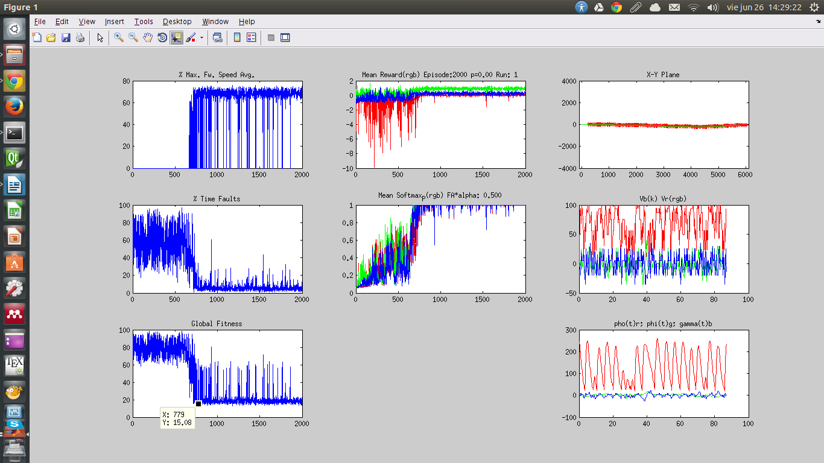
e-greedy with decremental learning rate

RL.param.alpha = 0.5; % 0.3-0.5 learning rate

alpha0 = 1;%RL.param.alpha;

epsDec2 = -log(0.80) * 1/EXPLORATION; %epsilon decrece a un 10% (0.1) en maxEpisodes cuartos (maxepisodes/EXPL_EPISODES_FACTOR)

RL.param.alpha2 = alpha0*(dec2);

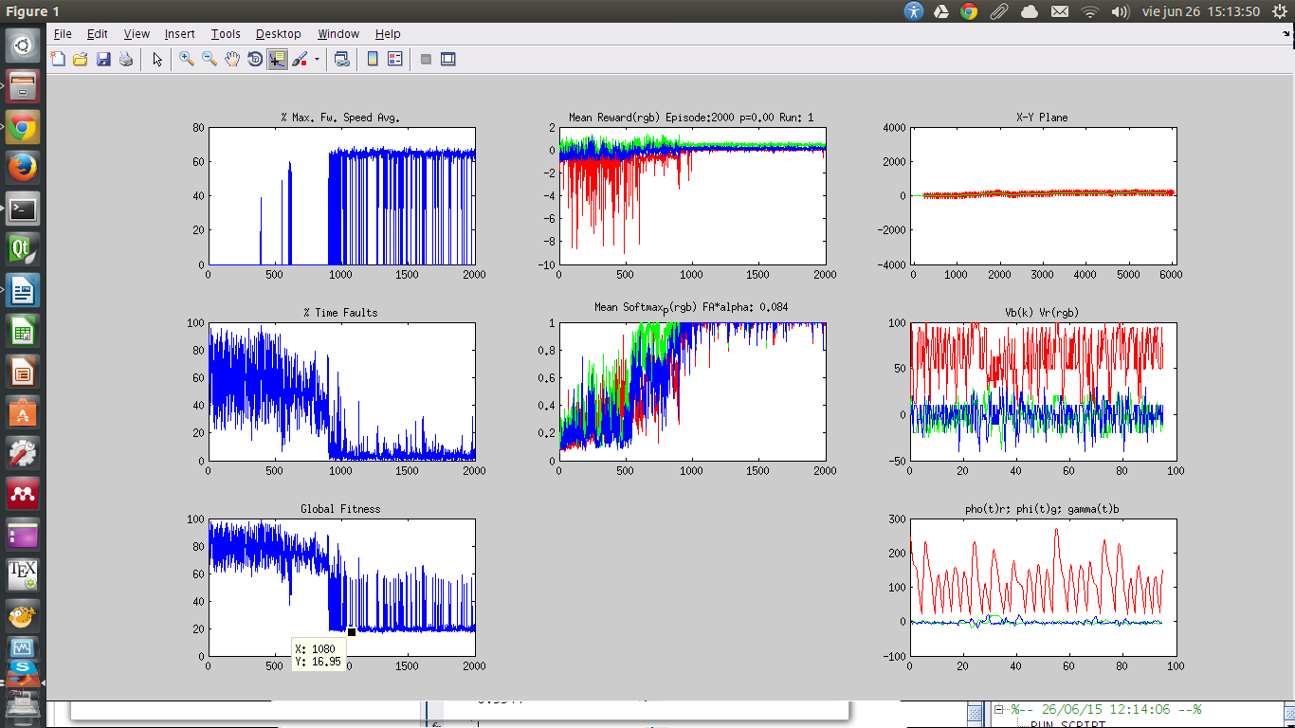

Softmax with incremental learning rate
alpha0 = 1;

epsDec2 = -log(0.10) * 1/EXPLORATION; %epsilon decrece a un 10% (0.1) en maxEpisodes cuartos (maxepisodes/EXPL_EPISODES_FACTOR)

RL.param.alpha2 = alpha0*(1-dec2);
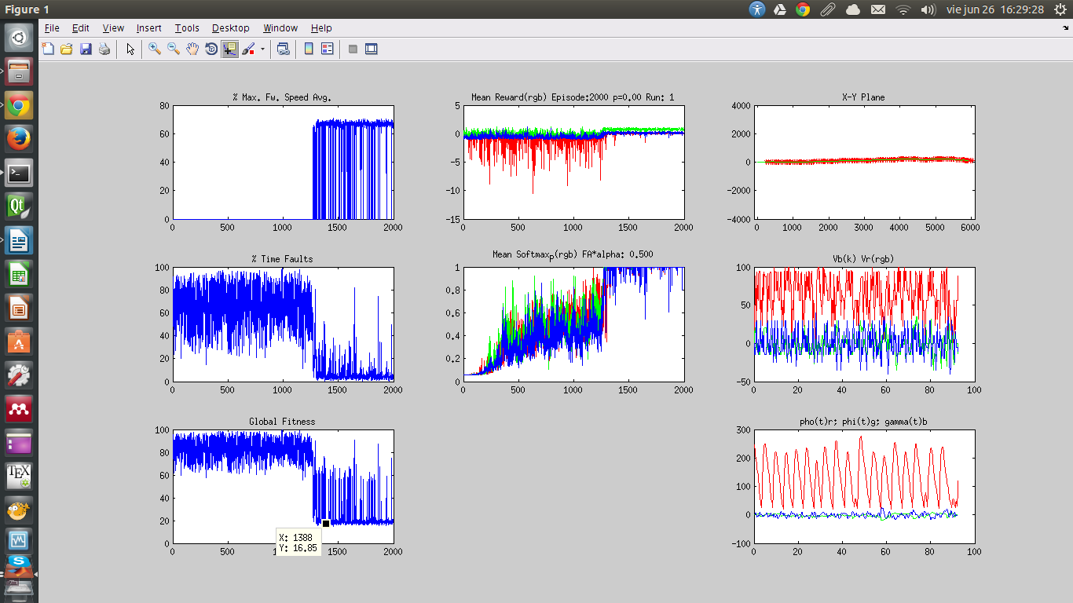

alpha0 = RL.param.alpha;

epsDec2 = -log(0.10) * 1/EXPLORATION; %epsilon decrece a un 10% (0.1) en maxEpisodes cuartos (maxepisodes/EXPL_EPISODES_FACTOR)

RL.param.alpha2 = alpha0*(1-dec2);

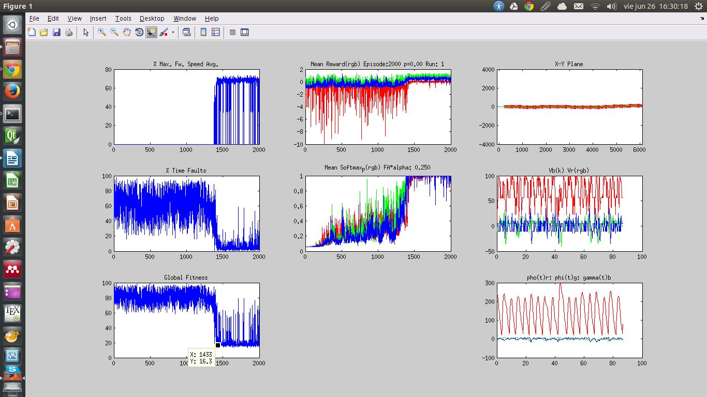

Softmax with decremental learning rate
conf.boltzmann = 20; % Boltzmann temperature (5 by default), if <= 0 e-greaddy

alpha0 = 1;%RL.param.alpha;

epsDec2 = -log(0.80) * 1/EXPLORATION;

RL.param.alpha2 = alpha0*(dec2);
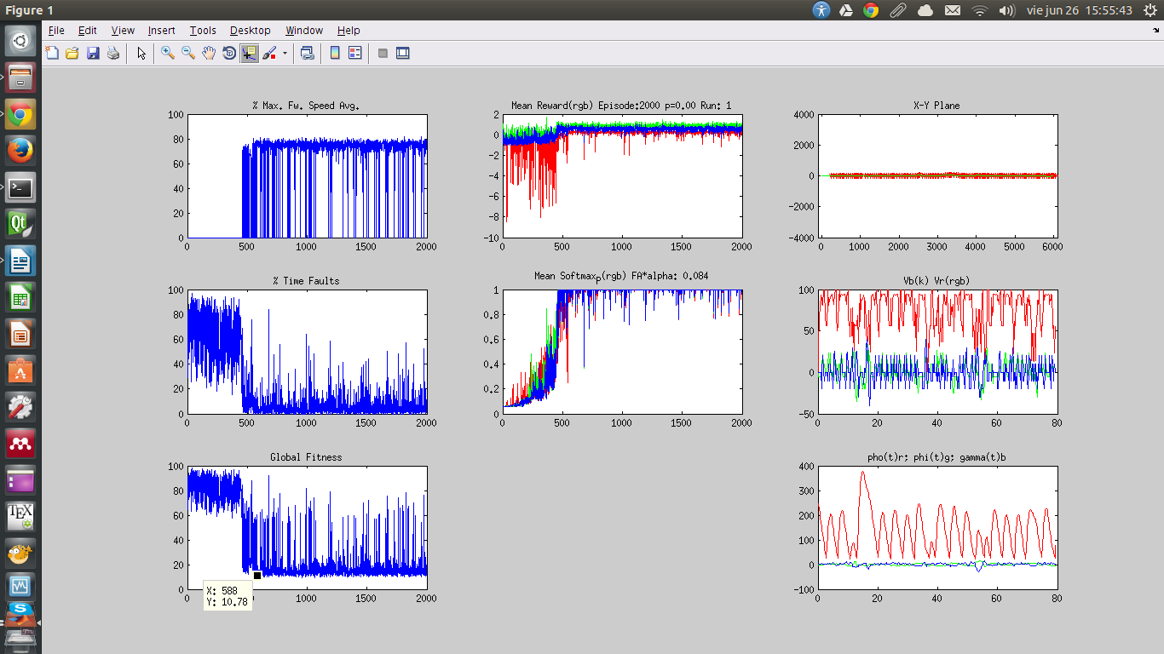

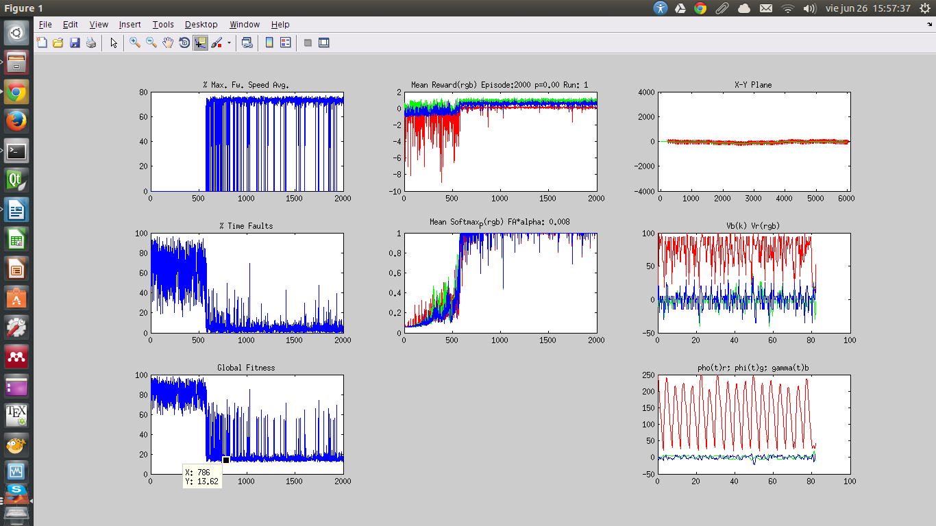
epsDec2 = -log(0.60) * 1/EXPLORATION;

Softmax with adaptive decremental learning rate

fap = 1-min([fa_x, fa_y, fa_rot]) + 0.05;
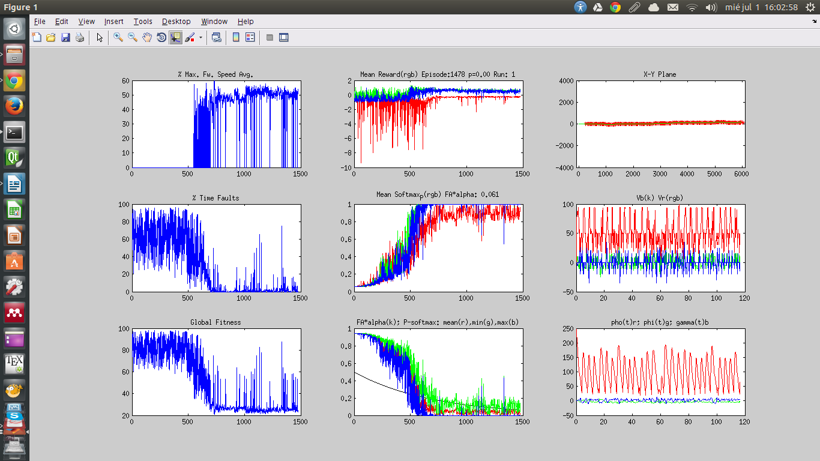

fap = 1-max([fa_x, fa_y, fa_rot]) + 0.05;
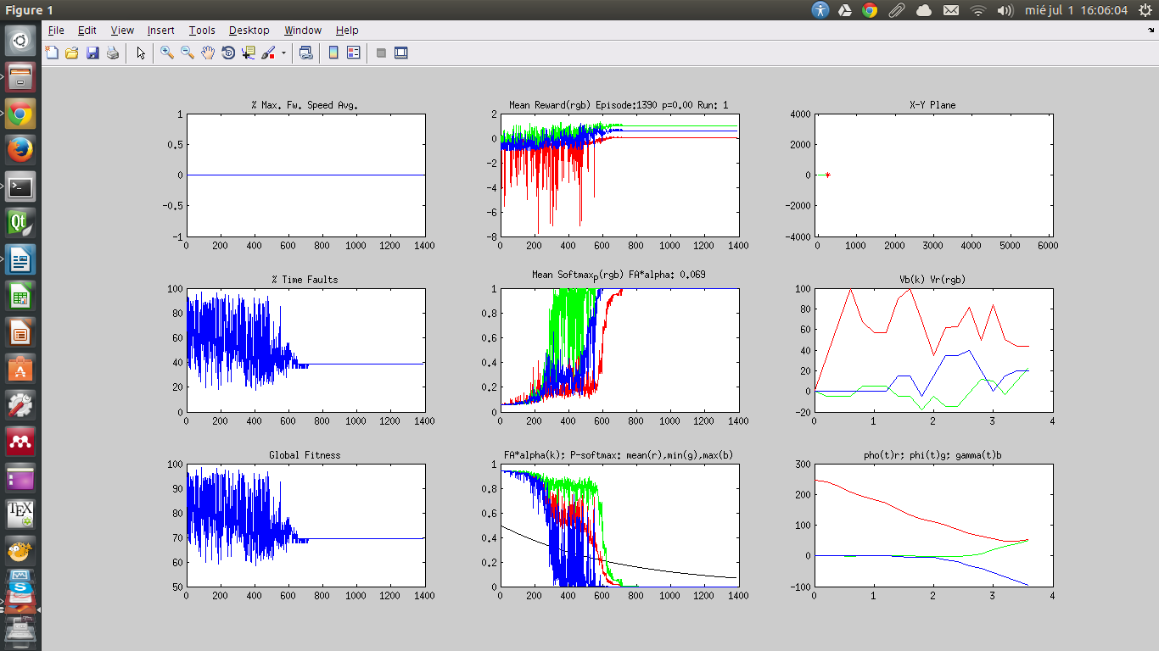
fap = 1-mean([fa_x, fa_y, fa_rot]) + 0.05;
NUNCA CONVERGE

Softmax SARSA with lenience

M=3
