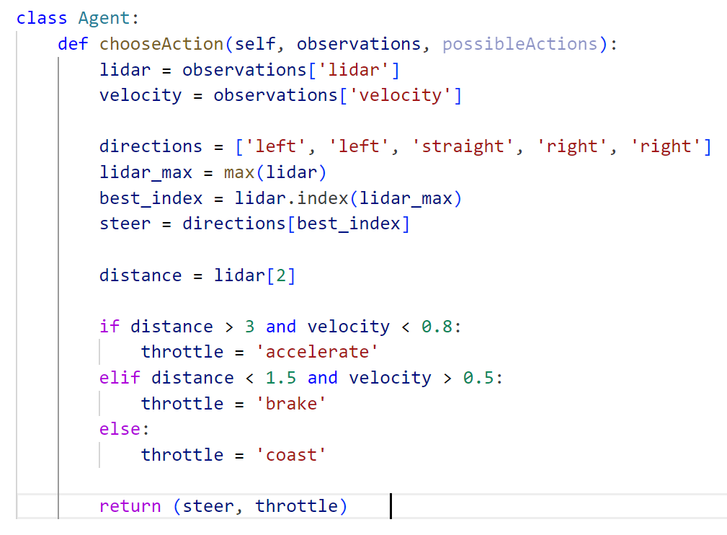

At the first trial, the average score was 33.37 with the lowest score of Oval -12.18, followed by Spiral score -3.42. So, I had chosen to focus on the game where I got a minus score. Then, I changed the coefficient of velocity. I have found that even the object was so fast that it hit the wall, it still accelerated or coasted. Therefore, I thought the object needed to accelerate at a small velocity and brake at a velocity larger than that previous velocity for acceleration and I set the velocity as 0.1. The result unfortunately didn’t show up in the leaderboard, but It really does not hit any wall in any game.

