Weekly Schedule:
8/13 to 8/20

CONFIDENTIAL

Features

Bugs

Summary Completed Tasks
For Previous Week

___________________________________________________Feature 1: ACL List
Feature Summary:
Add a separate ACL list where users can add editors, owners, and viewers in the GUI to support this

Link:
https://app.asana.com/0/1339956179101/1360974400079

Summary of Implementation:
Outgoing Quotes ACL should not be the same as Incoming Request. As a result, add a separate ACL list where users can add editors, owners, and viewers in the GUI to support this. Also, need to test versioning to make sure this works correctly as well. Also, when the OutgoingQuote is created, its ACL should be initialized so that its sole owner is the user who created it and the editors and viewers are empty

Summary of changes to frontend and backend
- Add a separate collection of views for Outgoing Quotes including: Tab in Incoming Request to create a new Outgoing Quote
- Add a ‘show’ action and view containing the quote information
- Add a ‘tools’ action and view containing utilities for an outgoing quote
- Expand sharing dialog to support outgoing quote
- Add versioning methods in the outgoing quotes model to find latest version, all version, etc
- Remove propogation from Incoming Request to Outgoing Quotes in the Sharing Machine

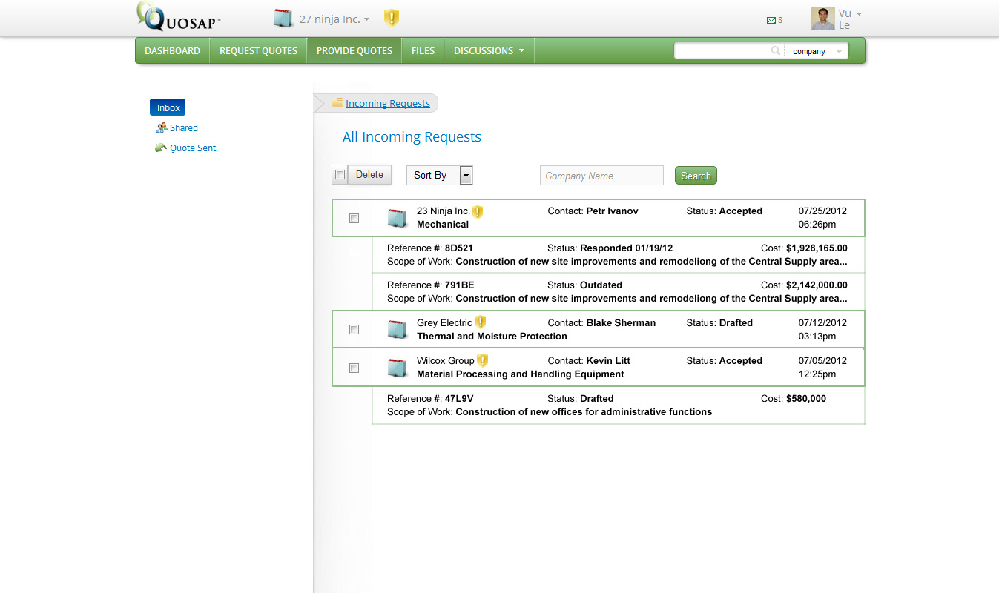
New Mockup for Incoming Request Interface
Anticipated changes to database and gemfile
None

Summary of tests (rspec, cucumber) needed
Added 8 new rspec model tests to cover changing roles.

Expected duration for completion.
6 days (4 days for backend, 1 for frontend, 1 for testing)

