**Where does the ISI distribution come from? From the renewal process model to spiking modes.**

Assume no dependence on spike history beyond most recent spike (i.e. no adaptation or resonance, note: this can be relaxed via the “quasi-renewal approximation”, Gerstner et al 2014). Then the interval distribution ($P\left(s\right)$, probability density that next event occurs at time $\hat{t}+s$, given last spike at time $\hat{t}$) can be expressed in terms of the hazard function ($ρ\left(t | \hat{t}\right)$, the probability of spiking at time $t$ given the last spike at time $\hat{t}$). $$P\left(s\right)=P\left(\hat{t}+s | \hat{t}\right)=ρ\left(t | \hat{t}\right)S\left(t | \hat{t}\right)=ρ\left(t | \hat{t}\right) exp⁡\left[-\int_{\hat{t}}^{t}{ρ\left(t | \hat{t}\right) }\right]$$ 
where $S\left(t | \hat{t}\right)= exp⁡\left[-\int_{\hat{t}}^{t}{ρ\left(t | \hat{t}\right) }\right]$ is the survivor function, or probability that the cell “survives” until time $t$ without spiking since $\hat{t}$. Some examples of interval distributions and their corresponding survivor and hazard functions can be seen in Fig 7.10, from Gerstner 2014.

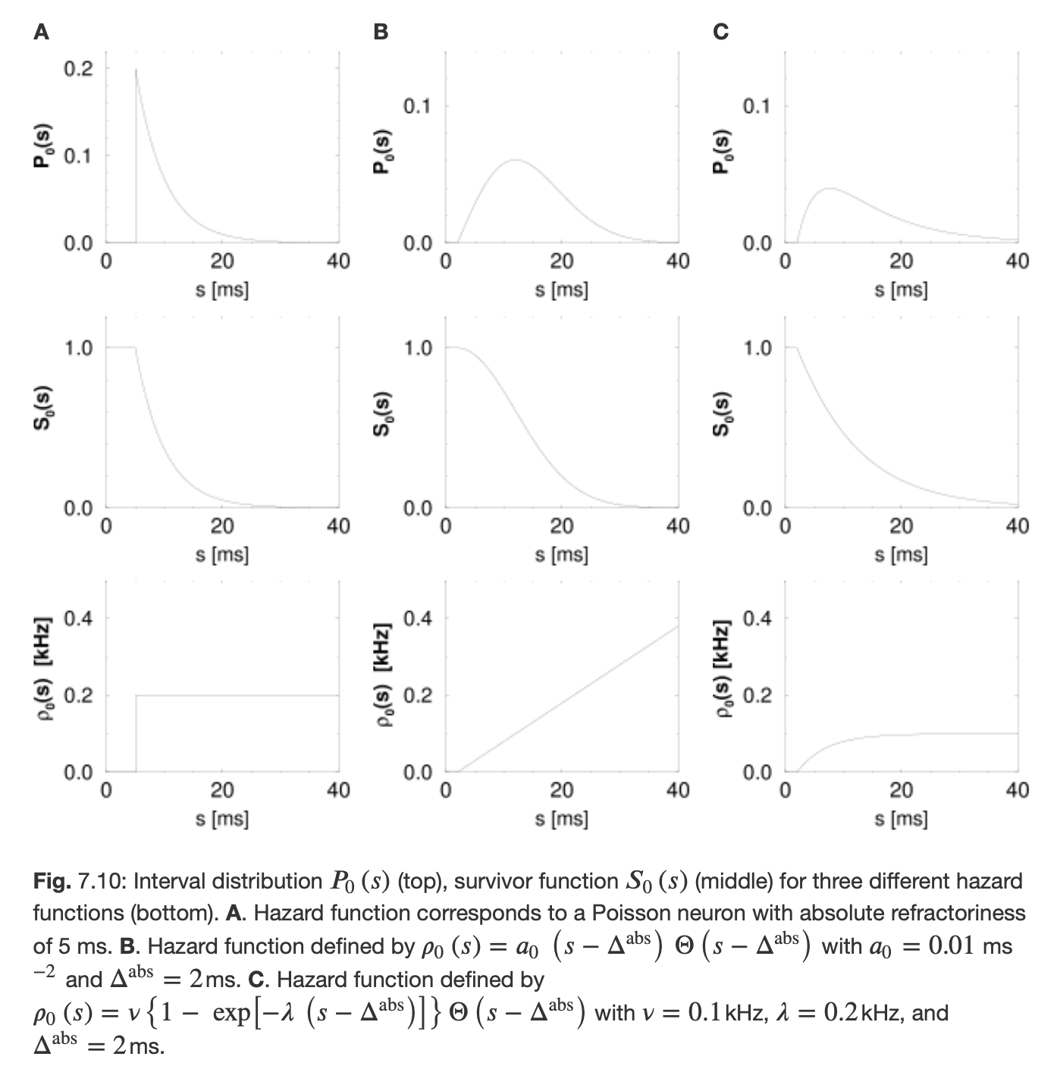

This is notable because hazard models can be directly related to integrate and fire models, in a form known as the Spike Response Model with escape noise (Gerstner 2014),

$$ρ\left(t | \hat{t}\right)=f\left(u\left(t | \hat{t}\right)\right)$$

$$u\left(t | \hat{t}\right)=η\left(t-\hat{t}\right)+h\left(t\right)+u_{rest}$$

where $u(t)$ is the membrane potential at time $t$ (written as $u\left(t | \hat{t}\right)$ to emphasize dependence only on last spike time and input), $f\left(u\right)$ is the escape rate, or potential-to-rate transfer function, $η\left(s\right)$ is the refractory kernel, and $h\left(t\right)$, is the input, which is often expressed as presynaptic spike times convolved with a synaptic kernel. With stationary input (note: or consistent time-varying input…), we can thus calculate the ISI distribution from the refractory kernel, input, and escape rate.

But, in a real recording $t∈T$, things change over time… and so to calculate the ISI distribution we need to know the hazard at each point in time. $$P_{T}\left(s\right)=\int_{T}{dt P\left(t | \hat{t}\right)}=\int_{T}{dt ρ\left(t | \hat{t}\right)S\left(t | \hat{t}\right)}$$

Let’s assume that at each time, the neuron (and its inputs) is in a (hidden) state $a_{t}$, which has associated with it a hazard function $ρ\left(\hat{t}+s | \hat{t},a\right)$, we can then calculate the interval distribution from the states. Then the interval distribution can be found by integrating over the interval distributions expected from each state at each time. $$P_{T}\left(s\right)=\int_{T}{dt P\left(\hat{t}+s | \hat{t},a_{t}\right)}$$

If, however, the hazards are similar enough* between any two timepoints, we can consider them to be the same state. Thus, the modal approximation is akin to saying that neural activity over time is well-represented by a small number of states, $a_{n}, n∈\{1, …, N\}$, each of which is associated with a unique hazard function $ρ_{n}\left(\hat{t}+s | \hat{t}\right)$.

$$P_{T}\left(s\right)=\sum_{n=1}^{N}{p_{T}\left(a_{n}\right) P_{n}\left(\hat{t}+s | \hat{t},a_{n}\right)}+\int_{T_{X}}{dt P\left(t | \hat{t}\right)}$$

where $p_{T}\left(a_{n}\right)$ is the fraction of time in state $a_{n}$, $P_{n}\left(\hat{t}+s | \hat{t}\right)$ is the interval density associated with $a_{n}$ (via the hazard function), and $T_{X}$ is all time in the recording that is not associated with one of the states. If $\sum_{n=1}^{N}{p_{T}\left(a_{n}\right) }≈1$ (i.e. the amount of time not in any of the “common” modes is small), then we have the modal approximation,

$$P_{T}\left(s\right)=\sum_{n=1}^{N}{p_{T}\left(a_{n}\right){ P}_{n}(s) }$$

where each mode reflects a distinct hazard function, which can come from mode-specific spike generation statistics $f_{n}\left(u\right)$, intrinsic resonant or refractory properties $η_{n}\left(s\right)$, or (possibly time-varying) input patterns $h_{n}\left(t\right)$.