Alarm Router
Custom Web Control Documentation - v1.0.0

Control Preview
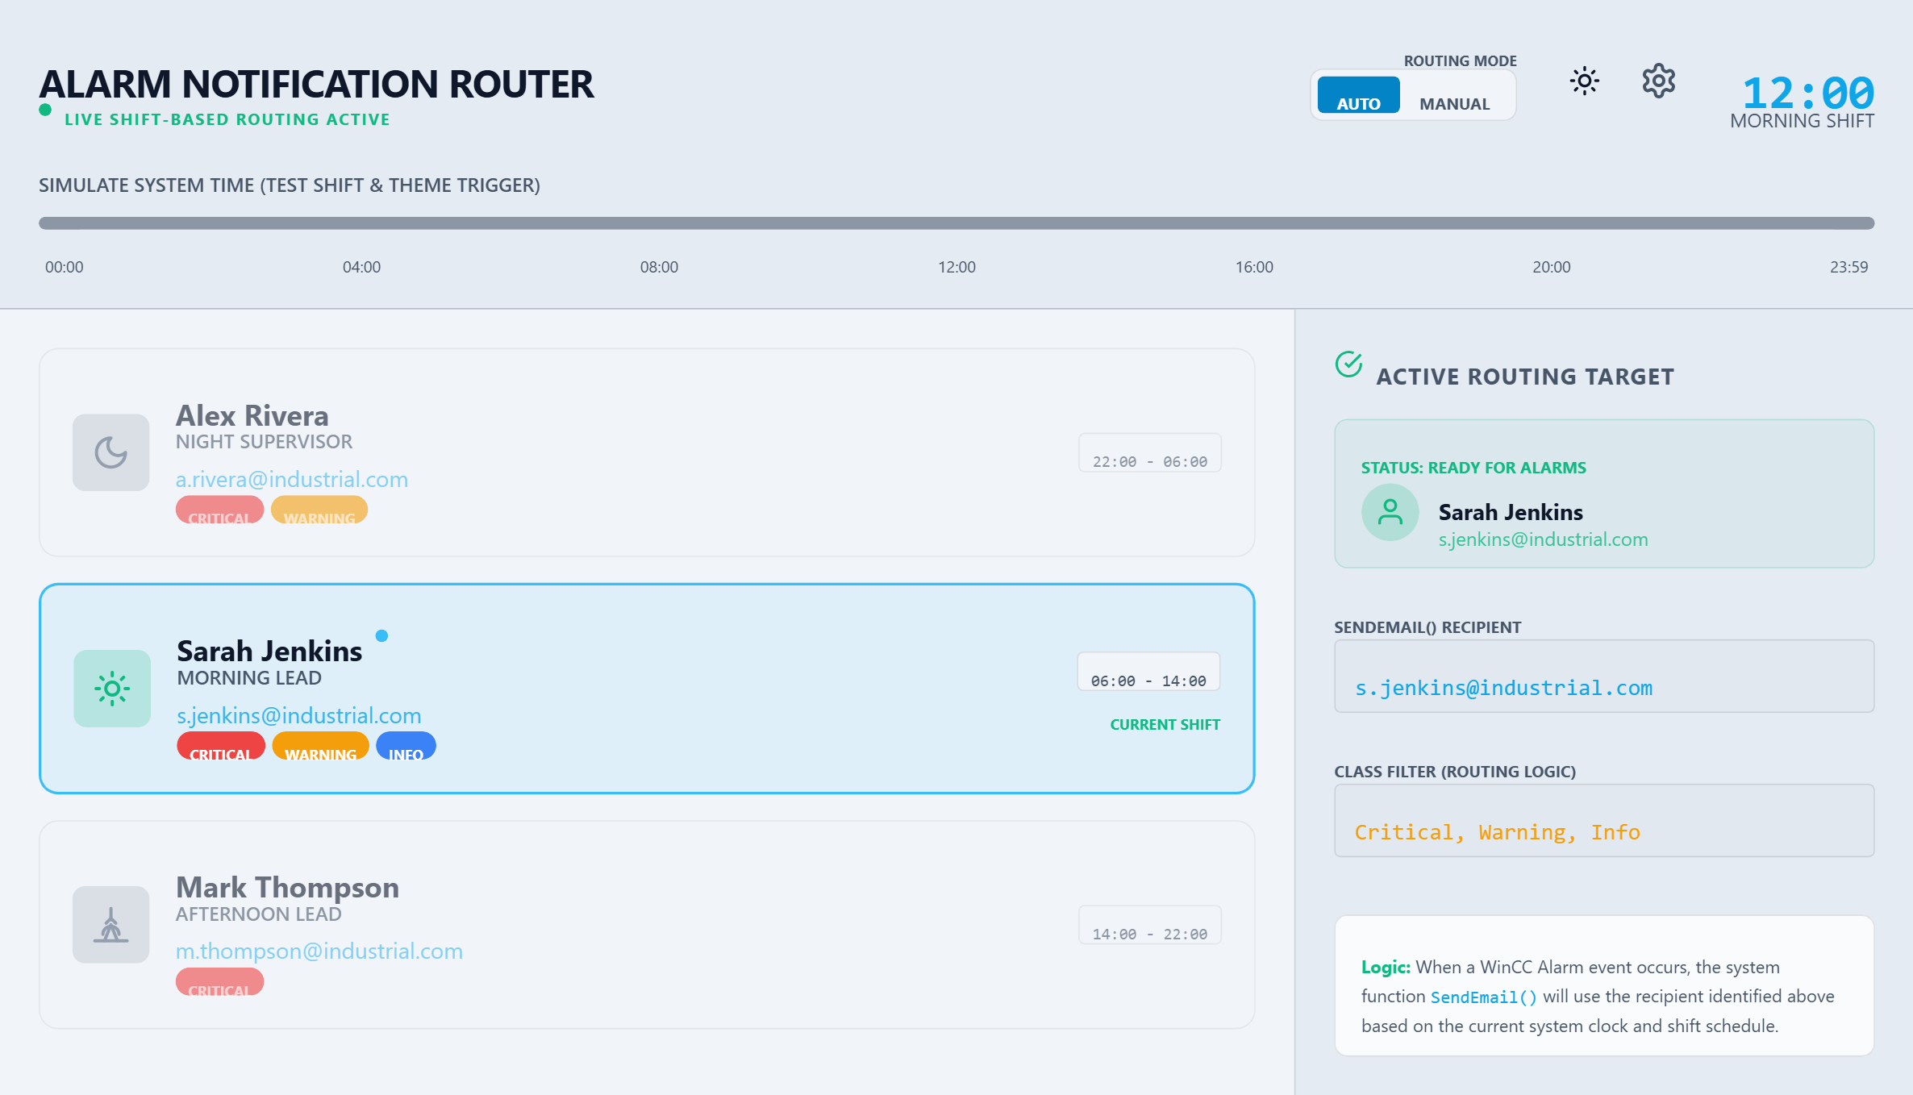

Overview
The Alarm Notification Router is a high-end management interface designed for WinCC Unified SCADA systems to dynamically direct process alerts to the correct personnel based on active work shifts. Visually, it features a modern industrial dashboard with clear status indicators, personnel cards, and a dedicated sidebar showing the currently active routing target in real-time. The control provides a live overview of all available supervisors and technicians, automatically highlighting the person currently on shift while allowing operators to manually override the selection for emergency handovers. Engineers can fully customize the visual identity of the control by adjusting background colors and titles, and can choose between automated time-based themes or a fixed dark/light mode for low-light control room environments. Integration is seamless through WinCC Unified tags, where the system hour can be synchronized with the PLC clock to ensure routing accuracy, while the control fires specific events to update notification variables or email recipients automatically. This tool is particularly valuable in large-scale manufacturing facilities or power plants where critical alarms must reach specific duty managers without manual intervention, and it includes a built-in data editor for bulk-importing contact lists directly from spreadsheet software like Excel.

Control Information
Author: Developer
Company: Company
Dimensions: 500 x 300 px
GUID: E732E129-2A14-4F1B-9319-FBA8D44E2B60

Properties (16)
The following properties can be configured to customize the control's appearance and behavior:

backgroundColor (Color)
Default Value: 4278853402
Main background color of the control container.

title (String)
Default Value: Alarm Notification Router
Main header title text.

subtitle (String)
Default Value: Live Shift-Based Routing Active
Status text shown below the main title.

routingModeLabel (String)
Default Value: Routing Mode
Label for the Auto/Manual routing toggle.

targetPanelTitle (String)
Default Value: Active Routing Target
Header for the sidebar info panel.

confirmButtonText (String)
Default Value: APPLY CHANGES
Text for the primary action button in the settings overlay.

cancelButtonText (String)
Default Value: CANCEL
Text for the secondary/dismiss button in the settings overlay.

exportButtonText (String)
Default Value: EXPORT TSV
Label for the TSV export action button.

importButtonText (String)
Default Value: IMPORT TSV
Label for the TSV import action button.

tsvMatrixLabel (String)
Default Value: Contact & Shift Matrix (TSV)
Header label for the TSV editor area.

autoSelectByShift (Boolean)
Default Value: true
If true, the routing target is automatically selected based on system hour.

themeControlMode (String)
Default Value: auto
Defines how theme is selected: 'auto' (time-based) or 'manual'.

manualTheme (String)
Default Value: dark
The active theme when themeControlMode is 'manual'. Options: 'light', 'dark'.

systemHour (Number)
Default Value: 12
The current hour (0-23) used for shift calculations.

selectedEmail (String)
Default Value:
The email address of the currently active or manually selected contact.

contacts (Array<Object:Contact>)
Default Value: [{"name":"Alex Rivera","email":"a.rivera@industrial.com","role":"Night Supervisor","shiftStart":22,"shiftEnd":6,"iconType":"moon","alarmClasses":"Critical, Warning"},{"name":"Sarah Jenkins","email"...
List of personnel and their shift schedules.

Events (3)
The control fires the following events that can be handled in your application:

SelectionChanged
Fired when the active recipient changes due to shift time or manual selection
Arguments: email (String)

ThemeChanged
Fired when the visual theme switches between light and dark
Arguments: theme (String)

Confirmed
Fired when the user explicitly confirms a manual selection
Arguments: email (String)

Methods (7)
The following methods can be called to interact with the control programmatically:

setMode()
Sets the routing mode to 'auto' or 'manual'.
Parameters: mode (String)

toggleTheme()
Toggles between light and dark mode manually.
Parameters: no parameters

openSettings()
Opens the configuration overlay programmatically.
Parameters: no parameters

setSystemHour()
Programmatically update the hour to sync with WinCC Unified system time
Parameters: hour (Number)

exportData()
Triggers the TSV export process.
Parameters: no parameters

selectEmail()
Programmatically select a contact by their email address
Parameters: email (String)

setThemeMode()
Set the theme control logic to 'auto' or 'manual'
Parameters: mode (String)

Installation Guide

Installing for WinCC Unified (TIA Portal)
You have two options to install Custom Web Controls:

Option 1: Project-Specific Installation
<project>\UserFiles\CustomControls\

Option 2: Global Installation (all projects)
C:\Program Files\Siemens\Automation\Portal VXX\Data\Hmi\CustomControls\

Using the Control in WinCC Unified
1. Open a WinCC Unified screen in TIA Portal.
2. Click the Update (blue refresh) icon in "Tools > My Controls" palette.
3. Wait for the message: "All objects are up to date".
4. Drag the control from "My Controls" palette to the screen.
5. Configure properties in the Inspector window.
6. Configure events in the "Events" tab of the Inspector.
7. For methods, define functions in the script editor with exact names from Manifest.json.

NOTES (WinCC Unified):
- When copying a project to another PC, Custom Web Controls are NOT transferred. You must install them on the new computer.
- When loading a project to the Operator Panel, TIA Portal transfers the Custom Web Control automatically.

Installing for WinCC V8 and above
Follow these steps to install Custom Web Controls:

1. Open the directory of your project in Windows Explorer.
2. Open the "GraCS" subfolder.
3. Create a folder named "CustomWebControls" (if it doesn't exist).
4. Place the {GUID}.zip file in the "CustomWebControls" folder.

Alternative Installation Paths (WinCC V8)
Custom Web Controls can also be installed in:
C:\Program Files (x86)\Siemens\WinCC\bin\CustomWebControls
C:\Users\Public\Documents\Siemens\WinCC\UserData\CustomWebControls

Using the Control in WinCC V8
1. The "Controls" tab in WinCC Graphics Designer automatically updates to show the new control.
2. Drag the Custom Web Control from the "Controls" tab onto your picture.
3. Select the control and open the "Event" tab in "Object properties".
4. Configure scripts for the events used in the control.
5. Open the "Properties" tab to assign static values or dynamize interface properties.
6. For methods, define functions in the WinCC V8 script editor with exact names from Manifest.json.

NOTES (WinCC V8):
- Deployment for WinCC/WebNavigator and WinCC/WebUX is automatic.

Disclaimer and Legal Notice

AI-GENERATED CONTENT

This Custom Web Control was generated using Artificial Intelligence technology. While every effort has been made to ensure quality, the generated code may contain errors, bugs, or unexpected behavior.

It is the responsibility of the project integrator to thoroughly test and validate all functionality before deployment in production environments.

THIRD-PARTY LIBRARIES

This control may use external libraries that have their own licensing terms. Some libraries may not permit commercial use without proper licensing. The integrator must review all library attributions and ensure compliance with applicable licenses before commercial deployment.

External Libraries Used
The following external libraries are included in this control:
- tailwindcss
- papaparse

Please review the licensing terms for each library before commercial use.

━━━━━━━━━━━━━━━━━━━━━━━━━━━━━━━━━━━━━━━━━━━━━━━━━━━━━━━━━━━━
Generated with AI using CWC AI Creator | https://ai.hmix.tech

