3. Measuring Operating Costs for High Speed Rail in California

Prior to estimate the total operating cost of the Los Angeles-San Francisco high-speed rail system, the number of trains-kilometers and trainsets-kilometers as well as the number of trains-hours and trainsets-hours must be estimated. Those quantities cannot be expressed by a simple algebraic function of the level of travel demand since they depend upon numerous factors such as the fluctuations of the demand within the day and the week for every origin-destination (OD) considered in the studied network as well as the schedules, the capacity of the trainsets and the stopping pattern of the different services. SIMEX, designed by the French Railroad, is a simulation program which allows to go from the level of travel demand to the number of train(set)s-kilometers and train(set)s-hours.

3.1 The SIMEX Simulation Program

SIMEX enables one to measure and optimize operating cost for a given set of OD markets. The SIMEX simulation program provides a very detailed estimate of the operating cost and the interest and depreciation of the rolling stock. It also provides the optimal train schedules and the expected mean load factor and revenue for each train.

In the SIMEX simulation program, the travel demand is previously estimated using the M.A.T.I.S.S.E. model designed by INRETS. The M.A.T.I.S.S.E. model also provides estimates of passengers’ time targets within the day as well as the variation of the total
demand within the week. SIMEX considers four time target distributions depending on the travel time of the OD market being studied, as shown in Appendix A. These distributions are based on the actual fluctuations of the demand observed for four French domestic OD markets : Paris-Le Mans (50 minutes), Paris-Lyon (2 hours), Paris-Bordeaux (3 hours) and Paris-Marseille (4 hours and 40 minutes). Those distributions vary whether the program is run for a random weekday or a weekly peak day (such as Friday evening or Sunday evening). The time target distributions are expressed in terms of hourly percentage of the daily demand. Every OD market is characterized by a travel time and the corresponding time target distribution.

Obviously, supply characteristics affect the travel demand. Thus, the optimal supply proposed by SIMEX must be consistent with the volume of travel demand on which the simulation is based. An algorithm, in which the M.A.T.I.S.S.E. demand model and the SIMEX simulation program are sequentially used, is run until the optimal supply proposed by SIMEX corresponds to the level of demand predicted by M.A.T.I.S.S.E..

The simulation program developed for the Californian corridor is based on an approach similar to the SIMEX methodology. Since M.A.T.I.S.S.E. forecasts are not available for the Californian high speed rail project, the CalSpeed travel demand estimates, as listed in Table 3.1, will be used.

High Speed Rail Ridership Forecasts
one-way trips per day

OD Markets : | Los Angeles | Bakersfield | Fresno
Bakersfield | 1,729
Fresno | 1,499 | 200
San Jose | 3,140 | 93 | 310
San Francisco | 7,877 | 244 | 430

Table 3.1
High Speed Rail Ridership Forecasts for California

Since the San Jose-San Francisco segment is a short, urban speed restricted segment, high speed rail may not be the best adapted service to serve this OD market. Therefore, the San Jose-San Francisco travel demand will not be taken into account when optimizing the schedules. Nonetheless, available capacity provided by express services from Los Angeles to San Francisco and vice-versa may be allocated to the San Jose-San Francisco OD market.

3.2 The Los Angeles-San Francisco High Speed Line

Suppose that the new high speed line is served by Los Angeles-San Francisco non-stop services as well as express services calling at Bakersfield, Fresno and San Jose as illustrated in Figure 3.1. The travel time between Los Angeles and San Francisco is 2

Los Angeles-San Francisco High Speed Line

Segment : | Distance  (Miles) | Max. Speed  (mph) | Avg. Speed  (mph) |  |  | Travel  Time
Los Angeles-Bakersfield | 144 | 200 | 153 |  |  | 56
Bakersfield-Fresno | 108 | 200 | 200 |  |  | 32
Fresno-San Jose | 135 | 200 | 175 |  |  | 46
San Jose-San Francisco | 37 | 100 | 84 |  |  | 27

Table 3.2
Los Angeles San Francisco High Speed Line :
Distances, Speeds and Travel Times

hours and 41 minutes according to Table 3.2. Every station is characterized by a 10 minutes stopping time which is longer than the actual time the train stops at the station in order to take into account the delay due to deceleration and re-acceleration. Thus, the Los Angeles-San Francisco express train travel time is 3 hours and 11 minutes.

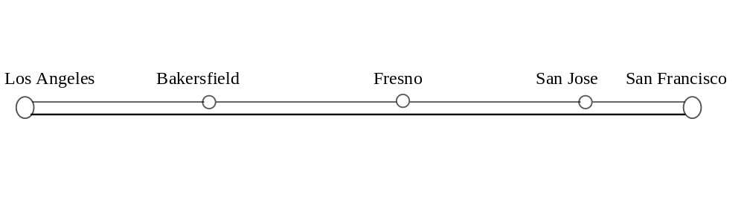
Figure 3.1
Express and Non-Stop Services
from Los Angeles to San Francisco

3.3 Supply Characteristics

Assume that the capacity of the trainsets used for the Los Angeles-San Francisco high speed line is 350 seats. The number of services needed to carry the traffic expected to run on the new infrastructure is calculated based on the commercial capacity rather than the maximal capacity. The commercial capacity is less than the maximal capacity in order to take into account the normal fluctuations of the demand. It is assumed that the commercial capacity is 75% of the maximal capacity.

Moreover, it is assumed that the factor load on a segment must be less than 90% so that the number of available seats will be high enough to take into account the normal fluctuations of the demand. The factor load on a given segment is often lower bounded in order avoid over-capacity and, therefore, a great number of seat-miles unoccupied for a given train. Nonetheless, at this stage of the simulation, this lower bound will not be taken into account. Finally, the mean daily factor load for both express and non-stop services must be greater than 65%.

3.3 Step 1 : Service Attractiveness

Prior to allocate the demand to the different services offered, the average period of time during which each train is expected to attract passengers must be approximated.

OD markets to and from San Jose, Fresno and Bakersfield will be referred to as secondary markets. Travel demand is first allocated to express services since they are the only trains to serve secondary markets and, thus, must carry all the demand for those markets. The expected secondary market traffic volume carried by express services on each segment of the new line is illustrated in Figure 3.2 below.

Los Angeles | Bakersfield | Fresno | San Jose |  | San Francisco
6367 passengers | 5175 passengers | 4216 passengers | 674 pax

Figure 3.2
Secondary Markets Traffic Flows in every Segment

The most heavily trafficked segment of the new line is the Los Angeles-Bakersfield segment with an expected traffic of 6367 secondary market passengers. The total traffic expected on the Los Angeles-Bakersfield segment (i.e., 6367 secondary market passengers and 7877 Los Angeles-San Francisco passengers) requires to run 54.26 services, either express or non-stop. Secondary market traffic requires 24.25 express services. In order to minimize costs, the number of services retained for the simulation program is 54 non-stop or express trains. Additional services may be offered during off-peak period if the remaining travel demand is high enough.

- Express Service Attractiveness for Los Angeles-San Francisco Passengers

Passengers traveling between Los Angeles and San Francisco may choose between non-stop and express services. Non-stop trains provide faster services, however, when taking into account the schedule delay, express trains may be more convenient depending on passengers’ time targets. Thus, in spite of a longer travel time, express services may attract passengers traveling between Los Angeles and San Francisco.

The attractiveness of a given express services depends upon the scheduling of the other services. An express train can be scheduled between two other express services (with a probability Pº), between a non-stop train and an express service (with a probability P¹) and between two non-stop services with a probability P²). Note N_{exp} and N_{ns} the number of express and non-stop services from Los Angeles to San Francisco, respectively. Let N be the total number of services from Los Angeles to San Francisco. We have :

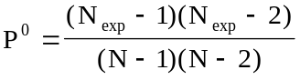, 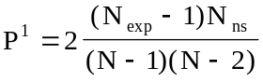 and 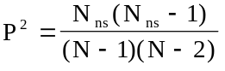.

As stated before, an express train may provide a faster service than a non-stop train, when taking into account the schedule delay. To illustrate, consider an express service (express 1) scheduled between a non-stop service and another express train (express 2) as shown in Figure 3.3. Let us define as the travel time difference between express and non-stop services. Note A as the average time between two services. Define δ as the weighting coefficient for frequency delay. It is assumed that A is greater than .

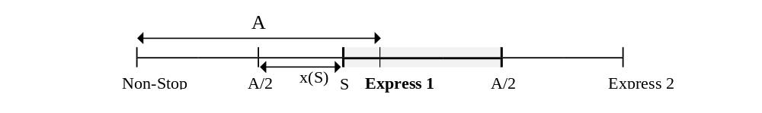
Figure 3.3
Attractiveness of an Express Service

A passenger traveling between Los Angeles and San Francisco will choose express 1 if it provides the lowest total travel time, taking into account the frequency delay. Therefore, a passenger whose time target is S will choose express 1 if :

(3.3.1)
where :

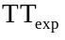 = express service travel time
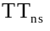 = non-stop service travel time

and where x(S) is defined as shown in Figure 3.3.
According to equation (3.3.1), a passenger will take express 1 if his time target, S, is such that x(S) is greater than . Moreover, a passenger will choose express 1 rather than express 2 if his time target is closer to the time of departure of express 1. Thus, the average period of time during which express 1 is expected to attract passengers can be expressed as : .

In the case where a non-stop service is scheduled instead of express 2, this period of time becomes : .
Assuming that A is greater than , if express 1 is scheduled between two express services, the average period of time during which it is expected to attract passengers from Los Angeles to San Francisco is A. Thus, the average period of time during which an express service is expected to attract passengers can be expressed as follows :

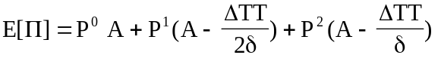 (3.3.2)

It is possible to relax the assumption that A is greater than . It can be shown that the average period of time during which an express service is expected to attract passengers can be expressed as follows :

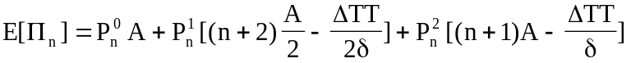 (3.3.6)
where :

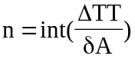,

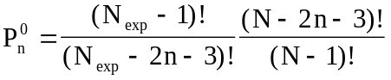, 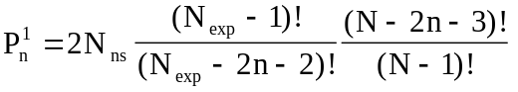 and

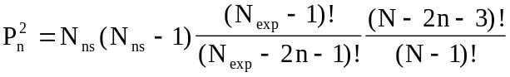

As stated before, the total number of services from Los Angeles and San Francisco retained for the simulation is 54. Assume there is transport demand between 5 A.M. and 12 A.M. It comes that the average period of time between two trains is A = 21 minutes. Let further assume that the frequency delay is less valued by passengers as on-board travel time, and assume that δ = 0.75. Since non-stop services are 30 minutes faster than express services, n is equal to 1.

Table 3.3 indicates the average period of time during which an express service is expected to attract passengers for a given level of frequency of express services. The proportion of Los Angeles-San Francisco passengers expected to travel by express trains depends upon this period of time. As stated before, 24.25 services are already required to carry the travel demand on secondary markets. Additional express services must be provided in order to carry the Los Angeles-San Francisco passengers expected to choose express trains.

Table 3.3 indicates the minimum required number of express services to be provided to meet the travel demand for both secondary markets and the Los Angeles-San Francisco market. Obviously, this minimum number of services to be provided must be greater than the frequency of services actually supplied. As shown in Table 3.3, this requires than the number of express services must be greater than 26.

N_{exp} | N_{ns} | P⁰ | P¹ | P² | E[Π] | LA-SFO  Demand | Total Travel Demand | Number of Express  Services Required
24 | 30 | 0.03 | 0.09 | 0.06 | 2 | 304 | 6671 | 25.42
25 | 29 | 0.04 | 0.10 | 0.06 | 2 | 359 | 6726 | 25.62
26 | 28 | 0.04 | 0.11 | 0.06 | 2 | 420 | 6787 | 25.86
27 | 27 | 0.05 | 0.12 | 0.06 | 3 | 489 | 6856 | 26.12
28 | 26 | 0.06 | 0.13 | 0.06 | 3 | 566 | 6933 | 26.41
29 | 25 | 0.07 | 0.14 | 0.06 | 3 | 651 | 7018 | 26.74
30 | 24 | 0.08 | 0.15 | 0.06 | 4 | 746 | 7113 | 27.10

Table 3.3
Number of Express Services Required for a
Total Number of 54 Los Angeles-San Francisco Services

Since non-stop trains provide faster services for passengers traveling between Los Angeles and San Francisco, one would tend to maximize the number of non-stop services. Thus, the number of services provided is :

- 26 express services calling at Bakersfield, Fresno and San Jose, and
- 28 non-stop services.

As indicated in Table 3.3, the expected length of the period of time during which an express service is expected to attract passengers traveling from Los Angeles to San Francisco is 2 minutes. Thus, the period of time during which a non-stop service is expected to attract passenger traveling between Los Angeles and San Francisco is 39 minutes.

Secondary OD markets are served by 28 trains. Thus, the period of time during which an express service is expected to attract secondary market passengers is 44 minutes.

3.5 Step 2 : Non-Stop Service Scheduling Process

During off peak hours, the total demand for an express train, serving all the secondary OD markets as well as the Los Angeles-San Francisco market, may be high enough to provide a viable service whereas the travel demand for a non-stop service only serving a single OD market may be to low. During peak periods, though, the disparity of the demand among the different segments of the new line, as shown in Figure 3.2, is likely to yield empty seats on the less heavily trafficked segments. To illustrate, suppose that the Los Angeles-Bakersfield travel demand for a train leaving at 6 A.M. is so high that many passengers willing to travel beyond Bakersfield cannot get a seat. The factor load is likely to be low on the Bakersfield-Fresno segment if the number of passengers expected to get on the train in Bakersfield is negligible compared to the number of those who get off at this station.

Therefore, non-stop services should first be scheduled during peak hours so that the Los Angeles-San Francisco travel demand will be high enough to viably provide such a service. In addition, this is expected to smooth the demand allocated to express services and, thus, alleviate the problem of the disparity of the traffic volume expected on the different segments of the new line.

The non-stop service scheduling methodology used in the simulation program is pictured in Figure 3.3. The first non-stop service is scheduled at the time when the travel demand between Los Angeles and San Francisco is the highest. As shown in Figure 3.3, a train leaving Los Angeles at 6.30 A.M. would be expected to attract the greatest number of passengers. Since the maximum load factor is 90%, only 315 passengers are allocated to this train. Scheduling the 6.30 A.M. train affects the potential demand for non-stop services leaving Los Angeles between 6 A.M. and 7 A.M. as shown in Figure 3.4. The new demand profile leads us to schedule the next train at 3.15 P.M.. The remaining demand after scheduling the 6.30 A.M. and the 3.15 P.M. trains is pictured in Figure 3.5. It leads us to schedule the next trains at 4 P.M., 2.30 P.M. and 9.15 A.M. as shown in Figure 3.5. The same methodology is used to schedule the remaining Los Angeles-San Francisco non-stop services. If the factor load of a non-stop service is less than 20%, the program stops the non-stop scheduling process. The factor loads of the 28 non-stop services are listed in Table 3.4. Table 3.4 also indicates the revenue provided by every non-stop train assuming that the one-way Los Angeles-San Francisco fare is $ 56.

Since the travel demand is assumed to be symmetric, the non-stop service scheduling process from San Francisco to Los Angeles leads to similar schedules and revenues.

Expected Travel Demand for Non-Stop Services
depending on the time of departure of the trains

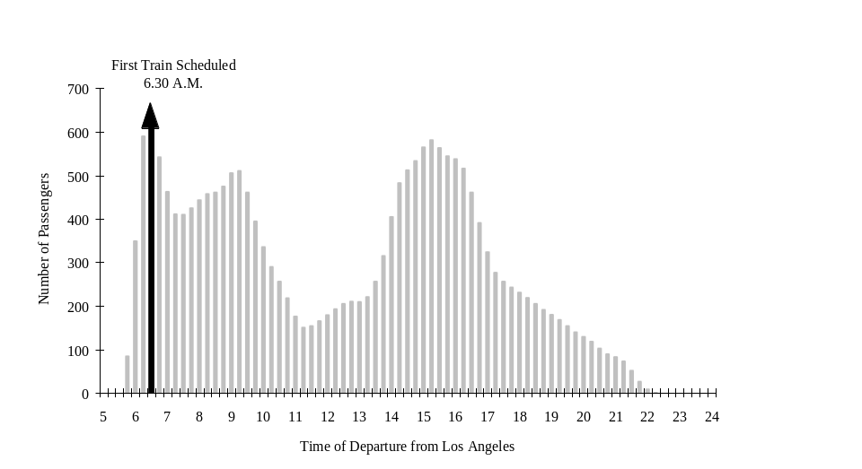
Figure 3.3
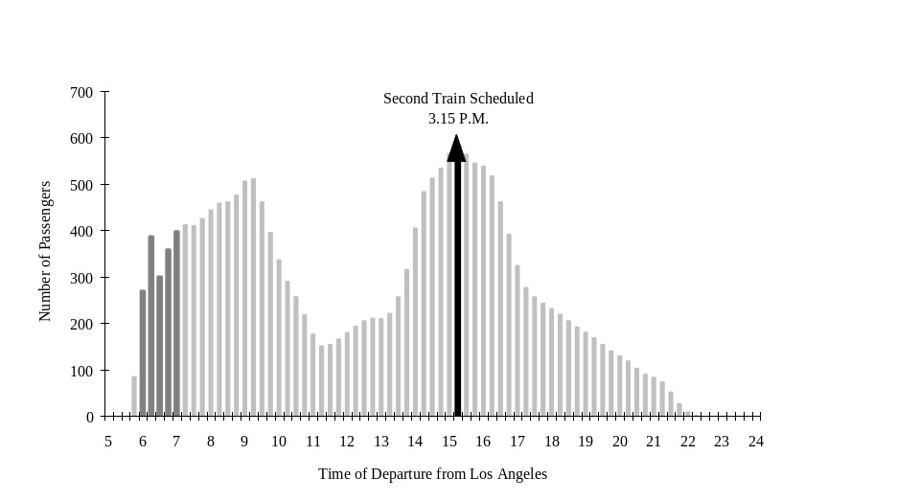
Figure 3.4
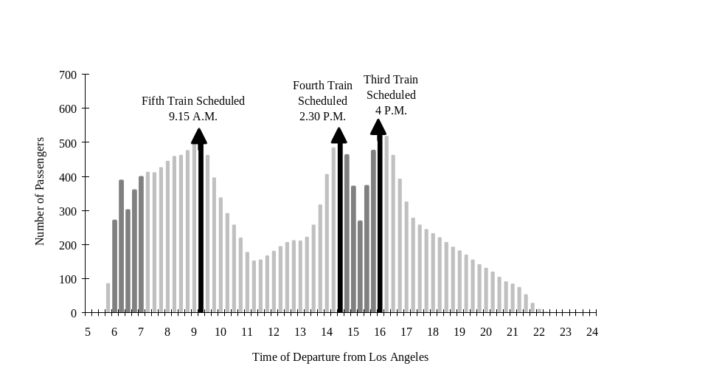
Figure 3.5
Non-Stop Service Factor Load and Revenue Northbound and Southbound

Time of Departure |  | 6.30 |  | 15.15 |  | 16.00 |  | 14.30 |  | 9.15 |  | 8.30 |  | 7.45 |  | 7.00 |  | 16.45 |  | 6.15
Factor Load |  | 176% |  | 166% |  | 154% |  | 146% |  | 146% |  | 132% |  | 121% |  | 113% |  | 112% |  | 110%
Truncated Factor Load |  | 90% |  | 90% |  | 90% |  | 90% |  | 90% |  | 90% |  | 90% |  | 90% |  | 90% |  | 90%
Revenue |  | $ 17,640 |  | $ 17,640 |  | $ 17,640 |  | $ 17,640 |  | $ 17,640 |  | $ 17,640 |  | $ 17,640 |  | $ 17,640 |  | $ 17,640 |  | $ 17,640
Time of Departure |  | 10.00 |  | 14.00 |  | 15.30 |  | 14.45 |  | 17.30 |  | 16.15 |  | 9.00 |  | 13.15 |  | 18.15 |  | 10.45
Factor Load |  | 96% |  | 95% |  | 85% |  | 76% |  | 73% |  | 67% |  | 66% |  | 63% |  | 62% |  | 62%
Truncated Factor Load |  | 90% |  | 90% |  | 85% |  | 76% |  | 73% |  | 67% |  | 66% |  | 63% |  | 62% |  | 62%
Revenue |  | $ 17,640 |  | $ 17,640 |  | $ 16,702 |  | $ 14,841 |  | $ 14,336 |  | $ 13,144 |  | $ 12,884 |  | $ 12,345 |  | $ 12,246 |  | $ 12,196
Time of Departure |  | 12.30 |  | 8.15 |  | 19.00 |  | 11.45 |  | 7.30 |  | 9.30 |  | 19.45 |  | 6.45
Factor Load |  | 59% |  | 53% |  | 51% |  | 47% |  | 42% |  | 40% |  | 40% |  | 31%
Truncated Factor Load |  | 59% |  | 53% |  | 51% |  | 47% |  | 42% |  | 40% |  | 40% |  | 31%
Revenue |  | $ 11,469 |  | $ 10,483 |  | $ 10,063 |  | $ 9,258 |  | $ 8,234 |  | $ 7,906 |  | $ 7,828 |  | $ 5,997

Table 3.4
Non-Stop Service Factor Load and Revenue

The total revenue for non-stop services is $ 391,613 par day and per direction. The average factor load for non-stop services is 71.36% while the number of non-stop services to be provided had been estimated on the basis of a 75% average factor load, referred to as the commercial capacity. Thus, while the Los Angeles-San Francisco travel demand expected to be allocated to non-stop services had been estimated to be as high as 7457 passengers each way, the actual allocation is only 6993 passengers. The remaining travel demand between Los Angeles and San Francisco for express services is 884 passengers.

3.6 Step 3 : Express Service Scheduling Process

The express service scheduling process is somewhat more complex since it must be directly based on the maximization of the revenue rather than the potential number of passenger attracted by a given service. While non-stop service revenue is proportional to the number of passengers carried, the travel demand potentially attracted by a given express service corresponds to different OD markets and, thus, different fares. Moreover, the disparity of the demand in the different segments of the new line is likely to yield empty seats on the less heavily trafficked segments as stated in Section 3.5. Thus, the express service which leads to the highest revenue does not necessarily correspond to the one which attracts the greatest number of passengers.

Every fifteen minutes, from 5 A.M. to 12 A.M., the potential demand for an express service is calculated. If the potential demand for a given express service on the most heavily trafficked segment exceeds 90% of the capacity, the demand on this segment is truncated so that the number of passengers potentially attracted by this service is exactly 90% of the capacity. The composition of the travel demand according to the different OD markets remains the same. To illustrate, suppose that the travel demand for an express service leaving Los Angeles at 8.30 A.M. is 370 passengers on the Los Angeles-Bakersfield segment while the capacity is 350 seats. Only 315 passengers can be allocated to this service. Assume that 35% of these 370 passengers belong to the Los Angeles-San Jose OD market, 35% of the 315 passengers actually allocated to the 8.30 A.M. express service will travel from Los Angeles to San Jose. This new demand allocation has an impact on the other segments served by the express train. If the demand on the most heavily trafficked remaining segment exceeds 90%, the same operation is repeated. The final travel demand allocation is completed as when the factor loads in the different segments of the line is less than 90%.

The Los Angeles-San Francisco travel demand is allocated to the different express services assuming that the average period of time during which an express train is expected to attract Los Angeles-San Francisco passengers is 2 minutes as discussed in section 3.3. Thus, the conditional probability that an express train attract Los Angeles-San Francisco passengers knowing the non-stop schedules is not taken into account at this stage of the simulation.

Then, knowing the composition of the demand according to the different OD markets, it is possible to calculate the expected revenue for the studied service. The fares used for the simulation are listed in Table 3.5. They roughly correspond to 75% of the average airfare for a end-to-end market alternative (Hall et. al., 1993).

High Speed Rail Fares |  |  | One-Way
OD Markets : | Los Angeles | Bakersfield | Fresno
Bakersfield | $ 25
Fresno | $ 30 | $ 18
San Jose | $ 50 | $ 35 | $ 25
San Francisco | $ 56 | $ 40 | $ 30

Table 3.5
High Speed Rail One-Way Fares for California

Although the travel demand is assumed to be symmetric, the express service scheduling process is likely to yield different schedules and revenues. To illustrate a train leaving Los Angeles at 8.30 A.M. will attract passengers from Los Angeles to San Jose and San Francisco whose time target is closed to 8.30 A.M. while a 8.30 A.M. express service from San Francisco to Los Angeles will potentially attract San Francisco-Los Angeles passengers whose time target is closed to 8.30 A.M. as well as San Jose-Los Angeles passengers whose time target is closed to 8.57 A.M..

Tables 3.6 and 3.7 show the express service factor loads in the different segments of the new line for the northbound and southbound directions, respectively.

Express service revenue is shown in Table 3.8. The contribution of every OD market to the service revenue is shown in Appendix B.

Express Service Factor Loads in the Different Segments of the New Line
Northbound

Time of Departure : | 15.45 | 15.00 | 6.15 | 16.30 | 14.15 | 17.45 | 7.00 | 7.45 | 8.30 | 18.30 | 9.30 | 17.00 | 19.15
Los Angeles-Bakersfield | 90% | 90% | 90% | 90% | 90% | 90% | 90% | 90% | 90% | 90% | 90% | 78% | 90%
Bakersfield-Fresno | 85% | 84% | 80% | 83% | 79% | 73% | 74% | 73% | 74% | 69% | 74% | 67% | 64%
Fresno-San Jose | 81% | 81% | 79% | 75% | 72% | 61% | 65% | 60% | 60% | 53% | 62% | 57% | 42%
San Jose-San Francisco | 18% | 19% | 15% | 17% | 16% | 23% | 13% | 12% | 12% | 21% | 6% | 23% | 17%
Time of Departure : | 10.15 | 13.30 | 20.00 | 12.45 | 12.00 | 11.15 | 20.45 | 8.45 | 21.15 | 6.00 | 11.00 | 6.45 | 15.00
Los Angeles-Bakersfield | 70% | 72% | 90% | 65% | 59% | 54% | 72% | 55% | 39% | 25% | 26% | 28% | 24%
Bakersfield-Fresno | 67% | 63% | 60% | 56% | 51% | 49% | 47% | 43% | 27% | 24% | 25% | 21% | 21%
Fresno-San Jose | 59% | 56% | 34% | 47% | 41% | 42% | 22% | 34% | 13% | 26% | 23% | 17% | 18%
San Jose-San Francisco | 19% | 20% | 15% | 16% | 14% | 19% | 10% | 2% | 7% | 15% | 12% | 0% | 3%

Table 3.6
Northbound Express Service Factor Loads

Express Service Factor Loads in the Different Segments of the New Line
Southbound

Time of Departure : | 8.30 | 7.45 | 14.15 | 15.00 | 13.30 | 6.15 | 15.45 | 7.00 | 16.30 | 18.30 | 17.45 | 17.00 | 5.45
Los Angeles-Bakersfield | 90% | 90% | 90% | 90% | 90% | 90% | 90% | 90% | 90% | 90% | 90% | 90% | 90%
Bakersfield-Fresno | 90% | 84% | 84% | 82% | 82% | 79% | 78% | 76% | 70% | 67% | 66% | 66% | 70%
Fresno-San Jose | 85% | 76% | 76% | 72% | 72% | 67% | 66% | 66% | 55% | 50% | 49% | 50% | 54%
San Jose-San Francisco | 17% | 16% | 16% | 18% | 18% | 12% | 17% | 14% | 16% | 19% | 18% | 21% | 0%
Time of Departure : | 9.15 | 12.45 | 10.15 | 19.15 | 12.00 | 11.15 | 20.00 | 15.00 | 15.45 | 6.00 | 20.45 | 11.00 | 9.45
Los Angeles-Bakersfield | 72% | 71% | 68% | 69% | 65% | 62% | 40% | 39% | 39% | 28% | 18% | 26% | 24%
Bakersfield-Fresno | 69% | 59% | 59% | 55% | 52% | 52% | 41% | 32% | 29% | 24% | 20% | 23% | 22%
Fresno-San Jose | 64% | 49% | 49% | 45% | 44% | 42% | 38% | 26% | 22% | 21% | 30% | 19% | 19%
San Jose-San Francisco | 11% | 16% | 19% | 18% | 14% | 17% | 18% | 4% | 3% | 12% | 16% | 12% | 5%

Table 3.7
Southbound Express Service Factor Loads

Express Service Revenue

Northbound | Revenue | Southbound | Revenue
Departure Time | in US Dollar | Departure Time | in US Dollar
3.45 P.M.  3.00 P.M.  6.15 A.M.  4.30 P.M.  2.15 P.M.  5.45 P.M.  7.00 A.M.  7.45 A.M.  8.30 A.M.  6.30 P.M.  9.30 A.M.  5.00 P.M.  7.15 P.M.  10.15 A.M.  1.30 P.M.  8.00 P.M.  12.45 P.M.  12.00 P.M.  11.15 A.M.  8.45 P.M.  8.45 A.M.  9.15 P.M.  6.00 A.M.  11.00 A.M.  6.45 A.M.  3.00 P.M. | 15,927  15,796  15,678  15,530  14,951  14,874  14,512  14,050  13,981  13,901  13,815  12,909  12,828  12,091  12,088  11,967  10,578  9,514  9,214  8,901  8,112  4,936  4,902  4,683  4,064  3,793 | 8.30 AM.  7.45 A.M.  2.15 P.M.  3.00 P.M.  1.30 P.M.  6.15 A.M.  3.45 P.M.  7.00 A.M.  4.30 P.M.  6.30 P.M.  5.45 P.M.  5.00 P.M.  5.45 A.M.  9.15 A.M.  12.45 P.M.  10.15 A.M.  7.15 P.M.  12.00 P.M.  11.15 A.M.  8.00 P.M.  3.00 P.M.  3.45 P.M.  6.00 A.M.  8.45 P.M.  11.00 A.M.  9.45 A.M. | 16,180  15,491  15,377  15,146  15,021  14,736  14,716  14,679  13,816  13,481  13,444  13,293  13,018  12,552  11,273  11,017  11,008  10,237  9,846  7,649  5,886  5,524  4,599  4,558  4,323  3,970
TOTAL | 293,293 | TOTAL | 290,843

Table 3.8
Express Service Revenue for both Directions

The total revenue for express services for both directions is US $ 584,136.

3.7 Travel Demand Allocation

Prior to run the simulation, the Los Angeles-San Francisco traffic expected to be carried by non-stop services was 94.6% of the total demand according to non-stop service attractiveness compared to express services. This estimate was based on the assumption that the average factor load was 75%. As previously stated, the average factor load is only 71.36%. Therefore, only 91.5% of the 15,754 Los Angeles-San Francisco or vice-versa
passengers are actually allocated to non-stop services. The remaining demand for express services is 884 passengers in each direction versus 420 previously predicted as shown in Table 3.3. The non-carried demand remaining is 229 passengers northbound and 239 passengers southbound. Table 3.9 summarizes the Los Angeles-San Francisco travel demand allocation for both directions.

Los Angeles-San Francisco Travel Demand Allocation Both Directions

Period of the Day | 5-6 A.M. | 6-7 | 7-8 | 8-9 | 9-10 | 10-11 | 11-12 | 12-1 P.M. | 1-2 | 2-3
Total Travel Demand | 0 | 1890 | 1260 | 1418 | 1418 | 788 | 474 | 630 | 788 | 1576
Non-Stop Services | 0 | 1774 | 1202 | 1372 | 1406 | 686 | 320 | 504 | 684 | 1496
Express Services | 0 | 108 | 49 | 39 | 5 | 88 | 154 | 126 | 86 | 52
Remaining Demand | 0 | 8 | 9 | 7 | 7 | 14 | 0 | 0 | 18 | 7
Period of the Day | 3-4 | 4-5 | 5-6 | 6-7 | 7-8 | 8-9 | 9-10 | 10-11 | 11-12
Total Travel Demand | 1734 | 1418 | 788 | 630 | 472 | 316 | 158 | 0 | 0
Non-Stop Services | 1582 | 1320 | 618 | 570 | 422 | 30 | 0 | 0 | 0
Express Services | 145 | 33 | 165 | 57 | 47 | 119 | 25 | 0 | 0
Remaining Demand | 65 | 5 | 3 | 3 | 167 | 133 | 0 | 0 | 0

Table 3.9
San Francisco-Los Angeles Travel Demand Allocation

The travel demand allocation for secondary markets is shown in Tables 3.10 for both directions.

Secondary Markets |  |  | Both Directions
Travel Demand :  OD Markets : | Total | Carried | Carried/Total
Bakersfield-Los Angeles | 3458 | 2977 | 86%
Fresno-Los Angeles | 2998 | 2679 | 89%
San Jose-Los Angeles | 6280 | 5741 | 91%
Fresno-Bakersfield | 400 | 367 | 92%
San Jose-Bakersfield | 186 | 178 | 96%
San Francisco-Bakersfield | 488 | 469 | 96%
San Jose-Fresno | 620 | 569 | 92%
San Francisco-Fresno | 860 | 790 | 92%

Table 3.10
Secondary Market Demand Allocation

3.8 Operating Cost Estimates

The simulation provided estimates of the expected number of passengers carried as well as the number of trains or trainsets-kilometers and train or trainsets-hours. In order to estimate the interest and depreciation of the rolling stock, the number of trainsets required to provide the 108 services serving the Los Angeles-San Francisco corridor must be calculated. As shown in Appendix B, the required number of trainsets is 34. This minimum number is usually increased by 5% in order to take into account the non-disposability a proportion of the total fleet due to defection or maintenance. Thus the total number of trainsets in the fleet would be 36.

Table 3.13 summarizes the results of the simulation.

Operating Costs | Units | Unitary Cost | Quantity | Cost
1. Sales and Administration | passengers |  | 10,130,940
3. Shunting | train |  | 38,325
3. Train Operations
Train Servicing | trainset-hour |  | 115,267
Driving | train-hour |  | 111,781
Catering | trainset-hour |  | 115,267
Operations/Safety on High Speed Lines | train-kilometer |  | 26,145,928
Operations/Safety on Conventional Lines | train-kilometer |  | 0
4. Energy
Energy on High Speed Lines | trainset-hour |  | 115,267
Energy on Conventional Lines | trainset-hour |  | 0
5. Maintenance of Way
Electric Traction Installations | train-kilometer |  | 26,145,928
Others MOW Costs | trainset-kilometer |  | 26,892,955
6. Maintenance of Equipment | trainset-kilometer |  | 26,892,955
Total Operating Costs

Total Passenger Revenue |  |  |  | 499,087,130
Gross Operating Surplus
Capital Cost of Rolling Stock
Professional Tax | trainset |  | 36
Interest and Depreciation of Rolling Stock | trainset |  | 36
Gross Margin
Charges for the New High Speed Line | fixed
Net Contribution

Table 3.13
Operating Cost Estimates for High Speed Rail in California

The term train stopping patterns refers to the sequence of stations served by a same train.
CalSpeed Report : Revenue and Ridership Potential for a High-Speed Rail Service in the San Francisco/ Sacramento-Los Angeles Corridor. Peter Hall, Dan Leavitt and Erin Vaca. 1993. These forecasts are based on the assumptions that stations will be built in Palo Alto, Gilroy, Burbank, Santa Clarita and Palmdale. In our example the travel demand to and from these stations will not be taken into account.
Source : CalSpeed : High-Speed Trains For California. Volume II : Detailed Segment Descriptions, Cost Estimates, and Travel Times Calculation. Peter Hall, Daniel Leavitt and Erin Vaca. 1992.
the number of service required is calculated according to the commercial capacity of the trainsets.
75% of the air fare for a end-to-end market alternative as assumed in the 1993 CalSpeed Report by Peter Hall, Dan Leavitt and Erin Vaca.
a 8.30 A.M. San Francisco-Los Angeles express service would leave San Jose at 8.57 A.M.

