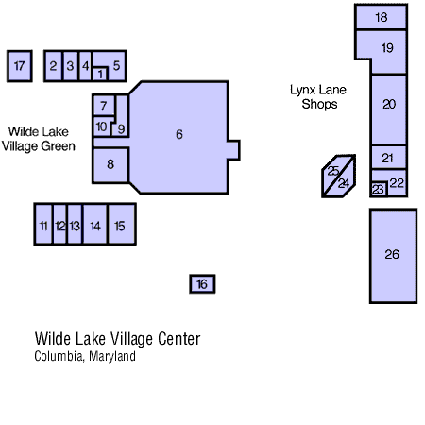Open: 1967  Overhaul: (Lynx Lane expansion 1974)  Vacancies:0  Square Feet: 80,000 | 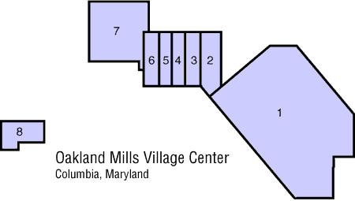  Open: 1969  Overhaul: 1998  Vacancies:3 (including Supermarket)  Square Feet: 56,000
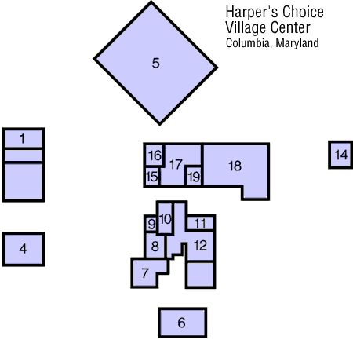  Open: 1971 as Joseph;s Square  Overhaul: 1997  Vacancies:0  Square Feet: 92,000 | 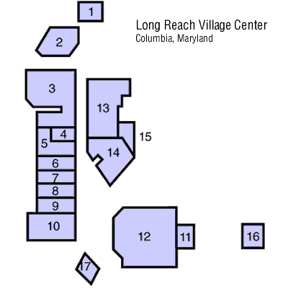Open: 1974  Overhaul: 1998  Vacancies: 4  Square Feet: 91,000
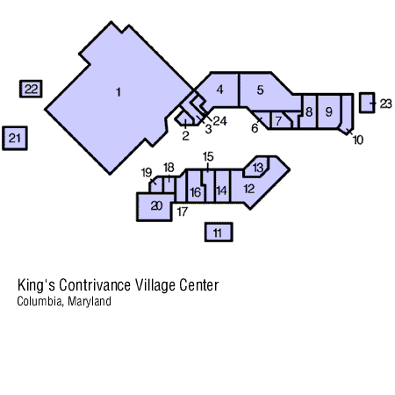  Open: 1986  Overhaul: N/A  Vacancies: 2  Square Feet: 86,000 | 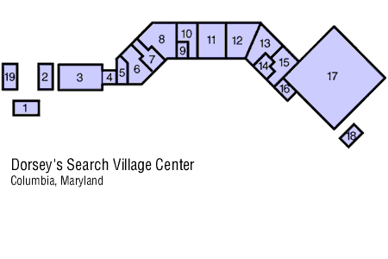  Open: 1986  Overhaul: N/A  Vacancies:0  Square Feet: 92,000
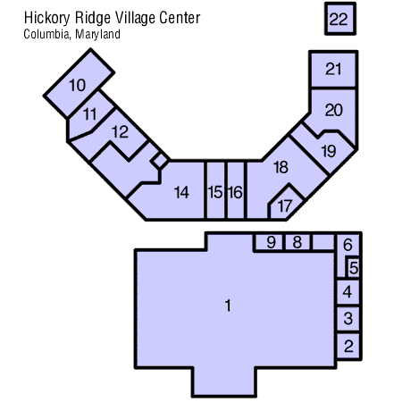  Open: 1992  Overhaul: N/A  Vacancies:0  Square Feet: 104,000 | 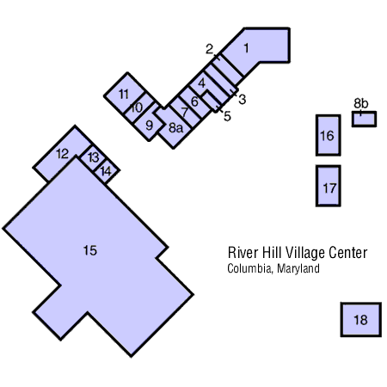  Open: 1997  Overhaul: N/A  Vacancies:0  Square feet: 103000

notes: Images, square footage from, www.therousecompany.com Vacancy data from Stacy, Cindy (2001) "How healthy are the Village Centers?" Columbia Flier April 5, 2001. Excluded is Owen Brown Village Center owned by Giant Food Stores (12 stores, 5 vacant, 58,000 sq.ft., opened 1979, expanded 1987). Opening Dates from various sources, www.columbiamarylnd.com, June 25, 1997 Baltimore Sun p. 3b "Stores stake a claim in River Hill Village center, Erin Texeira". Columbia: A Celebation Timeline

OTHER COLUMBIA MAJOR RETAIL

Name | # Stores | Square Feet | Opening
The Mall in Columbia | 190 | 1,262,000 | 1971
Dobbin Center | 16 | 300,000 | 1983
Snowden Square | 16 | 500,000 | 1992
Columbia Crossing | 22 | 430,000 | 1996
Other | 96 | 341,000

