Because the last arrival time is {

The integers {1, …, N} denote the number of players arriving in that time slot; 0 denotes no player arriving in that time slot.

Note: if there are 2 arrival clusters and N=6, one slot has 1 agent, the other slot has 5, (denoted {1,5}) or one slot has 2 agents, and the other has 4 ({2,4}), and so on.

Here 1 denotes one of the players departing in that time slot without considering the vehicle identification, while 0 denotes that no player departs in that time slot; the subscripts {

When Nash equilibria (NE) exist, the LTC is the Lowest Total Cost of Nash equilibria, which are denoted by boldface; the global minimum, if less than that of NE, is listed in the parentheses; otherwise the LTC is the global minimum of all arrival patterns.

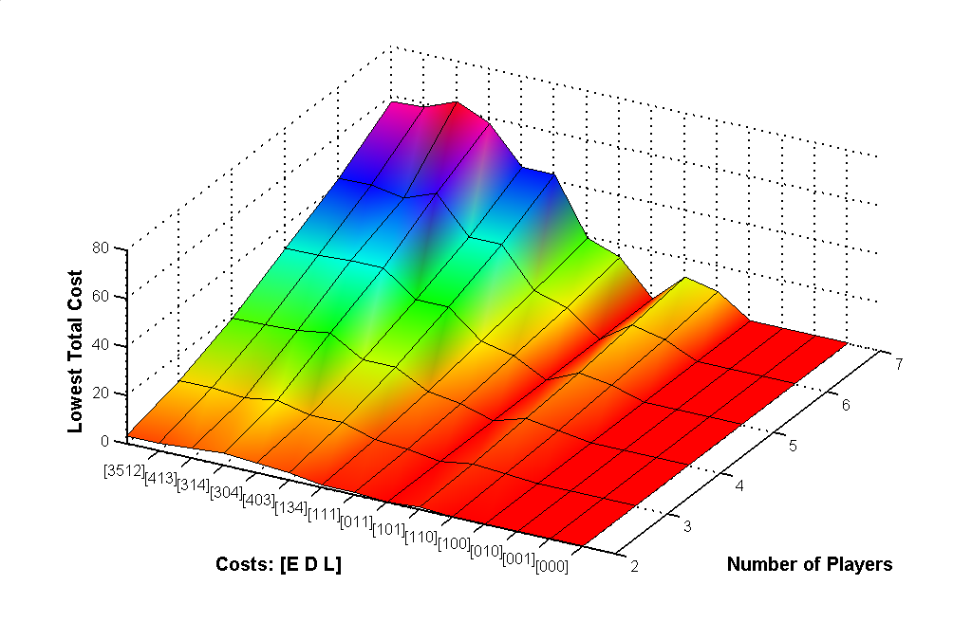
FIGURE 2. Comparison of Lowest Total Costs in N-Player Games
1, L = 4

