Home Page
- Navigation Bar - (Our Schools Dropdown to display with Pictures)
- Alumni and Parent Portal Buttons
- Updated Video to be Provided
- Background Formatting (SK to Find options)
- Text Changes – Unified Group Portal,
  - Deep green legacy should be Flagship Campus
  - Deep Purple Innovation should World School Campus
  - Enter School Portal should be Changed to ‘Visit School Website’
- Add Campus Pictures for School Section
- 30+ Years of History, 3000+ Active Learners,
- Separators for Section on Home Page
- Order of Sections as below
  - Video in the Background
  - School Awards
  - Our Pedagogy
  - Our Schools
  - What Sets us APart
  - Admissions
  - Contact Us
- Academic Progression Change – Change Picture for Primary School, Switch Picture for Middle School with Secondary School.
- What Sets us Apart
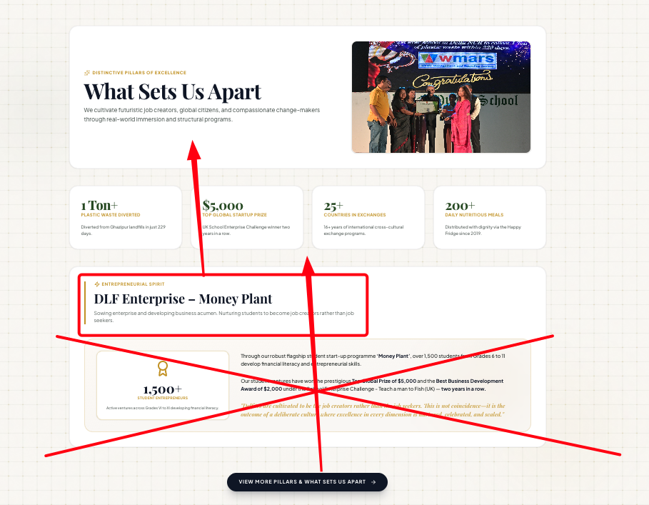

- Remove Interested in Our Educational Philosophy Section

Thinking School with a Soul – Reformat text boxes. Too much white space. Add View More Button in all boxes.
Vision Mission – To be Formatted Similarly
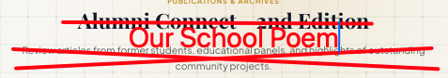

Our Management
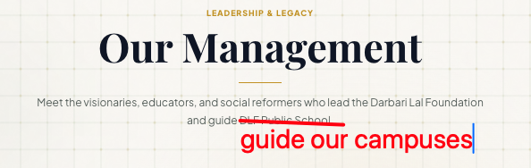
Remove Full Profile of Seema Jerath (Principal)
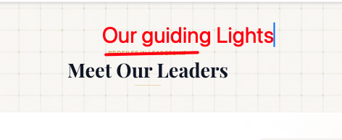

Parents as Partners
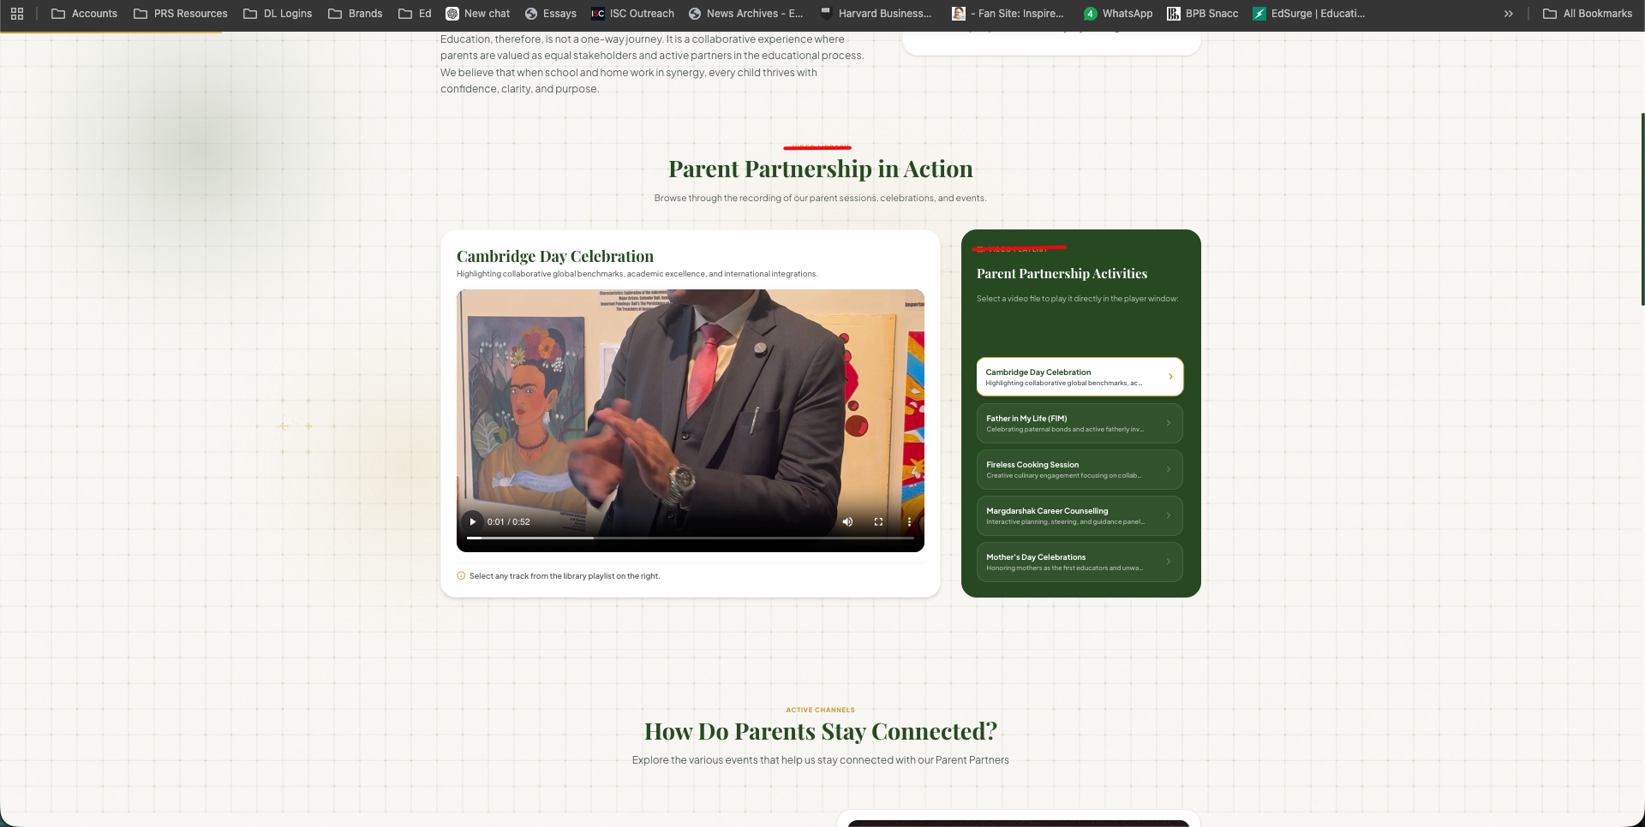
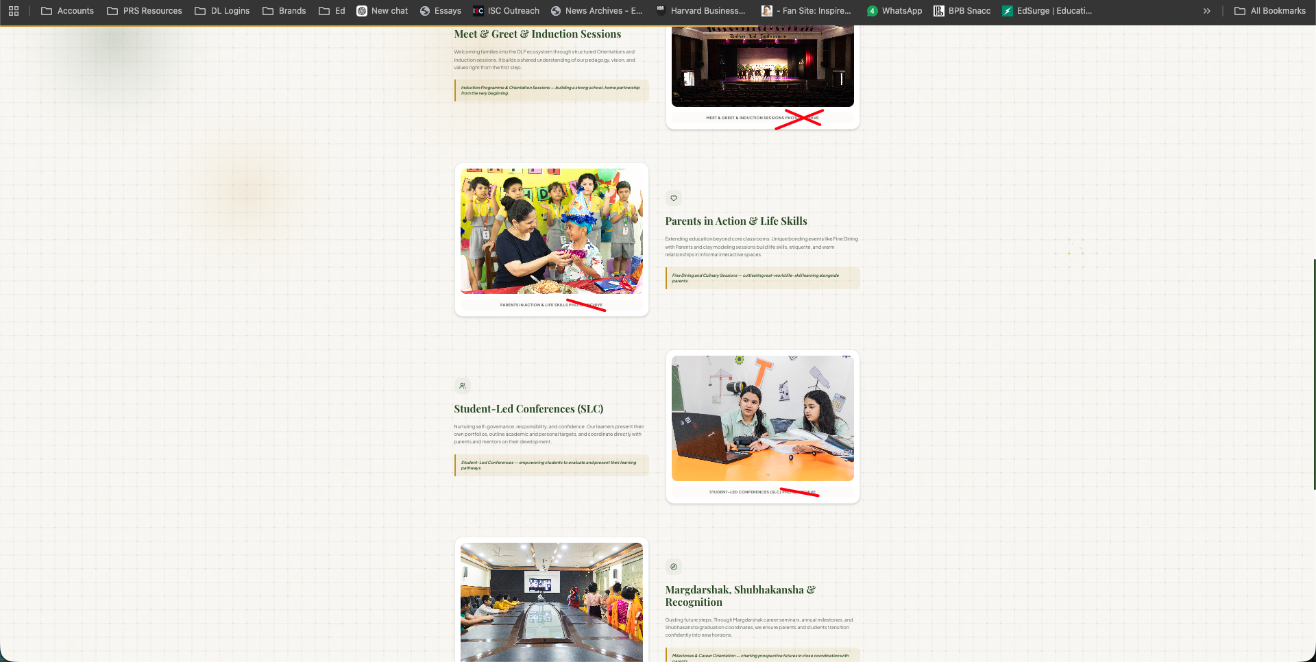
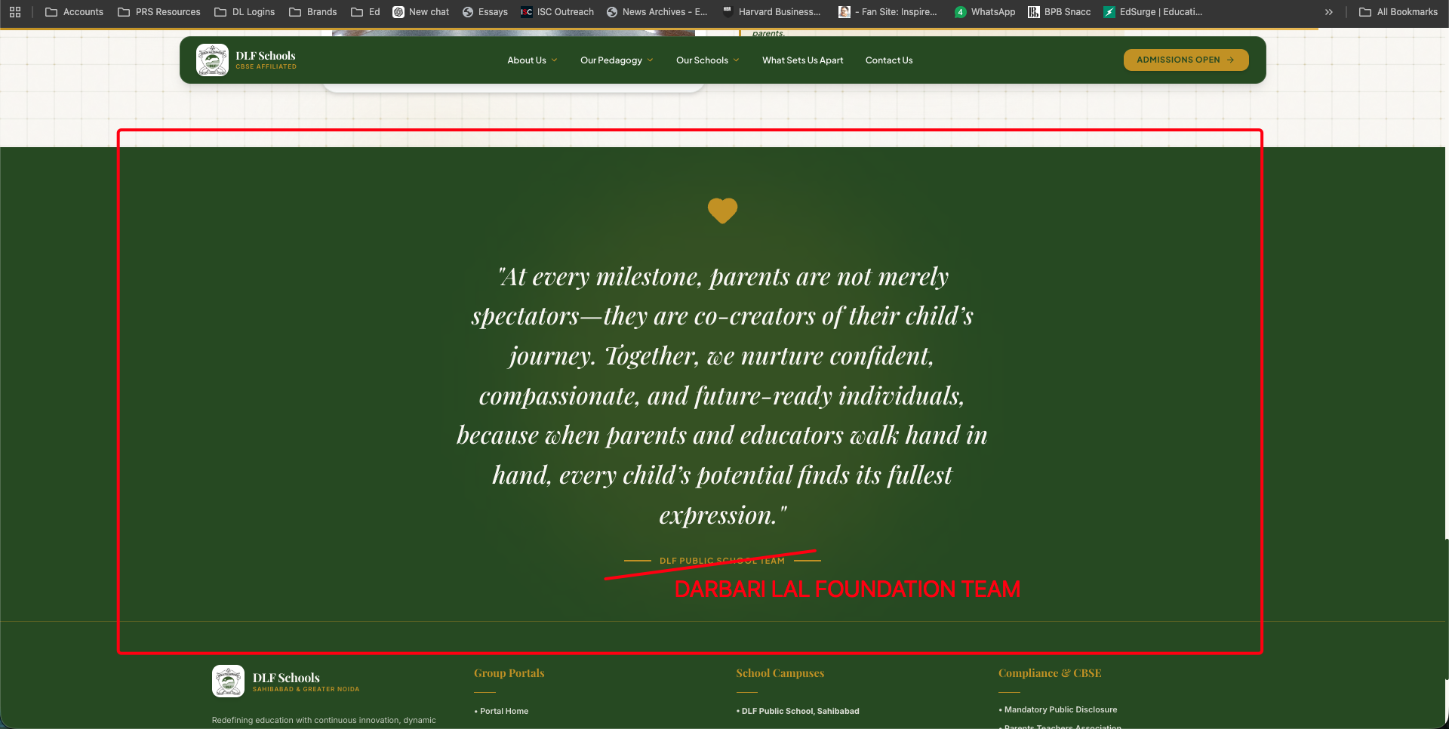
School Awards – To be Modified
What Sets us Apart
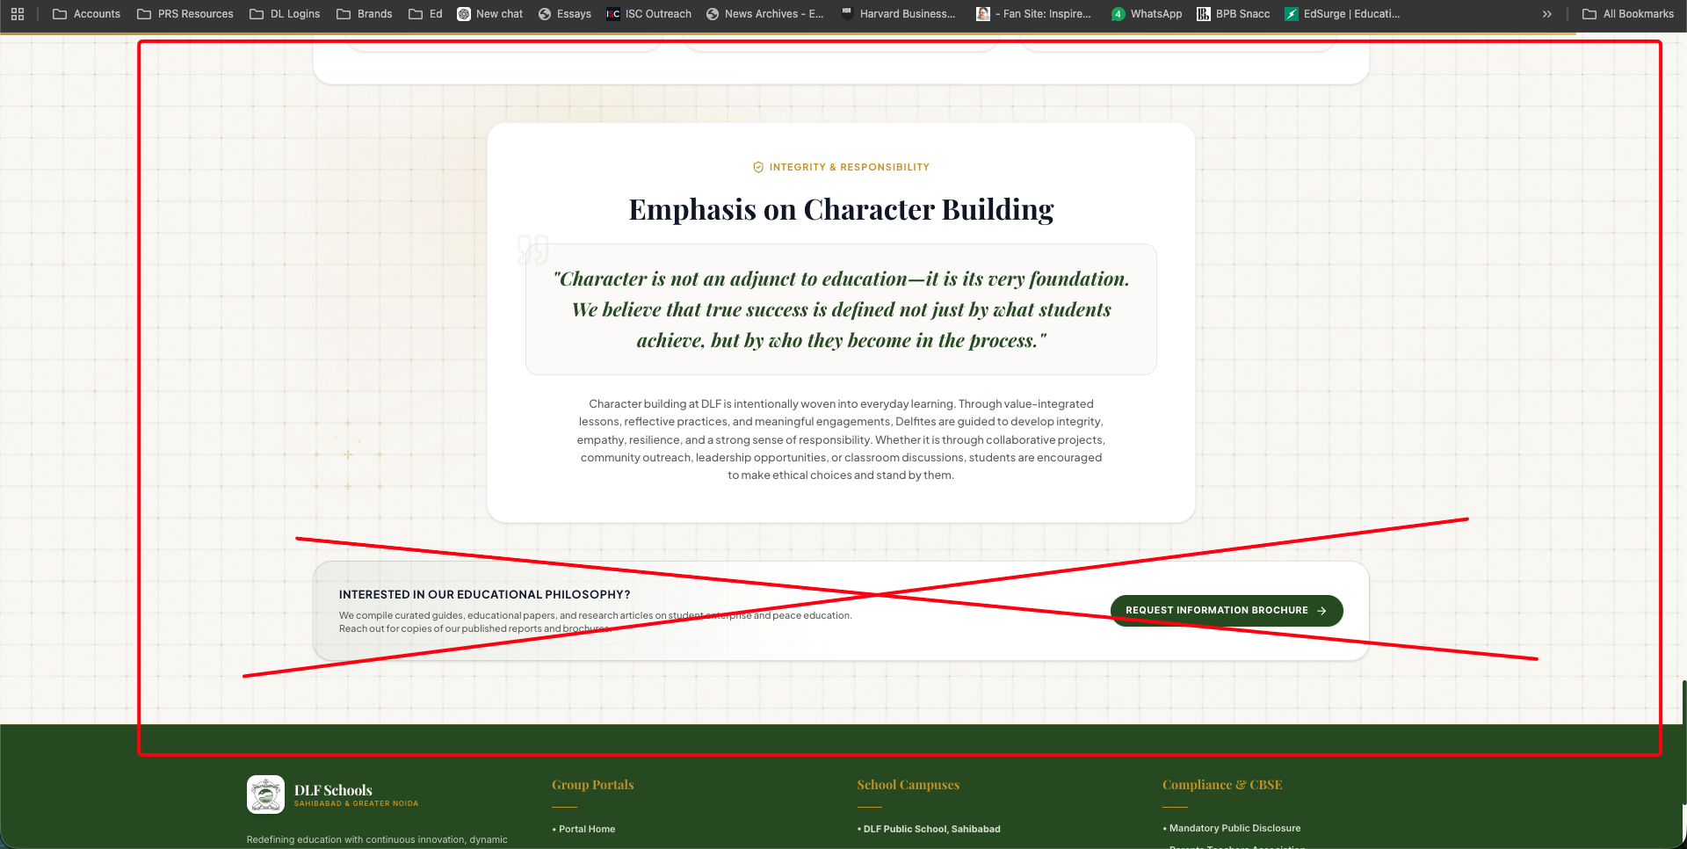
Our Pedagaody
- Pre Primary – Remove Exemplate & Frameworks
- 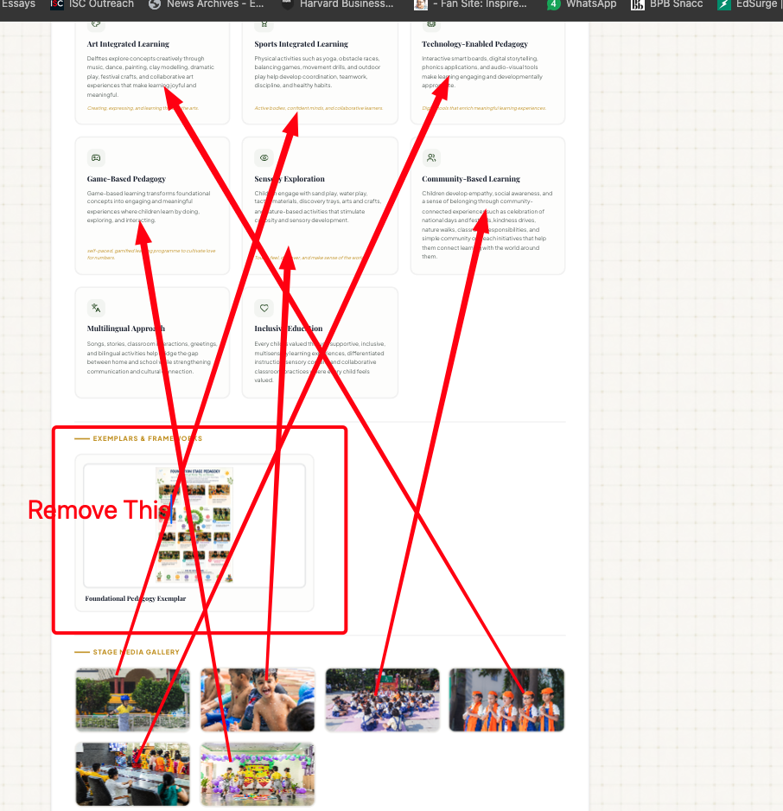
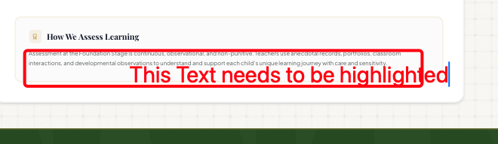

Primary 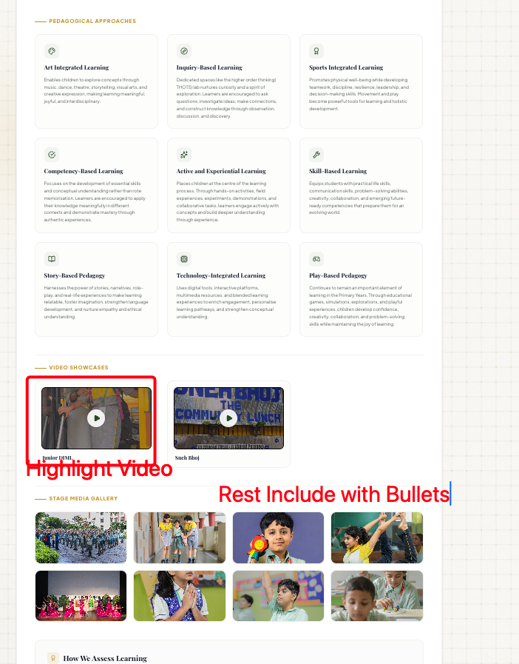

Middle
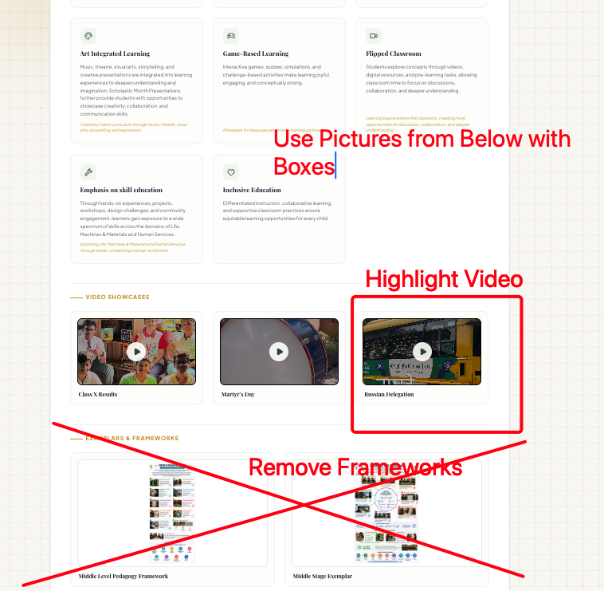

Senior Year
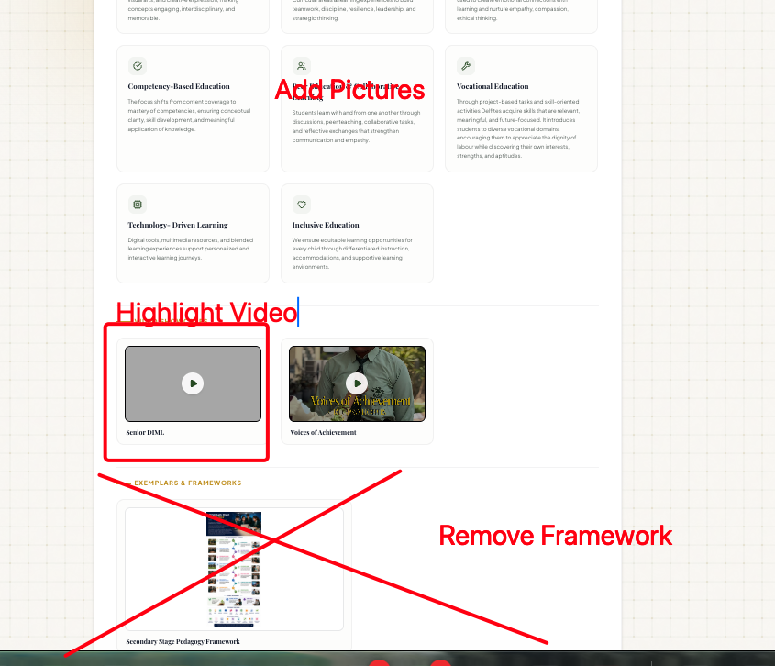

Navigation Page
(Our Schools to display with Pictures)

Contact Us
