Tinder-Claude
System Design Document
Version 1.0 • February 2026

Table of Contents
1. Executive Summary
2. System Architecture
2.1 High-Level Architecture Diagram
2.2 Technology Stack
2.3 Project Structure
3. Data Models
3.1 Entity Relationship Diagram
3.2 Model Definitions
4. API Design
4.1 Endpoint Summary
4.2 Response Envelope
4.3 Error Handling
5. Data Flow Diagrams
5.1 User Request Lifecycle
5.2 Feed Generation Pipeline
5.3 Match Detection Flow
6. User Journey – Sequence Flow
7. Service Layer Details
7.1 InMemoryStore
7.2 FeedService
7.3 SwipeService
8. Testing Strategy
9. Security Considerations
10. Future Enhancements

1. Executive Summary
Tinder-Claude is a backend REST API prototype that implements core dating-app mechanics: profile creation, location-based discovery feeds, swiping interactions (LIKE/PASS), and mutual match detection. Built with FastAPI and Python 3.11+, it serves as an educational reference for developers studying matching systems and geo-spatial filtering logic.
The system uses an in-memory singleton store for data persistence, making it lightweight and easy to test while clearly demonstrating the architectural patterns that would scale to a production system backed by a real database.
Key characteristics:
- RESTful API with six endpoints covering the complete user lifecycle
- Three-tier feed filtering: zone-based → self-exclusion → seen-state
- Bidirectional match detection on mutual LIKE actions
- Pydantic v2 models for strict request/response validation
- Comprehensive test suite with unit and integration tests
- Standardized API response envelope (data, meta, errors)

2. System Architecture

2.1 High-Level Architecture Diagram
The system follows a layered architecture with clear separation of concerns. HTTP requests flow from the client through the FastAPI application layer, are routed to endpoint handlers, which delegate business logic to specialized services that interact with the centralized in-memory store.
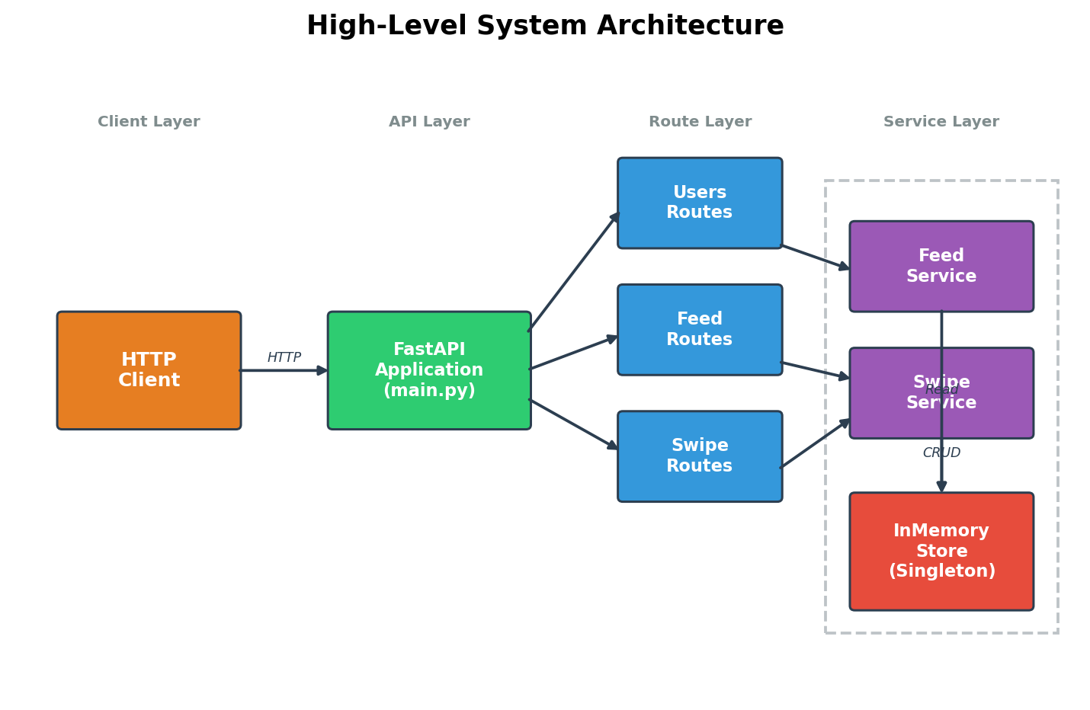

2.2 Technology Stack
Layer | Technology | Purpose
Language | Python 3.11+ | Core runtime with modern type hints
Framework | FastAPI ≥0.110 | High-performance async web framework
Server | Uvicorn ≥0.29 | ASGI server for FastAPI
Validation | Pydantic ≥2.6 | Data parsing and validation
Storage | In-Memory (dict/list) | Prototype data persistence
Testing | pytest ≥8.0 + httpx | Unit & integration testing
Linting | ruff ≥0.3 | Code formatting and lint checks
Package Mgr | uv | Fast Python package management

2.3 Project Structure
tinder-claude/
├── app/
│ ├── main.py # FastAPI app entry point, router setup
│ ├── models/
│ │ └── schemas.py # Pydantic data models & enums
│ ├── services/
│ │ ├── store.py # InMemoryStore singleton
│ │ ├── feed_service.py # Feed generation with 3-tier filter
│ │ └── swipe_service.py # Swipe processing & match detection
│ └── routes/
│ ├── users.py # POST/GET user endpoints
│ ├── feed.py # GET feed endpoint
│ └── swipe.py # POST swipe, GET matches endpoints
├── tests/
│ ├── conftest.py # Shared fixtures (client, users)
│ ├── test_api.py # Integration tests (35+ scenarios)
│ ├── test_store.py # Store unit tests
│ ├── test_feed_service.py # Feed service unit tests
│ └── test_swipe_service.py# Swipe service unit tests
├── pyproject.toml # Dependencies & tool configuration
└── README.md # User-facing documentation

3. Data Models

3.1 Entity Relationship Diagram
The system uses three core entities: User, Swipe, and Match. Users generate Swipes; when two users mutually LIKE each other, a Match record is created. All models use UUID identifiers and UTC timestamps.
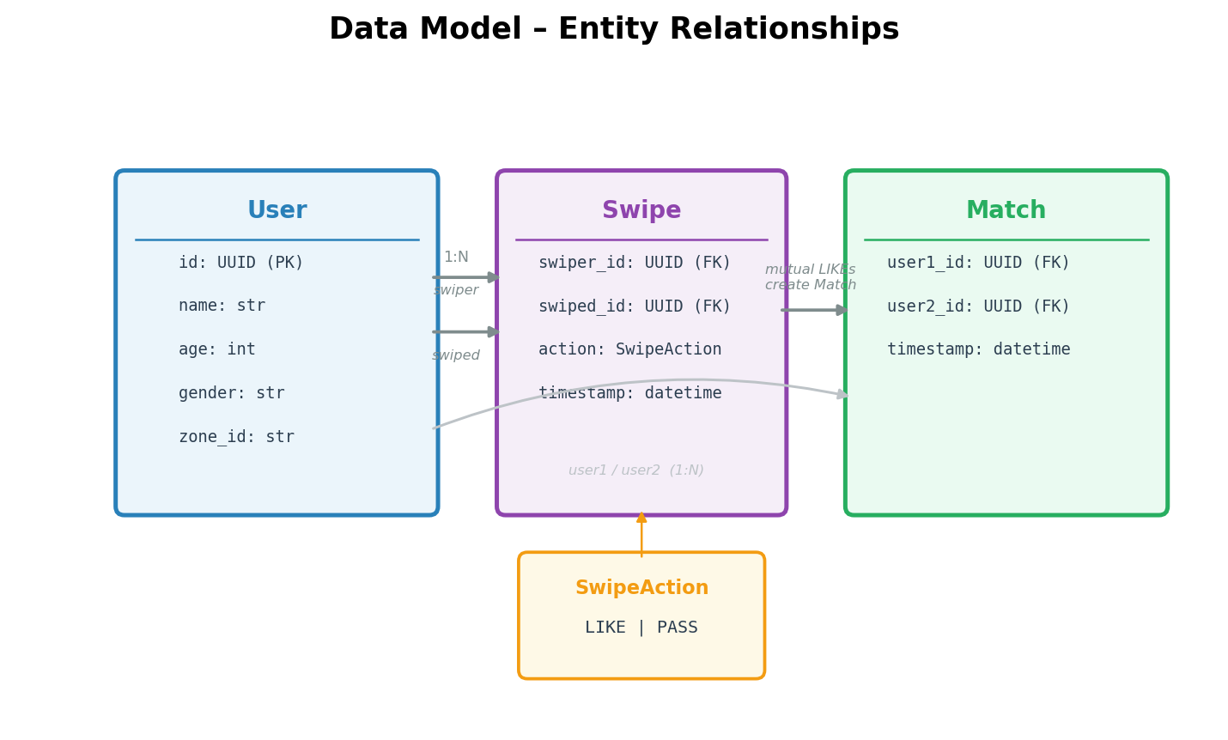

3.2 Model Definitions

User Model
Field | Type | Default | Description
id | UUID | uuid4() | Unique identifier
name | str | required | Display name
age | int | required | User age
gender | str | required | Gender identifier
zone_id | str | required | Geographic zone for feed filtering

Swipe Model
Field | Type | Default | Description
swiper_id | UUID | required | ID of the user who swiped
swiped_id | UUID | required | ID of the user being swiped on
action | SwipeAction | required | LIKE or PASS
timestamp | datetime | utcnow() | When the swipe occurred

Match Model
Field | Type | Default | Description
user1_id | UUID | required | First user in the match
user2_id | UUID | required | Second user in the match
timestamp | datetime | utcnow() | When the match was created

4. API Design

4.1 Endpoint Summary
Method | Endpoint | Status | Description | Error Codes
GET | / | 200 | Health check | —
POST | /users/ | 201 | Create a new user profile | 422
GET | /users/{id} | 200 | Retrieve user by UUID | 404
GET | /feed?user_id= | 200 | Get filtered discovery feed | 404
POST | /swipe | 201 | Submit a swipe action | 400, 422
GET | /matches?user_id= | 200 | List matches for a user | 404

4.2 Response Envelope
All API responses are wrapped in a standardized ApiResponse envelope to provide a consistent interface for clients:
{
"data": <primary_payload>, // Main response data
"meta": {"count": N, ...}, // Metadata (counts, pagination)
"errors": [{"message": "..."}] // Error details (if any)
}

4.3 Error Handling
The API uses standard HTTP status codes with descriptive error messages:
- 400 Bad Request — Business logic errors (self-swipe, invalid user references in swipe)
- 404 Not Found — Requested user or resource does not exist
- 422 Unprocessable Entity — Request body fails Pydantic validation (missing/invalid fields)

5. Data Flow Diagrams

5.1 User Request Lifecycle
Each API request follows a consistent pipeline: validation, business logic processing, store interaction, and response formatting. The diagram below shows the data flow for all four primary operations.
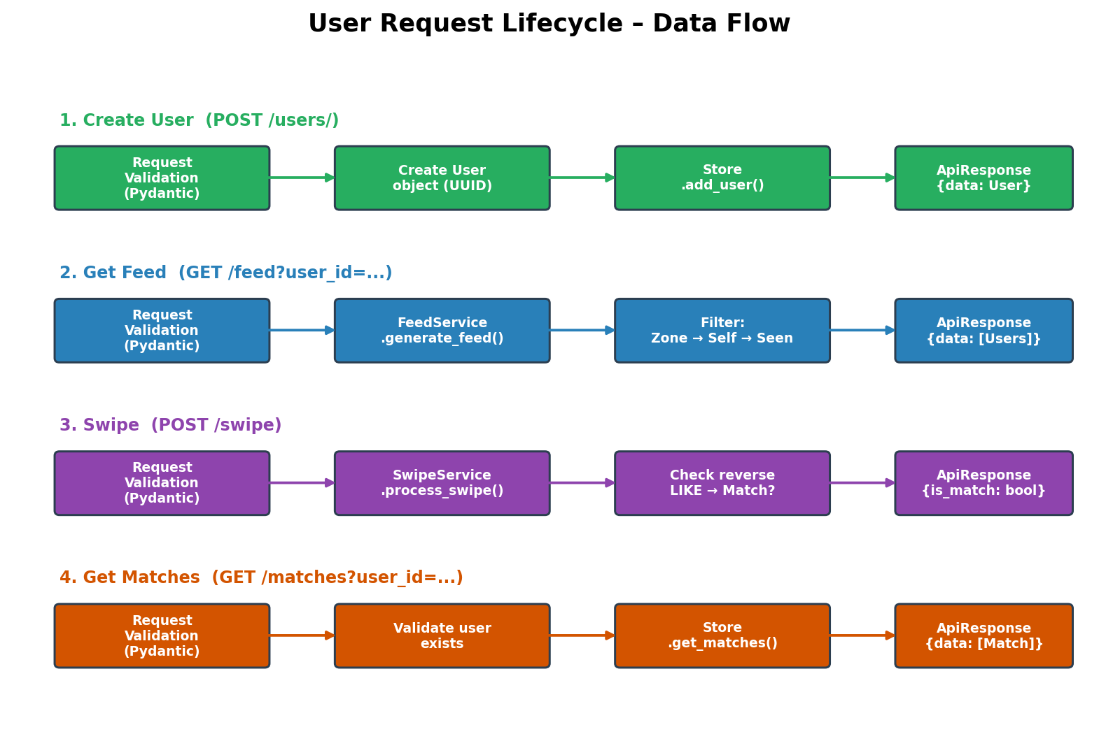

5.2 Feed Generation Pipeline
The feed generation system applies a three-tier filtering pipeline to produce a personalized discovery feed. Each filter progressively narrows the candidate pool:
- Zone Filter — Only users in the same geographic zone (zone_id match)
- Self-Exclusion — Remove the requesting user from results
- Seen-State Filter — Remove users already swiped (LIKE or PASS) by the requester
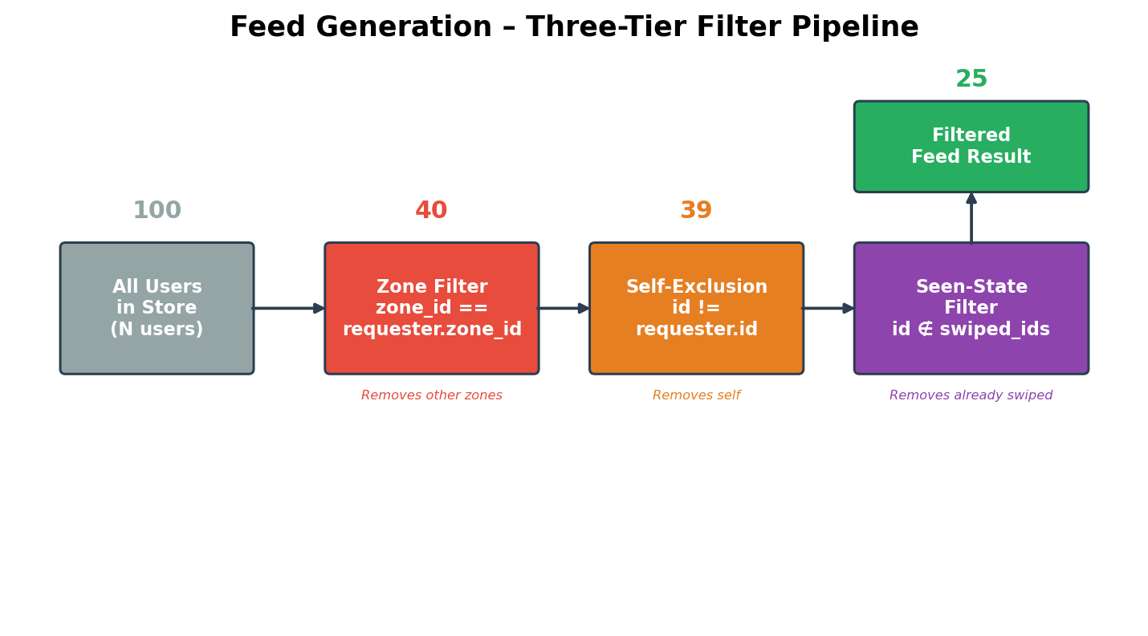

5.3 Match Detection Flow
Match detection occurs during swipe processing. When a LIKE swipe is recorded, the system checks for a reverse LIKE from the target user. If both users have liked each other, a Match record is created and the response indicates a successful match.
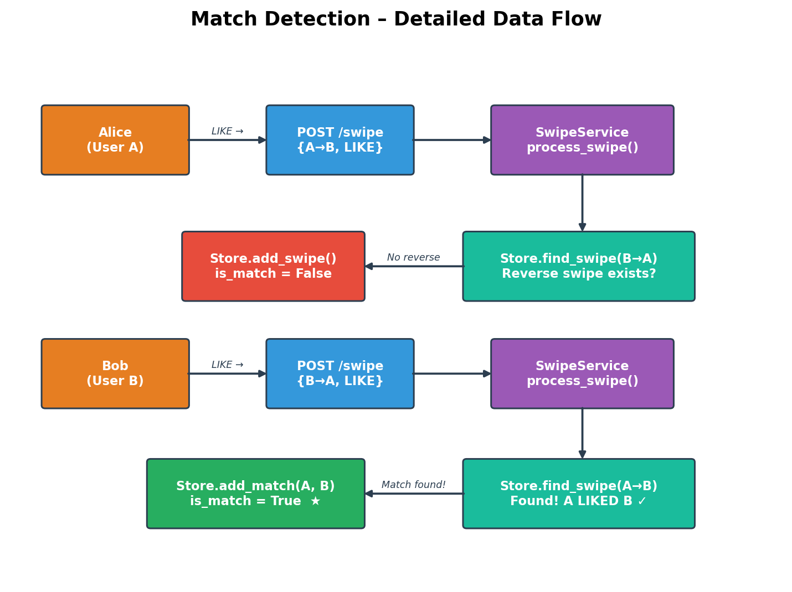

Match detection algorithm:
def process_swipe(swiper_id, swiped_id, action):
store.add_swipe(Swipe(swiper_id, swiped_id, action))
if action == LIKE:
reverse = store.find_swipe(swiped_id, swiper_id)
if reverse and reverse.action == LIKE:
store.add_match(Match(swiper_id, swiped_id))
return True # It's a match!
return False

6. User Journey – Sequence Flow
The following sequence diagram illustrates a complete user journey from profile creation through feed discovery, swiping, and match retrieval. It shows the interaction between four system components: the client (Alice), the API layer, the service layer, and the data store.
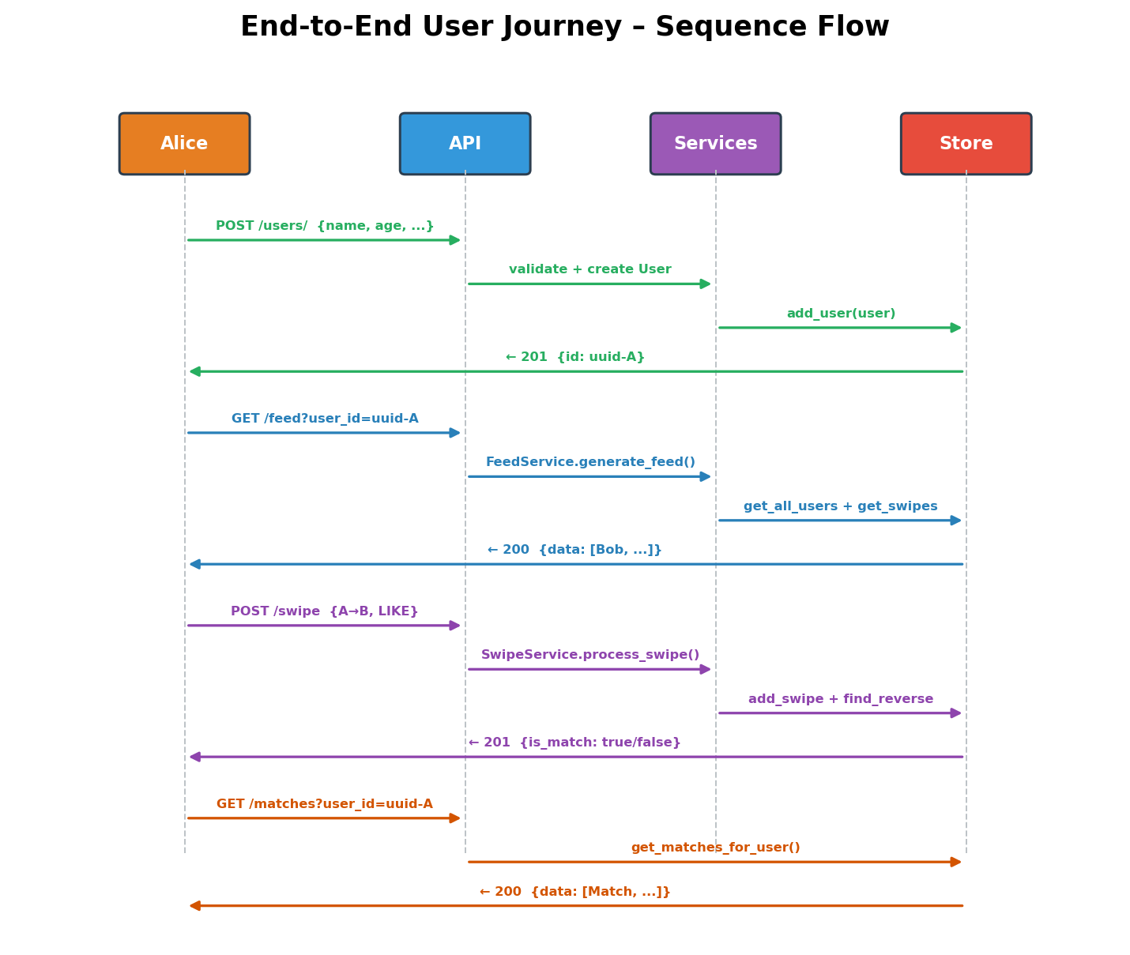

Typical user journey steps:
1. Create Profile — User registers with name, age, gender, and zone. Receives UUID.
2. Discover Feed — User requests discovery feed filtered by zone, excluding self and already-swiped profiles.
3. Swipe Actions — User submits LIKE or PASS decisions. Each swipe is recorded and checked for a mutual match.
4. View Matches — User retrieves list of all mutual matches for further interaction.

7. Service Layer Details

7.1 InMemoryStore
The InMemoryStore is a singleton class that serves as the centralized data persistence layer. It maintains three collections:
- users: dict[UUID, User] — O(1) lookup by user ID
- swipes: list[Swipe] — Chronologically ordered swipe records
- matches: list[Match] — Chronologically ordered match records
The singleton pattern ensures all services share the same data state. A reset() method is provided for test isolation. Key operations include add_user(), get_user(), get_all_users(), add_swipe(), get_swipes_by_user(), find_swipe(), add_match(), and get_matches_for_user().

7.2 FeedService
FeedService is responsible for generating personalized discovery feeds. It receives a user ID and applies the three-tier filter pipeline (zone → self → seen-state) to produce a list of candidate profiles. The service raises a ValueError if the requesting user does not exist.
Performance characteristics: The current implementation iterates through all users in the store (O(N)) and builds a set of already-swiped IDs for O(1) membership checks. This is efficient for the prototype scale but would require indexing by zone_id for production workloads.

7.3 SwipeService
SwipeService handles swipe processing and match detection. It validates that both users exist, prevents self-swiping, records the swipe action, and on LIKE actions, checks for a reciprocal LIKE to detect mutual matches.
The match detection is O(N) on the swipes list in the worst case (via find_swipe). For production, this would benefit from an indexed lookup structure or database query optimization.

8. Testing Strategy
The project includes a comprehensive test suite organized into unit tests for individual services and integration tests for the full API.
Test File | Type | Coverage | Key Scenarios
test_store.py | Unit | InMemoryStore | Singleton behavior, CRUD, reset
test_feed_service.py | Unit | FeedService | Zone filtering, self-exclusion, seen-state
test_swipe_service.py | Unit | SwipeService | Match detection, self-swipe prevention
test_api.py | Integration | All endpoints | 35+ scenarios, error cases, full flows

Test fixtures in conftest.py provide an auto-use store reset fixture to ensure test isolation, a shared HTTP test client, and pre-configured sample users across multiple zones.

9. Security Considerations
As a prototype, the current implementation does not include authentication or authorization. The following areas should be addressed before any production deployment:
- Authentication — Implement JWT or OAuth2 token-based authentication
- Authorization — Ensure users can only perform actions on their own behalf
- Rate Limiting — Protect against abuse with per-user request throttling
- Input Sanitization — While Pydantic handles type validation, additional business rule validation may be needed
- HTTPS — All production traffic should be encrypted in transit
- Data Persistence — Replace in-memory store with a proper database with encryption at rest
- Audit Logging — Track sensitive operations for security monitoring

10. Future Enhancements
The following enhancements would bring the system closer to production readiness:
- Database Integration — PostgreSQL with SQLAlchemy ORM for persistent storage
- Real-time Notifications — WebSocket support for instant match notifications
- Geolocation — GPS coordinate-based distance filtering instead of zone strings
- Recommendation Engine — ML-based profile suggestions beyond simple zone filtering
- Media Support — Profile photo upload and storage (S3/cloud storage integration)
- Messaging — In-app chat system for matched users
- Pagination — Cursor-based pagination for feed and match endpoints
- Caching — Redis layer for frequently accessed data (feeds, user profiles)
- Containerization — Docker support with docker-compose for deployment
- CI/CD — Automated testing and deployment pipeline

