There are 1987 culverts.

We clipped 1987 samples with size 800X800 meter from a large area (fig1). Each of samples have at least 1 culvert (fig2).

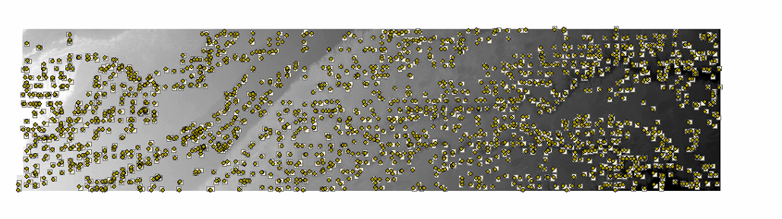

Fig1

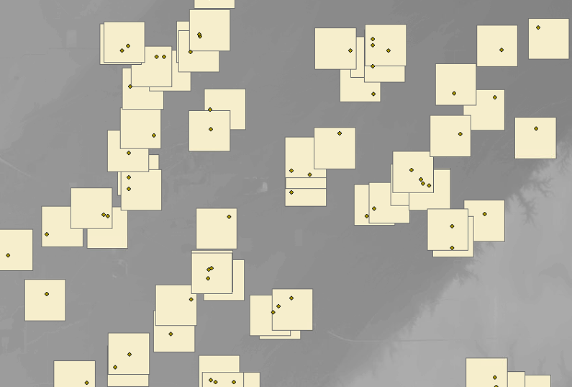

Fig2

Coordinate_in_Bbox.csv contains culverts local coordinate in each samples (fig3).

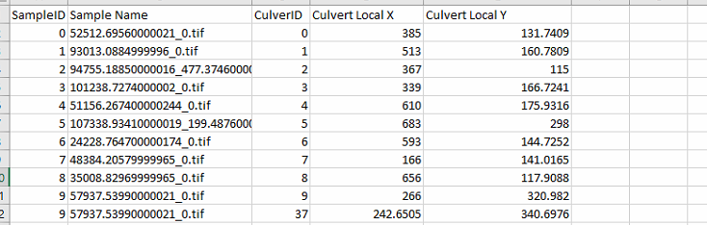

Some samples may contain more than 1 culvert

Fig3

Y

X

800m

800m

(0,0)

Culvert