RPI Gateway : ./total.sh (packet forwarding && mosquitto shell)

Gateway: ./mqtt_sub.sh

(TTN uplink information MQTT 로 downlink 받기 성공)

Broker : mosquitto_sub -h us-west.thethings.network -t "+/devices/+/up" -u "ksw2019agiot" -P "ttn-account-v2.nJAy-JFHF3lX1Pl6iy84cGHEw_MwdIc6h-nNGsgwL8k" -v > log.txt

--------------------------------------------------------------------

mosquitto_sub -h us-west.thethings.network -t "+/devices/+/up " -u "ksw2019agiot" -P "ttn-account-v2.nJAy-JFHF3lX1Pl6iy84cGHEw_MwdIc6h-nNGsgwL 8k" -v -C 1 > log.txt

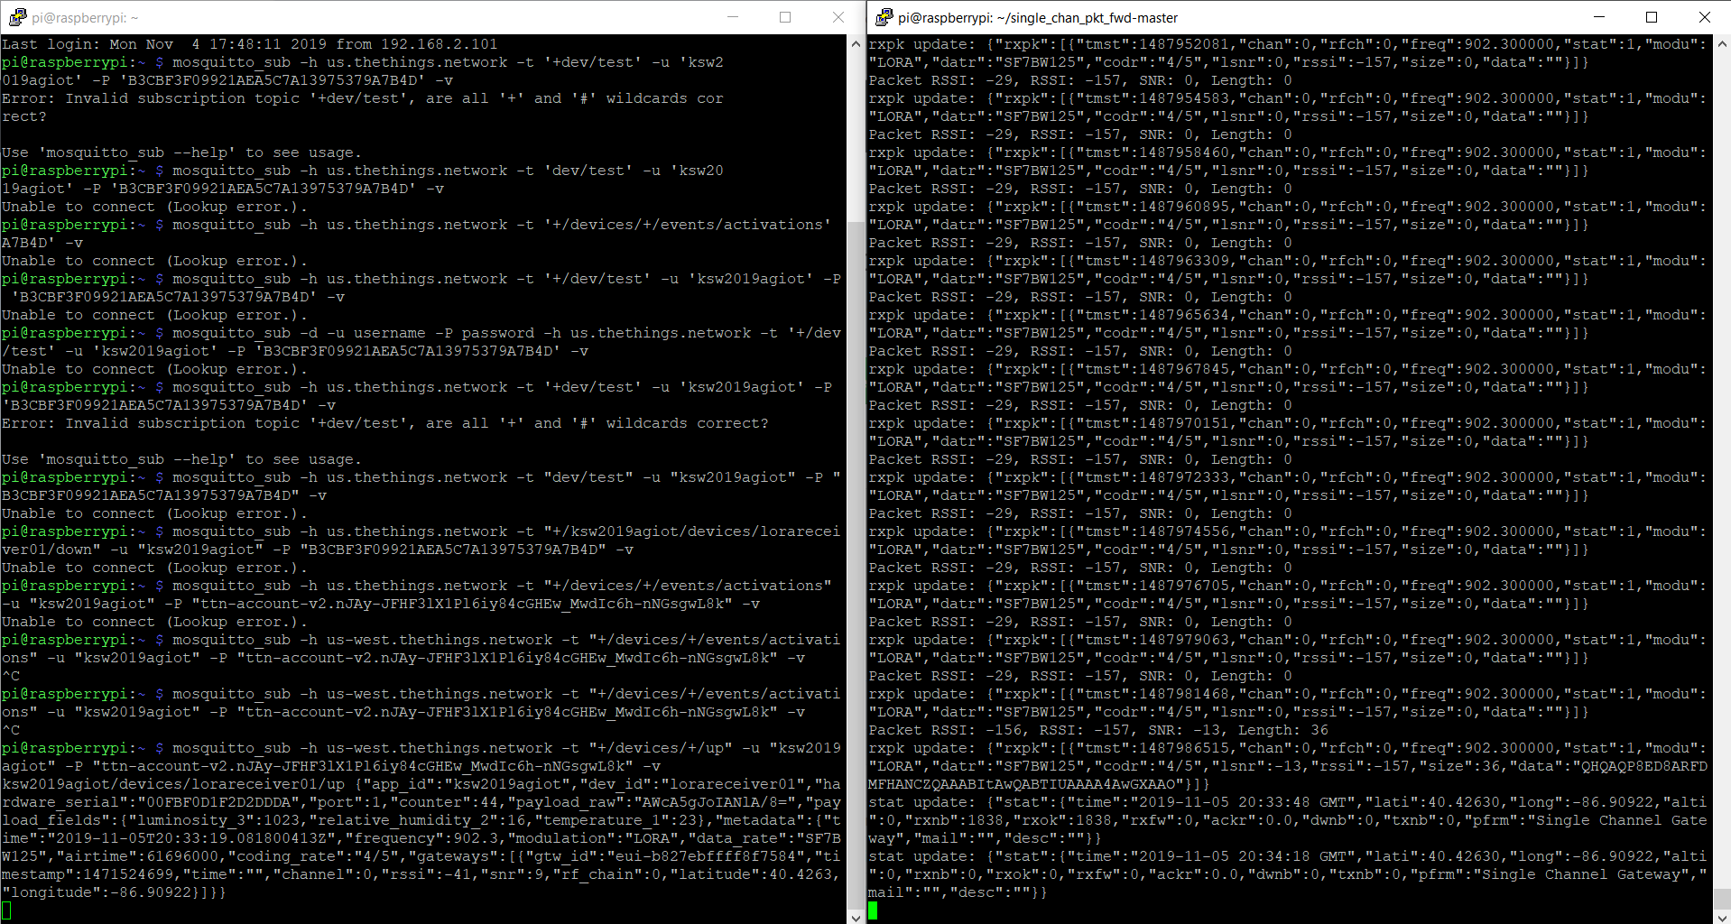

—————————————————————————————————--

Broker : mosquitto_pub -h 192.168.2.62 -p 1883 -u username -P password -t "dev/test" -m "time:"2019-11-05T21:03:28.72443542Z",luminosity_3:1023,relative_humidity:16,temperature:23”

*/ -> on behalf of TTN

Gateway : mosquitto_sub -u agiot -P 2019 -t "dev/test" -C 1 > data.txt

MQTT: <http://mqtt.org/faq>

MQTT stands for MQ Telemetry Transport. It is a publish/subscribe, extremely simple and lightweight **messaging protocol**, designed for constrained devices and low-bandwidth, high-latency or unreliable networks. The design principles are to minimize network bandwidth and device resource requirements whilst also attempting to ensure reliability and some degree of assurance of delivery. These principles also turn out to make the protocol ideal of the emerging “machine-to-machine” (M2M) or “Internet of Things” world of connected devices, and for mobile applications where bandwidth and battery power are at a premium.

한국어 버젼

<https://jgtonys.github.io/iot/2018/07/13/mqtt-test/>

<https://docs.oasis-open.org/mqtt/mqtt/v5.0/mqtt-v5.0.html>

1. Mosquitto

<https://mosquitto.org/blog/>

Broker:

관련 YouTube 영상

<https://www.youtube.com/watch?v=AsDHEDbyLfg>

Arduino MQTT Code

<https://www.baldengineer.com/mqtt-tutorial.html>

Arduino MQTT Install

<https://www.digikey.com/en/maker/blogs/2018/how-to-use-basic-mqtt-on-arduino>

Simple LoraGateway

<https://github.com/leedowthwaite/SimpleLoRaGateway>

MQTT logger

<http://www.steves-internet-guide.com/simple-python-mqtt-topic-logger/>

MQTT Client Library Tutorial

<https://www.hivemq.com/mqtt-client-library-encyclopedia/>

1. Cayenne

<https://developers.mydevices.com/cayenne/docs/cayenne-mqtt-api/>

Broker: Cayenne Cloud

MQTT-SN over LoRa

<https://github.com/bngesp/mqtt-sn-over-lora-communication.git>

MQTT VS MQTT-SN

<http://www.mqtt.org/new/wp-content/uploads/2009/06/MQTT-SN_spec_v1.2.pdf>

LoRa server 공홈에서 MQTT-> lorawan 기반

<https://www.loraserver.io/community/source/>

IBM MQTT

<https://developer.ibm.com/recipes/tutorials/lora-radio-addon-for-iot-gateway/>

Raspberry Pi TTN

[**https://www.instructables.com/id/Use-Lora-Shield-and-RPi-to-Build-a-LoRaWAN-Gateway/**](https://www.instructables.com/id/Use-Lora-Shield-and-RPi-to-Build-a-LoRaWAN-Gateway/)

If use IBM buy this

<https://www.amazon.com/Adafruit-Assembled-Feather-ESP8266-Stacking/dp/B074XMF9W7/ref=asc_df_B074XMF9W7/?tag=hyprod-20&linkCode=df0&hvadid=309777534894&hvpos=1o2&hvnetw=g&hvrand=2085102168063354313&hvpone=&hvptwo=&hvqmt=&hvdev=c&hvdvcmdl=&hvlocint=&hvlocphy=9016722&hvtargid=pla-572925712012&psc=1&tag=&ref=&adgrpid=58425267301&hvpone=&hvptwo=&hvadid=309777534894&hvpos=1o2&hvnetw=g&hvrand=2085102168063354313&hvqmt=&hvdev=c&hvdvcmdl=&hvlocint=&hvlocphy=9016722&hvtargid=pla-572925712012>