보유 목록 ( What we have)

|  |  |  |
| --- | --- | --- |
| Name | Count |  |
| Arduino Uno | 4 |  |
| Raspberry Pi | 2 |  |
| Ultimate GPS Breakout v3 | 1 | GPS sensor |
| LUMEX 1902D/A | 1 | LCD |
| 1602A | 1 | LCD |
| Argent Data System RadioShield 2.1 | 3 | Radio shield |
| DS18b20 | 3 | temperature sensor |
| ??? | 1 | GPS Antenna |
| HC-SR04 | 1 | Sonic Distance Sensor |
| UC-346 | 1 | Arduino Camera |
| DHT11 | 4 | humidity-temperature sensor |
| DHT22 | 16 | humidity-temperature sensor |
| Adafruit T-Cobbler Plus |  | Cobbler |
| SRD-12VDC-SI-C | 1 | Songle Relay..? |
| B103 joystick | 1 |  |
| HX1-144.390-3 | 1 | Radio Transmitter |
| NRX1-173.250-10 | 1 | Radio Receiver |
| Lithium Polymer battery | 1 |  |
| 2212-920 모터 | 2 |  |
| DRAGINO Lora Shield v1.4 | 1 | Lora Shield |
| Arduino ETHShield | 1 | Arduino ETHShield |
| DRAGNO Lora GPS Shield v1.3 | 2 | Lora GPS Shield |
| VH400 | 2 | Soil humidity-temperature |
| Lora GPS HAT for RPI v1.4 | 1 | Lora GPS HAT |

필요한 목록(Things we need)

|  |  |  |  |
| --- | --- | --- | --- |
| Name | Link | Count | Have |
| HX1 | <https://lemosint.com/product/hx1-144-390-3/> | 3 | 1 |
| DHT11 | X | 2 | 4 |
| radio shield | X | 2 | 3 |
| Ultimate GPS Breakout v3 | X | 2 | 2 |
| Arduino Uno | X | 3 | 4 |
| Raspberry Pi | X | 2 | 2 |
| Lora Shield | X | 1 | 1 |

작년 가을 List:

|  |  |  |  |  |
| --- | --- | --- | --- | --- |
| Raspberry Pi 3 | <https://www.amazon.com/Raspberry-Pi-RASPBERRYPI3-MODB-1GB-Model-Motherboard/dp/B01CD5VC92/ref=sr_1_3?s=electronics&ie=UTF8&qid=1537283478&sr=1-3&keywords=Raspberry+Pi> | 34.99 | 2 | 69.98 |
| Ambient weather | <https://www.amazon.com/gp/product/B01N5TEHLI/ref=s9_acsd_top_hd_bw_bQtb07_cr_x__w?pf_rd_m=ATVPDKIKX0DER&pf_rd_s=merchandised-search-3&pf_rd_r=T2ZGZGP3ZZTV5BKVE8AQ&pf_rd_r=T2ZGZGP3ZZTV5BKVE8AQ&pf_rd_t=101&pf_rd_p=c1b3202b-0032-51bc-814d-12861e2e20e4&pf_rd_p=c1b3202b-0032-51bc-814d-12861e2e20e4&pf_rd_i=397435011> | 169 | 1 | 169 |
| Long distance wireless 915 Mhz Lora and GPS Expansion Board for Raspberry Pi | <https://www.amazon.com/distance-wireless-Expansion-Board-Raspberry/dp/B01M7V7PRL/ref=sr_1_1?s=wireless&ie=UTF8&qid=1537146753&sr=8-1&keywords=Long+distance+wireless+915+Mhz+Lora+and+GPS+Expansion+Board+for+Raspberry+Pi> | 28.5 | 4 | 114 |
| Lora Gateway 915Mhz | <https://www.tindie.com/products/edwin/lg01-lora-openwrt-iot-gateway/> | 56 | 2 | 112 |
| Vegetronix VH400 Soil Moisture Sensor Probes | <https://www.vegetronix.com/Products/VH400/> | 39.95 | 4 | 159.8 |
| HackRF One | [Amazon Link](https://www.amazon.com/NooElec-Software-Defined-Antenna-Adapter/dp/B01K1CCHR0/ref=sr_1_4?ie=UTF8&qid=1537369202&sr=8-4&keywords=hackrf+one&dpID=51ySHR3O-0L&preST=_SY300_QL70_&dpSrc=srch) | $317.95 | 1 | $317.95 |
| Battery / Solar Charger | <https://www.amazon.com/dp/B07F39SQQ2/ref=sspa_dk_detail_6?psc=1&pd_rd_i=B07F39SQQ2&pf_rd_m=ATVPDKIKX0DER&pf_rd_p=f52e26da-1287-4616-824b-efc564ff75a4&pf_rd_r=8TR658TVJ80QNNEB8S8K&pd_rd_wg=sWewX&pf_rd_s=desktop-dp-sims&pf_rd_t=40701&pd_rd_w=UtCSO&pf_rd_i=desktop-dp-sims&pd_rd_r=1e79f5bf-c1e9-11e8-b8af-f95a7d78e913> | $45 | 4 | 180 |
|  |  |  |  |  |
| Water Solenoid Valve 3/4" NMPT | <https://www.amazon.com/DIGITEN-Electric-Solenoid-Normally-Closed/dp/B00YPA6XRA#customerReviews> | 10.99 | 1 | 10.99 |
| Water Tank (TBD) (Thinking a 275gal) | <https://www.ntotank.com/275gallon-nto-white-reconditioned-ibc-tote-tank-x7738445?gclid=Cj0KCQjwxvbdBRC0ARIsAKmec9YtcZp6aPuCZn-2AfC7o7xboq6Gu8QtK_gQczTPgSxDc54LRhewPEsaAuVKEALw_wcB> | 179.99 | 1(TBD) | 179.99 |
| Water Tank Locking Cam Female x 2" MNPT | <https://www.mcmaster.com/5535k22> | 10.22 | 1 | 10.22 |
| 2" FNPT x 3/4" FNPT | <https://www.mcmaster.com/44605K331> | 15.73 | 1 | 15.73 |
| 3/4" FNPT x 3/4" MGHT | <https://www.mcmaster.com/73605t93> | 4.63 | 1 | 4.63 |
| 3/4" GHT Hose Splitter | <https://www.mcmaster.com/7459t11> | $10.79 | 1 | $10.79 |
| 3/4" GHT Drip Tapes | <https://www.amazon.com/Melnor-Flat-Soaker-Garden-Hose/dp/B074WHN7K7?keywords=drip%2Btape&qid=1539215023&sr=8-17&ref=sr_1_17&th=1> | 18.13 | 1 (set) | 18.13 |

2019 Summer Circuit Board

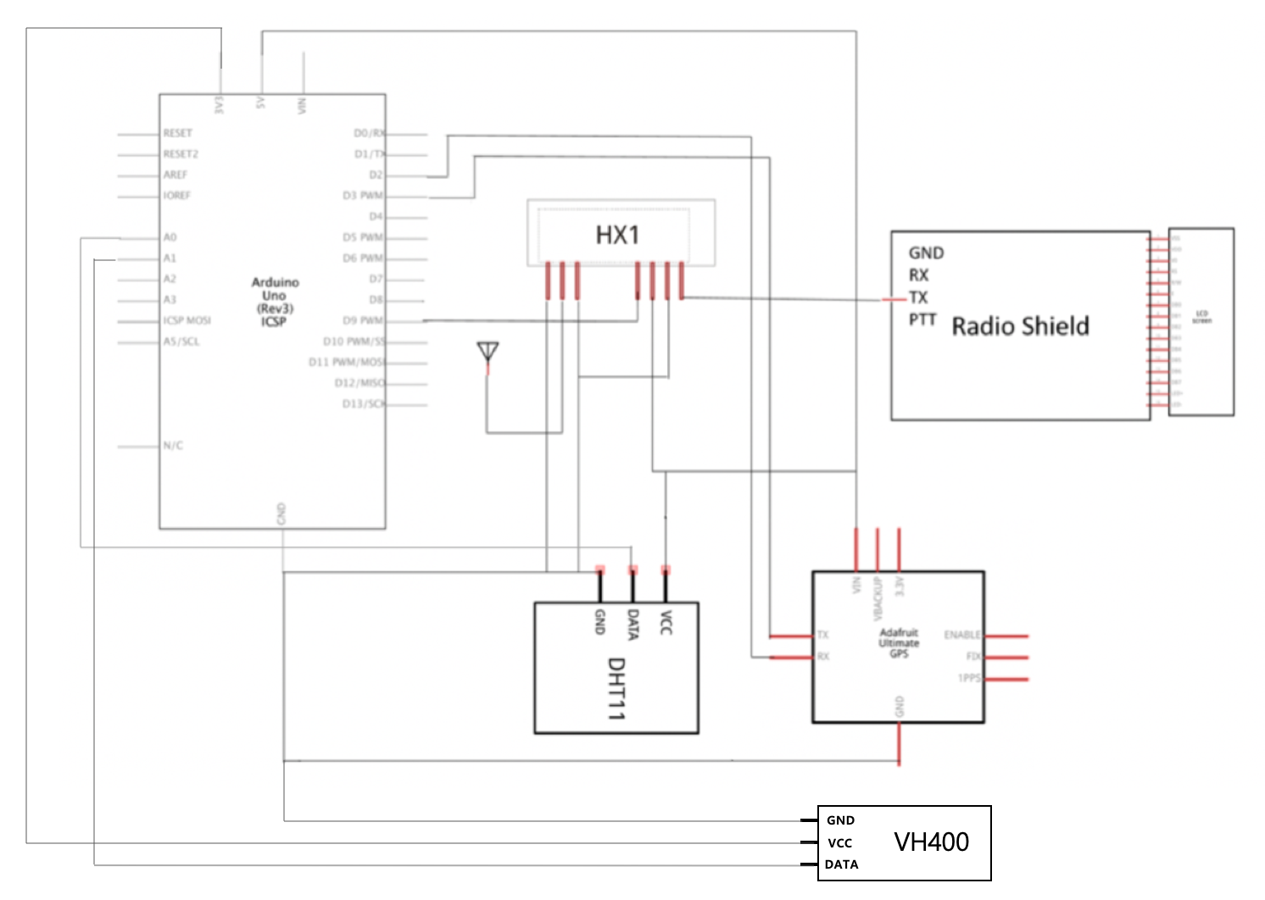

HX1: Transmitter

DHT11: humidity, temperature sensor

1. Raspberry Pi3

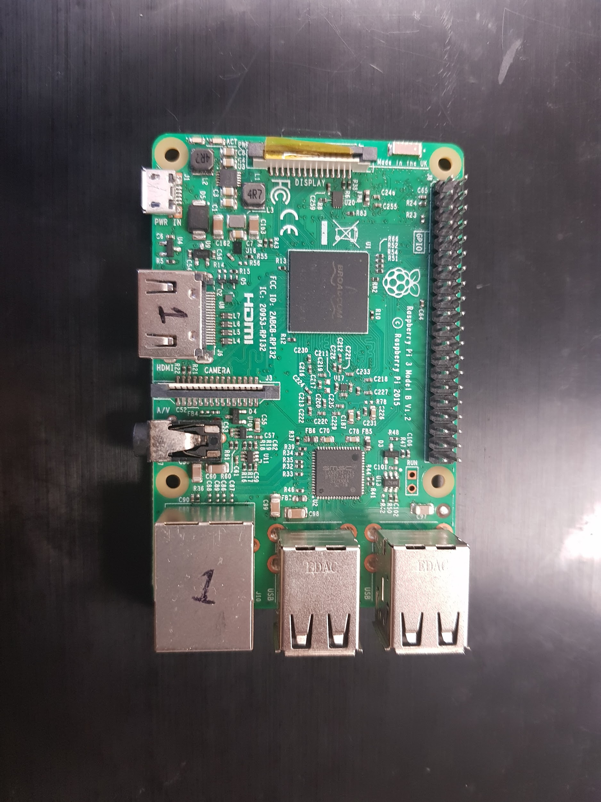

1. Arduino

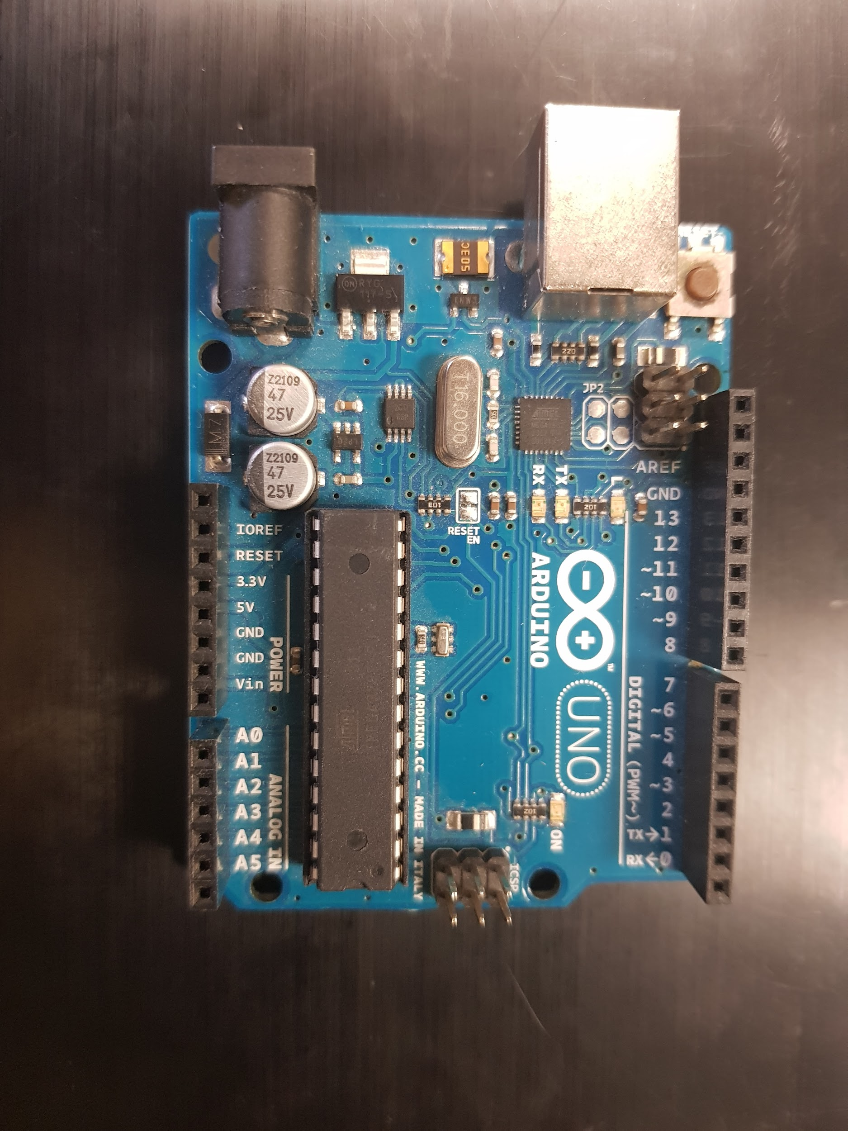

1. Argent Data Systems RadioShield 2.1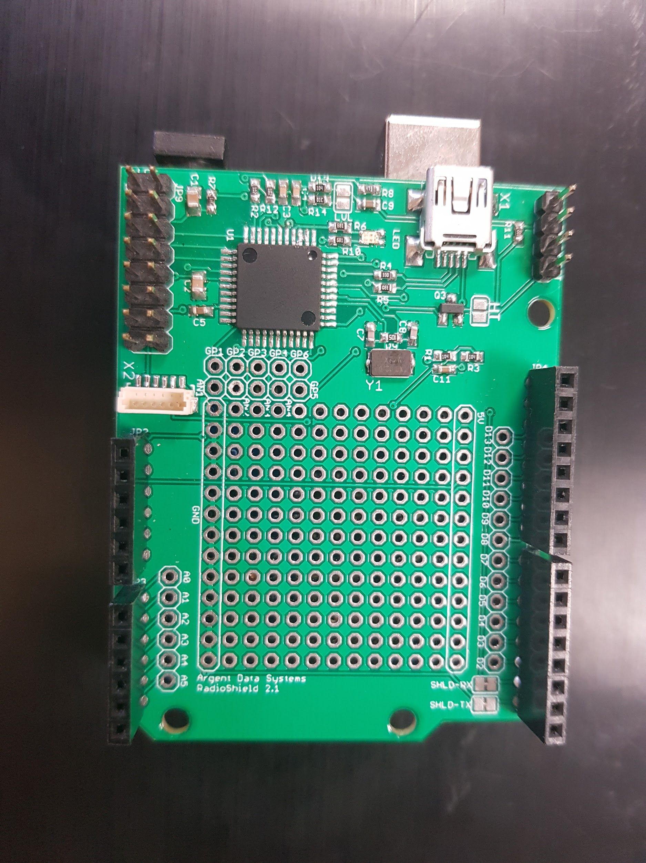

<http://wiki.argentdata.com/index.php?title=Radio_Shield_2> - wiki for radio shield 2

1. GPS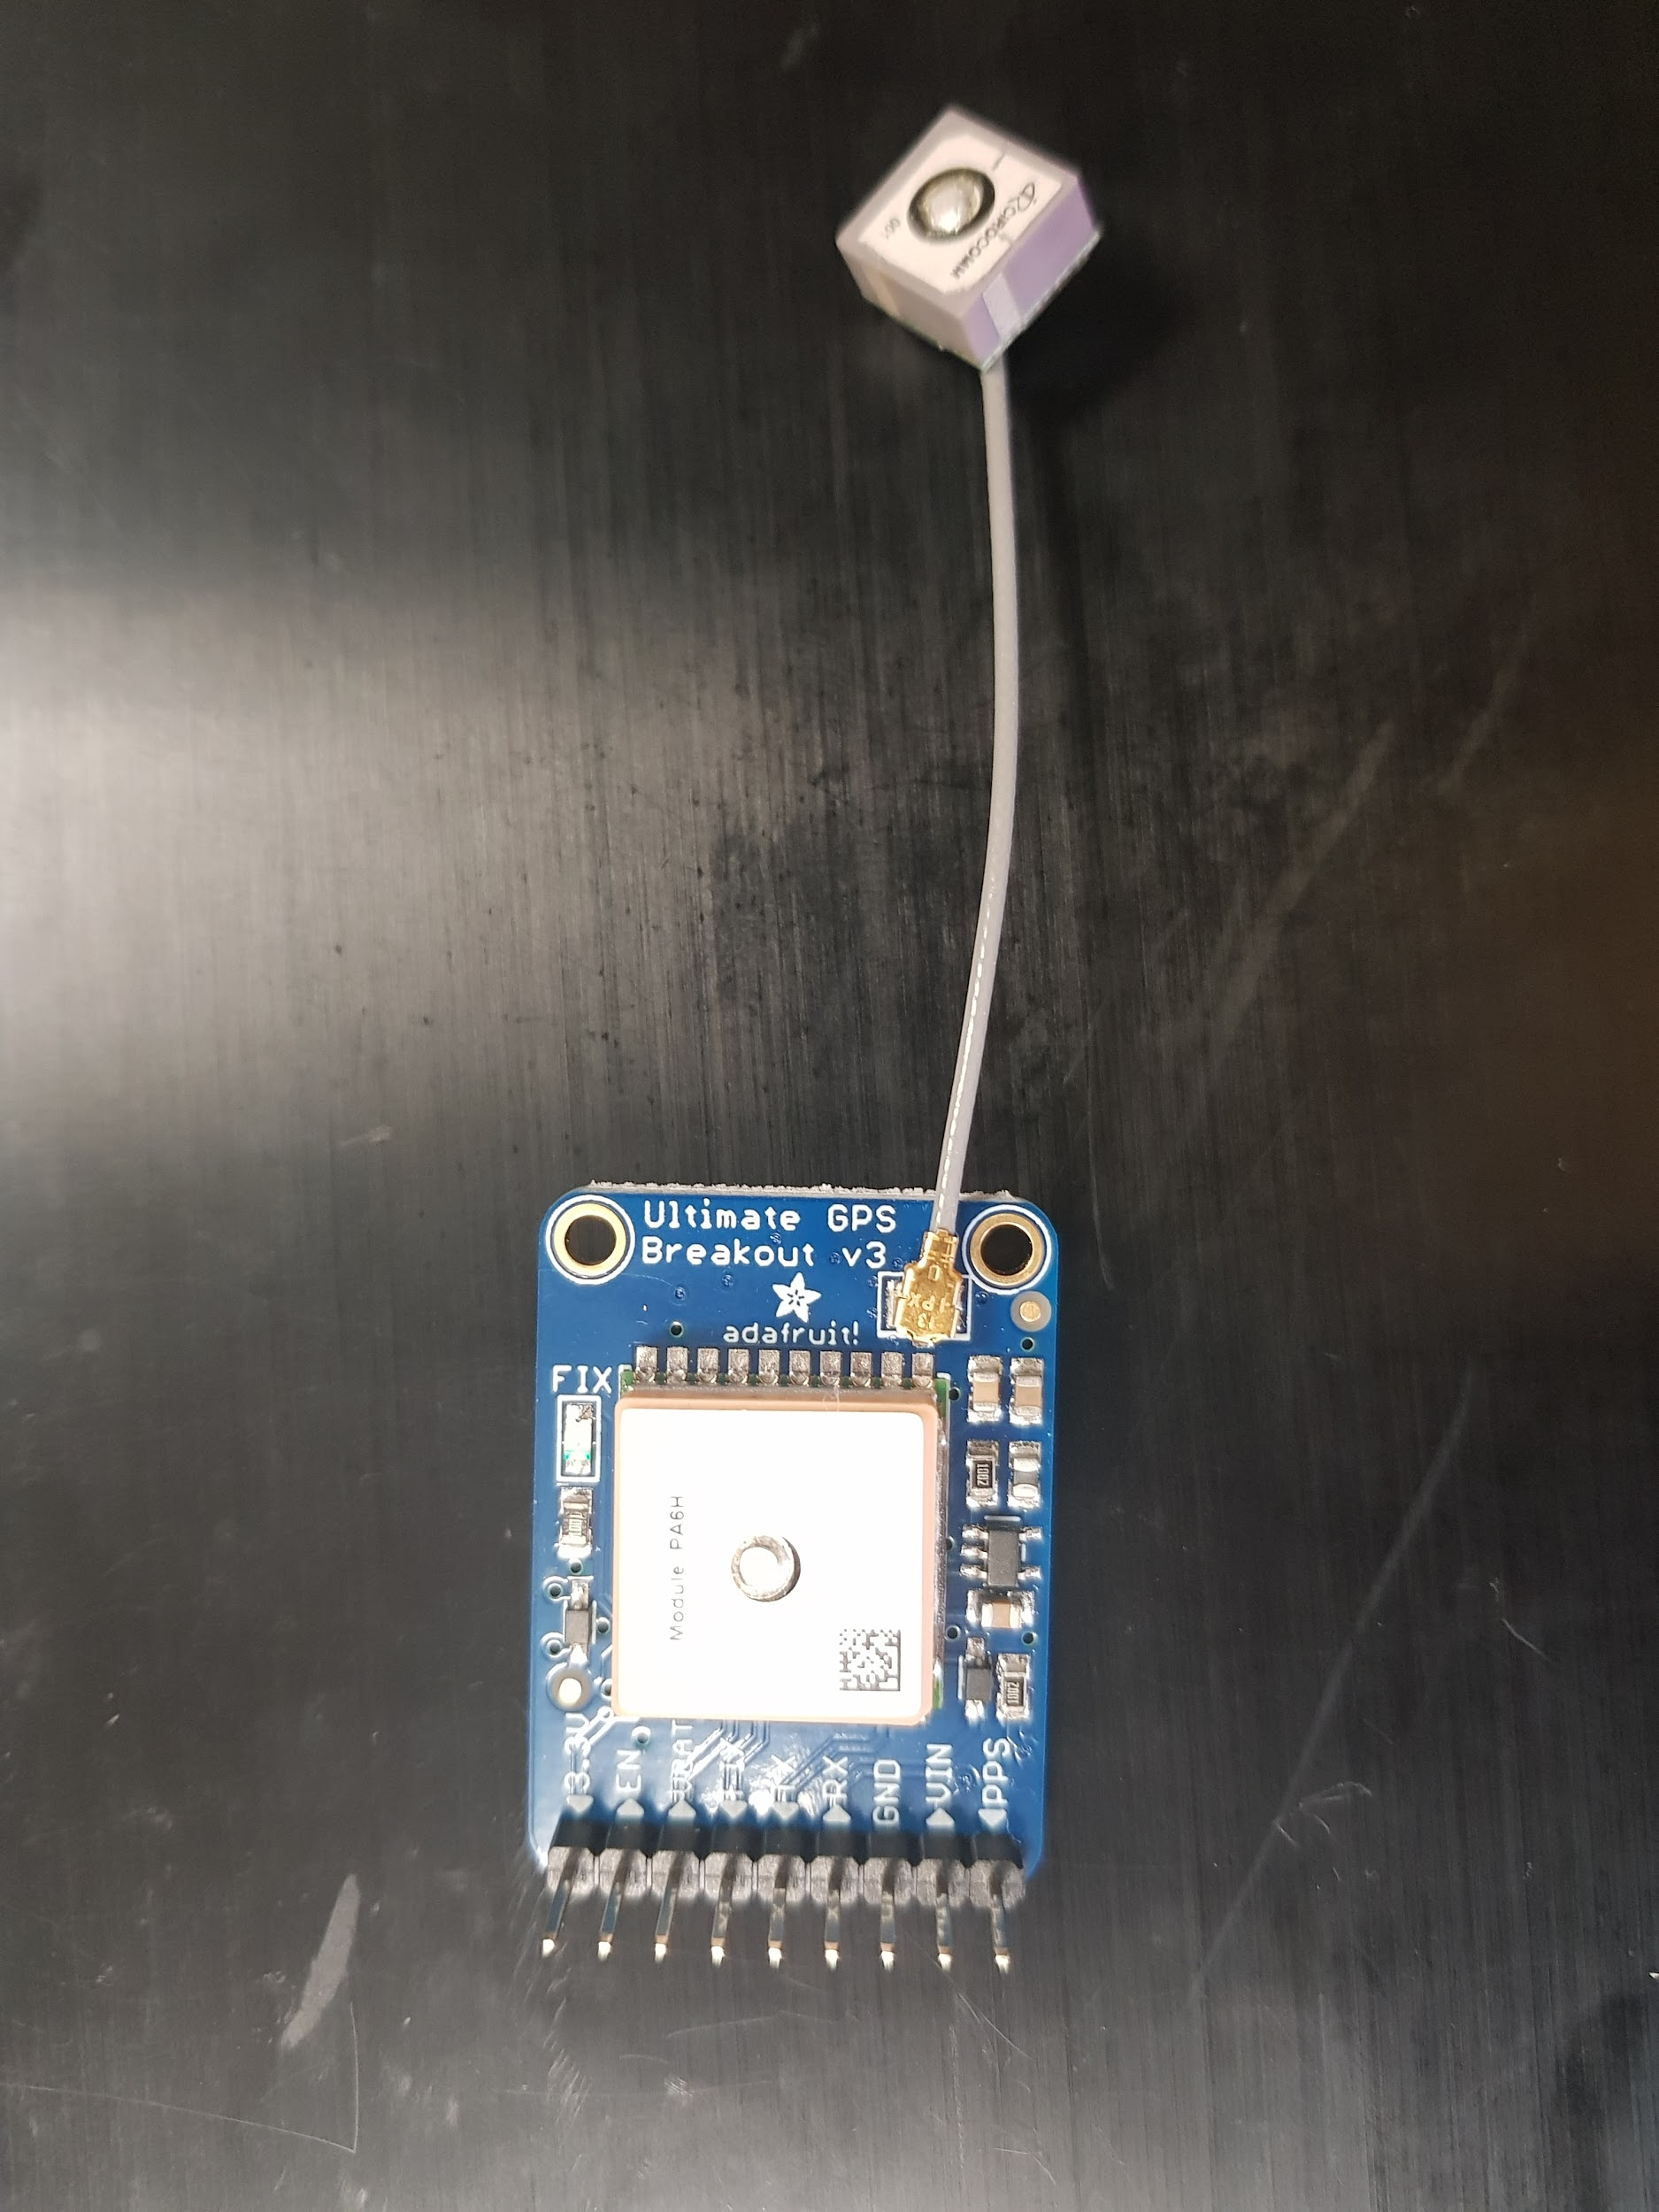
2. Radiometrix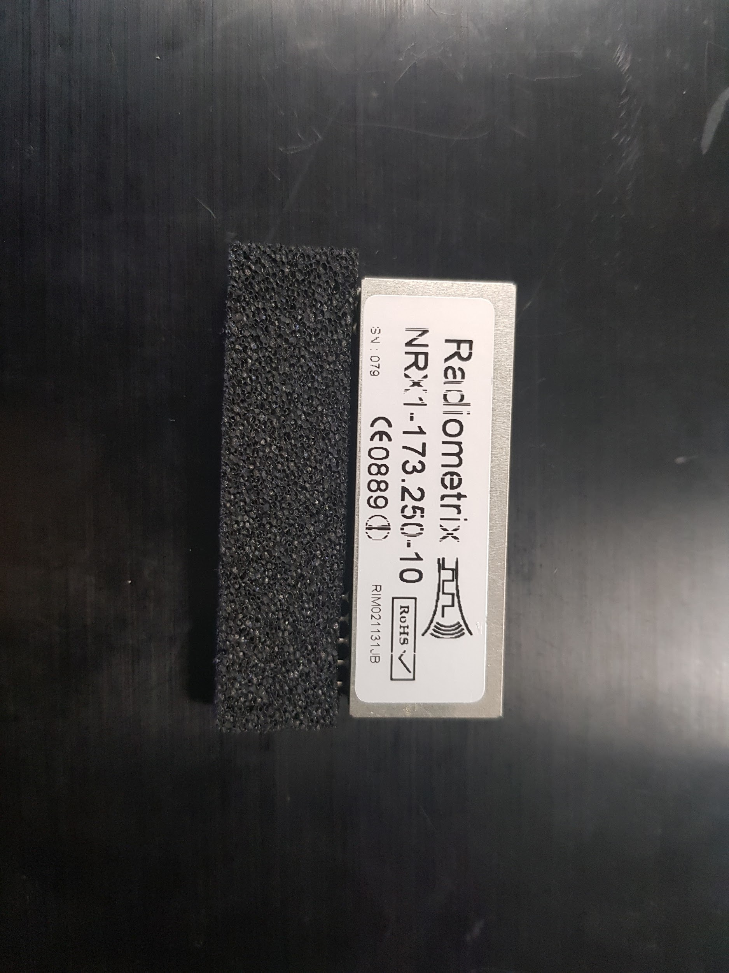

<http://www.radiometrix.com/content/nrx1>

The NRX1 is a VHF radio data receiver and it offers a low power, reliable data link in a Radiometrix SIL standard pin out and foot print. It is an enhanced, low cost version of the Radiometrix RX1, but in a slightly larger dimension.

NRX1 is compatible with the TX1 series of transmitters, and the BiM1 transceiver.

## **Features**

* **Designed to comply with harmonised radio standard EN 300 220-3 and EMC standard EN 301 489-3**
* **Frequencies available as standard: 151.3000MHz, 169.4125MHz, 173.2250MHz and 173.2500MHz**
* **Other custom frequencies from 120MHz to 180MHz available to order**
* **Data rates up to 10 kbps with 25kHz channel spacing**
* **Usable range to 10km+ with matching transmitter**
* **Fully screened**