Planning
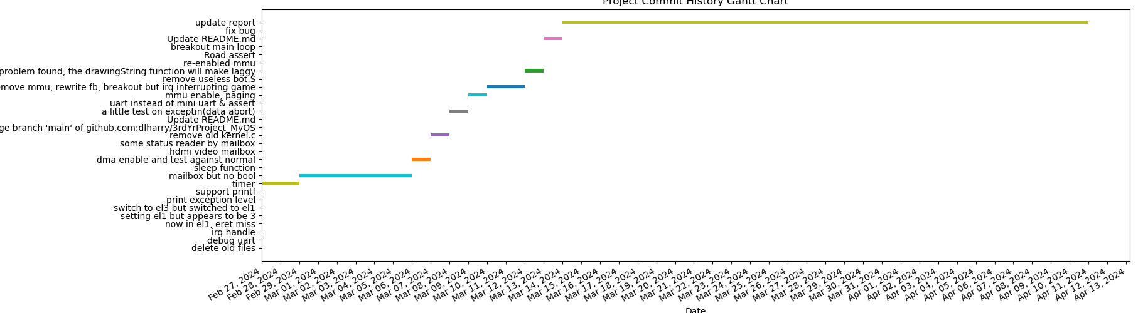
The Gantt chart detail the project's version history over a period from February to April, based on commit messages from a GitHub repository. It visually represents the timeline and duration of different tasks and milestones in the development of the bare-metal system kernel on a Raspberry Pi.
Initial Setup (Late February): The chart begins with initial tasks such as enabling UART and experimenting with exception levels, indicating foundational setup activities. This period likely involved setting up the development environment, establishing the basic structure of the project, and ensuring that the Raspberry Pi could boot and handle low-level operations.
Core Development (Early March): The subsequent phase includes activities such as managing IRQs, developing the print functionality for debugging, and optimizing exception level handling. These tasks suggest a deep dive into the intricacies of the system's architecture and a focus on establishing robust error handling and output for developmental feedback.
Peripheral Integration (Mid-March): The progression continues with mailbox communication setup, highlighting the integration of the ARM CPU with the VideoCore GPU. During this phase, the project tackled direct hardware communication, a crucial aspect of bare-metal programming on the Raspberry Pi, which allows for various operations including querying system information and managing frame buffer configurations for video output.
Performance Optimization (Late March): Notable commits point towards enabling DMA, indicating a shift toward performance optimization, particularly for video output. By harnessing DMA, the project moved from CPU-bound operations to more efficient, hardware-accelerated processes, significantly improving rendering times and system efficiency.
Enhanced Functionality (Early April): As the project neared completion, commits suggest refinement and additional functionality, such as improving the drawing function to address lag issues and updating the system's report. These activities likely represent the polishing phase of the project, where features are optimized and documentation is updated to reflect the system's capabilities and design choices.

Final Adjustments (Mid-April): The last few commits, including multiple updates to the report, indicate a phase of evaluation and final adjustments. This final stage likely involved documenting the project, fixing any remaining bugs, and preparing the project for presentation or delivery.
Overall Project Implementation Insights:
The Gantt chart demonstrates a well-structured approach to development, with clear phases marked by setup, core development, integration, optimization, enhancement, and final adjustments. Each phase is characterized by focused commits that suggest a sequential and methodical approach to tackling the complexities of bare-metal programming.
The tasks outlined in the chart reflect the project's complexity, from manipulating low-level system hardware to optimizing high-level functionalities like video output. The gradual shift from foundational tasks to performance and functionality enhancements illustrates a mature development process, emphasizing iterative testing, feature integration, and continuous improvement.
This visual representation of the project timeline is an excellent tool for understanding the progression of complex software development projects, offering insights into the project management and technical challenges overcome by the author.

