Introduction
By learning the course operating system, the author have grew great interest in developing his own operating system, this final year project has provided a great chance for this. However during the planning and developing, the author realized little by little that it is impossible to achieve what he imagined at the first place, which is an operating system that contains UI, file system, memory management, process scheduling and finally allow user to run their own games or programs on the Raspberry Pi, instead, the project gradually become a bare-metal game that boots directly from Micro SD card running on Raspberry Pi model 4B, displaying graphic output on the monitor and receive user input from serial cable. It has been a deep pity to the author himself that due to the time limit on the project he cannot finish all, but the project will keep develop in the future work.
The report is written for COMP----- Final Year project, describing the design, implementation and outcomes from creating a bare-metal kernel communicating with peripherals running a recreation of legacy game ‘Breakout’ on Raspberry Pi model 4B (RPI 4 in short).
The ideas that project mentioned allow author grow deeper understanding of computer architecture and concepts in Unix-like operating systems. Since the programming is mostly low-level and the specific processor model BCM2711 that RPI 4 uses, the languages chosen for programming the project are C and ARMv8 Assembly, the project has achieved a significant improve on author’s programming ability in the languages, valuable for building more robust and efficient software at higher levels of abstraction.

Background

The part will start with providing concepts of ‘bare-metal’ as well as its pros/cons before moving onto Raspberry Pi and its associated concepts including ARM v8. It will discuss the motivation of choosing this specific product and the game ‘Breakout’ for development. The section will provide prior knowledge for the reader understand the work completed in the report better.

Bare-metal
Bare machine (or bare metal) in computer science means computers executing instructions directly on hardware without abstraction layer like an operating system (OS). In the present day, modern OS has evolved to complex systems integrating multiple services. Before OS’s development, sequential instructions were executed on the computer hardware directly using machine language without any system software layer. This approach is termed the ”bare machine” precursor to modern operating systems. Today it is mostly applicable to embedded systems and firmware with time-critical latency requirements, while conventional programs are run by a runtime system overlaid on an OS. Which provides author a suitable way of developing an embedded OS.

Advantages/Disadvantages of Bare-metal
Bare-metal programming offers several advantages in terms of control and efficiency:
- Direct hardware control: Bare-metal programming allows developers have direct access to the hardware components of a system, such as the CPU, memory, and peripherals, which provides sufficient control for developing OS and utilizing hardware resources.
- Minimal resource overhead: OS introduce overhead in terms of memory and processing power. Bare-metal programming allows author to implement his own memory management.
- Deterministic behaviour: Bare-metal programs typically exhibit deterministic behaviour since there are no other processes or tasks running concurrently that could interfere with their execution.
- Reduced latency: By bypassing the layers of abstraction introduced by an operating system, bare-metal programs can achieve lower latency in responding to inputs or events.
However, challenges of bare-metal programming are still not ignorable.
For a given application, bare-metal programming requires more effort to work properly and is more complex because the services provided by the operating system and used by the application have to be re-implemented regarding the needs. Including: system boot, memory management, interruptions handling, peripherals management, error management, etc. De-bugging a bare-metal program is difficult since there are no supports (like error notifications, standard output, etc) as in software development unless they have been implemented and validated.
Additionally, bare-metal programs are less portable and may require more effort to maintain and update compared to software developed using higher-level abstractions.

Raspberry Pi
The Raspberry Pi series developed in the United Kingdom by the Raspberry Pi Foundation in association with Broadcom is a collection of single-board computers (SBCs), popular in a variety of projects and applications for its low-cost, multi-functioning and easy to use. Domains including STEM education, robotic/electronics experimentation, internet of things (IoT) application all has a place for RPI.
The Raspberry Pi 4 Model B that the author’s choice in this project was released in June 2019 with a 1.5 GHz 64-bit quad core ARM Cortex-A72 processor, a 40-pin general purpose input-output (GPIO) pinout, powered via a USB-C port or GPIO pins and many other interesting peripherals but since they are not relevant to the project, the report will not introduce further here.

UART
Serial input/output is an easy-to-implement tool mostly used when debugging embedded projects. It allows sending/receiving data needed from microcontroller to a computer's serial port so it can be viewed using a terminal emulator. These two devices are compatible from a software perspective, however just hook a microcontroller up to a computer will not work since the hardware interfaces are not compatible, that is when UARTs (universally asynchronous receiver/transmitter) comes into play, that can be used to receive and transmit data serially. UARTs transmit one bit at a time at a specified data rate (i.e. 9600bps, 115200bps, etc.). This method of serial communication is referred to as TTL serial (transistor-transistor logic). Serial communication at a TTL level will always remain between the limits of 0V and Vcc, which is often 5V or 3.3V. A logic high ('1') is represented by Vcc, while a logic low ('0') is 0V. (https://www.sparkfun.com/tutorials/215)
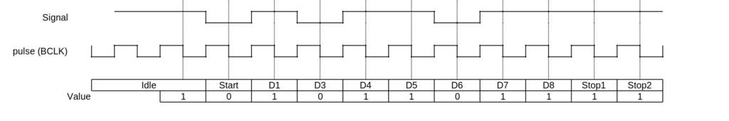
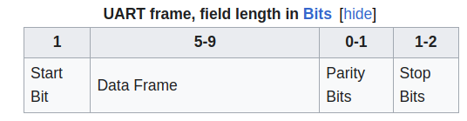
GPIO and the 40-pin header
A general-purpose input/output (GPIO) is an uncommitted digital signal pin on an integrated circuit or electronic circuit board which may be used as an input or output, or both, and is controllable by software. GPIOs have no predefined purpose and are unused by default. If used, the purpose and behaviour of a GPIO is defined and implemented by the designer of higher assembly-level circuitry: the circuit board designer in the case of integrated circuit GPIOs, or system integrator in the case of board-level GPIOs. Any of the GPIO pins can be designated in software as an input or output pin and used for a wide range of purposes.
This project will only be using GPIO 14 and GPIO 15 for UART input and pin 6 for GROUND, which are defined in the Raspberry Pi BCM2711 manual.
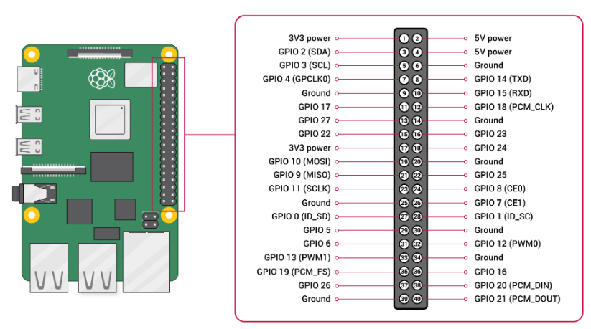
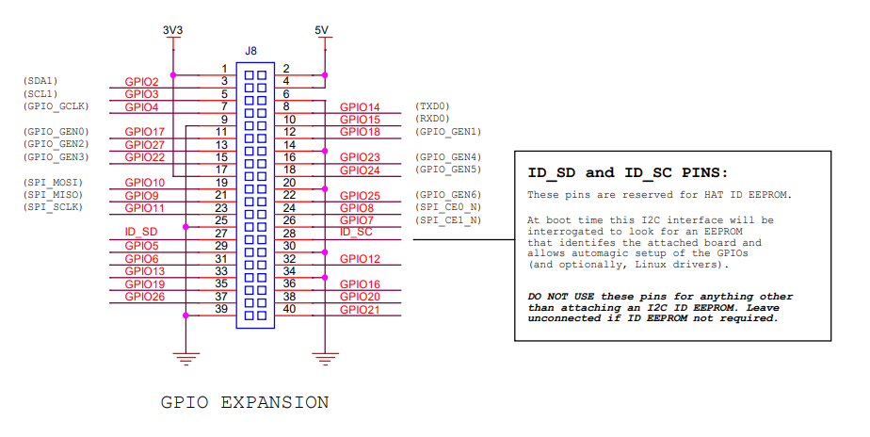

Processor
In mid-2021, Pi 4 B models appeared with the improved version of processor BCM2835, BCM2711. The BCM2711 processor in Raspberry Pi 4 with 1 MB shared L2 cache unlike previous models, which all used a custom interrupt controller poorly suited for virtualisation, the interrupt controller on the board is compatible with the ARM Generic Interrupt Controller (GIC) , providing hardware support for interrupt distribution when using ARM virtualisation capabilities. The VideoCore IV of the previous models has also been replaced with a VideoCore VI running at 500 MHz.
The board is shipped with a BCM2837 on-board chip. That includes a VideoCore GPU ARM-Cortex-A53 CPU (ARMv8) Some MMIO mapped peripherals. Interestingly the CPU is not the main processor on the board. When it’s powered up, first GPU runs. When it’s finished with the initialization by executing the code in bootcode.bin, it will load and execute the start.elf executable. That’s not an ARM executable, but compiled for the GPU. What interests us is that start.elf looks for different ARM executables, all starting with kernel and ending in .img. As we’re going to program the CPU in AArch64 mode, we’ll need kernel8.img only, which is the last to look for. c
Similarly, all peripherals communicates in memory with the CPU. Each has it’s dedicated memory address starting from 0x3F000000 (TBC), but it’s not in real RAM (called Memory Mapped IO). Now there’s no mailbox for peripherals, instead each device has it’s own protocol. What’s common for these devices that their memory must be read and written in 32 bit units at 4 bytes aligned addresses (so called words), and each has control/status and data words. Unfortunately Broadcom (the manufacturer of the chip) is legendary bad at documenting their products. The best we’ve got is the BCM2835/BCM2711 documentation, which is close enough.
There’s also a Memory Management Unit in the CPU which allows creating virtual address spaces. This can be programmed by specific CPU registers. Some of the interesting MMIO addresses that has contributes on project are:
0x3F003000 | System Timer
0x3F00B000 | Interrupt controller
0x3F00B880 | Video-Core mailbox
0x3F100000 | Power management
0x3F104000 | Random Number Generator
0x3F200000 | General Purpose IO controller
0x3F201000 | UART0 (serial port, PL011)
0x3F215000 | UART1 (serial port, AUX mini UART)
0x3F300000 | External Mass Media Controller (SD card reader)
0x3F980000 | Universal Serial Bus controller

For more information, see Raspberry Pi firmware wiki and documentation on GitHub.

Interrupt Request
In a computer, an interrupt request (or IRQ) is a hardware signal sent to the processor that temporarily stops a running program and allows a special program, an interrupt handler, to run instead. Hardware interrupts are used to handle events such as receiving data from a modem or network card, key presses, or mouse movements.

ARM v8 and Cross-compilation
The ARM Cortex-A72 processor, powering the Raspberry Pi 4B, represents a substantial advancement in computing power, employing the ARMv8-A 64-bit instruction set architecture (ISA).
There are 2 modes in the architecture, AArch64 and AArch32.The architecture offers backward compatibility however the project will focuses on aarch64 mode.
The shifting to a 64-bit execution mode (AArch64) rather than the traditional 32-bit mode (AArch32). Which expands the addressable memory space and improves computational performance with wider registers. In the project’s development, author also used a tool called cross compiler, which is a compiler capable of creating executable code for a platform other than the one on which the compiler is running, useful to compile code for multiple platforms from one development host. A cross compiler Direct compilation on the target platform might be infeasible, for example on embedded systems with limited computing resources. Cross compilers are distinct from source-to-source compilers. A cross compiler is for cross-platform software generation of machine code, while a source-to-source compiler translates from one coding language to another in text code.
Aarch64 has four exception levels ranging from EL0 (user applications) to EL3 (secure monitor). Higher levels indicate more privileges with EL1 typically used for the operating system kernel and EL2 for the hypervisor. There are two security states; Secure and Non-secure. The project will deal only with the Non-secure state.
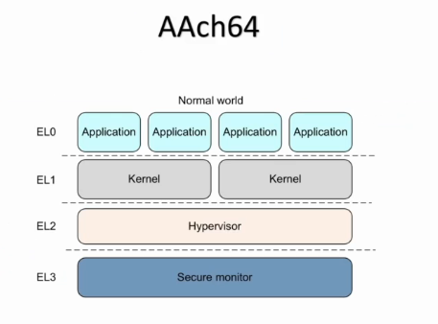
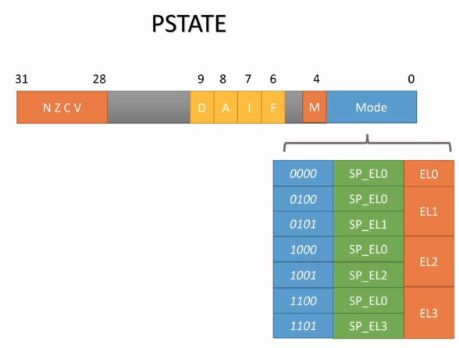
AArch64 features 32 64-bit general-purpose registers (x0 – x30), including some interesting special registers worth mentioning, such as zero registers that always holds zero, stack pointer for stack operation, PSTATE register that indicates the processor state, tracking conditions like negative results or overflows from operations, additionally, the “DAIF” fields manage the masking of different types of interrupts and exceptions, determining whether they are ignored or processed.. PSTATE register will contribute to the project’s exception level switching.
To handle the exceptions, the project will implement the exception handler for synchronous and ssynchronous Exceptions: Synchronous exceptions include system calls and illegal instructions, while asynchronous exceptions involve interrupts like system errors.

Micro SD Card
Micro SD card is RPI’s boot/storage medium and it is popular for its low power consumption, portability and affordability.
By meaning of boot medium, when RPI is powered, it reads the bootloader from the SD card, which then loads the system kernel and the OS into memory. While for storage medium, it can store RPI’s OS, applications, and data. Micro SD card remains the most popular storage choice for embedded application developers and users since it allows users to switch between different OS or configurations simply by swapping cards. The RPI’s supporting for Micro SD card makes it portable and easy to use and that is one of the main reasons RPI has been chosen for this project.

Operating System
The operating system (OS) acts as an intermediary between programs and the computer hardware. As its core, kernel's primary responsibility is offering essential services like manage memory, processing power, and software/hardware resources, achieve user interfaces (UI), maintain file and network and security controls.
In contrast with modern OS like Windows or macOS that offer pre-built drivers which provide functions abstract from complex hardware, bare-metal programming requires developers implement software that runs directly on the hardware without the abstraction layer provided by an operating system. Hence bare-metal developers must have a deep understanding of the complexity of hardware, as they are responsible for all aspects of system control, from memory management to peripheral communication.
By bypassing the operating system, the project utilizes the RPI's hardware, creating a custom kernel that runs a recreation of legacy game 'Breakout'.
Exception Level
The exception levels simply control access to what lower levels can do because some registers are not accessible in the lower levels. It is important to realize running things at higher exception levels does not make things safer it actually makes it less safe because if the system is breached they can access more registers. What you really want is to run the various parts of the O/S at the level they require and no more. The MMU dovetails into this and the same situation applies. So running code at higher EL than it really requires actually reduces security.
The cortexA53 is setup with a basic strategy
EL0 = Applications.
EL1 = OS kernel and associated functions that are typically described as privileged.
EL2 = Hypervisor.
EL3 = Secure monitor.
So a generic O/S like linux and windows would usually only ever run in EL0/EL1 and that is exactly how Raspbian does run.
VMWare like programs would run EL2 and things like ARM trustzone O/S would run in EL3.

Dual-boot
Many projects that involves cross compilation or cross-platform development use dual-boot with Windows and Linux (Ubuntu in this project) and benefits from it since the project might require access to software or tools specific to both platform and using dual-boot provides flexibility in that aspect. For example, certain software that used in this project are designed only for Windows, while Ubuntu is favoured for its compatibility with open-source development tools and libraries.

Quick Emulator (QEMU)
An open-source testing tool for software development and experiment by emulating different hardware platforms, especially useful when developers may not have access to the hardware physically or might wish to simplify the process of booting. This is particularly beneficial for this project since it avoid switching SD cards from pc to RPI, saving plenty of time for debugging. What is more, QEMU supports cross-compilation, allowing developers to compile software on a host machine for the ARM architecture targeted by the Raspberry Pi. Combined with emulation, this enables developers to build and test their code in a more efficient and flexible manner, without the need for constant interaction with physical. It also provides a virtualized environment that is isolated from the host system, enabling developers to experiment with different configurations, test software under various conditions, and debug without the risk of affecting the host environment or hardware.

Breakout
An arcade video game released by Atari on May 13, 1976. The game’s concept is based on another dual-player competitive game released by Atari before Breakout, Pong. In Breakout, a layer of bricks lines the top third of the screen and the goal is to destroy them all by repeatedly bouncing a ball off a paddle into them. Original Breakout begins with eight rows of bricks, with two rows each of a different colour. Using a single ball, the player must knock down as many bricks as possible by using the walls and the paddle below to hit the ball against the bricks and eliminate them. If the player’s paddle misses the ball’s rebound, they will lose a turn. The player has three turns to try to clear two screens of bricks. Breaking bricks with different colour will earn different points.
Yellow bricks earn one point each, green bricks earn three points, orange bricks earn five points and the top-level red bricks score seven points each. The paddle shrinks to one-half its size after the ball has broken through the red row and hit the upper wall. Ball speed increases at specific intervals: after four hits, after twelve hits, and after making contact with the orange and red rows. For a bare-metal project like the one in this report, Breakout is suitable for its simplicity in game mechanics and graphics.

Glyph Representation
The array is initialized with values for each glyph. The comments indicate the Unicode code point of the character each glyph represents. For example, { 0x00, 0x00, 0x00, 0x00, 0x00, 0x00, 0x00, 0x00} represents the 'nul' character, and subsequent lines define the visual representation of other characters like '!', '"', '#', and so on.
The values within each glyph's byte array correspond to the pixels that are "on" (1) or "off" (0) for the 8x8 glyph representation. This bitmap font allows the system to render text on the screen using these pre-defined glyph patterns.
Special Character Glyphs
The array also contains definitions for extended ASCII characters and symbols such as U+00C7 (Ç, C with cedilla) and U+00FC (ü, u with umlaut), along with graphical characters that are used to draw simple line graphics and block elements, for example, U+2588 for a solid block.
This header is used for text output on the terminal, where text needs to be rendered to a display output, such as an HDMI-connected monitor. The VGA colour palette and bitmap font together provide the necessary data to represent text in various colours and with the correct character glyphs on the screen. It's a fundamental part of a simple graphical user interface for a bare-metal system, enabling user interaction through command-line input/output and the rendering of simple user interfaces.
Design
The part will describe the planned development process for RPI 4B base on the development diary kept on the project GitHub wiki, including develop environment set up, peripherals interface, project test. For highlights, focusing on GPIO management, UART/IRQ implementation, memory management, Video-Core communication, graphic optimization and the core of Breakout. To be mentioned, is the importance of direct reference to the RPI's official documentation for accurate peripheral address mapping.

Setup
Setup a development environment is crucial for such a project that might have extensions during the development or in the future for the author’s own interests.
The project kicked off with installing a dual-system (Ubuntu and Windows) and install Visual Studio Code on Linux which was chosen as the primary IDE after a few weeks’ development trial on Windows, the author suggests Windows users to utilize a Linux virtual machine or WSL (Windows Subsystem for Linux) for cross-compilation since the cross-compiler used in this project is aarch64-linux-gnu that suggested by ARM which is easier to install on Ubuntu with a single command, there are other choices like AArch64 ELF bare-metal target (aarch64-none-elf), which has been tested has no difference in the project development.
Structure the project folder is also a essential part of development. Organization of the project's directory structure with source (src) and include (include) folders is inspired by Sergey Matukovic’s bare metal project structure.
Project Structure
.
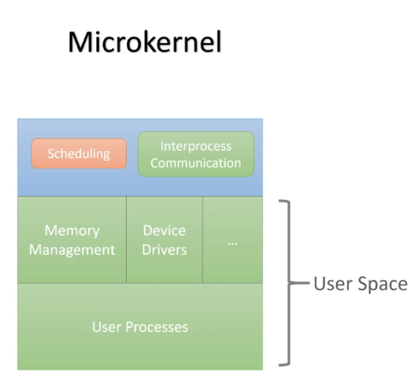
├── /armstub
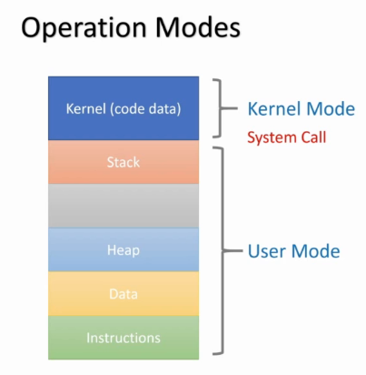
│ ├── /build
│ └── /src
│ └── armstub.S
├── armstub-new.bin
├── /build
├── config.txt
├── /include
│ ├── breakout.h
│ ├── common.h
│ ├── debug.h
│ ├── entry.h
│ ├── fb.h
│ ├── gpio.h
│ ├── irq.h
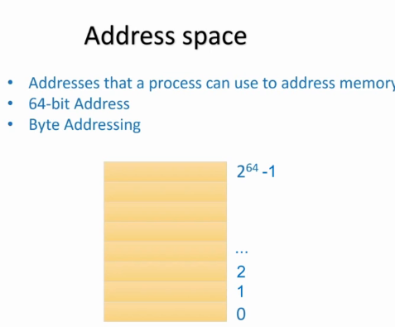
│ ├── mailbox.h
│ ├── mem.h
│ ├── mini_uart.h
│ ├── mm.h
│ ├── mmu.h
│ ├── /peripherals
│ │ ├── aux.h
│ │ ├── base.h
│ │ ├── gpio.h
│ │ ├── irq.h
│ │ └── timer.h
│ ├── printf.h
│ ├── print_to_screen.h
│ ├── screen.h
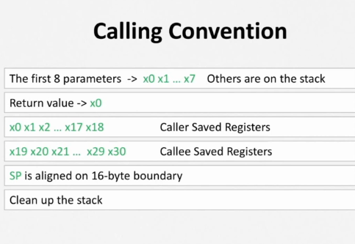
│ ├── sysregs.h
│ ├── terminal.h
│ ├── timer.h
│ └── utils.h
├── kernel8.img
├── link.ld
├── Makefile
├── README.md
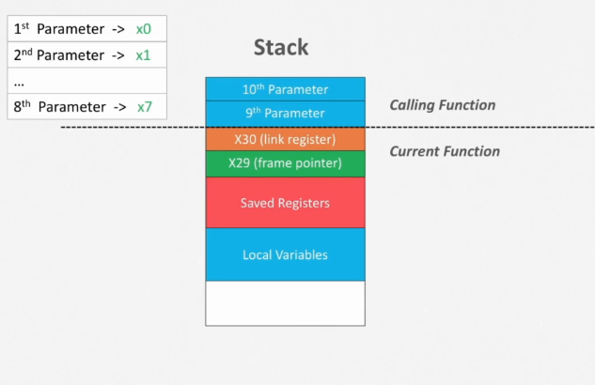
└── /src
├── boot.S
├── breakout.c
├── debug.c
├── entry.S
├── fb.c
├── gpio.c
├── irq.c
├── irq.S
├── kernel.c
├── linker.ld
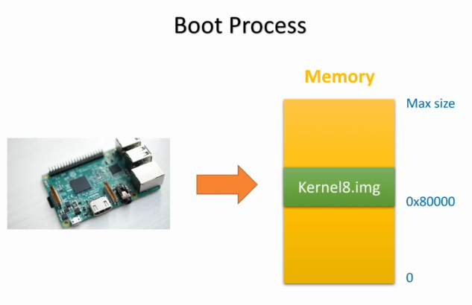
├── mb.c
├── mem.c
├── mini_uart.c
├── mm.S
├── printf.c
├── print_to_screen.c
├── timer.c
└── utils.S

Kernel Initialization and Peripheral Setup
After the software development environment, setting up peripheral communication is also essential, by testing the RPI with installing the official OS provided. After that the author can proceed on custom kernel. Essential to this was connecting pc and RPI with USB to TTL Serial Cable, implementing header files such as common.h, which defined standard types, mini_uart.h for communicating with UART and displaying error messages on terminal, boot.S which act as bootloader, Makefile and linker.ld which organize the compiled code into a binary format for the RPI’s boot process. Inspirations will be RPI OS’s source code. Additionally, functions for delay and memory operations were implemented in assembly language.

GPIO and Mini UART Setup
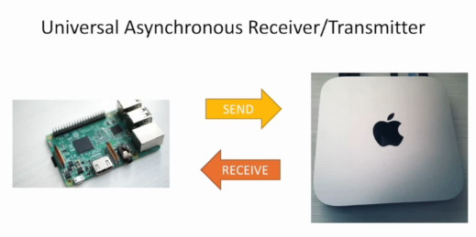
General-Purpose Input/Output (GPIO) management were then implemented for the setting up of the mini UART functionality by utilizing pin 6, 8 and 10 which represents GROUND, GPIO Receive, and GPIO Transmit, with utility functions within header file gpio.h to facilitate easy and accurate GPIO management, provide a fundamental rock for the further development.

SD Card Setup and Testing
The final step of Setup will be install the kernel on an SD card and test the code on the Raspberry Pi, after downloading and writing the Raspberry Pi OS (Lite version) to the SD card, compiled kernel image and config.txt which essential for the custom kernel to run were copied to the boot partition automatically thanks to Makefile. Then use screen command on Linux or Putty on Windows to monitor the system’s behaviour during boot and operation.

Exception Level Management and System Timer Interrupts
When an exception occurs, the processor may escalate to a higher exception level unless it's already at the lowest level (EL0), as exceptions cannot downgrade levels. A dedicated exception handler (or interrupt service routine) is implemented for each type of exception with the help of vector table, which directs the processor to the appropriate handlers.
The kernel will boot in Exception Level 1 (EL1), which is a standard operating system practices, allow the following procedure of developing further into IRQ management, enabling the development of a sleep function.
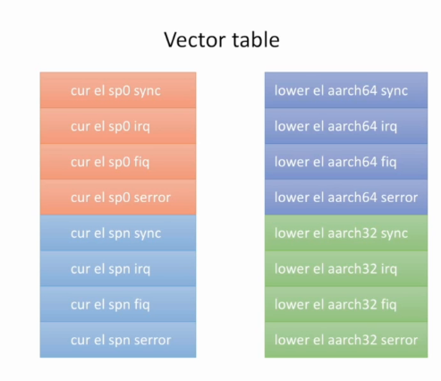
Video-Core and Optimization
After dealt with exceptions, the project will utilize RPI's mailbox interface that enable direct communication with VideoCore by implementing header file that configure the frame buffer with the help of BCM2711 documentation. Then the project will implement some optimization through DMA rather than CPU-driven pixel manipulation aiming at faster rendering times, inspired by insights from the Circle project and Broadcom peripherals documentation.

Memory Management
Further exploration into enabling the Memory Management Unit (MMU) addressed challenges such as handling unaligned data structures, highlighting the series' commitment to tackling complex hardware interactions.
A notable advancement in the project was the optimization of video output through DMA, aimed at enhancing the efficiency of graphical rendering. This technique, inspired by the Circle project and Broadcom documentation, illustrated a shift towards more efficient data transfers, significantly improving rendering times. Further, the series tackled enabling the Memory Management Unit (MMU) to address challenges such as handling unaligned data structures, showcasing the series' dedication to resolving complex hardware interactions.

Game Core
By synchronizing with interrupt handlers and utilize the video core related functions implemented, the game’s core can be implemented following the flowchart:
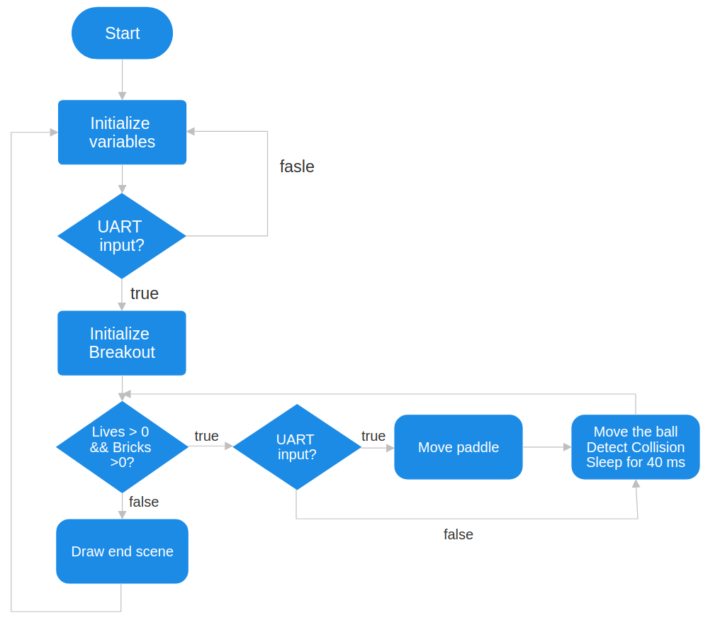
Implementation

QEMU Problem: Lack of Direct Raspberry Pi 4B Support in QEMU
Using QEMU for simulating RPI environment is beneficial mainly in reducing testing time and prevent Micro SD card’s disposal due to multiple plug-in and remove. However, using QEMU for simulating a specific RPI model can be a unique set of challenges, particularly when the project is using newer hardware RPI 4B.
There are replacement workarounds for QEMU RPI 4B like emulating older models, such as the Raspberry Pi 2 or 3, however they are tested to be inaccurate on memory mapping after comparing to the memory maps on real-RPI, which do not fully capture the hardware advancements, including its improved CPU, GPU, and IO capabilities. Hence the lack of direct support introduces the major discrepancy: Unable to fully replicate the Raspberry Pi 4's hardware in an emulated environment.
And the workarounds like using emulated models while aware of the differences and test periodically on real-RPI hardware to ensure compatibility are discarded by author due to the ineffective and time-consuming with aware that this is a personal project so there is limited time for implementation.

Makefile
This should be expanded
https://jsandler18.github.io/explanations/makefile.html
BOOTMNT defines where the files after compiling, essentially image file and config file, will be copied to, ARMGNU defines the base name for the cross compiler that is used in the project, COPS defines the options sending to c compiler due to the nature of bare-metal with lack of standard libraries and freestanding hence passing the include directories and specifying the use of general registers only. ASMOPS defines the options sending to assembly compiler, which only specifying the include path. BUILD_DIR and SRC_DIR defines the build and source code directories location.
“all” is the main of the Makefile, which builds kernel8.img after clean the old image avoid conflics.
C_FILES, ASM_FILES, OBJ_FILES are compiling all source code files and storing C/Assembly compiled object files in the build directory, creating directories if not exsist.
“kernel8.img” builds the image file by linking the object files into one executable elf file and convert it into a raw binary executable image. Since the RPI OS original kernel image is named as “kernel8.img”, the custom image file will be renamed when copying to Micro SD card in case there are further tests needed.

Header Files (include directory):
The header files located in the include directory but not in peripherals directory are declarations for shared functions and types. For some of the highlights, breakout.h includes the declarations to run the core of the game, universal types and utilities functions like memory manipulation and delays are provided through common.h and utils.h, ensuring consistent types are used and improve code readability. debug.h contributes to testing and debugging by assertion checks and error handling. The files like irq.h that handling interrupts, mem.h and mmu.h that managing memory, and terminal.h that facilitating text user interface are offering the necessary abstractions for managing system resources.
Key files are listed with their roles respectively down below.
aux.h | Manages auxiliary peripherals including Mini UART, essential for serial communication and system debugging.
breakout.h | Header for the breakout game logic
common.h | Contains common type definitions
debug.h | Provides debugging functionalities
entry.h | Definitions related to exception entry
fb.h | Framebuffer setup and manipulation
gpio.h | Controls General-Purpose Input/Output (GPIO) pins
irq.h | Manages hardware interrupts
mailbox.h | Interacts with the VideoCore mailbox interface
mem.h | Memory management and allocation
mini_uart.h | Manages Mini UART functionalities
mm.h | Memory-related definitions
mmu.h | Sets up and manages the Memory Management Unit (MMU)
print_to_screen.h | Functions for printing to the screen
printf.h | Custom printf function for formatted output
screen.h | Defines for screen dimensions or properties
sysregs.h | System register access
terminal.h | Terminal interface for user interaction
timer.h | System timer interface for timing and delays
utils.h | Utility functions like delay, memory read/write(put32, get32).  Central of the memory manipulation.

Variables and data structure in terminal.h
terminal.h introduces structures and variables that are the central for creating a terminal interface for the bare-metal operating system. By introducing vgapal[], an array of colour values representing a standard VGA colour palette defined in hexadecimal format, project can draw text and graphics in different colours on the screen.
unsigned int vgapal[]: This is an array of colour values representing a standard VGA colour palette, which is used to draw text and graphics in different colours on the screen. An enum containing font properties such as width and height of each character. A 2D array font[FONT_NUMGLYPHS][FONT_BPG] representing a bitmap font, storing glyph representation of each character, FONT_NUMGLYPHS defines the number of glyphs in the font, and FONT_BPG is the number of bytes used to store each glyph.

Header Files Peripheral Base Address ( include/peripherals directory):
The header files located in the include/peripherals directory defines the structures and addresses that will contribute to interfacing with hardware by the project according to the official document of RPI and ARM, they are implemented base on rules of modular, type-safe, clear access to interact with multiple peripherals and providing adaptability to not only RPI 4 but also RPI 3 since the fundamental functionality has been tested on QEMU with simulated RPI 3 hardware.
Key files are listed with their roles respectively down below.
aux.h | Access the auxiliary peripheral registers  by defining the structure AuxRegs.  The registers included allow for control and status checks, data I/O, interrupt handling, and more for the auxiliary peripherals.  Defines macro REGS_AUX to access the base address for peripherals.
base.h | Defines base addresses for memory map. Such as starting address for peripheral I/O PBASE, designated memory location safe for general use SAFE_ADDRESS, beginning of device memory DEVICE_START. Contributes to locating the system's various hardware registers and simplifies the process of updating memory locations if needed.
gpio.h | GPIO control registers and pin data structure  Describes the GPIO (General-Purpose Input/Output) register interface in detail. The GpioRegs structure which contains registers for function selection, setting and clearing outputs, and detecting pin levels and events.  Define REGS_GPIO macro for the base address of GPIO register access.
irq.h | Enumerates RPI interrupt sources and defines interrupt handling structures.  This file includes the enumeration vc_irqs that lists various interrupt sources like system timer interrupts and the auxiliary interrupt. It also defines two structures, arm_irq_regs_2711 and arm_irq_regs_2837, corresponding to the interrupt register layouts for the BCM2711 (used in Raspberry Pi 4) and BCM2837 (used in Raspberry Pi 3) chips respectively.  Defines macro REGS_IRQ to access the base address for interrupt registers.
timer.h | Defines the system timer interface with the timer_regs structure. This includes registers for the timer's control and status, the 64-bit timer counter, and the compare registers used for interrupt scheduling. The frequency of the system timer is set with CLOCKHZ.  Defines macro REGS_TIMER to access the base address of timer.
PBASE in base.h
The values come from the RPI documentation BCM2837 for model 3 (which is a modified version of BCM2835), and BCM2711 for model 4.
In the section 1.2.3 of BCM2835 documentation, it addressed that the physical addressed range from 0x20000000 to 0x20FFFFFF for peripherals and the bus address range starts at 0x7E000000, in the section 1.2.3 of BCM2711 documentation, it addressed that the physical addresses range from 0x47C000000 to 0x47FFFFFFF for main peripherals and 0x4C0000000 to 0x4FFFFFFFF for ARM local peripherals. But by experiment during the process, the addresses are not working as intended hence instead of documentations the author utilized the device tree information from the last raspberry pi linux source tree [and i'll paste that address in the comment section]
On the GitHub page of raspberry pi linux/arch/arm/boot/dts section, all the dts files for the raspberry pi including bcm2837 and BCM2711 are stored there. By checking the dts files in detail, author figured the ranges of peripherals addresses are defined under soc section, defining the real addresses that can be used for RPI peripherals, which are 0x3F000000 for BCM2837 (used for RPI 3) and 0xFE000000 for BCM2711 (used for RPI 4).

Structure in aux.h
By taking deeper look at section 2.2 in BCM2835, the author noticed that the register map follows a neat structure, the first 2 registers are the general auxiliary registers locating at 0x7E215000 and 5004, followed by all the mini uart related registers including io error handling, uart enable handling etc. To be noticed that there is a big gap in-between the general registers and mini uart registers while all mini uart registers are located one after the other hence each are 32-bit registers. And according to the same section, by setting the AUXENB register’s zeroth bit, mini uart is enabled, hence in the aux.h, the author create a structure named AuxRegs for the registers mentioned above. To deal with the gap, the structure contains a reserved section with size of 32 bits times fourteen. By defining the structure, the specific mini uart registers are able to map directly to these memory addresses, there are register that are not used in the project but since they come one after another in the memory map hence the structure still provides access to them, which improves the compatibility and provide ease for the future extensions. By translating the peripherals address offset 0x7E215000 to 0x3F215000, and create a define REGS_AUX that creates a pointer to that location in memory which gets cast as a pointer to the struct by utilizing PBASE defined in base.h, the project is able to access these fields from REGS_AUX.

Source Files (src directory):
The source files located in src directory contains Assembly code and C code for the implementation of the functions declared in header files mentioned before. Key files and their functionalities are listed below, with kernel.c anchoring the main operational logic and breakout.c providing game core logic.
boot.S | This is the assembly file that sets up the environment when the Raspberry Pi boots up. It includes disabling the MMU, setting up exception level registers, and jumping to the kernel_main function in kernel.c.
breakout.c | Contains the implementation of a simple breakout game. It includes initialization, game loop, drawing functions, and handling of game objects like bricks, the ball, and the paddle.
debug.c | Provides a simple assertion and error checking mechanism that halts the system and outputs an error message if an assertion fails.
entry.S | Contains exception vector entries for different CPU modes and is responsible for saving and restoring state when an exception occurs.
fb.c | The framebuffer code for setting up the display and drawing functions like pixels, rectangles, lines, and circles.
gpio.c | Implement the GPIO functionality according to documentation.
irq.c | Provide support for interrupt handling, and setup.
irq.S | Provide support for interrupt handling, and setup.
kernel.c | The main kernel code that initializes the various subsystems of the OS, including the UART for serial communication, the framebuffer, and the breakout game.
link.ld | The linker script that defines the memory layout for the kernel.
mb.c | Handles communication with the VideoCore GPU via the mailbox property interface.
mem.c | Manages memory allocation and freeing in the kernel.
mini_uart.c | Initializes and handles communication over the mini UART peripheral of the Raspberry Pi.
mm.S | Assembly code for memory-related operations.
print_to_screen.c | Contains functions for printing text to the screen using the framebuffer.
printf.c | A small printf implementation suitable for embedded systems, which provides formatted text output.
timer.c | Contains the timer initialization and handling code, used for system timing and delays.
utils.S | Assembly utilities for basic memory operations and delay loops.

GPIO related structure and implementation
According to the section 6 of BCM2835, which includes the GPIO setup procedure diagram and the address map for registers. By observing and summarizing the map like what the author has done to the AUX registers, GPIO registers has a similar pattern, starting with 7 function select registers at 0x7E200000 followed by a reserved register and two registers with pin data for output set and then the same structure with 3 registers for output clear and then the same 3 registers structure for level, the following registers for event detect, rising edge detect, falling edge detect and more are all on the same pattern of reserved and two following registers, all the way down to the clock pins. Hence the author create structures GpioPinData which models 3 registers structure and GpioRegs which represents the whole memory map for GPIO registers by utilizing GpioPinData. Followed by taking the second half of the first register’s address, which is 0x0020000, the macro REGS_GPIO is defined which does essentially the same thing as REGS_AUX, but for GPIO registers in the gpio.h file located in peripherals directory.
According to the documentation same section, the function select registers need to have values, for a certain register, the first two bits are reserved, followed by 10 3-bit fields FSEL9 to FSEL0, essentially 10 pins controlled by the register, for each bit, setting the values as shown in the diagram will provide different functions, to be noticed that the values are not in order hence it need to be treated with caution as the project used a neat structure mapping the memory instead of put values directly into memories. So a single register will actually control a total of 10 pins and setups are defined in the documentation, by creating a enum GpioFunc in gpio.h located in include directory, the project can setup the values for the fields with more understandable names instead of int numbers. Also the declarations for the functions setting up and enabling gpio pins are created in the same file.
In gpio.c located in the src directory, by using module operation the bit starts in the register is figured out and stored in bitStart. By using bit manipulation the function is set in the corresponding bits of registers. For pin enable, the documentation addressed a a few steps to follow to help microcontroller understand the demanding for GPIO pins shown in the pic below:
By using the delay function declared in utils.h, the author is able to implement the steps according to the documentation and enable the gpio pin.

Linker implementation
https://ftp.gnu.org/old-gnu/Manuals/ld-2.9.1/html_mono/ld.html#SEC6
The first section in the linker script is “.text.boot” also defined in boot.S where the linker will put it right at the top of the binary file, followed by “.text”, “.rodata” for read-only data section, “.data” for normal data section, “.bss” for static or uninitialized data section. In the boot.S, the .bss section is erased as 0 with the help of custom memory manipulate function memzero defined in mm.h and implemented in mm.S.

Other Important files:
armstub.S | Initialization code (a stub) that runs immediately after the processor comes out of reset and before the main kernel is executed, introduced here to help with exception level setting.
config.txt | Configuration file for RPI kernel settings. Required by RPI documents.
kernel8.img | The output kernel image for the Raspberry Pi.
Makefile | Script for automating the build and testing process. Compile and link all these components into the final kernel8.img before copying config.txt and kernel8.img into Micro SD card.
README.md | Documentation file for the project.

armstub.S
This should be Important
The armstub.S file is an assembly file typically used in the boot process of an ARM-based system, such as the Raspberry Pi. It's designed to be a small piece of initialization code (a stub) that runs immediately after the processor comes out of reset and before the main kernel is executed.
Here's a breakdown of what this code is doing:
.globl _start: This directive makes the _start symbol globally accessible, meaning it can be seen by the linker. It marks the entry point of the stub, where execution begins.
_start:: This is a label indicating the beginning of the stub code. The CPU starts executing from this point.
ldr w0, kernel_entry32: This instruction loads the word (32-bit value) at the address labeled kernel_entry32 into the w0 register. The ldr instruction is used for loading data from memory into a register, and w0 is a 32-bit wide register.
br x0: This instruction causes a branch to the address contained in the x0 register. The x0 register is the 64-bit wide version of w0, so this instruction effectively jumps to the kernel entry point for a 32-bit kernel.
.ltorg: A directive that tells the assembler to place the current pool of literals (constants) into the output.
.org 0xf0, .org 0xf4, .org 0xfc: These directives set the location counter of the assembler to the specified addresses, which is used to position pieces of data at specific offsets from the start of the file.
stub_magic, stub_version, kernel_entry32: These labels are defined with specific values or addresses. They are used as metadata or configuration for the stub. The stub_magic is a kind of signature for the stub, stub_version could be used to hold version information, and kernel_entry32 would hold the address of the 32-bit kernel entry point.
In the context of an ARM-based system, this stub is usually compiled and linked with the kernel image. It provides a jumping-off point for the CPU to begin executing the main kernel. The use of .org to position the stub_magic, stub_version, and kernel_entry32 suggests that some bootloader or firmware might look for these specific values at these specific offsets within the stub to verify the image or to obtain necessary information before jumping to the actual kernel entry point.

boot.S
The boot.S file is an ARMv8 assembly source code for the initial boot sequence of a bare-metal kernel running on a Raspberry Pi. Let's break down its key components and their implementation:
Section Declaration: The .section ".text.boot" directive places the following code in a specific section of the kernel image, typically the beginning.
Processor Initialization
Global Start Label: The _start label is marked as global, indicating the entry point where execution begins.
Processor ID Check: The code reads the mpidr_el1 register to get the processor ID. If the processor is not the main core (core 0), it jumps to an infinite loop (proc_hang), effectively putting secondary cores in a waiting state.
Transition to EL1
SCTLR Configuration: System Control Register (sctlr_el1) is set up with the intention to disable the Memory Management Unit (MMU) initially (SCTLR_VALUE_MMU_DISABLED).
HCR, SCR, and SPSR Configuration: Registers for Hypervisor Configuration (hcr_el2), Secure Configuration (scr_el3), and Saved Program Status (spsr_el3) are configured, presumably to set up the appropriate execution state for EL1.
MMU Initialization (Conditional)
MMU Settings: If INIT_MMU is set to 1, this section initializes various registers related to the MMU, including setting access rights (CPACR_EL1), configuring Translation Control (TCR_EL1), and setting Memory Attributes (MAIR_EL1).
Exception Level Transition and MMU Enablement
Exception Level Transition: The eret instruction is used to return from an exception and move the execution to EL1 (el1_entry).
BSS Zeroing: Before entering the kernel's main function, the memzero function is called to zero the BSS segment, which is a common initialization step in C programs to set all uninitialized global variables to zero.
Stack Pointer Initialization: The stack pointer is set to LOW_MEMORY, indicating the start of the stack for use in EL1.
Final MMU Configuration: If INIT_MMU is set, additional steps to initialize the MMU are taken, such as setting the Translation Table Base Register to the address of the identity page table (id_pgd) and enabling the MMU (SCTLR_MMU_ENABLED).
Kernel Entry and Hang
Kernel Main Call: The bl kernel_main instruction calls the main kernel function, passing control to the main part of the bare-metal software.
Post Kernel Hang: After kernel_main, if the system has nothing else to execute, it enters an infinite loop (proc_hang).
Identity Page Table Address
Page Table Address Export: The id_pgd_addr label provides an address that will likely be used as a reference to the base of the identity page table.
Highlights and Potential:
Synchronous Multiprocessor (SMP) Handling: The code initiates a process to bring up the system in a uniprocessor state by halting all other cores except the primary one. This is a common technique in SMP systems to ensure a controlled startup sequence.
Low-Level Initialization: The code demonstrates an understanding of ARMv8 exception levels and system registers, which is critical in bare-metal environments.
Conditional MMU Initialization: By conditionally initializing the MMU, the code provides flexibility for the kernel to be compiled with or without MMU support based on the requirements.
Zeroing BSS: Zeroing out the BSS segment is an essential step to prevent any undefined behavior caused by uninitialized variables.
Optimized Transition to Main Kernel: The code shows an efficient transition from the boot sequence to the main kernel while handling memory and processor state effectively.
This assembly file is a clear example of the low-level control required in bare-metal system programming, where software has direct interaction with the hardware without an intervening OS layer. It sets up the necessary environment for the kernel to run with the correct privileges and memory management settings, which is a vital step in any bare-metal project.

kernel.c
The kernel.c file is the main C source file of the bare-metal kernel for the Raspberry Pi 4B. It includes the main function kernel_main, which is called after the initial assembly boot setup. This file is the heart of the bare-metal system, initializing various subsystems and entering the main program loop.

Overview
Includes: The file begins by including necessary headers for various components such as UART, timers, framebuffer, memory management, and the custom breakout game.
Initialization Functions
UART: Initializes the UART for serial communication.
Printf: Integrates a custom printf function that uses UART to output text to the serial console.
Interrupts: Sets up interrupt vectors, enables the interrupt controller, and enables IRQs.
Timer: Initializes the system timer.
Framebuffer: Sets up the framebuffer for HDMI output, crucial for visual display on a monitor.
System Setup
Global Variables: Defines variables for UART input handling and screen output locations.
Printf Function: Implements a function to output characters via UART, handling newlines appropriately.
Memory Alignment Check
Structure Definitions: Defines two structures to demonstrate packed vs. unpacked memory alignment.
Memory Copy: Copies bytes from a buffer into these structures to showcase how alignment affects memory operations.
Main Loop
Kernel Main: This is the main function called by the assembly boot code.
Initializes hardware components and systems like UART, interrupts, and framebuffer.
Checks the running version of the Raspberry Pi and whether the MMU is initialized, with output messages to both UART and the screen.
Performs an alignment check to demonstrate packed and unpacked structure behavior.
Conducts memory allocation and deallocation to test the memory management system.
Retrieves the current exception level and outputs it, confirming the kernel's current operating state.
Outputs a welcome message to the console and screen.
Game Logic
Breakout Game: Calls the breakout function to run the game.
Upon completion or exit from the game, it displays the score and a prompt to replay.
Timing and Sleep Demonstrations
Sleep Functions: Demonstrates the use of the timer to create delays (sleep functionality) for specific durations.
Highlights and Potential:
Integration of Multiple Components: The file shows how various hardware components are initialized and brought together to create a functioning system.
Memory Alignment Illustration: It educates on the importance of memory alignment in ARM architectures and demonstrates how to handle unaligned data structures.
Custom Printf Implementation: The inclusion of a custom printf function tailored for the UART showcases the kernel's independence from standard libraries, a characteristic of bare-metal programming.
Memory Management Testing: Demonstrates dynamic memory allocation and deallocation, an essential feature for any system that aims to manage its resources effectively.
User Interaction via UART: The UART interrupt handling for user input and the display of text on the screen signify the kernel's interactive capabilities.
Sleep Mechanism: Shows the implementation of non-blocking delays, which is essential for multitasking and efficient use of processor time.
Modular Game Integration: The inclusion of the breakout game within the kernel_main loop highlights the ability to extend the kernel with additional user-space applications or games, showcasing the potential for further development and expansion of the kernel's capabilities.
The kernel.c source code is a robust demonstration of bare-metal programming principles, exemplifying direct control over the Raspberry Pi's hardware and illustrating the process of creating a minimal yet functional operating environment. The file combines low-level system setup with higher-level functionalities, bridging the gap between hardware control and user interaction. It's a clear showcase of the meticulous planning and layered development approach required in such a project.

linker.ld
The linker.ld file is a linker script that controls the layout of the final output binary when the kernel is compiled. This file determines how different sections of the code (such as executable code, read-only data, and uninitialized data) are organized in memory.
Memory Layout
Base Address: The base memory address for the kernel is set to 0x80000, which is a common starting address for Raspberry Pi kernels.
Text Section
.text: This is where the executable instructions reside. The KEEP(*(.text.boot)) directive ensures that the boot code is kept in place and is not optimized away by the linker. The rest of the *(.text .text.* .gnu.linkonce.t*) pattern includes all other text sections (regular executable code).
Read-Only Data Section
.rodata: The read-only data section includes constants and other data that should not be modified at runtime.
Data Section
.data: The data section comes after the read-only data section (PROVIDE(_data = .);) and contains initialized global and static variables that can be modified at runtime.
BSS Section
.bss: This section holds uninitialized data that needs to be zeroed out at startup. The ALIGN(0x8) directive ensures that the .bss section starts on an 8-byte boundary, which is important for performance on many architectures. The bss_begin and bss_end symbols mark the start and end of the BSS section and are typically used in the startup code to zero out this section.
Page Table Section
id_pgd: This label marks the start of the identity page table for the MMU. The identity page table is a vital part of setting up virtual memory and is typically aligned to a page boundary, as ensured by ALIGN(0x00001000). The .data.id_pgd section is reserved with enough space for the page table entries (6 pages of size 4KB each).
Highlights and Potential:
Memory Alignment: The script enforces proper alignment for the BSS and page table sections, which is crucial for performance and avoiding memory access errors.
Explicit Control: By explicitly defining the memory layout, the developer has full control over where and how the kernel's different parts are placed in memory. This is particularly important for bare-metal development where the kernel must interface directly with the hardware.
Preparation for MMU: Allocating space for the page table and aligning it correctly is essential for enabling the MMU, which is a complex but powerful feature that supports virtual memory, process isolation, and other advanced memory management techniques.
In summary, the linker.ld file is an essential part of the build process for the bare-metal kernel, as it defines how different sections of the kernel are mapped into memory. This configuration ensures that when the Raspberry Pi boots up, the CPU knows exactly where to find the executable code, initialized data, and how much space to clear for uninitialized data. It also prepares the system to handle more complex memory management tasks by setting up the foundation for the MMU.

common.h

The common.h header file is designed to provide common type definitions and includes for use throughout the bare-metal kernel project for the Raspberry Pi. It serves as a central place for defining commonly used data types, which promotes consistency and clarity across the project. Here's an explanation of each part:

Pragma Once
#pragma once: This is a preprocessor directive that ensures the file is included only once during compilation, preventing duplicate definitions if this header is included by multiple other files.
Type Definitions
typedef uint8_t u8;: Defines u8 as an alias for an 8-bit unsigned integer. It is used for variables that are expected to store values between 0 to 255.

typedef uint16_t u16;: Defines u16 as an alias for a 16-bit unsigned integer, commonly used for variables that hold values between 0 to 65,535.

typedef uint32_t u32;: Defines u32 as an alias for a 32-bit unsigned integer, suitable for variables that contain values between 0 to 4,294,967,295.

typedef uint64_t u64;: Defines u64 as an alias for a 64-bit unsigned integer, which is often used for variables that require large numerical ranges or for addresses in a 64-bit environment.

Volatile Register Type
typedef volatile u32 reg32;: Declares reg32 as an alias for a volatile 32-bit unsigned integer. The volatile keyword is used here to tell the compiler that the value of the variable may change at any time without any action being taken by the code the compiler finds nearby. This is particularly important for memory-mapped hardware registers, where the value may change as a result of hardware activity outside of the control of the running program.
Highlights and Usefulness:
Clarity and Simplicity: By providing shorter type names (u8, u16, u32, u64), the code can be more readable and easier to write.

Consistency: These type definitions ensure that variables have the same size across different compilers and platforms, which is vital for low-level programming where exact sizes of data types are crucial.

Hardware Interaction: The reg32 type is essential for interacting with hardware registers, making it clear that these variables should not be optimized away and their reads and writes correspond to important hardware actions.

Portability: Although bare-metal development is closely tied to the hardware it runs on, using standard fixed-width integer types makes the code more portable and future-proof, which would be beneficial if parts of the code are repurposed for other platforms or projects.

In essence, common.h encapsulates fundamental and reusable type definitions for the project, enforcing a strong type system and improving the integrity and maintainability of the bare-metal kernel code. It establishes a shared understanding of variable sizes and behaviors that are expected throughout the kernel, which is especially important in a bare-metal context where the developer must have precise control over memory and processor resources.

Irq.h

The irq.h header file is crucial for managing interrupts in a bare-metal Raspberry Pi environment, particularly focusing on the Raspberry Pi 3 and 4 models. This file includes the definitions of structures that map to the interrupt controller registers, and an enumeration that identifies specific interrupt sources. Let’s dive into the details:

Prerequisites
Includes: It starts by including the peripherals/base.h for the base peripheral address (PBASE) and common.h for common type definitions like reg32.
Interrupt Source Enumeration
enum vc_irqs: Defines constants representing various interrupt sources. The values correspond to bits in the interrupt pending registers that indicate whether a specific interrupt is pending. It includes system timer interrupts (SYS_TIMER_IRQ_0 to SYS_TIMER_IRQ_3) and the auxiliary interrupt (AUX_IRQ), each represented by a specific bit position.
Interrupt Registers Structures
struct arm_irq_regs_2711 and struct arm_irq_regs_2837: Define the register maps for the interrupt controller on two different versions of the Raspberry Pi hardware (BCM2711 for Pi 4 and BCM2837 for Pi 3, respectively). Each structure contains fields that map to specific interrupt controller registers for pending interrupts, enable bits, and disable bits, but with slight differences in layout and reserved spaces (res0, res1, and fiq_control) to match each SoC's specifications.
Conditional Type Definitions
typedef struct arm_irq_regs_2837 arm_irq_regs; and typedef struct arm_irq_regs_2711 arm_irq_regs;: These conditional typedefs alias arm_irq_regs to the appropriate structure based on the Raspberry Pi version being targeted (RPI_VERSION). This approach provides a unified interface for accessing interrupt registers, abstracting away the differences between hardware versions.
Interrupt Registers Base Address
REGS_IRQ Macro: A macro that calculates the base address of the interrupt controller registers (PBASE + 0x0000B200) and casts it to a pointer to arm_irq_regs. This allows direct access to the interrupt controller's registers through the arm_irq_regs structure, facilitating the enabling, disabling, and checking of interrupt statuses.
Highlights and Usage
Abstraction and Portability: The header abstracts the differences in interrupt controller hardware between Raspberry Pi models, allowing the rest of the kernel code to interact with interrupts in a unified manner regardless of the specific SoC.

Direct Hardware Manipulation: Provides a clean and type-safe way to manipulate hardware interrupt registers, essential for enabling and handling interrupts in a bare-metal environment.

System Timer and Auxiliary Interrupts: Enumerates key interrupts for common tasks such as timing and auxiliary device handling (e.g., Mini UART), highlighting their importance in system operations.

Potential Use Cases
System Scheduling and Timing: By enabling and handling system timer interrupts, the kernel can implement timing functions, task scheduling, or time-sharing mechanisms.

Device Communication: The auxiliary interrupt can be used to signal data transmission or reception events from devices like the Mini UART, facilitating efficient, interrupt-driven I/O operations.

In summary, irq.h plays a pivotal role in the kernel's interrupt management by providing a structured interface to the Raspberry Pi's interrupt controller. It enables the kernel to efficiently handle interrupts, which are critical for responsive and real-time tasks within the bare-metal system. This header demonstrates a thoughtful design that accommodates differences in hardware, ensuring that the kernel can be easily adapted for different versions of the Raspberry Pi.

periphrals/timer.h

The timer.h header file is specifically designed for managing the system timer on a Raspberry Pi, providing both the structure for accessing the timer registers and defining constants relevant to timer operations. Here's a breakdown of its components and functionalities:

Header Guard and Dependencies
#pragma once: Ensures the header is only included once in a compilation unit to prevent redefinition errors.
Includes: Incorporates peripherals/base.h for the base peripheral address (PBASE) and common.h for standard type definitions, ensuring that reg32 and other types are properly defined.
System Timer Frequency
CLOCKHZ: Defines the clock frequency of the system timer. On the Raspberry Pi, the system timer operates at 1MHz (1000000 Hertz), which is crucial information for calculating timer intervals and setting up timer-based delays or scheduling tasks.
Timer Registers Structure
struct timer_regs: Represents the layout of the system timer's hardware registers in memory, mapping directly to the Broadcom BCM2835 (and compatible) System Timer peripheral found on all Raspberry Pi models. The structure includes:
control_status: A register for various control and status information of the timer.
counter_lo and counter_hi: 32-bit registers representing the lower and upper parts of the 64-bit system timer counter, allowing for high-precision time measurements.
compare[4]: An array of four 32-bit compare registers used to set up timer interrupts at specific counter values.
Timer Registers Base Address
REGS_TIMER Macro: Calculates the base address of the timer registers (PBASE + 0x00003000) and casts it to a pointer to struct timer_regs. This macro provides a simple and type-safe way to access the timer registers, enabling the setup and handling of timer-related functionalities such as delays, time measurement, and event scheduling.
Highlights and Potential Use Cases:
High-Precision Timing: The structure of the timer registers, including the 64-bit counter split into two 32-bit registers (counter_lo and counter_hi), enables high-precision timing and scheduling, crucial for tasks requiring exact timing such as periodic operations or measuring time intervals.

Event Scheduling: The compare registers allow for setting up to four distinct timer interrupts, which can be used for scheduling tasks or triggering actions at specific times, enhancing the system's ability to perform time-based operations efficiently.

System Health and Monitoring: The timer can be used for system health checks, monitoring runtime, or implementing watchdog timers to ensure system responsiveness and reliability.

Challenges, Insights, and Future Directions
Throughout its progression, the project encountered numerous challenges, from discrepancies in documentation to the intricacies of configuring hardware registers and managing system resources. The series provided invaluable insights into the ARM architecture, low-level programming, and direct control of hardware, underscoring the importance of perseverance, attention to detail, and a thorough understanding of system documentation.

Looking ahead, the series promises to explore disk access and further optimizations in text rendering or memory management, venturing deeper into the potential of bare-metal programming on the Raspberry Pi. This commitment to advancing the understanding of the Raspberry Pi's capabilities ensures that viewers are not only equipped with the knowledge to tackle complex projects but are also inspired to explore the boundaries of computer science and hardware programming.

Conclusion
Bare-metal development for the Raspberry Pi 4B serves as a testament to the power of direct hardware programming, offering a panoramic view of the RPI's capabilities from booting custom kernels to optimizing video output and managing memory. By bridging the gap between theoretical knowledge and practical application, the project demystified the layers of abstraction typically shielding developers from the intricacies of hardware interaction, providing a solid foundation for future explorations in computing and system development, inspiring a deeper understanding of the Raspberry Pi's potential and the broader landscape of computer science.
The timer.h header file exemplifies a clear and structured approach to interacting with the system timer hardware on the Raspberry Pi, crucial for a myriad of time-sensitive operations in a bare-metal environment. By abstracting the hardware details into a structured interface, it simplifies the development of timer-related functionalities, providing a foundation for building more complex timing and scheduling mechanisms within the kernel.

Algorithm for line and shapes drawing
This should be expanded
Result and Evaluation

