PMX report Test

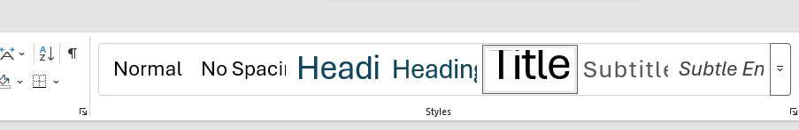

- Bullet
- Bullet2

New page

Title

  - asdgf

