PMX report Test

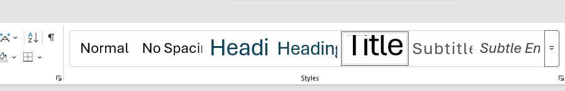

- Bullet
- Bullet2

New page

Title

asdgf

New page

