|  |  |  |
| --- | --- | --- |
| **Ranking**  **(by intra-cluster)** | **Column Names Removed** | **Evidence** |
| **1** | None Removed |  |
| **2** | Sales Removed |  |
| **3** | Annual and Investment Removed |  |

**Everything included**

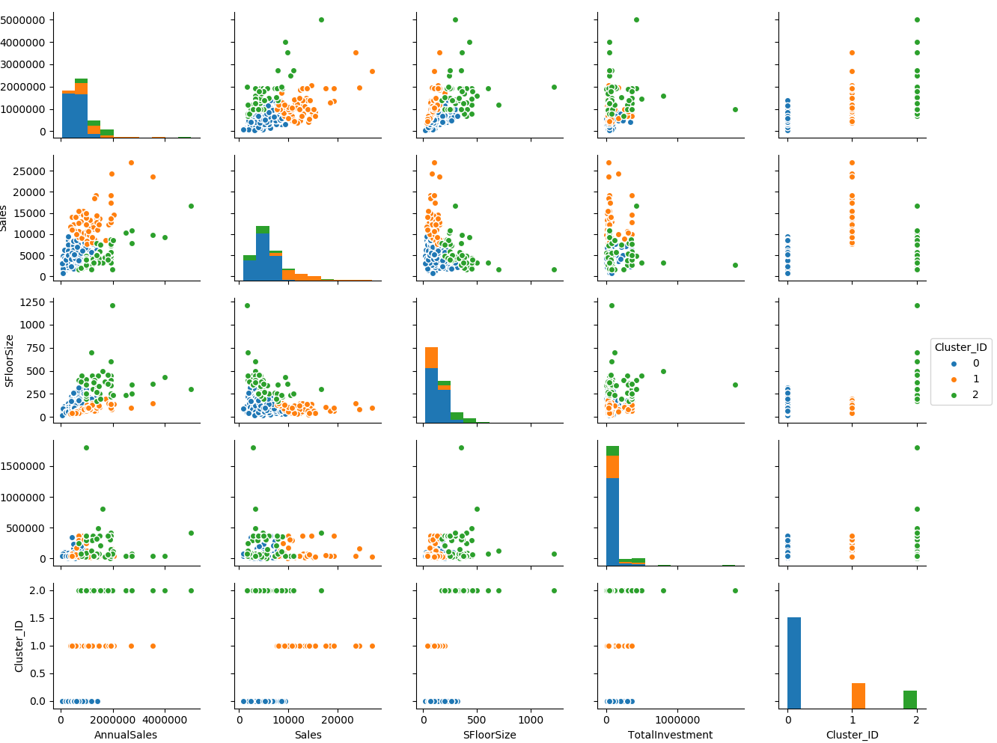

**Each clusters are defined here. However, half of it has really good visualisations of clusters (e.g. first two rows)**

**But as rows go down, it is harder to visualize and distinguish each cluster**

**Sales Removed**

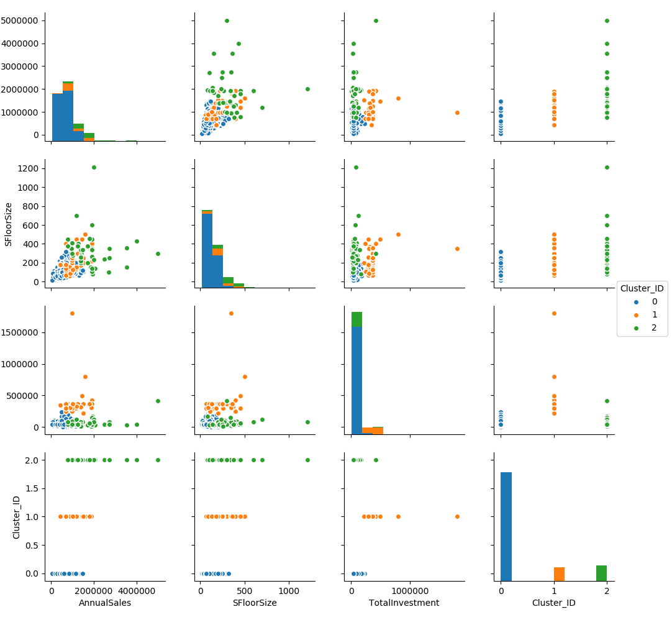

**Clusters are easier to visualize in here, every cluster is mostly visible and we can clearly identify each clusters**

**Annual Sales & Investment Removed**

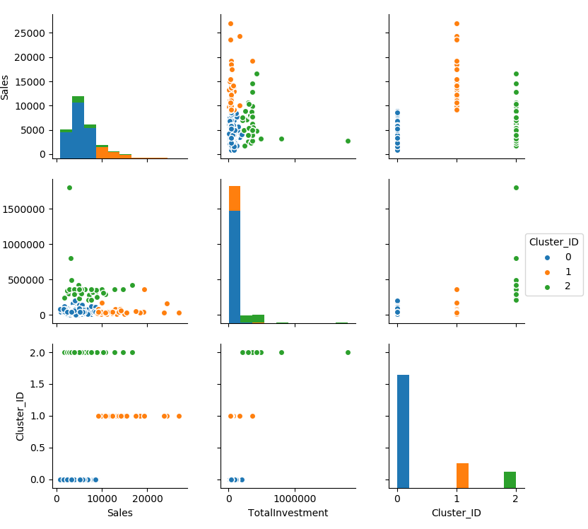

**This Clustering model is the worst, has the lowest intra-cluster distance and also, you can’t get much out of this. Except lower investment gets higher sales (first row 2nd column)**