Prototype – Instructional Setup (Running Bash Scripts)
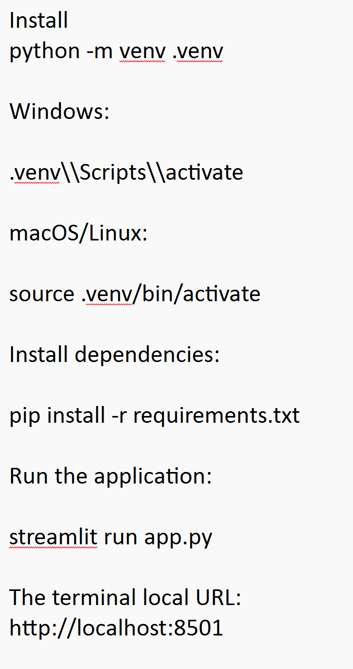
Terminal Local URL: http://localhost:8501

Workflow Demonstration
- Open the dashboard.
- Show the overall student monitoring KPIs.
- Filter to High Risk students.
- Select Learners such as Isaac Goh or Farah Ahmad.
- Show the risk score and indicators.
- Explain why the student is flagged.
- Show the recommended intervention.
- Return to the overview and explain how a lecturer could use the dashboard for early intervention.
Project Link
Repository placeholder:
https://github.com/dlimks2002/ai-student-progress-risk-monitoring
Prototyping model could be further enhanced with the following:
Future Enhancements
- Train a supervised ML model using historical anonymised student data.
- Add weekly progress trend charts.
- Integrate LMS/student information system data through APIs.
- Add lecturer notes and intervention tracking.
- Add model evaluation metrics and fairness monitoring.
- Add role-based access control and privacy safeguards.
- Use an LLM/RAG layer to generate personalised learning-resource recommendations.

AI Concern:
The prototype should support lecturers rather than replace professional judgement. Risk flags can be affected by incomplete data, contextual factors or bias. Any real deployment should use appropriate governance, access control, data minimisation, transparency, human review and model monitoring.

What the prototype does for us
The dashboard includes:
- 20 leaners
- Attendance monitoring
- Assessment performance
- Engagement percentage
- Assignment submission
- Explainable risk score
- Low / Medium / High risk classification
- Risk distribution chart
- Student search/filter
- Individual student drill-down
- Explanation of why a student is flagged
- Suggested lecturer interventions
- Responsible-AI disclaimer
The risk model is deliberately simple and explainable:
Risk Score =
- 35% assessment performance
- 30% attendance
- 20% engagement
- 15% assignment submission
This is a good choice for a prototype demonstration because we can clearly explain how the system works instead of claiming that a complex AI model magically predicts student failure.

Running the Project
After doing the ZIP Extraction - Running it:
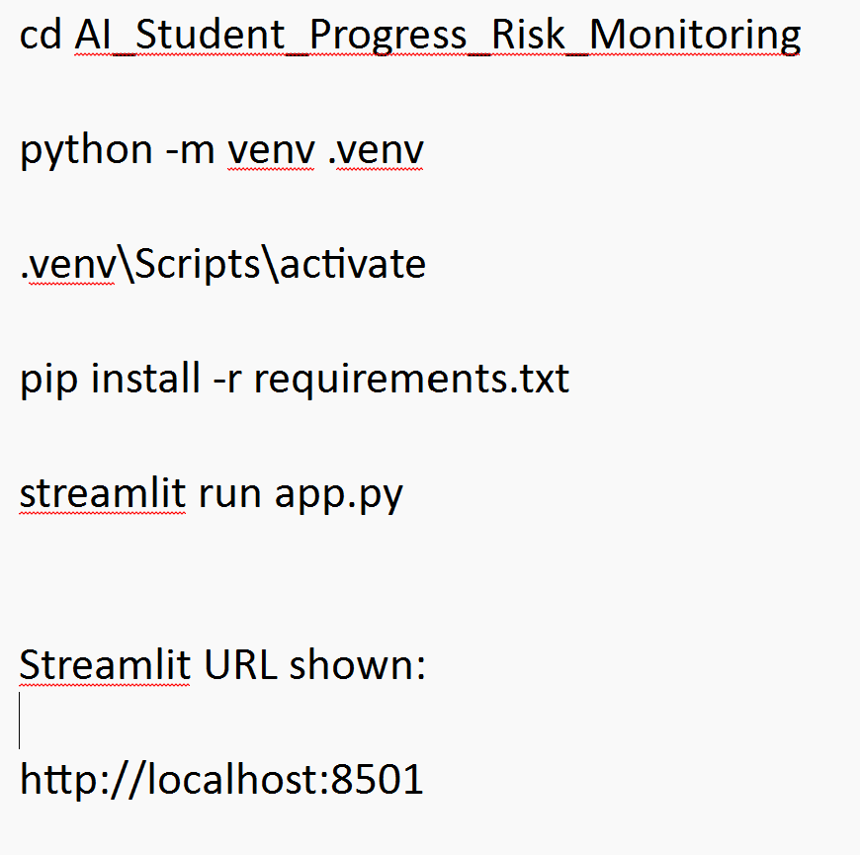

Recommendation Data Testing
- We would recommend using Isaac Goh as the main high-risk example for the demonstration.

Submission Prototype URL
Live Prototype:
https://ai-student-progress-risk-monitoring.streamlit.app
Source Code:
https://github.com/your-username/ai-student-progress-risk-monitoring

https://ai-student-progress-risk-monitoring.streamlit.app

