**A SOLAR IRRADIANCE CLIMATE DATA RECORD**

O. Coddington1, J. L. Lean2, P. Pilewskie1, M. Snow1, D. Lindholm1

1. *Laboratory for Atmospheric and Space Physics, University of Colorado Boulder, Boulder, CO, 80305*

2. *Space Science Division, Naval Research Laboratory, Washington D.C. 20375*

**Abstract**

We present a new climate data record for total solar irradiance and solar spectral irradiance between 1610 and present-day with associated wavelength and time dependent uncertainties, and quarterly updates. The data record, which is part of the National Oceanographic and Atmospheric Administration’s (NOAA) Climate Data Record (CDR) Program, provides a robust, sustainable, and scientifically defensible record of solar irradiance that is of sufficient length, consistency, and continuity for use in studies of climate variability and climate change on multiple time scales, and for user groups spanning climate modeling, remote sensing, and natural resource and renewable energy industries. The data record, jointly developed by the University of Colorado at Boulder’s Laboratory for Atmospheric and Space Physics (LASP) and the Naval Research Laboratory (NRL), is constructed from solar irradiance models that determine the changes from quiet Sun conditions when facular brightening and sunspot darkening features are present on the solar disk, where the magnitude of the changes in irradiance are determined from linear regression of the proxy Mg II index and sunspot area indices against the approximately decade-long solar irradiance measurements of the SOlar Radiation and Climate Experiment (SORCE). To promote long-term data usage and sharing for a broad range of users, the source code, the dataset itself, and supporting documentation are archived at NOAA’s National Centers for Environmental Information (NCEI). The dataset is also available through the Laboratory for Atmospheric and Space Physics (LASP) Interactive Solar Irradiance Data Center (LISIRD) for user-specified time periods and spectral ranges of interest.

**Capsule**

We describe a solar irradiance climate data record of daily and monthly solar irradiance values from 1882 to the present, and annual values since 1610, sustained with periodic updates.

**1. The Role of the Sun in Climate Change**

The Sun is the dominant energy source for the Earth, establishing the Earth’s surface temperature, structuring the overlying atmosphere, and powering complex, coupled radiative, dynamical and chemical processes that produce myriad land-ocean-atmosphere interactions that define our terrestrial habitat. On average, the rate of transport of total radiative energy per unit area that the Sun presently provides at the top of the Earth’s atmosphere is 1361 W m-2(Figure 1).This is the total (spectrally integrated) solar irradiance, or TSI (with units W m-2), which is definedfor the Earth at a distance of one Astronomical Unit from the Sun. The spectrum of solar irradiance (the solar spectral irradiance, or SSI, with units W m-2 nm-1) that composes the total is similar in shape to a black body near 6000oC (Figure 1), which is the approximate temperature of the emitting layer of the Sun’s lower atmosphere from where more than 99% of the solar irradiance emerges.

Neither the TSI nor SSI is constant despite the historical reference of TSI as “the solar constant”. The Sun’s 11-year, and longer, cycles of magnetic activity, driven by a sub-surface dynamo, alter the amount of magnetic flux that emerges from the solar interior into the Sun’s atmosphere thereby producing solar irradiance variations (e.g., Lean et al. 1988). Sunspots are magnetic features that appear as dark spots on the visible surface of the Sun because the enhanced magnetic field strength is sufficient to quell the upwelling energy from the convection zone below. The spots appear dark because they are cooler than the surrounding photosphere (e.g., Rempel and Schlichenmaier 2011). Sunspots can persist on the Sun’s surface for several days to weeks; their presence reduces the Sun’s irradiance. Bright magnetic features called faculae typically accompany sunspots. Faculae are longer-lived and more dispersed over the solar disc than are sunspots. Bright photospheric faculae, which expand into regions called “plage” in the overlying chromosphere, are hotter than the surrounding solar atmosphere; their presence on the Sun’s disk increases irradiance (e.g., Walton et al. 2003).

Disk-integrated solar irradiance at any time is thus the net of the competing emission enhancements in all bright faculae (and plage) and emission reduction in all dark sunspots. As solar activity increases during the 11-year cycle, the enhanced facular emission more than compensates for the irradiance reduction in sunspots such that the TSI at solar activity maximum exceeds that at solar minimum (Figure 2). But on shorter time scales the Sun’s rotation, which has an approximately 27-day cycle, can alter the number of sunspots and faculae on the hemisphere of the solar disk projected to Earth, such that there are times when large sunspots reduce irradiance much more than the dispersed facular features increase it. Space-era observations of TSI demonstrate, unequivocally, that the Sun emits approximately 0.1% more radiative energy at solar maximum than at solar minimum (Kopp and Lean 2011) although TSI decreases in excess of 0.3% can occur on time scales of days to weeks (Woods et al. 2004). Both observations (Harder et al. 2005) and solar atmosphere theoretical models (Fontenla et al. 1993, Solanki and Unruh 1998) indicate that the irradiance spectrum varies as a strong function of wavelength during the solar rotation and the solar cycle. Figure 3 shows the modeled time series of SSI from 1978 to 2014; the SSI has been binned into four broad wavelength bands spanning the ultraviolet to the near infrared.

Because of wavelength-dependent absorption and scattering processes, the Earth system responds in distinct ways to the Sun’s energy inputs in different wavelength regions of the electromagnetic spectrum. The atmosphere completely absorbs solar radiation at wavelengths shortward of 295 nm; this ultraviolet energy both creates and destroys ozone and is a primary determinant of middle atmosphere dynamics and temperature (e.g., Swartz et al. 2012). Longer wavelength visible and near-infrared radiation penetrates to the troposphere and Earth’s surface, where roughly half of the globally averaged incoming solar radiation is absorbed (Trenberth et al. 2009, Stephens et al. 2012). The balance of incident solar radiation that is absorbed or reflected by the Earth’s surface and atmospheric components (such as clouds and gases) with that radiation that the Earth-atmosphere system emits to space (at infrared wavelengths) defines the Earth’s radiation budget (Loeb et al. 2009). Changes in the radiation balance impact surface temperature and other climate parameters. Solar irradiance, therefore, is designated an *essential climate variable[1]* whose long-term measurement is necessary for the understanding of past and present climate and the projection of future climate (Kratz et al. 2014, Bojinski et al. 2014, Holdren 2014).

Determining the Sun’s role in climate variability requires uninterrupted records of TSI and SSI that are of sufficient length, consistency, and continuity to be useful for evaluating variations in solar irradiance on a wide range of time scales, so as to specify this natural forcing of climate change (Kopp and Lean 2013). The National Oceanographic and Atmospheric Administration (NOAA) Climate Data Record program defines a climate data record (CDR) as the sustained and routine generation of products using observational records that span decades to centuries and assigns a “maturity matrix” level to quantify the reliability of a CDR for use in decision making across many socioeconomic sectors (Bates and Privette 2012). The maturity matrix establishes the transition from basic research to quality-controlled, routinely generated data in these thematic areas: code stability, compliance of metadata with international standards, documentation, product validation, public accessibility to data and code, and utility to a broad user community (Bates and Privette 2012).

The extant database of space-age observations of TSI and SSI (for TSI, 37 years or approximately 3 solar cycles, and less for SSI) lacks the length and, with respect to SSI, the stability to quantify true solar variability over multiple 11-year solar activity cycles. Most of the individual observations made thus far have neither sufficiently small uncertainties nor adequate repeatability to achieve the measurement requirements for a climate data record of total and spectral solar irradiance. Table 1 lists these requirements: the challenge is to detect variations of less than 0.01% per decade in TSI and 0.1-0.5% per decade for SSI that underlie a dominant 11-year activity cycle of comparable magnitude. This motivates the use of solar irradiance variability models to constrain and interpolate the measurement record and to provide past and future irradiance variability estimates. We present new versions of the Naval Research Laboratory (NRL) solar irradiance variability models (Lean 2000, Lean et al. 2005, Lean and Woods 2011), namely, NRLTSI2 and NRLSSI2, for TSI and SSI respectively, as a Solar Irradiance Climate Data Record (hereafter, the Solar Irradiance CDR).

The Climate-Algorithm Theoretical Basis Document (C-ATBD) for Total Solar Irradiance and Solar Spectral Irradiance (Coddington and Lean 2015) describes in detail the theoretical and operational implementation of the algorithm, including the model inputs, ancillary data, and uncertainty analysis that is used to estimate the Solar Irradiance CDR with the NRLTSI2 and NRLSSI2 models. In the following section, we summarize these elements and illustrate aspects of the Solar Irradiance CDR.

**2. Solar Irradiance Climate Data Record****Algorithm**

*a. NRLTSI2 and NRLSSI2 Model Formulation*

The calculation of total solar irradiance, *T(t)*, and solar spectral irradiance, *I(λ,t)*, at a specified time, *t*, assumes that the presence on the solar disk of bright faculae and dark sunspots alters the baseline, quiet, total solar irradiance, *TQ*, by amounts *∆TF(t)* and *∆TS(t)*, respectively, so that . Similarly, the faculae and sunspots alter the baseline solar spectral irradiance, *IQ(λ),* by wavelength-dependent amounts, *∆IF*(*λ,t*) and *∆IS*(*λ,t*), so that where the integrated spectral irradiance equals the corresponding total irradiance, such that and the integrated spectral facular and sunspot increments equal their respective contributions to the total solar irradiance: and .

The algorithm begins by determining indices for the facular brightening, *F(t)*, and sunspot darkening, *S(t),* from ground and/or space based observations. Applying scaling coefficients to these indices converts them to corresponding incremental changes in total solar irradiance and solar spectral irradiance (in irradiance units), which are then added to the quiet sun reference values to determine the total solar and spectral solar irradiance at time, *t*.

The spectral irradiance is then partitioned into 3785 wavelength bins of variable width, designed appropriately for input to general circulation climate models. There are 635 bins of 1 nm width on wavelengths grid centers from 115.5 to 749.5 nm, 850 bins of 5 nm width on wavelength grid centers from 752.5 to 4997.5 nm, 500 bins of 10 nm width on wavelength grid centers from 5005.0 to 9995.0 nm and 1800 bins of 50 nm width on wavelength grid centers from 10025.0 to 99975.0 nm.

*b. Adopted Quiet Sun Reference*

The choice of irradiance for the “quiet” (invariant) Sun (Figure 1) is based on measurements from a time period during solar minimum conditions when the solar disk was free of both faculae and sunspots. For TSI, this reference value is 1360.45 W m-2 and is based on NASA’s SOlar Radiation and Climate Experiment (SORCE) (Rottman, 2005) Total Irradiance Monitor (TIM) (Kopp et al. 2005) measurements of total solar irradiance (Kopp and Lean 2011). For SSI, the reference spectrum is obtained as follows: For wavelengths less than 300 nm, the spectrum is that of the Whole Heliosphere Interval (WHI) SSI reference spectrum garnered from SORCE measurements between March 20, 2008 and April 16, 2008 (Woods et al. 2009). For wavelengths between 300 nm and 1000 nm, the spectral irradiance is that reported from measurements made by the SOLar SPECtrum (SOLSPEC) instrument on the ATLAS 1 space shuttle mission (Thuillier et al. 1998) constrained to match the overall spectral shape of the WHI reference spectrum. At longer wavelengths, the spectral irradiance is from SORCE SIM measurements between 1000 and 2400 nm and from the Kurucz (1991) theoretical spectrum for 2400 to 100000 nm. In a final step, the spectrum is scaled to make the integral of the quiet sun reference spectrum equal to the adopted quiet sun TSI value (i.e., 1360.45 W m-2).

*c. Model Scaling Coefficients*

The model coefficients that scale the input facular and sunspot indices are determined from regression of the indices against SORCE observations[2] over the time period from 2003 to 2014: for TSI, observations are from the TIM instrument (version 17 data) and for SSI the observations, at variable spectral resolution, are from the SOLar STellar Irradiance Comparison Experiment (SOLSTICE; version 13 data) (McClintock et al. 2005a) for wavelengths between 115 and 309 nm and from the SIM instrument (version 21 data) for wavelengths between 309 nm to 2400 nm. The model assumes that the scaling coefficients are time invariant.

Because the calibrations of the SOLSTICE and SIM instruments are less stable over time than is the TIM’s, instrumental trends that are likely present in the SSI measurements (Lean and DeLand 2012) preclude the formulation of reliable models of SSI variability from directly measured SSI observations over long time scales. Instead, a relationship between SSI variability and facular brightening and sunspot darkening is first determined using observations over solar rotational time scales where instrumental trends are minimal, especially in comparison to those over the solar cycle. For each 1 nm bin, the observed SSI and the facular brightening and sunspot darkening indices are detrended by subtracting 81-day running means. Multiple linear regression analysis is then used to determine the wavelength-dependent relationships of the detrended time series.

However, regression coefficients of models developed from detrended SSI time series differ somewhat from those developed from direct (i.e. not detrended) SSI observations. This is due in part to the smaller range of facular variability in the detrended time series than during the solar cycle, and in part to the “imperfect” natures of the facular brightening and sunspot darkening indices in representing the true sources of irradiance variability. To account for this, we apply a linear scaling to adjust the coefficients obtained from the multiple regression analysis using the detrended SSI time series by the following approach. Firstly, the TSI observations are used to numerically determine ratios of the multiple regression coefficients obtained using direct observations of TSI with those obtained using detrended TSI observations. Secondly, these ratios are used to adjust the coefficients for SSI variations at wavelengths longer than 295 nm (where faculae and sunspots both modulate solar spectral irradiance) determined from the multiple regression analysis of the detrended SSI time series. Finally, we apply small, additional facular and sunspot spectral irradiance corrections to numerically constrain the integrated facular brightening and sunspot darkening components in the spectral irradiance such that they equal their respective total solar irradiance counterparts.

*d. Model Inputs and Ancillary Data*

Proxy indicators of solar magnetic variability are the principal inputs to the irradiance variability models. When facular brightening and sunspot darkening features are present on the solar disk, the magnitude of the changes in irradiance are determined from a scaling computed from the proxy indices quantifying their magnitude and the model coefficients. Figure 2 shows the individual facular brightening and sunspot darkening components, in irradiance units, for the modeled time series of TSI from 1978 to 2014. In the extant satellite era, the proxy of facular brightening on the Sun is irradiance (i.e. integrated over the solar disk) measurements of Magnesium (Mg) II emission. The Mg II index (Viereck et al. 2001) is the ratio of measurements from the core of the H and K Mg II emission lines at 280 nm to measurements in the nearby wings (278 and 282 nm) and variability in the Mg II index is attributed to chromospheric extensions of the photospheric faculae. Since 1978, multiple satellite missions have recorded the Mg II index (Skupin et al. 2004, Viereck et al. 2004, Snow et al. 2014). For the Solar Irradiance CDR, we utilize the University of Bremen[3] Mg II measurement composite.

The proxy of sunspot darkening on the Sun is computed from the areas and locations of sunspots on the solar disk on any given day (Allen 1979, Foukal 1981, Lean et al., 1998, Brandt et al. 1994) as reported by the Air Force Solar Observing Optical Network (SOON) sites. For sunspot region information[4] prior to 1982, we use Greenwich Observatory observations, which began in 1882.

A third component of irradiance variability is an assumed long-term facular contribution that is speculated (see review in Solanki et al. 2013) to produce secular irradiance change underlying the solar activity cycle on historical time scales (prior to 1950), including during the Maunder Minimum period of anomalously low solar activity from 1645 to 1715. According to simulations from a magnetic flux transport model (with variable meridional flow) of eruption, transport, and accumulation of magnetic flux on the Sun’s surface since 1617, a small accumulation of total magnetic flux and possibly the rate of emergence of small, magnetic bipole regions on the quiet Sun (called ephemeral regions), produce a net increase in facular brightness (Wang et al. 2005); the increase in TSI from the Maunder Minimum to the present-day quiet Sun is about 0.04% (e.g., Lean et al. 2005 compare different estimates of TSI from the Maunder minimum to the present). For the Solar Irradiance CDR, the spectral irradiance changes since 1610 are consistent with the Wang et al. (2005) flux transport simulations and integrate to give the corresponding TSI values.

*e. Uncertainty Estimates*

The Solar Irradiance CDR algorithm calculates time- and wavelength dependent irradiance uncertainties pertaining to the absolute scale of the reference quiet Sun values, the input facular brightening and sunspot darkening indices, and the coefficients used to scale the facular and sunspot proxy indices to equivalent irradiance increments. Not yet accounted for in the uncertainty analysis are assumptions about the proxy indices’ representations of facular brightening and sunspot darkening; these additional, more complex uncertainties are difficult to quantify and their assessment is ongoing.

Uncertainties in the facular and sunspot proxy indices input to the model are the largest sources of uncertainty in the modeled irradiance variability. When the facular brightening and sunspot darkening contributions are zero, as may occur during minima in solar activity, the error budget reduces to that of the absolute uncertainty of the adopted irradiance of the quiet Sun (i.e., the absolute uncertainty reported for the SORCE measurements). But such conditions are not typical, and whenever magnetic regions manifest on the solar disk the uncertainties increase as the components that alter the irradiance from background conditions are estimated. The variability in the sunspot darkening and the facular brightening indices that are input to the algorithm are specified as ±20%, which is representative of statistical variations among sunspot darkening values derived from the USAF SOON network sites.

*f. Verification and Validation of Model Output*

We verify the Solar Irradiance CDR algorithm performance by making a number of numerical comparisons. Firstly, the spectrally integrated modeled SSI is compared with the modeled TSI. On average (over several solar cycles, from 1978 to 2014) the agreement of these two quantities is within 0.015 Wm-2 and the standard deviation of their differences is 0.004 Wm-2. Secondly, the spectrally integrated facular brightening and sunspot darkening components of the modeled SSI are compared with their TSI model counterparts. On average, the agreement in the two facular brightening components is better than 0.014 W m-2 and the standard deviation of their differences is 0.006 W m-2. The agreement of the two sunspot darkening components is within 0.002 W m-2 and the standard deviation of their differences is 0.002 W m-2. Lastly, we compare the modeled solar irradiance (total and spectral) with observations and other models.

1) Comparisons of modeled and measured solar irradiance

Figure 4 shows comparisons of the modeled TSI from the NRLTSI2 model with SORCE TIM observations for solar rotation periods in the descending phase of solar cycle 23 (Figure 4a), the minimum at the beginning of solar cycle 24 (Figure 4b) and for the duration of the SORCE mission (Figure 4c). Residual differences are shown in Figure 4d. Over this time period (of approximately one solar cycle) NRLTSI2 explains 92% of the variability of the SORCE TIM observations, with a correlation coefficient of 0.96. The standard deviation of the residuals is 0.1 W m-2 and the slope is 1 part per million (ppm) per year, which indicates that the NRLTSI2 model produces an irradiance record that agrees with the SORCE TIM observations to within their 10 ppm per year estimated repeatability (Kopp and Lean 2011). Facular brightening and sunspot darkening activity were relatively high in late October 2003 and the rapid short term decrease in TSI evident in Figure 4a was as large as any TSI change measured in the history of the satellite era. Hence, the irradiance changes over this approximately two-week period are about as large as we anticipate and the associated uncertainty (see Section 2d) in the modeled TSI, on the order of 1000 ppm (0.1%), therefore represents an upper limit in the modeled TSI variability.

Figure 5 compares the modeled SSI from the NRLSSI2 model with SORCE SOLSTICE and SORCE SIM observations in four broad wavelength bands. The comparisons are made over solar rotation (27-day) time scales, for which instrumental effects in the observations are considered to be small compared with true solar irradiance variability. Note that the uncertainties shown in Figure 5 do not include uncertainty in the SSI absolute scale, estimated to be 2-3% for the SORCE SOLSTICE observations (McClintock et al. 2005b) and for the SORCE SIM observations below 1350 nm, increasing to 8% for SORCE SIM observations above 1350 nm (Harder et al. 2010).

2) Comparisons of solar irradiance Between the new and original model formulations

The newly formulated NRLTSI2 and NRLSSI2 models differ from the original NRL models of solar irradiance variability in several significant ways including the adopted value for the quiet Sun reference (Section 2b), the records of TSI and SSI observations used in multiple linear regression to establish the scaling coefficients (Section 2c), and in the sunspot and facular proxy indices (Section 2d).

The original NRL model of total solar irradiance variability was based on a composite TSI record from 1978 to 2003, which Fröhlich and Lean (2004) constructed using irradiance observations of the Sun from different instruments on four separate, missions: Nimbus 7 (Kyle et al. 1993), Solar Maximum Mission (SMM) and Upper Atmosphere Research Satellite (UARS) (Willson, 1994), and the Solar and Heliospheric Observatory (SOHO) (Fröhlich et al. 1997). Spectral information for wavelengths less than 400 nm was based on SSI observations by SOLSTICE on the UARS mission, from 1992 to 1995 (Lean et al. 1997). Due to the lack of observations of solar irradiance variability at wavelengths longer than approximately 400 nm, theoretical estimates from a solar atmosphere model (Unruh et al. 2000) were used to represent the wavelength dependence of sunspot and facular contributions (Lean 2000, Lean et al. 2005, Lean and Woods 2011).

At the time of the original NRLTSI and NRLSSI models, the commonly accepted value of the quiet Sun total solar irradiance was 1365.5 W m-2. The original reference spectrum for the NRLSSI model was an average of SOLSTICE observations during the UARS time period for wavelengths between 120 and 400 nm and observations from the ATLAS shuttle mission (Thuillier et al. 1998) for wavelengths between 401 nm to 874 nm. At longer wavelengths, a theoretical spectrum was used (Kurucz 1991). In a final step, the original reference spectrum was scaled such that the integral of the SSI equaled the previously adopted value for the TSI of the quiet Sun.

Figure 6 compares NRLTSI2 to the earlier model, NRLTSI, for the same time period of Figure 2. NRLTSI2 has a lower absolute scale because it was produced directly from the SORCE TIM observations. In addition, NRLTSI2 has about 10% more variability than NRLTSI. Figure 7 compares the solar cycle changes in spectral irradiance estimated by NRLSSI2 (with associated uncertainties) with those estimated by the original NRLSSI model. NRLSSI2 has more variability than NRLSSI at wavelengths between 300 and 400 nm but less variability than NRLSSI at wavelengths between 300 and 600 nm.

**3. Solar Irradiance Datasets**

Included with the Solar Irradiance CDR is a composite *observational* record of total solar irradiance constructed from space-based radiometer measurements between 1978 and 2014. The prescribed observational composite is the average of two individual, composite records each constructed separately using different bias corrections and assumptions about the uncertainties and repeatability of the extant solar irradiance database. Fröhlich and Lean (1998) describe the Physikalisch-Meteorologisches Observatorium Davos (PMOD) composite and Willson and Mordvinov (2003) the Active Cavity Radiometer Irradiance Monitor (ACRIM) composite. Figure 8a shows the Solar Irradiance CDR observational composite and Figure 8b shows the residual differences from the observational composite and the NRLTSI2 variability model. For the time period spanning 1978 to 2014, the average standard deviation of the composite observational record and the NRLTSI2 model is 0.25 W m-2.

In the near-term, the TSI observational composite will be extended using observations as available from measurements made by the TIM instruments on SORCE and on the Joint Polar Satellite System (JPSS) Total solar irradiance Calibration Transfer Experiment (TCTE). The TCTE TSI dataset began in late 2013 with the launch of the U.S. Air Force STPSat-3 satellite (Woods et al. 2014). The TCTE TIM is a nearly identical copy (i.e., a ground “witness”) of the SORCE TIM instrument, repurposed for quick integration on STPSat-3 following the 2011 launch failure of Glory that carried a next-generation TIM.

In the longer-term future, the Solar Irradiance CDR will be expanded to include total and spectral irradiance measurements made by the next-generation TIM and SIM instruments, scheduled for launch to the International Space Station in August, 2017 as the Total and Spectral Solar Irradiance Sensor (TSIS) mission. The TSIS TIM and SIM have been designed, built, and calibrated to meet the measurement requirements necessary for a climate data record of solar irradiance (see Table 1). The TSIS SIM employs three (compared with SORCE SIM’s two) measurement channels to better quantify instrument degradation and related uncertainties. The TSIS instruments have been calibrated in the TSI and Spectral Radiometer Facilities at LASP (Kopp et al. 2007, Richard et al. 2011), which are the only calibration facilities in the world capable of characterizing TSI and SSI instruments at the power levels and vacuum conditions experienced in flight. Coddington et al. (2013) describe these next-generation TIM and SIM instruments in the TSIS Algorithm Theoretical Basis Document (ATBD). In the future, new versions of the Solar Irradiance CDR are expected to accrue from the TSIS observational record of TSI and SSI, which will permit validation and modification, as necessary, of the associations of solar irradiance variability with the facular and sunspot proxy indices.

**4. Deliverables**

LASP creates the Solar Irradiance CDR, updates the record quarterly, and provides the record to the National Centers for Environmental Information (NCEI) in netCDF4 format with accompanying metadata that meets current Climate and Forecast (CF) conventions. The algorithm source code and supporting documentation, as well as the input faculae and sunspot indices are also delivered as part of the CDR dataset. Table 2 summarizes the delivered products.

Daily and monthly averaged data are provided from 1882 to 2014 and annually averaged data from 1610 to 2014. Quarterly (preliminary) extensions to the Solar Irradiance CDR are transferred to NCEI and ultimately replaced with final products at year-end.

The Solar Irradiance CDR team provides stewardship of the CDR through a yearly Quality Assurance document describing the stability of the model inputs and the data record. NOAA’s NCEI[5] is the definitive source of the Solar Irradiance CDR, but users may also download the data over a user-defined time and spectral range of interest from LASP’s Interactive Solar Irradiance Data Center (LISIRD, http://lasp.colorado.edu/lisird) server.

NRLTSI2 files include time-dependent uncertainties in the modeled TSI and the data are aggregated as follows: a) daily and monthly-averaged TSI are provided in separate files for each year in the period of record, b) annually averaged TSI is provided in a separate, single file. NRLSSI2 files do not include time-dependent uncertainties in the modeled SSI (due to file size consideration), but the data are aggregated similarly as for the TSI. Because users of SSI typically require knowledge of the TSI as a constraint, the NRLSSI2 files also include the modeled TSI and its associated uncertainty.

Also provided as part of the Solar Irradiance CDR are modeled reference spectra at 1 nm spectral resolution that are indicative of varying levels of solar activity; quiet, low, moderate, and high. These reference spectra correspond to appropriate 1-month averages obtained at discrete periods during solar cycle 23: July 2008 for low solar activity, May 2004 for moderate solar activity, and September 2001 for high solar activity. The quiet Sun reference spectrum corresponds to that described in Section 2a. An additional spectrum assumed to represent solar radiative output at the time of the Maunder minimum period of anomalously low solar activity is also provided. These five, unique, reference spectra are a one-time (i.e., no operational update) delivery.

To facilitate validation with independent datasets, the time series of the facular brightening and sunspot darkening proxy inputs are also archived at NCEI, with preliminary and final updates at the same cadence as the solar irradiance files.

The composite observational record (as described in Section 3) is the final product delivered to NOAA NCEI as part of the Solar Irradiance CDR package.

**5. Operational Implementation**

The flow diagram in Figure 9 provides an overview of the algorithm processing steps to calculate TSI and SSI at a specified time using procedures that are 100% numerically reproducible given identical sunspot darkening and facular brightening inputs. The data processing system runs as part of LISIRD. Automated daily processing updates the data inputs needed for computing the sunspot darkening and facular brightening indices. The LaTiS software framework provides a web service interface that the processing code uses to access input data.

*a) Data Latency*

The availability of the proxy data used to compute the facular brightening and sunspot darkening indices determine the latency of the updates for the Solar Irradiance CDR. New USAF sunspot data files are expected to accrue weekly with a latency of approximately 2 weeks. The latency is a result of the organization of the sunspot data files by sunspot group number (i.e., not by calendar date) and the time it takes a sunspot group to appear and then rotate off the solar disk. There is also a potential for data latency with the University of Bremen Mg II composite record.

*b) Operational Monitoring & Quality Flagging*

The quality assurance process is ongoing and utilizes both science analysis and data quality assurance. The Solar Irradiance CDR team oversees this process, which involves regular and careful examination of all solar and proxy data, and assesses the veracity and quality of the data to be released. The quality assurance takes several different forms based on: 1) the confidence in the calibration and performance of the instruments providing the solar and proxy observations, 2) comparisons of NRLTSI2 and NRLSSI2 model output with measurements, and 3) an understanding of the Sun and its variability based on a broad range of solar models and on multiple solar observations at other wavelengths.

The production system supports both automatic and manual diagnostic statistical analyses of the science products. Deviations from expected or predicted values, flagging of anomalous values, and trending of the sunspot blocking function and facular brightening function relative to independent proxies of solar variability, as well as trends in final science values relative to independent models and measurements of solar irradiance, are all incorporated into the assessment of the stability in the final science data products. The Solar Irradiance CDR team initially monitors the quality flags in the final science products manually, moving to automating portions of the quality control as the algorithm matures; manual monitoring, particularly of the physical representativeness of the facular brightening function and sunspot darkening indices, will continue to be necessary to some extent.

For example, the relationship between sunspot area and sunspot number must be monitored to identify a physically plausible “zero sunspot area” that occurs when there are no sunspots (i.e. as can occur during solar minimum conditions) from a physically implausible result of “zero sunspot area” that may occur with a missing USAF SOON station record. The sunspot catalog maintained by the Debrecen, Hungary Heliophysical Observatory[6] (Győri et al. 2011) is one independent data source that will be accessed for quality assurance of the sunspot darkening. The veracity of the Mg II index can be approximately assessed using the F10.7 cm solar radio flux[7], which is an independent proxy of chromospheric variability (with a coronal component) (Tapping 2013).

**6. Outlook**

Solar irradiance is an essential, universal input to myriad terrestrial applications and we envisage the Solar Irradiance CDR to be of broad use to industry, scientific, and government applications, including renewable energy, water resources, hydrology, atmospheric chemistry, global climate models, stratospheric and stratospheric-climate models, and community radiative transfer models. Future knowledge gained from the more accurate and stable TSIS instruments will be transferred to the ongoing SORCE and TCTE instrument record so that future Solar Irradiance CDR versions may incorporate altered quiet Sun reference levels and model scaling coefficients reflecting revised and ongoing solar irradiance datasets (see section “Deliverables”).

New Solar Irradiance CDR versions may also employ altered facular brightening and sunspot darkening indices, which are regularly scrutinized by comparison with multiple other related indices. Preliminary comparisons of the NRLTSI2 and NRLSSI2 models with observations suggest that improvements can be made in the models’ representation of the irradiance reduction due to sunspot darkening. For example, NRLTSI2 and NRLSSI2 overestimate slightly the reduction in TSI and SSI during times of large sunspot darkening (see, for example, Figures 4a and 5). Future work will examine the parameterization of the sunspot contrast with area by calculating different sunspot darkening functions and evaluating their performance in the model formulation. Improvements in the sunspot darkening function will, by necessity, also improve the facular brightening function; this source of improvement to the facular brightening function is independent to the improvements to be gained from a higher fidelity Mg II composite record (see below).

Future efforts will include expanded and improved uncertainty estimates. This work will take into account uncertainties arising from assumptions in the model formulation, including the representation of the Mg II index for the facular brightening component and the USAF sunspot area and location for the sunspot darkening component. These efforts will also encompass improvements in the quantitative uncertainties in the wavelength dependencies of the sunspot and facular contrasts to be gained from the improvements in the TSI observational record, and the facular brightening and sunspot darkening indices described above.

Activities as part of a European-led collaboration called the SOlar Irradiance Data exploitation (SOLID)[8] project will lead to improved composite records of the Mg II index and TSI developed using advanced Bayesian statistical approaches (Dudok de Wit 2014) that define the maximum likelihood values of Mg II index and TSI from a set of individual measurement records from different instruments that are making observations at the same, or different periods of time. The Solar Irradiance CDR team plans to utilize these future composite records as an improved facular brightening index and as the (longer) TSI measurement record from which to derive the models’ coefficients.

Further enhancements of the Solar Irradiance CDR include the potential for additional irradiance products such as the solar spectral irradiance at the high spectral resolution needed for fundamental, line-by-line calculations of atmospheric heating rates.

Finally, there is the possibility that future research may reflect new understanding of the causes of solar irradiance variability, necessitating additional terms in the regression analysis and, perhaps, a different model formulation. Members of the Solar Irradiance CDR team are also part of NASA’s recently formed Solar Irradiance Science Team (SIST). The future research activities described above will be conducted as part of SIST activities and the NOAA CDR program. Coddington and Lean (2015) describe in more detail the enhancements listed in this section and planned improvements to the processing code in terms of exception handling and data quality flagging. Comparisons of the Solar Irradiance CDR with a variety of measurements and other models are underway (Coddington et al. manuscript in progress, 2015).

**7. Acknowledgements**

NOAA funded the development and transition of the Solar Irradiance Climate Data Record. NASA supported the construction of the NRLTSI2 and NRLS2 models as part of the SORCE program. The Solar Irradiance CDR team gratefully acknowledges Anand Inamdar, Philip Jones, and Daniel Wunder of NOAA’s National Centers for Environmental Information (NCEI) for their assistance in transitioning this climate data record to operations and Bruce Kindel for his assistance with the Modtran5 simulations.

**8. References**

Allen, C. W., 1981: *Astrophysical Quantities.* 3rd ed., Athlone Press.

Bates, J. J., and J. L. Privette, 2012: A maturity model for assessing the completeness of climate data records. *Eos Trans. AGU*, **93**, 44, 441.

Berk, A., G.P. Anderson, P.K. Acharya, L.S. Bernstein, L. Muratov, J. Lee, M. Fox, S.M. Adler-Golden, J.H. Chetwynd, M.L. Hoke, R.B Lockwood, J.A. Gardner, T.W. Cooley, C.C. Borel, P.E. Lewis and E.P. Shettle, 2006: MODTRAN5: 2006 Update, *Proc. SPIE*, **6233**, 62331F, 2006.

Bojinski, S., M. Verstraete, T. C. Peterson, C. Richter, A. Simmons, and M. Zemp, 2014: The Concept of Essential Climate Variables in Support of Climate Research, Applications, and Policy. *Bull. Amer. Meteor. Soc*., **95**, 1431-1443.

Brandt, P, N., M. Stix, M., and H. Weinhardt, 1994: Modelling solar irradiance variations with an area dependent photometric sunspot index. *Solar Phys*., **152**, 119-124.

Coddington, O., and J. Lean, 2015: Climate Algorithm Theoretical üasis Document: Total Solar Irradiance and Solar Spectral Irradiance. CRDP-ATBD-0612, 56 pp.

Coddington, O., and Coauthors, 2013: Algorithm Theoretical Basis Document: Total and Spectral Solar Irradiance Sensor, NOAA NCDC, draft submitted 10/29/2013, 117 pp.

Dudok de Wit, T., S. Bruisma, M. Kretzschmar, L. Lefèvre, and C. Marqué, 2014: 60 years of solar radio proxies for assessing the long-term evolution of solar forcing. *Geophys. Res. Abstracts, Proceedings of the EGU Gen. Assembly*, **16**, EGU2014-14074.

Foukal, P., 1981: Sunspots and changes in the global output of the sun. *Proc. The Physics of Sunspots*, 1981, Sunspot, NM, A83-18101 06-92), 391-423.

Fontenla, J. M., E. H. Avrett, and R. Loeser, 1993: Energy balance in the solar transition region, III – Helium emission in hydrostatic, constant-abundance models with diffusion. *Ap.J*., **406**, 319-345.

Fröhlich, C., and the VIRGO team, 1997: First Results from the VIRGO, The Experiment for Helioseismology and solar irradiance monitoring on SOHO. *Solar Physics*, **170**, 1-25.

Fröhlich, C., and J. Lean, 1998: The Sun’s Total Irradiance: Cycles, Trends and Related Climate Change Uncertainties since 1976, *Geophys. Res. Lett*., **25**, 23 4377-4380.

Győri, L., T. Baranyi, and A. Ludmány, 2011: Photospheric data programs at the Debrecen Observatory. *Proc. Of the Intern. Astron. Union*, **6**, Symp. S273, doi:10.1017/S174392131101564X.

Harder, J., G. Lawrence, J. Fontenla, G. Rottman, and T. Woods, 2005: The Spectral Irradiance Monitor: Scientific Requirements, Instrument Design, and Operation Modes, *Solar. Phys*., **230**, 141-167.

Harder, J., G. Thuillier, E. C. Richard, S. W. Brown, K. R. Lykke, M. Snow, W. E. McClintock, J. M. Fontenla, T. N. Woods, and P. Pilewskie, 2010: The SORCE SIM Solar Spectrum: Comparison with Recent Observations. *Solar Phys*., **263**, 3-24.

Holdren, J.P., 2014: National Plan for Civil Earth Observations. Natl. Sci. and Technol. Counc., Washington, D.C., 62 pp. [Available online at http://www.whitehouse.gov/sites/default/files/microsites/ostp/NSTC/national_plan_for_civil_earth_observations_-_july_2014.pdf.]

Kopp, G., K. Heuerman, D. Harber, and V. Drake, 2007: The TSI Radiometer Facility - Absolute Calibrations for Total Solar Irradiance Instruments. *Proc. SPIE,* **6677**, 667709, doi:10.1117/12.734553.

Kopp, G., and J. Lean, 2011: A new, lower value of total solar irradiance: Evidence and climate significance. *Geophys. Res. Lett*., **38**, doi:10.1029/2010GL045777.

Kopp, G., G. Lawrence, and G. Rottman, 2005: The Total Irradiance Monitor (TIM): Science Results. *Sol. Phys*., **230**, 129-139.

Kopp, G., and J. Lean, 2013: The Solar Climate Data Record: Scientific Assessment of Strategies to Mitigate an Impending Gap in Total Solar Irradiance Observations between the NASA SORCE and NOAA TSIS Missions (Study B). Prepared for NOAA’s National Climatic Data Center (NCDC), Asheville, NC, 27 pp.

Kratz, D. P., P. W. Stackhouse, J. T. Wong, P. Sawaengphokhai, A. C. Wilber, S. K. Gupta, and N. G. Loeb, Eds., 2014: [Global Climate] Earth radiation budget [in “State of the Climate in 2013”], *Bull. Amer. Meteor. Soc*., **95**, 7, S30-S32.

Krivova, N. A., S. K. Solanki, and Y. C. Unruh, 2011: Towards a long-term record of solar total and spectral irradiance, J*. Atmos. Sol.-Terr. Phys*., **73**, 223-234, doi:10.1016/j.jastp.2009.11.013.

Kurucz, R.L., 1991: The solar spectrum. *Solar interior and atmosphere*, A. N. Cox, W. C. Livingston, and M. S. Matthews, Eds., The University of Arizona Press, Tucson.

Kyle, H. L., D. V. Hoyt, J. R. Hickey, R. H. Maschoff, and G. J. Vallette, 1993: Nimbus-7 Earth Radiation Budget Calibration History - Part 1: The solar channels. *NASA Reference Publication,* **1316***.*

Lean, Judith, 2000: Evolution of the Sun’s Spectral Irradiance since the Maunder Minimum. *Geophys. Res. Lett*., **27**, 2425-2428.

Lean, J. L., J. Cook, W. Marquette, and A. Johannesson, 1998: Magnetic sources of the solar irradiance cycle. *Astrophys. J*., **492**, 390-401.

Lean, J. L., and M. T. DeLand, 2012: How Does the Sun’s Spectrum Vary?. *J. Climate*, **25**, 2555–2560, doi: <http://dx.doi.org/10.1175/JCLI-D-11-00571.1>

Lean, J. L., G. J. Rottman, H. L. Kyle, T. N. Woods, J. R. Hickey, and L. C. Puga, 1997: Detection and parameterization of variations in solar mid and near ultraviolet radiation (200 to 400 nm). *J. Geophys. Res*., **102**, 29939-29956.

Lean, J., G. Rottman, J. Harder, and G. Kopp, 2005: SORCE contributions to new understanding of global change and solar variability. *Solar Phys*., **230**, 27-53, doi: 10.1007/s11207-005-1527-2.

Lean, J. L., and T. N. Woods, 2010: Solar spectral irradiance measurements and models. *Evolving Solar Physics and the Climates of Earth and Space*, Karel Schrijver and George Siscoe Eds., Cambridge Univ. Press.

Loeb, N. G., B. A. Wielicki, D. R. Doelling, G. L. Smith, D. F. Keyes, S. Kato, N. Manalo-Smith, and T. Wong, 2009: Toward Optimal Closure of the Earth's Top-of-Atmosphere Radiation Budget. *J. Climate*, **22**, 748–766, doi: http://dx.doi.org/10.1175/2008JCLI2637.1.

McClintock, W. E., G. J Rottman, and T. N. Woods, 2005a: Solar-Stellar Irradiance Comparison Experiment II (SOLSTICE II): Instrument Concept and Design. *Sol. Phys*., **230**, 225-258.

McClintock, W.E., M. Snow, and T. N. Woods, 2005b: Solar-Stellar Irradiance Comparison Experiment II (SOLSTICE II): Pre-launch and On-orbit Calibrations. *Sol. Phys*., **230**, 259-294.

Rempel, M. and R. Schlichenmaier, 2011: Sunspot Modeling: From Simplified Models to Radiative MHD Simulations. *Living Rev. Solar Phys.* **8**, 3, (cited on 28Mar2015), [Available online at <http://www.livingreviews.org/lrsp-2011-3>].

Richard, E., D. Harber, J. Rutkowski, K. O’Malia, M. Triplett, G. Drake, J. Harder, P. Pilewskie, S. Brown, A. Smith, and K. Lykke, 2011: Future Long-term Measurements of Solar Spectral Irradiance by the TSIS Spectral Irradiance Monitor: Improvements in Measurement Accuracy and Stability. *Proceedings 11th International Conference on New Developments and Applications in Optical Radiometry*, Maui, HI, S. Park and E. Ikonen, Eds.,paper INV004.

Rottman, G., 2005: The SORCE mission, *Sol. Phys*., **230**, 7-25.

Schmidt, G. A., and Coauthors, 2011: Climate forcing reconstructions for use in PMIP simulations of the last millennium (v1.0). *Geosci. Model Dev*., **4**, 33–45, doi:10.5194/gmd-4-33-2011.

Skupin, J., M. Weber, H. Bovensmann, and J. P. Burrows, 2004: The Mg II solar activity proxy indicator derived from GOME and SCIAMACHY. *Proceedings of the ENVISAT & ERS Symposium (SP-572)*, ESA Publications Division.

Solanki, S. K. and Y. C. Unruh, 1998: A model of the wavelength dependence of solar irradiance variations. *Astron. Astrophys*., **329**, 747-753.

Solanki, S. K., N. A. Krivova, and J. D. Haigh, 2013: Solar Irradiance Variability and Climate. *Annu. Rev. Astron. Astrophys*., **51**, 311–351, doi: 10.1146/annurev-astro-082812-141007.

Snow, M. J., M. Weber, J. Machol, R. Viereck, and E. Richard, 2014: Comparison of Magnesium II core-to-wing ratio observations during solar minimum 23/24. *Space Weather Space Clim*., **4**, A04, http://dx.doi.org/10.1051/swsc/2014001.

Stephens, G. L., and Coauthors, 2012: An update on Earth’s energy balance in light of the latest global observations. *Nat. Geosci*., **5**, 691-696.

Swartz, W. H., R. S. Stolarski, L. D. Oman, E. L. Fleming, and C. H. Jackman, 2012: Middle atmosphere response to difference descriptions of the 11-yr solar cycle in spectral irradiance in a chemistry-climate model. *Atmos. Chem. Phys*., **12**, 5937-5948, doi:10.5194/acp-12-5937-2012.

Tapping, K. F., 2013: The 10.7 cm solar radio flux (F10.7). *Space Weather*, **11**, 394-406, doi:10.1002/swe.20063.

Thuillier, G., M. Hersé, P. C. Simon, D. Labs, H. Mandel, D. Gillotay, and T. Foujols, 1998: The visible solar spectral irradiance from 350 to 850 nm as measured by the SOLSPEC spectrometer during the ATLAS I mission. *Solar Phys*., **177**, 41-61.

Thuillier, G., and Coauthors, 2013: Analysis of Different Solar Spectral Irradiance Reconstructions and Their Impact on Solar Heating Rates. *Solar Phys*., doi 10.1007/s11207-013-0381-x.

Trenberth, K. E., J. T. Fasullo, and J. Kiehl, 2009: Earth’s Global Energy Budget. *Bull. Amer. Meteor. Soc.*, **90**, 311-323, doi:http://dx.doi.org/10.1175/2008BAMS2634.1.

Unruh, Y.C., S. K. Solanki, and M. Fligge, 2000: Modelling solar irradiance variations: Comparison with observations, including line-ratio variations. *Space Sci. Rev*., **94**, 1-2, 145-152, doi:10.1023/A:1026758904332.

Walton, S. R., D. G. Preminger, and G. A. Chapman, 2003: The Contribution of Faculae and Network to Long-Term Changes in the Total Solar Irradiance, *Astrophys. J*., **590**, 1088-1094.

Wang, Y.-M., J. L. Lean, and N. R. Sheeley, Jr., 2005: Modeling the Sun’s magnetic field and irradiance since 1713. *Astrophys. J*., **625**, 522–538.

Willson, R. C., 1994: Irradiance observations of SMM, Spacelab-1, UARS, and ATLAS Experiments. *The Sun as a Variable Star*, J. Pap, C. Fröhlich, H. Hudson, and S. Solanki, Eds., Cambridge Univ. Press, New York, 54-62.

Willson, R. D., and A. V. Mordvinov, 2003: Secular total solar irradiance trend during solar cycles 21-23. *Geophys. Res. Lett*., **30**, doi:10.1029/2002GL016038.

Woods, T. N., P. C. Chamberlin, J. W. Harder, R. A. Hock, M. Snow, F. G. Eparvier, J. Fontenla, W. E. McClintock, and E. C. Richard, 2009: Solar irradiance reference Spectra (SIRS) for the 2008 Whole Heliosphere Interval (WHI). *Geophys. Res. Lett*., **36**, L01101, doi:10.1029/2008GL036373.

Viereck, R. A., L. E. Floyd, P. C. Crane, T. N. Woods, B. G. Knapp, G. Rottman, M. Weber, L. C. Puga, and M. T. DeLand, 2004: A composite Mg II index spanning from 1978 to 2003. *Space Weather*, **2**, S10005, doi:[10.1029/2004SW000084](http://dx.doi.org/10.1029/2004SW000084).

Viereck, R., L. Puga, D. McMullin, D. Judge, M. Weber, and W. K. Tobiska, 2001: A proxy for solar EUV. *Geophys. Res. Lett*., **28**, 1343-1346.

Woods, T. N., R. Cahalan, W. Denig, G. Kopp, P. Pilewskie, and T. Sparn, 2014: Rapid Coordination Extends Space-Based Sun-Climate Record, Eos. Trans. AGU, **95**, 429.

Woods, T. N., F. G. Eparvier, J. Fontenla, J. Harder, G. Kopp, W. E. McClintock, G. Rottman, B. Smiley, and M. Snow, 2004: Solar irradiance variability during the October 2003 solar storm period, *Geophys. Res. Lett*., **31**, L10802, doi:10.1029/2004GL019571.

Table 1: Measurement requirements established for the TSIS TIM and SIM instruments that are driven by the need to understand Earth’s climate response to solar variability, for separating natural from anthropogenic climate forcing effects, and for the monitoring and interpretation of the variability in wavelength dependent processes induced by changes in Earth’s surface and atmosphere.

|  |  |  |
| --- | --- | --- |
| **Parameter** | **TSI CDR Requirement** | **SSI CDR Requirement** |
| Absolute Accuracy | 0.01% | 0.2% |
| Stability | 0.001% / year | 0.05% / year (λ < 400 nm)  0.01% / year (λ > 400 nm |
| Noise | 0.001% | 0.02% |

**Table 2**. Products delivered with the Solar Irradiance Climate Data Record.

|  |  |  |  |
| --- | --- | --- | --- |
| Product | Type | Number of Wavelength Bins | Time Range and Update Cadence |
| Total Solar Irradiance Composite | Observational composite | N/A | 1978-2014  Periodic updates |
| Total Solar Irradiance  (Daily- and monthly-averages) | NRLTSI2  Model output | N/A | 1882-2014 Quarterly updates |
| Total Solar Irradiance  (Yearly-averages) | NRLTSI2  Model output | N/A | 1610-2014 Yearly updates |
| Solar Spectral Irradiance (Daily- and monthly-averages) | NRLSSI2  Model output | 3785  (variable width) | 1882-2014 Quarterly updates |
| Solar Spectral Irradiance (Yearly-averages) | NRLSSI2  Model output | 3785  (variable width) | 1610-2014  Yearly updates |
| Solar Spectral Irradiance  Reference Spectra | NRLSSI2  Model output | 99884  (1 nm width) | 1. Quiet Sun 2. Low, moderate and high solar activity 3. Maunder Minimum |
| Facular brightening and sunspot darkening indices | NRLTSI2/NRLSSI2  Model input | N/A | 1882 – 2014  Quarterly updates |

**List of Figure Captions**

**Figure 1**: Reference spectrum of the quiet sun adopted for the NRLSSI2 irradiance variability model on a log-log scale. Purple region denotes spectral range obtained from SORCE SOLSTICE and SIM observations. Solid black line denotes contributions to the reference spectrum from a theoretical model (see text). The integral of the spectrum is equal to the SORCE TIM measurements of TSI at solar minimum (1360.45 W m-2), which is the adopted quiet sun TSI for the NRLTSI2 model. The dashed grey curve is a theoretical Planck irradiance curve for a blackbody temperature of 5770 K. The green curve is the (smoothed) solar irradiance at Earth’s surface computed using the Modtran5 (Berk et al. 2006) radiative transfer code.

**Figure 2**: a) Time series of NRLTSI2 total solar irradiance and b) the contributions by facular brightening (pink) and sunspot darkening (blue) to the quiet Sun reference TSI over the time period.

**Figure 3**: NRLSSI2 solar spectral irradiance binned into four broad wavelength bands for the same broad time period shown in Figure 2.

**Figure 4**: Comparison of NRLTSI2 and SORCE TIM (v17) measurements. Figure 4a illustrates NRLTSI2 variations with associated uncertainties (grey shading) in the NRLTSI2 model variability for a high solar activity time period in 2003.5 to 2004, covering five solar rotations. Figure 4b is a comparison during a period of low solar activity and Figure 4c is the comparison across the entire period of the SORCE mission. Figure 4d is the difference between the SORCE TIM measurements and the NRLTSI2 modeled variability for the entire mission; the solid purple curve is a 365-day smooth of the difference values, and the dashed black line depicts zero difference. NRLTSI2 uncertainties shown in Figures 4a-c do not include uncertainty in the TSI absolute scale, estimated to be 350 ppm for the SORCE TIM observations (Kopp and Lean 2011).

**Figure 5**: Comparison of NRLSSI2 variations (green) with associated uncertainties (grey shading) in the NRLSSI2 model variability and SORCE SSI measurements (purple) on solar rotational modulation time scales for the period 2003.5 to 2005.0. The spectral irradiances are binned into four broad wavelength bands from the ultraviolet to the near infrared. NRLSSI2 uncertainties in Figures 5a-d do not include uncertainty in the SSI absolute scale (see text). SORCE data are scaled for improved visualization and the scaling factor varies with the spectral range; the scaling factor was arbitrarily selected so that measured and modeled irradiance are equivalent in early 2004. The legend denotes the contributions to the measured spectral range by the SOLSTICE and/or SIM instruments and the value of the scaling factor applied.

**Figure 6**: a) Comparison of NRLTSI2 (orange) and NRLTSI (cyan) for 1978 through 2014. NRLTSI values are scaled in magnitude to reflect the new value of TSI of the quiet Sun (see text). b) Residual difference in NRLTSI2 and the (scaled) NRLTSI.

**Figure 7**: a) Comparison of NRLSSI2 (pink) and NRLSSI (black) solar spectral irradiance changes (max/min – 1) during solar cycle 24, in percentages. Grey regions denote the uncertainty in the NRLSSI2 model variability (restricted to positive values). b) As in Figure 7a, but the solar cycle irradiance changes (max – min) are shown in energy units. In both plots, solar minimum conditions are defined as 2008-11-28 through 2008-12-23 and (near) solar maximum conditions are defined as 2013-01-11 through 2013-01-22.

**Figure 8**: The TSI observational composite in the initial CDR is the average of the PMOD and ACRIM composites, shown in the top panel. In the bottom panel are the differences of this observational composite with the NRLTSI2 model that the CDR algorithm uses to calculate TSI.

**Figure 9**: Outline of the Solar Irradiance CDR algorithm flow from proxy inputs of facular brightening to sunspot darkening to modeled irradiance using the NRLTSI2 and NRLSSI2 variability models.

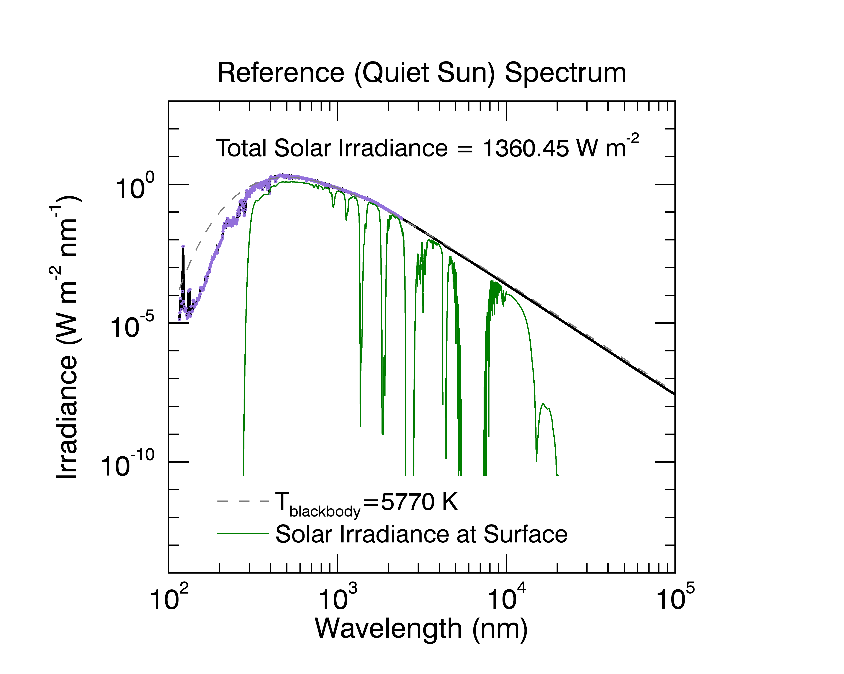

**Figure 1**: Reference spectrum of the quiet sun adopted for the NRLSSI2 irradiance variability model on a log-log scale. Purple region denotes spectral range obtained from SORCE SOLSTICE and SIM observations. Solid black line denotes contributions to the reference spectrum from a theoretical model (see text). The integral of the spectrum is equal to the SORCE TIM measurements of TSI at solar minimum (1360.45 W m-2), which is the adopted quiet sun TSI for the NRLTSI2 model. The dashed grey curve is a theoretical Planck irradiance curve for a blackbody temperature of 5770 K. The green curve is the (smoothed) solar irradiance at Earth’s surface computed using the Modtran5 (Berk et al. 2006) radiative transfer code.

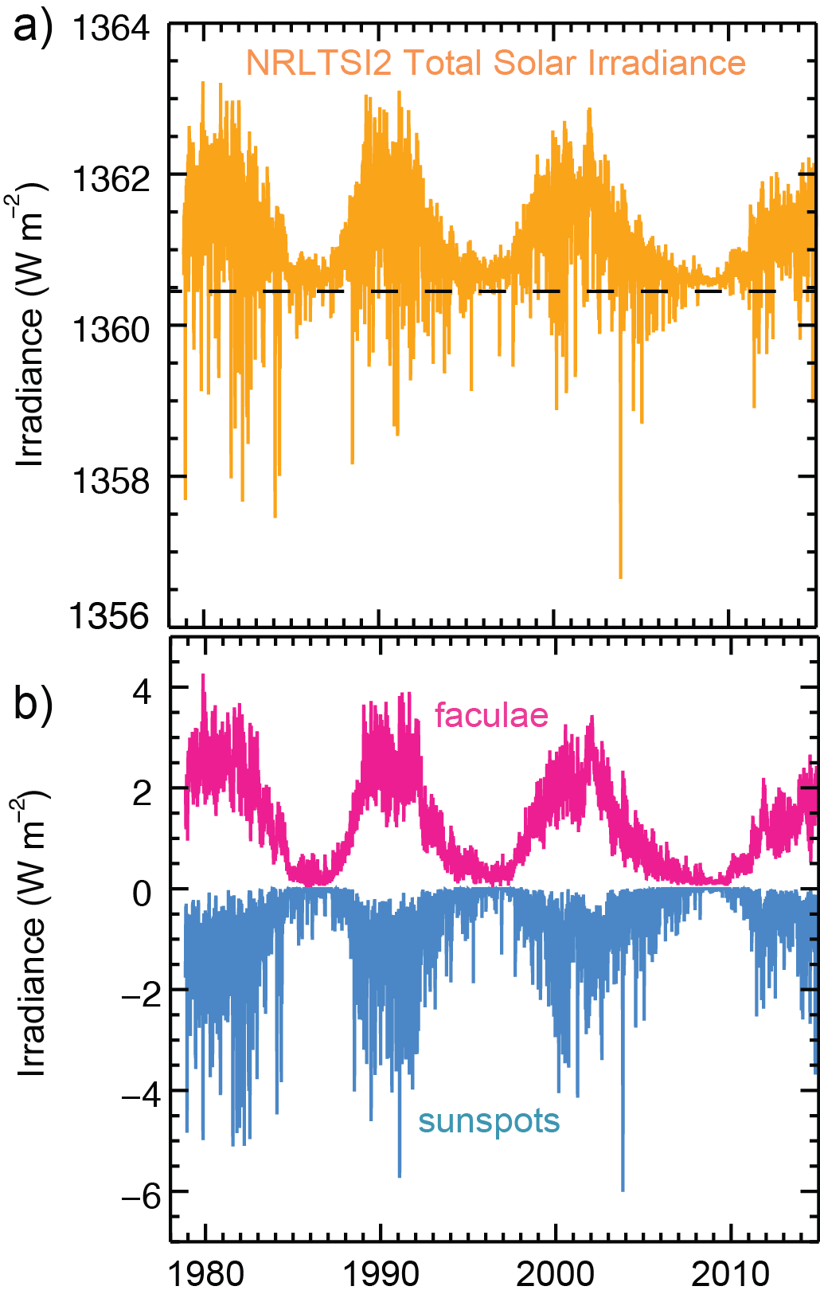

**Figure 2**: a) Time series of NRLTSI2 total solar irradiance and b) the contributions by facular brightening (pink) and sunspot darkening (blue) to the quiet Sun reference TSI over the time period.

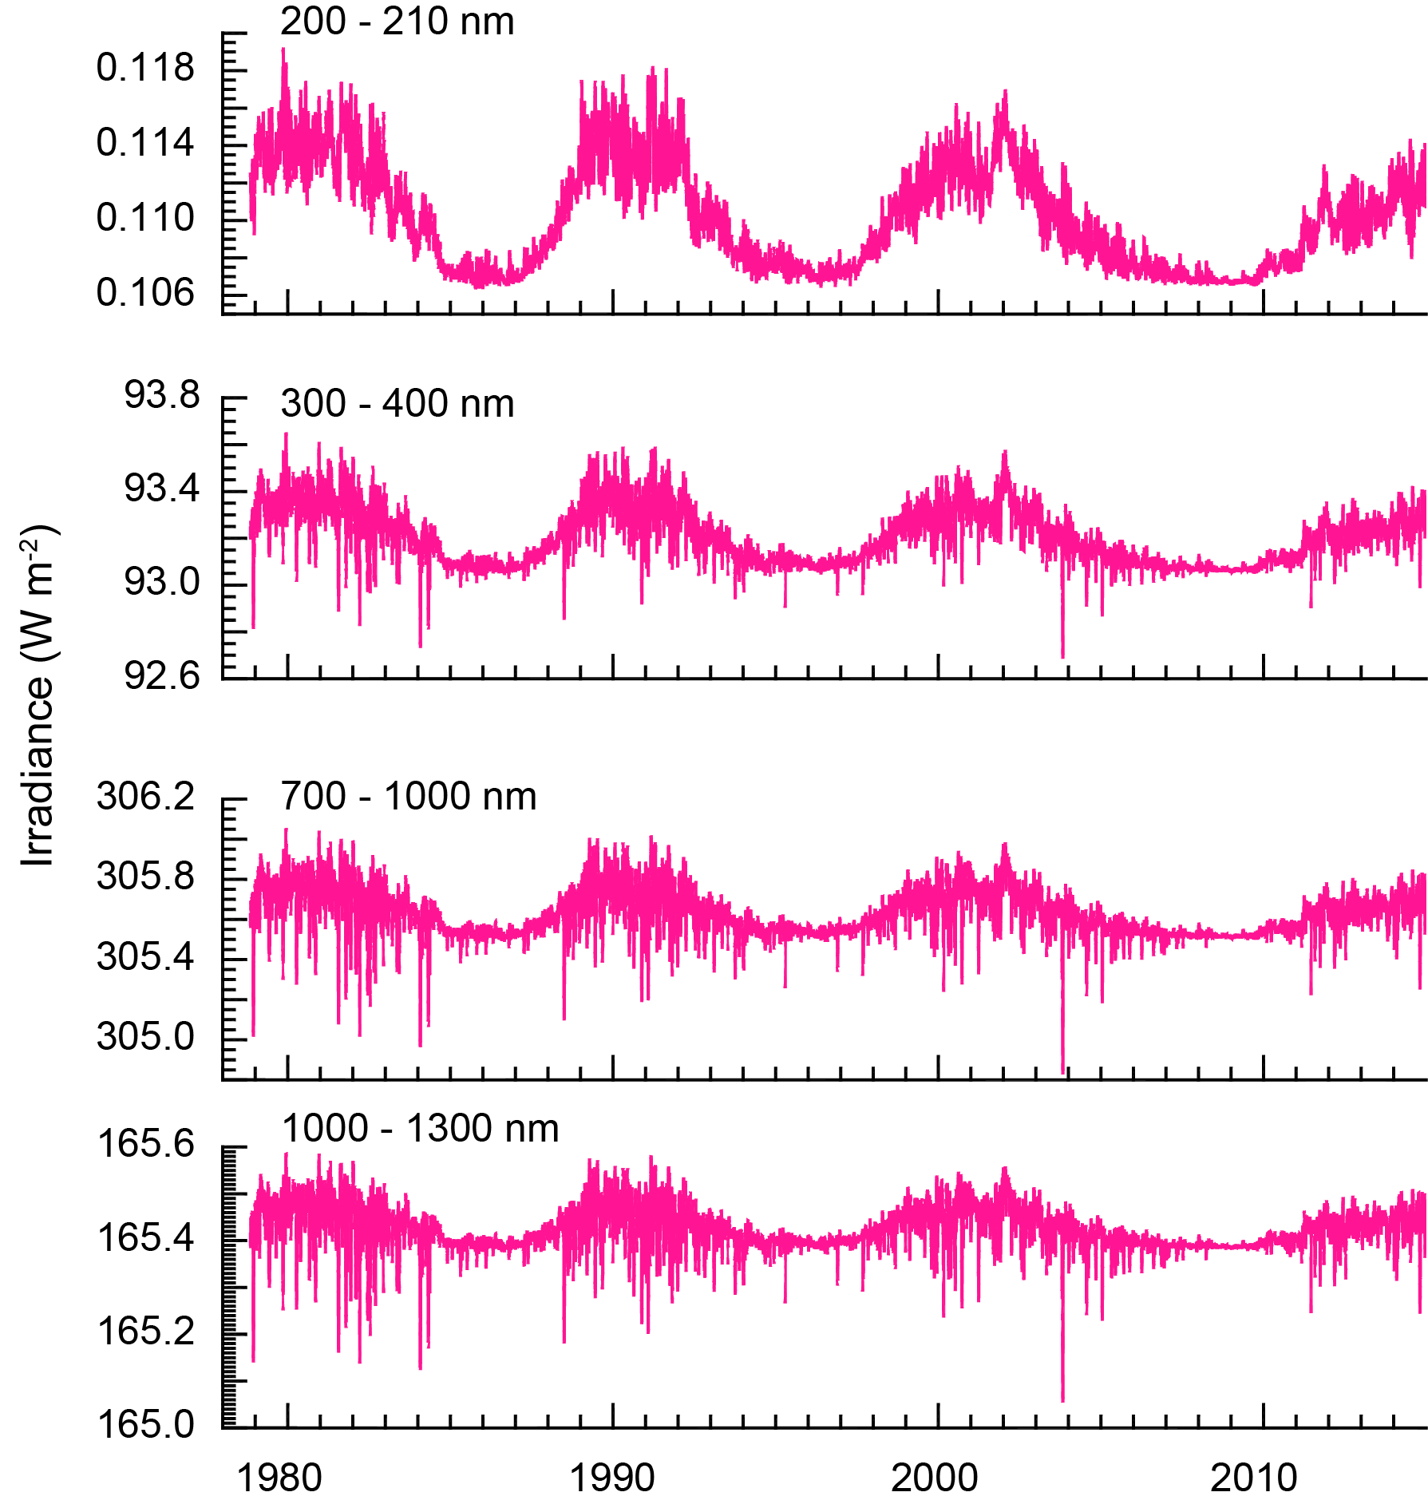

Figure 3: NRLSSI2 solar spectral irradiance binned into four broad wavelength bands for the same broad time period shown in Figure 2.

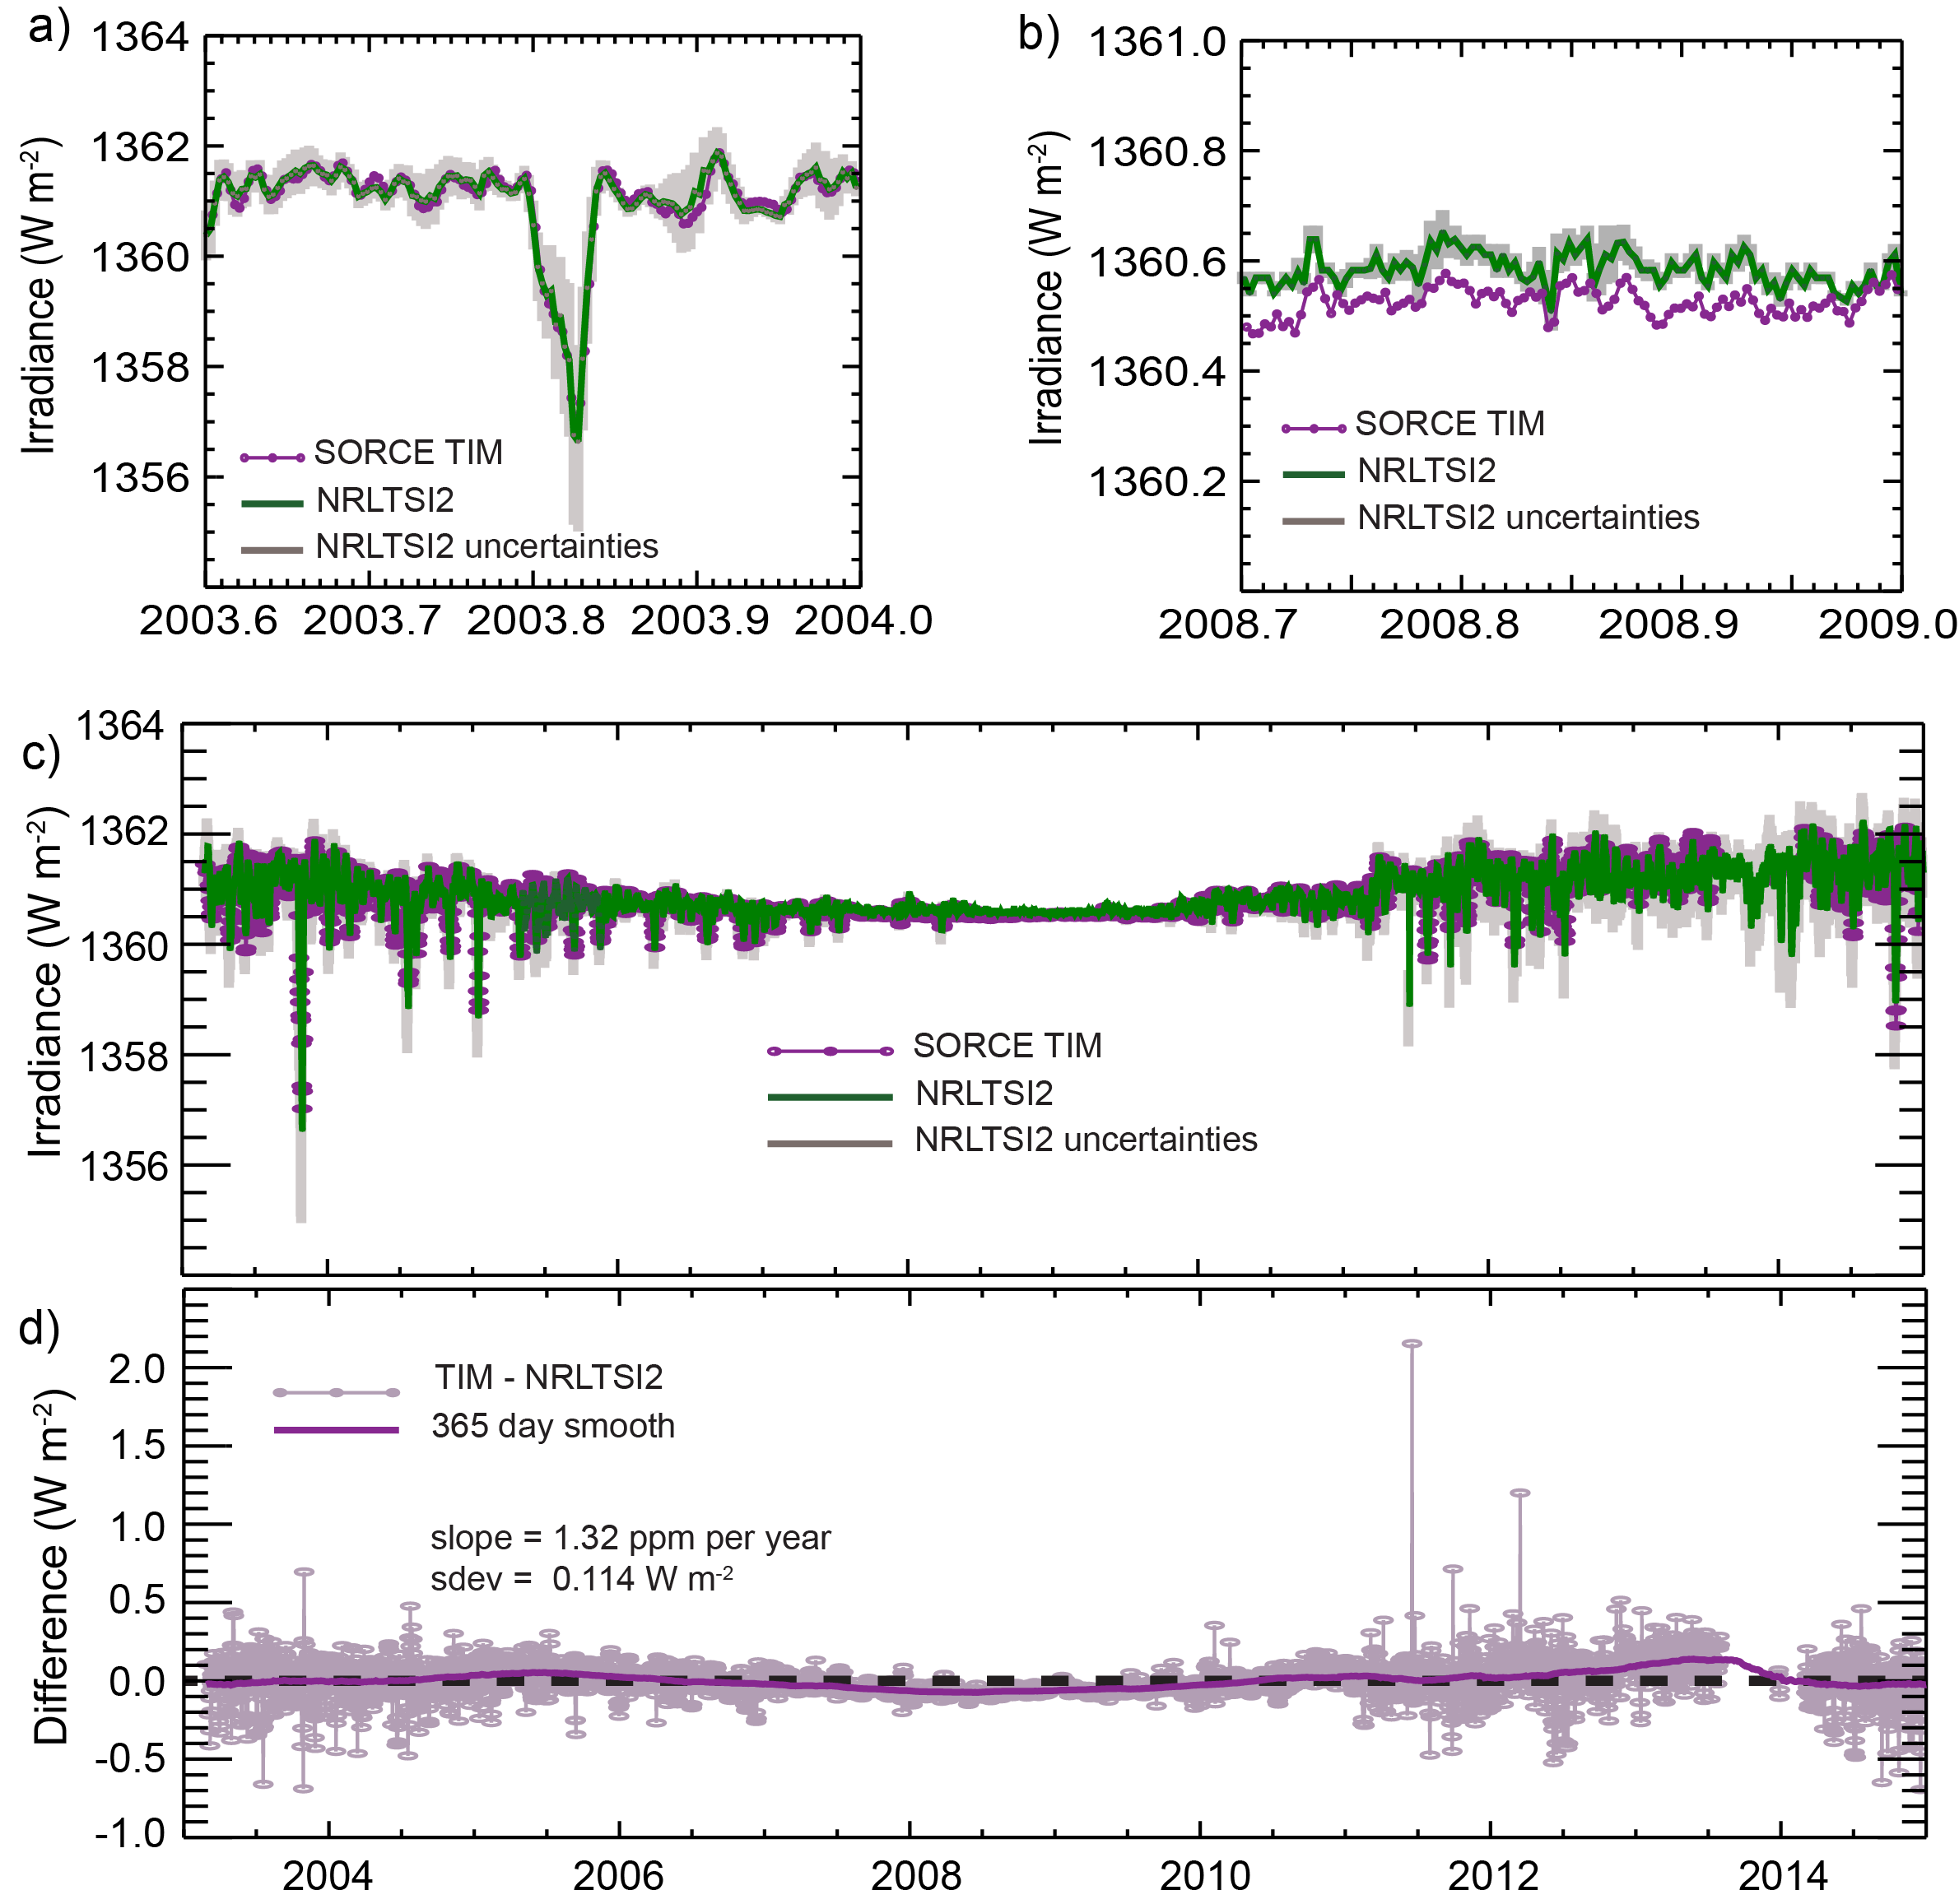

**Figure 4**: Comparison of NRLTSI2 and SORCE TIM (v17) measurements. Figure 4a illustrates NRLTSI2 variations with associated uncertainties (grey shading) in the NRLTSI2 model variability for a high solar activity time period in 2003.5 to 2004, covering five solar rotations. Figure 4b is a comparison during a period of low solar activity and Figure 4c is the comparison across the entire period of the SORCE mission. Figure 4d is the difference between the SORCE TIM measurements and the NRLTSI2 modeled variability for the entire mission; the solid purple curve is a 365-day smooth of the difference values, and the dashed black line depicts zero difference. NRLTSI2 uncertainties shown in Figures 4a-c do not include uncertainty in the TSI absolute scale, estimated to be 350 ppm for the SORCE TIM observations (Kopp and Lean 2011).

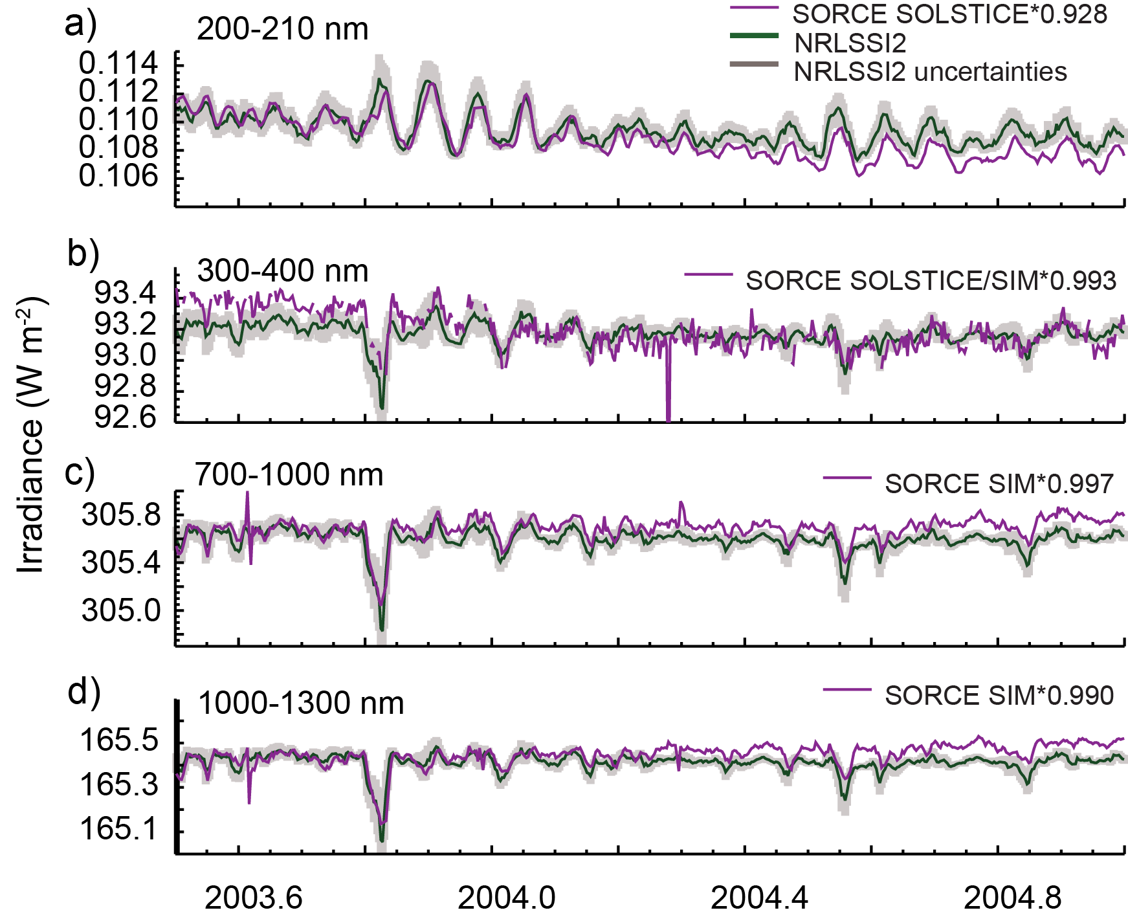

**Figure 5**: Comparison of NRLSSI2 variations (green) with associated uncertainties (grey shading) in the NRLSSI2 model variability and SORCE SSI measurements (purple) on solar rotational modulation time scales for the period 2003.5 to 2005.0. The spectral irradiances are binned into four broad wavelength bands from the ultraviolet to the near infrared. NRLSSI2 uncertainties in Figures 5a-d do not include uncertainty in the SSI absolute scale (see text). SORCE data are scaled for improved visualization and the scaling factor varies with the spectral range; the scaling factor was arbitrarily selected so that measured and modeled irradiance are equivalent in early 2004. The legend denotes the contributions to the measured spectral range by the SOLSTICE and/or SIM instruments and the value of the scaling factor applied.

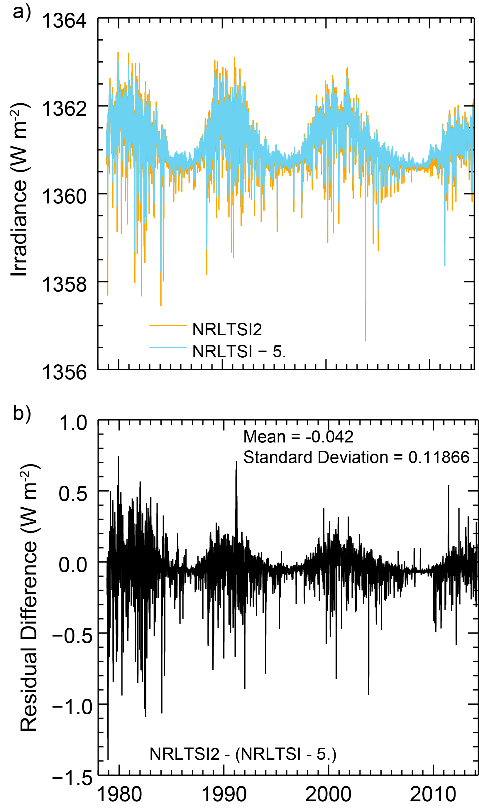

Figure 6: a) Comparison of NRLTSI2 (orange) and NRLTSI (cyan) for 1978 through 2014. NRLTSI values are scaled in magnitude to reflect the new value of TSI of the quiet Sun (see text). b) Residual difference in NRLTSI2 and the (scaled) NRLTSI.

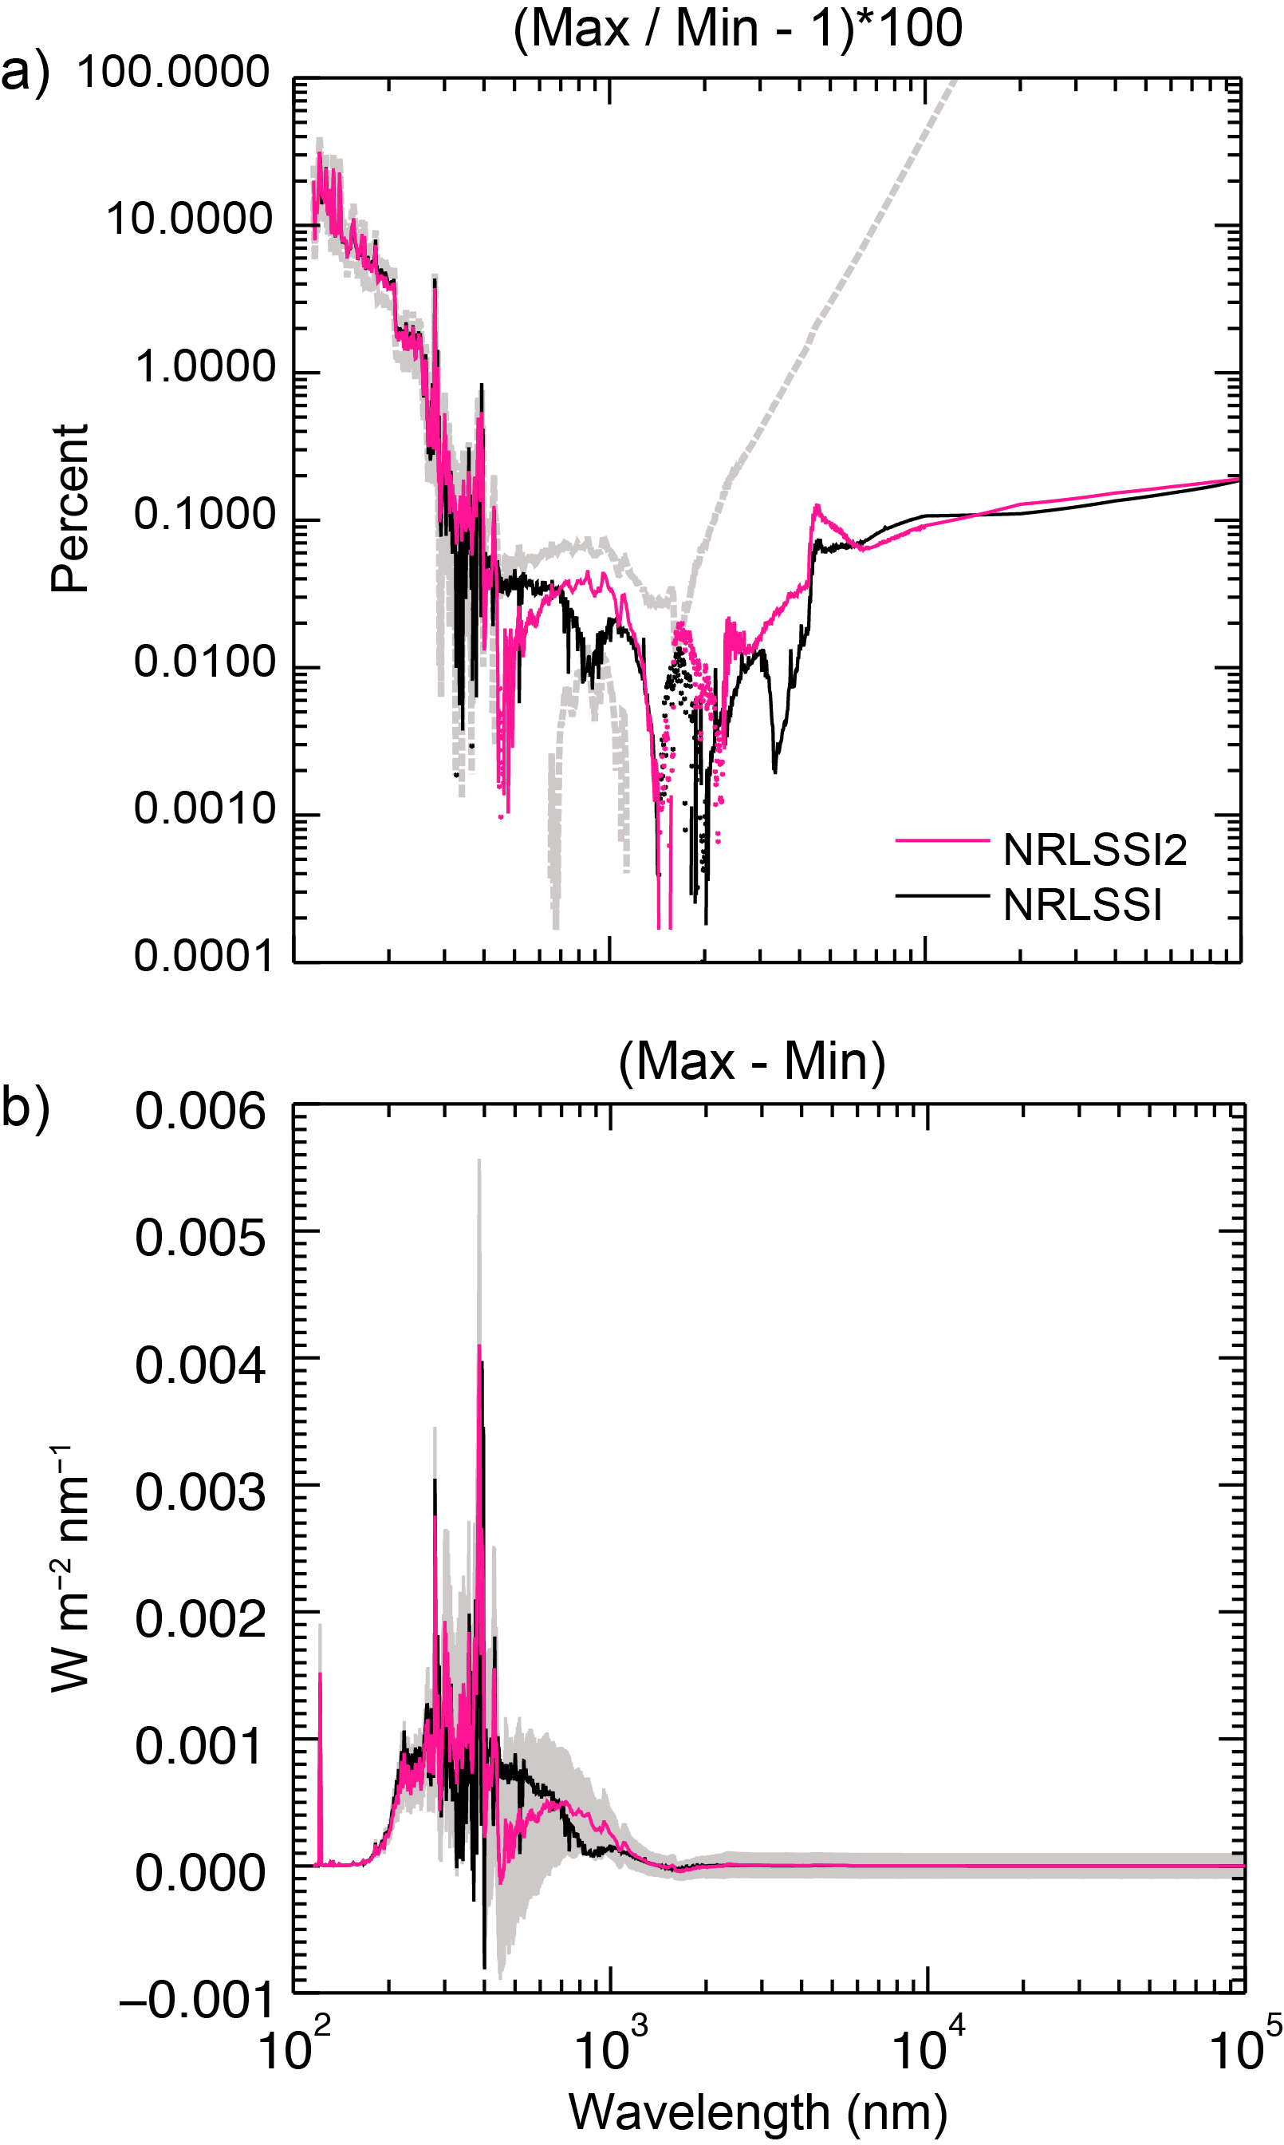

**Figure 7**: a) Comparison of NRLSSI2 (pink) and NRLSSI (black) solar spectral irradiance changes (max/min – 1) during solar cycle 24, in percentages. Dotted segments indicate negative values. Grey regions denote the uncertainty in the NRLSSI2 model variability (restricted to positive values). b) As in Figure 7a, but the solar cycle irradiance changes (max – min) are shown in energy units. In both plots, solar minimum conditions are defined as 2008-11-28 through 2008-12-23 and (near) solar maximum conditions are defined as 2013-01-11 through 2013-01-22.

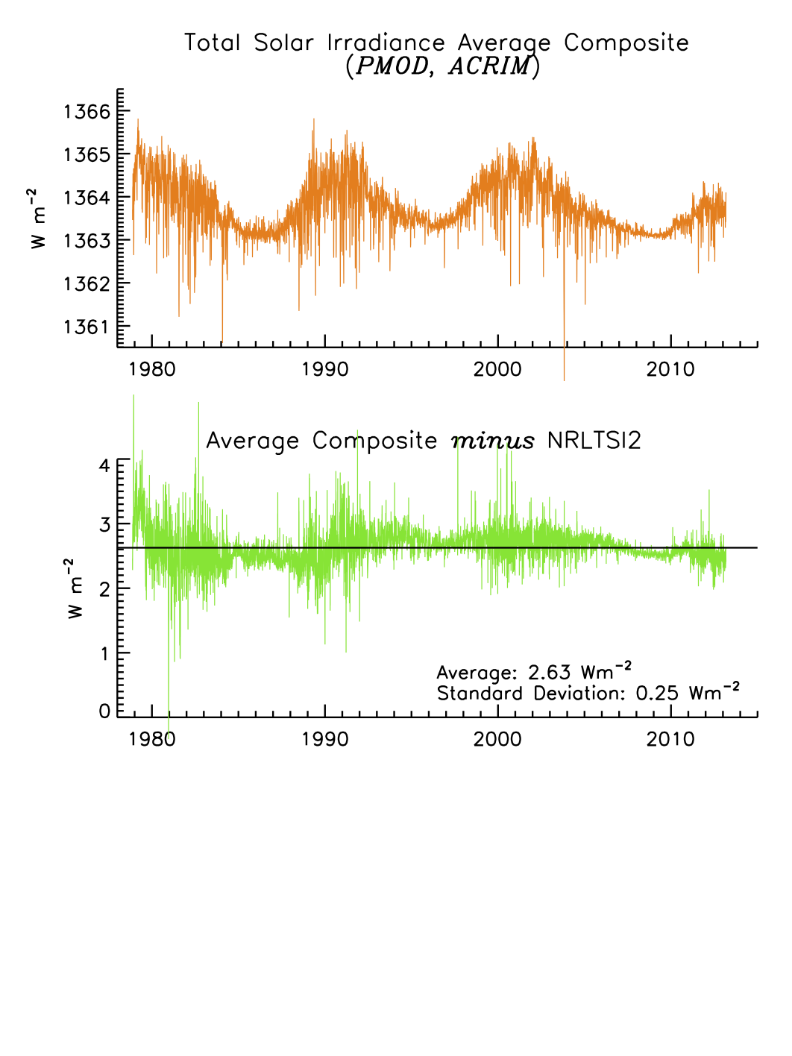

**Figure 8**: The TSI observational composite in the initial CDR is the average of the PMOD and ACRIM composites, shown in the top panel. In the bottom panel are the differences of this observational composite with the NRLTSI2 model that the CDR algorithm uses to calculate TSI.

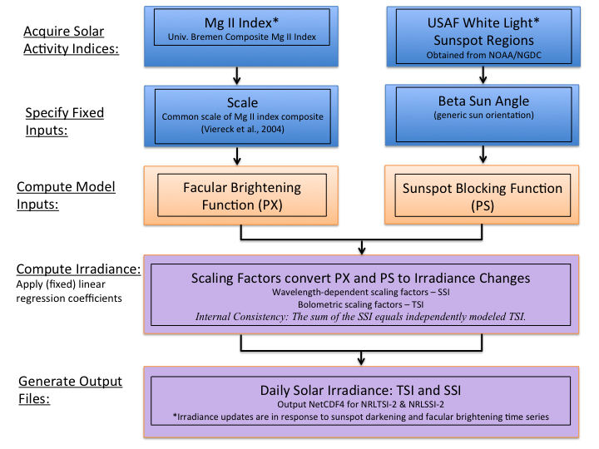

**Figure 9**: Outline of the Solar Irradiance CDR algorithm flow from proxy inputs of facular brightening to sunspot darkening to modeled irradiance using the NRLTSI2 and NRLSSI2 variability models.

1. The 50 Global Climate Observing System (GCOS) essential climate variables (ECVs) are tabulated at http://www.wmo.int/pages/prog/gcos/index.php?name=EssentialClimateVariables
2. The SORCE data collection is publically available at <http://lasp.colorado.edu/home/sorce/data/>. The SORCE data used in this study are from TIM L3 (v17) data: sorce_tsi_L3_c24h_latest.txt and combined SSI L3 data: sorce_ssi_L3_c24h_0000nm_2413nm_20030301_20130729-3.txt.
3. The University of Bremen’s composite Mg II index is available online at http://www.iup.physik.uni-bremen.de/gome/gomemgii.html.
4. For the Solar Irradiance CDR, we utilize sunspot information archived by NOAA’s National Centers for Environmental Information (NCEI), formally the National Geophysical Data Center (NGDC). The record is available online at http://www.ngdc.noaa.gov/stp/spaceweather.html.
5. Data sets for NOAA’s CDR program are available at http://www.ncdc.noaa.gov/cdr/operationalcdrs.html.
6. Debrecen Photoheliographic Data (DPD) is available at http://fenyi.solarobs.unideb.hu/deb_obs_en.html.
7. The adjusted value of 10.7 cm solar radio flux measured from the Dominion Radio Astrophysical Observatory in Penticton, CA is available from National Research Council of Canada at http://www.spaceweather.ca/solarflux/sx-eng.php.
8. Information about the European SOLID project is available at http://projects.pmodwrc.ch/solid/.