We are very appreciative of the reviewer’s comments. These comments and suggestions have greatly improved the content of this paper. We have addressed all reviewer comments. Our responses are nested below each comment and identified by indented margins. When changes to manuscript text have been made, we often include the revised text (in italics) within our response. Note that, due to text revisions, the original line numbers identified in the reviewer’s comments may no longer correspond directly to those in the revised manuscript. We attempt to identify new line numbers in our response.

**Reviewer #1:** GENERAL SUMMARY AND COMMENTS

This paper describes the creation of solar irradiance data products, for both total irradiance and spectrally resolved irradiance, that can be used and archived as climate data records (CDRs).  In order to provide sufficient temporal and spectral coverage for many different users, the CDR product is created by using solar irradiance models combined with multi-decadal proxy index data sets of facular brightening and sunspot darkening.  The coefficients required to create the solar irradiance values are determined by analyzing short-term variations in SORCE SOLSTICE and SORCE SIM measurements.

The work reported in this paper describes a "thematic CDR" as defined on the NOAA CDR web site (Often generated by blending satellite observations, in-situ data, and/or model output).  This choice is understandable in terms of the spectral and temporal gaps in the observed SSI record compared to the requirements of an operational CDR.  However, it does impose an additional need to clearly explain to users how the CDR product successfully represents the original observable quantity (solar spectral and total irradiance).

A fundamental need for the modeled irradiance is to provide data when (and in the spectral domain, *where*) no observable data exists so we do not follow this last statement. In its current form, the text clearly states that the modeled irradiances instantaneously match, to within observational uncertainty, their measured counterparts. We compare the CDR modeled TSI to measured irradiances (Figure 4) and the modeled SSI to measured SSI (Figure 5), as well as we compare the CDR modeled TSI to an observational composite (Figure 8).

SPECIFIC COMMENTS

1.  p. 5, lines 105-108:  The SSI long-term requirements listed in Table 1 are roughly an order of magnitude better than any existing data set has been able to achieve.  The caption indicates that these requirements are a goal for TSIS, but is it reasonable to expect such large improvements for this instrument?  A full discussion of the detailed justification is not needed in this paper, but the issue should be addressed.

Yes, it is reasonable to expect these changes, and they aren’t “such large improvements”. The SORCE TIM already has an uncertainty of 350 ppm [Kopp and Lean, 2010]. The Glory TIM, a second-generation version of that same instrument, had an uncertainty under 100 ppm but the Glory spacecraft failed to reach orbit. The TSIS SIM is the first rebuild of the SORCE SIM. It has undergone a laboratory-based characterization and validation process similar to the TIM, using a cryogenic NIST-traceable standard radiometer and NIST laser sources. Its error budget meets the 2000 ppm requirement listed in table 1. We added and revised text to succinctly state that TSIS is expected to meet these requirements (lines 109-118). We note that the advanced laboratory characterization and calibration facilities at LASP (the TSI Radiometer Facility, TRF, and the Spectral Radiometer Facility, SRF) are new capabilities for TSIS. Neither of the SORCE TIM or SIM (actually, no instrument ever prior to TSIS) had ever undergone this degree of component and instrument level characterization.

Reviewer 3 asked that these requirements be referenced. The original requirements trace back to the National Polar-orbiting Operational Environmental Satellite System (NPOESS) technical requirements document:

NPOESS (National Polar-Orbiting Operational Environmental Satellite System) Technical Requirements Document, Prepared for: NPOESS – Integrated Program Office, Silver Springs, MD, Version 7, 24 January 2002.

Now that TSIS has been transferred to NASA, NASA is responsible for drafting a new requirements document (in preparation):

Appendix to the Earth Systematic Missions Program Plan: Program-Level Requirements on the Total and Spectral solar Irradiance Sensor (TSIS) Project

These citations have been added (line 107).

2.  p. 6, lines 114-118:  The reference citation does not indicate where this document can be obtained.  Given that this article is targeted to a broad audience, providing access to a more detailed discussion for interested readers would be very helpful (and also probably addresses some of the further questions posed in this review).

We agree and apologize for the difficulties in obtaining the C-ATBD document during the initial review stage. This was due to a combination in the modernization of web pages at NCEI and a delay in making the data “landing page” at NCEI publicly visible. To address this we have added a URL in the reference citation. Note, that in addition to the C-ATBD, the source code and other ancillary information will also be available from this url.

3.  p. 7, lines 154-155:  ATLAS 1 SOLSPEC measurements (taken in March 1992) correspond to solar maximum conditions.  While solar variability is much smaller between 300-1000 nm compared to shorter wavelengths, the ATLAS 3 measurements taken in November 1994 would be more appropriate for constructing a "quiet Sun" irradiance spectrum.

In principle this comment is correct. However, the uncertainty in the ATLAS1 or ATLAS3 spectral irradiance at wavelengths longer than 300 nm is at least a few percent and this exceeds the spectrum variability (i.e., the expected solar-related changes) between 1992 and 1994 by an order of magnitude. Therefore, any difference between ATLAS1 and ATLAS3 spectra in the near UV, visible and IR spectrum are most certainly instrumental rather than solar in origin. We confirmed this with Gerard Thuillier, who stated that with respect to ATLAS 1, the ATLAS 3 “*spectrum remains the same in visible and IR taking into account the accuracy of these measurements with respect to the solar variability in these domains*.”

Appropriate adjustments to the quiet sun reference spectrum will be considered in future versions of the CDR. For example, we are in the process of examining differences in the spectral resolution of the ATLAS measurements and that of SIM on SORCE. Additionally, a new solar minimum spectrum may become available from the SOLSPEC instrument on the International Space Station. Finally, we will eventually revise the CDR reference spectrum to be consistent with the TSIS solar spectral irradiance, after validating that this represents the most reliable absolute spectral irradiance.

4.  p. 7, line 156:  What exactly does the phrase "constrained to match the overall shape of the WHI reference spectrum" mean here?  It sounds more complex than normalizing at a single wavelength, or forcing agreement of wavelength-integrated irradiance values.  Are different adjustments applied in different spectral regions?  Comparisons of reference spectra often show complex spectral structure.  Is any single spectral region considered more important for this process?

The spectral resolution of SOLSPEC measurements on ATLAS is higher than that of SORCE SIM at the near UV wavelengths and longer, which means that the SOLSPEC spectrum exhibits somewhat enhanced spectral structure. In constructing the solar reference spectrum for the quiet Sun, we retained the spectral resolution of the ATLAS spectrum but since, as the Reviewer notes above in #3, the ATLAS measurements (whether 1, 2 or 3) were not at solar minimum, the smoothed irradiance level was adjusted to match the SORCE WHI reference spectrum, which is considered more indicative of the true quiet sun. The adjustments to the ATLAS spectrum to achieve agreement with the WHI interval were made separately in selected wavelength regions. For example, the largest adjustment was made to the ATLAS spectrum at 310-330 nm, which was scaled by 0.95. Additional adjustments were made in various spectral regions, for example that from 670 to 689 nm was scaled by 0.99 and that from 1303 to 1995 nm by 1.013. The adjustments made were all within the absolute measurement uncertainties of the ATLAS and WHI observations. No single spectral region was considered more important in this process. We provide in the C-ATBD a figure (copied below) comparing the absolute scale of the quite sun reference spectrum adopted for the CDR with other spectra. As noted above in our response to #3, we plan to revise the absolute scale in the future as new measurements emerge and/or older measurements are revised.

We clarify this point by revising the sentence and adding a follow on sentence (lines 164 – 170) as following, “*For wavelengths between 300 nm and 1000 nm the spectral irradiance is that reported from measurements made by the SOLar SPECtrum (SOLSPEC) instrument on the ATLAS 1 space shuttle mission (Thuillier et al. 1998) constrained in magnitude to match the overall irradiances of the WHI reference spectrum. The constraining process, which is spectrally dependent, allows for the higher spectral resolution of the SOLSPEC measurements relative to SORCE measurements while maintaining the irradiance levels of the quiet Sun WHI spectrum; the scaling adjustments (at most ± 5%) were within the absolute uncertainties of the contributing measurements.* ”

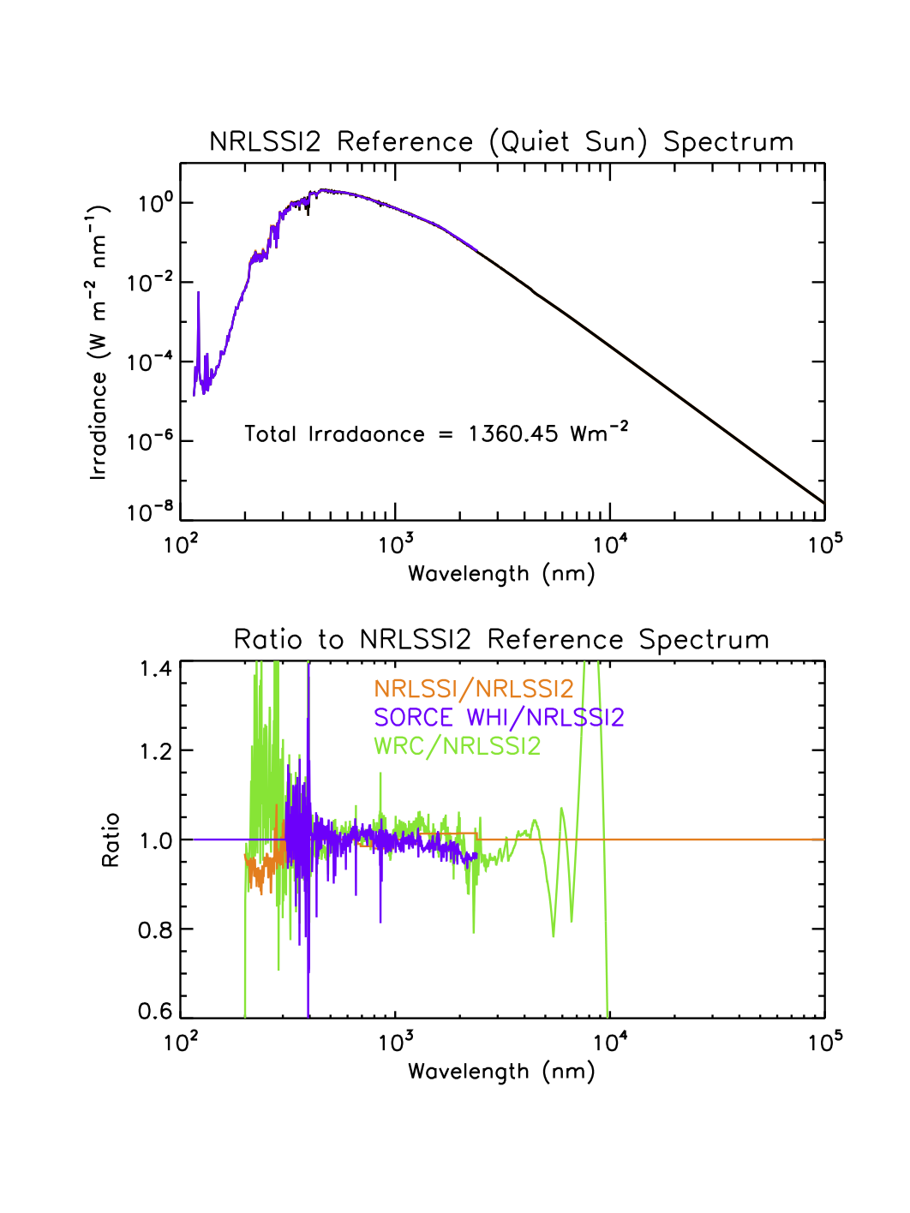

5.  p. 8, lines 157-158:  Harder et al. [2010] show spectrally varying irradiance differences between SIM data and the ATLAS 3 composite spectrum over the wavelength range 258-1300 nm.  How were those differences addressed in creating the CDR reference spectrum, particularly given the adjustments discussed in comment #4?

The adopted quiet sun irradiance spectrum was constructed as described above in #4. The specific SIM data used to construct the reference spectrum are those that Wood et al. (2009) used to construct the WHI spectrum, and the adjustment made to the ATLAS spectrum to match the WHI are as described in response to #4.

6.  p. 8, lines 168-169:  Have you done the same analysis with other SSI data sets (e.g. UARS SUSIM) to verify this statement?

The NRLSSI2 model developed from SORCE observations gives very similar variability in the UV spectrum as the original NRLSSI model (developed using a similar approach) with UARS/SOLSTICE observations from 1992 to 1996. The analysis has also been applied to UARS/SUSIM observations, again with similar coefficients. As well, the NRLTSI2 model, developed from SORCE/TIM TSI observations after 2003, gives similar TSI variability to the original NRLTSI model developed from a composite of TSI observations from 1978 to 2002. Using PMOD or ACRIM TSI datasets also gives similar results. This is because in each case the modeling approach extracts the variations explained by the sunspot and facular time series, which are common to each of the analyses of various observational datasets. These analyses all suggest that the model coefficients are stable, at least to within the uncertainties of the analysis and datasets. The extant datasets available thus far are inadequate for establishing if the coefficients are stable over a range of solar cycles. With future observations made by TSIS on Space Station we may have an opportunity to readdress this issue.

We support the statement with a follow on sentence (lines 184-188), “*The consistency of scaling coefficients (not shown) derived from other records of SSI at ultraviolet wavelengths and TSI in the observational database support the assumption of time invariance but the lengths of these observational records are too short to establish whether this assumption is valid over a range of solar cycles.*”

7.  p. 8, lines 174-176:  Some scientists question the validity of using scaling coefficients derived from short-term variability to estimate solar cycle (and longer) spectral irradiance variations, although published results do show good agreement between calculated long-term irradiance variations and satellite measurements.  You may want to address this topic.

We agree that scaling the short term variability to estimate solar cycle changes can produce erroneous results in some wavelengths regions, specifically those longer than about 300 nm where both sunspots and faculae contribute to the variability. Rotationally-modulated irradiance does not scale to solar cycle variability in the near-UV, visible and near-IR spectrum because the sunspot signal is pronounced and has a distinctive temporal shape during rotation (as well as during the solar cycle) but the facular signal manifests mainly during the solar cycle. So, as the Reviewer expects, for the spectrum at wavelengths above 300 nm the facular component would not scale properly from rotational to solar cycle variability. Below, we discuss our approach to testing the “scalability” of the rotational-to-cycle irradiances in different spectral bands and outline our approach for correcting for deficiencies in scalability.

For wavelengths less than 300 nm, we tested the “scalability” of UV irradiance by comparing the solar cycle variability we produce in the NRLSSI2 model against the solar variability in a 2-decades long time series of Sac Peak CaII K full disk fluxes, which are a good proxy for UV irradiance variations produced by bright plage and faculae. We found that scaling the rotational modulation to the solar cycle using the Mg II index reproduced the observed Ca II solar cycle variability to within 5%.

However, sunspots as well as faculae contribute to the variability of the spectrum at wavelengths longer than 300 nm. We assessed the simultaneous scalability of the sunspot and facular indices by using the TSI time series whose variability is the result of combined sunspot and facular sources. First, we determined how the model coefficients changed for the sunspot and facular indices when using the directly measured TSI series and then we performed the same analysis for the detrended TSI time series. We found that the sunspot coefficient changed by 6% and the facular coefficient by 30% (larger) when using the directly measured TSI series compared to the detrended (rotationally modulated) TSI time series. In the NRLSSI2 model, these factors of 6% and 30% are applied to the model coefficients determined for the detrended SORCE SSI observations at wavelengths above 300 nm.

This discussion provides the reason for the larger solar cycle variability in the 300-400 nm region in NRLSSI2 model compared to the original NRLSSI model (see Figure 7). In the original version of the NRLSSI model, the rotational modulation coefficients were used to calculate the solar cycle changes directly without applying the additional 6% (sunspot) and 30% (facular) variability corrections, thus underestimating these changes. We describe this approach in detail in the C-ATBD document and provide the equations and coefficients used. This document also details how this additional uncertainty is propagated into the final uncertainty. Finally, we note that we will not be able to properly test the corrections to our model scalings until solar spectral irradiance observations with improved stability over solar cycle time scales are available. Motivated by this we are in the process of understanding calibration challenges in the 1980’s SME Ultraviolet spectrometer (UVS) observation record, whose long term degradation was less than in current observations due to a lower observing duty cycle.

To clarify, we revise one sentence (lines 204-207) and add another sentence (lines 213-214) as following, *"To account for this, we adjust the coefficients obtained from the multiple regression analysis on the rotational time scale (i.e. the detrended SSI time series) to the solar cycle time scale by applying a linear scaling constrained by TSI variability in the following way (see Coddington and Lean 2015 for details).”*

*“The rotational-to-solar-cycle adjustments for the facular and sunspot coefficients are 30% and 6%, respectively”*

8.  p. 9, lines 178-179:  What parameters are included in the "multiple" regression analysis?  For example, it has been shown that a 2-term relationship (daily value + constant) with the facular brightening index is sufficient to represent irradiance variations down to ~170 nm, but that an additional intermediate-scale term (81-day average index) is necessary to represent variations at shorter wavelengths.  Calculating regression coefficients using detrended data does not allow for this additional term to be included.

For the entire spectrum and the total solar irradiance, the multiple regression uses two daily-varying parameters, the facular index and the sunspot index, which is therefore a three-term approach (constant + facular daily value + sunspot daily value). We note that our approach to modeling the solar spectrum variability by using the detrended spectral irradiance time series effectively precludes the inclusion of an 81-day term, since this is what we subtract from the directly measured time series in order to detrend it. Including an additional 81-day term in the multiple regression would be appropriate for non-detrended spectral irradiance time series, but we have assumed that the SOLSTICE and SIM measurements contain uncorrected instrumental trends. We support our approach by showing that we are able to model the TSI variability quite successfully (to within TIM’s 10 ppm per year long term repeatability) without including an 81-day smoothed term.

Separate analysis of the TIMED SEE EUV irradiances (not shown) did suggest that a third 81-day component may be needed to model the EUV spectrum but at the present time we haven’t established that it is needed for the FUV spectrum, including at Lyman alpha. If, at some future time, the evidence becomes unequivocal for an additional 81-day term in our model, then we can and will include it in a future version of the model.

9.  p. 9, lines 189-192:  This sentence suggests that irradiance variations at all wavelengths longer than 295 nm are being constrained to follow TSI variations.  Is this a correct interpretation?

This is not the case. The TSI variability in the model results from one particular combination of the facular and sunspot indices – the coefficients for these indices pertain to the “bolometric” irradiance. The coefficients that give the relative contributions of the facular and sunspot contributions depend on wavelength so, at any one wavelength, the time series of the modeled SSI does not track the TSI per se. The way that the SSI is constrained to follow TSI is via the separate facular and sunspot components. The *integral* of the SSI changes arising from facular variations is constrained to track the facular component of the independently modeled direct TSI variations (derived from TIM observations). And the *integral* of the SSI changes due to sunspots is likewise constrained to track the sunspot component of the independently modeled TSI variations. This high fidelity tracking (which has a one sigma standard deviation of 0.005 Wm-2 as described in the C-ATBD document) is accomplished in the model with small increments in the facular and sunspot indices used to model SSI. These increments are quantified below in our response to #10. By constraining both the facular and sunspot terms separately, we ensure that the *integral* of the SSI tracks the TSI but the *relative* facular and sunspot contributions at any given wavelength are not constrained to match those of TSI. Thus, the time series of SSI NUV irradiance variability at, say, 350 nm is not the same as that of TSI, nor of the SSI in the near-IR region, where the sunspot contribution is larger relative to the facular contribution. Near 1600 nm for example, the sunspot contribution to SSI variability is sufficiently large that it exceeds the facular variation over the solar cycle, producing out-of-phase (with the overall solar cycle) SSI changes that are quite different form the in-phase TSI variations.

We clarify this by adding a follow on sentence (line 219-224) as follows, “*We note that at any given wavelength, the relative facular brightening and sunspot darkening irradiance contributions are not constrained to match TSI itself; spectral irradiance differs relative to TSI variability in different ways, depending on wavelength, even becoming out-of-phase (with respect to the TSI solar cycle change) near 1600 nm where the sunspot darkening contribution exceeds that of the facular brightening”*

10.  p. 9, lines 192-195:  What does "small…corrections" mean relative to the original coefficient values?  1%?  10%?  Larger than the original uncertainty of the derived coefficient value?

To quantify the magnitude of the “small” corrections relative to the original coefficient values, we computed the magnitude of the facular brightening and sunspot darkening contributions to the spectral irradiance relative to the quiet sun irradiance (similar to what is shown in Figure 2b for the total irradiance). The computation was done with the small correction, and then without the small correction, such that the magnitude of the correction of the small correction could be quantified by taking the difference of these values. We show the results of this analysis in four broad wavelength bins (200-210, 300-400, 700-1000, and 1000-1300 nm) in the following two plots. In each plot, the solid lines are the final values of the facular brightening and sunspot darkening contributions (i.e. with the small correction included) and the dashed lines are the magnitude of the “small correction”. The magnitude of the small correction to the facular brightening contribution is approximately 10-15% at periods of high solar activity when facular contributions are larger. The magnitude of the small correction to the sunspot darkening contribution is approximately 5% at periods of high solar activity when sunspot contributions are larger.

In the revised text, we removed the word “small” and replaced it with these quantified values (line 217-218)– both of which are smaller than the original uncertainty of the derived coefficient value

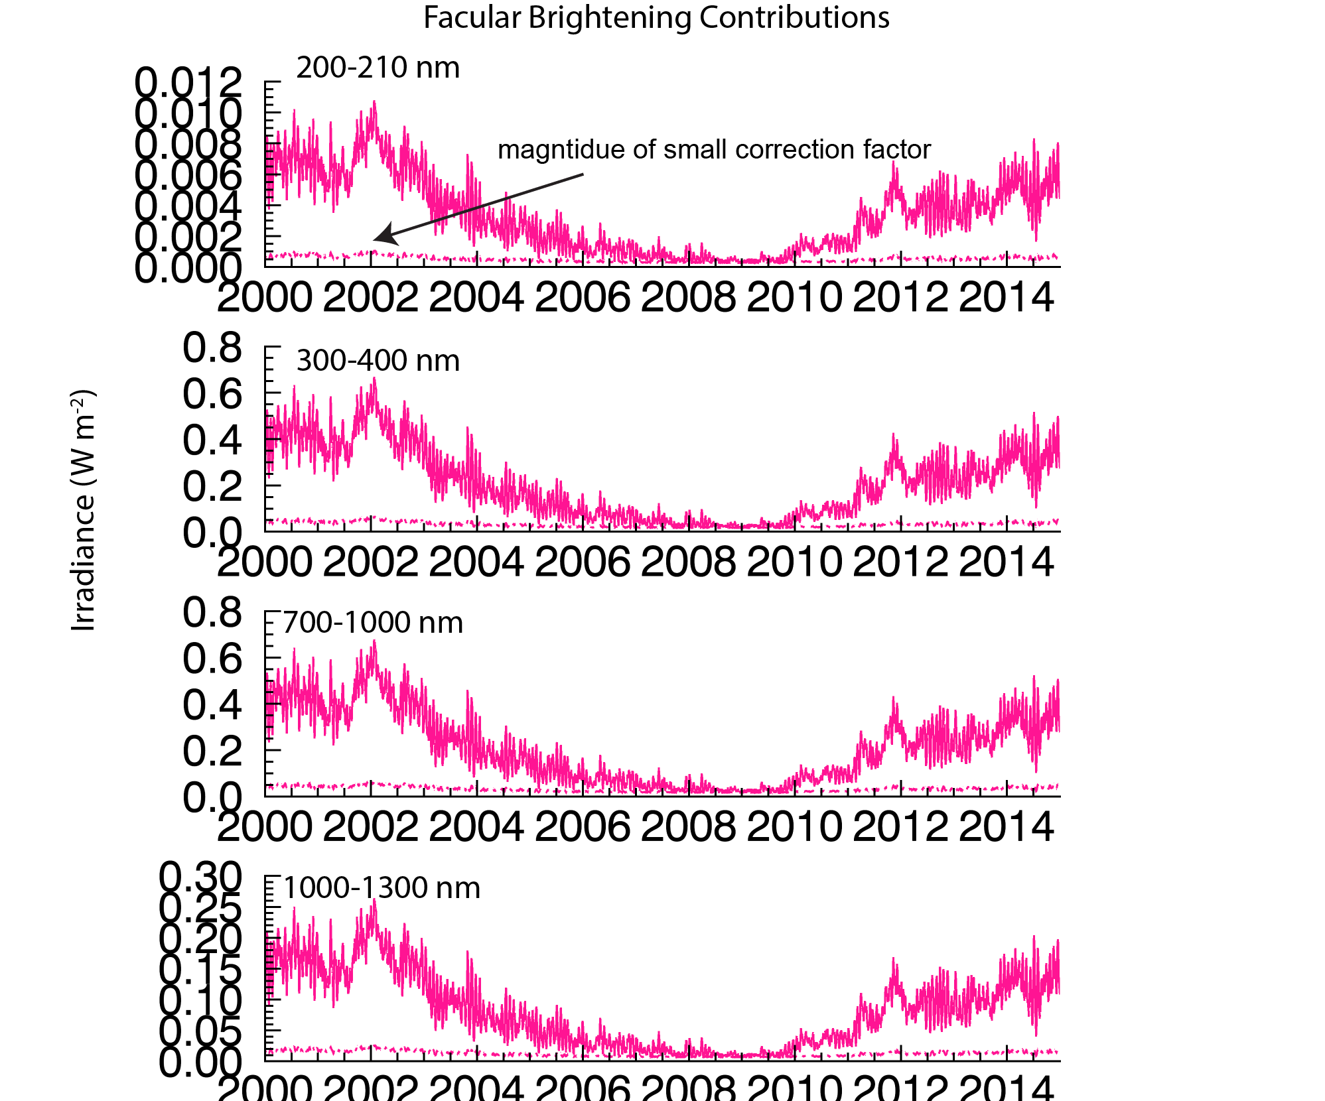

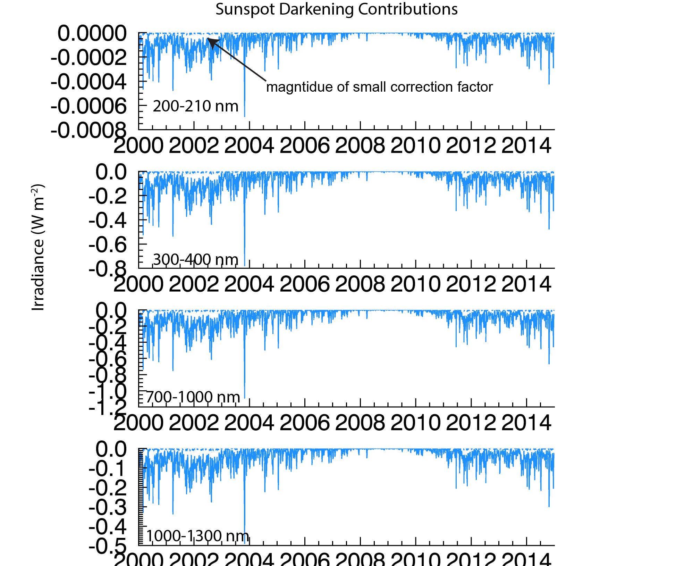

11.  p. 10, lines 209-211:  Note that the Bremen composite product does have some step changes in its data record, as discussed by Snow et al. [2014].  Any similar changes in the future would therefore be propagated into the full SSI CDR.

A proxy model such as NRLSSI2 will inherit any artifacts in the input proxy datasets.  Continued improvements in the proxy records, both Mg II and sunspots, will propagate into improvements in the modeled irradiances. For this reason, we have in place a system of tracking (see Sections 5 and 6 on Operational Implementation and Outlook) the two indices with other independent, related indices. For the Mg index, we also use both the Sack Peak and Kitt Peak CaK indices. For the sunspot darkening we use other determinations such as those made from Debrecen observations. The careful tracking and validation of the input indices is perhaps the most difficult and important aspect of the CDR irradiance model.

We revise the sentence (line 490-494), “*The veracity of the Mg II index can be approximately assessed through correlation studies (e.g., Lean et al. 2001) with independent chromospheric indices such as the Ca II K (Donnelly et al. 1994) and by using the F10.7 cm solar radio flux, which is an independent proxy of chromospheric variability (with a coronal component) (Tapping 2013).*”

We also include a footnote to point to the url for National Solar Observatory Sacramento Peak Ca II K line data.

*We revise the sentence (line 505-507), “New Solar Irradiance CDR versions may also employ altered facular brightening and sunspot darkening indices derived from the same, or improved, input proxy datasets (for example, Clette et al. 2015), which are regularly scrutinized by comparison with multiple other related indices.”*

12.  p. 11, lines 228-230:  Additional versions of estimated solar irradiance changes on centennial time scales have been published (e.g. Krivova et al. [2011], Shapiro et al. [2011]), with substantial differences in predicted changes over the Maunder Minimum period.  For users who plan to use the solar irradiance CDR for such long-term studies, some further discussion about the reasons for selecting the Wang et al. [2005] approach identified in this paper would be helpful.

We continue to address and revisit the long-term component of the solar irradiance CDR. In particular, a new reconstruction of sunspot number (see response to #11 above that includes a reference to the Clette et al. 2015 recalibration of sunspot and group numbers) appears to imply the need for a somewhat smaller in magnitude background component. This may be implemented in future versions of the CDR, if ongoing analysis warrants this.

We add the following paragraph (lines 258-266), “*The increase in total solar irradiance from the seventeenth century Maunder minimum to contemporary solar minima is of order 0.6 Wm-2. This adopted long-term increase in TSI magnitude is similar to that of the Spectral And Total Irradiance Reconstructions (SATIRE-T) model (Krivova et al. 2010), but an order of magnitude smaller than the 6 Wm-2 increase that Shapiro et al. (2011) suggest. However, Judge et al. (2012) report that comparative solar and stellar data indicate that the Shapiro et al. (2011) estimate is at least a factor of two too large. By comparing simulated and observed surface temperatures, Feulner (2011) conclude that the increase in TSI since the Maunder Minimum is less than 1 Wm-2, and possibly in the range 0 to 0.3 Wm-2.*”

We include as a footnote:

*Interested users may request from the authors calculations of solar irradiance changes since 1610 that are associated only with the solar cycle (i.e., with no added background component).*

We add these references:

Feulner, G. (2011), Are the most recent estimates for Maunder Minimum solar irradiance in agreement with temperature reconstructions? Geophys. Res. Lett., 38, L16706, doi:10.1029/2011GL048529.

Judge, P. G., G. W. Lockwood, R. R. Radick, G. W. Henry, A. I. Shapiro, W. Schmutz, and C. Lindsey (2012), Confronting a solar irradiance reconstruction with solar and stellar data (Research Note), A&A 544, A88, DOI: 10.1051/0004-6361/201218903

Krivova, N. A., L. E. A. Vieira, and S. K. Solanki (2010), Reconstruction of solar spectral irradiance since the Maunder minimum, J. Geophys. Res., 115, A12112, doi:10.1029/2010JA015431.

Shapiro, A. I.,, W. Schmutz, E. Rozanov, M. Schoell, M. Haberreiter, A. V. Shapiro, and S. Nyeki (2011), A new approach to the long-term reconstruction of the solar irradiance leads to large historical solar forcing, A&A, 529 (2011) A67, 10.1051/0004-6361/201016173.

13.  p. 11, lines 234-235:  Do the uncertainties for the coefficients also incorporate uncertainties in the SSI data?

No, the uncertainties in the coefficients are statistical estimates obtained from multiple regression of the indices with the SSI data, assuming that the SSI values are “true”. Uncertainties in the SSI data are added contributions to the error budget. In future work we plan to improve the calculations of the uncertainties, for example by testing a weighted linear least squares fitting to incorporate the variance (uncertainties) in the SSI observations. We note that the uncertainties in the absolute scale of the SSI are significantly larger than the variations that our model calculates.

The C-ATBD (tables 5 and 7) provides examples of the uncertainty propagation in the coefficients and the contribution by measurement error to a total uncertainty. We have clarified the text (lines 268-272) as follows:

*“The Solar Irradiance CDR algorithm calculates time and wavelength dependent irradiance uncertainties arising from changes in the input facular brightening and sunspot darkening indices (relative to their minimum values) and the coefficients used to scale the facular and sunspot proxy indices to equivalent irradiance increments. Coddington and Lean (2015; Tables 5 and 7) outline the error propagation approach to include the additional uncertainties pertaining to the absolute scale of the reference quiet Sun values.”*

14.  p. 11-12, lines 240-244:  It is not yet clear whether the lowest values reached by the facular brightening term during solar minimum conditions are the same between different solar cycles.  This additional uncertainty is important for evaluating the accuracy of calculated SSI variations on centennial time scales.

Yes, we agree. In our model the facular and sunspot indices directly determine the magnitude of the total and special irradiance during each of the recent minima. The sunspot index returns to zero at each minimum so, to the extent that there are true inter-minima differences in irradiance, our model captures this only if such changes are proportionally present in the facular index. The Bremen Mg index that we use does actually show slightly lower levels in 2008 than in 1996. For the historical changes where we add a speculated long term component, the uncertainty of the irradiance is set equal to the magnitude of that component (currently, we do this for the yearly averaged irradiances and, in the future, we will include this in the uncertainties for the daily and monthly averaged irradiances). In a future CDR version we will try and include uncertainties in the long-term absolute scale of the facular index. As well, for interested users, we have produced an analogous model of total and solar spectral irradiance changes since 1610 of just the solar cycle changes without an additional background component (see our response to #12).

15.  p. 12, lines 246-249:  Is this variability relative to the overall solar cycle range of each index?  Relative to the solar minimum value?  The Bremen composite Mg II index only varies by ~15% of its solar minimum value over a solar cycle, but users are requesting 0.2% accuracy to be able to address cycle-to-cycle changes.  The quoted variability sounds quite large relative to reaching the requirements specified in Table 1.

The variability is relative to the solar minimum value. With respect to the derived sunspot blocking function (with a solar minimum value of ‘0’), the variability of 20% reflects the variability in the value of the derived function as derived from a single, a subset, or all the USAF SOON network reports of sunspot area, number, and location. With respect to the derived facular brightening function (with an assigned solar minimum value of 0.1502), the 20% variability encompasses the variability over the solar cycle and the uncertainty in the value of the facular brightening term at solar minimum. Note that the variability in the model indices does not translate to the same variability in the modeled irradiances. However, we agree that the quoted uncertainties are conservative and the modeled irradiances do not achieve the CDR requirements of uncertainties quoted in Table 1 (those uncertainties are specific to the measurements by the future TSIS instrument suite). Please also see response to #1which provides clarification and references for the measurement requirements assigned in Table 1. We revise the text (line 284-288):

“*The variability in the sunspot darkening and the facular brightening indices that are input to the algorithm are specified as ±20% relative to their respective solar minimum values (i.e. one-fifth of the solar cycle variability), which is representative of statistical variations among sunspot darkening values derived from the USAF SOON network sites.*”

16.  p. 12, lines 253-255:  The SSI scaling coefficients are tuned to match TSI variations for most wavelengths with significant absolute irradiance (lines 189-192), so it seems like this agreement should be expected by definition.

The scaling coefficients themselves are not tuned to match the TSI variations but, as explained in our response to #9, the spectrally integrated facular and sunspot variations are “tuned” to match the facular and sunspot variation contributions to TSI. This agreement is not achieved by tuning the wavelength-dependence of the SSI scaling coefficients.

17.  p. 13, lines 279-283:  Even though the stated focus is on the agreement of rotational irradiance variations, there is clear relative drift between the NRLSSI2 and SORCE data sets over the 1.5 year period shown in Figure 5 that exceeds the indicated model uncertainty.  Validation of whether the NRLSSI2 results give the "correct" long-term irradiance variations for many such irradiance bands remains an open issue.

The added contribution to the uncertainty in the modeled irradiances due to the absolute scale of the reference quiet Sun value is not included, as discussed in figure caption and revised text (see our response to #13). Also not shown in the plot are the SORCE measurement uncertainties (which span 2-8% as discussed).

We can not yet know that the model is correct. We agree that there is a drift between the model and measurements. This drift, which is assumed to contain an instrumental trend, is the reason why we use only rotational modulation variability to develop our model. As noted above in our responses to prior comments, we do not believe that SSI observations exist with sufficient repeatability (possibly with the exception of some UV datasets) and that the observational SSI database is too short to validate the NRLSSI2 model. We consider SORCE TIM observations as the most reliable observations of true solar cycle irradiance variability and this is why our modeled SSI is “constrained”, via the integral of sunspot and facular components (as described in previous responses), to match those that reproduce the TIM solar cycle changes.

In figure caption, we make note that the SORCE SSI data is not detrended and refer to the assumption of instrumental drift (Lean and DeLand, 2012) in the text (lines 323-325).

18.  p. 15, lines 319-321:  (a) The text as written gives contradictory statements about variability in the spectral range 300-400 nm.  (b)  This statement is difficult to evaluate with the logarithmic wavelength scale used in Figure 7.  While the figure as presented is useful to show the full spectral range of the model output, changes in the calculated forcing at shorter wavelengths are particularly important for the atmospheric response.  An additional panel that is limited to the 200-500 nm spectral range might be helpful.

We thank the reviewer for catching this error. In addition, Figure 7 did not provide enough information to properly interpret the text. A potential for confusion was also noted by Reviewer #3. Accordingly, we have clarified the text and implemented additional panels in Figure 7 to show the energy changes restricted to the 200-600 nm region, and to show the integrated energy changes over different broad wavelength bands. The revised Figure 7 illustrates that the increased variability (in NRLSSI2 relative to NRLSSI) in 300-400 nm has correspondingly been accompanied by reduced variability in the 400-600 nm range. Revisions to the text (lines 358-360) are: “*NRLSSI2 has more variability than NRLSSI at wavelengths between 300 and 400 nm but less variability than NRLSSI at wavelengths between 400 and 600 nm (see Figures 7c-7f).*” Revisions to Figure 7 and the caption are:

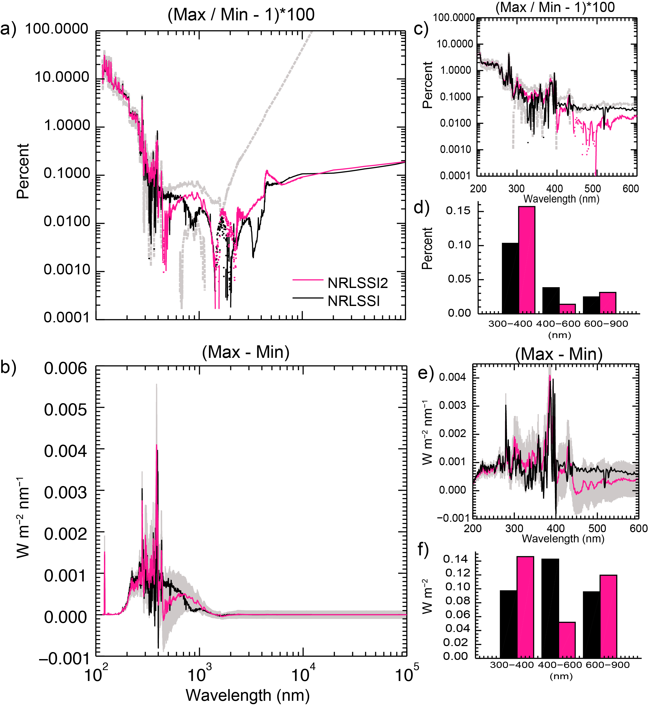

**Figure 7**: a) Comparison of NRLSSI2 (pink) and NRLSSI (black) solar spectral irradiance changes (max/min – 1) during solar cycle 24, in percentages. Dotted segments indicate negative values. Grey regions denote the uncertainty in the NRLSSI2 model variability (restricted to positive values). b) As in Figure 7a, but the solar cycle irradiance changes (max – min) are shown in energy units. c) and d) A subset (200 – 600 nm) of the solar spectral irradiance change over the solar cycle (in percentages) shown in Figure 7a and integrated over 3 broad wavelength bins, respectively. e) and f) As in Figures 7c and 7d, but for energy units. In all plots, solar minimum conditions are defined as 2008-11-28 through 2008-12-23 and (near) solar maximum conditions are defined as 2013-01-11 through 2013-01-22.

19.  p. 15, lines 325-330:  Is this averaging being done to "wash out" the differences between these TSI data sets that have been discussed in multiple papers over the last 10-15 years (e.g. Willson and Mordinov [2003], Frohlich [2009])?  Does the ACRIM data set incorporate the revisions proposed by the recent laboratory intercomparison of TSI instruments?

The main reason we show the average of the PMOD and ACRIM TSI composites in comparison with the TSI CDR time series is because we are technically unable to choose one or the other based on the literature. We thus assume that the least uncertain specification of TSI is the average of two observations, rather than one single observation. This follows a similar approach to that of Kopp and Lean (GRL, 2011). Yes, the ACRIM time series incorporates the new revisions proposed by recent laboratory measurements. We note that ongoing work to revise the ACRIM composite is underway as part of the NASA Solar Irradiance Science Team (SIST) and we will continue to compare the TSI CDR with new PMOD and ACIM composite time series (and their averages) as they become available.

We have revised our approach to the observational composite by first scaling the PMOD and ACRIM average to the SORCE TIM level by regression analysis and then taking the average of these revised composites. Then, the subset of the average that overlaps in time with SORCE TIM is replaced by the TIM observations and the assigned uncertainties are those reported by SORCE TIM. Prior to the SORCE TIM epoch, the assigned uncertainties are equal to the differences in the PMOD and ACRIM composites (after their normalization to the SORCE TIM scale) plus an added value of 0.5 Wm-2 that is the uncertainty of the SORCE TIM’s absolute scale. The observational composite will be extended in the future by appending TIM observations and their associated uncertainties. The average standard deviation of the residual difference in the composite observational record and the NRLTSI2 model (from 1978 to 2014) is 0.24 Wm-2.

For clarity, we have added the versions of these two TSI composites to the updated figure caption of the revised figure. There is new and revised text describing the observational composite on lines 367-378.

20.  p. 15, lines 331-332:  The residual differences at solar minimum periods in Figure 8b vary by ±0.2 W/m2 (0.015%).  This level of agreement is quite good, but also serves to illustrate how challenging the TSI requirement listed in Table 1 (0.01%/decade) really is.

Yes, we agree – and the SSI requirements are also equally challenging. The requirements reflect the need for measurements of true solar irradiance changes within the uncertainties needed for climate change research. We have added a reference (line 110) to the NRC report that justifies and explains the reasons for these requirements. Reference: “Review of NOAA Working Group Report on Maintaining the Continuation of Long-term Satellite Total Solar Irradiance Observation”, NRC 2013.

21.  p. 16, lines 354-355:  The citation for this reference states that it was submitted for review in October 2013.  Since its contents would presumably help to address some of the points raised in comment #1, it would be very helpful to have an accepted version available to the public almost 2 years later.  At the least, a status update should be provided.

No, the citation for the reference states that a draft was submitted in 2013, but not that it went under a review process. TSIS is a space mission that has been long-delayed due to the restructuring of NPOESS, its transfer to JPSS, transfer from JPSS to Polar-Free Flyer, dissolution of the Polar-Free Flyer and subsequent manifestation to the International Space Station, and now transfer from NOAA to NASA. In 2013, a draft ATBD was submitted to the NOAA Climate Data Record Program that funded its development. Since that time the decision was made to deploy to ISS. The ATBD is undergoing revisions, after which it will undergo a formal review by NASA.

Reviewer 2 asked a similar question.

22.  p. 17, lines 373-376:  The discussion of deliverables in Section 4 is presented in the present tense, but solar irradiance CDR data as described in this paper are not currently (27 July 2015) available at either of the web sites listed here.

Agreed. We apologize for any confusion in obtaining the CDR data, source code, and ancillary data. Please see our response to comment #2. The data *is* publicly available, and we have updated the footnote to point to the updated urls. Due to a problem with a new server at LASP that will ultimately also host the CDR data on LISIRD, we have revised the text to reflect that this public accessibility will occur in the future. The revised text (lines 421-422) is:

“*NOAA’s NCEI8 is the definitive source of the Solar Irradiance CDR, but future capabilities will allow users to also download the data over a user-defined time and spectral range of interest from LASP’s Interactive Solar Irradiance Data Center (LISIRD, http://lasp.colorado.edu/lisird) server.”*

23.  p. 19, lines 412-413:  The long-term continuity of the Bremen composite index Mg II data record should also be addressed.  What data source is expected to provide follow-on data to the GOME-2 measurements?

The GOES-R series of instruments (Snow et al. 2009 EUVS-C: the measurement of the magnesium II index for GOES-R EXIS, Proc SPIE, article id 743803 doi: 10.117/12.828566).

We revise lines 235-237 as, “*Since 1978, multiple satellite missions have recorded the Mg II index (Skupin et al. 2004, Viereck et al. 2004, Snow et al. 2014) and future missions will extend the record (Snow et al., 2009).*”

Other possibilities may be the Mg index derived from OMI observations, and we are in discussion with NOAA and Matt DeLand about this. Ultimately, if no suitable facular index is available but there are reliable TSI measurements (such as expected from TSIS), we believe we can use our model to continue calculating SSI as follows: We use the sunspot darkening time series to remove these effects from the measured TSI, thereby provide a “residual” time series that is dominated by faculae. We then use this derived facular component along with the sunspot darkening, to calculate the SSI.

24.  p. 19, lines 420-421:  Referring back to comment #17, how will the quality of long-term NRLSSI2 SSI variations be evaluated?  This question applies to both past and future model output.

The validation of NRLSSI2 will be evaluated though continued comparisons between the modeled and measured irradiance spectra. This relies on extending the length of full-spectrum SSI observations beyond the current one-solar cycle, and improved understanding of instrument degradation and stability on orbit. The quality of the long-term variations can only be addressed in time, and as our understanding of the variability in the Sun’s spectrum, obtained through measurements and models, improves.

25.  p. 20, lines 441-442:  This simple statement is more complex to evaluate in practice.  Gross errors in Mg II index data may be evident by inspection with such comparisons, but an appropriate CDR-level validation requires a more sophisticated understanding of the relationship between these proxy data sets.

Such a comparison between the proxies seems beyond the scope of this paper.

26.  p. 21, lines 452-453:  So scaling coefficients derived from TSIS observations may eventually replace coefficients derived from previous data sets?

Yes, that is correct. We have established an operational approach where a transition to a future version of the Solar Irradiance CDR will derive from model coefficients established using an extended and improved measurement record from TSIS.

27.  p. 23, lines 493-495:  This decision is up to the journal editors, but "manuscript in progress" is not usually sufficient as a reference.

We took guidance from the BAMS editorial staff and revised the in-text citation to (O. Coddington et al. 2015, unpublished manuscript) and removed it from the list of references.

**Reviewer #2:** This is an informative and well written article presenting a pair of new models for the Solar Irradiance Climate Data Record for the Total Solar Irradiance and Solar Spectral Irradiance. I have only minor comments that that author may wish to consider.

Line 54; It may be more accurate to say "Changes to the disk-integrated solar irradiance at any time are thus the net .  .  . "

Agreed. We have implemented the change.

Line 354; Is the TSIS ATBD readily available? I could not find a reference to this document at the NCEI CDR website (<http://www.ncdc.noaa.gov/cdr/grants.html>)

No, it is not yet readily available. NCEI has a draft version, but do to multiple restructuring of the TSIS space mission, a transfer from NOAA to NASA, and recently a decision to deploy to the ISS, the ATBD is undergoing revisions. After that, it will undergo a NASA review. Please see detailed response to Reviewer #1, comment #21.

Page 29; Solanki al. and Snow et al. references are out of order.

Agreed, we corrected the ordering.

Figure 5; "NOAA/NGDC" should be changed to "NOAA/NCEI".

While we didn’t see the usage of NOAA/NGDC in Figure 5, we did find it in Figure 9 (i.e. the outline of the Solar Irradiance CDR algorithm). We corrected the usage in Figure 9, plus made additional changes to be consistent with symbols used in the text (per Reviewer #3’s request).

**Reviewer #3:** In this manuscript the authors describe the creation of a total and spectral solar irradiance climate data record (CDR) based on TSI, SSI, and solar proxy observations that would not otherwise meet the requirements for a CDR.  The CDR represents a significant update to the previous NRLTSI/SSI reconstruction, in wide use.  The methodology is described in detail, including derivation of uncertainties, as well as the CDR deliverables made publicly available.  This is an important, well written paper to a wide audience, well suited for BAMS.  I accept, with minor revisions.

In our response to l.108, we discuss changes and additions to the text to better explain the role of the solar variability model.

Suggestions, in order of appearance in the manuscript ("l." means line number):

l. 13: Replace "from" with "in comparison to" or "with respect to".  Otherwise it is tempting to read "from" as meaning "derived from", which is confusing because the quiet Sun doesn't have faculae or sunspots.

Agreed. We changed “from” to “with respect to”.

l. 59: Add "apparent" when describing the 27-day rotation (apparent rotation period as viewed from Earth).

Agreed. The sentence now includes this modified text, “*But on shorter time scales the Sun’s rotation, which has* *the Sun’s rotation, which has an apparent period of approximately 27-days as viewed from Earth*, …”

l. 105: Is there a reference for how these requirements in Table 1 were determined?

Yes, there are references, which we have now included in the revised text. Please see response to reviewer #1, comment #1.

l. 108: Make a more explicit statement that the use of the solar variability model is what makes the solar irradiance CDR possible (as the space observations themselves can't meet the CDR requirements).

The text has been revised to better explain the role of the solar irradiance variability model. In fact, the SORCE TIM *does*, and TSIS TIM and SIM *will* meet CDR requirements*.* See the revised text (lines 110-118). In Figure 8, we compare the CDR modeled TSI to an observational composite of TSI. Additionally, we have produced preliminary irradiances for the first two quarters of 2015 and these compare very well with SORCE TIM (these prelim irradiances will be public in the very near future). It is the space observations that enable the solar irradiance variability model that produced the CDR record.

l. 132-137: "The algorithm begins…."  I suggest the authors consider calling Figure 9 out in this paragraph.  It would provide the reader a very nice visual roadmap as the algorithm is described.  Also, in Figure 9, it would be good to use the same nomenclature so there is a more precise and obvious correspondence between what is in the text and what is in the flow chart.

Agreed. In addition to revising the text, we also revised the symbols in Figure 9 to be consistent with the text and corrected the usage of NOAA/NGDC to NOAA/NCEI (per Reviewer #2 request). The revised text (line 146) includes, *“Further details about algorithm flow and operational implementation are provided in Section 5 (e.g., Figure 9).”*

l. 150-161: How are the transitions between the spectral regions coming from different sources handled?  Are there discontinuities?  Are they somehow smoothed?  And is the entire merged spectrum scaled uniformly to integrate to the quiet Sun TSI value?

Reviewer #1, Comment #4 shared questions regarding the spectrum of the quiet Sun and we also refer you to our response to that. There are no discontinuities despite there being significant wavelength-dependent differences among various reference spectra (please see figure in response to reviewer #1). This is because we have used the LASP WHI as the “backbone” of the reference spectrum and have adjusted the ATLAS and Kurucz spectra to seamlessly blend with this. Making this merged spectrum numerically integrate to TSI was primarily achieved by small changes in the longest wavelength (Kurucz IR) spectrum, where the absolute uncertainties are larger.

l. 156: "…constrained to match the overall spectral shape of the WHI reference spectrum."  Please clarify this sentence.  I don't understand what it means to constrain one spectrum to the shape of another.

Yes, we agree that not enough details were provided and this concern was also voiced by Reviewer #1. We have explained in detail how we constructed the reference spectrum in our response to Reviewer #1 whose Comment #4 is essentially the same as this comment.

l. 163: There is a footnote for the SORCE data.  Are any of the other spectra used in this section available on-line?  I note at the end that some (all?) are made available as a deliverable.  If so, perhaps this could be commented on in section 2b?

Table 2 lists only the CDR-related products that we provide through this work. However, the Whole Heliosphere Interval (WHI) SSI reference spectrum is available online and we have provided a footnote (footnote #3) with a url for this in the revised manuscript. An online link to the Kurucz theoretical spectrum was not found. While one link suggests SOLSPEC data is publicly available (http://www.pole-ether.fr/etherTypo/index.php?id=526&L=1), following it didn’t provide the access requested. The lack of public access to the SOLSPEC data is a problem shared by the entire science team.

l. 235-238: Do you have a sense for whether the unquantified uncertainty of the proxy indices' representativeness of facular brightening and sunspot darkening is larger or smaller than that associated with the indices themselves (discussed in the following paragraph, starting at l. 239)?

The facular and sunspot indices are constructed from a variety of observations made over different time periods using different instruments. The fidelity of our model depends on the precision (stability, repeatability) of the facular and sunspot indices rather than on their absolute scales but uncertainties of the absolute measurements of the indices contribute to the (lack of) the long-term repeatability. At the present time, we believe that our assigned uncertainties of ±20% encompass differences in the Mg index and sunspot darkening after 1978. After adjusting for different absolute calibrations, which can be a factor of two, the Bremen, SORCE and SOLID Mg indexes during the three recent solar minima agree to within (much smaller than) this amount. The sunspot darkening index differs somewhat depending on how we parameterize the dependence of sunspot contrast but different dependencies alter only slightly the overall agreement of the model with the TSI observations.

This is not, however, the case for our reconstructed irradiances prior to 1978. There are no Mg index measurements prior to 1978 so the facular index that we use builds on prior (published, Lean et al. 2001) work connecting the Ca K plage index and smoothed 10.7 cm flux after 1950 to the Mg index. We use the Royal Greenwhich Observatory (RGO) sunspot region observations prior to 1976 which are considered to be larger than the SOON areas in the range of a factor of 1.2 to 1.5. For the solar irradiance CDR we scale the RGO sunspot darkening by 0.8. We have already begun a more detailed assessment of the CDR irradiance uncertainties taking into account these larger uncertainties in the sunspot and facular indices prior to 1978, than we have done for the current version of the CDR.

We include a reference to the Lean et al. 2001 work in the revised manuscript (Section 5b; lines 489-490).

l. 242-244: What uncertainties are assumed for the non-SORCE portions of the quiet Sun irradiance?

The uncertainties that we adopt for the CDR quiet sun irradiance, which we do not include in our model of irradiance variability (statistical) because they significantly exceed the actual solar variability, are 10% at 121.5 nm and 5% at l250.5, 500.5 and 1000.5 nm. We give these numbers in the Solar Irradiance C-ATBD, Table 6, which is publically available from the NOAA CDR web site. In the revised manuscript, we have supplied a url link for the C-ATBD in the list of references.

l. 320: I am guessing it should read "…NRLSSI at wavelengths between 400…" (not 300, at the end of the line).

We thank the reviewer for catching this error. Please see our detailed response to Reviewer #1, comment #18, which describes revisions to text and figure.

l. 384-392: Would you add an additional reference spectrum, that of time-averaged mean solar conditions, to the low, quiet, moderate, etc.?  This could be used in models when solar variability is not applied.  (The reference spectra already present are a great idea, by the way.)

Thank you! In a future version of the CDR, this additional reference could be included. In the interim, we are happy to provide additional spectra on request. Through the NCEI CDR program, we would first need to go through a change request process before making changes or additions to the CDR provided data.

Figure 3: Adding relative (%) scales on the right side of the panels would drive the point home that solar variability is a strong function of wavelength.

Agreed, this is an excellent idea. We modified the plot as shown here and the caption accordingly.

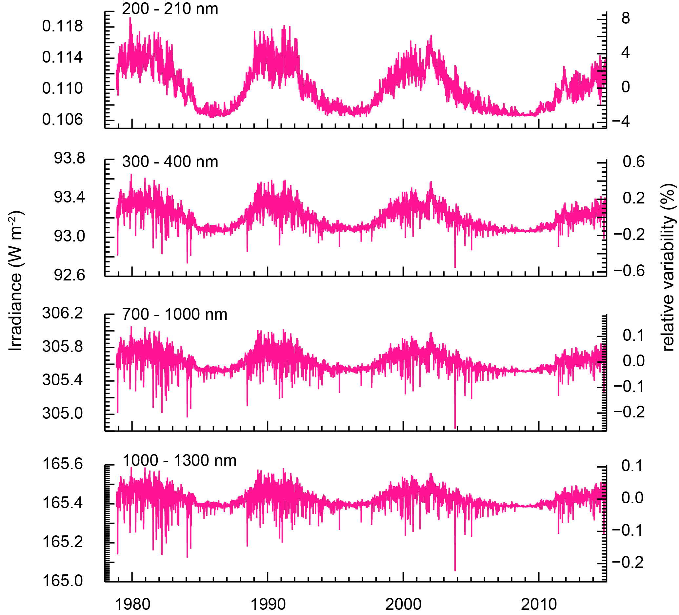

Figure 4: Expressing panel (d) with a log-y axis would make the differences easier to see.

We agree that the time series of the differences between the measurements and the model could be better shown. Instead of a logarithm y-axis, we reproduced the figure with a scale break in the y-axis as shown here. The figure caption has been modified accordingly.

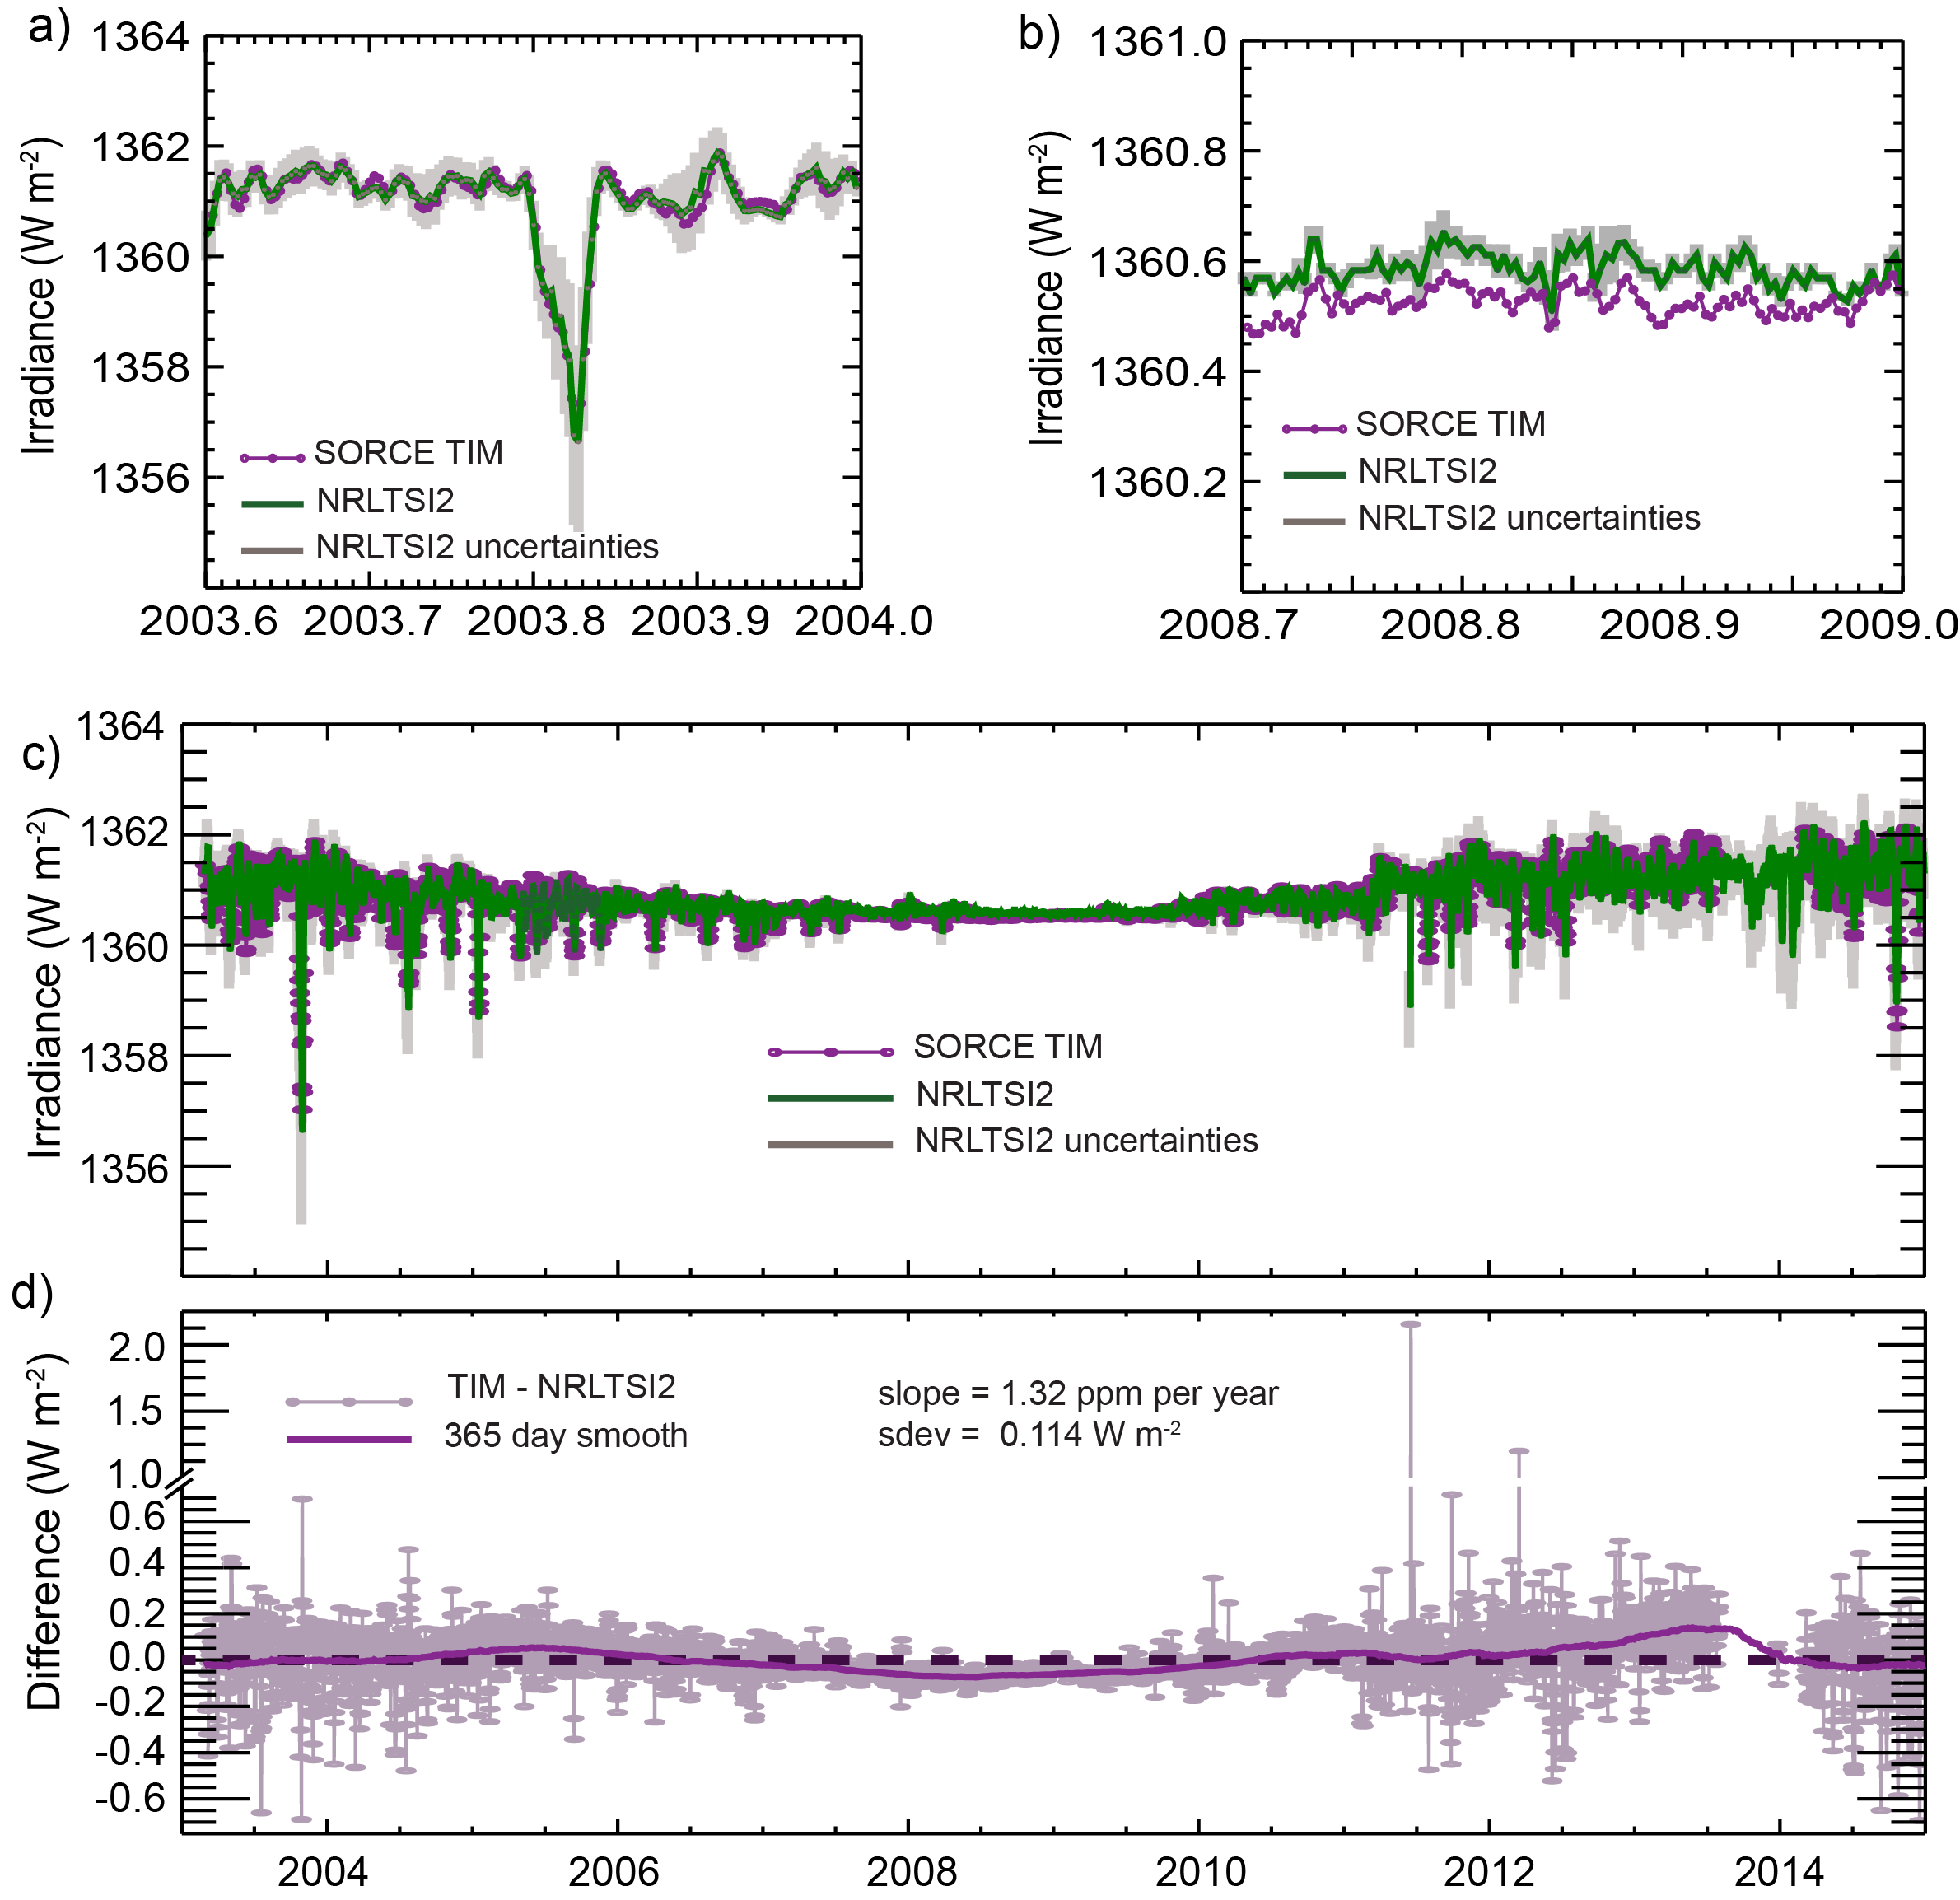

Figure 5: Please add the SORCE version numbers to the caption, analogous to TIM in Figure 4.

Agreed and implemented.

Minor comments:

* Compound adjectives not always hyphenated.  Example:

l. 3: "time dependent"

Agreed. We made multiple changes in hyphenation of compound adjectives throughout the manuscript by following the general principle, “Do not use a hyphen unless it serves a purpose.” We do not provide a line number listing of these changes.

* Commas sometimes incorrectly used, separating two nouns or noun phrases in a compound object.  Examples (should remove these commas):

l. 8: "multiple time scales, and for user groups"

l. 25: "to the present, and annuals values"

Agreed, we identified a number of instances of “comma abuse” and corrected these. We do not provide a line number listing of these changes.