Climate Data Record (CDR) Program

Climate Algorithm Theoretical Basis Document (C-ATBD)

Solar Irradiance



CDR Program Document Number: TBD by CDR Program Document Manager

Originator Document Number: TBD by PI organization or use N/A

Revision 1 / <Month> <day>, YYYY

DSR Number: DSR-XXX by CDR Program Document Manager

REVISION HISTORY

|  |  |  |  |  |
| --- | --- | --- | --- | --- |
| Rev. | Author | DSR No. | Description | Date |
| 1 | Odele Coddington  Judith Lean | DSR-XXX | Initial Submission to CDR Program | MM/DD/YYYY |
|  |  |  |  |  |
|  |  |  |  |  |
|  |  |  |  |  |
|  |  |  |  |  |
|  |  |  |  |  |
|  |  |  |  |  |
|  |  |  |  |  |
|  |  |  |  |  |
|  |  |  |  |  |

TABLE of CONTENTS

1. Introduction 1

1.1 Purpose 1

1.2 Definitions 1

1.3 Document Maintenance 2

2. Overview of Solar Irradiance Climate Data Record 3

2.1 Products Generated 3

2.2 Instrument and Model Characteristics 4

3. Algorithm Description 5

3.1 Algorithm Overview 5

3.2 Processing Outline 5

3.3 Algorithm Input 7

3.3.1 Primary Input Data 7

3.3.2 Ancillary Data 8

3.3.3 Derived Data 9

3.3.4 Forward Models 10

3.4 Theoretical Description 10

3.4.1 Physical and Mathematical Description 15

3.4.2 Data Merging Strategy 18

3.4.3 Numerical Strategy 18

3.4.4 Calculations 18

3.4.5 Look-Up Table Description 18

3.4.6 Parameterization 18

3.4.7 Algorithm Output 18

4. Test Datasets and Outputs 20

4.1 Test Input Datasets 20

4.2 Test Output Analysis 21

4.2.1 Reproducibility 21

4.2.2 Precision and Accuracy 21

4.2.3 Error Budget 21

5. Practical Considerations 22

5.1 Numerical Computation Considerations 22

5.2 Programming and Procedural Considerations 22

5.3 Quality Assessment and Diagnostics 22

5.4 Exception Handling 22

5.5 Algorithm Validation 23

5.6 Processing Environment and Resources 24

6. Assumptions and Limitations 25

6.1 Algorithm Performance 25

6.2 Sensor Performance 25

7. Future Enhancements 26

7.1 Enhancement 1 26

7.2 Enhancement 2 26

7.3 Enhancement 3 26

8. References 27

Appendix A. Acronyms and Abbreviations 29

LIST of FIGURES

Figure 1: Algorithms Flow Diagram

Figure 2: Sunspot darkening and facular brightening time series – native scale, solar cycle.

Figure 3: Sunspot darkening and facular brightening time series – native scale, solar rotation.

Figure 4: Reference quiet sun spectrum and comparisons with other spectra.

Figure 5: Wavelength-dependent scaling coefficients that convert the facular brightening and sunspot darkening time series in Figures 3 and 4 into irradiance increments, in energy units.

Figure 6: NRLTSI2 time series

Figure 7: NRLSSI2 time series in selected wavelength bands

Figure 8: comparison of NRLTSI and ∑NRLTSI2 time series of total, faculae and spot values, and residuals.

Figure 9: comparison of NRLSSI and NRLSSI2 time series observations, and residuals.

Figure 10: comparison of NRLTSI2 (and NRLTSI) with TIM & ratios.

Figure 11: comparison of NRLSSI2 and SIM (and other) spectral irradiance solar cycle changes.

Figure 12: comparison of NRLSSI, NRLSSI2 spectral irradiance solar cycle changes.

LIST of TABLES

Table 1: Definitions of symbols

Table 2: Products that this CDR provides

Table 3: Output file names

Table4: Error Budget

1. Introduction
   1. Purpose

The purpose of this document is to describe the algorithm submitted to the National Climatic Data Center (NCDC) by Judith Lean (Space Science Division, Naval Research Laboratory), Odele Coddington and Peter Pilewskie (Laboratory for Atmospheric and Space Science, University of Colorado) that is used to create the Solar Irradiance Climate Data Record (CDR). Also described are the solar activity indices of sunspot darkening, S(t) ,and facular brightening, F(t), which are input to the algorithm. The algorithm calculations of solar irradiance augment direct measurements made by the Total and Spectral Solar Irradiance Sensor (TSIS). The actual algorithm is defined by the computer program (code) that accompanies this document; this C-ATBD provides a guide to understanding that algorithm, from both a scientific perspective and in order to assist a software engineer or end-user performing an evaluation of the code.

This C-ATBD for the Solar Irradiance Climate Data Record describes the procedures, algorithms and input datasets used to construct the total solar irradiance and the concurrent spectral solar irradiance variations during recent decades and in historical time periods since 1615. Also described are the output files of daily, monthly and annual solar irradiance, and validation procedures for the modeled solar irradiance. The solar irradiance reconstructions that this C-ATBD describes compliment the direct measurements made of total and spectral solar irradiance by the TSIS instrument, documented in the TSIS ATBD.

* 1. Definitions

**Table 1. Definitions of symbols used in the C-ATBD**

|  |  |  |
| --- | --- | --- |
| Symbol | Definition | Units |
| t | time |  |
| λ | Wavelength |  |
| T(t) | Total solar irradiance at time t | W m-2 |
| TQ | Total solar irradiance of the quiet (inactive) Sun; invariant with time | W m-2 |
| I(λ,t) | Solar spectral irradiance at wavelength λ and time t | W m-2 per wavelength bin |
| IQ(λ) | Solar spectral irradiance of the quiet (inactive) Sun at wavelength λ | W m-2 per wavelength bin |
| F(t) | Facular brightening index at time t |  |
| S(t) | Sunspot darkening index at time t |  |
| FQ | Facular brightening of the quiet (invariant) Sun, corresponding to IQ and SQ |  |
| SQ | Sunspot darkening of the quiet (invariant) Sun, corresponding to IQ and FQ |  |
| AS | Sunspot area | millionths of solar hemisphere |
| μ | sunspot location in radial heliocentric coordinates |  |
| Mg(t) | The Mg II index at time t, determined as the ratio of core to wing emission in the Mg II Fraunhofer line |  |
|  |  |  |
|  |  |  |
|  |  |  |
|  |  |  |

* 1. Document Maintenance

The algorithm that calculates the total solar irradiance (TSI) and solar spectral irradiance (SSI) that compose the Solar Irradiance Climate Data Record uses bolometric (for TSI) and wavelength-dependent (for SSI) coefficients to convert two time-varying inputs, the facular brightening index, F(t), and the sunspot darkening index, S(t), into their respective modulations of the solar irradiance of the “quiet” Sun (i.e., in the absence of these activity features). The starting point for the algorithm is a baseline (invariant) value of total, TQ, and spectral, IQ(λ), irradiance representative of the “quiet” (inactive) Sun, obtained directly from space-based irradiance observations. The numerical values of the coefficients that determine the irradiance modulation imposed by sunspots and faculae, when these features are present on the solar disk, are determined from analysis of variability in extant TSI and SSI datasets measured by instruments onboard the Solar Radiation and Climate (SORCE) spacecraft (Rottman et al., 2005). Neither the baseline irradiance values nor the coefficients that calculate the irradiance modulation with time are expected to change on time scales shorter than a few years, which is the time frame over which new information can be expected from ongoing TSIS measurements. For this reason, it is not expected that the algorithm will evolve rapidly, nor that frequent synchronization will be needed.

1. Overview of Solar Irradiance Climate Data Record
   1. Products Generated

The Solar Irradiance Climate Data Record provides values of the total and spectral irradiance as functions of time, listed in Table 1. Total solar irradiance, T(t), is the total, spectrally integrated (i.e., bolometric) energy input to the top of the Earth’s atmosphere, at a standard (invariant) distance of one Astronomical Unit (1AU) from the Sun. Its units are W per m2. Solar Spectral Irradiance, I(λ,t), is the corresponding spectrum that integrates self-consistently to the total. Values of spectral irradiance are provided in 3785 (variable width) wavelength bands from 115.5 ± 0.5 nm to 99,975 ± 25 nm, in units of W per m2 per band.

Both direct observations and model calculations contribute to the Solar Irradiance Climate Data record. The Total and Spectral Irradiance Sensor (TSIS) is the corresponding observing system that measures the total solar irradiance and solar spectral irradiance directly. It is described in a separated ATBD (ref). The Naval Research Laboratory Total Solar irradiance (NRLTSI2) and Naval Research Laboratory Solar Spectral irradiance (NRLSSI2) models, developed from the SORCE database of solar irradiance observations, calculate the irradiance from two primary (time varying) inputs, the sunspot darkening, S(t), and facular brightening, F(t).

Also provided are four reference spectra indicative of quiet, moderate and high solar activity levels, and the Maunder Minimum, in 99844 bins of equal 1 nm width, from 115.5 to 99999.5 nm.

Table 2: Products that this CDR provides.

|  |  |  |  |  |
| --- | --- | --- | --- | --- |
| Product | Type | Number of Wavelength Bins | Time Range | Cadence |
| Total Solar Irradiance | Observational composite | 1 | 1978-presemt | daily |
| Total Solar Irradiance | NRLTSI2 model | 1 | 1882-present | daily, monthly |
| Total Solar Irradiance | NRLTSI2 model | 1 | 1610-present | annually |
| Solar Spectral Irradiance | NRLSSI2 model | 3785  (variable width) | 1882-present | daily, monthly |
| Solar Spectral Irradiance | NRLSSI2 model | 3785  (variable width) | 1610-present | annually |
| Solar Spectral Irradiance | Reference Spectrum | 99884  (1 nm width) | Quiet, moderate & high solar activity |  |
| Solar Spectral Irradiance | NRLSSI2 model spectrum | 99884  (1 nm width) | Maunder Minimum  (estimated) |  |

* 1. Instrument and Model Characteristics

The primary solar irradiance observational dataset for the Solar Irradiance Climate Data Record is that measured by the Total Solar and Spectral Irradiance Sensor (TSIS), which a separate ATDB document describes (ref).

The present document describes the algorithm that calculates solar total and spectral irradiance using the NRLTSI2 and NRLSSI2 models, developed from direct solar irradiance observations made by Total Irradiance Monitor (TIM) and Solar Irradiance Monitor (SIM) instruments on the Solar Radiation and Climate Experiment (SORCE) spacecraft from 2003 to 2014. The NRLTSI2 and NRLSSI2 models are the second generation of the NRLTSI and NRLSSI solar irradiance variability models that input proxy indicators of faculae and sunspots to calculate the change in a reference spectrum that these features produce, when present on the solar disc. Lean and Woods (2010) provide an overview of the NRLTSI and NRLSSI models.

The total solar irradiance generated by the NRLTSI2 model is directly comparable with daily average values of the total solar irradiance measured by the next-generation TIM, which is part of TSIS. The solar spectral irradiance generated by the NRLSSI2 model is directly comparable with daily average values of the next-generation SIM, which is also part of TSIS, after adjustment to match the wavelength bins on which the TSIS SIM measurements are reported.

1. Algorithm Description
   1. Algorithm Overview

The Solar Irradiance Data Record algorithm uses the NRLTSI2 and NRLSSI2 models to calculate values of the total irradiance and the solar spectral irradiance in 3,785 (variable) wavelength bins (on a wavelength grid from 115.5 to 99975 nm) when supplied with two inputs; the facular brightening, F(t), and sunspot darkening, S(t), indices, each of which varies with time, t.

The facular and sunspot influences on solar irradiance are calculated in Wm-2 by applying (constant) scaling coefficients to the input facular and sunspot indices, and the resultant irradiance increments are then applied to adjust the specified (invariant) baseline total irradiance and spectral irradiance which indicate the “quiet” sun. For the purposes of the algorithm, the quiet sun irradiance is that corresponding to the absence of both sunspots and faculae. An additional third component is calculated to estimate the contribution of an assumed long-term facular component speculated to produce secular irradiance change underlying the solar activity cycle on historical time scales (prior to 1950), since 1615, including during the Maunder Minimum of anomalously low solar activity.

Table 1 summarizes the outputs of the algorithm.

* 1. Processing Outline

The flow diagram in Figure 1 provides an overview of algorithm processing steps in calculating the total solar irradiance, T(t), and solar spectral irradiance, I(λ,t), at a specified time, t. The algorithms assumes that when faculae and sunspots are present on the solar disc, they alter the baseline (quiet) total solar irradiance, TQ, by amounts and respectively:

Similarly the faculae and sunspots alter the baseline solar spectral irradiance, IQ(λ), by wavelength-dependent amounts, and :

such that the integrated spectral irradiance equals the corresponding total irradiance:

The first step in the algorithm is determination of the corresponding values for the sunspot darkening, S(t), and facular brightening, F(t), indices at time, t, which produce incremental changes in total solar irradiance:

and in solar spectral irradiance:

such that

The facular brightening index is obtained by downloading the space-based Mg II composite index of solar activity constructed by combining observations made by the GOME, SCIAMACHY and GOME-2 instruments, available at <http://www.iup.physik.uni-bremen.de/gome/gomemgii.html>.

The sunspot darkening index is obtained from data downloaded from NOAA NGDC, in the form of annual files of active region information compiled from the Air Force Solar Observing Optical Network (SOON) sites. The link is <http://www.ngdc.noaa.gov/stp/spaceweather.html>, ftp access, Solar_Data, Sunspot_Regions, USAF_MWL. The files provide information about the areas, AS, and locations, μ, of individual sunspot active regions present on the solar disk.

Adding the total and spectral irradiance increments due to faculae and sunspots to the baseline reference total solar irradiance and spectral irradiance then determines the total and spectral irradiance at time, t. Values of the (invariant) total and spectral irradiance of the quiet Sun, and , are specified in the algorithm code as baseline references for this purpose. Solar spectral irradiance is estimated on a uniform wavelength grid, on 0.5 nm centers, in 1 nm bins from 115 .5 to 99999.5 nm, which is also the wavelength grid of the reference spectrum. The spectral irradiance is then summed into 3785 wavelength bins of variable width, designed appropriately for input to general circulation climate models.

Output files are generated separately for total solar irradiance and solar spectral irradiance. The TSI is one value per input facular brightening and sunspot darkening index values, typically daily. The units are W m-2. The SSI is one spectrum per input facular brightening and sunspot darkening index values, also typically daily. The solar spectral irradiance is produced in 3785 wavelengths binds, in units of W m-2 for the wavelength bin.

**Figure 1 Flow diagram of the Algorithm Processing.**

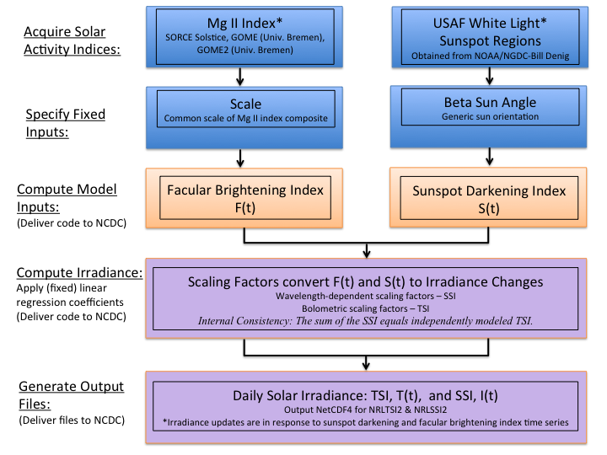

* 1. Algorithm Input
     1. Primary Input Data

Adopted for the facular brightening index, F(t), is the global (disk-integrated) Mg II emission from the Sun’s chromosphere, whose variations are dominated by chromospheric extensions of photospheric faculae. The Mg II index (which is the ratio of core emission in Fraunhofer lines to emission in the nearby continuum) is such a proxy because the core emission is enhanced in magnetically active bright regions, and the indices are sensitive indicators of the total (net) emission from all bright regions on the solar disk. Furthermore, as the ratio of absolute fluxes, the Mg II index is (in principle) less susceptible to instrumental sensitivity changes that potentially contaminate the temporal fidelity of time series.

The sunspot darkening index, S(t), is calculated following Lean et al., (1998) using direct observations of the areas, AS and heliocentric locations, μ, of Nspot individual sunspot regions that the Air Force SOON (and other ground- and space-based) sites observe daily. The calculation effectively sums the projected area of sunspot regions on the solar hemisphere and multiplies this by the contrast of sunspots relative to the background (reference) Sun, taking into account variations with limb position on the solar disk. Areas prior to 1976 are reduced by 20% to account for systematic area differences between Greenwhich and Air Force SOON measurements.

Summing over all sunspots, the sunspot darkening index is

where μ = cos(latitute) × cos(longitude) for spot latitude (adjusted for the Bo angle of the Sun’s axis to the ecliptic plane) and longitude in heliocentric coordinates.

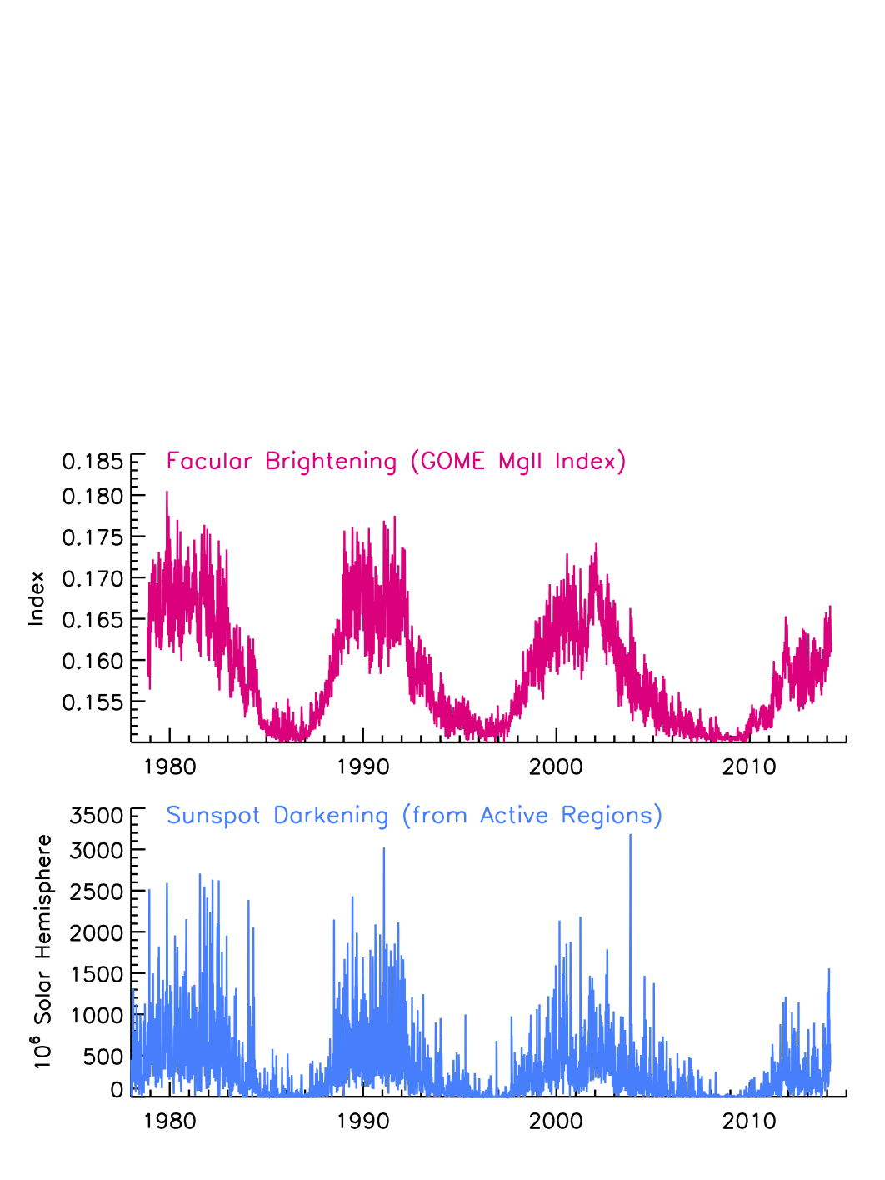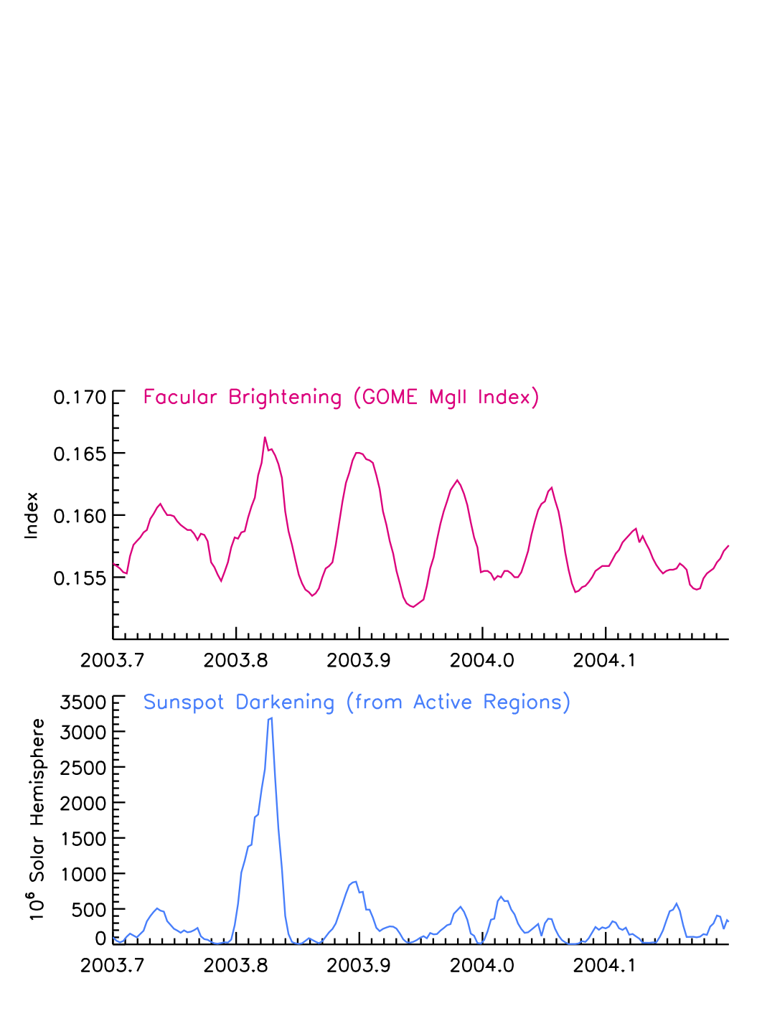Figures 2 shows time series of the facular brightening and sunspot darkening indices since 1978, illustrating their evolution during the solar cycle as active regions emerge, evolve, and disappear from the solar disk. Figure 3 shows variations of these indices during 2003-2014, illustrating their shorter-term modulation arising from solar rotation. The facular brightening, F(t), and sunspot darkening, S(t), time-varying inputs that the Solar Irradiance Climate Data Record algorithm uses to calculate solar irradiance must be carefully calculated and validated, with possible erroneous values flagged for investigation.

**Figure 3 Facular brightening and sunspot darkening time series during solar rotation.**

**Figure 2 Facular brightening and sunspot darkening time series during the solar cycle.**

* + 1. Ancillary Data

The algorithm uses constant baseline values of the total solar irradiance, TQ, and solar spectral irradiance, IQ (λ), to represent the quiet sun, as shown in Figure 4. Constant bolometric and wavelength-dependent coefficients, shown in Figure 5, linearly scale the facular brightening and sunspot darkening inputs to produce corresponding irradiance increments that are then applied to adjust the baseline irradiance, either increasing or deceasing it depending on the wavelength-dependent strengths of the facular and sunspot influences at that time. The bolometric and wavelength-dependent coefficients are included as part of the algorithm. Additional (invariant) data also specified in the algorithm are the angles of the solar rotation axis and the ecliptic plane, termed the beta angle, throughout the year. This angle is used to adjust the projection of sunspot areas to the direction of the Earth, as it orbits the Sun.

New versions of the model are generated when – if – the coefficients are determined to need revision, based on additional observations and analysis sufficient to permit reformation of the model coefficients.

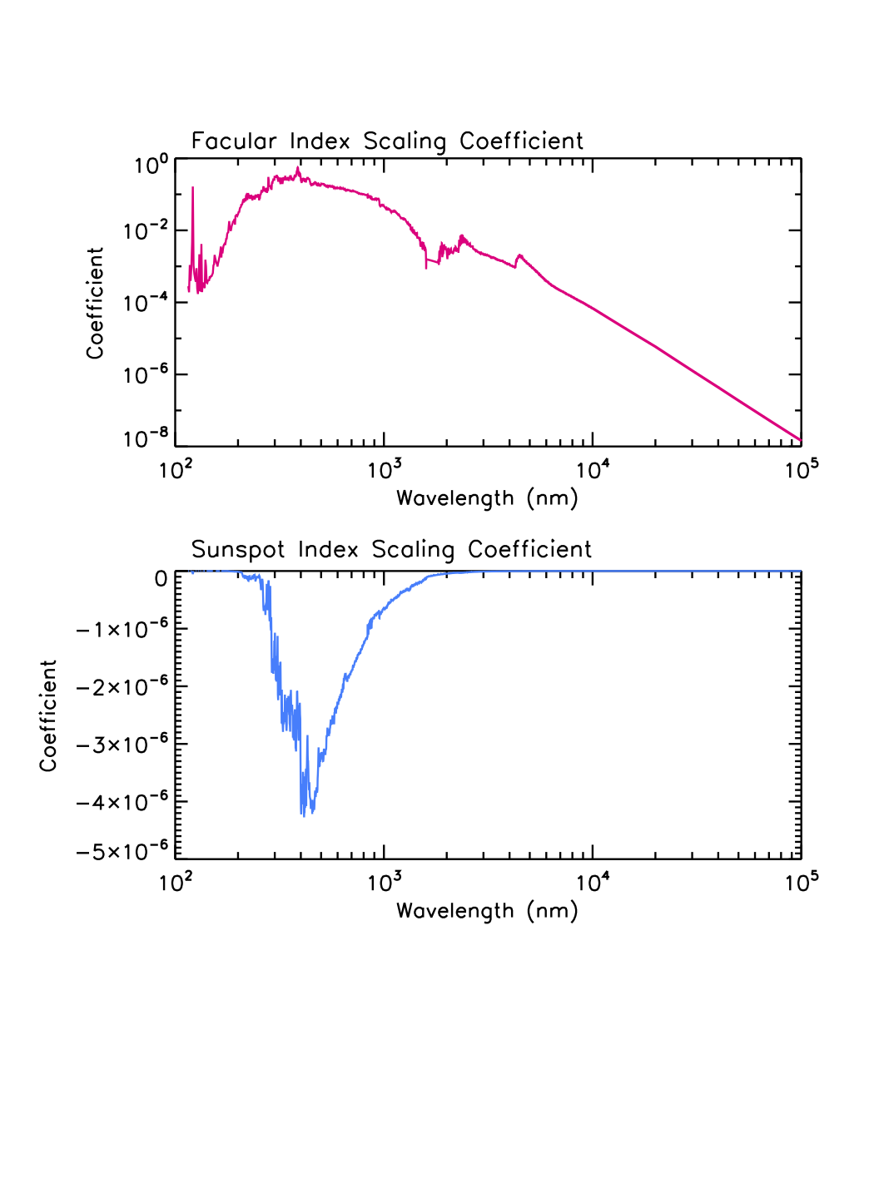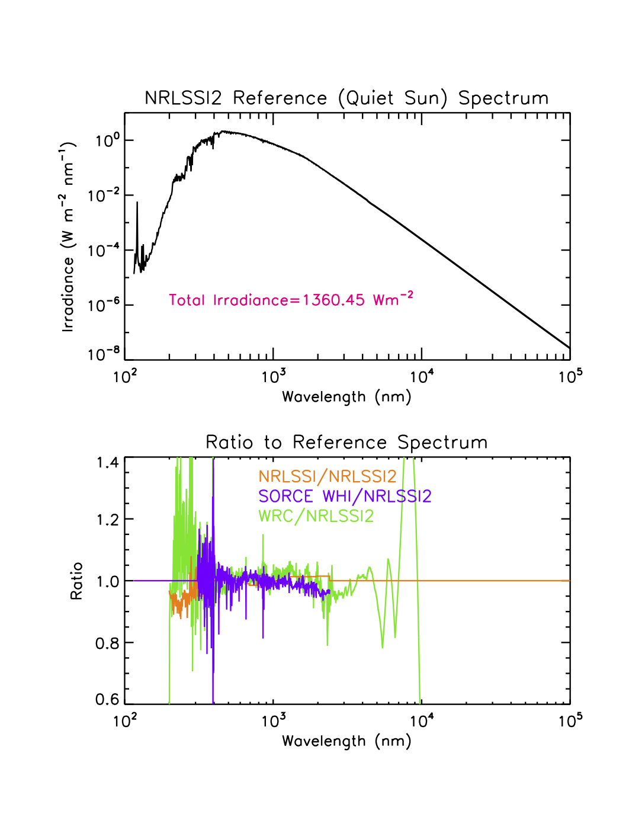

**Figure 5 Scaling coefficients that convert the facular brightening and sunspot darkening indices in Figures 2 and 3 to their equivalent irradiance change, in energy units.**

**Figure 4 Reference Spectrum of the Quiet Sun in NRLSSI2**

* + 1. Derived Data

Once the facular brightening and sunspot blocking inputs are obtained, they are linearly scaled to convert them to equivalent increments of total and spectral irradiance, which are then added to the baseline (quiet) total and spectral irradiance to determine solar irradiance at time t as specified in 3.2. The application of the irradiance increments to the baseline spectral irradiance is implemented in 1 nm bins on 0.5 nm grid centers. The 1 nm spectral irradiance thus calculated is then summed into 3785 wavelength bins of varying width:

1 nm bins on wavelengths grid centers from 115.5 to 749.5 nm (635 bins)

5 nm bins on wavelength grid centers from 752.5 to 4997.5 nm (850 bins)

10 nm bins on wavelength grid centers from 5005.0 to 9995.0 nm (500 bins) 50 nm bins on wavelength grid centers from 10025.0 to 99975.0 nm (1800 bins)

There are no further processing steps; the calculated total and spectral irradiance are then written to output files. A time series of the output total solar irradiance since 1978 is shown in Figure 6 and examples of the corresponding solar spectral irradiance outputs in broad wavelength bands are shown in Figure 7.

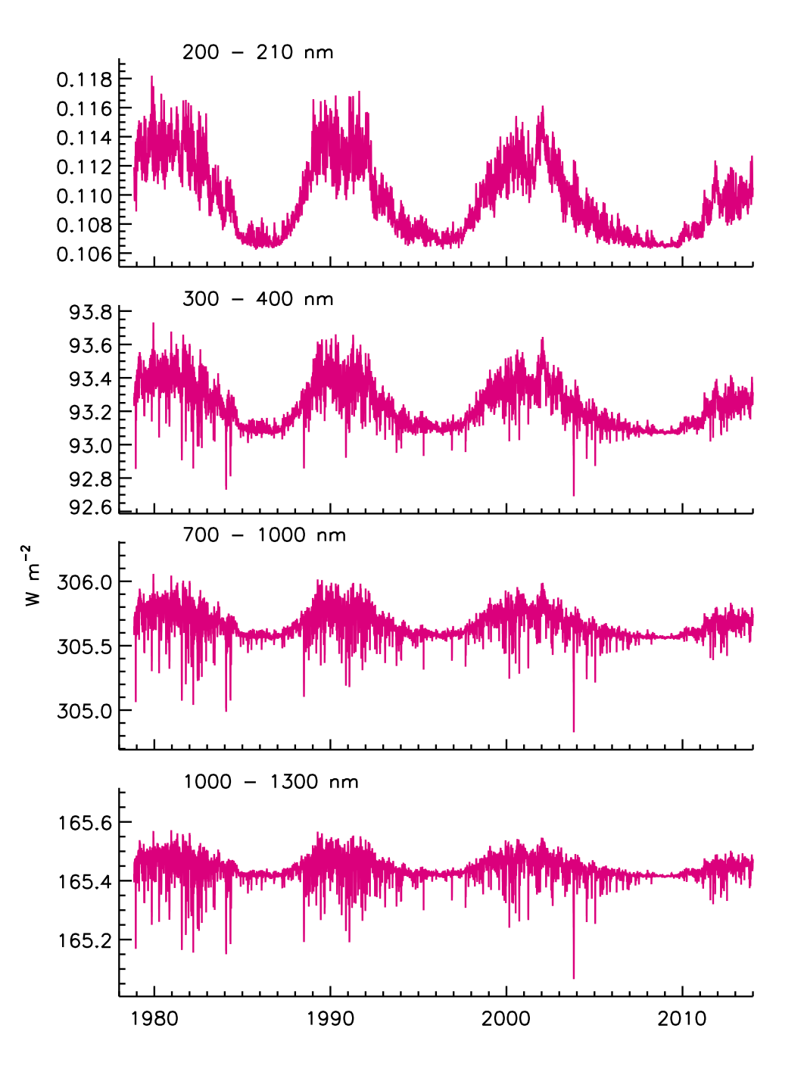Because validation of the facular brightening and sunspot darkening inputs is crucial for reliable solar irradiance calculations, the processed facular brightening and sunspot darkening time series (e.g., Figure 2) used in the algorithm are output to a separate file, to facilitate validation with independent datasets.

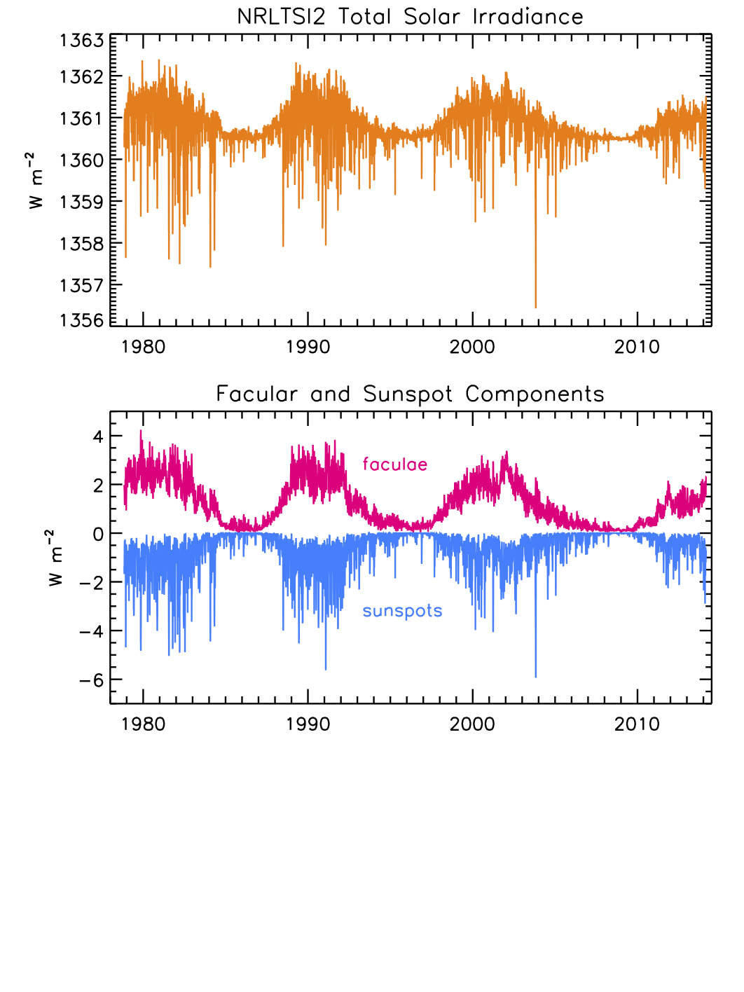

**Figure 7 Spectral irradiance in broad bands reconstructed with the NRLSSI2 model**

**Figure 6 Total solar irradiance reconstructed with the NRLTSI2 model (upper), and the corresponding the facular and sunspot contributions (lower).**

* + 1. Forward Models

Not applicable.

* 1. Theoretical Description

The overall approach of the Solar Irradiance Climate Data record algorithm builds on, and advances, the NRLTSI and NRLSSI models, as described in Lean (2000), Lean et al. (2005) and summarized in Lean and Woods (2010). Developed over a decade ago, prior to the launch of the Solar Radiation and Climate Experiment (SORCE) spacecraft (Rottman, 2005), the NRLTSI and NRLSSI solar irradiance variability models have been widely used for a variety of model simulations of climate and atmospheric change, including for the IPCC reports.

**Original NRLTSI and NRLSSI Models**

The NRLTSI model was formulated using a composite of total solar irradiance constructed by Fröhlich and Lean (2004), by combining observations made by Nimbus 7, ACRIM on SMM and UARS and PMOD on SOHO. The NRLSSI model was constructed for wavelengths less than 400 nm from a linear association of spectral irradiance variations observed by the Solar Stellar Irradiance Comparison Experiment (SOLSTICE, Rottman, 2000), relative to a reference spectrum (the average SOLSTICE spectrum during the UARS time period), with corresponding changes in facular brightening and sunspot darkening, also relative to their respective reference values.

Lacking observations of solar spectral irradiance variability at wavelengths longer than ~400 nm, NRLSSI’s spectral irradiance variations in the visible and infrared spectral regions were determined from the wavelength-dependence of the sunspot and facular contributions, according to their respective theoretical contrasts (ratio of emission to the background quiet solar atmosphere). For the quiet irradiance spectrum a composite was compiled on a 1 nm grid from space-based observations made by SOLSTICE on UARS (from 120 to 401 nm) and SOLSPEC on the ATLAS shuttle mission (from 0401 to 874 nm) (Thuillier et al., 1998), and a theoretical spectrum at longer wavelengths (Kurucz, 1991). The agreement among these three spectra in their regions of overlap is better than 2%, which is well within their absolute measurements uncertainties (Thuillier et al., 1998). The initially compiled composite spectrum was multiplied by 0.99 at all wavelengths to make its integral equal the independently measured total irradiance of the quiet Sun, whose most likely value at that time was considered to be 1365.5 Wm-2.

Neither Lean (2000) nor Lean et al (2005) refer explicitly to the spectral irradiance calculations, described above, as the NRLSSI model. Following the extension of the model to include the extreme ultraviolet spectrum (Lean et al., 2011), the designation NRLSSI was chosen (e.g., as summarized in Lean and Woods, 2010) to collectively describe an empirical capability to specify the entire solar spectral irradiance and its variability from 1 to 100,000 nm. The NRLSSI model calculates the solar spectral irradiance in 1 nm bins across the entire electromagnetic spectrum, daily since 1950, monthly since 1882 and annually since 1610.

**Newly Formulated NRLTSI2 and NRLSSI2 Models**

The Solar Irradiance Monitor (SIM) and the SOLSTICE instruments on SORCE have provided new observations of spectral irradiance variability throughout the descending phase of solar cycle 23 and the ascending phase of cycle 24. New versions of irradiance variability models, designated NRLTSI2 and NRLSSI2, have been formulated directly from the TIM and SIM observations, and are implemented in the Solar Irradiance Data record algorithm that this C-ATBD describes. The measurements made by the Total Irradiance Monitor (TIM) on SORCE indicate that the actual total irradiance of the quiet sun is ~5 Wm-2 lower than in NRLTSI (Kopp and Lean, 2011), and the NRLTSI2 and NRLSSI2 models are consistent with this new, lower value of solar irradiance.

As described in Section 3.2, the basic formulation of total and spectral solar irradiance, T(t) and I(λ,t), determines their variations arising from faculae and sunspots superimposed on specified, invariant, quiet sun reference values, TQ(t) and IQ(λ,t) (Figure 4), as,

where and are functions of the facular brightening index, F(t), and and are functions of the sunspot darkening index, S(t). Specifically, for the NRLTSI2 total irradiance variability model

where FQ and SQ (= 0) are the values of the facular brightening and sunspot darkening indices corresponding to TQ, i.e., for the quiet sun.

Similarly, the corresponding facular brightening and sunspot darkening components in the NRLSSI2 spectral irradiance variability model are

The a, b, c(λ) and d(λ) coefficients for faculae and sunspots are specified (Figure 5) and supplied with the algorithm. Note that the a and c coefficients are nominally zero so that when F=FQ and S=SQ then T=TQ and I=IQ. The additional wavelength-independent terms in the spectral irradiance facular and sunspot components evaluated with the eF and eS coefficients provide small adjustments to ensure that numerically

The F(t) and S(t) are calculated using independent solar observations made approximately daily, respectively, the Mg index of global - disk integrated - facular emission and information about the area and locations of sunspot active regions on the solar disk, as describe in 3.3.1. Ideally, were the F(t) and S(t) physically and observationally “perfect” indicators of the sunspot and faculae sources at each wavelength, then the coefficients eF and eS would be zero. Improvements in F(t) and S(t) may enable this in future versions of the algorithm.

The NRLTSI2 model uses multiple linear regression to determine the scaling coefficients of the facular brightening and sunspot darkening time series that best reproduce the total solar irradiance variability measure directly by TIM from 2003 to 2014:

The observed, TTIMl and modeled, Tmod,total solar irradiance have a correlation coefficient of 0.96 and the standard deviation of the residuals, TTIM – Tmod, is 0.1 Wm-2.

Because SIM’s calibration is far less stable than TIM’s, it is likely that instrumental trends are present in SIM’s solar spectral irradiance measurements (Lean and DeLand, 2011). This precludes the formulation of reliable models of solar spectral irradiance from the SIM observations, directly. Instead, a relationship of solar spectral irradiance variability to sunspot darkening and facular brightening is first determined using observations of solar rotational modulation: instrumental trends are smaller over the (much) shorter rotational times scales than during the solar cycle. For each 1 nm bin, the observed spectral irradiance and the facular brightening and sunspot darkening indices are detrended by subtracting 81-day running means. Multiple linear regression is then used to determine the relationships of the detrended time series:

The range of facular variability in the detrended time series is smaller than during the solar cycle which, together with the “imperfect” nature of the facular brightening (and sunspot darkening) index, causes the coefficients of models developed from detrended time series to differ from those developed from direct (i.e., not detrended) observations.

The total irradiance observations are used to numerically determine ratios of the coefficients obtained from multiple regression using direct observations of solar irradiance, with those obtained from multiple regression of detrended observations. A second model of the TIM observations was formulated analogous to that used for NRLTSI2, but using detrended, instead of direct, time series. The ratios of the coefficients for the two different approaches were then used to adjust the coefficients for spectral irradiance variations, determined from the detrended time series. For wavelengths longer than 295 nm, where both sunspots and faculae modulate the spectral irradiance (as they do total irradiance), dS and dF are estimated as

For wavelengths shorter than 295 nm where faculae are the dominant cause of irradiance variability (and dS(λ) ~ 0), the adjustments for the coefficients were estimated using the Ca K time series, a facular index that is independent of the Mg II index, and a well-recognized indicator of UV spectral irradiance variability.

The average difference between the spectrally integrated NRLSSI2 model and NRLTSI2 from 2003 to 2014, is 0.00014 Wm-2 and the standard deviation of the differences is 0.001 Wm-2.

**Speculated Irradiance Changes beyond the Solar Cycle**

As well as being a dominant determinant of solar cycle irradiance variations, faculae are speculated to cause longer-term (decadal to centennial) irradiance trends. Specifying the past evolution of the facular signal is therefore necessary for reconstructing historical irradiance variations. But unlike the sunspot signal, which is suggested by direct observations of sunspot numbers, the facular component is highly uncertain and dependent on circumstantial evidence. For example, based on current observations of facular contrast and disk coverage, the disappearance of all faculae from the Sun's surface is estimated to decrease total solar irradiance about 0.1% (Lean et al., 1992). Attempts have been made to translate variations in the chromospheric activity in Sun-like stars to a plausible range of the facular influence on solar irradiance (Lean et al., 1992, 1995), with results broadly consistent with inferences from the cosmogenic and geomagnetic indices. Changes in solar structure are also considered as possible sources of long-term irradiance variations in addition to, or instead of, facular variations (Hoyt and Schatten, 1993; Tapping et al., 2007) producing levels as much as 0.3% below contemporary solar minima values (e.g., review of Maunder Minimum levels in Lean et al., 2005).

In the original version of NRLSSI (Lean, 2000) the long-term “background” component of the facular index, FBG(t), was specified as a 15-year running mean of annual sunspot group numbers in which the reduction from the quiet Sun to the Maunder Minimum is 92% of the increase in FBG(t) from the quiet Sun to cycle maximum (Nov. 1989). These changes mimicked the reduced Ca fluxes in non-cycling Sun-like stars compared with the range of fluxes in cycling Sun-like stars (Radick et al, 1998 and Lean et al., 2000, provide additional details) which at the time of the NRLSSI model were thought to exemplify long-term solar irradiance changes. However, a subsequent reassessment of the stellar data was been unable to recover the original bimodal separation of (lower) Ca emission in non-cycling stars (assumed to be in Maunder Minimum type states) compared with (higher) emission in cycling stars (Hall and Lockwood, 2004). Nor do long-term trends in the aa index and cosmogenic isotopes (generated by open flux) necessarily imply equivalent long-term trends in solar irradiance (which track closed flux) according to simulations of the transport of magnetic flux on the Sun and propagation of open flux into the heliosphere (Lean et al., 2002; Wang et al., 2005).

These developments motivated revision of the long-term “background” component of the NRLSSI model using a flux transport model to estimate the plausible magnitude of a long-term secular facular component. The flux transport model (with variable meridional flow) simulates the eruption, transport, and accumulation of magnetic flux on the Sun’s surface from the Maunder Minimum to the present in strengths and numbers proportional to the sunspot number (Wang et al., 2005). The model estimated variations in both open and total flux arising from the deposition of bipolar magnetic regions (active regions) and smaller-scale ephemeral regions on the Sun’s surface: The open flux compares reasonably well with the geomagnetic and cosmogenic isotopes, which gives confidence that the approach is plausible. A small accumulation of total flux (and possibly ephemeral regions) produces a net increase in facular brightness that, in combination with sunspot blocking, permits the reconstruction of total solar irradiance.

The increase in total solar irradiance from the Maunder Minimum to the present-day quiet Sun is about 0.04%, based on the flux transport model simulations. For comparison, because of the larger background facular component adopted in Lean (2000), the increase from the Maunder Minimum to the present-day quiet Sun in the original version of the NRLSSI model is about 0.16%, four times larger. (See Lean et al., 2005, for comparison of different estimates of TSI from the Maunder minimum to the present). The spectral irradiance changes in the NRLSSI2 model are consistent with the Wang et al. (2005) flux transport simulations and were obtained by using a background component 27% of that adopted in the spectral irradiance reconstructions of Lean (2000).

* + 1. Physical and Mathematical Description

The NRLTSI2 and NRLSSI2 models, which the Solar Irradiance Climate Data record algorithm utilizes, assume that bright faculae and dark sunspots are the only causes of solar irradiance variability on contemporary time scales. The occurrence of these features on the Sun varies during the Sun’s 11-year activity cycle, producing a prominent 11-year cycle in solar irradiance. The rotation of the Sun on its axis alters the population of faculae and sunspots projected to earth, producing an additional 27-day irradiance modulation.

Following the approach of Lean et al (1998), when the sun is inactive, the “quiet” irradiance at the Earth (at a distance of 215 times the solar radius) is determined by integrating the radiance, R(λ,1), at the center of the disk (µ = 1) over the entire disk using the center-to-limb function, L(λ, µ) to define the ratio of R(λ, µ) to R(λ, 1) at heliocentric position µ, which ranges from 0 (at the disk’s limb) to 1 (at disk center). Thus the irradiance of the quiet sun is

Magnetic features – dark sunspots and bright faculae – when present on the solar disk solar disk alter the otherwise homogeneous distribution of radiance, and hence the irradiance at the Earth, which is at some (non-quiet) time, t, given as

where

is the ratio of the Sun’s radiance at heliocentric location, μ, relative to the radiance of the surrounding quiet Sun. This ratio is termed the contrast.

Separating radiance elements on the solar disk into those that are brighter than, darker than or equal to the quiet sun radiance permits expression of the irradiance as

where CF(λ,μ) and CS(λ,μ)are the contrasts of the faculae and sunspots, respectively. For the number of radiance elements defined as faculae, Nfac, and sunspots, Nspot , with actual area on the solar surface of Afac and Aspot, at a given time, t, the corresponding solar irradiance is (with A = dμ for solar radius rsun ..not entirely sure about this relationship yet ….)

which is analogous *to* the basic formulation used in the Solar Irradiance Climate Data Record algorithm for the solar spectral irradiance:

where

The corresponding total solar irradiance is

which is analogous *to* the basic formulation used in the Solar Irradiance Climate Data Record algorithm for the total spectral irradiance:

The calculation of the sunspot darkening index in Section 3.3.1 is physically an estimate of made using the above theoretical basis with a number of assumptions and parameterizations, as follows. The center-to-limb variation is assumed to be independent of wavelength and specified as

The sunspot contrast CS(λ) = RS(λ) /RQ(λ) is assumed to be independent of μ and its bolometric (i.e., spectrally integrated) value, nominally 0.32, determined experimentally to depend on AS, where AS is expressed in millionths of the solar hemisphere, as reported by NOAA

With these assumptions,

Typically, information about sunspot areas and locations are recorded at different times throughout the day (depending on local time) by a dozen or so different ground-based stations. The sunspot darkening index used to evaluate NRLTSI2 and NRLSSI2, shown in Figure 6, is the average of all the available information on a given day. As well, individual sites calculate sunspot darkening factors, and it has also been applied to space-based white light images made by MDI on SOHO.

Although the facular brightening can be calculated similarly to the sunspot darkening index, as Lean et al. (1998) demonstrated for the irradiance at 200 nm using histograms of calibrated Ca K solar images to identify bright faculae, the characteristics of facular are in general poorly observed in solar imagery and inadequately specified compared with the more compact, darker and relatively well-defined sunspot regions. Furthermore, whereas sunspot regions are typically discrete and therefore relatively easily quantified, faculae occur with a continuous distribution of sizes and contrasts, so that statistical definitions (which can be ambiguous) are needed for practical quantification. Because of the lack of reliable quantitative data for facular areas, center-to-limb functions and contrasts, the NRLSSI2 model (like NRLSSI) calculates spectral irradiance change due to faculae as a linear function of a “flux” (i.e., disk-integrated) proxy of facular brightening, F(t).

* + 1. Data Merging Strategy

No data merging is needed for the NRLTSI2 and NRLSSI2 models to calculate solar irradiance.

* + 1. Numerical Strategy

The NRLTSI2 and NRLSSI2 models do not include numerical algorithms.

* + 1. Calculations

The algorithm calculate the total and solar spectral irradiance using an IDL procedure to applying the previously derived (and constant in time) coefficients to scale the two inputs, the facular brightening and sunspot darkening indices.

* + 1. Look-Up Table Description

There are no Look-Up tables.

* + 1. Parameterization

There are no parameterizations.

* + 1. Algorithm Output

**TSI**

The NRLTSI2 model produces a value of total solar irradiance on an absolute scale defined by TIM on SORCE, for given inputs of the facular brightening and sunspot darkening indices, estimated daily using inputs from ground and space-based solar observations when available, as specified above.

Typical total solar irradiance output files in NetCDF4 format have the structure as identified in Table 2. The files follow CF-1.5 metadata convections for variable names and attributes.

Table : Structure of NRLTSI2 output for daily values of TSI from 1978 to the present.

|  |  |  |  |  |
| --- | --- | --- | --- | --- |
| **Variable Name** | **Long Name** | **Standard Name** | **Units** | **Missing Value** |
| TSI | NOAA Fundamental Climate Data Record of Daily Total Solar Irradiance (Watt/ m**2) | toa_incoming_shortwave_flux | W/m2 | -99.0 |
| time | ISO-8601 date/time (YYYY-MM-DD) format | time | N/A | N/A |

The TSI data will be organized in several different ways to support the needs of the user communities. Firstly, there is a 1-month file containing daily TSI, with approximately 1-3 month updates. Secondly, the daily TSI values will also be available in 1-year files. Thirdly, monthly-averaged values of TSI will be available in 10-year files. Lastly, historical, annually-averaged TSI values will be available in a single file.

The time ranges covered by the science data product is 1978 to the present for contemporary TSI, from 1882 to the present for historical, daily values and monthly-averaged TSI, and 1615 to the present for historical and annually-averaged TSI.

For the monthly-averaged and yearly-averaged files, the “Time” variable will be …Determine how to output ‘time’ for the monthly-averaged files.

The file naming conventions for the TSI data described above is as follows:

[data-short-name]_[data-version]_[version-revision]_[extra-attribute]_[begin-date]_[end-date]_[creation-date].nc

where [data-short-name] is ‘TSI’, [data-version] is the version number beginning at V001 indicating the initial release of the science data product, [version-revision] is the revision number beginning at R00 for revision 0, and [extra-attribute] is ‘day’ for daily TSI, ‘mon’ for monthly-averaged TSI, or ‘ann’ for annually averaged TSI. The [begin-date] and [end-date] denote the starting and ending time period for the science data product, while creation date denotes the date the file was created using the LASP LaTiS server (Section 5.1).

The [begin-date] and [end-date] formats vary based on whether the science data is daily TSI, or monthly or annually averaged. For example, the time format for daily TSI follows YYYYMMDD convention, monthly-averaged TSI follows YYYYMM convention, and annually-averaged TSI follows YYYY convention. For all files, the creation date follows a format of DDMMMYY.

**SSI**

The NRLSSI2 model produces solar spectral irradiance values on an absolute scale such that the integrated spectral irradiance is equivalent to the total irradiance observed by TIM on SORCE, for given inputs of the facular brightening and sunspot darkening indices, estimated daily using data from ground and space-based solar observations when available, as specified above.

Typical solar spectral irradiance output files in NetCDF4 format have the structure as identified in Table 3. The files follow CF-1.5 metadata convections for variable names and attributes.

Table : Structure of NRLSSI2 output for daily values of SSI from 1978 to the present.

|  |  |  |  |  |
| --- | --- | --- | --- | --- |
| **Variable Name** | **Long Name** | **Standard Name** | **Units** | **Missing Value** |
| SSI | NOAA Fundamental Climate Data Record of Daily Solar Spectral Irradiance (Watt/ m**2/ nm**1) | N/A | W/m2/nm | -99.0 |
| Central Wavelength | Wavelength grid center | N/A | nm | N/A |
| Wavelength Bands | Wavelength bands. Centered on Central Wavelength | N/A | nm | N/A |
| TSI | NOAA Fundamental Climate Data Record of Daily Total Solar Irradiance (Watt/ m**2) | toa_incoming_shortwave_flux | W/m2 | -99.0 |
| time | ISO-8601 date/time (YYYY-MM-DD) format | time | N/A | N/A |

The SSI data will be organized in different ways to support the needs of the user communities. Firstly, there is a 1-month file containing daily SSI, with approximately 1-3 month updates. Secondly, the daily SSI values will also be available in 1-year files. Thirdly, monthly-averaged values of SSI will be available in 1-year files. Lastly, annually-averaged SSI values will be available in 10-year files.

The time ranges covered by the science data product is 1978 to the present for contemporary SSI, from 1882 to the present for historical, daily values and monthly-averaged SSI, and 1615 to the present for historical, annually-averaged SSI.

For the monthly-averaged and yearly-averaged files, the “Time” variable will be …Determine how to output ‘time’ for the monthly-averaged files. (midpoint, or start of the month/year, etc.)

The file naming conventions for the SSI data described above is as follows:

[data-short-name]_[data-version]_[version-revision]_[extra-attribute]_[begin-date]_[end-date]_[creation-date].nc

where [data-short-name] is ‘SSI’, [data-version] is the version number beginning at V001 indicating the initial release of the science data product, [version-revision] is the revision number beginning at R00 for revision 0, and [extra-attribute] is ‘day’ for daily SSI, ‘mon’ for monthly-averaged SSI, or ‘ann’ for annually averaged SSI. The [begin-date] and [end-date] denote the starting and ending time period for the science data product, while creation date denotes the date the file was created using the LASP LaTiS server (Section 5.1).

The [begin-date] and [end-date] formats vary based on whether the science data is daily SSI, or monthly or annually averaged. For example, the time format for daily SSI follows YYYYMMDD convention, monthly-averaged SSI follows YYYYMM convention, and annually-averaged SSI follows YYYY convention. For all files, the creation date follows a format of DDMMMYY.

The science data product for solar spectral irradiance also contains the value of TSI because users interested in SSI (for example, climate modelers) also require the integrated quantity to constrain the total incoming solar irradiance. By including the TSI with the SSI science data product, we provide the user community the necessary data in a single file.

1. Test Datasets and Outputs
   1. Test Input Datasets

As a first test that the algorithm is performing as expected, the total solar irradiance is compared numerically with the integral of the solar spectral irradiance, and the individual faculae and sunspot components are also compared. Figure 8 shows these comparisons.

A second test for algorithm performance is comparison of selected time series of the NRLTSI2 and NRLSSI2 irradiance values that the algorithm calculates with the corresponding time series of the original NRLTSI and NRLSSI models (which have, themselves, been widely compared with available observations). Figure 9 shows such comparisons.

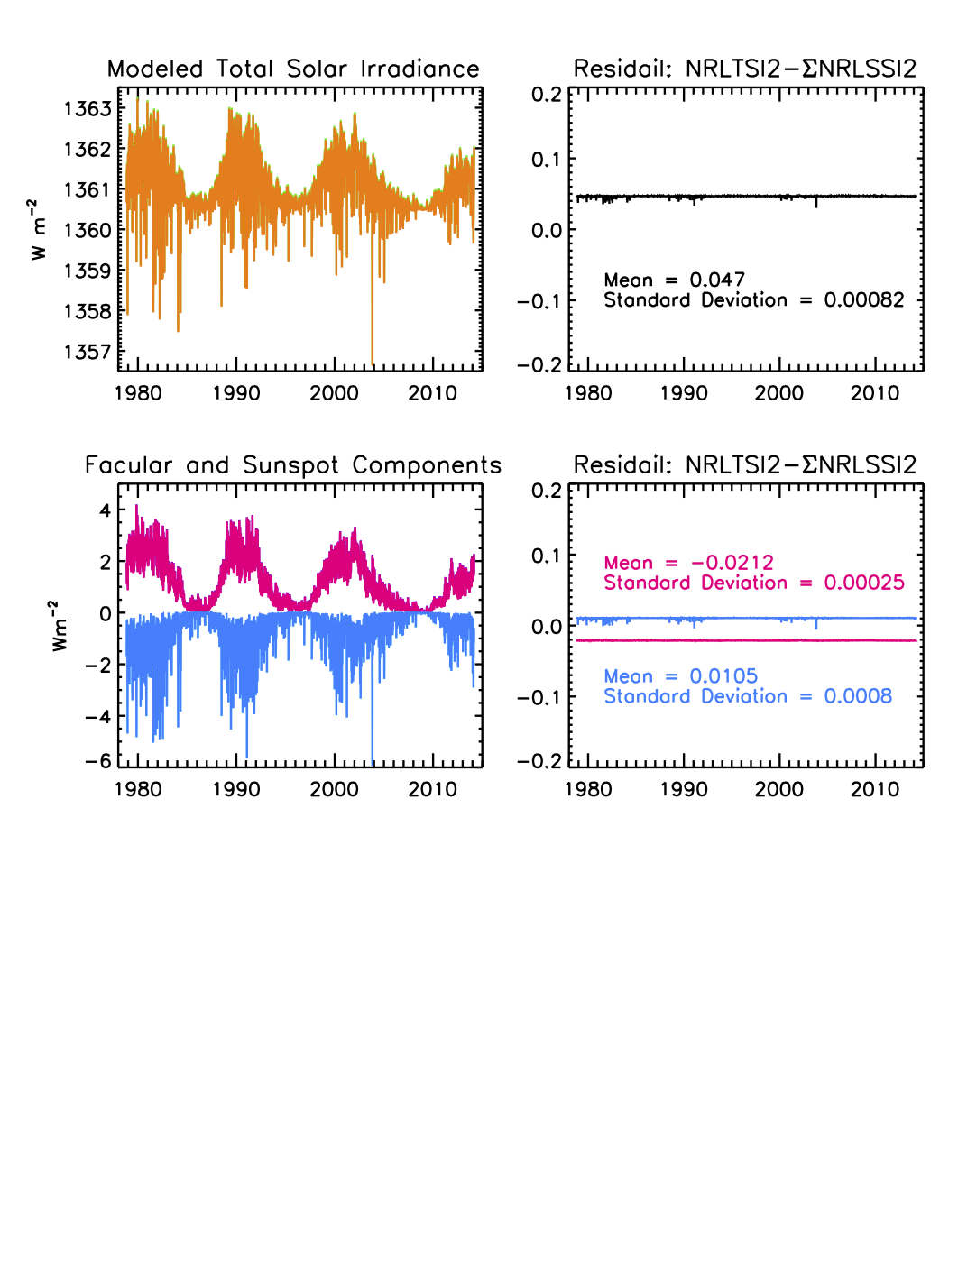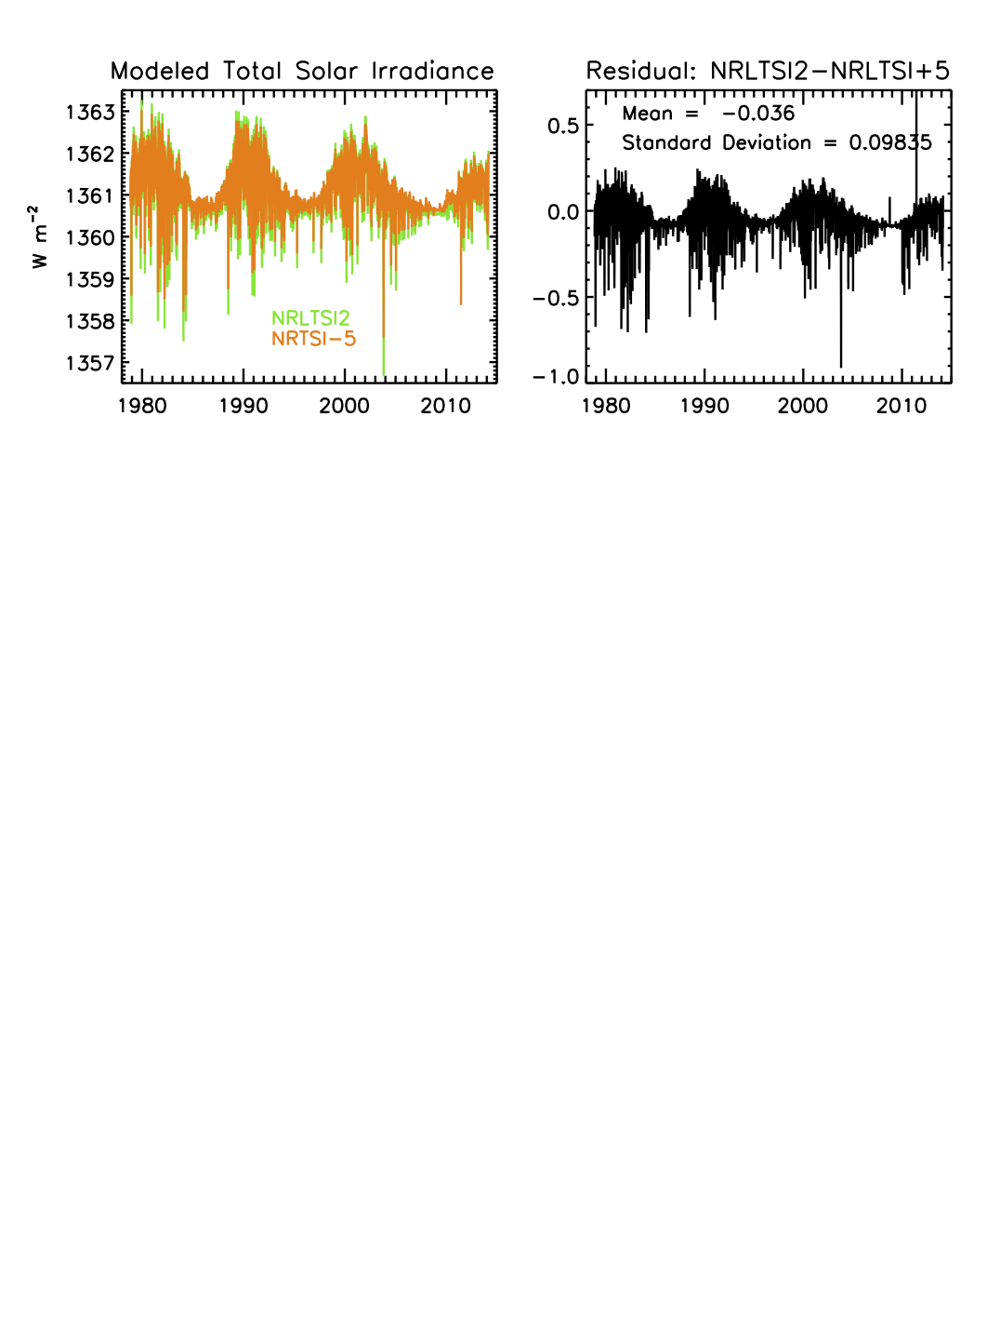

**Figure 9 Comparison of NRLTSI2 total solar irradiance, calculated by the C-ATBD algorithm with an earlier model, NRLTSI.**

**Figure 8 Comparison of NRLTSI2 total irradiance calculated by the C-ATBD algorithm, with the integral of the NRLSSI2 spectra also calculated by the algorithm, upper, and of their respective facular and sunspot components (lower).**

* 1. Test Output Analysis
     1. Reproducibility

The algorithm’s calculation of total and spectral irradiance is 100% numerically reproducible given identical sunspot darkening and facular brightening inputs.

* + 1. Precision and Accuracy

Describe the precision and accuracy expectations for the algorithm, and provide details on how these may be measured.

Numerically, the algorithm itself precisely and accurately calculates the total and spectral irradiance according to the specified sunspot darkening and facular brightening inputs, the baseline (quiet) reference irradiance values and the bolometric and wavelength-dependent scaling factors.

The precision and the accuracy of the derived solar irradiance depend on:

1) uncertainties in the absolute scale of the reference quiet sun values.

2) assumptions used to formulate the basic algorithm equations (see Table 4 for a listing).

3) uncertainties in input facular brightening and sunspot darkening values, including those related to measurements of the indices, and to assumptions about the indices’ representation of facular brightening and sunspot darkening (see Table 4 for a listing).

4) statistical uncertainties on the coefficients used to scale the sunspot and facular inputs to equivalent irradiance increments.

* + 1. Error Budget

Organize the various error estimates into an error budget, presented as a table. Error budget limitations should be explained. Describe prospects for overcoming error budget limitations with future maturation of the algorithm, test data, and error analysis methodology.

The original NRLTSI and NRLSSI values for modeled solar irradiance did not have accompanying error estimates. As part of this work, initial uncertainty estimates, that are independent of time and wavelength, will be computed from the statistical uncertainties of the coefficients used to scale the sunspot and facular inputs to equivalent irradiance increments. Expand

Future work, spurred by this effort to bring the climate data record of solar irradiance from research to operations, is to provide an extended error estimate, including time and wavelength dependencies, to the NRLTSI2 and NRLSSI2 modeled solar irradiance. The future uncertainty estimates will comprise an understanding of the impacts in the assumptions in the algorithm’s theoretical basis and uncertainties in the input facular brightening and sunspot darkening values on the derived solar irradiance (itemized in Table 4). This future understanding will incorporate findings from previous peer-reviewed studies and statistical results from the operational production of the modeled solar irradiance.

Expand/modify.

1. Practical Considerations
   1. Numerical Computation Considerations

Describe how the algorithm is numerically implemented, including any parallelization. Include any possible issues with computationally intensive operations (e.g., large matrix inversions), and any situations that could lead to inaccurate results, exceptions, or infinite loops (e.g., the effects of round-off error on operations involving both very large and very small numbers).

The Solar Irradiance Data Record algorithm uses basic algebra. There are no matrix inversions, extrapolations, or interpolations in the algorithm itself, which is computationally rapid, efficient and repeatable.

The Solar Irradiance Data Record processing will utilize the LASP Time Series Server (LaTiS), an Application Programming Interface that allows software programs to access modeled solar irradiance data sets on LASP’s Interactive Solar Irradiance Datacenter (LISIRD) for a desired time range and for the desired variables. The Solar Irradiance Data Record will also be provided as NetCDF4 data files (Section 3.4.7) and delivered to NOAA NCDC.

The Solar Irradiance Data Record processing system will access data files of sunspot area and location data of individual sunspot active regions present on the solar disk stored at NOAA’s National Geophysical Data Center (NGDC). The automated routine will look for new files daily and download files via ftp to LASPs LISIRD for access by the NRL2 solar irradiance algorithm. New sunspot files are expected to occur roughly weekly with a latency of approximately 2 weeks. The latency is a result of the organization of the sunspot data files by sunspot group number (i.e. not by calendar date) and the time is takes for a sunspot group to rotate off the solar disk.

The Solar Irradiance Data Record processing system will also operationally access the Mg II index record from LASP’s LISIRD with the same underlying LaTiS time series server. Needs updating. I.e. Which Mg II index, a description, and a reference if not elsewhere

* 1. Programming and Procedural Considerations

Describe any important programming and procedural aspects related to implementing the numerical model into operating code. Execution speed optimizations should be included here.

<Enter Text Here>

* 1. Quality Assessment and Diagnostics

Describe how the quality of the output products can be assessed and documented, and how any anomalies can be diagnosed.

The quality assurance (QA) process is a subset of both the science analysis and the data quality assurance. The Solar Irradiance Data Record team oversees this process, which involves a careful examination of all solar and proxy data and judges the reasonableness and quality of the data to be released. The quality assurance takes several different forms: 1) based on the confidence in the calibration and performance of the instruments measuring total and spectral solar irradiance, 2) based on comparison of model output with previous and simultaneous measurements, 3) based on our understanding of the Sun and its variability – an understanding based on solar models and on solar observations at other wavelengths.

The Solar Irradiance Data Record production system supports both automatic and manual diagnostic statistical analyses of the science products. Deviations from expected or predicted values, flagging of anomalous values, and trends of the sunspot blocking function and facular brightening function, as well as final science values, are all incorporated into the assessment of the stability in the final science data products. The Solar Irradiance Data Record team will initially monitor the quality flags in the final science products manually. As the operational implementation of the Solar Irradiance Data Record algorithm matures, the Solar Irradiance Data Record team will move toward automating portions of the quality flag in the final science products; manual monitoring, particularly of the physical representativeness of the facular brightening function and sunspot darkening function, will continue to be necessary to some extent.

A derived relationship between the Mg II index and the F10.7 cm flux (another proxy of chromospheric variability, independent of the Mg II) will be developed to monitor, identify, and flag outliers in the Mg II index value that is used to derive the facular brightening function relative to Quiet sun values. In addition, the time series of sunspot number will be monitored to screen a value of ‘0’ sunspot area as a “negative” result when the cause is missing station data, or a “positive” result when a value of ‘0’ sunspot area is physically plausible at solar minimum conditions with zero sunspot number.

Statistical analysis of the time series of the mean sunspot blocking and facular brightening functions, and their respective variances, will be used to flag potential outliers, alerting the Solar Irradiance Data Record team to investigate the input data sets. The original NRLTSI and NRLSSI models provide robust data sets that will be used to define minimum and maximum ranges of the sunspot darkening and facular brightening functions. Statistical monitoring of the time series of the mean modeled solar irradiance (total and spectral), and their respective variances, will be monitored including near real-time comparison with observations of total and spectral irradiance being made by SORCE, the TSI Transfer Calibration Experiment (TCTE), and the future TSIS instrument suite scheduled to launch to the International Space Station (ISS) in 2017.

Table 4 lists the assumptions in the algorithm. The operational steps to monitor time series of algorithm inputs and the output solar irradiance are also noted.

* 1. Exception Handling

List the complete set of expected exceptions, and describes how they are identified, trapped, and handled.

<Enter Text Here>

* 1. Algorithm Validation

Describe how the algorithm was validated prior to being submitted to the CDR and describe in detail the recommended approach for validation prior to being it being made operational by the CDR Program.

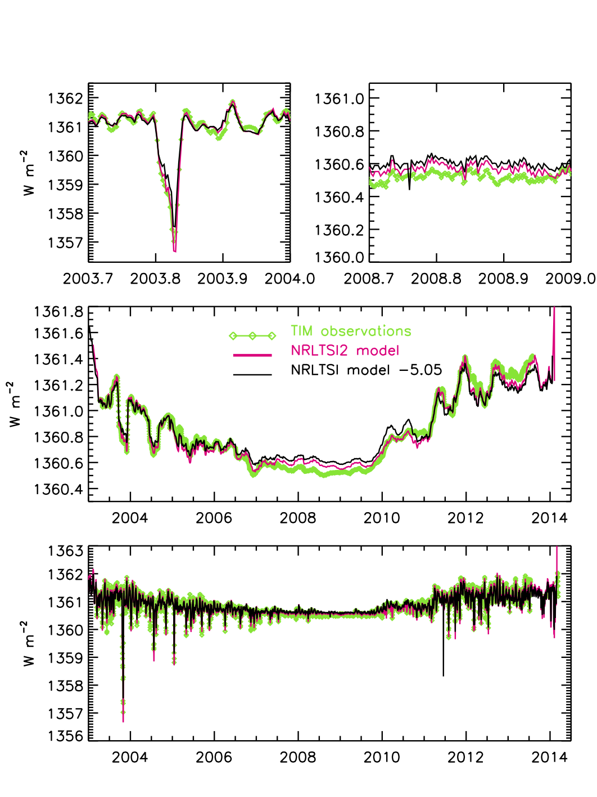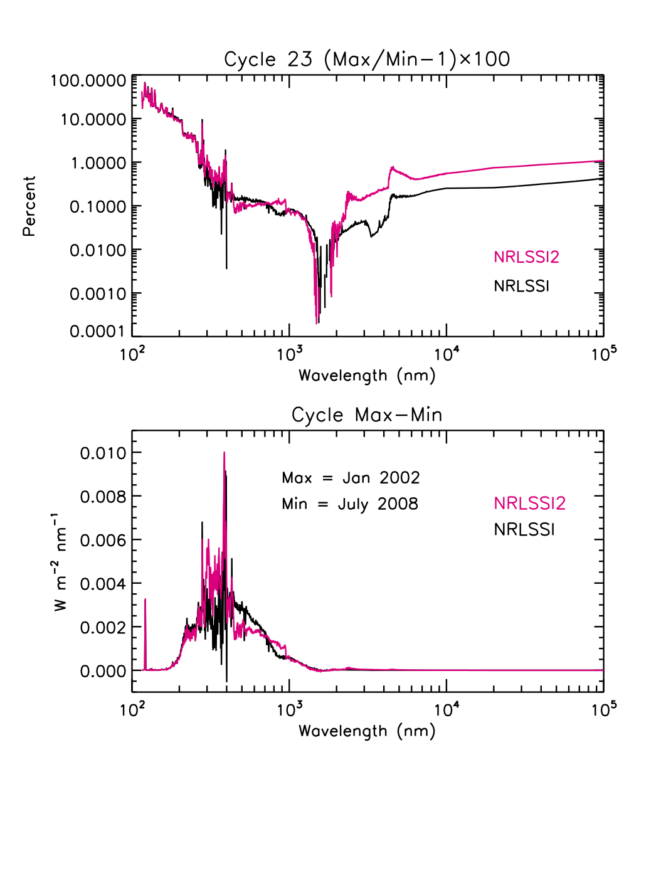In addition to the checks on the algorithm performance, described in Section 4, the algorithm is further validated by comparing the total and solar irradiance times series that it produces with direct observations where available, and with other models of irradiance variability.

**Figure 12 Solar cycle changes shown as percentages (upper) and in energy units (lower) in the NRLSSI2 model, compared with NRLSSI.**

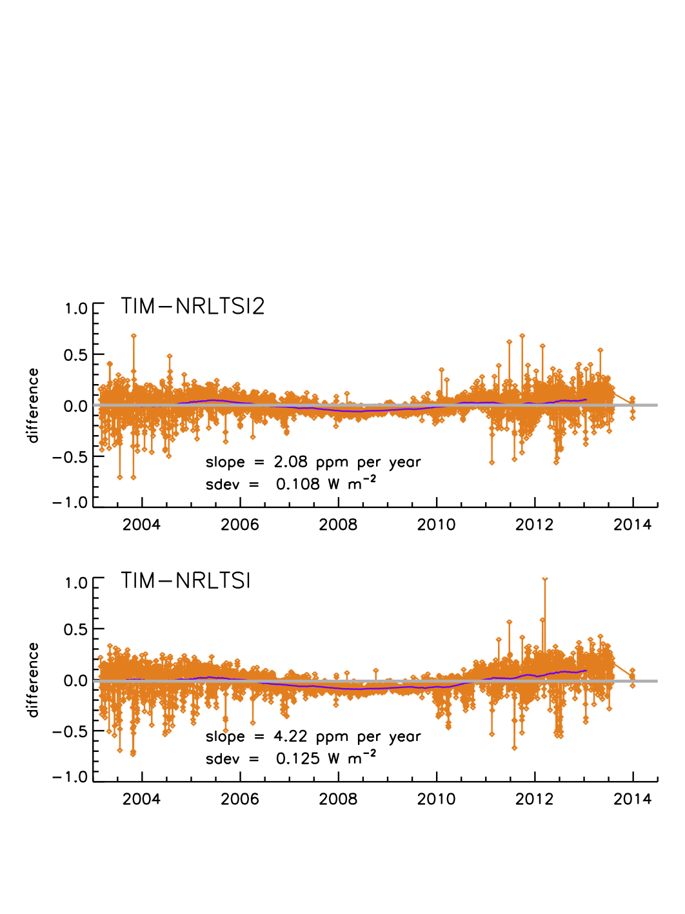

**Figure x. Ratios of NRLTSI2 and NRLTSI models to TIM observations of total solar irradiance variability.**

**Figure x. Comparison modeled total solar irradiance time series with observations made by TIM on SORCE**.

Ongoing efforts: The algorithm validation will be an ongoing effort by the Solar Irradiance Data Team

Compare output from LASP operational system to output from NRL operational system?

Recreate modeled solar irradiance for arbitrary date, and for a range of dates.

* 1. Processing Environment and Resources

Identify the computer hardware, operating system, programming language(s), compilers, external libraries, and their versions that were used to create the data products being submitted. Please also indicate the total CPU and wall clock time that was used, and the amount of temporary storage needed during processing.

1. Assumptions and Limitations

The assumptions in the algorithm’s theoretical basis are detailed in Section 3. Table 4 summarizes these assumptions and the approach, where possible, to monitoring their impacts on the modeled solar irradiance (i.e. validatoin). The accuracy of the modeled solar irradiance also depends on the inputs (facular brightening and sunspot darkening), but the measurements of the indices used to derive these inputs (the Mg II index and sunspot area) have uncertainties themselves. In addition, there are uncertainties in the representativeness to facular brightening and sunspot darkening. Also contributing to the uncertainty in the modeled irradiance, and possibly the easiest to quantify, is how statistical uncertainties in the coefficients obtained by multiple regression of the input indices to the measured solar irradiance (total and spectral) correlate to uncertainty in the modeled solar irradiance (total and spectral).

A number of validation studies have previously been performed (refs). As part of this work, plans to estimate a first-time uncertainty in the NRL modeled solar irradiance will incorporate findings from uncertainty in the multiple regression coefficients and how this correlates to equivalent irradiance increments.

Table : Summary of assumptions in the theoretical basis for modeled solar irradiance, model inputs and the potential validation approaches. Particular validation approaches that can be monitored over time (i.e. statistical) to provide an estimate in the uncertainty in the modeled solar irradiance are labeled ‘*Operational’*.

|  |  |
| --- | --- |
| **Assumptions & Scientific Support/Citation(s)** | **Validation Approach** |
| Adopted value of the Quiet Sun (total and spectral) is invariant (Lean et al., 1998). | Comparison to irradiance measurements at solar minimum conditions. |
| Faculae brightening and sunspot darkening are the only modulators of *contemporary* solar irradiance and their respective impacts on irradiance are represented by linear adjustments of baseline, Quiet Sun, conditions (Lean et al., 1998, 2005; Lean, 2000; Lean and Woods, 2010). | The derived facular and sunspot functions are imperfect indicators of the sunspot darkening and facular brightening sources. Small ‘epsilon’ regression coefficients correct for these differences.   * ***Operational***: Monitor the correlation between contemporary modeled and measured solar irradiance, and the standard deviation of residuals between modeled and measured solar irradiance. * Future improvements in the facular and sunspot functions may enable elimination of the small, but non-zero, correction coefficients. |
| The background, facular brightening at *historical*, longer-term time scales (decade, centennial) is speculated (Lean et al., 1992, 1995, 2000, 2002, 2005; Hoyt and Schatten, 1993; Tapping et al., 2007; Radick et al, 1998; Hall and Lockwood, 2004; Wang et al., 2005) | A plausible magnitude of facular brightening is simulated from a flux-transport model that simulates eruption, transport, and accumulation of magnetic flux from Maunder Minimum to present as a function proportional to sunspot number.   * The effect is 27% lower than estimated in original NRLSSI model. * Monitor circumstantial evidence of facular impacts on irradiance trends:   + Reduction in measured TSI corresponding with disappearance of faculae.   + Variations in chromospheric activity of Sun-like stars.   + Inferences with cosmogenic and geomagnetic indices.   + Inferences with changes in solar structure. |
| The sunspot darkening function can be computed using sunspot areas, heliocentric locations, and number of individual sunspot regions (Allen, 1979; Foukal, 1981; Lean et al., 1998; Brandt, Stix and Weinhart, 1994).   * The relative contrast of sunspots to Quiet Sun irradiance is known with these assumptions:   + The Center-to-limb variance is independent of wavelength.   + Sunspot contrast is independent of position on solar disk and has an experimental bolometric (integrated) value of 0.32 with a dependency on sunspot area.   + Sunspot darkening function is the average of all sunspot areas and locations over the day. | The solar rotation axis, ecliptic plane (beta angle) are known throughout the year and are used to adjust the projection of sunspot areas to the direction of the Earth, as it orbits the Sun.   * Sunspot areas prior to 1976 are corrected for a systematic 20% high bias (measurement error). * ***Operational***: Monitor mean and standard deviation of time series of sunspot darkening function. * ***Operational***: Implement quality flags for the sunspot blocking function. Flag:   + Missing station data   + Duplicate records   + Larger (or smaller) than expected variability. * ***Operational***: Monitor relationship between sunspot areas and sunspot number. If sunspot number is zero, a physically plausible result of sunspot area is 0 (i.e. “positive” result). If sunspot number is non-zero, a physically implausible result is a sunspot area of 0 (i.e.“negative” result). |
| The facular brightening function is a linear function of a flux “proxy” of facular brightening (Lean et al., 1998).   * The Mg II index is a proxy for chromospheric variability, which is an extension of photospheric faculae (Snow et al., 2005). * The Mg II index is (relatively) free of instrumental sensitivity (drifts). | Faculae are poorly observed in solar imagery and inadequately specified.   * ***Operational***: Monitor mean and standard deviation of time series of facular brightening function.   + For single, and multiple (i.e. overlapping in time) instruments. * ***Operational***: Monitor relationship between time series of Mg II index and the F10.7 cm flux. The relationship is expected to be consistent; a deviation is expected to be indicative of outlier in the Mg II record. * ***Operational***: Implement quality flags for facular brightening based on Mg II record. Flag:   + Time gaps   + Larger (or smaller) than expected variability.   + Outliers (when compared to F10.7 cm flux). * Future, reliable and quantitative, observations can be used to define statistical definitions of spectral irradiance changes due to faculae. |
| SORCE TIM measurements from 2003 to 2014 are the total solar irradiance standard used to compute scaling coefficients of facular brightening and sunspot darkening for NRLTSI2 using a multiple linear regression technique.   * TSI of Quiet Sun is 1360.8 ± 0.5 Wm-2 (Kopp and Lean, 2011), based on SORCE TIM measured irradiance at solar minimum. | ***Operational***: Monitor the correlation between contemporary modeled and measured total solar irradiance, and the standard deviation of residuals between modeled and measured total solar irradiance. |
| SORCE SIM measurements contain instrumental trends (Lean and Deland, 2012).   * Prior to application of multiple linear regression technique to observations, the SORCE SIM data is detrended (with 81 day running mean). | Compare wavelength-dependent scaling coefficients of facular brightening and sunspot darkening to their respective theoretical contrasts (ratio of emission to quiescent solar atmosphere).  For λ > 295 nm: Use detrended TSI observations to determine the ratio of SSI multiple regression coefficients from direct observations to the detrended observations (i.e. an adjustment factor).  For λ < 295 nm: Estimate adjustment to detrended multiple regression coefficients using Ca K time series; Ca K is a proxy of chromospheric variability independent of the Mg II index. |

The most probable cause of the algorithm generating incorrect irradiance values lies with the determination of the facular brightening and sunspot darkening indices, which rely on ground- and space-based observations of sunspot active regions and global facular brightness. The accuracy and precision of these ground-based observations is essentially unknown, and spurious inputs could produce unrealistic irradiance values. The algorithms flags input values that are deemed implausible, outside the range of current observed values.

Planned for future versions of the algorithms, are more sophisticated near-real time validation of the sunspot darkening and facular brightening inputs that will aid in securing a more robust algorithm. e.g., comparisons of simultaneous calculations from independent databases.

* 1. Algorithm Performance

There are no assumptions made concerning algorithm performance. The algorithm is designed to compute modeled solar irradiance, using basic algebra, over a user-defined time range, and this input time range can be of arbitrary length. The algorithm is free of matrix inversions, parameter extrapolations, or interpolations, and the execution is rapid (insert running time as a function to the number of steps, or storage locations) and repeatable.

* 1. Sensor Performance

The solar irradiance reconstructions that this C-ATBD describes compliment the direct measurements made of total and spectral solar irradiance by the Total Solar and Spectral Solar Irradiance Sensor (TSIS) instrument, documented in the TSIS ATBD (ref). The TSIS ATBD describes the algorithms used to produce all data levels of solar and spectral irradiance for the TSIS instrument complement, which consists of the Total Irradiance Monitor (TIM) and Spectral Irradiance Monitor (SIM). The TSIS ATBD also describes the predicted science and housekeeping operation modes, measurement error budgets, and the plan to monitor and correct for instrument degradation.

For solar irradiance, variations of less than 0.1% per decade are typical of the kinds of signals that must be extracted from “noisy” time-series measurements. The calibration approach adopted for TSIS characterizes the flight instrument as an “absolute sensor”. This involves characterizing each term in the measurement equation and tabulating a list of individual uncertainties and root sum square errors for overall measurement uncertainty.

***Accuracy and Long-term Stability of the TSIS Instrument Complement***

The TSIS TIM instrument is about three times more accurate than the SORCE TIM due to engineering advances in the optical and electrical sensors and to the end-to-end validation of the radiometer at the TSI Radiometer Facility (TRF) at the Laboratory for Atmospheric and Space Physics (LASP).

Lessons learned from the first-ever measurements of spectral solar irradiance made by the SORCE SIM have been incorporated by TSIS SIM to meet the measurement requirements. The specific TSIS SIM capabilities over SORCE SIM include reduced uncertainties in the prism degradation correction to meet long-term stability requirements, improved noise characteristics of the electrical substitution radiometer (ESR) and photodiode detectors to meet the measurement precision requirement, and improved absolute accuracy through pre-launch calibration using the novel, Spectral Radiometer Facility (SRF) at LASP.

The TSIS TIM will measure 4x daily total solar irradiance with an absolute accuracy of 100 ppm and a relative accuracy of 10 ppm. The TSIS SIM will measure 2x daily solar spectral irradiance at variable resolution from 200-2400 nm with an absolute accuracy of 0.2% (2000 ppm), a relative accuracy of 0.02% (200 ppm), and with long-term relative stability of 0.05% per year (for wavelengths shortward of 400 nm) and 0.01% per year for wavelengths longward of 400 nm.

SORCE SIM data is currently being reanalyzed and its uncertainty estimates may be affected. It has been suggested that the SORCE SIM time series has not been fully corrected for instrument degradation and that the long-term trends are not solely of solar origin (*Lean and Deland*, 2011). To reduce the dependency of the modeled solar spectral irradiance to these potential instrumental trends, the respective coefficients for sunspot darkening and facular brightening are derived from a multiple linear regression technique applied to the sunspot area and Mg II index data, respectively, and the *detrended* (i.e. subtraction of an 81-day running mean) SORCE SIM observations (as described in Section 3.4).

***Degradation Monitoring and Correction of the TSIS Instrument Complement***

The sensitivities of all instruments on TSIS are assumed to degrade as the mission progresses. There are general assumptions that the degradation will be small, that the sensitivity will monotonically decrease with time, and that a primary cause of the decreased sensitivity is related to the exposure to the harsh radiation environment from the Sun. However, there is no guarantee these assumptions will be met and other changes that are strictly time-dependent, or aging effects, must also be considered. The possibility that instrument sensitivity may increase cannot be ruled out, and the degradation analysis does not preclude this condition. That is, the analysis is open to the possibility that aging effects improve sensitivity, or that radiation and exposure may in fact “scrub” surfaces and improve their throughput.

Exposure and time-dependent degradation is a challenging problem and will require refinements throughout the mission as well as considerable analyses effort by the TSIS instrument scientists. In addition, any correction parameterization used initially may need evaluation and modification during the mission. Unexpected changes to the thermal stability of the spacecraft environment may require offsets in the analysis of certain data, and electronics and detector functionality can be impacted by energetic particles in major solar storms. Such impacts may require discontinuous changes in the science product rather than parameterized functions.

The TSIS instrument science team will examine pre-launch characterizations and in-flight calibrations to derive appropriate degradation corrections. The technique used to understand instrument degradation for the TSIS TIM and SIM instruments is to have completely independent instrument channels, to use each channel with a varying duty cycle, and then to compare their observations of the Sun. The degradation in the instruments is assumed to be primarily dependent on the exposure of the optics and detectors to solar radiation. If the exposure times are dramatically different, say one to one hundred, the ratio of the measurements will change with time. With the assumption that exposure-dependent degradation will proceed proportionally faster for the normal channel, an exposure-dependent model of degradation is developed. The TSIS ATBD outlines one proposed model for monitoring and correcting each TSIS SIM observation for degradation.

1. Future Enhancements

Describe potential future enhancements to the algorithm, the limitations they will mitigate, and provide all possible and useful related information and links. This subsection should be organized into separate subsections for each potential enhancement, ordered according to a combination of highest operational priority and greatest feasibility.

Planned for future versions of the algorithms, additional, are more sophisticated near-real time validation of the sunspot darkening and facular brightening inputs will aid in securing a more robust algorithms. e.g., comparisons of simultaneous calculations from independent databases.

* 1. Enhancement 1

Improve sunspot darkening function.

* 1. Enhancement 2

Investigate new Mg indices eg from JPSS

* 1. Enhancement 3

Investigate the need for new scaling coefficients for spectral irradiance, and the relationship of the coefficients derived from detrended versus direct time series, as time series of SSI become available with improved long term stability.

1. References

Include all references cited in the CATBD. References should be listed in alphabetical order. References that begin with an author list should begin with the last name of the lead author. The following examples indicate the preferred style for three common types of references. Use the CDR Reference style to format references.

Brandt and Stenneger

Brandt, P, N., Stix, M., and Wdinhardt, H.: 1994, Solar Phys. 152 (119).

Fligge, M., and Solanki, S. K.: 1997, Solar Phys., 173, 427-439

Foukal 1981

Fröhlich, C et al

Fröhlich, C., and Lean, J.: 2004, Astron. Astrophys. Rev., 12 (4), 273-320, doi: 10.1007/s00159-004-0024-1

Hall and Lockwood 2004

Hudson et al 1980

Kopp, G., and Lean, J. L.: 2011, Geophys. Res. Lett., 38, L01706, doi:10.1029/2010GL045777 2011

Kurucz, R.L.: 1991, The University of Arizona Press, Tucson, pp. 663-669

Lean, J., Skumanich, A., and White, O. R.: 1992. Geophys. Res. Lett., 19, 1591-1495

Lean, J., Beer, J., and Bradley, R.: 1995, Geophys. Res. Lett., 22, 3195-3198

Lean, J. L., Rottman, G.J., Kyle, H.L., Woods, T.N., Hickey, J.R., and Puga, L.C.: 1997, J. Geophys. Res., 102, 29939-29956

Lean, J.L., Cook, J., Marquette, W., and Johannesson, A.: 1998, Astrophys. J., 492, 390-401

Lean, J.L., White, O.R., Livingston, W.C., and Picone, J.M.: 2001, J. Geophys. Res., 106, 10,645-10,658

Lean, Judith: 2000, Geophys. Res. Lett., 27, 2425-2428

Lean, J., Rottman, G., Harder, J., and Kopp, G.: 2005, Solar Phys., 230, 27-53, DOI: 10.1007/s11207-005-1527-2

Lean, J., Wang, Y.-M., and Sheeley, Jr., N. R.: 2002, Geophys. Res. Lett., 29, doi:10.1029/2002GL015880

Lean, Judith L., and Woods, Thomas N.: 2010, in Evolving Solar Physics and the Climates of Earth and Space, Karel Schrijver and George Siscoe (Eds), Cambridge Univ. Press

Lean and DeLand 2011

Lean, J. L., and Deland, M. T.: 2012, J. Climate, 25, 2555-2560, doi: http://dx.doi.org/10.1175/JCLI-D-11-00571.1.

Radick et al 1998

Rottman, G.J.: 2000, Space Sci. Rev., 94 (1-2), 83-91, DOI: 10.1023/A:1026786315718

Rottman, G. J.: 2005, Solar Phys., 230, 7-25, DOI: 10.1007/ s11207-005-8112-6

Snow, M., McClintock, W. E., Woods, T. N., White, O. R., Harder, J. W., and Rottman, G,: 2005, Solar Phys., 230, 325-344.

Tapping, K. F., Boteler, D., Charbonneau, P., Crouch, A., Manson, A., and Paquette, H.: 2007, Sol. Phys., 246, 309–326, doi:10.1007/s112070079047x

Thuillier, G., Hersé, M., Simon, P.C., Labs, D., Mandel, H., Gillotay, D, and Foujols, T.: 1998, Solar Phys., 177, 41-61

Thuillier, G., Melo, S. M. L., Lean, J. L, Krivova, N. A., Bolduc, C., Fomichev, V. I., Charbonneau, P., Shapiro, A. I., Schmutz, W., and Bolsée, D.: 2013, Solar Phys., doi:10.1007/s11207-013-0381-x.

Unruh, Y.C., Solanki, S. K. and Fligge, M.: 2000, Space Sci. Rev., 94 (1-2), 145-152, DOI: 10.1023/A:1026758904332

Wang, Y.-M., Lean, J. L., and Sheeley, Jr., N. R.: 2005, Astrophys. J., 625, 522–538

Woods et al., 2009 WHI spectrum

1. Acronyms and Abbreviations

|  |  |
| --- | --- |
| Acronym or Abbreviation | Meaning |
| λ | Lambda; wavelength (nm) |
| μ | Heliographic position |
| AA index | Magnetic activity index |
| ACRIM | Active Cavity Radiometer Irradiance Monitor |
| C-ATBD | Climate Algorithm Theoretical Basis Document |
| Ca K | Calcium Potassium (emission line of the Sun) |
| CDR | Climate Data Record |
| F(t) | Facular Brightening Function (time-dependent) |
| F10.7 | Solar flux at 10.7 cm |
| GOME | Global Ozone Monitoring Experiment |
| GOME-2 | Global Ozone Monitoring Experiment 2 |
| I(t) | Solar Spectral Irradiance (time-dependent) |
| IQ | Solar Spectral Irradiance of the Quiet Sun |
| ISS | International Space Station |
| LASP | Laboratory for Atmospheric and Space Physics |
| LISIRD | LASP Interactive Solar Irradiance Data Center |
| m | meter |
| Mg II | Magnesium II index |
| MDI | Michelson Doppler Imager |
| NCDC | National Climatic Data Center |
| netCDF4 | Network Common Data Format |
| NOAA | National Oceanographic and Atmospheric Administration |
| NGDC | NOAA National Geophysical Data Center |
| NRL | Naval Research Laboratory |
| NRLSSI | Naval Research Laboratory Solar Spectral Irradiance model (original) |
| NRLSSI | Naval Research Laboratory Solar Spectral Irradiance model (version 2) |
| NRLTSI | Naval Research Laboratory Total Solar Irradiance model (original) |
| NRLTSI2 | Naval Research Laboratory Total Solar Irradiance model (version 2) |
| nm | nanometer |
| NOAA | National Oceanic and Atmospheric Administration |
| PMOD | Physikalisch-Meteorologisches Observatorium Davos |
| ppm | Part per million |
| QA | Quality Assurance (Analysis) |
| R | Radiance |
| S(t) | Sunspot Darkening Function (time-dependent) |
| SCIAMACHY | SCanning Imaging Absorption SpectroMeter for Atmospheric CHartographY |
| SIM | Spectral Irradiance Monitor |
| SMM | Solar Maximum Mission |
| SOHO | Solar and Heliospheric Observatory |
| SOLSTICE | Solar Stellar Intercomparison Experiment |
| SOON | Solar Observing Optical Network (US Air Force) |
| SORCE | Solar Radiation and Climate Experiment |
| SRF | Spectral Radiometer Facility (LASP) |
| SSD | Space Science Division (Naval Research Laboratory, Washington, DC) |
| SSI | Solar Spectral Irradiance |
| T(t) | Total Solar Irradiance (time-dependent) |
| TQ | Total Solar Irradiance of the Quiet Sun |
| TCTE | TSI Transfer Calibration Experiment |
| TIM | Total Irradiance Monitor |
| TRF | TSI Radiometer Facility (LASP) |
| TSI | Total Solar Irradiance |
| TSIS | Total and Spectral Solar Irradiance Sensor |
| UARS | Upper Atmosphere Research Satellite |
| UV | ultraviolet |
| W | Watt |