Error propagation for NRLTSI2 and NRLSSI2 models (examples are given for SSI, but are applicable to TSI, without the wavelength component).

General Error propagation equation (from Taylor, 1982).

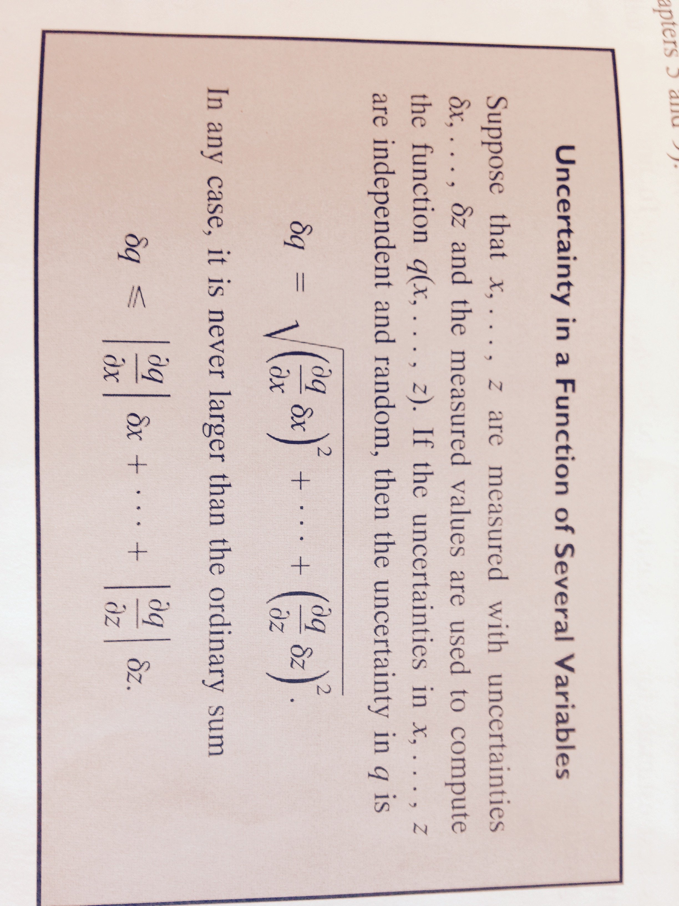

Case 1: Averaged Irradiance over time (for example, a reference “solar max” irradiance obtained by averaging over 1 month of days)

Avg. SSI (λ) =

Uncertainty in the average SSI (λ) = (for case of random, independent uncertainties in the daily irradiance values)

Case 2: Differences of Averaged Irradiance (for example, taking the difference of a reference “solar max” irradiance obtained by averaging over 1 month of days from a reference “solar min” irradiance obtained by averaging over a different time period)

Difference of Avg. SSI (λ) = - ;where N is the number of days used in the solar max time average and M is the number of days used in the solar min time average.

Uncertainty in the difference of the averaged SSI(λ) values:

Step 1: Compute individual uncertainties (δ’s) as in Case 1 for solar max period and for solar min period

Step 2: Compute uncertainty in the differenced quantities as follows:

Uncertainty in the differences of the Avg. SSI (λ) =

Example: Irradiance difference of the Average SSI max (from time period ‘2013-01-11’ to ‘2013-01-22’) and the Average SSI min (from time period ‘2008-11-28’ to ‘2008-12-23’)

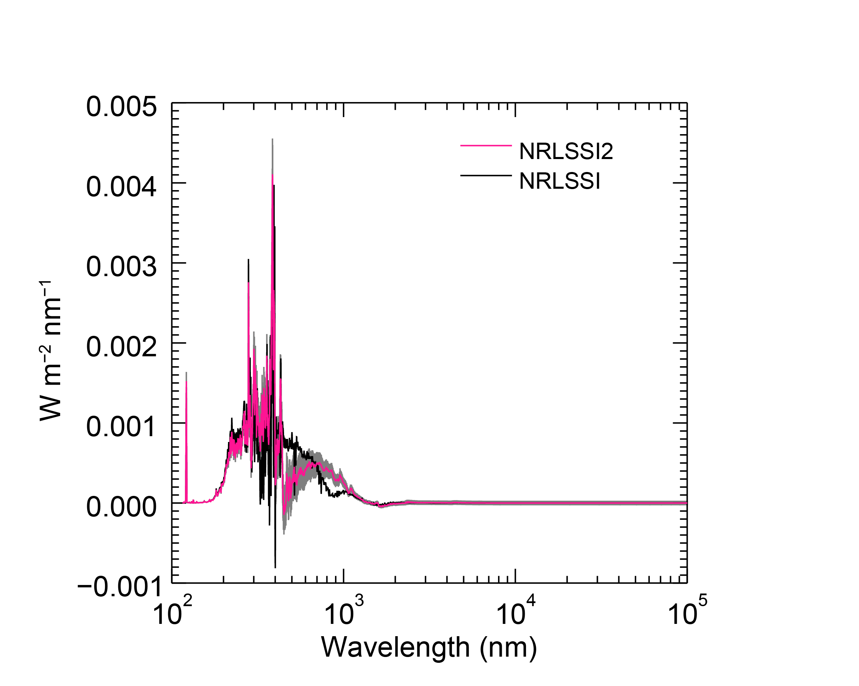

Figure : Comparison of solar cycle energy change in NRLSSI2 (with associated uncertainties) and NRLSSI1. Uncertainties computed using the error propagation described in Case 2.

Case 3: Ratios of Averaged Irradiance (for example, computing the solar cycle irradiance change in energy units)

Irradiance change (in energy units) = SC = (max/min – 1)\*100%

Uncertainty in irradiance change (in percent) =

where and

is the uncertainty in the averaged irradiance for solar max conditions (i.e. following Case 1 example)

and

= and

is the uncertainty in the averaged irradiance for solar min conditions (i.e. following Case 1 example)

Therefore, Uncertainty in irradiance change (in percent) =

Example: Energy Change (max/min -1 (%)) i.e. the ratio of the Average SSI max (from time period ‘2013-01-11’ to ‘2013-01-22’) and the Average SSI min (from time period ‘2008-11-28’ to ‘2008-12-23’) (then subtract 1 and take percentage).

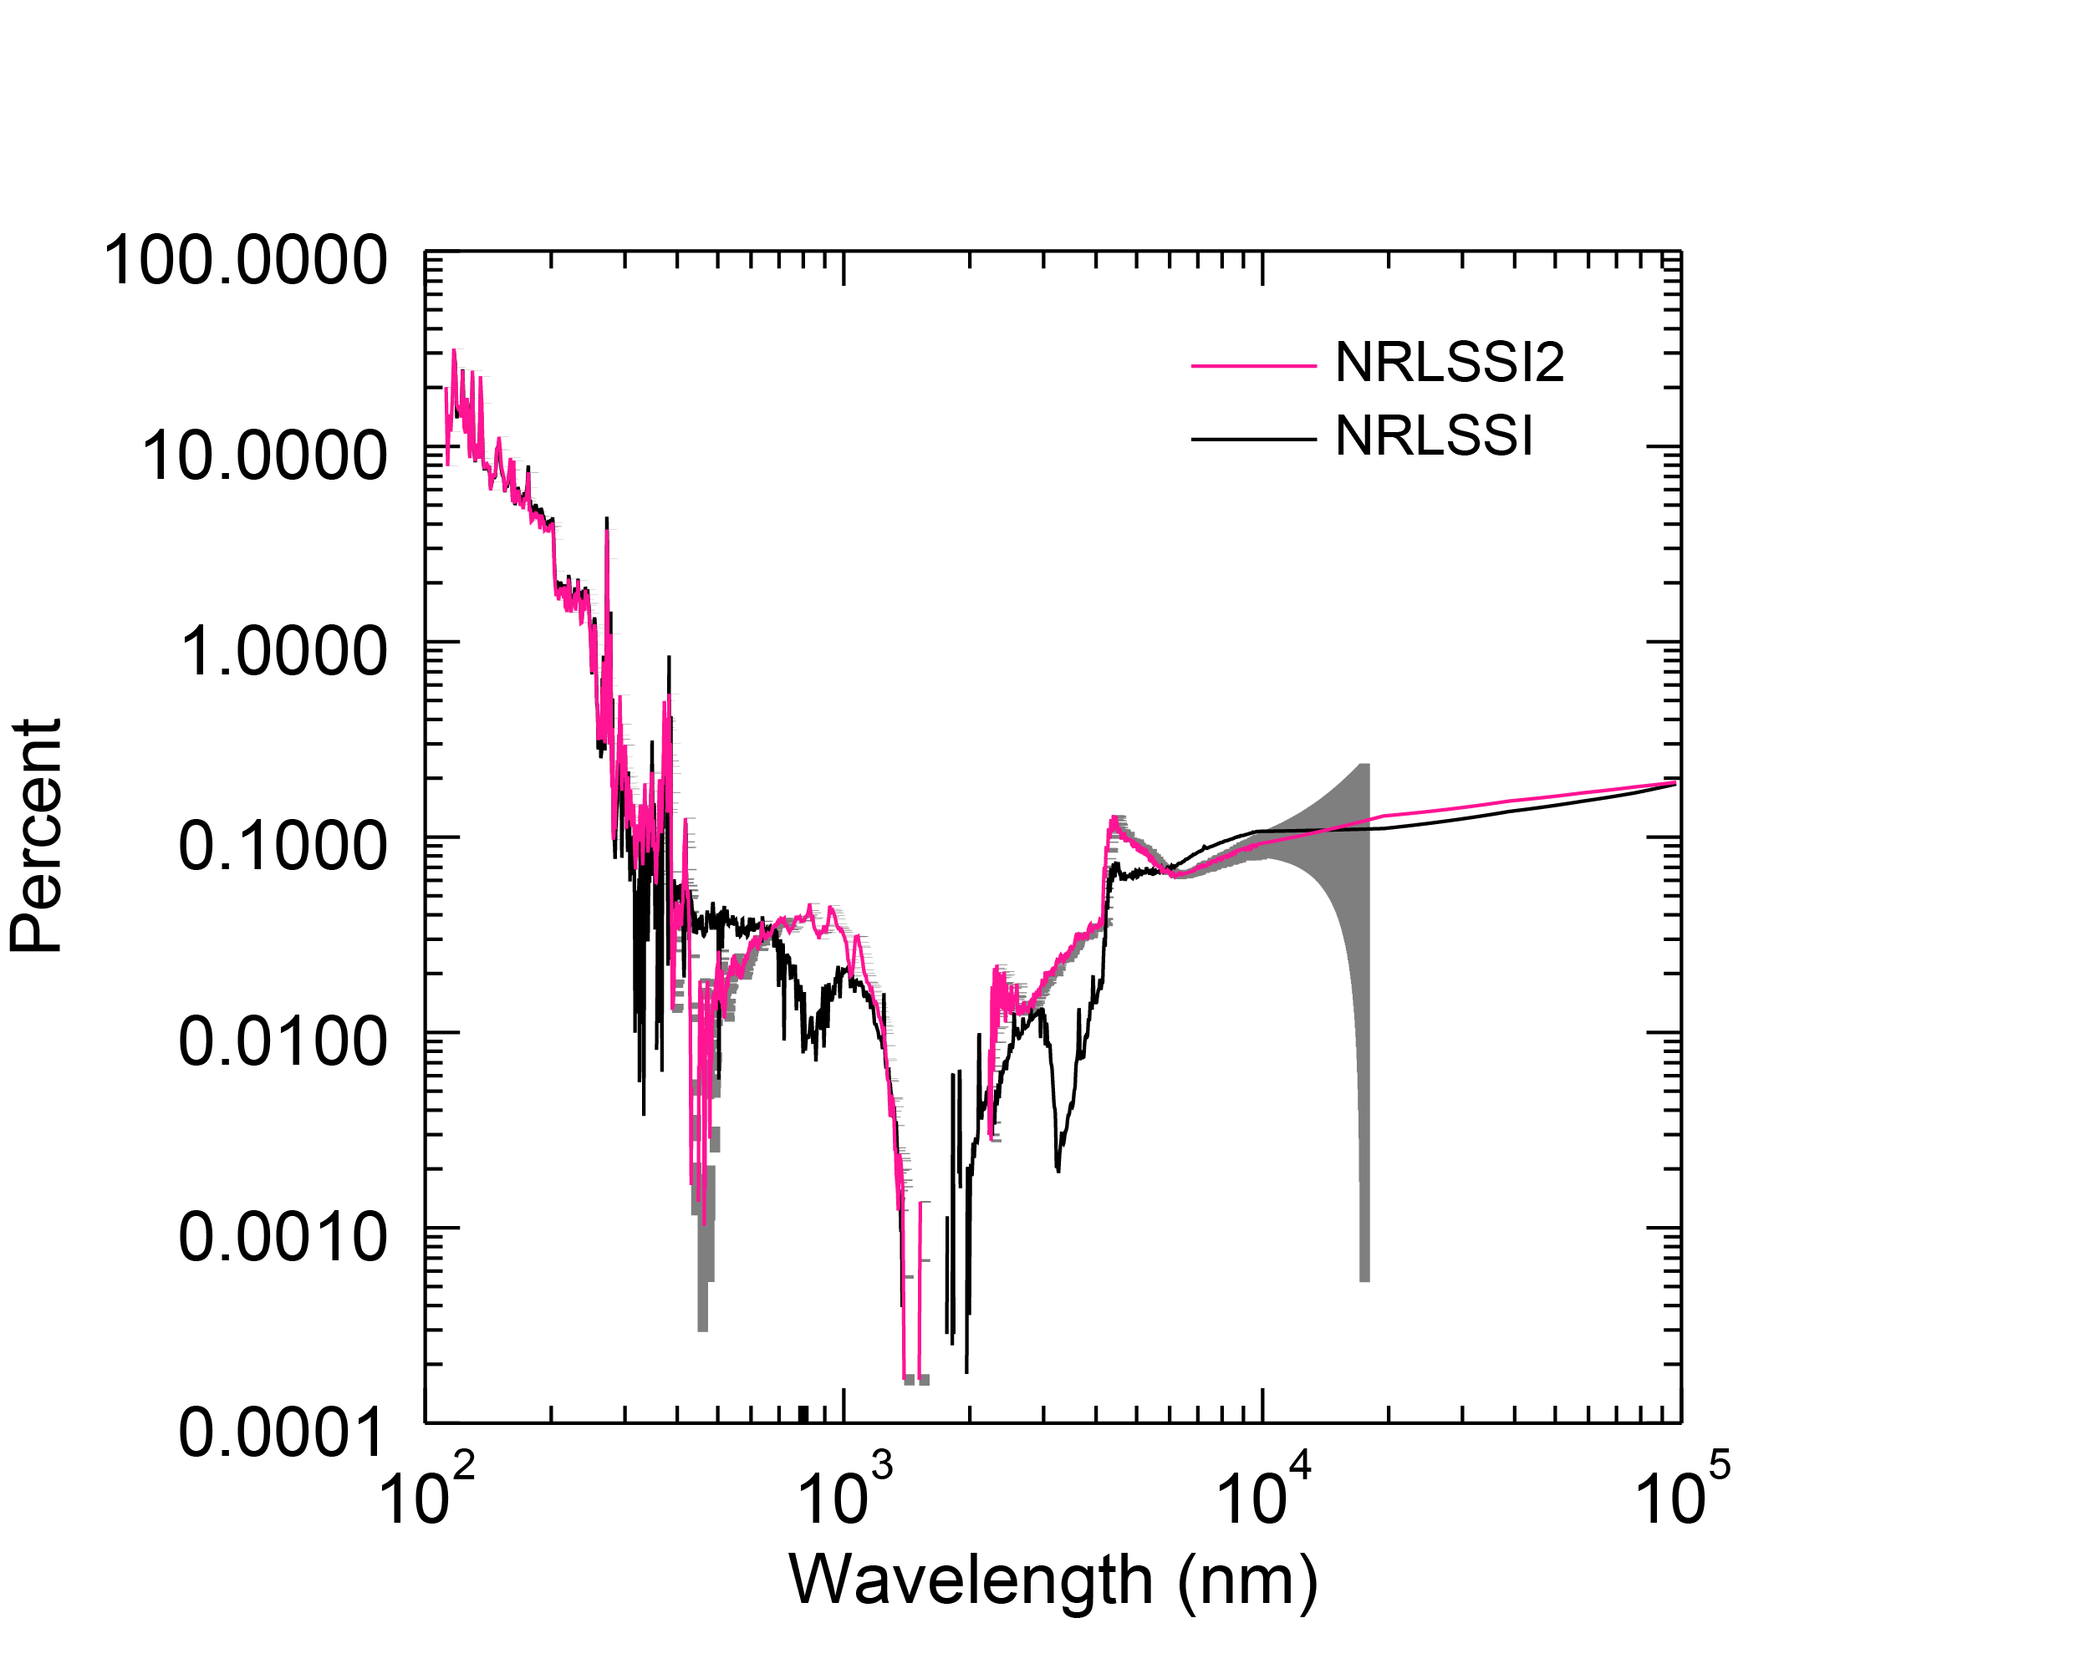

Figure Comparison of solar cycle energy change in Figure 1, but shown in percent (max/min-1 (%)) in NRLSSI2 (with associated uncertainties) and NRLSSI1. Uncertainties computed using the error propagation described in Case 3.