RPn Architecture Specification

- Motivation

After a successful experience with a pure JAVA beta release of RPn we have evolved to a more flexible proposal in order to promote a more productive development experience to numerics layer programmers.

- Architecture overview

The majority of programmers developping numerical components are Mathematicians and they are not fluent JAVA programmers. In order to overcome this limitation we first proposed the hybrid solution having a JNI cut in the architecture enabling a native numerics layer. This first solution is now being adjusted in order to have a completely native numerics layer (other than just the numerics physics model functions as we first imagined) where calculations are demanded from a pure JAVA visualization and control layer :

Geometry (Rn)

CONTROLS
Aplication Layer
contains
User

Conceptual Model Elements (Data Module)
VIEW contains

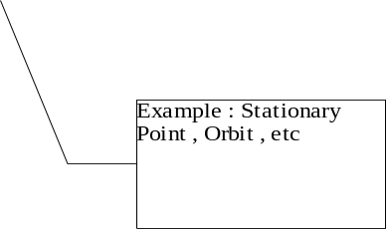

DATA TRANSFER

JNI (C++ to/from Java communication layer)

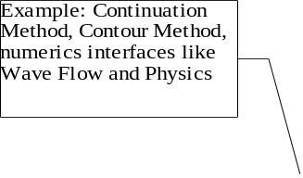

DATA TRANSFER
Numerics Methods and Conceptual
Elements (Function Model)

C/C++ (numeric layer)

contains contains
EDO

Numerics Packages
uses

  - Visualization and Control Layer :

- pure JAVA layer
- user interaction code
- requests calculations for the model elements construction

  - RPn semantics Translation Layer :

- Visualization and Control / Numerics communication layer
- takes the results from numerics layer and build objects that application layer can use using RPn semantics

  - Numeric Layer :

- low level calculations layer
- semantics here are as raw as possible (primitive types)

- Detailed description of architecture elements

  - Conceptual Model JAVA interfaces
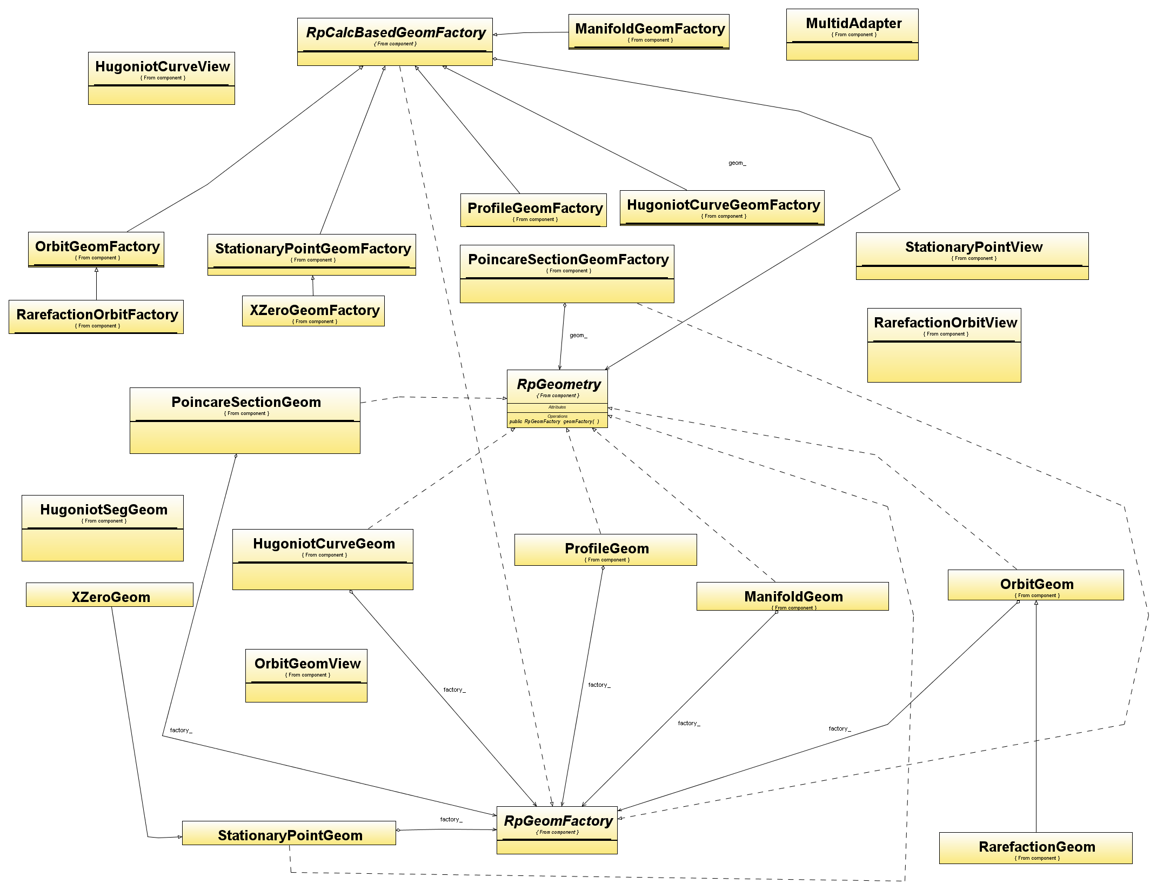

  - The Design of the translation JNI layer

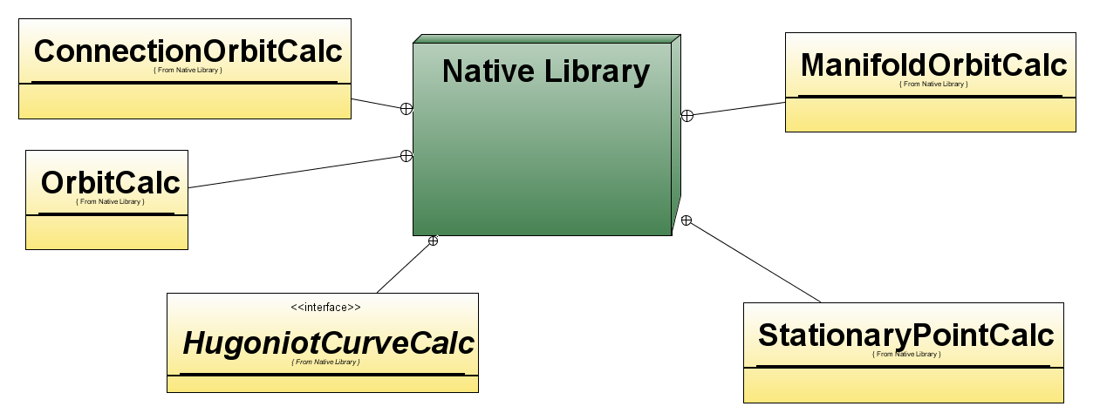

  - Conceptual Model C++ interfaces
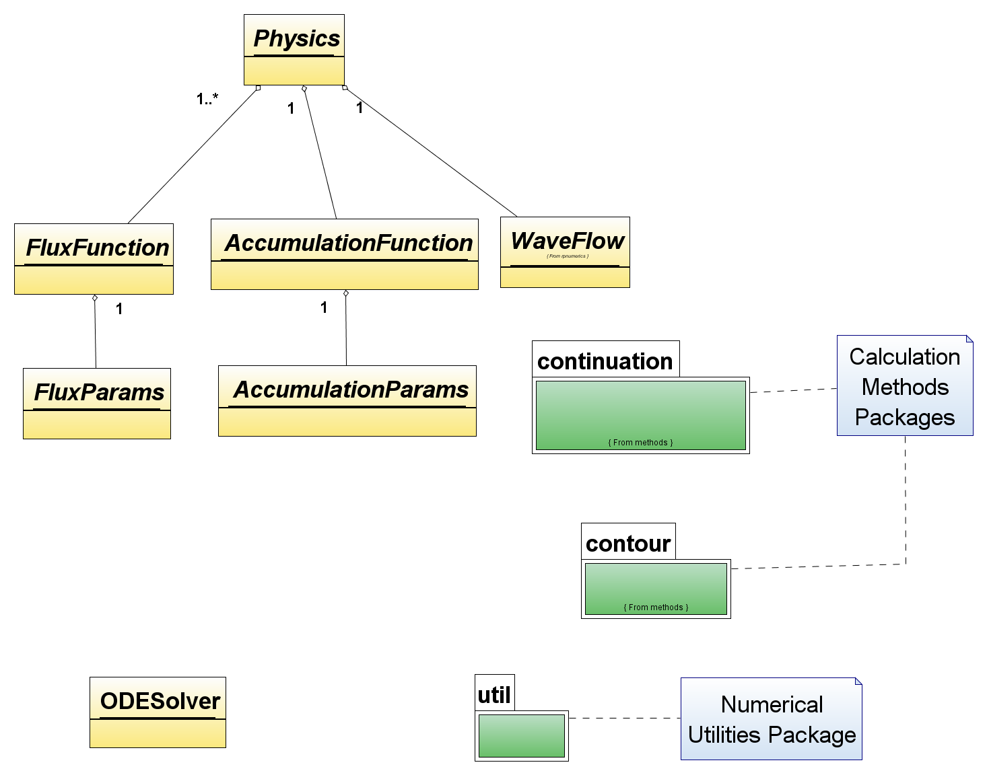

  - ODE Solver
  - Numeric utilities
    - NewMat

- Conclusion

Our expectations with this proposal is to promote a long standing development environment for the RPn project bridging the gap between Mathematics and Software Development domains so that development efforts can be optmized and the overall programming experience more effective.

