(Box In Japanese)
Overview:
The aim of the game is to be the last man standing. To do this you must capture the Time Dilation Device [TDD] long enough to outlast the other players. Each player will start with 120 seconds at the end of this time they will die. The TDD will pause your personal countdown timer of 120 seconds.
Other players will compete with you for the TDD. Players can die by falling into traps or falling too far down the level. The level will be 3D but displayed in a 2D view side on to the level.
There will be no weapons however players can attack each other and push each other off objects. If the player holding the TDD is attacked he will fall to the ground for 2 seconds allowing other players to make a quick exit the the TDD. Alternatively the player holding the TDD can just run away from other players and wait out the countdown.
Scattered across the level there will be time pickups that will increase players' time if picked up.
On every level there will be at least one rotation switch. If this is activated the level will randomly rotate. After the level is rotated players will be able to control their fall to some extent. They will take damage if they fall on something nasty.

Player Balancing:
The only difference between players will be if they are a male or female character model and their colour. Character hit boxes will BE THE SAME. Players choose either male or female and will be assigned a predefined colour. These changes will not effect the handling of the character in any way so players will have to depend on their skill to beat one another. These changes are only to distinguish the individual players.
The level will be designed in a way that positions the TDD equal amount of units away from each player at the start of each level so there will be an equal amount of chance to acquire it.When the level is rotated players will be able to control their fall. Players will start to fall after level is completely rotated.
Rotation:
Players will need to active the rotation switches by being in contact with them for a total of 3 seconds. When the switches are activated the level will rotate randomly 90, 180 or 270 degrees clockwise or counter clockwise. The rotation switches are small green buttons located in the middle of each wall.
Platforms will be located with an even amount of mass on either side of the unit edge to ensure that when the level is rotated it will still be playable.
Time:
Players health will not be measured with a health bar but instead a time bar. The fuller the time bar the more time the players has left and the more empty the bar is the less time the player has left. When the bar is totally diminished this means the player has run out of life and he or she will explode.
Players have 5 sticks of dynamite strapped to the front of them. A players dynamite countdown timer will start at 120 seconds but can be increased by time pickups of 10 seconds. Players can lose health by just the gradual progress of time or by physical damage. Traps that don't kill you instantly will take off up to 30 seconds damage.
Player falls 4 units and below = No damage.
Player falls 5 units = 5 seconds damage.
Player falls 6 units = 6 seconds damage.
Player falls 7 units = 7 seconds damage.
Player falls 8 units = 8 seconds damage.
Player falls 9 units = 9 seconds damage.
Player falls 10 units = 10 seconds damage.
Player falls 11 units and above = 15 seconds damage.

Units:
Units are part of the games' scale. A character will be half a unit tall. He will be able to jump 1 and a half units vertically and 1 unit horizontally. A player can double jump up to 2 units. Characters will take 2 steps to travel a units width and this will take 1 second.
Units are part of a grid that the platforms will be placed on. A platform can be placed horizontally or vertically on the edge of any unit and no matter what direction the level is rotated it will still be playable.

Animations Needed:
Run
Jump
Double jump
Jump pad jump
Attack
Push other player
Collision
Falling

Deaths will be done using ragdoll and animation blending.
Game Items Purposes:
Female Character Model and Male Character Model:
These are of course the models that players will control. When players die they will no longer be in control of the characters. The character models will bounce around using physics. When the levels are rotated the characters will rotate with the level then fall down in a fall that the players will be able to control.

TDD:
This device will pause players' time countdown. It will be spawned into levels an equal amount of units away from each player so the chance of acquiring it is balanced. This object will not have physics but will be a fixed part of the level until someone picks it up. If the TDD is then dropped it will stay at the position where it was dropped. If a player falls into a trap and dies the TDD will bounce out of the trap and land next to the trap.
The player holding the TDD will have an aura around them in their chosen player colour.

Time Pickups:
Time Pickups are almost like a med pack. They increase the players health [time]. They will come in three varieties. 5 seconds, 10 seconds and 15 seconds. These will be colour coded so players can distinguish between them.

Slow-Motion Pickup:
This pickup will have an obvious purpose. It will slow down other players while the player holding the pickup will maintain normal speed. The pickup will not affect the entire level. It will have a radius of 4 units shown as a bubble around the player. Other players outside this bubble will not be affected be the pickup. The Slow-Motion Pickup will last for a total of 25 seconds. The countdown timer of the player holding the Slow-Motion Pickup will not be slowed down at all.

Spiked Floor Tiles, Electric Floor Tiles and Spike Balls [Traps]:
Spiked Floor Tiles are a spike trap that will rest on the floor. These traps will not kill you if you fall on them they will however take off 30 seconds of time.

Electric Floor Tiles are also trap that will rest on the floor. They will a slightly different colour from the rest of the floor tiles and will occasionally spawn a shower of sparks. If players fall on these traps they will die instantly.

Spike Balls are big spiky balls that will roll around the level killing players if they are squashed by them. They will often be contained in one area. An area the players need to go in.

Jump Pads:
Jump Pads are what the name suggests: Jump pads. They will propel the player up 5 units.
Pretty Stuff:
1500-2000 polygons will be allocated for each player with normal maps. 5000 - 15000 will be allocated for the level along with normal maps. Assets will be no more than 500 polygons and will have one 256x256 texture. Textures will be one 512x512 maps per player character and one 1024x1024 for level. The GUI/HUD & menu will have a limit of 5000 polygons with a two 1024x1024 textures.

Game Engine & Plugins:

The game will be played on a single PC, with input coming from the keyboard and/or joystick(s). The open source engine Ogre3D will be used for graphics in conjunction with OIS for input, OpenAL for audio and Ageia PhysX for physics.

Music & Sound Effects:
Music will be a mix of light rock and techno. We are hoping to rope a local band into helping us. Hopefully there will be 10 songs about 2 minutes and 20 seconds long each & they will be cued randomly repeating when all of them have been played. Sound effects will be no more than 5 seconds long and as follows:

When the TDD is picked up.
When the TDD is dropped.
When Time is picked up.
When Time spawns.
When players spawn.
When Slow-Motion power up it picked up.
Electricity.
Player dieing.
Player being impaled.
Player hitting the ground from a long fall.
Player attacking another player.
Player running out of time.
All sounds and music will be ogg vorbis format.

Tools:
The game will have a simple level editor which will allow artists to drag and drop game elements onto the screen and create level of varying sizes.

The Menu:
The keys to be used will be mouse and left click or direction keys and select. Please click here for menu flow.
Camera & Character Movement:
The camera will be mainly fixed but shake if someone falls too far or the TDD is dropped.
Characters will move with arrows and have a button each for jump and attack. Level transitions will involve a cube which has a screen shot of each level per side and as the camera zooms out the cube will rotate to show the next level and will then zoom in and continue the match.

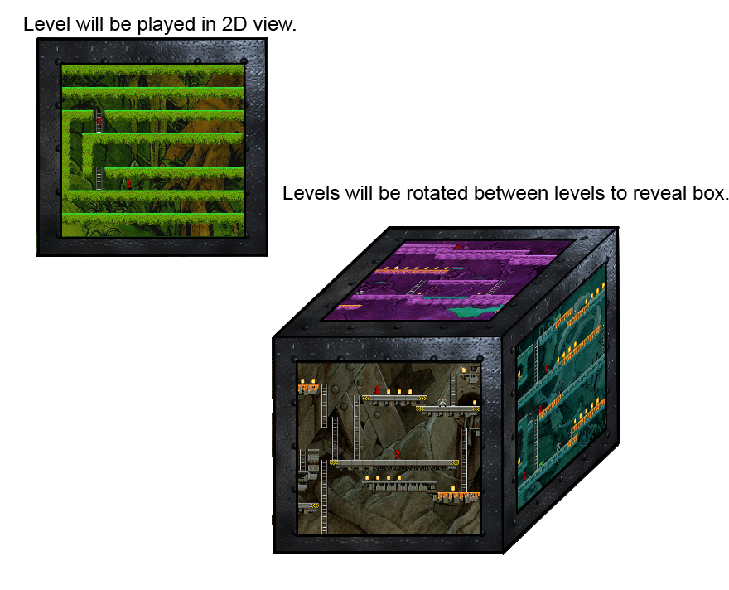

GUI/HUD:
The GUI will be minimal and simple to keep the main focus on game play. Time bars will also change to the colour that the player has selected to be.

Naming Convention:
All files will have our game name followed by an underscore then their type [assets, characters, sounds, textures] followed by another underscore then what the object is.
Example:

sajiki_textures_femalecharacter

Scale:
As mentioned above player models will be half a unit tall. They will also be approximately a 3rd of a unit across. The floor tiles will also be a 3rd of a unit across. For example if a unit is 9cm by 9cm a single floor tile will be 3cm across.

File Types:
All files will be in the ogre format of:
.mesh ~ The Polygons of models
.skeleton ~ The bone rig and animation
.material ~ A material script describing the textured and how they are to be displayed. This can also load shaders and basic texture animations.
Story:
You are a young Mu-shi Warrior competing for the right to serve in the Emperors’ army. This great honor is sought after by many and many have died trying to attain it. Thousands of years into our future these mighty warriors fight in the cube like arena called Sajiki. Pausing time and defying gravity to stay alive, they fight to the death.
Game Play Description:
DefaultPlayer01 spawns into the level. The Time Dilatation Device (TDD) is three platforms above him and to his left. There is a spike trap on his right and beyond that is a rotation switch and a lava trap is below him. The round stars and the countdowns begin. DefaultPlayer01 starts by running 5 units to his left then jumping up to the next level of platforms one unit up and one unit across. He then continues to run left for three units which takes him to the rotation switch. He stands there for a total of three seconds waiting for the switch to activate. The switch is activated and the level rotates counter clockwise 180 degrees. DefaultPlayer01 falls down a total of 4 units taking no damage for his fall. The TDD falls a total of 3 units landing it five units to DefaultPlayer01’s left and right next to the player Frank. Frank picks up the TDD pausing his countdown at 99 seconds. DefaultPlayer01 chases Frank to the left 3 units where Frank jumps down onto the platforms below them and runs to the right 2 units with DefaultPlayer01 chasing him. Frank falls down 2 units to the ground level taking no damage for his fall. Frank runs 1 unit to the right to find player Polka-dot standing on the rotation switch. The rotation switch is activated and the level rotates clockwise 90 degrees. All the player fall down 6 units to the ground level each taking 6 seconds damage. Frank runs to the right 6 units still holding the TDD with DefaultPlayer01 and Polka-dot chasing him. DefaultPlayer01 stops running standing on top of the rotation switch while Frank and Polka-dot continue to run a further 3 units. The switch is activated and the level rotates 180 degrees counter clockwise. Polka-dot falls down 2 units taking no damage for her fall. DefaultPlayer01 falls down 5 units taking 5 seconds damage for his fall. Frank falls down 2 units into a pool of lava and is killed. The TDD re-spawns next to the pool of lava and Polka-dot picks it up pausing her time on 76 seconds. DefaultPlayer01 runs to his left one unit while Polka-dot runs to the edge of her platform and falls down 3 units next to DefaultPlayer01 taking no damage for her fall. DefaultPlayer01 attacks Polka-dot. He wins combat and takes the TDD off Polka-dot rendering her immobilized for 2 seconds pausing his time at 56 seconds. DefaultPlayer01 run off along the platform jumping a gap that Polka-dot forgets to jump. She falls down into a pool of lava which kills her, making DefaultPlayer01 the winner.
The level spins around to reveal the next level and they start again.
After a lot of time of breath holding and 5 crazy rounds the final leader board is shown with Frank at the top with 5 points, DefaultPlayer01 with 1 points and Polka-dot coming in with a courageous 0. There is much victorious celebrating on Frank's behalf and the menu slowly fades in as the game ends.

