SRU Class Scheduler

Testing

Monday, April 25, 2022

Name: Dean Lisko, Autumn Kriebel, Katherine Settle

Date Completed: April 25, 2022

Table of Contents

Testing Plan 3

Overview of Testing 3

Instructions 3

Human Factor Testing 4

Starting the program 4

Selecting Excel File 4

Checking Error Log 4

Changing Classroom Information 5

Adding a Classroom 6

Changing Class Times 6

Traditional Classes 6

Single-Day Classes 6

Changing Class Attributes 6

From Scheduler Tab 7

From Class List Tab 7

Add a Class 7

Changing Professor Attributes 7

Saving Your Changes 8

Static Analysis 9

Compiler Warnings 9

Integration Testing 9

Adding Information 9

Main Window to Add Class 9

Main Window to Add Classroom 9

Main Window to Add Professor 9

Editing Information 10

Main Window to Edit Class 10

Main Window to Edit Classroom 10

Main Window to Edit Professor 10

Black Box Testing 11

Scheduler Window 11

Save Changes 11

Continuous Testing 11

Changes to Class Scheduler Logic Code 11

Changes to Class Scheduler User Interface Code 11

# Testing Plan

## Overview of Testing

This document will outline the testing procedures that took place for the SRU Class Scheduling Program. The types of testing used will include the following:

* Human Factor Testing
* Static Analysis
* Integration Testing
* Black Box Testing
* Continuous Testing

## Instructions

Please follow each step checking off when completed. Unique instructions will be provided for each test type. Any question, problems, or discrepancies may be noted in the margins or on the reverse side of this test plan.

Unit

1

# Human Factor Testing

## Starting the program



### Selecting Excel File

1. Start the SRU Semester Scheduler by selecting the icon.
2. Click the Select File Button.
3. Select Excel file with semester information.
4. Note that a gear icon replaces the Select File Button.
5. Note that after a few seconds the start window closes and is replaced by the main window.

## Checking Error Log

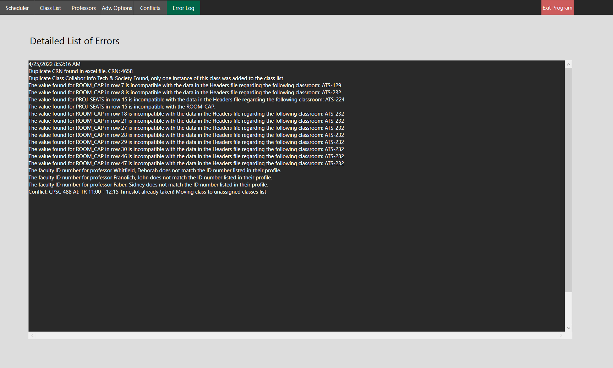

__6. Click the “Error Log” tab in the upper left corner of the main window.

__7. Note that all errors that occurred during startup will appear in this window.

__8. Note that errors that occur during runtime will appear in the error log.

## Changing Classroom Information

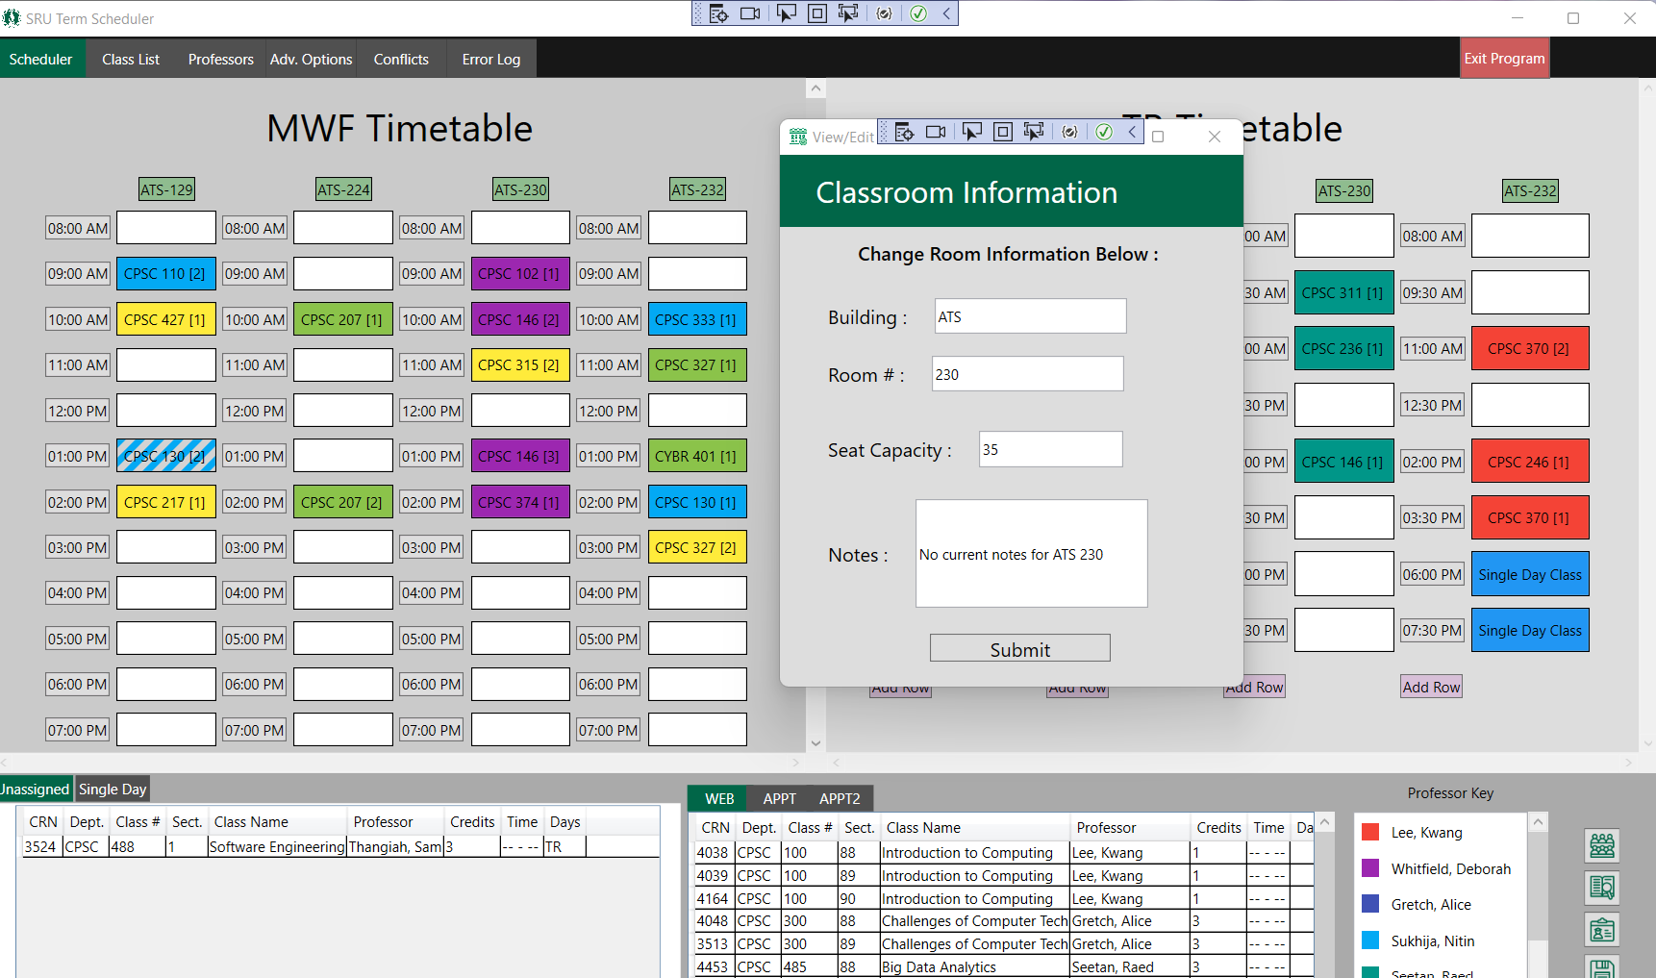

__9. Click the “Scheduler” tab in the upper left corner of the main window.

__10. Click any of the classrooms that appear as buttons on the top of the table underneath the table title.

__11. Alter the classroom information to your liking or leave it the same.

__12. Click submit or exit in the top right corner of the popup.

__13. If changes were submitted, the user will see those implemented.

### Adding a Classroom

__14. Click on the “Add Classroom” button in the lower right corner of the main window.

__15. Enter the desired information and click submit.

## Changing Class Times

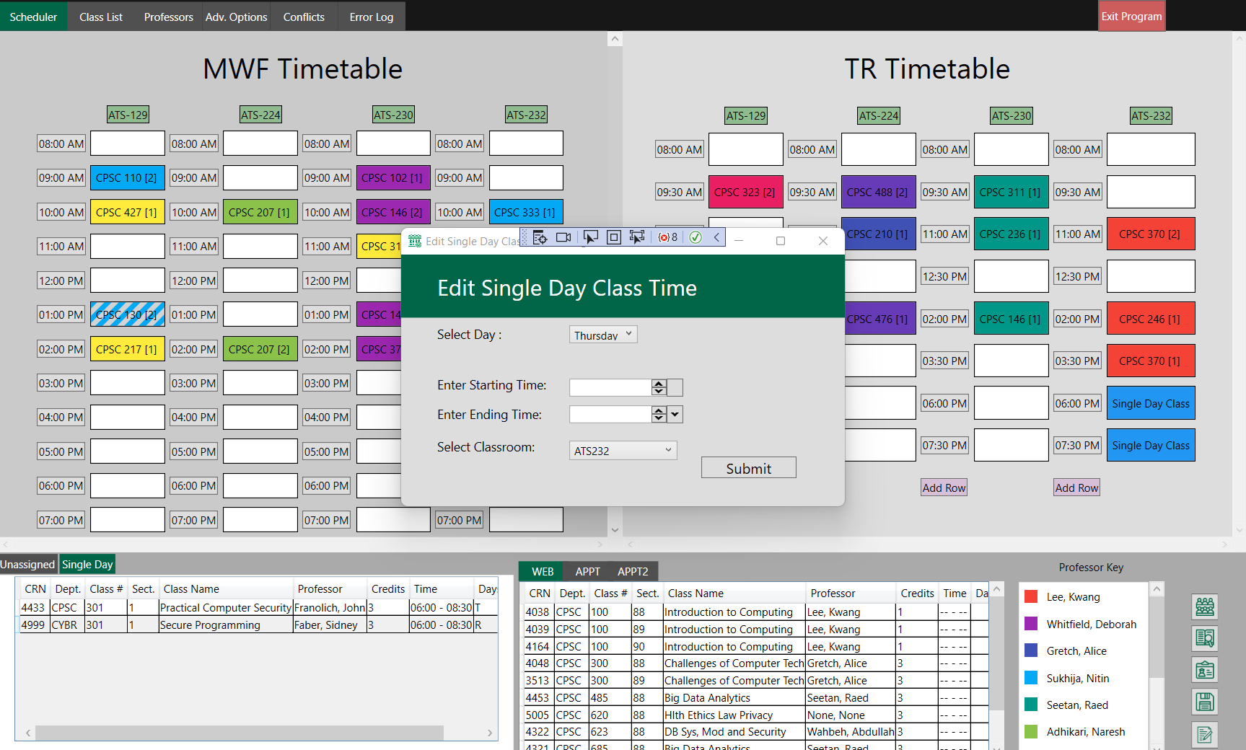

### Traditional Classes

__16. Click the “Scheduler” tab in the upper left corner of the main window.

__17. Click and drag any of the classes onto an empty spot on the grid.

### Single-Day Classes

__18. In the “Single Day” tab on the bottom left of the main window, right-click on the class.

__19. Select “Edit Class Time.”

__20. Enter the desired information and click submit.

## Changing Class Attributes

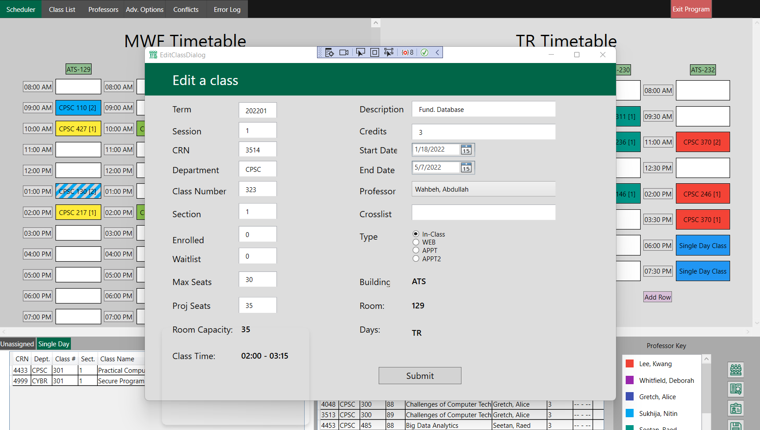

### From Scheduler Tab

__21. Right-click any traditional, online, unassigned, or single-day class in the window.

__22. Select “Edit Class” option.

__23. Enter the desired information and click submit.

### From Class List Tab

__24. Right-click on any part of the class you wish to edit.

__25. Select “Edit Class” option.

__26. Enter the desired information and click submit.

### Add a Class

__27. Click on the “Add Class” button in the lower right corner of the main window.

__28. Enter the desired information and click submit.

## Changing Professor Attributes

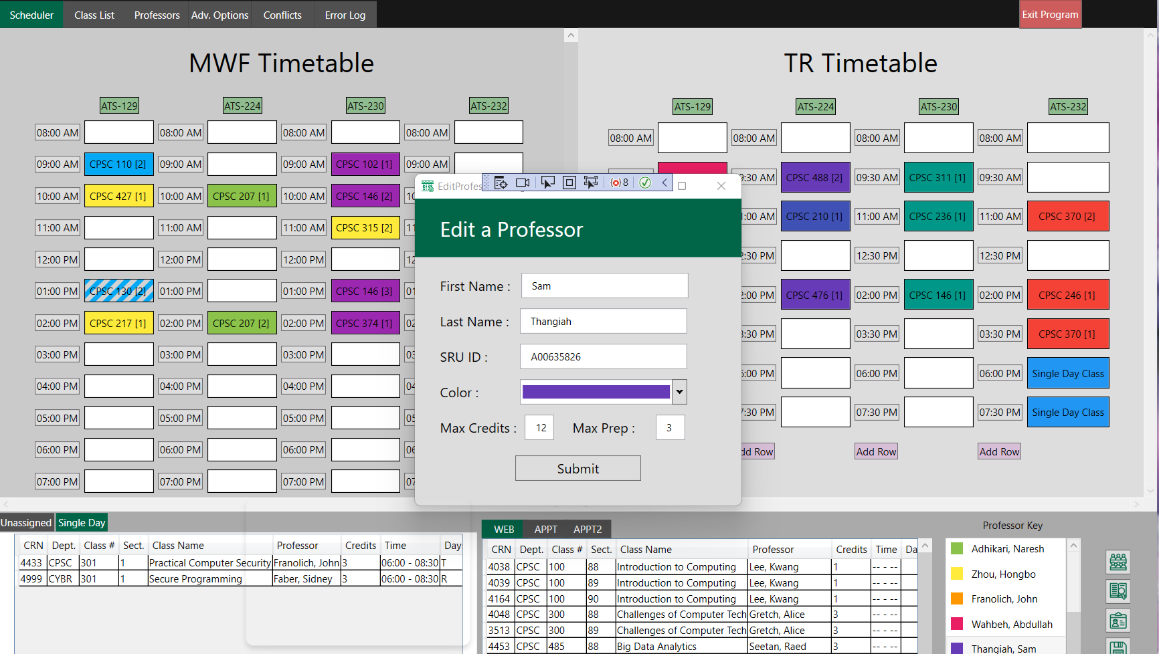

__29. Click the “Scheduler” tab in the upper left corner of the main window.

__30. Right-click on any professor in the Professor Key in the bottom right corner.

__31. Select “Edit Professor” option.

__32. Enter the desired information and click submit.

## Saving Your Changes

__33. Click on the “Save Changes” button in the lower right corner of the main window.

__34. Navigate to the desired location in your file explorer and enter the title of what you would like to save the Excel spreadsheet as.

__35. Save your changes.

__36. Note that now you can safely exit the program and all of your changes will be found within the Excel spreadsheet that you named as well as the Headers file.

Unit

2

# Static Analysis

## Compiler Warnings

On many of the variables that are only used in certain circumstances, there were compiler warnings. To eliminate these, the severity level was set to “None.” Many cases were regarding exceptions in the code.

# Integration Testing

## Adding Information

### Main Window to Add Class

* Information being sent
  + Add Class Dialog Box: to allow for user input
  + Requirements: to validate user input
  + Rejection Icons: to communicate to user that the input is invalid
* Information being received
  + Add Class Dialog Box: user input becomes a class

### Main Window to Add Classroom

* Information being sent
  + Add Classroom Dialog Box: to allow for user input
  + Requirements: to validate user input
  + Rejection Icons: to communicate to user that the input is invalid
* Information being received
  + Add Classroom Dialog Box: user input becomes a classroom

### Main Window to Add Professor

* Information being sent
  + Add Professor Dialog Box: to allow for user input
  + Requirements: to validate user input
  + Rejection Icons: to communicate to user that the input is invalid
* Information being received
  + Add Professor Dialog Box: user input becomes a professor

## Editing Information

### Main Window to Edit Class

* Information being sent
  + Edit Class Dialog Box: to allow for user input
  + Requirements: to validate user input
  + Rejection Icons: to communicate to user that the input is invalid
* Information being received
  + Edit Class Dialog Box: user input updates the current class

### Main Window to Edit Classroom

* Information being sent
  + Edit Classroom Dialog Box: to allow for user input
  + Requirements: to validate user input
  + Rejection Icons: to communicate to user that the input is invalid
* Information being received
  + Edit Classroom Dialog Box: user input updates the current classroom

### Main Window to Edit Professor

* Information being sent
  + Edit Professor Dialog Box: to allow for user input
  + Requirements: to validate user input
  + Rejection Icons: to communicate to user that the input is invalid
* Information being received
  + Edit Professor Dialog Box: user input updates the current professor

Unit

3

# Black Box Testing

## Scheduler Window

After reading in a sample class scheduling file. The information in the file was quality checked to ensure that it reflected the information in the sample class scheduling file.

## Save Changes

After changing information within the program, the new information was saved to a new Excel file. It was then quality checked to ensure the information was corrected and all changes were highlighted in red.

# Continuous Testing

## Changes to Class Scheduler Logic Code

For all changes within the logic of the code, such as reading in the excel file. Unit testing and Integration testing will be run to check if there are errors.

## Changes to Class Scheduler User Interface Code

For all changes to the user interface, such as the creation of new buttons or windows. Human Factor testing will be utilized to test the accuracy of the program.