Install and Configuration Manual
By Autumn Kriebel, Dean Lisko, Katherine Settle
March 19, 2022

Overview
This manual explains how to download and setup the SRU Semester Scheduler for use in creating a schedule.

System Requirements
- IDE comparable to Visual studio 2022
- Microsoft Office installed on the system
- At least 1GB Process memory

Assumptions
User is using Visual Studio 2022

4. Installing SRU Semester Scheduler
- Download the correct repository from GitHub by clicking on the “Code” dropdown menu and selecting “Download ZIP” as shown in Figure 1-1
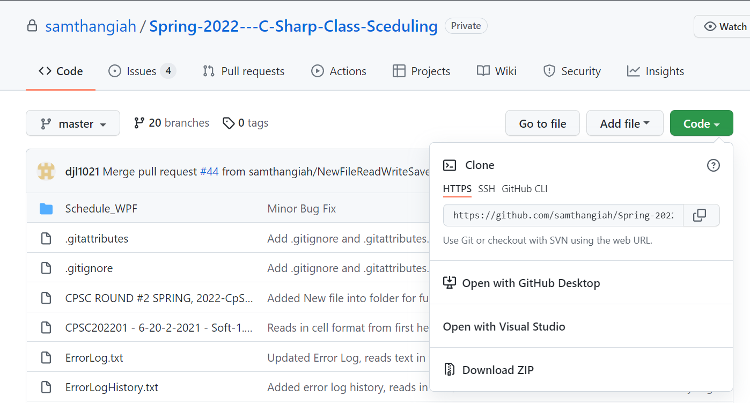
Figure 1-1

- Once downloaded, extract all into the empty target folder.

- Go into the target folder that now holds the extracted repository and click on the “Spring-2022---C-Sharp-Class-Sceduling-master” folder.

- Next, right-click on the Visual Studio file titled “Schedule_WPF.sln”. Click “Open With” and then select “Microsoft Visual Studio 2022” as show in Figure 1-2 and Figure 1-3.

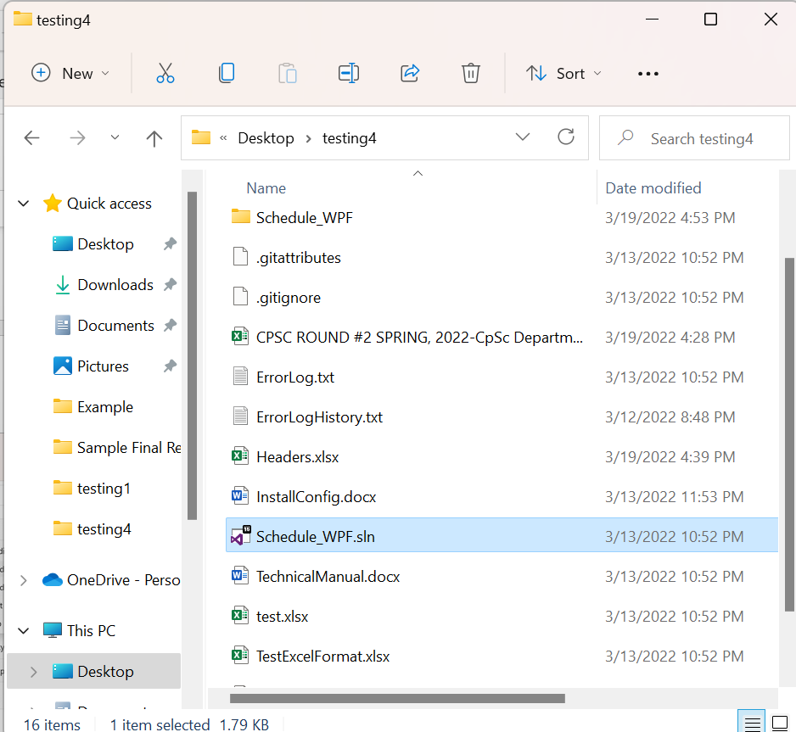
Figure 1-2: Select Schedule_WPF.sln

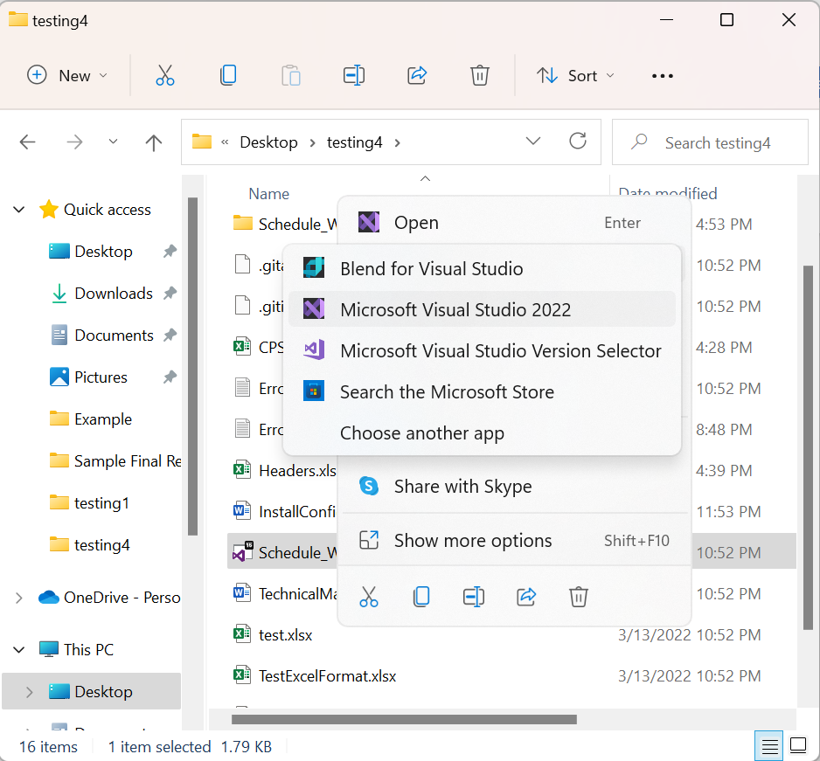
Figure 1-3: Open with Microsoft Visual Studio 2022

- Once loaded, go to the user’s folder of the extracted repository and place the Headers.xlsx file, ErrorLog.txt, and ErrorLog.txt file within Schedule_WPF -> bin -> debug folder. As shown in Figures 1-4, 1-5, 1-6
This step is very important as without these files in the correct spot the program will be unable to run.
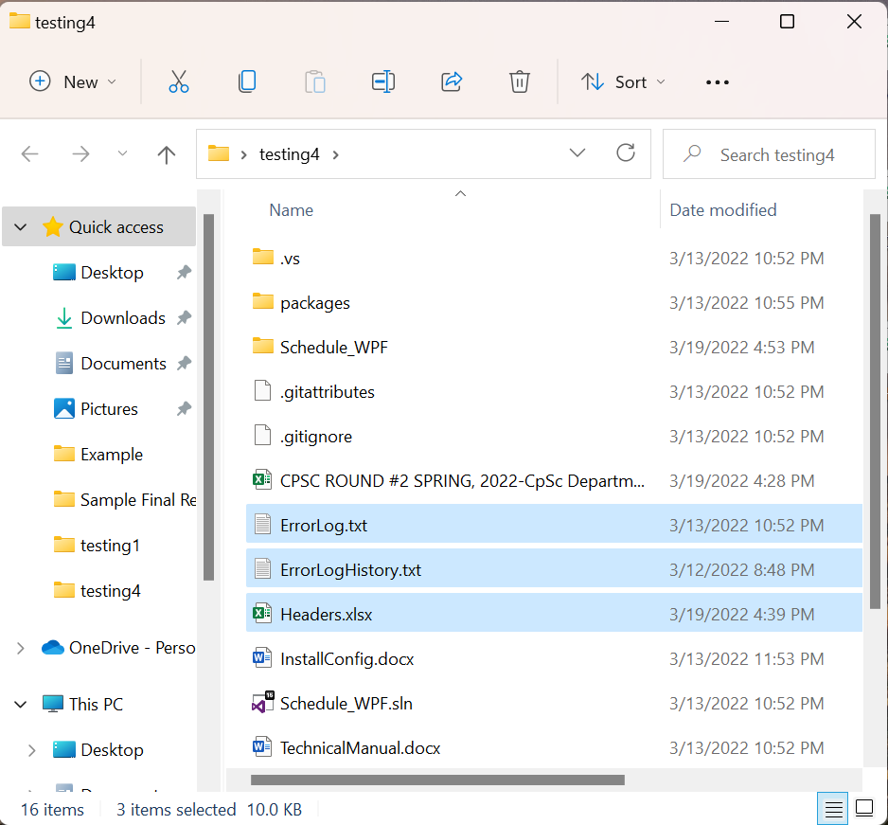
1
2
Figure 1-4: (1) Selected files to move into Schedule_WPF -> bin -> debug, (2) select Schedule_WPF
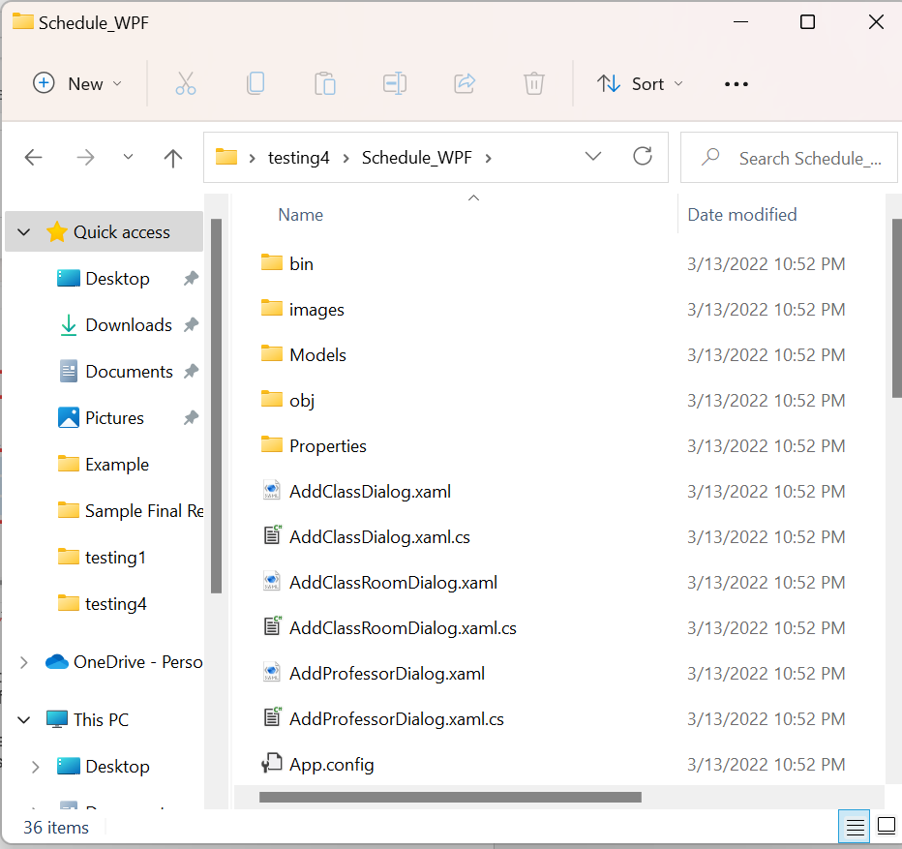

Figure 1-5: Select bin
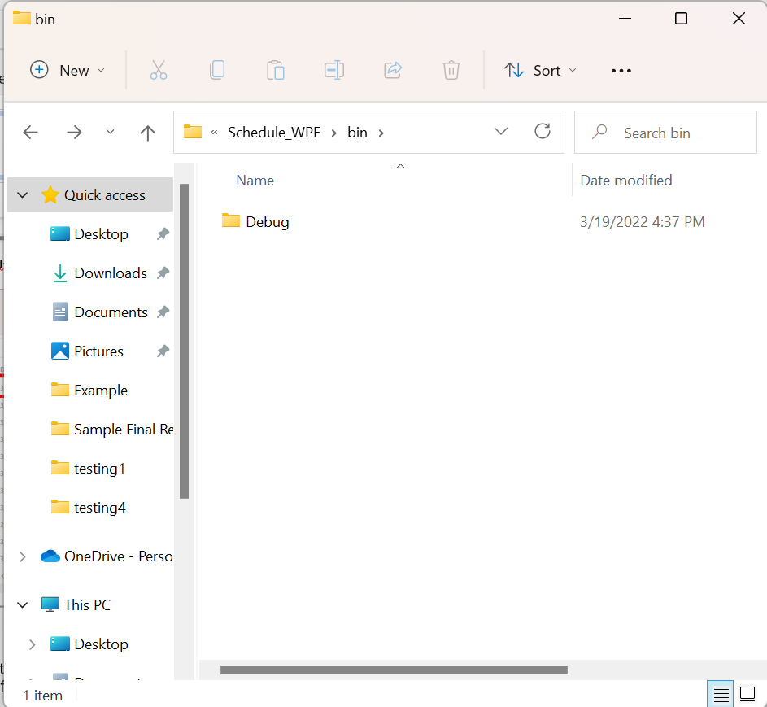
Figure 1-6: Select Debug

- Close Visual Studio. Return to the folder of the extracted repository and right-click on the Visual Studio file titled “Schedule_WPF.sln” as described above.
Click “Open With” and then select “Microsoft Visual Studio 2022” (Or the most current version that the user has installed).

5. First use of program
- Once loaded, right-click the Schedule_WPF project in the “Solution Explorer” tab on the side of your screen.
- Click “Debug” and then select “Start new instance.” This will begin the program.
- A window will appear and ask you to select a file. Select the appropriate Excel file that is in accordance with the available Headers.xlsx (see user manual for more details). If no errors occur, the appropriate timetables will appear, and the user may begin utilizing the class scheduling program.

