

Information Science and Engineering

Java & J2EE

IS63

JAVA SERVER PAGES

Submitted by:

1. Bansuri J Sanganal

1MS17IS034

1. Bhushan G Y

1MS17IS036

1. Kumar Hegde

1MS18IS406

INTRODUCTION

In today’s time every clinic or hospital faces the problem of managing appointments with doctors. Our project ‘BookMyAppointment’ is a small scale solution that aims at digitizing the process of booking appointments with doctors at small clinics or hospitals which is easy and fast, thereby doing away with the legacy system of booking appointments using pen and paper which is cumbersome and not easy to maintain in the long run.

BookMyAppointment is a web application built using Java. Java provides support for web application through Servlets and JSPs. This project is a collection of Java Server Pages along with support of MySQL database for data persistence.

DESIGN PHASE

This project facilitates the hospital or clinic lobby staff who manage appointments to log into their respective accounts after entering required credentials. Post login they will be provided with the list of doctors working in the hospital and another list of the patients who have visited them in the past.

The staff can enter the patient credentials like phone number or patient id to check if his records are already present the database. If not they can register the patient details with them. If the patient is already registered with them then they can update the patient records such as the age or their problem type if necessary. Upon updating, a list of doctors who are specialized in their respective fields is displayed along with their schedule for each week. The staff can assess this information and make appointments with the available doctor and convey the same to the patient.

To achieve the above mentioned work flow, there are a total of eleven jsp files namely:

1. Landing.jsp – The landing page for the application.
2. Login.jsp – This page provides the necessary UI for the staff to enter their credentials to log into the portal.
3. LoginProcess.jsp – This page handles the database logic which involves querying the specified table to see if the hospital staff is registered.
4. AfterLogin.jsp – This page displays the list of doctors working in the hospital

and the list of patients registered with the hospital along with the UI to enter the patient id or phone number to check if they have previously registered.

1. Check.jsp – This page queries the database to check if the patient records is present in the database. If not found, then it will redirect back to AfterLogin.jsp with an appropriate message. If present, then it will direct to the UpdatePatient.jsp page.
2. AddPatient.jsp – This page has the necessary UI to handle the registration of a new patient.
3. AddPatientProcess – This page has code that handles the database part of the registration process.
4. UpdatePatient.jsp – This page provides the required UI to enter the details that has to be updated the database. Post updation the staff member is directed to the BookPatient.jsp page.
5. BookAppointment.jsp – In this page, based on the type of problem the patient has entered, a list of available doctors along with their schedule is displayed based on which the hospital staff has to book appointments.
6. ShowAppointment.jsp – This page displays the details of the appointment booked along with the list of all the other appointments for that day.
7. Logout.jsp – End the session of the staff member and is diected back to the login page.

The database tables required for this process is as follows:

1. Staff Table – To store the details of the hospital staff who handle the appointment process with fields id, email, name, password.
2. Doctors Table - To store the details of the doctors working in the hospital with fields id, name, specialization, days available, timings.
3. Patients Table - To store the details of the patient having fields id, fname, lname,

problem, phone number, aadhar , address etc.

1. Appointments Table – To store the appointment details with fields doctor name, patient name, date, timings.

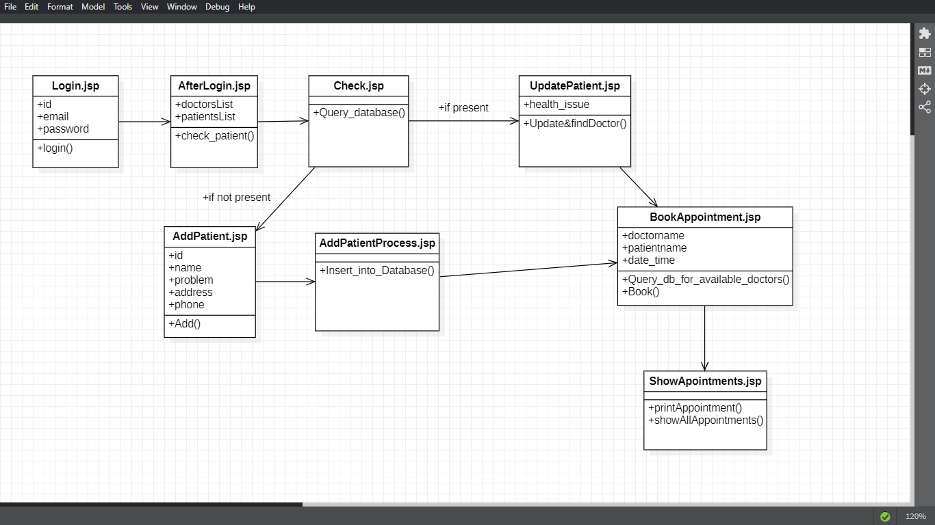DESIGN

IMPLEMENTATION PHASE

1. PSEUDO CODE:

while login:

if patient record present:

Update_patient_records();

Search_Available_Doctors();

Book_Appointment();

Show_Appointment();

else:

Add_Patient_record();

Search_Available_Doctors();

Book_Appointment();

Show_Appointment();

end

1. FLOWCHART

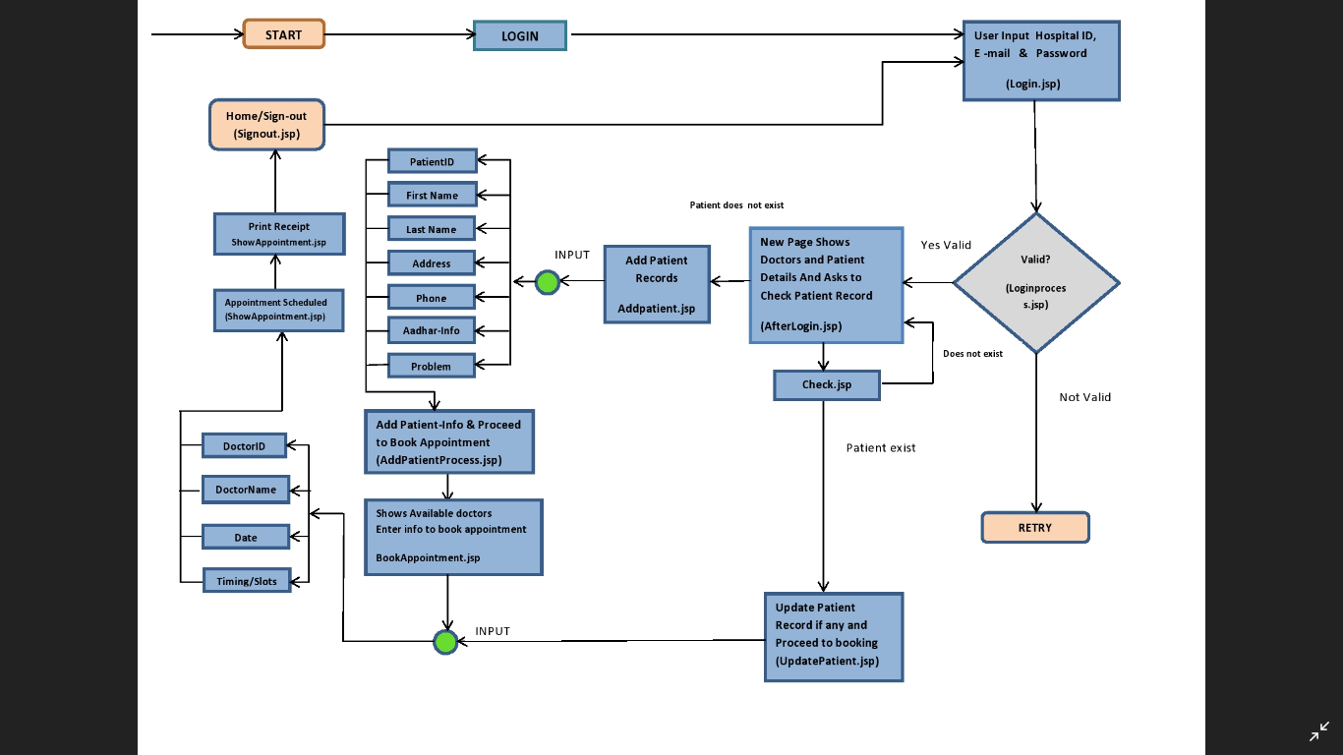

1. CODE

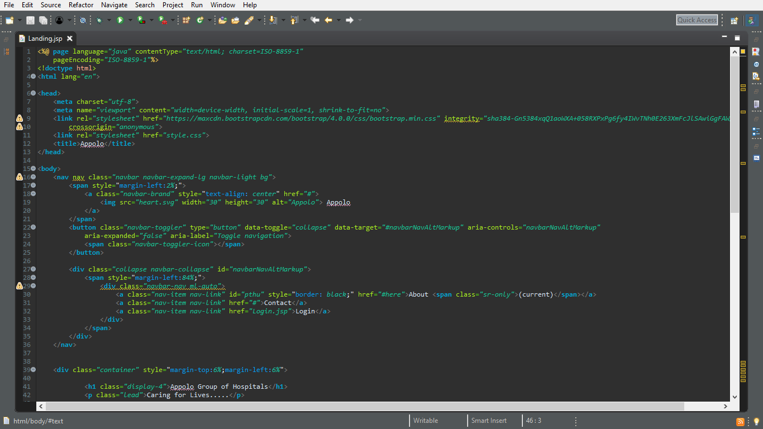Landing.jsp

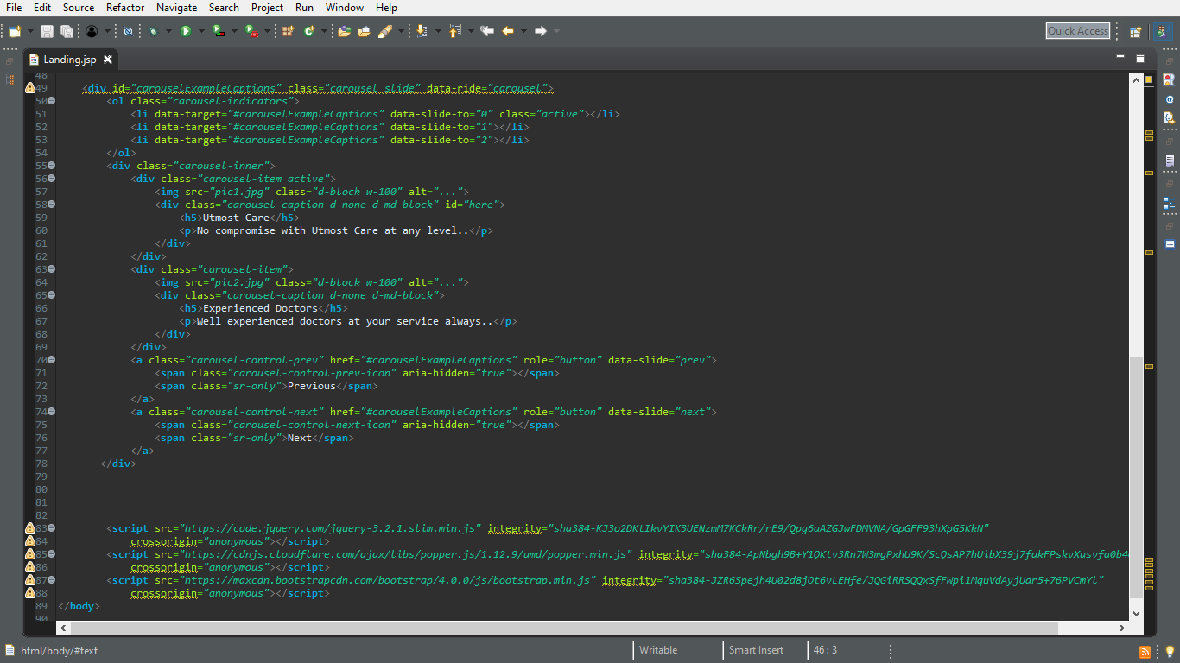

Login.jsp

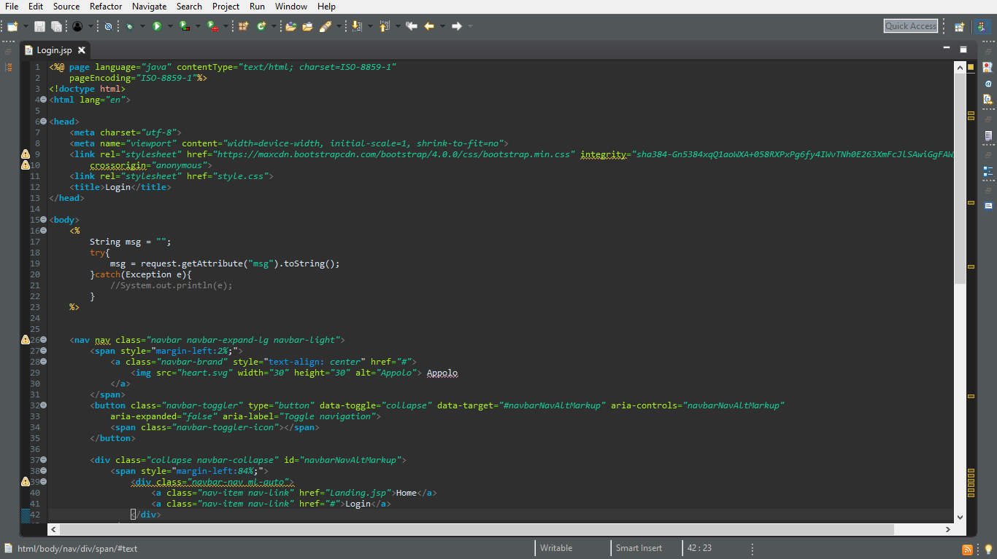

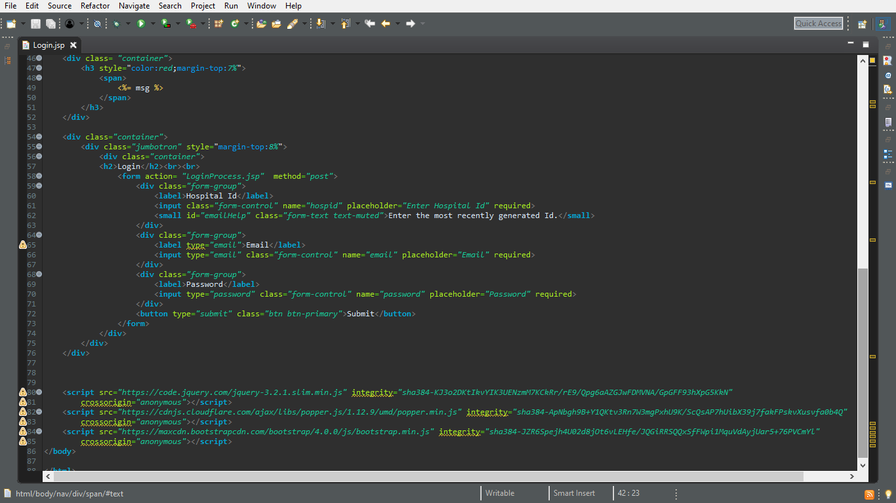

LoginProcess.jsp

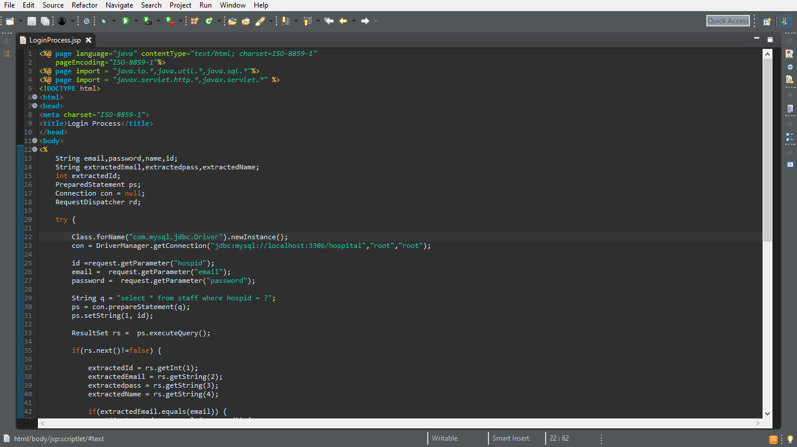

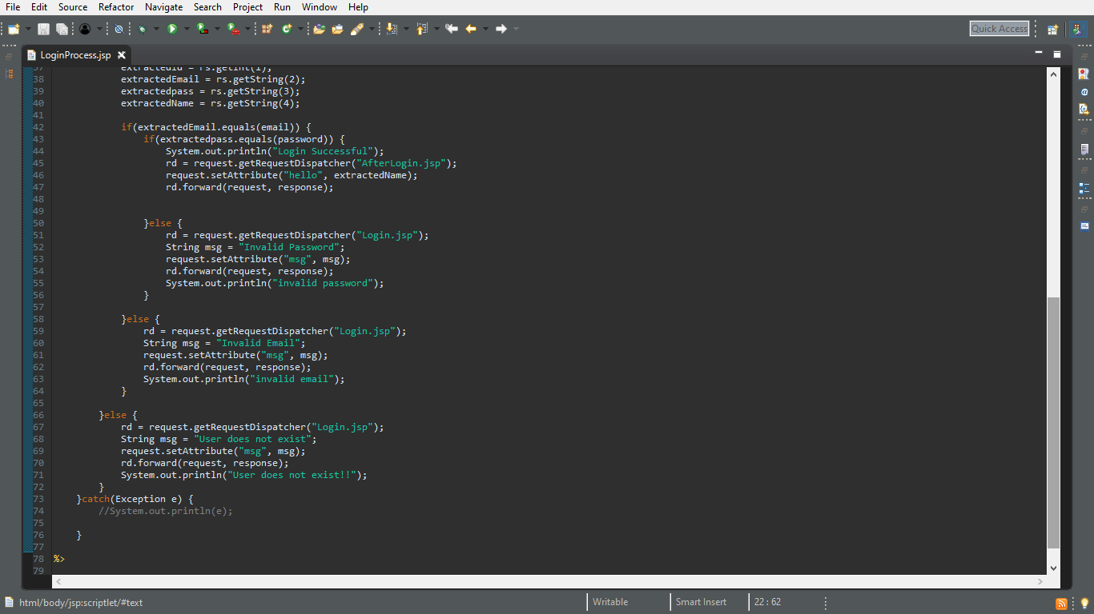

AfterLogin.jsp

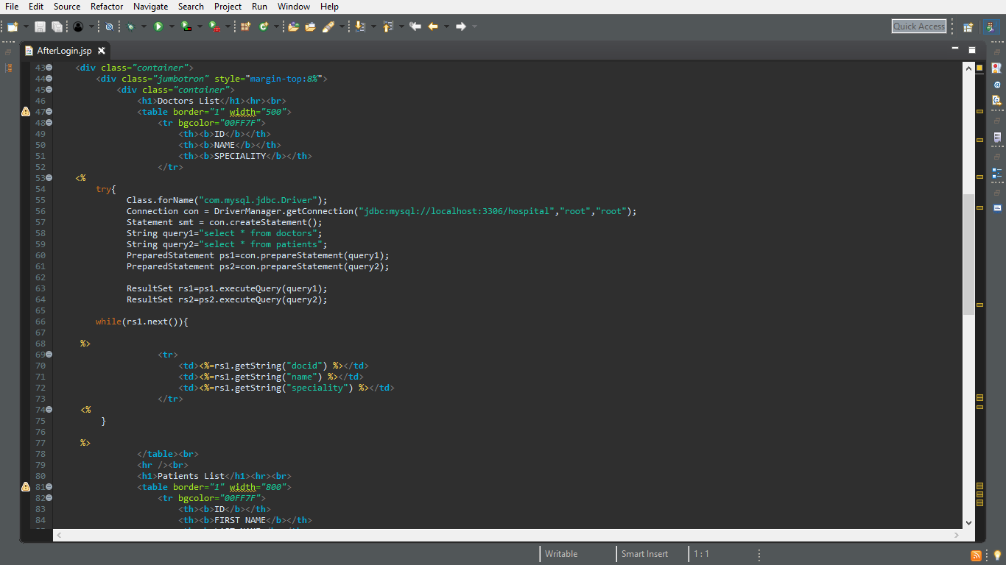

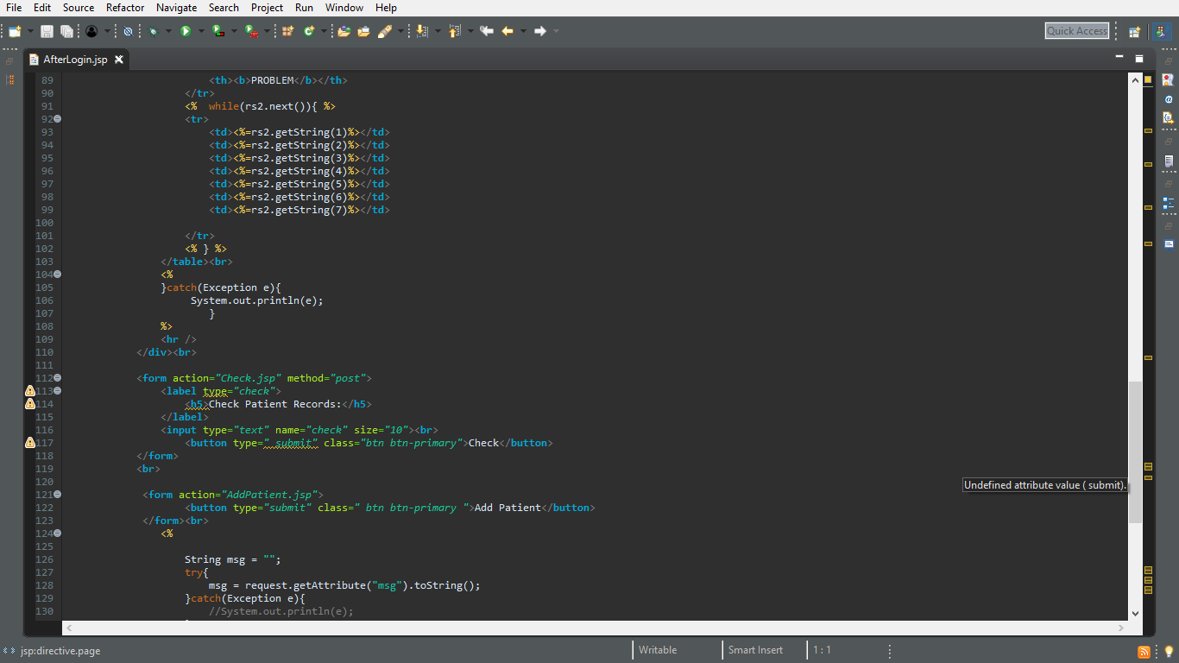

Check.jsp

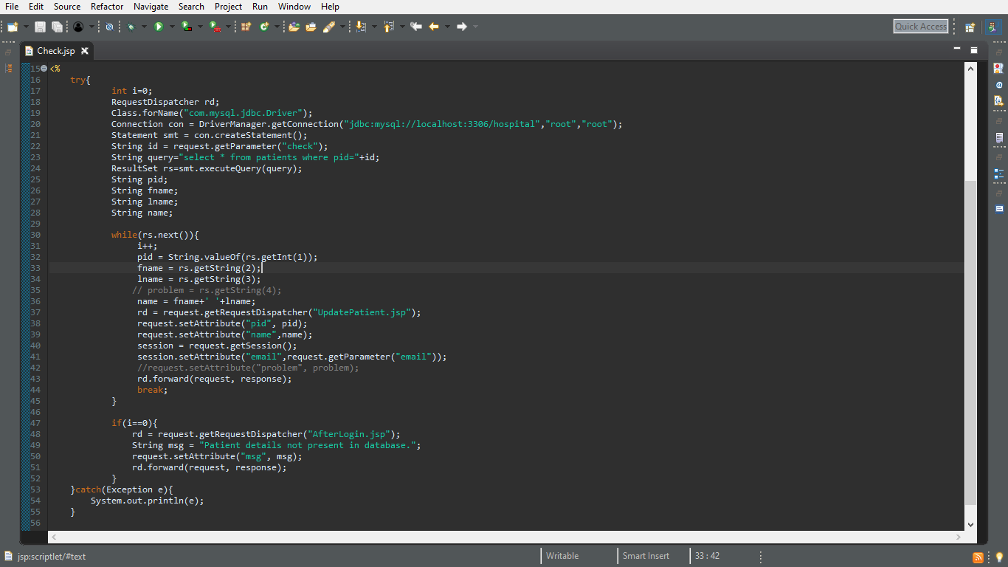

AddPatient.jsp

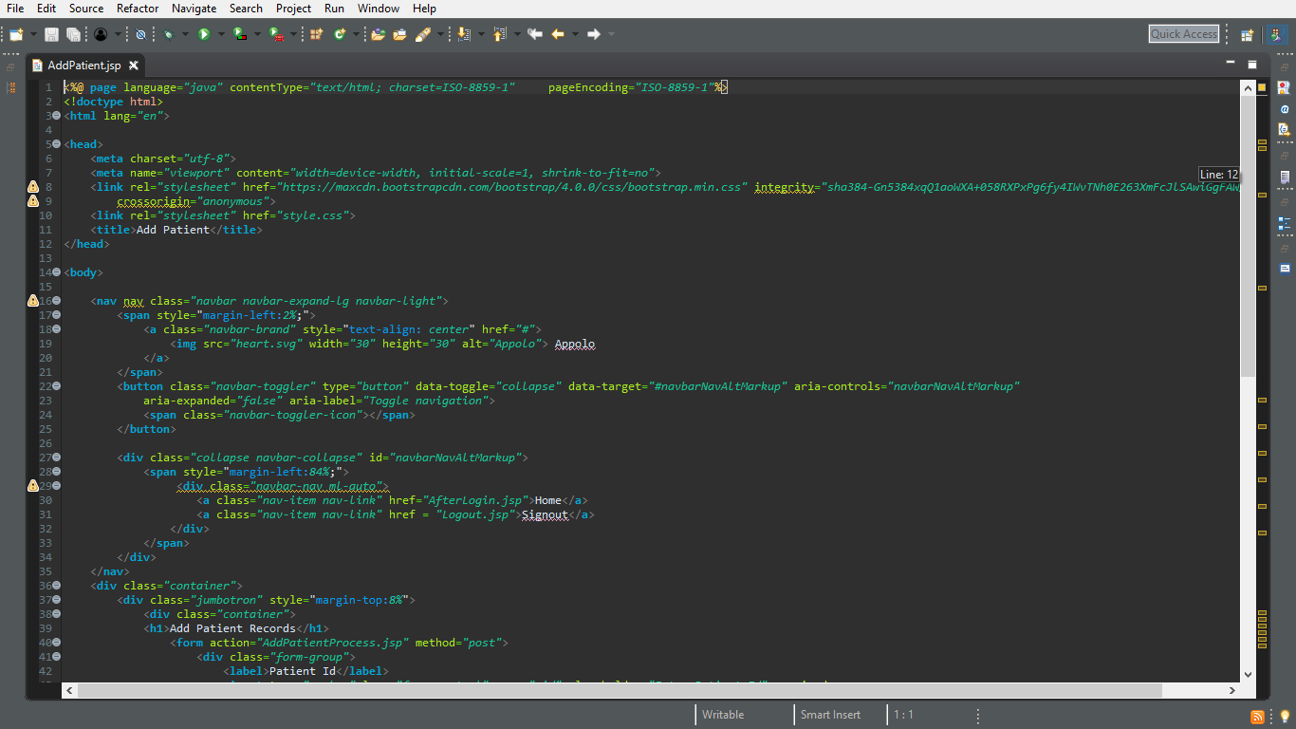

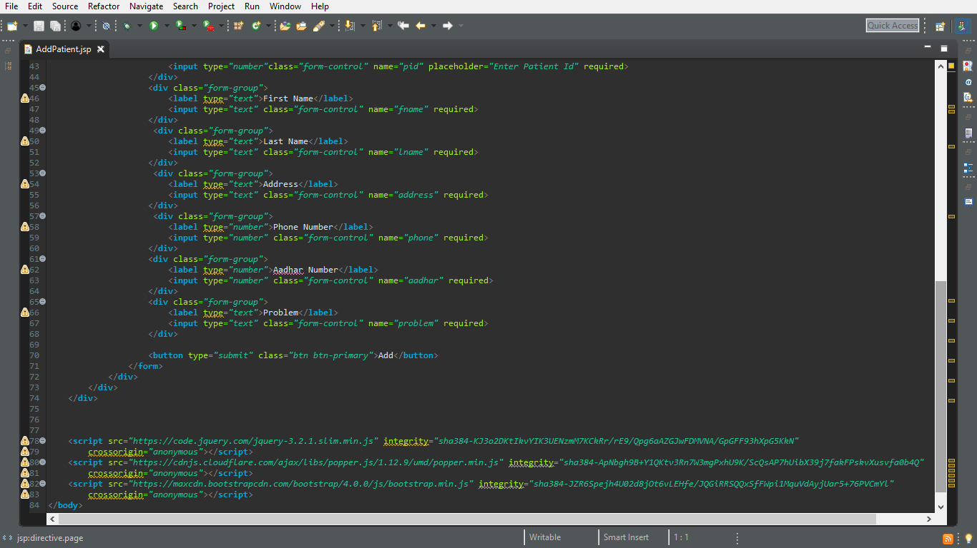

AddPatientProcess.jsp

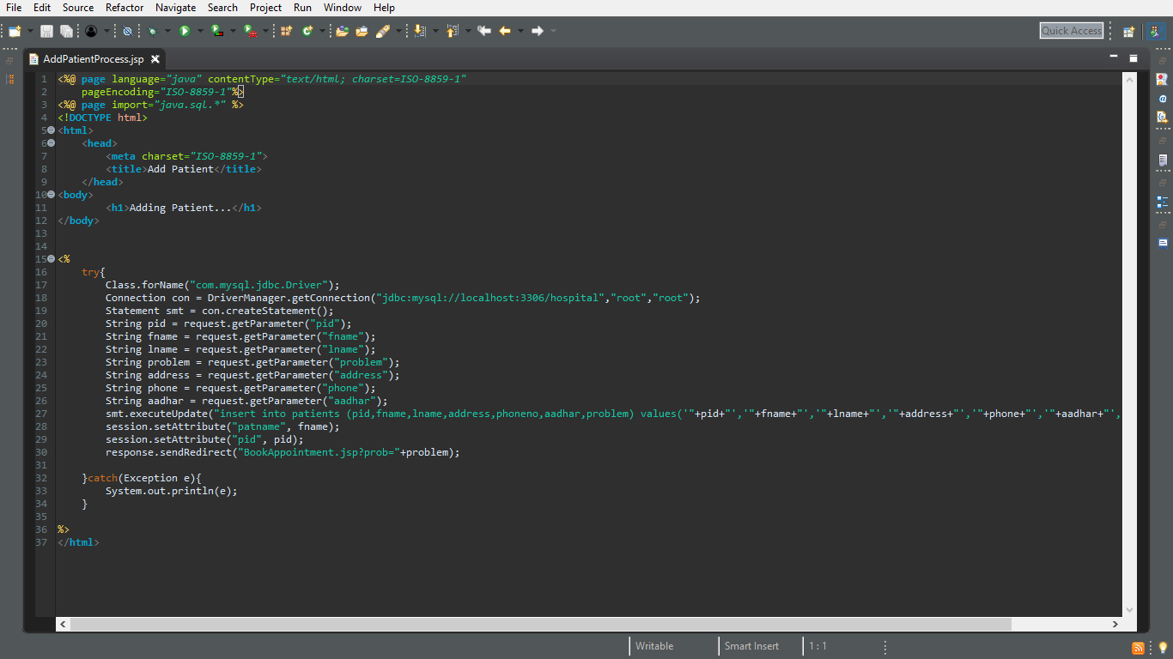

UpdatePatient.jsp

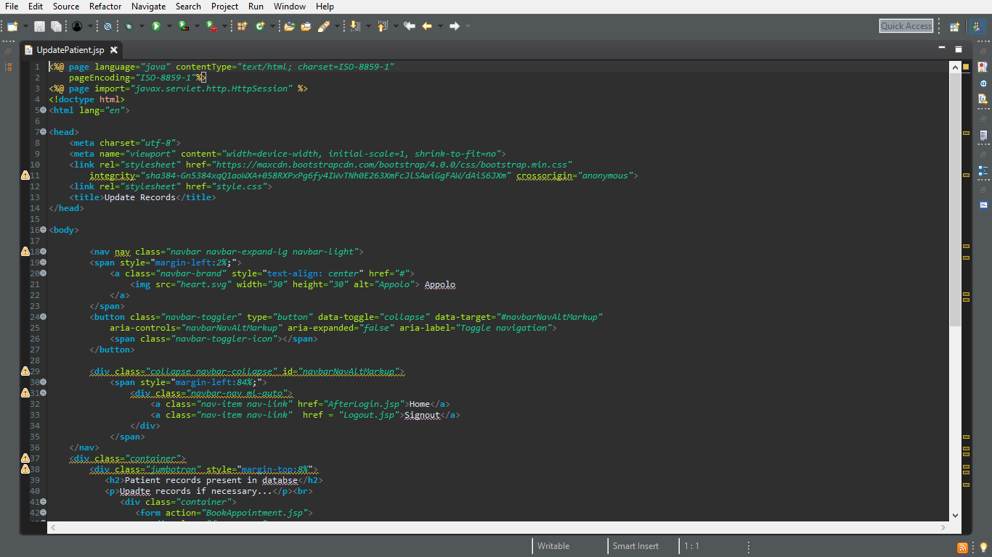

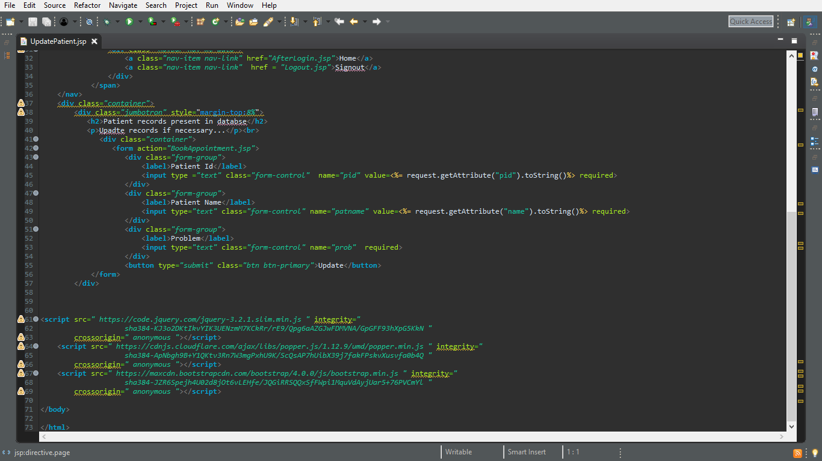

BookAppointment.jsp

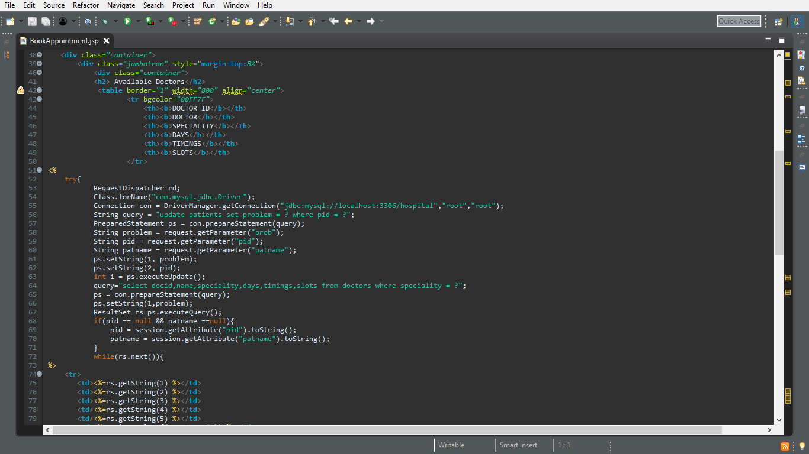

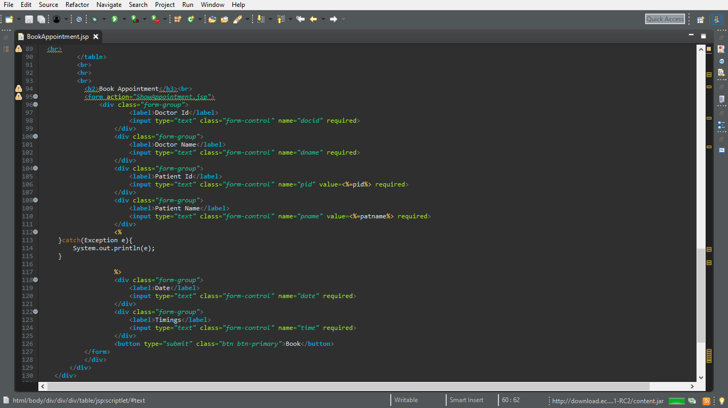

ShowAppointment.jsp

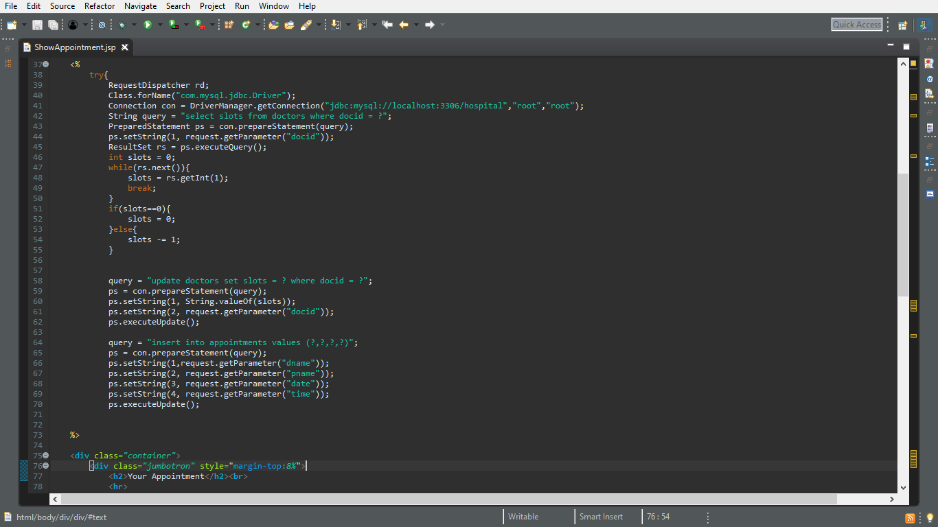

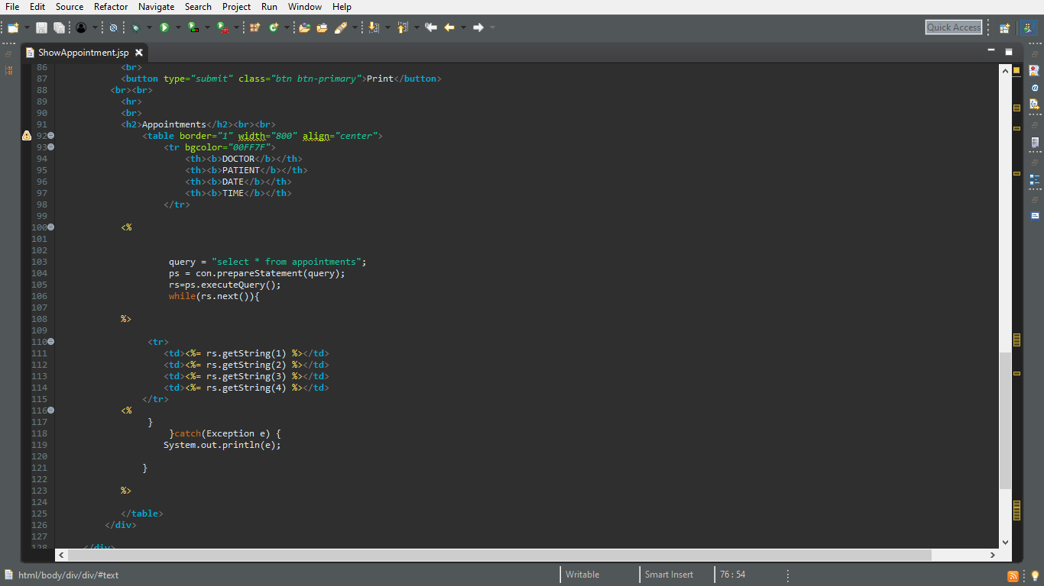

Logout.jsp

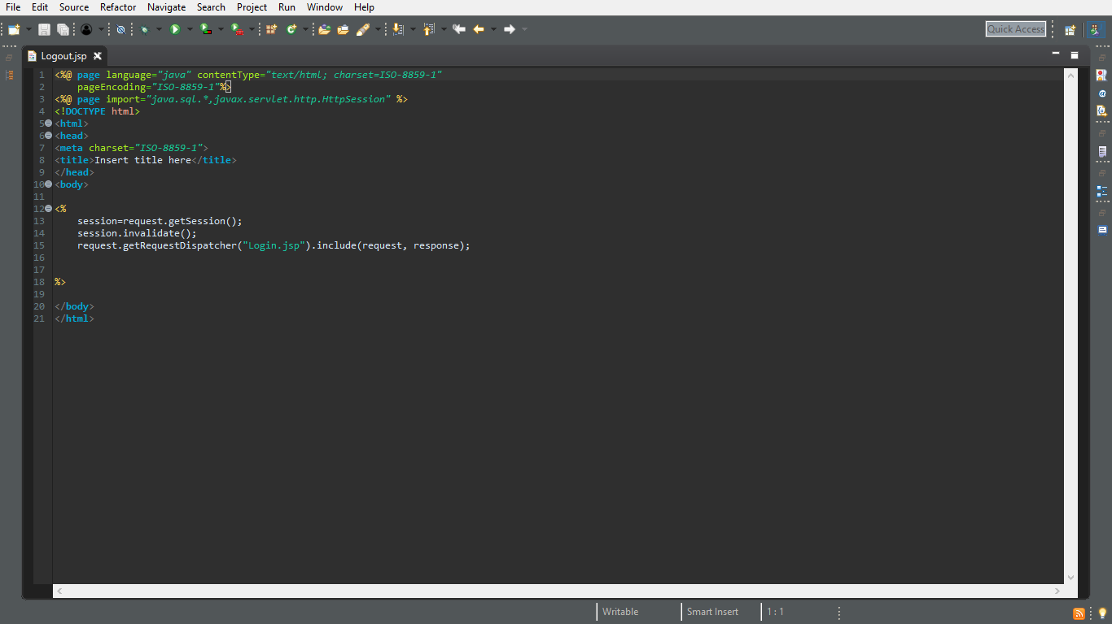

RESULTS