Technical Design Document
Spam Email Score Program
Name: Drew Bennett-Litts
Date: September 24, 2026
Course: COP 2373
Repository: https://github.com/dlitts01/COP-2373
Program Description
This program asks the user to enter an email message and checks it for 30 words and phrases commonly associated with spam. Every occurrence of a spam word or phrase adds one point to the spam score. The program then displays the total score, rates how likely the message is to be spam, and shows the words or phrases that increased the score.
Spam Words and Phrases Used
- free
- guaranteed
- act now
- limited time
- winner
- congratulations
- click here
- cash bonus
- risk free
- no obligation
- verify your account
- urgent
- make money
- earn money
- work from home
- special promotion
- exclusive deal
- buy now
- order now
- claim now
- prize
- million dollars
- credit card
- lowest price
- miracle
- 100% satisfied
- double your income
- apply now
- instant access
- no cost
Function Design
get_spam_words()
Description: Creates and returns the list of 30 spam words and phrases.
Parameters: None
Variables: spam_words
Logical Steps:
- Create a list containing the 30 spam words and phrases.
- Return the list to the main function.
Return Value: spam_words list
get_email_message()
Description: Gets the email message entered by the user.
Parameters: None
Variables: message_lines, line, email_message
Logical Steps:
- Display instructions to the user.
- Create an empty list for message lines.
- Use a loop to accept lines of text.
- Stop when the user enters a blank line.
- Join the lines into one email message.
- Return the email message.
Return Value: email_message string
calculate_spam_score(email_message, spam_words)
Description: Scans the email message and counts occurrences of the spam words and phrases.
Parameters: email_message, spam_words
Variables: message_lower, spam_score, matched_words, word, occurrences
Logical Steps:
- Convert the email message to lowercase.
- Set spam_score to 0 and create an empty matched_words list.
- Loop through each spam word or phrase.
- Count how many times each term appears in the email message.
- Add the number of occurrences to the spam score.
- Add matched terms to the matched_words list.
- Return the spam score and matched words.
Return Value: spam_score and matched_words
rate_spam_likelihood(spam_score)
Description: Rates the likelihood that the message is spam based on the score.
Parameters: spam_score
Variables: likelihood
Logical Steps:
- Check the spam score using if/elif/else statements.
- Assign a likelihood message based on the score range.
- Return the likelihood message.
Return Value: likelihood string
display_results(spam_score, likelihood, matched_words)
Description: Displays the spam score, likelihood rating, and matched spam terms.
Parameters: spam_score, likelihood, matched_words
Variables: word
Logical Steps:
- Display the spam score.
- Display the likelihood rating.
- If spam terms were found, loop through and display each one.
- Otherwise display that no spam words or phrases were found.
Return Value: None
main()
Description: Controls the order in which the program functions run.
Parameters: None
Variables: spam_words, email_message, spam_score, matched_words, likelihood
Logical Steps:
- Get the spam word list.
- Get the email message from the user.
- Calculate the spam score and matched terms.
- Rate the spam likelihood.
- Display the results.
Return Value: None
Spam Likelihood Scale
- 0 points: Very unlikely to be spam
- 1-2 points: Low likelihood of spam
- 3-5 points: Moderate likelihood of spam
- 6-9 points: High likelihood of spam
- 10 or more points: Very high likelihood of spam
Online Research Used
- Constant Contact - Common things that trigger spam filters (updated February 26, 2026)
- Unspam - 400+ Email Spam Trigger Words to Avoid in 2026
- Suped - What words and phrases are considered spammy and trigger spam filters?
Test Output Screenshot
The following screenshot shows a test run of the program using a sample spam-style email message.
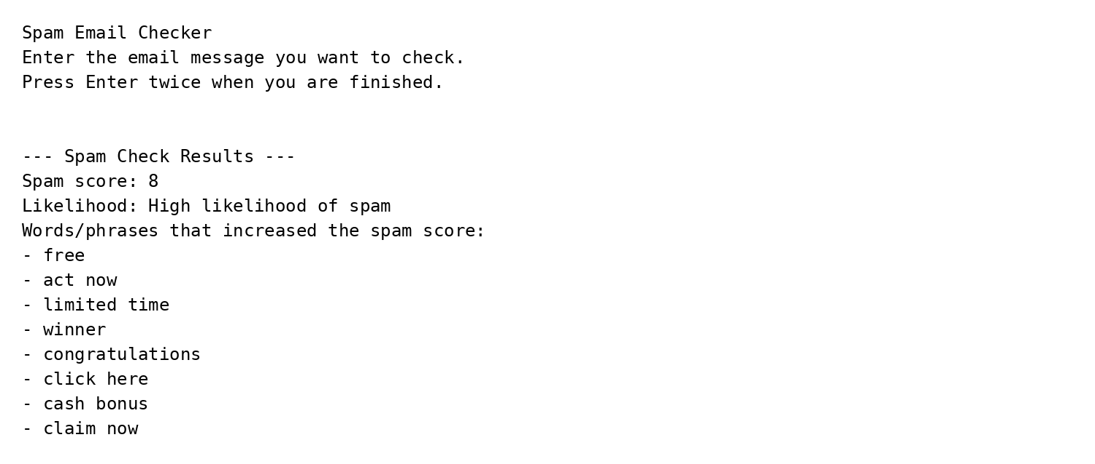
Repository Submission Check
- Upload Drew_Bennett_Litts_ProgrammingExercise_SpamScore.py to the COP 2373 repository.
- Upload Drew_Bennett_Litts_SpamScore_TechnicalDesignDocument.docx to the COP 2373 repository.
- Verify both files appear on GitHub before submitting the assignment in Canvas.

