CMSC203 Assignment 2 Implementation (Documentation)

Class: CMSC203 CRN XXXX
Program: Assignment #2
Instructor:
Summary of Description: (Give a brief description for each Program)
Due Date: 07/03/2022
Integrity Pledge: I pledge that I have completed the programming assignment independently.
I have not copied the code from a student or any source.

Part1: Pseudo Code: Here is a pseudo code for Assignment 2 program:

generate a random number between 1 and 100
ask the user to input a number
tell them if they got it right or not with a message saying higher or lower
ask for the next guess if necessary
once the user guesses the number ask if they want to play again
make sure to generate a new number for the new game
if they say no make sure to stop the code from looping

Part2: Comprehensive Test Plan
A good test plan should be comprehensive. This means you should have a few test cases that test when the input is in and out of range, division by 0, incorrect Data type, etc. (Provide valid and invalid input)
Cases | Input | Expected Output | Actual Output | Did Test Pass?
Case 1 | 101 | >>> Guess must be between 0 and 100. Try again | >>> Guess must be between 0 and 100. Try again | yes
Case 2 | 50 | Enter your first guess  50  Number of guesses is 1  Your guess is too low  Enter your next guess between 50 and 100 | Enter your first guess  50  Number of guesses is 1  Your guess is too low  Enter your next guess between 50 and 100 | yes
Case 3 | 50  25  13  7  9  12 | Enter your first guess  50  Number of guesses is 1  Your guess is too high  Enter your next guess between 0 and 50  25  Number of guesses is 2  Your guess is too high  Enter your next guess between 0 and 25  13  Number of guesses is 3  Your guess is too high  Enter your next guess between 0 and 13  7  Number of guesses is 4  Your guess is too low  Enter your next guess between 7 and 13  9  Number of guesses is 5  Your guess is too low  Enter your next guess between 9 and 13  12  Number of guesses is 6  Congratulations, you guessed correctly  Try again? (yes(1) or no(2))  2  Thanks for playing... | Enter your first guess  50  Number of guesses is 1  Your guess is too high  Enter your next guess between 0 and 50  25  Number of guesses is 2  Your guess is too high  Enter your next guess between 0 and 25  13  Number of guesses is 3  Your guess is too high  Enter your next guess between 0 and 13  7  Number of guesses is 4  Your guess is too low  Enter your next guess between 7 and 13  9  Number of guesses is 5  Your guess is too low  Enter your next guess between 9 and 13  12  Number of guesses is 6  Congratulations, you guessed correctly  Try again? (yes(1) or no(2))  2  Thanks for playing... | yes
Case 4 | 50  25  35  48  40  37  36  1  50  75  63  68  72  69  71  2 | Enter your first guess  50  Number of guesses is 1  Your guess is too high  Enter your next guess between 0 and 50  25  Number of guesses is 2  Your guess is too low  Enter your next guess between 25 and 50  35  Number of guesses is 3  Your guess is too low  Enter your next guess between 35 and 50  48  Number of guesses is 4  Your guess is too high  Enter your next guess between 35 and 48  40  Number of guesses is 5  Your guess is too high  Enter your next guess between 35 and 40  37  Number of guesses is 6  Your guess is too high  Enter your next guess between 35 and 37  36  Number of guesses is 7  Congratulations, you guessed correctly  Try again? (yes(1) or no(2))  1  Enter your first guess  50  Number of guesses is 1  Your guess is too low  Enter your next guess between 50 and 100  75  Number of guesses is 2  Your guess is too high  Enter your next guess between 50 and 75  63  Number of guesses is 3  Your guess is too low  Enter your next guess between 63 and 75  68  Number of guesses is 4  Your guess is too low  Enter your next guess between 68 and 75  72  Number of guesses is 5  Your guess is too high  Enter your next guess between 68 and 72  69  Number of guesses is 6  Your guess is too low  Enter your next guess between 69 and 72  71  Number of guesses is 7  Congratulations, you guessed correctly  Try again? (yes(1) or no(2))  2  Thanks for playing... | Enter your first guess  50  Number of guesses is 1  Your guess is too high  Enter your next guess between 0 and 50  25  Number of guesses is 2  Your guess is too low  Enter your next guess between 25 and 50  35  Number of guesses is 3  Your guess is too low  Enter your next guess between 35 and 50  48  Number of guesses is 4  Your guess is too high  Enter your next guess between 35 and 48  40  Number of guesses is 5  Your guess is too high  Enter your next guess between 35 and 40  37  Number of guesses is 6  Your guess is too high  Enter your next guess between 35 and 37  36  Number of guesses is 7  Congratulations, you guessed correctly  Try again? (yes(1) or no(2))  1  Enter your first guess  50  Number of guesses is 1  Your guess is too low  Enter your next guess between 50 and 100  75  Number of guesses is 2  Your guess is too high  Enter your next guess between 50 and 75  63  Number of guesses is 3  Your guess is too low  Enter your next guess between 63 and 75  68  Number of guesses is 4  Your guess is too low  Enter your next guess between 68 and 75  72  Number of guesses is 5  Your guess is too high  Enter your next guess between 68 and 72  69  Number of guesses is 6  Your guess is too low  Enter your next guess between 69 and 72  71  Number of guesses is 7  Congratulations, you guessed correctly  Try again? (yes(1) or no(2))  2  Thanks for playing... | yes

Part3: Screenshots related to the Test Plan:
Case 1
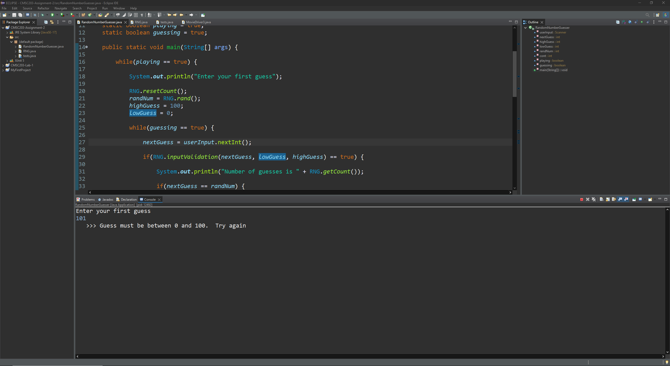
Case 2
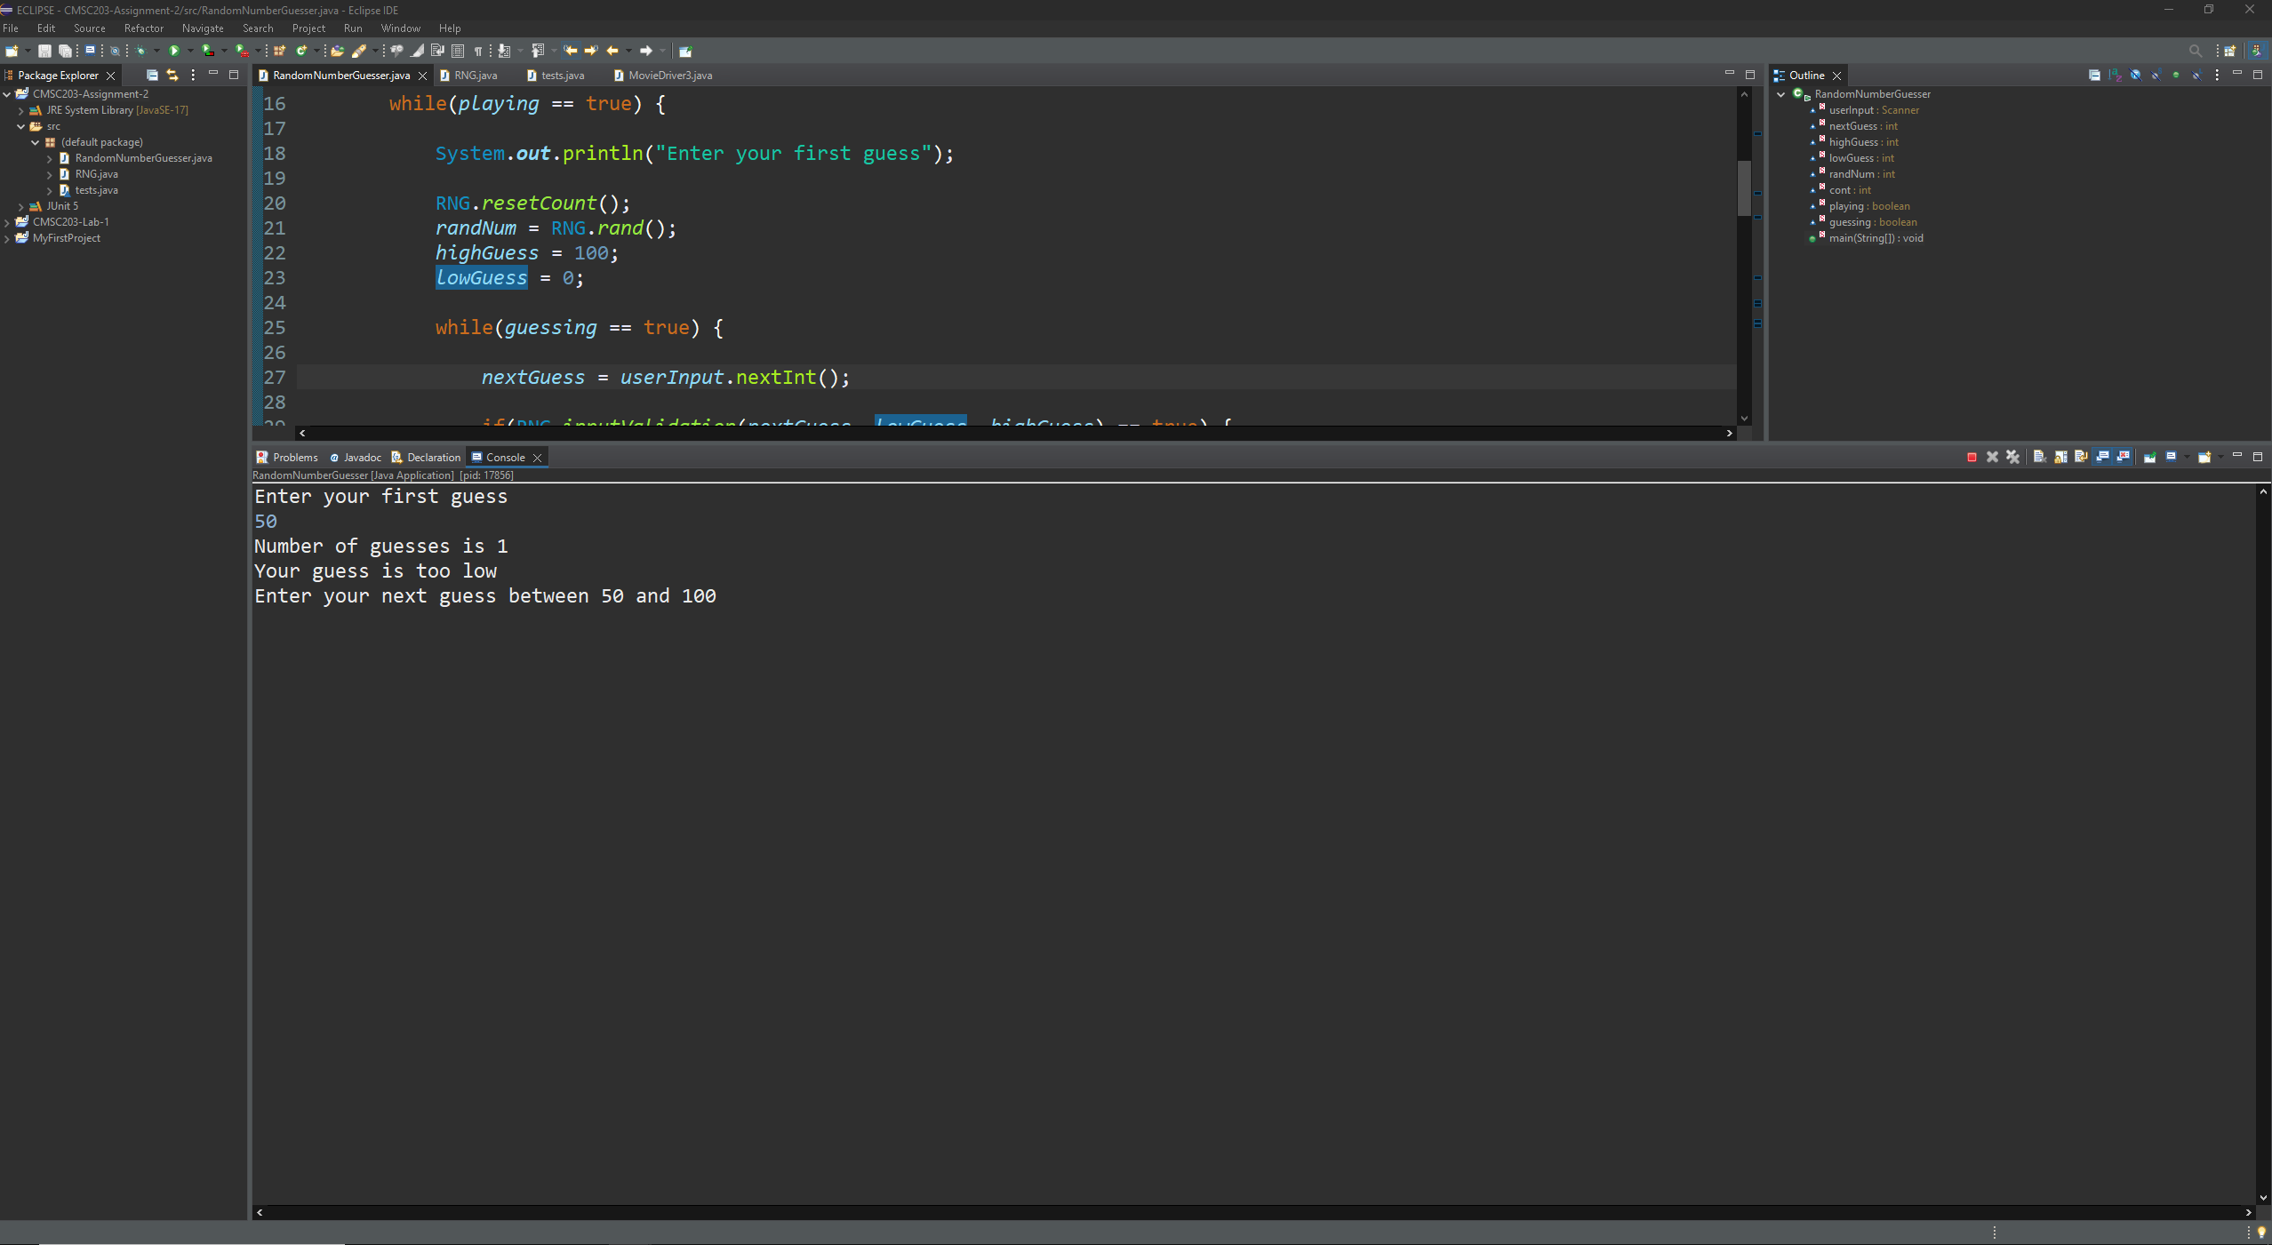
Case 3
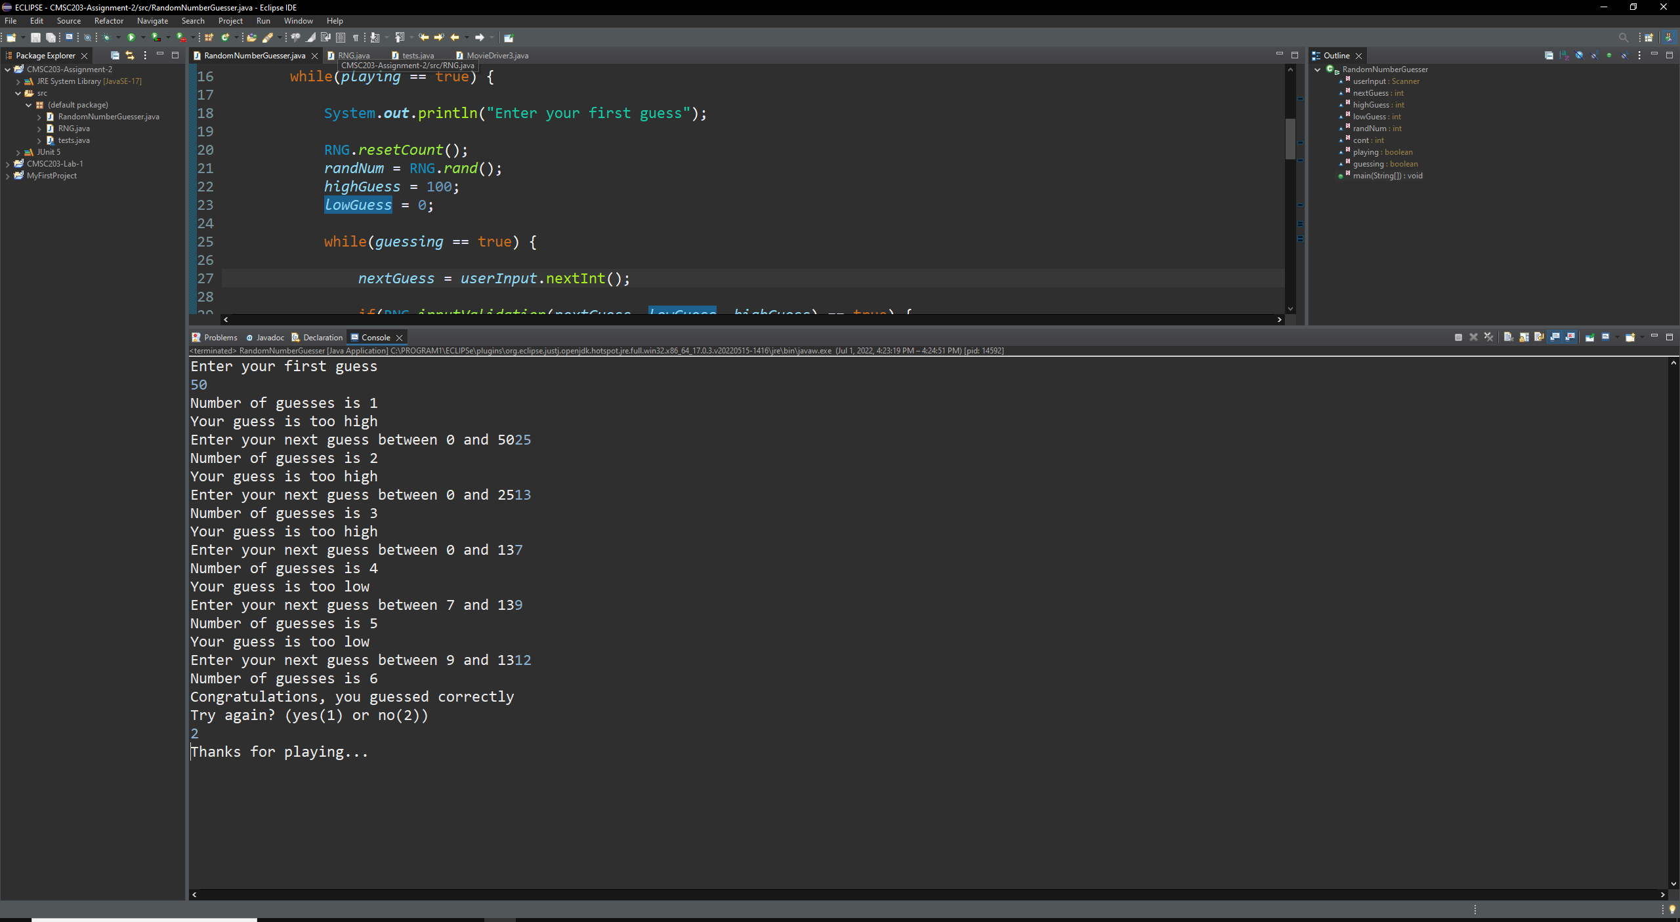
Case 4

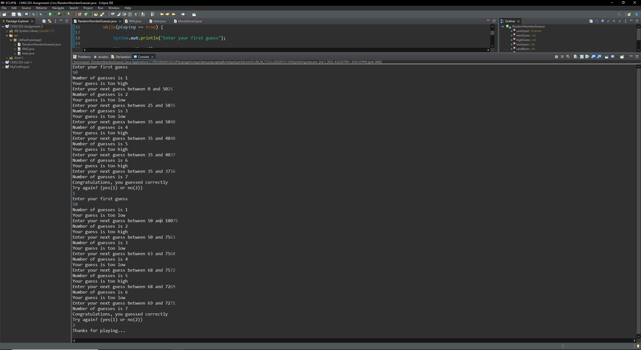
Lessons Learned <Provide answers to the questions listed above>:

Write about your Learning Experience, highlighting your lessons learned and learning experience from working on this project.

I learned about using scanners more and how they work, as well as affirmed my knowledge on how to create a class and use outside classes with the created class.

What have you learned?

Reaffirmed the knowledge that I learned from Lab 1

What did you struggle with?

Struggled a little with making the game loop when the user wants to play again.

What would you do differently on your next project?

I don’t think I would try and complete this assignment in any other way.

What parts of this assignment were you successful with, and what parts (if any) were you not successful with?

I was successful with using the RNG class to influence the RandomNumberGuesser class.

Provide any additional resources/links/videos you used to while working on this assignment/project.

Check List: <Provide answers to the column Y/N or N/A >:

# |  | Y/N | Comments
 | Assignment files:
 | - FirstInitialLastName_ Assignment#_Moss.zip | Yes or No
 | - FirstInitialLastName_Assignment#.docx/.pdf | Yes or No
 | - Source java files | Yes or No
 | Program compiles | Yes or No
 | Program runs with desired outputs related to a Test Plan | Yes or No
 | Documentation file:
 | - Comprehensive Test Plan | Yes or No
 | - Screenshots related to the Test Plan | Yes or No
 | - Screenshots of your GitHub account with submitted Assignment# (if required) | Yes or No or N/A
 | - UML Diagram (if required) | Yes or No or N/A
 | - Algorithms/Pseudocode (if required) | Yes or No or N/A
 | - Flowchart (if required) | Yes or No or N/A
 | - Lessons Learned | Yes or No
 | - Checklist is completed and included in the Documentation | Yes or No

