**Diversidad de Algas y Abundancia de Erizos**

Diego

Monday, May 25, 2015

# Diversidad de Algas en PS

## Distribución posterior de la riqueza de especies

Riqueza de especies y acumulación de algas, modelando la ocurrencia y la detectabilidad simultaneamente. Los datos se agruparon por transecto contando la aparición el los cuadrantes. Este análisis sigue el método de Dorazio et al. (2006). Este método es conocido como "detection-based hierarchical model for estimating species diversity" (Iknayan et al. 2014).

## Posterior computed in 14.9620891173681 minutes

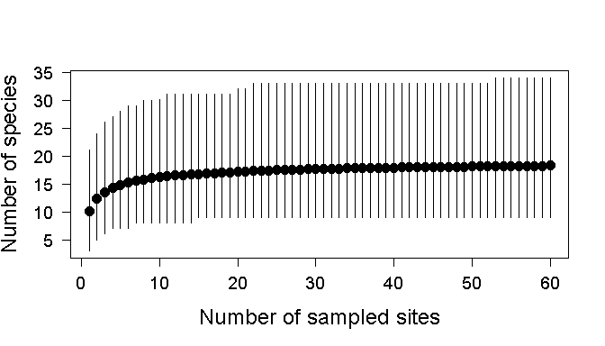 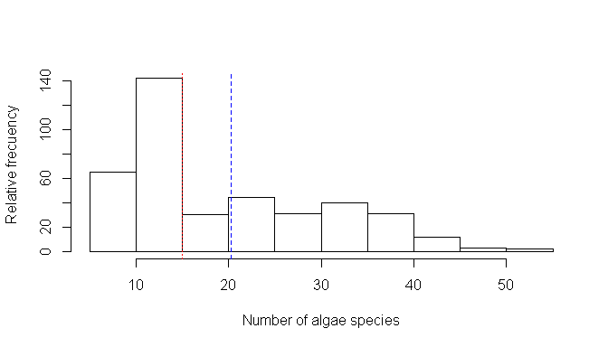 Distribución de posteriores del método jerárquico para estimar la diversidad. En rojo se muestra la mediana y en azul la media. Nueve es el número de especies de algas observado en los datos. Sin embargo la mediana es 11, sugiriendo que en el muestreo no se están detectando dos especies.

# PS exploration

## Relación entre especie de alga y variables

### Algas-Full dataset

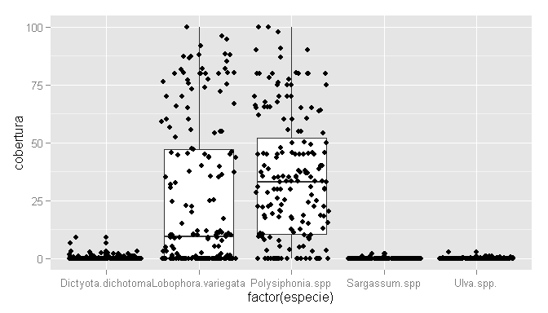 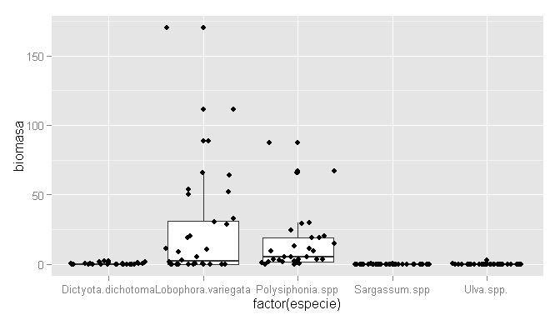 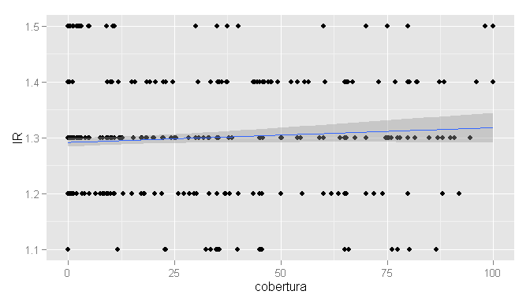 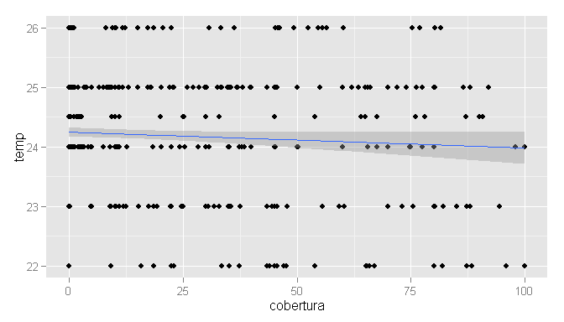 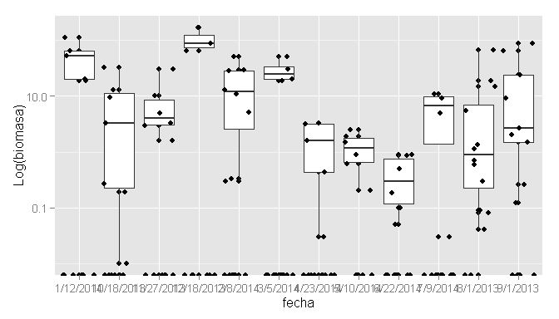

### Algas-Por especie

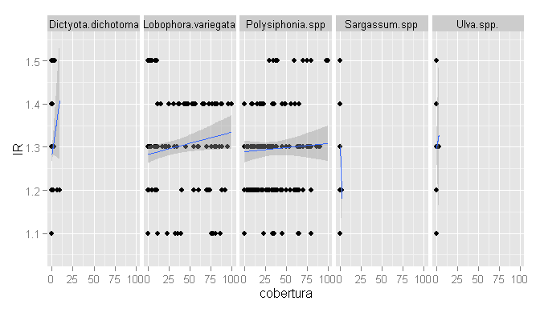 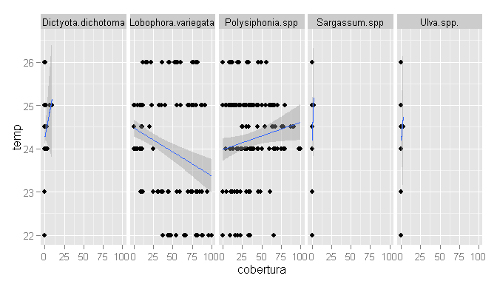 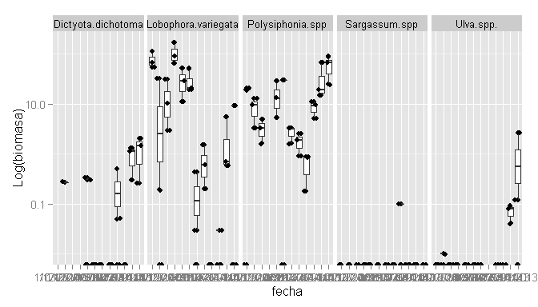

## Relacion entre sp de erizos

##   
## Pearson's product-moment correlation  
##   
## data: erizodata$conteo.D..mexicanum and erizodata$conteo.E..thouarsii  
## t = 0.1597, df = 206, p-value = 0.8733  
## alternative hypothesis: true correlation is not equal to 0  
## 95 percent confidence interval:  
## -0.1251043 0.1469449  
## sample estimates:  
## cor   
## 0.01112618

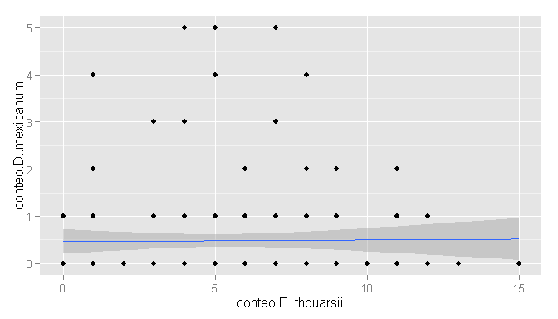

Curiosamente el valor de la correlación es muy bajo y la probabilidad indica que esta es no es significativa. Pero la relación es positiva entre los conteos de las dos especies.

# Modelo de la abundancia de los erizos

## Algebra del modelo

The N-mixture model or Poisson-Binomial mixture model (Royle 2004). In this model, all that is required to estimate detection probability and abundance is counts of unmarked individuals that are replicated in two dimensions: there must be a number of sites and there must be a number of replicate observations (i.e., counts) for at least some of the sites. The N-mixture model is a hierarchical extension of the Poisson GLM. We use the Poisson GLM as the base model for N but we regard N as latent variables (i.e., as unobserved or only partly observed). We augment the Poisson GLM with a model that describes how the observations Cij are related to the latent variable Ni. The model is also called a Poisson/binomial mixture model.

1. State process:
$$N_{i}∼Poisson(λ)$$

2. Observation process:

$$C_{ij}∼Binnomial(N_{i},p_{ij})$$

Here, $N_{i}$ is the latent abundance state at site i (i = 1…M) and $λ$ is the expected abundance, i.e., the mean abundance over all sites. $C_{ij}$ is the count at site i during survey j (j = 1…T) and $p_{ij})$ is the (per-individual) detection probability at site i during survey j.

unmarkedFrame Object

16 sites Maximum number of observations per site: 13 Mean number of observations per site: 13 Sites with at least one detection: 16

Tabulation of y observations: 0 1 2 3 4 5 6 7 8 9 10 11 12 13 15 13 19 8 23 24 27 19 21 27 14 2 4 5 1 1 0

Site-level covariates: otra_sp  
 Min. :46.00  
 1st Qu.:59.50  
 Median :70.50  
 Mean :68.12  
 3rd Qu.:75.50  
 Max. :82.00

Observation-level covariates: co_occu  
 Min. :0.0000  
 1st Qu.:0.0000  
 Median :0.0000  
 Mean :0.4808  
 3rd Qu.:1.0000  
 Max. :5.0000  
initial value 936.815815 iter 2 value 751.699085 iter 4 value 714.326805 iter 6 value 606.180121 iter 8 value 575.149904 iter 10 value 561.454545 iter 12 value 561.294054 iter 14 value 561.075679 iter 16 value 561.065267 iter 18 value 561.065223 final value 561.065209 converged initial value 936.815815 iter 2 value 690.931472 iter 4 value 572.690900 iter 6 value 562.208850 iter 8 value 559.410542 iter 10 value 555.590168 iter 12 value 554.159946 iter 14 value 554.128938 iter 14 value 554.128938 iter 14 value 554.128938 final value 554.128938 converged initial value 936.815815 iter 2 value 690.929650 iter 4 value 630.830146 iter 6 value 583.790719 iter 8 value 563.892156 iter 10 value 557.229040 iter 12 value 555.617478 iter 14 value 554.909284 iter 16 value 554.276648 iter 18 value 554.070948 iter 18 value 554.070948 final value 554.069815 converged initial value 771.020915 iter 2 value 713.619249 iter 4 value 630.722872 iter 6 value 588.850204 iter 8 value 581.779971 iter 10 value 577.122969 iter 12 value 570.574448 iter 14 value 564.029720 iter 16 value 555.583707 iter 18 value 554.611234 iter 20 value 554.401969 iter 22 value 554.277779 iter 24 value 554.240650 iter 26 value 554.155433 iter 28 value 554.136087 iter 28 value 554.136087 final value 554.136087 converged initial value 947.906169 iter 2 value 702.021663 iter 4 value 575.625573 iter 6 value 563.754603 iter 8 value 555.464103 iter 10 value 554.129187 iter 12 value 554.110709 iter 12 value 554.110709 final value 554.110579 converged 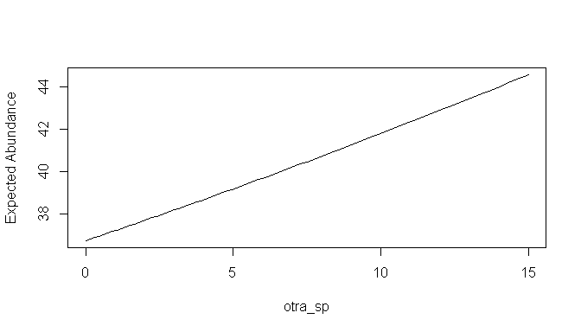 Predicted SE lower upper otra_sp 1 36.72381 12.05103 19.30294 69.86699 0 2 37.20224 12.05796 19.70963 70.21984 1 3 37.68691 12.06312 20.12479 70.57482 2 4 38.17789 12.06647 20.54858 70.93195 3 5 38.67526 12.06796 20.98119 71.29127 4 6 39.17912 12.06756 21.42279 71.65281 5 7 39.68954 12.06522 21.87356 72.01660 6 8 40.20660 12.06088 22.33367 72.38267 7 9 40.73041 12.05452 22.80333 72.75105 8 10 41.26104 12.04608 23.28271 73.12179 9 11 41.79858 12.03552 23.77200 73.49491 10 12 42.34312 12.02279 24.27141 73.87045 11 13 42.89476 12.00785 24.78113 74.24846 12 14 43.45359 11.99065 25.30136 74.62898 13 15 44.01969 11.97114 25.83230 75.01204 14 16 44.59317 11.94928 26.37416 75.39771 15 17 45.17413 11.92502 26.92715 75.78602 16 18 45.76265 11.89831 27.49149 76.17702 17 19 46.35884 11.86911 28.06739 76.57078 18 20 46.96279 11.83737 28.65506 76.96735 19 21 47.57461 11.80305 29.25472 77.36678 20

|  |  |  |  |
| --- | --- | --- | --- |
| model | AIC | nPars | delta |
| p(.)lambda(otra_sp) | 1114.25787639783 | 3 | 0 |
| p(co_occu)lambda(otra_sp) | 1116.13963015725 | 4 | 1.88175375942456 |
| p(.)lambda(otra_sp)zip | 1116.22115796643 | 4 | 1.96328156860341 |
| p(.)lambda(otra_sp)nb | 1116.27217491658 | 4 | 2.01429851875719 |
| p(.)lambda(.) | 1126.13041746952 | 2 | 11.8725410716895 |

La abundancia de la especie 1 de erizo puede ser explicada por la presencia de la otra especie.... Los modelos “negative bionomial” y “zero inflated model” no funcionaron muy bien.

# References

Dorazio, Robert M, J Andrew Royle, Bo Söderström, and Anders Glimskär. 2006. “Estimating Species Richness and Accumulation by Modeling Species Occurrence and Detectability.” *Ecology* 87 (4): 842–854.

Iknayan, Kelly J, Morgan W Tingley, Brett J Furnas, and Steven R Beissinger. 2014. “Detecting Diversity: emerging Methods to Estimate Species Diversity.” *Trends in Ecology & Evolution* 29 (2) (February): 97–106. doi:[10.1016/j.tree.2013.10.012](http://dx.doi.org/10.1016/j.tree.2013.10.012). <http://www.sciencedirect.com/science/article/pii/S0169534713002619>.

Royle, J Andrew. 2004. “N-Mixture Models for Estimating Population Size from Spatially Replicated Counts.” *Biometrics* 60 (1): 108–115.