Untitled

Diego J. Lizcano

August 16, 2015

# Relación entre las dos especies de erizos

## Conteos totales sin discriminar sitio.

##   
## Pearson's product-moment correlation  
##   
## data: erizodata$E_thouarsii and erizodata$D_mexicanum  
## t = -1.8064, df = 676, p-value = 0.0713  
## alternative hypothesis: true correlation is not equal to 0  
## 95 percent confidence interval:  
## -0.143856374 0.006016791  
## sample estimates:  
## cor   
## -0.06931087

## geom_smooth: method="auto" and size of largest group is <1000, so using loess. Use 'method = x' to change the smoothing method.

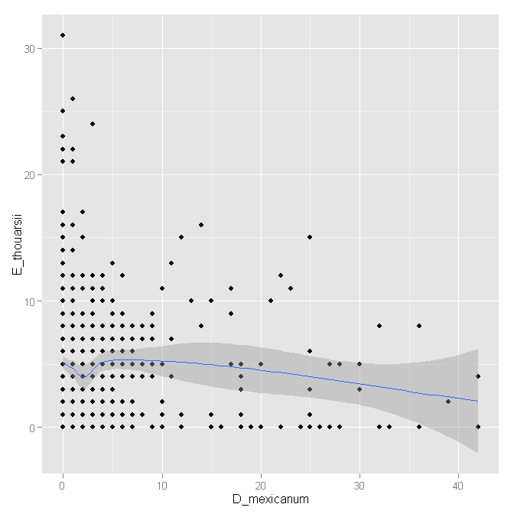

El valor de la correlación es muy bajo y la probabilidad indica que esta es no es significativa.

## Discriminando por el sitio

## geom_smooth: method="auto" and size of largest group is <1000, so using loess. Use 'method = x' to change the smoothing method.  
## geom_smooth: method="auto" and size of largest group is <1000, so using loess. Use 'method = x' to change the smoothing method.  
## geom_smooth: method="auto" and size of largest group is <1000, so using loess. Use 'method = x' to change the smoothing method.  
## geom_smooth: method="auto" and size of largest group is <1000, so using loess. Use 'method = x' to change the smoothing method.  
## geom_smooth: method="auto" and size of largest group is <1000, so using loess. Use 'method = x' to change the smoothing method.

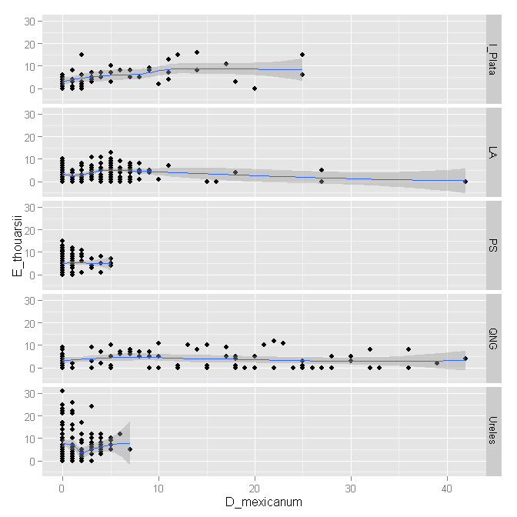 Pareciera haber algo en QNG y la Isla de la Plata?

# Modelo de la abundancia de los erizos

## Algebra del modelo

The N-mixture model or Poisson-Binomial mixture model (Royle 2004). In this model, all that is required to estimate detection probability and abundance is counts of unmarked individuals that are replicated in two dimensions: there must be a number of sites and there must be a number of replicate observations (i.e., counts) for at least some of the sites. The N-mixture model is a hierarchical extension of the Poisson GLM. We use the Poisson GLM as the base model for N but we regard N as latent variables (i.e., as unobserved or only partly observed). We augment the Poisson GLM with a model that describes how the observations Cij are related to the latent variable Ni. The model is also called a Poisson/binomial mixture model.

1. State process:
$$N_{i}∼Poisson(λ)$$

2. Observation process:

$$C_{ij}∼Binnomial(N_{i},p_{ij})$$

Here, $N_{i}$ is the latent abundance state at site i (i = 1…M) and $λ$ is the expected abundance, i.e., the mean abundance over all sites. $C_{ij}$ is the count at site i during survey j (j = 1…T) and $p_{ij})$ is the (per-individual) detection probability at site i during survey j.

La abundancia de la especie 1 de erizo puede ser explicada por la presencia de la otra especie.... Los modelos negative bionomial y zero inflated model no funcionaron muy bien.

# References

Royle, J. A. 2004. N-Mixture Models for Estimating Population Size from Spatially Replicated Counts. Biometrics 60:108–115.